**Practical – 1**

**(i) Aim: Find mean, median, and mode of the list [10, 12, 19, 20] using Python.**

**Code:**import numpy as np

import pandas as pd

data = [10,12,19,20]

print(np.mean(data))

print(np.median(data))

print(pd.Series(data).mode())

**Output:**

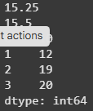

**(ii) Aim: Find mean, median, and mode of the 'cylinders' column from the Auto MPG dataset.**

**Code:**

# data_url = "/content/sample_data/Vatsal_costum_data/auto-mpg.csv" #dataset local ploaded

data_url = "https://archive.ics.uci.edu/ml/machine-learning-databases/auto-mpg/auto-mpg.data"

column_names = ["mpg", "cylinders", "displacement", "horsepower", "weight", "acceleration", "model year", "origin", "car name"]

df = pd.read_csv(data_url, names = column_names , delim_whitespace= True, na_values= "?")

print(df.head(10))

mean_cylinders = df["cylinders"].mean()

median_cylinders = df["cylinders"].median()

mode_cylinders = df["cylinders"].mode()

print("Mean of cylinders: ", mean_cylinders)

print("Median of cylinders: ", median_cylinders)

print("Mode of cylinders: ", mode_cylinders[0])

**Output:   
  
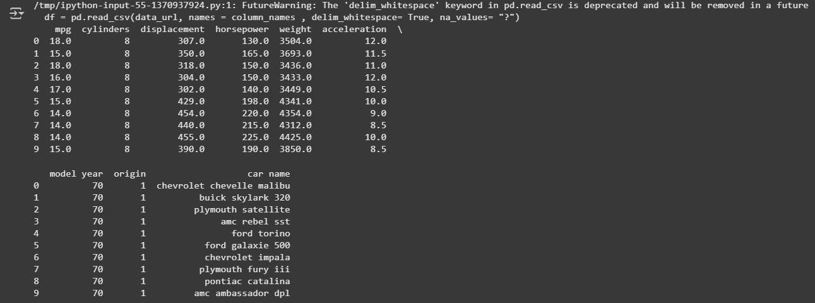**

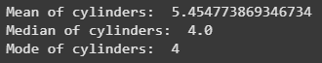

**Conclusion :**

Here, In this lab we have studied that the number of cylinders in cars using the Auto MPG dataset. The average or mean was about 5.45 cylinders, the median value was 4, and the mode was also 4. This means most of the cars in the dataset have 4-cylinder engines.