Project Report

1. Title Page

Project Name: Restaurant Billing System (Menu Categories and Discounts)
Subject: Programming in C
SAP ID : 590027526
Submitted By: Vatsal Chawla
Submitted To: Dr. Prashant Trivedi

2. Abstract
This project is a simple Restaurant Billing System made in C programming. The main idea is to make billing faster and easier for restaurants and to avoid manual mistakes. The system has a menu divided into categories like starters, main course, drinks, and extras. Each menu item has a name, price, and category, stored using a struct and an array. The program allows the user to select multiple items by entering the item number and quantity. It calculates the total bill automatically and applies a 10% discount if the total exceeds ₹300. Finally, it prints a clean bill summary showing the total amount, discount, and final amount to pay.

3. Problem Definition
In small restaurants, billing manually can take time and mistakes can happen. This program solves that by:
- Showing a menu and letting the customer select multiple item
- Calculating the total automatically.
- Giving a discount if the total is above 300.
- Showing a clear final bill.

4. System Design

4.1 Flowchart

Below is a flowchart for the code :

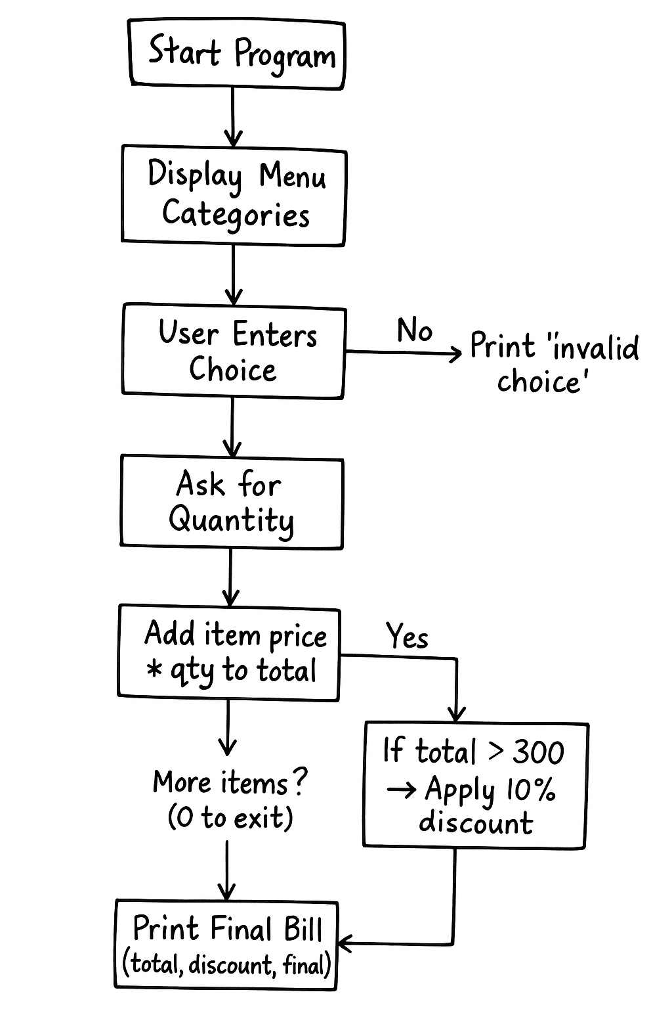

4.2 Algorithm
- Start program.
- Make a structure menu with item name, price, category.
- Hardcode all 12 menu items in an array.
- Print categories one by one using loops.
- Set total = 0.
- Start loop:
  - Ask user to enter item number (0 to exit)
  - If invalid, show message
  - Else ask quantity
  - Add price * qty to total
- After loop ends, check:
  - If total > 300, then discount = 10%. Otherwise no discount.
- Final price = total − discount
- Print bill
- End program

5. Implementation Details (with snippets)
5.1. Structure definition

This struct stores each menu item’s name, price, and what category it belongs.

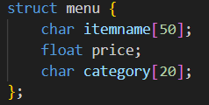

5.2. Menu Array

Here we make an array named m to store all menu items categorized into starters, main course, drinks and extras.
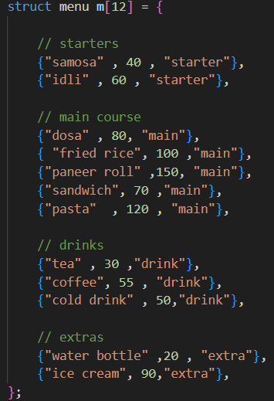

5.3. Displaying the Menu
Loops are used to print items category wise.
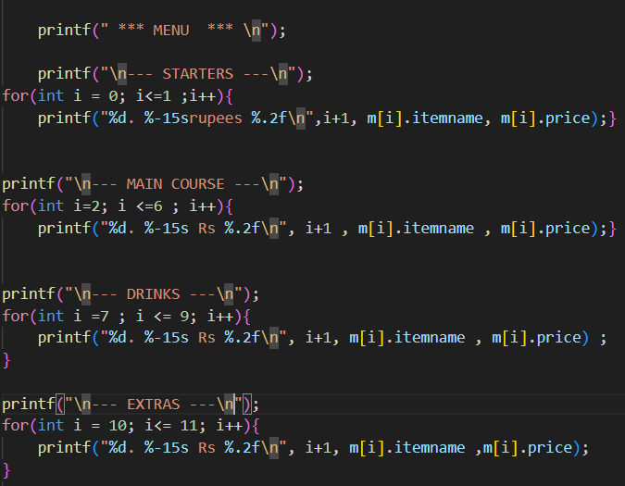
5.4. Taking Orders
A while(1) loop is used to take order input from the customer and ends when the customer enters 0. Customer’s choice is validated by checking if it lies between 1 and 12.
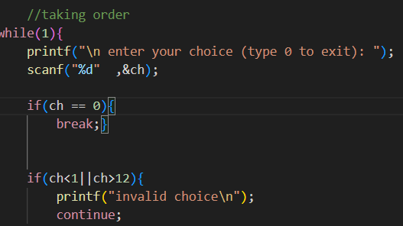

5.5. Calculating Total
After the user enters the item and quantity, the program calculates the total amount.
- It multiplies the price of the chosen item by the quantity.
- Then it adds this value to the running total.
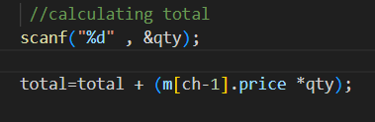
5.6. Discount
If the calculated total is more than or equal to 300, a discount of 10% is applied.
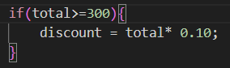
5.7. Final bill
The final amount is calculated by subtracting discount amount from total amount, and then displayed with total and discount amount.
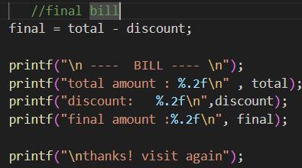

6. Testing And Results
Case 1: Ordering 1 Samosa, 1 pasta and 2 coffees.
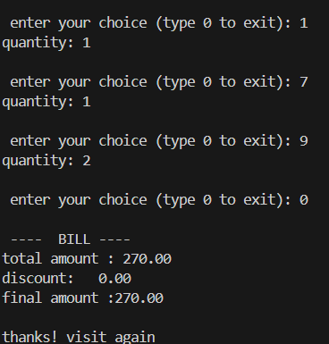
Observation: No discount applied as total is less than 300.

Case 2: Ordering 3 idli, 1 Dosa and 2 paneer rolls.
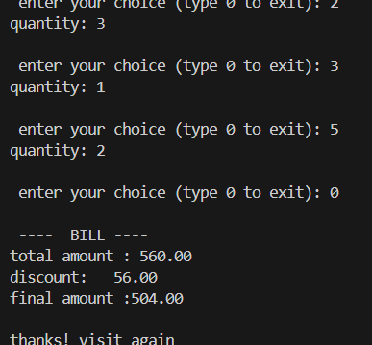
Observation: 10% discount applied since total was more than 300.

7. Conclusion & Future Work

Conclusion
This project helped me understand how to use structures, arrays, loops and conditions in C. The Restaurant Billing System works nicely for basic billing, shows menu categories, handles multiple items, and applies discount above ₹300.

Future Work
- Add GST
- Add multiple customers billing
- Save bill to a file
- Add item removal option
- Add login system

8. References
- Class notes
- Let us C by Mr. Yashavant Kanetkar
- Online C Tutorials.
Thank You.

