|  |
| --- |
| TIAA-CREF |
| Improving the intranet Homepage |
| HR Survey Project |
|  |
| **Team Three** |
| **7/20/2017** |

|  |
| --- |
| My team has surveyed 15 TIAA employees about the current state of the intranet homepage at TIAA. The most desired changes are improvements to the search function and additional links that can make finding information easier. |

Table of Contents

Proposed Changes 2

Metrics 3

Project Summary 4

Appendix 5

# Proposed Changes

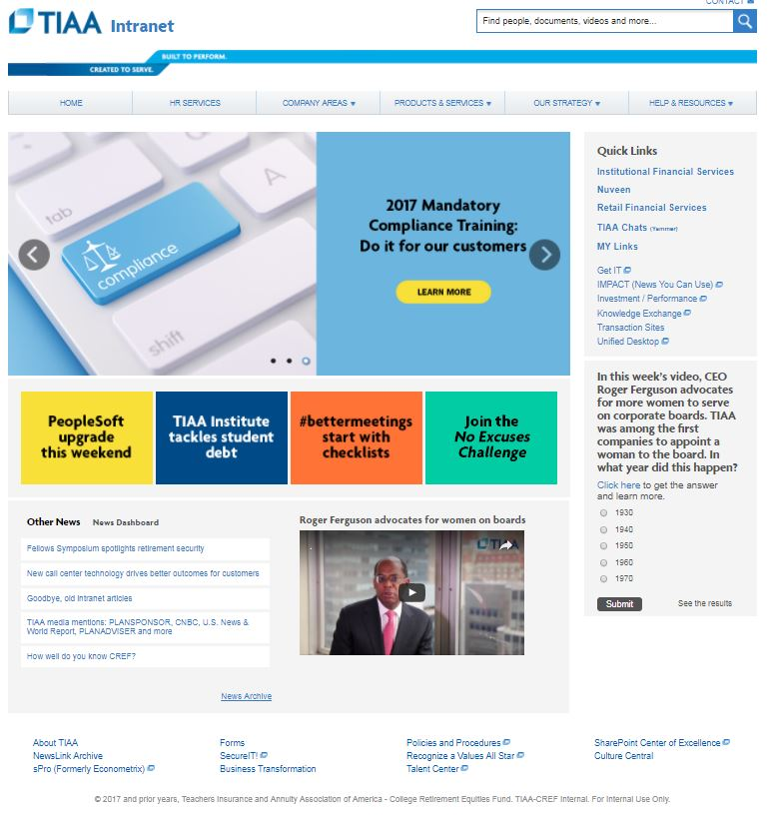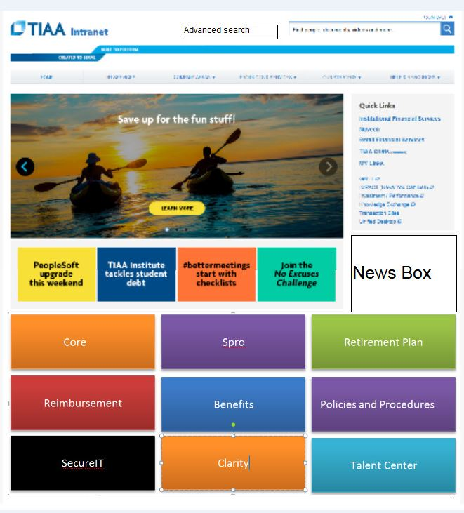

# Metrics

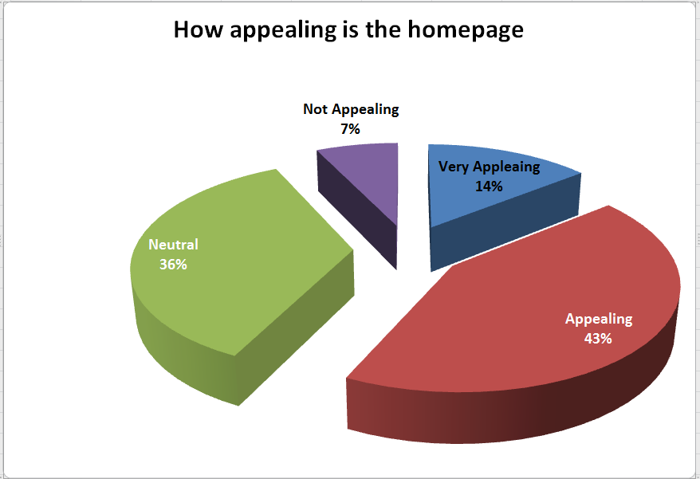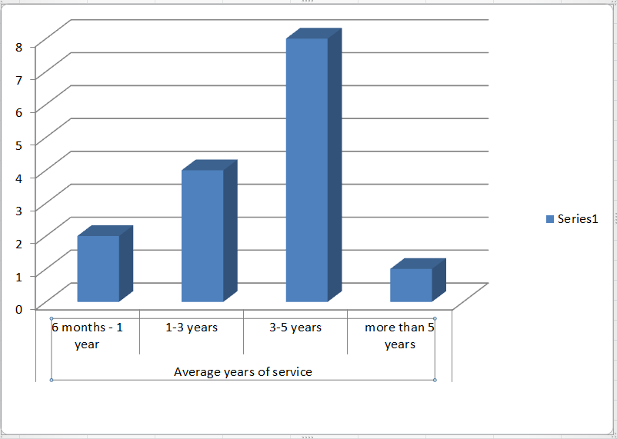

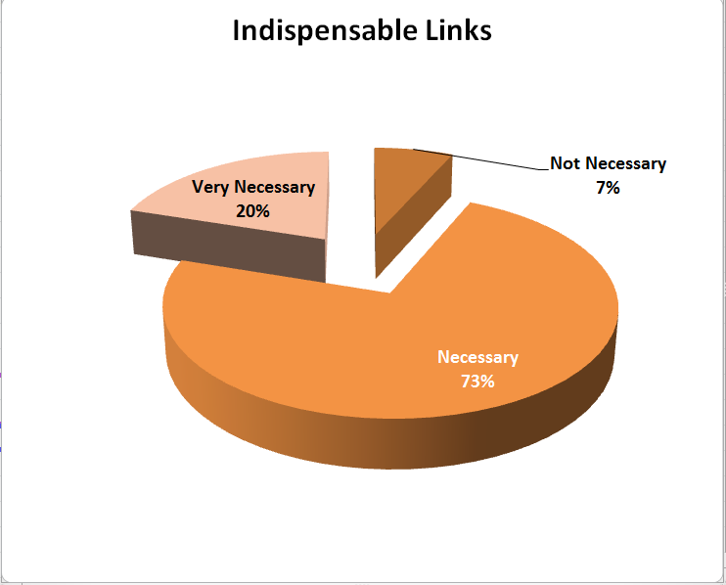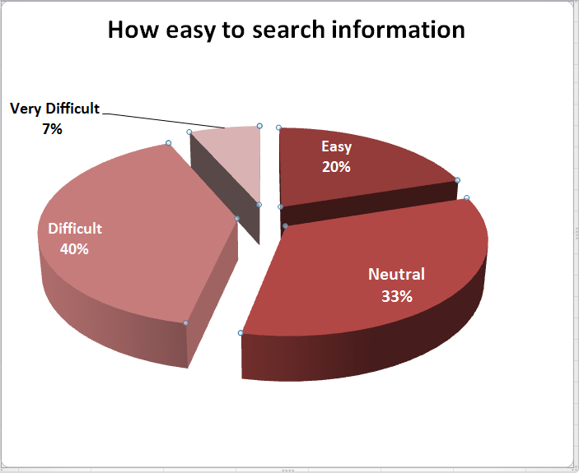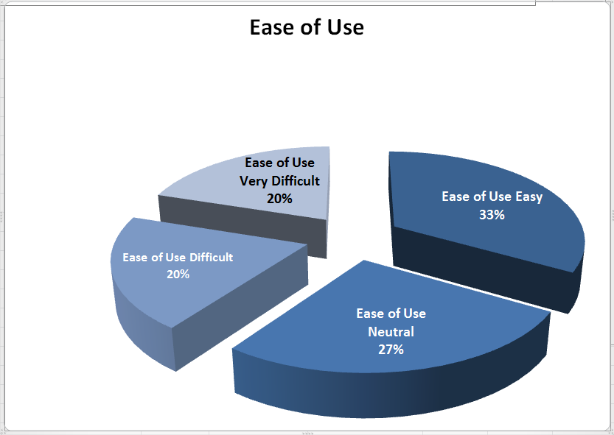

# Project Summary

The intranet homepage here at TIAA was created to be a hub for all employees to find important information about the company that accessing each employee’s company benefits. While the home page is functional, some changes will need to be made to increase employee productivity and invite extended use of the homepage. My team has been tasked with discovering the changes the employees desire that improve their overall experience with the homepage. To accomplish this task, my team created a simple five question likert-type scale survey, with answers ranging from one to five with one being the best option and five being the worst, as well as a free response question. The sample size of our survey was 15 random TIAA employees. The questions consisted of questions about overall appeal of the homepage, ease of use, and years of service to TIAA.

The results of our survey revealed that the majority of employees find the overall look and design of the homepage appealing and do not see that need to proceed with a complete overhaul of the homepage. The largest complaint comes from the usability of the homepage. Most employees find the search function does not return desired search results and would like a more robust algorithm to improve its functionality. Unfortunately this is somewhat out of scope for our project. Finding the desired links that will take employees to their chosen information on the company intranet was the second most coveted feature that most would like to see implemented. My team has worked together to create a proposed model of what we believe will need to be implemented to increase the usability of the intranet homepage. Using Draw.IO, a diagramming and modeling software, my team created a model that retains the aesthetic of the current intranet homepage while adding links to the most useful information suggested by the employees in the survey.

My team believes these proposed changes will increase employee productivity while using and welcome extended use of the intranet homepage.

# Appendix

