

**MGT1022  
 Lean Start-Up Management   
 DA - 2  
 REG : 18BCM0151**

**Name: Ermias Nigussie Zegeye**

**Startup vs Small Business**

Although the term startup is often used synonymously with new business, many people still don’t understand the difference between a startup and small business.

The difference between a startup and a small business is always subjective, it often comes to the company’s growth goals and revenue forecast. Startups always focus on disrupting markets and driving top-line revenue at a fast pace. Whereas small businesses, on the other hand, often set their goals on long-term, stable growth in an existing market.

With the launch and exponential growth of businesses like snapchat, it’s no surprise that the word startup has become so quickly integrated into the everyday dielectal of the business community.

**What is a startup**

Although we might define a startup in many ways, most i refer back to the definition put forth by silicon valley entrepreneur steve blank in 2010.

A startup is an organized form to search for a scalable and repeatable business model. According to blank, however, a startup is not only looking to find and execute on their business model, but they’re also looking to do so quickly and, in a way, they can significantly impacts or disrupts the current market.

**Growth intent**

One of the biggest differences between a startup and small business is the growth intent behind operations. A startup founders are look to significantly impact and disrupt the current market with their [startup business idea](https://www.justbusiness.com/starting-a-small-business/startup-ideas" \t "_blank), meaning they’re not looking to maintain a small, with limited team forever. Instead, they’re looking to grow quickly. This is why many startups are founded within the tech industry technology has a wide reach, and is easily scalable, and can fund fast.

In contrast to this concept of a startup, the small business administration (sba) defines a small business as a for-profit business of any legal structure, independently owned and operated, not nationally dominant in its field.

Based on this, the growth intent of a startup is very different from the intent behind most small businesses. Whereas a startup is very literally created for the purpose of growth, this may not be necessarily the case for a small business.

**Business objectives**

Linked directly to the growth intent of a startup are its goals and objectives. A startup founders looking to disrupt the market with their scalable and impactful business model, grow as quickly as possible, beat out competitors.

With a small business, on the other hand, this isn’t necessarily the case. To run a small business, we don’t need to disrupt the market or break into a completely new market; instead, we simply need to have the desire to start our own business and find a market that we can reach effectively. As long as we can do so while earning revenue, we can successfully run our small business.

In this way, whereas startups are typically founded in the tech industry, small businesses are often what we consider [main street businesses](https://www.justbusiness.com/starting-a-small-business/main-street-business" \t "_blank), local coffee shops, grocery stores, auto repair shops, hair salons, plumbers, and more. Although these businesses aren’t disrupting the market, they are the cornerstone of local economies and employment, employing many people.

Startups want to grow with a goal of disrupting the market. Small businesses, on the other hand, are created for the purpose of entrepreneurship and serving the local market and therefore, they aren’t concerned with growth on such a large scale.

**End goals**

During thestart a small business, it’s very likely that we plan to continue to run that business for some time until we eventually pass it on to a family member or sell it to an interested buyer after we retire. Therefore, until that time, our goal is simple, to stay in business. With a startup, on the other hand, this isn’t the same.

According to blank, a startup is a *short-lived* organization designed to search for a repeatable and scalable business model. The startup may [change business models](https://www.justbusiness.com/starting-a-small-business/business-model-generation" \t "_blank) to find the right one, but once it does, the goal of the organization then shifts to execute on that model. At that point, the organization will be no longer a startup, and instead, is a company.

**Funding**

Another of the biggest differences between a startup and small business is the way they’re funded. Although it will certainly be difficult for both startups and small businesses to find funding in comparison to established businesses, startups are much more likely to find success with equity financing in comparison to small businesses.

With equity financing, startups can look for investors or venture capitalists who are willing to offer large amounts of capital in exchange for equity, or ownership, in the company. Typically, these investors offer minimum amounts of capital in rounds and then with each series funding, the startup gives up equity. Therefore, as the startup continues to raise funding, it may reach a point where it no longer exists as an independent entity. Even though equity financing diversifies ownership of the startup, but it allows the founders to raise large amounts of capital, as well as earn the mentorship and guidance of the investors.

In contrast, equity financing just doesn’t work for most small businesses. Most small business owners don’t want to give up control of their small businesses and most investors and venture capitalists only want to work with high-growth-potential startups that are disrupting their industries. Instead, small business owners usually turn to different forms of debt financing loans, lines of credit, asset-based financing to fund their operations.

**Level of risk**

The operating principle of a startup is creating a product or service that can disrupt or significantly impact the market. Therefore, by going through the process to research, raise money, test the product or service. We’re taking a huge leap of faith that your startup will succeed and be able to make that impact. On the other hand, of course, we’re also taking a huge risk, if we don’t succeed, we have a lot to lose.

Although there are also a variety of risks associated with starting a small business and 20% of them fail within their first year. Small businesses have the benefit to launch within an already established market. In this way, the risks are much lower and can be much more manageable than startup owners.

**Plagiarism content**

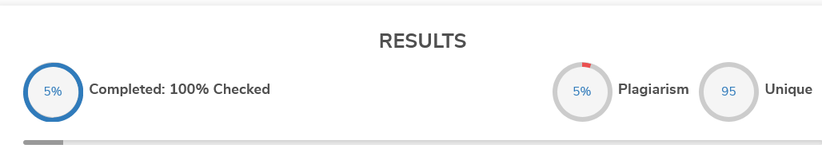

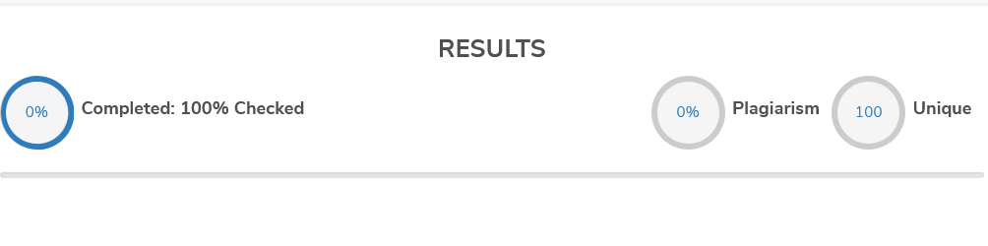

Average plagiarism content= 5%