HVAC and Air Outlet Control



Group Title

Group Members:

|  |  |  |
| --- | --- | --- |
| Sl. No. | Name | Employee ID |
| 1 |  |  |
| 2 |  |  |
| 3 |  |  |
| 4 |  |  |
| 5 |  |  |

© KPIT Technologies Ltd. All rights reserved. No part of this document may be reproduced, stored in a retrieval system or transmitted in any form, or by any means, electronic, mechanical, photocopying, recording or otherwise without the prior permission in writing of KPIT Technologies Ltd. Confidential & for internal circulation only.

Table of Contents

HVAC Control 3

Detailed Requirements 3

Functional Diagram 3

Comparison of Existing (Infineon, Renesas , Atmel etc ) 3

Proposed Design 4

Functional Requirements 4

Systems and Subsystems 4

Inputs and outputs of the Systems 6

Test Cases 6

UML Diagrams 6

Model Implementation 7

Code Generation of the Model 7

Autocode Generation 7

AUTOSAR complaint code generation 7

Test case Validation 8

Air Outlet Control 9

Detailed Requirements 9

Functional Diagram 9

Comparison of Existing (Infineon, Renesas , Atmel etc ) 9

Proposed Design 10

Functional requirements 10

Systems and Subsystems 10

Inputs and outputs of the Systems 12

Test Cases 12

UML Diagrams 12

Model Implementation 13

Code Generation of the Model 13

Autocode Generation 13

AUTOSAR complaint code generation 13

Test case Validation 13

# HVAC Control

HVAC Control enables users to control in-cabin Heating, Ventilation and Air Conditioning. It has two knobs, Ventilation Knob and Temperature Knob. It also have a switch to turn on and off the air conditioning if the desired temperature is cooling.

## Detailed Requirements

|  |  |
| --- | --- |
| **Requirement ID** | **Requirement Description** |
| HVAC000 | Ventilation Knob controls the rotation speed on fans. |
| HVAC100 | Temperature Knob sets the desired temperature. |
| HVAC200 | A/C Switch turns on and off the A/C if desired temperature is set to cooling. |

## Functional Diagram

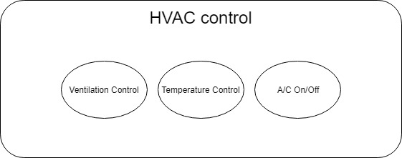

### Comparison of Existing (Infineon, Renesas , Atmel etc )

Infineon

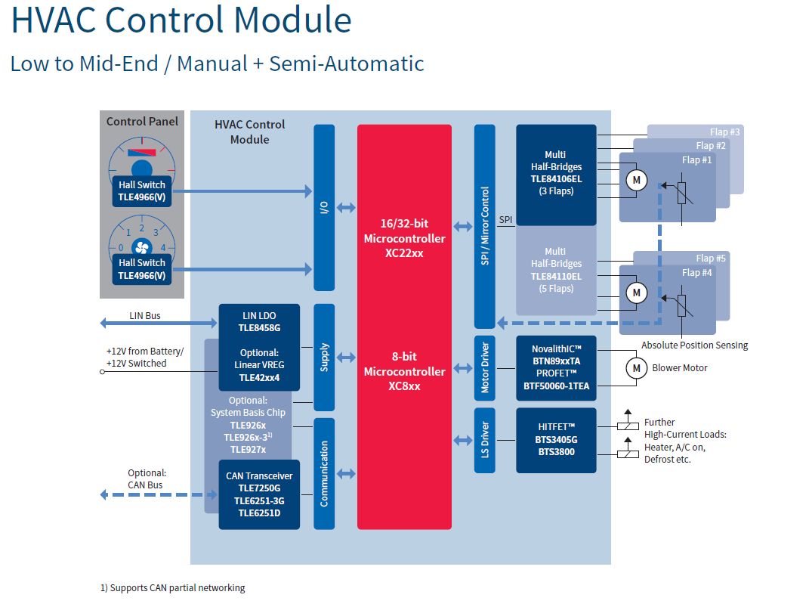

### Proposed Design

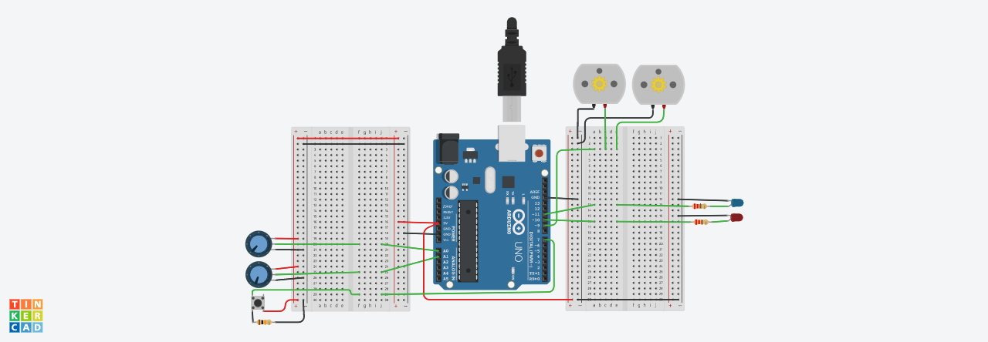

## Functional Requirements

|  |  |
| --- | --- |
| **Requirement ID** | **Requirement Description** |
| HVAC001 | Ventilation Knob sends analog signal to the MCU to determine the speed of ventilation fans. |
| HVAC002 | MCU controls the speed of ventilation fans depends on the input of Ventilation Knob. |
| HVAC101 | Temperature Knob sends analog signal to the MCU to determine the desired temperature. |
| HVAC102 | MCU controls the power of heating and air conditioning depends on the input of Temperature Knob. |
| HVAC301 | A/C Switch sends digital signal to MCU to indicate the power on/off of the A/C. |
| HVAC302 | MCU turns on or off the air conditioning depends on the input of A/C Switch. |

### Systems and Subsystems



|  |  |  |
| --- | --- | --- |
| **Name** | **Quantity** | **Component** |
| U1 | 1 | Arduino Uno R3 |
| M1, M2 | 2 | DC Motor |
| Rpot4, Rpot1 | 2 | 250 kOhm, Potentiometer |
| R1, R2 | 2 | 220 ohm Resistor |
| D1 | 1 | Red LED |
| D2 | 1 | Blue LED |
| S1 | 1 | Pushbutton |
| R3 | 1 | 10 kohm Resistor |

/*

This program simulate HAVC Control.

Input: Ventilation Knob, Temperature Knob, A/C switch

Output: Fans and LEDs simulation of HVAC

- Copyright 2018 YuPui

*/

#include<stdint.h>

#include<avr/io.h>

#include<avr/interrupt.h>

#include<util/delay.h>

#define sbi(sfr, bit) (_SFR_BYTE(sfr) |= _BV(bit))

#define SET_BIT(PORT, BIT) PORT|= (1 << BIT)

#define CLR_BIT(PORT, BIT) PORT&= ~(1 << BIT)

# define F_CPU 16000000UL

volatile uint16_t ventIn = 0;

volatile uint16_t tempIn = 0;

void setup() {

// Set up port C pin 0 as analog input

// Ventilation Knob

DDRC = (0 << 0);

PORTC = (0 << 0);

// Set up port C pin 0 as analog input

// Temperature Knob

DDRC = (0 << 1);

PORTC = (0 << 1);

// Analog input initializtion

ADMUX = 0x00;

ADMUX |=_BV(REFS0)|_BV(MUX3)|_BV(MUX2)|_BV(MUX1)|_BV(MUX0);

ADCSRA = 0x00;

ADCSRB = 0x00;

ADCSRA |=_BV(ADEN) | _BV(ADPS2) |_BV(ADPS1) | _BV(ADPS0);

ADCSRA |= _BV(ADSC);

// Set port D pin 7 as digital input

// A/C on/off switch

CLR_BIT(PORTD, PD7);

// Set up pin 9, 10, 11 as output

SET_BIT(DDRB, PB3);

SET_BIT(DDRB, PB2);

SET_BIT(DDRB, PB1);

CLR_BIT(PORTB, PB3);

CLR_BIT(PORTB, PB2);

CLR_BIT(PORTB, PB1);

// Set up timer 1 channel A for PWM output on pin 9

sbi(TCCR1A, COM1A1);

// Set up timer 1 channel B for PWM output on pin 10

sbi(TCCR1A, COM1B1);

// Set up timer 2 channel A for PWM output on pin 11

sbi(TCCR2A, COM2A1);

}

void loop() {

// Read the analog in value:

// Start reading value from port C pin 0

ADMUX &= 0xf0;

ADMUX |= 0X0; // port C pin 0

ADCSRA |= _BV(ADSC);

_delay_ms(10);

ventIn = ADC;

// Start reading value from port C pin 0

ADMUX &= 0xf0;

ADMUX |= 0X1; // port C pin 1

ADCSRA |= _BV(ADSC);

_delay_ms(10);

tempIn = ADC;

// analog output to pin 9 drive the fans

OCR1A = ventIn/4;

// determine heating or cooling

if (tempIn > 600) {

// Heating

// analog output to pin 10 and 11

OCR1B = (tempIn - 600)/2;

OCR2A = 0;

}

if (tempIn <= 600 && tempIn > 400) {

// Off

OCR1B = 0;

OCR2A = 0;

}

if (tempIn < 400) {

// Cooling, A/C on depend on switch input

OCR1B = 0;

OCR2A = (200 - tempIn/2)*(PIND >> 7);

}

}

int main() {

setup();

while (1) { // super loop

loop();

}

}

### Inputs and outputs of the Systems

Inputs:

Ventilation Knob

Temperature Knob

A/C Switch

Outputs:

2X Ventilation Fans

Heating Elements (Simulated by a Red LED)

Cooling Elements (Simulated by a Blue LED)

## Test Cases

|  |  |  |
| --- | --- | --- |
| **Test ID** | **Test Description** | **Expected Result** |
| HVACT001 | Turn Ventilation Knob to low | Ventilation fans set to low |
| HVACT002 | Turn Ventilation Knob to high | Ventilation fans set to high |
| HVACT003 | Turn Temperature Knob to high and A/C Switch off | Red led glows, blue led off |
| HVACT004 | Turn Temperature Knob to high and A/C Switch on | Red led glows, blue led off |
| HVACT005 | Turn Temperature Knob to low and A/C Switch off | Red led off, blue led off |
| HVACT006 | Turn Temperature Knob to low and A/C Switch on | Red led off, blue led glows |

## UML Diagrams

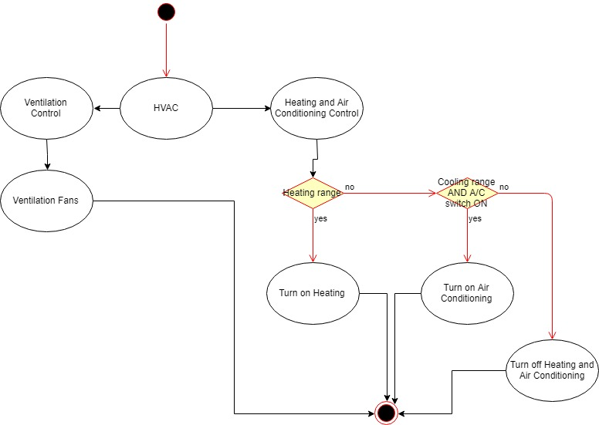

## Model Implementation

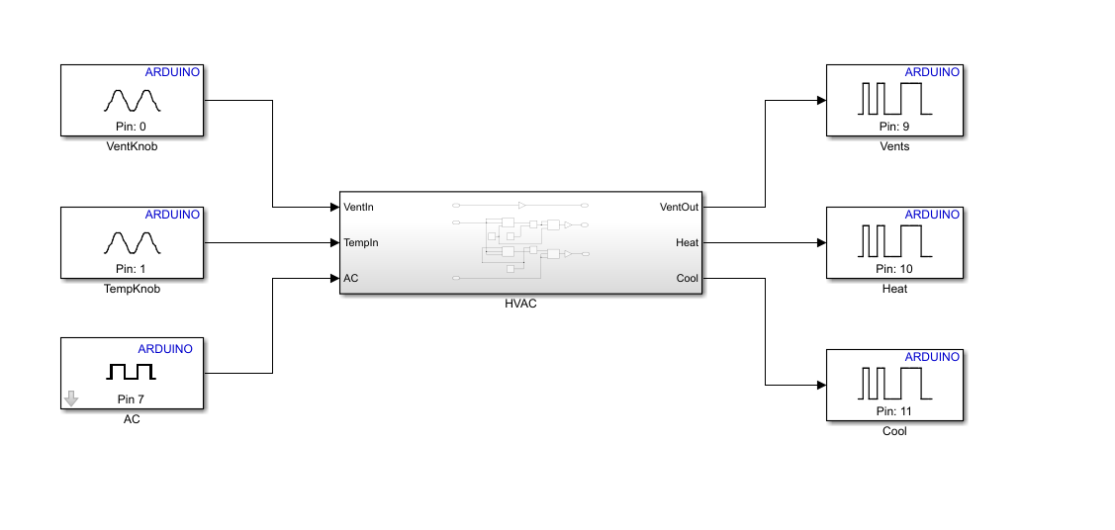

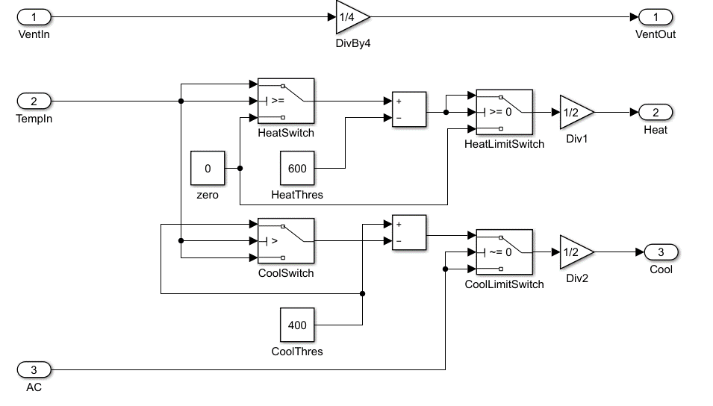

## Code Generation of the Model

Describe ..

### Autocode Generation

Describe ..

### AUTOSAR complaint code generation

Describe ..

## Test case Validation

Tests was perform in hardware with Embedded C code after they pass in the simulation on TinkerCAD and Simulink.

|  |  |  |  |
| --- | --- | --- | --- |
| **Test ID** | **Test Description** | **Expected Result** | **Test Result** |
| HVACT001 | Turn Ventilation Knob to low | Ventilation fans set to low | Ventilation fans set to low |
| HVACT002 | Turn Ventilation Knob to high | Ventilation fans set to high | Ventilation fans set to high |
| HVACT003 | Turn Temperature Knob to high and A/C Switch off | Red led glows, blue led off | Red led glows, blue led off |
| HVACT004 | Turn Temperature Knob to high and A/C Switch on | Red led glows, blue led off | Red led glows, blue led off |
| HVACT005 | Turn Temperature Knob to low and A/C Switch off | Red led off, blue led off | Red led off, blue led off |
| HVACT006 | Turn Temperature Knob to low and A/C Switch on | Red led off, blue led glows | Red led off, blue led glows |

# Air Outlet Control

Air Outlet Control enables user to control air outlet for ventilation fans. It has one knob that allow user to switch 5 modes. Mode 1 turns on outlet set 1 only. Mode 2 turns on outlet set 2 only. Mode 3 turns on outlet set 1 and 2. Mode 4 turns on outlet set 1 and 3. Mode 5 turns on outlet set 3 only.

## Detailed Requirements

|  |  |
| --- | --- |
| **Requirement ID** | **Requirement Description** |
| AOC000 | Air Outlet Modes Knob controls air outlet modes. |
| AOC100 | At mode 1, air outlet set 1 only shall be on. |
| AOC200 | At mode 2, air outlet set 2 only shall be on. |
| AOC300 | At mode 3, air outlet set 1 and 2 shall be on. |
| AOC400 | At mode 4, air outlet set 1 and 3 shall be on. |
| AOC500 | At mode 5, air outlet set 3 only shall be on. |

## Functional Diagram

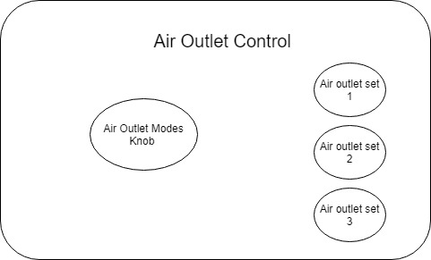

### Comparison of Existing (Infineon, Renesas , Atmel etc )

Infineon



### Proposed Design



## Functional requirements

|  |  |
| --- | --- |
| **Requirement ID** | **Requirement Description** |
| AOC001 | Air Outlet Modes Knob set the air outlet mode value, range from 0 to 1023. |
| AOC101 | When mode value < 200, air outlet set 1 on, rest is off. |
| AOC201 | When 200 <= mode value < 400, air outlet set 2 on, rest is off. |
| AOC301 | When 400 <= mode value < 600, air outlet set 1 and 2, rest is off. |
| AOC401 | When 600 <= mode value < 800, air outlet set 1 and 3, rest is off. |
| AOC501 | When mode value >= 800, air outlet set 3 on, rest is off. |

### Systems and Subsystems



|  |  |  |
| --- | --- | --- |
| **Name** | **Quantity** | **Component** |
| U1 | 1 | Arduino Uno R3 |
| RpotAir Outlet Modes Knob1 | 1 | 250 kOhm, Potentiometer |
| D2, D3, D4 | 3 | Red LED |
| R1, R2, R3 | 3 | 220 ohm Resistor |

/*

This program simulate Air Outlet Control.

Input: Air Outlet Modes Knob

Output: LEDs simulation of air outlets

- Copyright 2018 YuPui

*/

#include<stdint.h>

#include<avr/io.h>

#include<util/delay.h>

#define SET_BIT(PORT, BIT) PORT|= (1 << BIT)

#define CLR_BIT(PORT, BIT) PORT&= ~(1 << BIT)

# define F_CPU 16000000UL

int main() {

// Set up port C pin 0 as analog input

DDRC = (0 << 0);

PORTC = (0 << 0);

// Analog input initializtion

ADMUX = 0x00;

ADMUX |=_BV(REFS0)|_BV(MUX3)|_BV(MUX2)|_BV(MUX1)|_BV(MUX0);

ADCSRA = 0x00;

ADCSRB = 0x00;

ADCSRA |=_BV(ADEN) | _BV(ADPS2) |_BV(ADPS1) | _BV(ADPS0);

ADCSRA |= _BV(ADSC);

// Set up port D pin 5,6,and 7 as digital output

SET_BIT(DDRD, PD5);

SET_BIT(DDRD, PD6);

SET_BIT(DDRD, PD7);

CLR_BIT(PORTD, PD5);

CLR_BIT(PORTD, PD6);

CLR_BIT(PORTD, PD7);

while (1) { // super loop

// Start reading value from port C pin 0

ADMUX &= 0xf0;

ADMUX |= 0X0; // port C pin 0

ADCSRA |= _BV(ADSC);

if (ADC < 200) {

SET_BIT(PORTD, PD5);

CLR_BIT(PORTD, PD6);

CLR_BIT(PORTD, PD7);

}

if (ADC < 400 && ADC >= 200) {

CLR_BIT(PORTD, PD5);

SET_BIT(PORTD, PD6);

CLR_BIT(PORTD, PD7);

}

if (ADC < 600 && ADC >= 400) {

SET_BIT(PORTD, PD5);

SET_BIT(PORTD, PD6);

CLR_BIT(PORTD, PD7);

}

if (ADC < 800 && ADC >= 600) {

SET_BIT(PORTD, PD5);

CLR_BIT(PORTD, PD6);

SET_BIT(PORTD, PD7);

}

if (ADC > 800) {

CLR_BIT(PORTD, PD5);

CLR_BIT(PORTD, PD6);

SET_BIT(PORTD, PD7);

}

_delay_ms(100);

}

}

### Inputs and outputs of the Systems

Inputs:

Air Outlet Mode Knob

Outputs:

2X RED LED simulating the switch of air outlet sets

## Test Cases

|  |  |  |
| --- | --- | --- |
| **Test ID** | **Test Description** | **Expected Result** |
| AOCT001 | Turn Air Outlet Mode Knob to very low (below 200) | Mode 1: set 1 on. |
| AOCT002 | Turn Air Outlet Mode Knob to low (between 200 to 400) | Mode 2: set 2 on. |
| AOCT003 | Turn Air Outlet Mode Knob to middle (between 400 to 600) | Mode 3: set 1 and 2 on. |
| AOCT004 | Turn Air Outlet Mode Knob to high (between 600 to 800) | Mode 4: set 1 and 3 on. |
| AOCT005 | Turn Air Outlet Mode Knob to very high (above 800) | Mode 5: set 3 on. |
| AOCT006 | Turn Air Outlet Mode Knob back to high (between 600 to 800) | Mode 4: set 1 and 3 on. |

## UML Diagrams

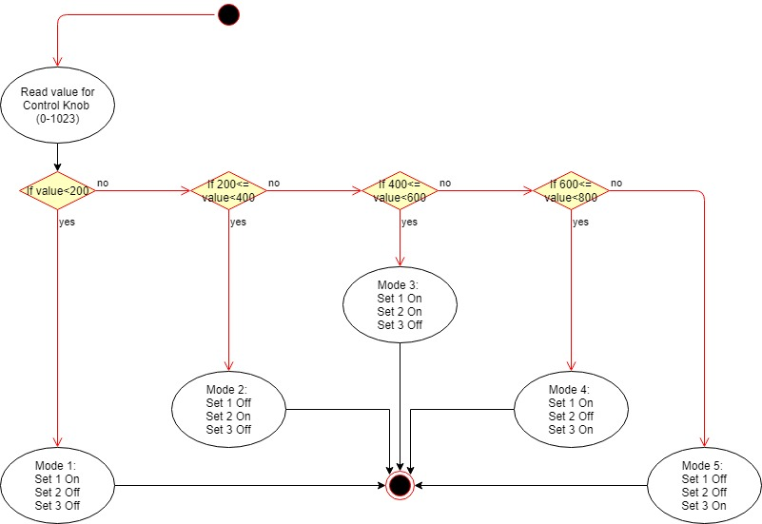

## Model Implementation

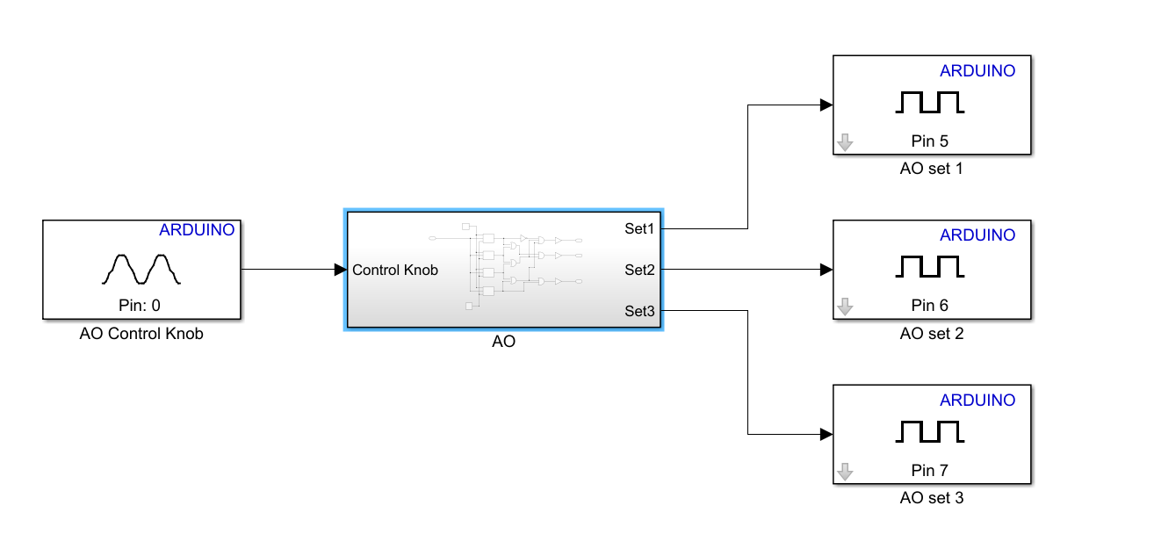

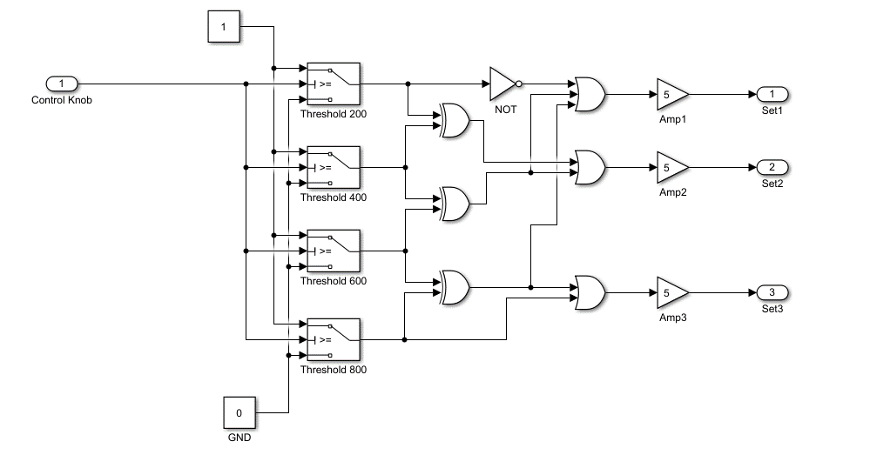

## Code Generation of the Model

Describe ..

### Autocode Generation

Describe ..

### AUTOSAR complaint code generation

Describe ..

## Test case Validation

Tests was perform in hardware with Embedded C code after they pass in the simulation on TinkerCAD and Simulink.

|  |  |  |  |
| --- | --- | --- | --- |
| **Test ID** | **Test Description** | **Expected Result** | **Test Result** |
| AOCT001 | Turn Air Outlet Mode Knob to very low (below 200) | Mode 1: set 1 on. | Mode 1: set 1 on. |
| AOCT002 | Turn Air Outlet Mode Knob to low (between 200 to 400) | Mode 2: set 2 on. | Mode 2: set 2 on. |
| AOCT003 | Turn Air Outlet Mode Knob to middle (between 400 to 600) | Mode 3: set 1 and 2 on. | Mode 3: set 1 and 2 on. |
| AOCT004 | Turn Air Outlet Mode Knob to high (between 600 to 800) | Mode 4: set 1 and 3 on. | Mode 4: set 1 and 3 on. |
| AOCT005 | Turn Air Outlet Mode Knob to very high (above 800) | Mode 5: set 3 on. | Mode 5: set 3 on. |
| AOCT006 | Turn Air Outlet Mode Knob back to high (between 600 to 800) | Mode 4: set 1 and 3 on. | Mode 4: set 1 and 3 on. |