ELECTRIC VEHICLE FEATURES



Group
Title
Group Members:

Sl. No. | Name | Employee ID
1 | Fabrice Claude Kamaha Ngayahala | 136174
2
3
4
5

© KPIT Technologies Ltd. All rights reserved. No part of this document may be reproduced, stored in a retrieval system or transmitted in any form, or by any means, electronic, mechanical, photocopying, recording or otherwise without the prior permission in writing of KPIT Technologies Ltd. Confidential & for internal circulation only.
Revision History

Version No. | Date | Prepared By/  Modified By | Overview of Changes | Approved By
0.1 | 24-10-16 | Team members names

Table of Contents
1 Introduction 5
1.1 Powertrain in Battery Electric Vehicle (BEV) 5
1.2 Plan 5
2 Battery Management System 5
2.1 Battery Recharging System 5
2.1.1 Detailed Requirements 5
2.1.2 Functional requirements 6
2.1.3 System and Components 6
2.1.4 Inputs and outputs of the Systems 8
2.1.5 Test Cases 8
2.1.6 UML Diagrams 9
2.1.7 Model Base Design 10
2.2 Battery Temperature Warning 11
2.2.1 Detailed Requirements 11
2.2.2 Detailed Requirements 12
2.2.3 Functional requirements 12
2.2.4 Systems and Subsystems 12
2.2.5 Inputs and outputs of the Systems 12
2.3 Test Cases 13
2.4 UML Diagrams 13
3 Door Control System 13
3.1 Requirements 13
3.1.1 Detailed Requirements 13
3.1.2 Functional Requirements 13
3.2 System and Components 14
3.2.1 System 14
3.2.2 Components 14
3.2.3 Code 14
3.3 Inputs and outputs of the Systems 15
3.4 Test Cases 15
3.5 Model Base Design 15
3.5.1 Door Control System 15
3.5.2 Switch Box Subsystem 15
3.5.3 SuperState Subsystem 16
3.5.4 LEDs Subsystem 16

Table of Figures (Please auto insert)
Figure 1-1- Features and requirements analysis 6

Table of Tables (Please auto insert)
No table of figures entries found.

1 Introduction

Powertrain in Battery Electric Vehicle (BEV)

Plan
The idea is to conceive a system that completely satisfies the all the requirements.

Battery Management System

Battery Recharging System

The system receives an input analog signal from the pedal, due the movement of the brake or pedal. The analog signal is then processed through an electronic control unit (ECU) that produces a pulse width modulation as output. The output generated by the ECU is then used as input by a generator to produce energy electric that will be use to charge the battery. At the same time, the battery is used to provide energy to the motor, which will be powering the system as long as the car is on. The flowchart of the system is shown below.

Detailed Requirements
Requirement ID | Requirement Description
BRS100 | An analog signal shall be generated when the driver pushes on the brake or accelerator.
BRS200 | The analog signal generated by the pedal shall be transformed using a generator into DC power.
BRS300 | The driver shall be able to see the level of energy recovered every time the pedal is pushed.

Functional requirements
Requirement ID | Requirement Description
BRS001 | The system requires 5V DC power supply.
BRS101 | Once the loss of energy reaches a given threshold, the system is automatically awaked.
BRS102 | Whenever energy is recovered, the system will blink a Red, Green or Blue LED according to the amount of energy restored.
BRS201 | Once the battery is fully charged, the charging system goes to sleep.
BRS202 | Every 5 minutes, the system check the level of the battery.

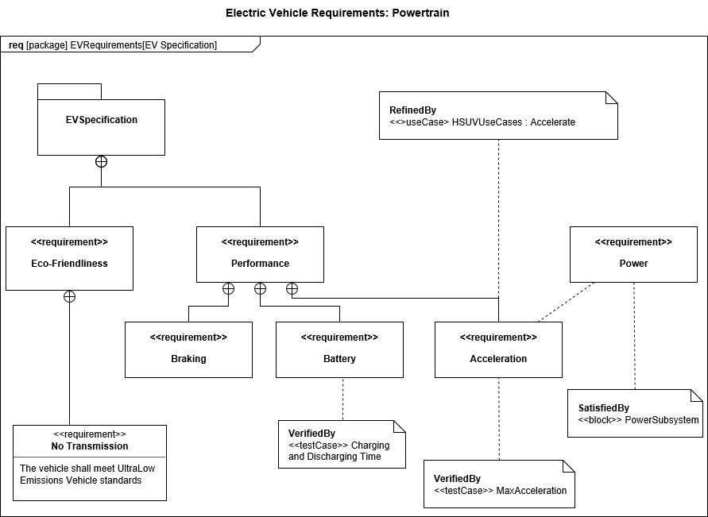

System and Components

System

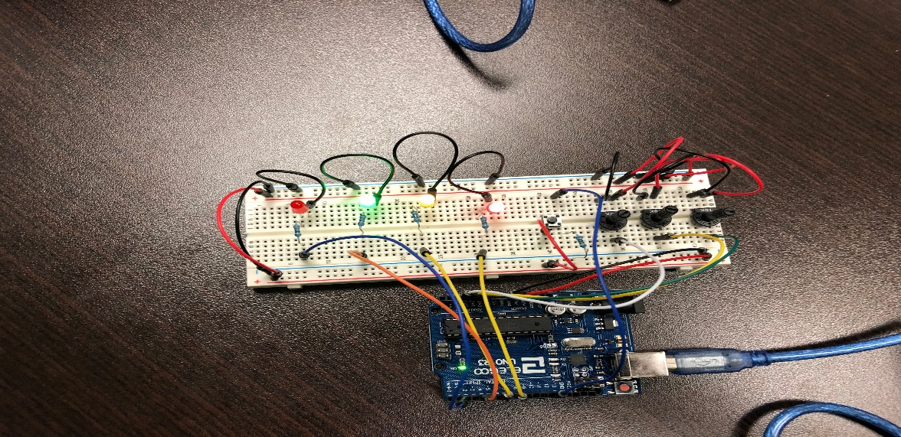

Components

Name | Quantity |  | Component
U1 | 1 |  | Arduino Uno R3
R1, R2,R3 | 3 |  | 220 ohm Resistor
RGB | 1 |  | RGB LED
P | 1 |  | 250 kOhm Potentiometer
S | 1 |  | Slide switch
M | 1 |  | D C Motor

Code

Inputs and outputs of the Systems
Inputs: Analog Signal
Outputs: DC power

Test Cases
Test Case ID | Test Case Description | Expected Result
BRST001 | Battery is full, car is on, and the driver pushes on the brake or accelerator. | No LEDs blink
BRST002 | Car is on and battery isn’t fully charged but the threshold is not reached yet. | No LEDs blink
BRST003 | Car is on, battery not full and threshold is reached | Charging System is On
BRST004 | After test BRST003, driver pushes on the brake or accelerator. | Green, Yellow or Red LED will blink
BRST005 | After test BRST004, the battery is fully charged and the car still on | Charging System Off

UML Diagrams

Flowchart

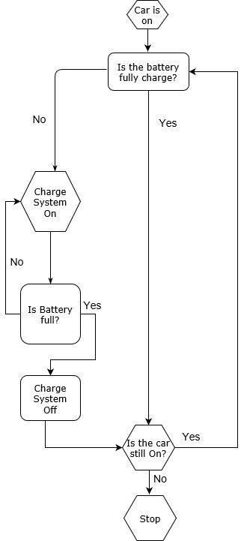

Functional Diagram
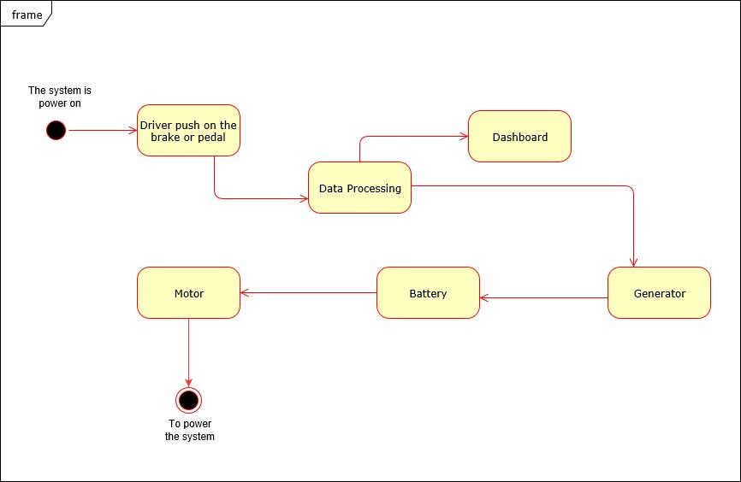

Model Base Design

Power System

Battery Subsystem

Power Manager Subsystem

Charging Subsystem

Battery Temperature Warning

Detailed Requirements
In electric powertrain system, energy from the battery will convert to kinetic energy to power the vehicle or thermal energy that will otherwise be wasted to ambient environment. Also sudden temperature increase may indicate the undesired reaction happened in the battery.

Detailed Requirements
Requirement ID | Requirement Description
BTW100 | Warning shall be given when battery temperature reaches critical.
BTW200 | Warning shall be given when sudden battery temperature increase occurs.

Functional requirements
Requirement ID | Requirement Description
BTW001 | The system requires 5V DC power supply.
BTW002 | The system will measure battery temperature every 2 seconds.
BTW101 | Upon battery temperature reaches critical, red LED trigger counter will be reset to 10.
BTW102 | When red LED trigger counter is greater than 0, red LED will blink and the red LED trigger counter by 1, for every 2 seconds.
BTW201 | Upon sudden temperature increase, yellow LED trigger counter will be reset to 10.
BTW202 | When yellow LED trigger counter is greater than 0, yellow red LED will blink and the yellow LED trigger counter by 1, for every 2 seconds.

Systems and Subsystems

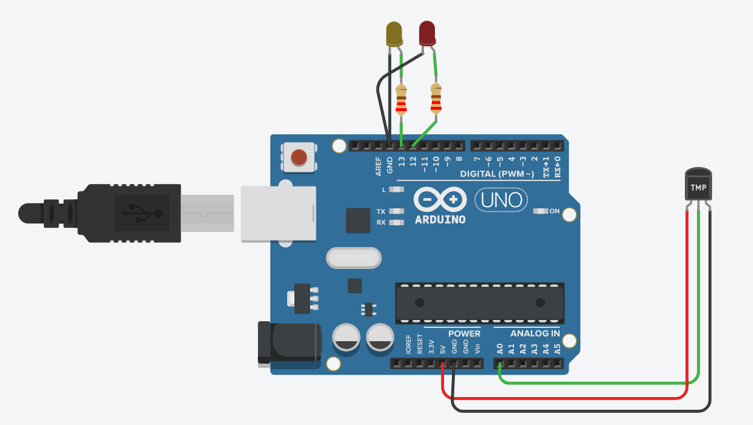
Name | Quantity |  | Component
U1 | 1 |  | Arduino Uno R3
R1, R2 | 2 |  | 220 ohm Resistor
D1 | 1 |  | Yellow LED
U2 | 1 |  | Temperature Sensor [TMP36]
D2 | 1 |  | Red LED

Inputs and outputs of the Systems
Inputs: Battery temperature
Outputs: LED warnings

Test Cases
Test Case ID | Test Case Description | Expected Result
BTWT001 | Set to room temperature(25C) for 2 seconds | No LEDs blink
BTWT002 | After test BTWT001, increase temperature by 10C by 2 seconds (to 35C) | No LEDs blink
BTWT003 | After test BTWT002, increase temperature by 25C by 2 seconds (to 60C) | Yellow LEDs blinks 10 times after
BTWT004 | After test BTWT003, increase temperature by 40C by 2 seconds (to 100C) | Red and Yellow LEDs blinks 10 times after
BTWT005 | Set the temperature by 0 and Increase temperature by 25 C | Yellow LEDs blinks 10 times after

UML Diagrams

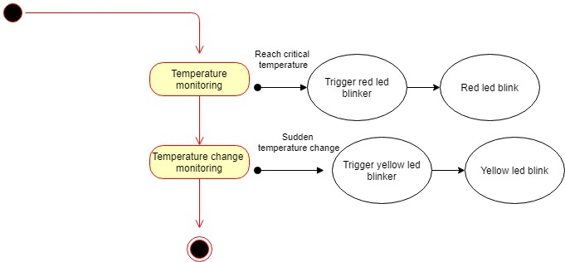

Door Control System

Requirements

Detailed Requirements
Requirement ID | Requirement Description
DCS100 | When all the doors aren’t closed, the driver shall be inform by the system
DCS200 | The driver shall be informed with the lights blinking and a given sound.
DCS300 | The alarm shall stop only when all the doors are closed.

Functional Requirements
Requirement ID | Requirement Description
DCS001 | The system requires 5V DC power supply.
DCS002 | The system will get signal from the switches whenever an event occurs.
DCS101 | Upon the signal is received, the system will generate an output based on the input received
DCS102 | When the signal received from a switch is 1, it means a door is opened. Therefore, there is a LED blinking according to the side where the door is opened. Additively, a sound is generated by a buzzer. When the signal’s value switches to 0, it means everything it alright and you have no light signaling or sound.
BCS201 | The system shall alerting the driver until everything correct.

System and Components

System
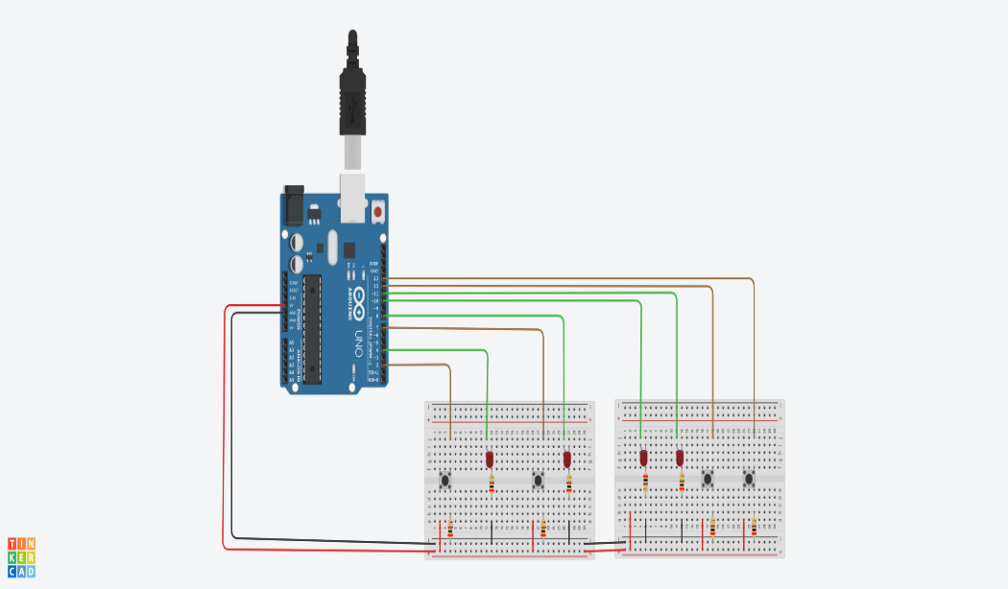

Components
Name | Quantity |  | Component
U1 | 1 |  | Arduino Uno R3
R3, R7, R8, R1, R2, R4, R5, R6 | 8 |  | 220 ohm Resistor
D1, D2, D3, D4 | 4 |  | Red LED
B | 1 | Buzzer
4, S5, S1, S2 | 4 |  | Pushbutton

Code

Inputs and outputs of the Systems
Inputs: Digital Signal from Switches
Outputs: Digital signal sent to the LEDs to turn on or off

Test Cases
Test Case ID | Test Case Description | Expected Result
DCST001 | All the doors are closed | No LEDs blink and buzzer off
DCST002 | All the doors are open | All the LEDs blink and buzzer on
DCST003 | Some doors are closed and other(s) open | LEDs corresponding to side where the doors are open blink and buzzer on

Model Base Design

Door Control System
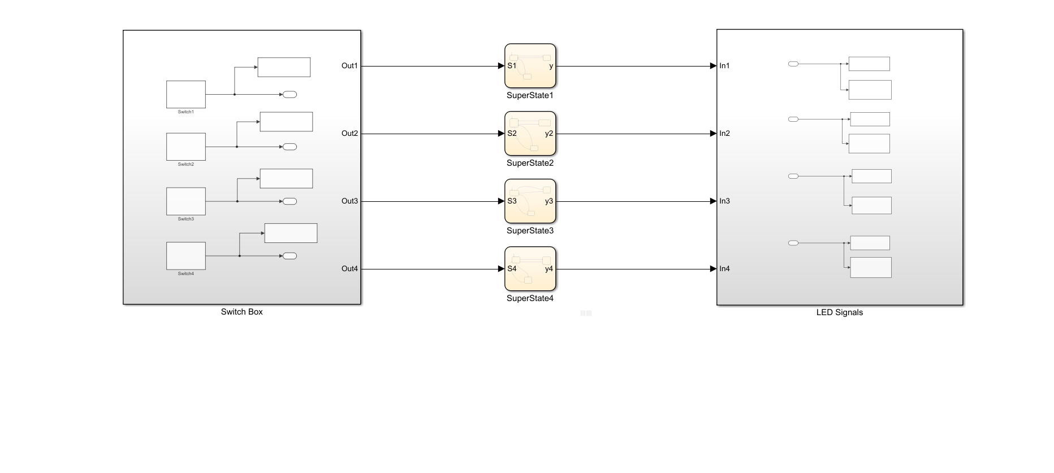

Switch Box Subsystem
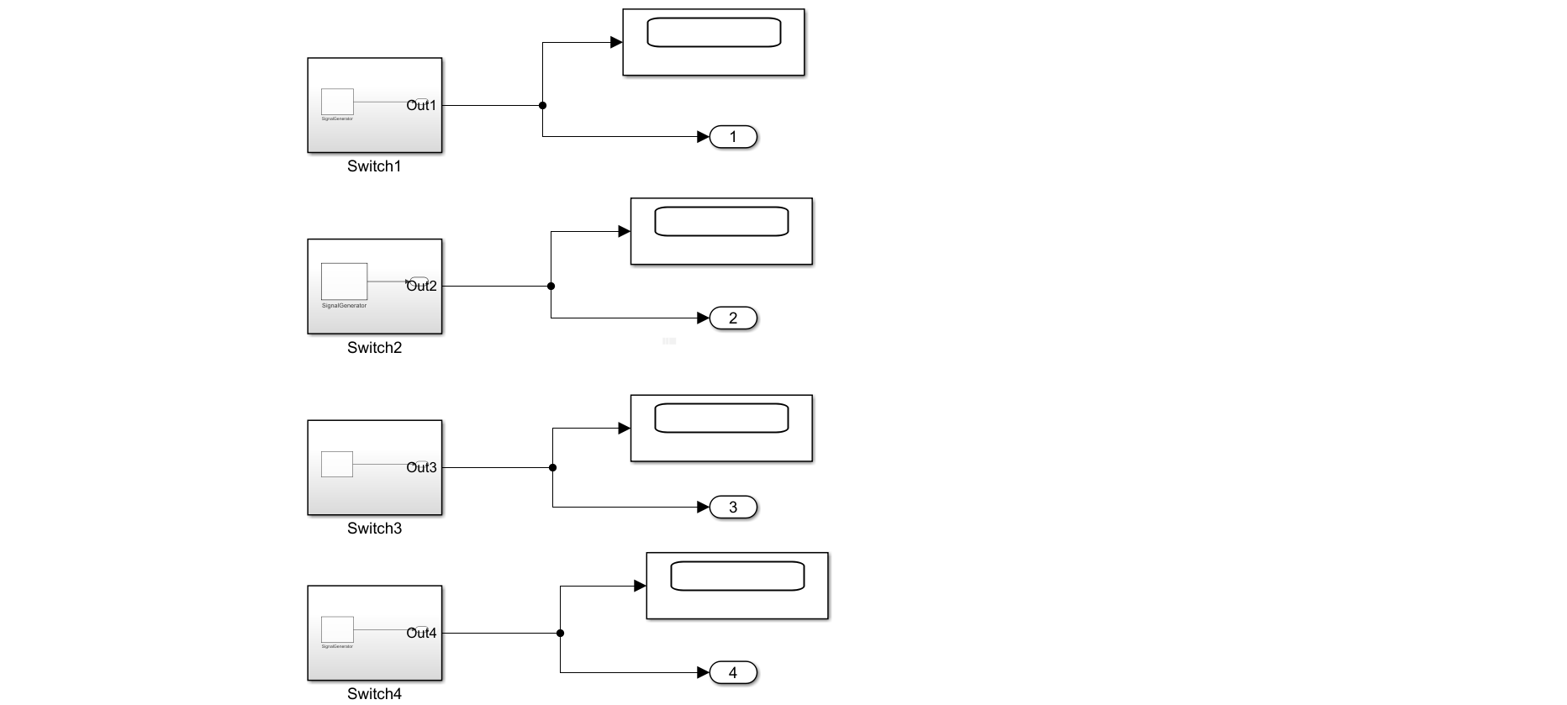

Switch Subsystem
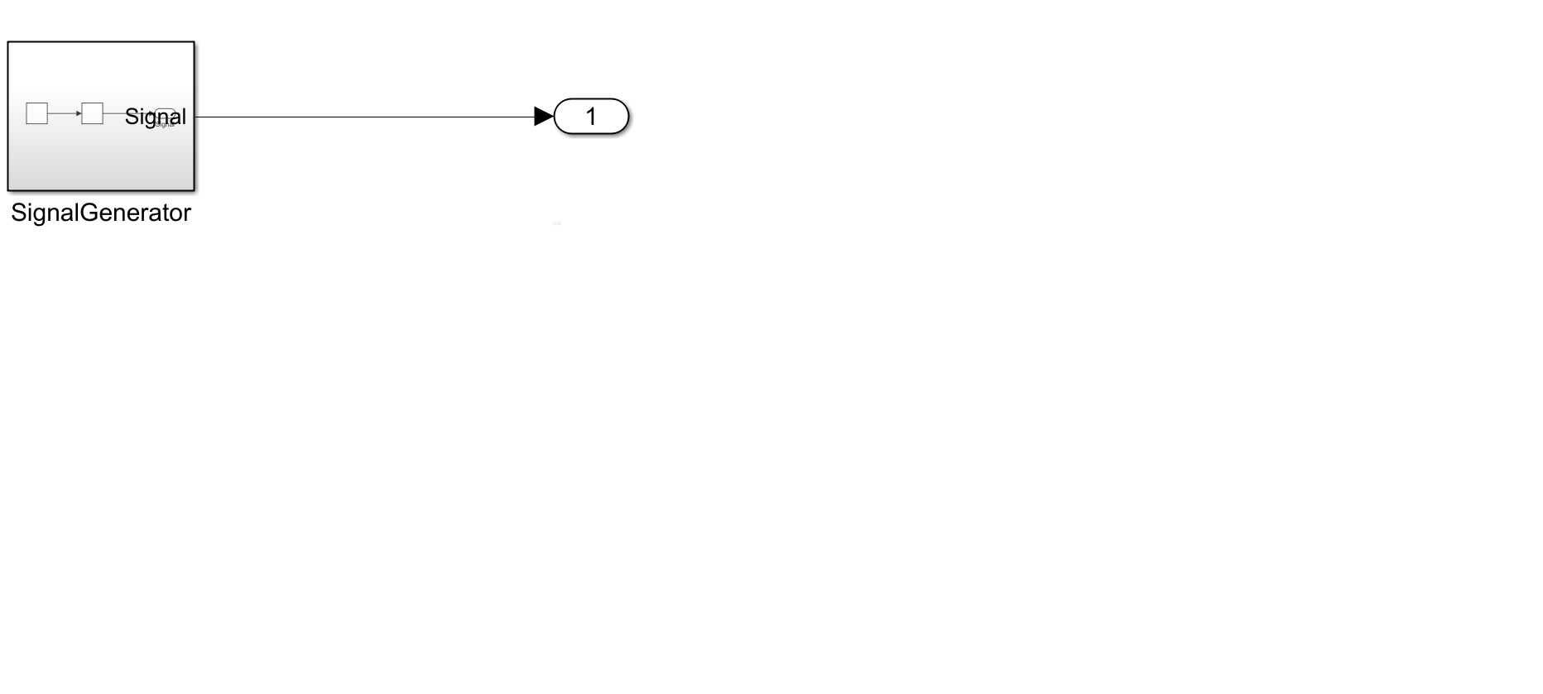

Signal Generator Subsystem

SuperState Subsystem

LEDs Subsystem

References

