**Chapter 1**

**INTRODUCTION**

* 1. **Purpose**

This software requirement specification (SRS) document describes the overall functional requirements of Faculty Portal. Intended to serve Faculties for reducing their effort for filling up leave and subject preferences.

* 1. **Scope**

FACULTY PORTAL is intended to serve the purpose of helping faculties for automatizing Subject Preferences and Leave Management. In Subject preference module, faculties can prefer subject according to current subject enabled by admin (of this module) and admin is provided with extra facilities of enabling and disabling subjects and current semester. In leave management module employees are supposed to apply for the respective leaves and allocate other faculties during their leave period .Faculties can see their leave history. HOD is provided extra functionality of looking at all other faculties leave history, leave is sanctioned only if HOD approves it.

In addition to that we also have functionality to add user (faculty) from user module, that also allow to Resetting passwords.

More ever we can take backup of data per year as and when needed.

**1.3 Definitions, Acronyms, and Abbreviations.**

SRS is used as SOFTWARE REQUIREMENT SPECIFICATION.

FP is used as FACULTY PORTAL

IEEE is used as Institute of Electrical and Electronic Engineers

1. **References www.stackoverflow.com**[**www.quora.com**](http://www.quora.com)

**docs.oracle.com/javase**

* 1. **Overview**

The SRS contains overall description in next section with the product perspective in that hardware and software interfaces, product functions, user characteristics, constraints, assumptions and dependencies and apportioning of requirements and also contains specific requirements, external interfaces and design constraints, software system attributes, organizing specific requirements.

**Chapter 2**

**The General Description**

**2.1 Product Perspective**

FACULTY PORTAL is desktop-based applications which will automatize the process of subject preferences and leave application of the faculties.

**2.1.1 System Interfaces**

This system does not provide system interfaces.

**2.1.2 Hardware Interfaces**

This system does not provide Hardware interfaces.

**2.1.3 Software Interfaces**

**Operating System:** Microsoft Windows 8.1

**Application Software: Front End Tool-**Java

**Server-**Apache Tomcat server

**Database-**MySQL (XAMPP Software)

**Other Tool-**Hibernate ORM Framework

**-**jasypt-1.9.0.jar (For password encryption)

**2.1.4 Memory Constraints**

2GB -Ram

100 GB -Hard Disk

1. **Operations**

**User Mode-**The user mode of this system will allow users toapply for leave and enter subject preferences.

**Admin Mode-**The admin will be able to enable or disable subjectpreferences list and edit the subject preferences list and also can sanction the leave, can take backups, can add user and can apply password reset for single of for all user.

**2.1.6 Site Adaptation Requirements**

This system needs a web browser installed on the client device, supported browsers are Chrome, Firefox, etc.

**2.2 Product Function**

System provides facility to select subject preference and apply for leave.

System provides Facility to display leave history and arrangement of work load during leave period.

System provides facility to administrator for managing the leave Information and also managing the subjects or editing the subjects.

* 1. **User Characteristics**

User must have knowledge about software and task to be performed.

**2.4 Software Requirements Specification**

1. System Security aspects
   1. System login

I/P : Username and Password

O/P: Success message on correct username and password

* 1. System Filter to check security according to user type, if user is normal user then not allow then get enter into privilege areas of admin section.

I/P : Page url to access

O/P: Validation confirmation

1. System should provide facility to prefer subjects from different subject preferences.
   1. System should provide facility to display subjects according to semester.

I/P : Semester type

O/P: Subjects List

* 1. System should provide facility to prefer different subjects according to current semester.

I/P : Selected subjects

O/P: Successful message

* 1. System should provide facility to View subject preferences.

I/P : Selected subjects

O/P: Successful message of selecting subjects

* 1. System should provide facility to enable or disable subject preferences.

I/P : System should provide facility to enable or disable subject preferences.

O/P: Modification done successfully message

* 1. System should provide facility to view offered subjects.

I/P : Semester type

O/P: List of subjects

* 1. System should provide facility to edit offered subjects.

I/P: Enable/disable Semester

O/P: Modification done successfully

* 1. System should provide facility to print subject preference list.
     1. System should provide facility to print subject wise list.

I/P: Option subject wise

O/P: Subject wise list

* + 1. System should provide facility to print slot wise list.

I/P: Option slot wise

O/P: Slot wise list

* + 1. System should provide facility to print Faculty wise list.

I/P: Option faculty wise

O/P: Faculty wise list

1. System should provide facility to apply for leave according to their requirement.
   1. System should provide facility to apply for leave.

I/P: Leave details

O/P: Successful leave message

* 1. System should provide facility to manage pending leaves.

I/P: Status of pending leaves to be settled

O/P: Status of leaves accordingly

* 1. System should provide facility Display Leave History.

I/P: Request

O/P: Leave history of faculties

1. System should provide facility to change password.
   1. System should provide facility to get old password before asking for new password.

I/P: Old password and new password

O/P: Password changed messaged

1. System should provide facility to add new User.
   1. System should provide facility to add new user, this functionality is open to only admin.

I/P: Details of User

O/P: Result of operation

1. System should provide facility to reset password.
   1. System should provide facility to reset password for all faculty members, this functionality is open to only admin.

I/P: New password (Old password not required)

O/P: Password changed messaged

* 1. System should provide facility to reset password for single faculty member, this functionality is open to only admin.

I/P: Username, New password (Old password not required)

O/P: Password changed messaged

**Chapter 3**

**Design**

**3.1 Use Case Diagram**

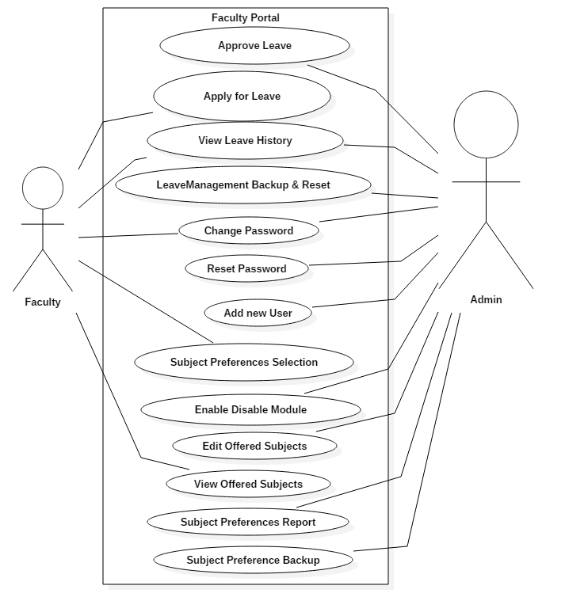

**Leave Management**

**3.2 Class Diagrams**

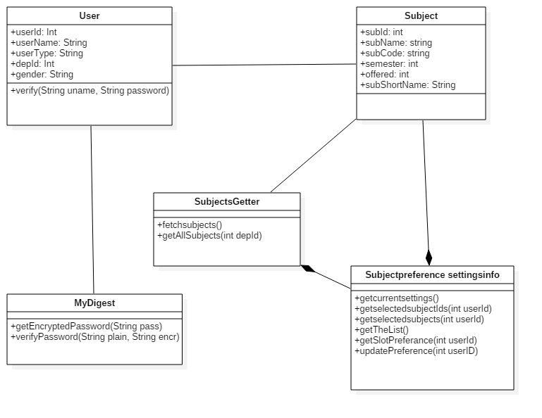

**Note** :- As whole system is working with database that classes are not included here, instead E-R diagram for database tables are available in section **3.6**.

**3.3 Sequence Diagram**

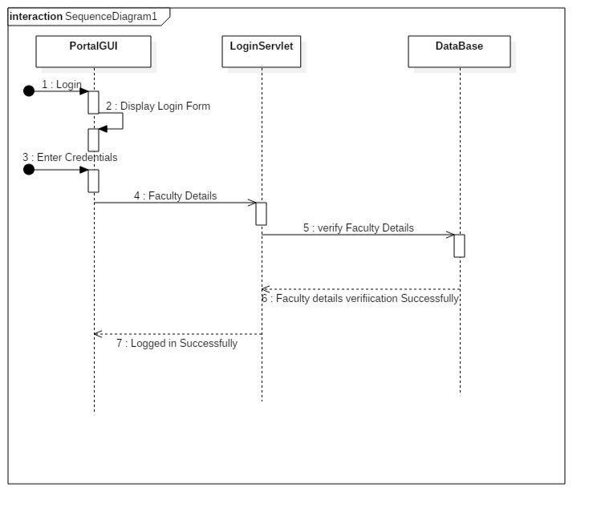

**Login**

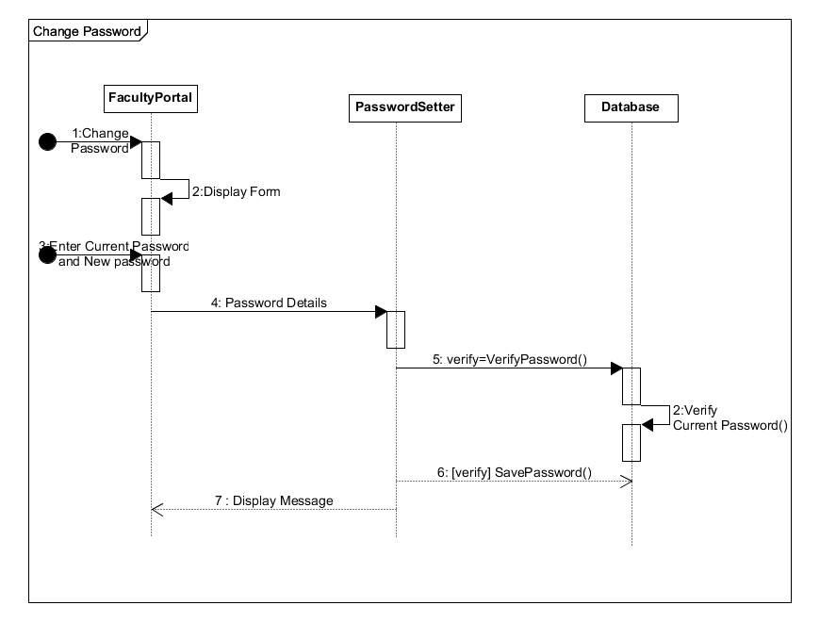

**Change Password**

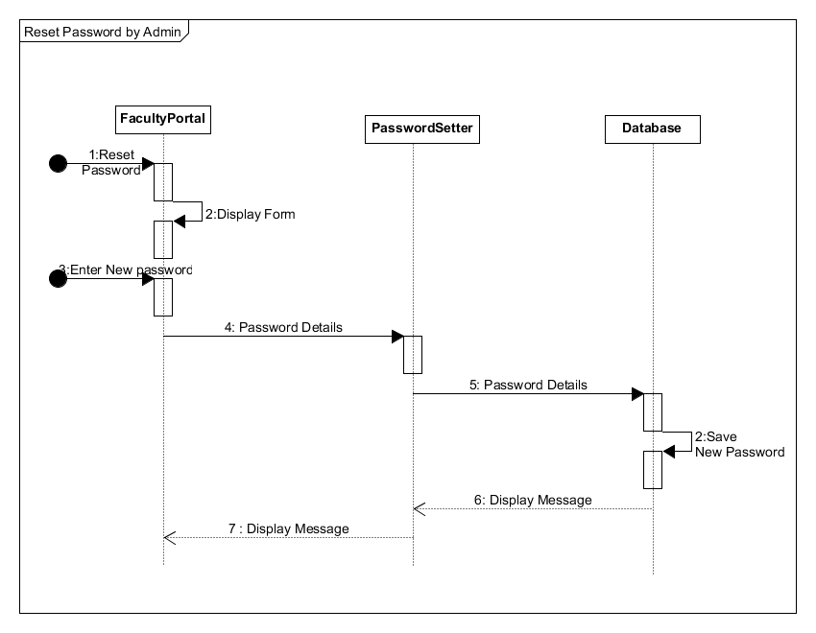

**Reset Password (Admin)**

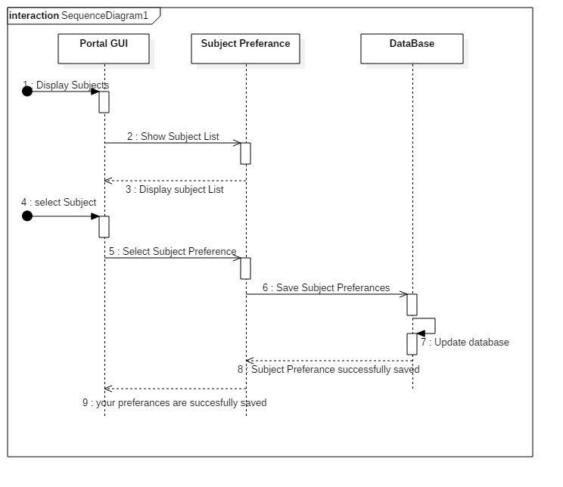

**Subject Preferences – Give Subject Preference**

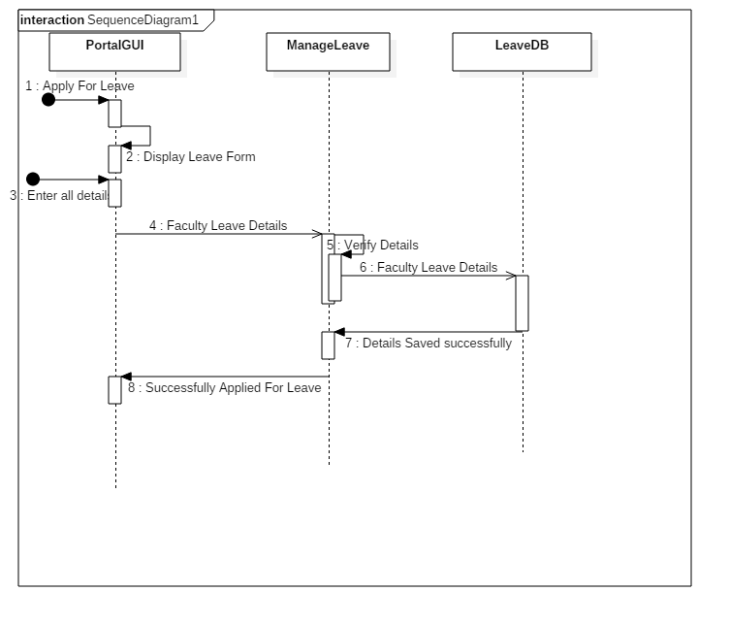

**Leave Management – Apply for leave**

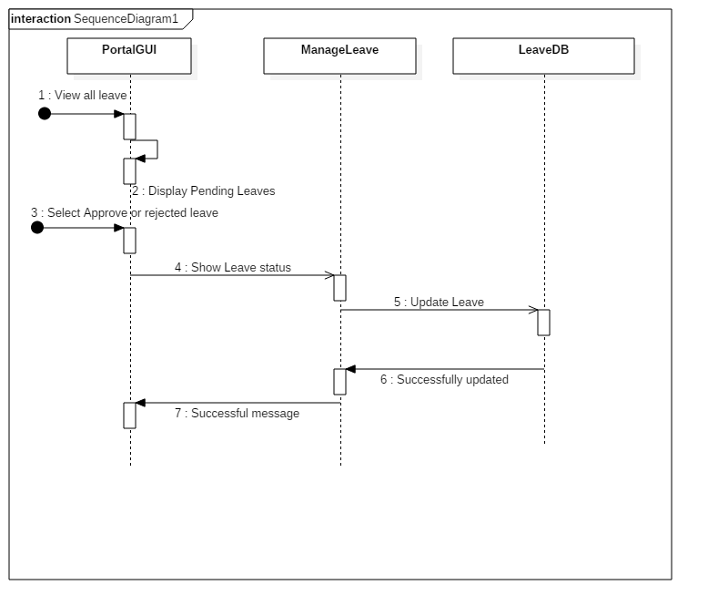

**Leave Management – Approve/Reject Leave (Admin)**

**3.4 Activity Diagram**

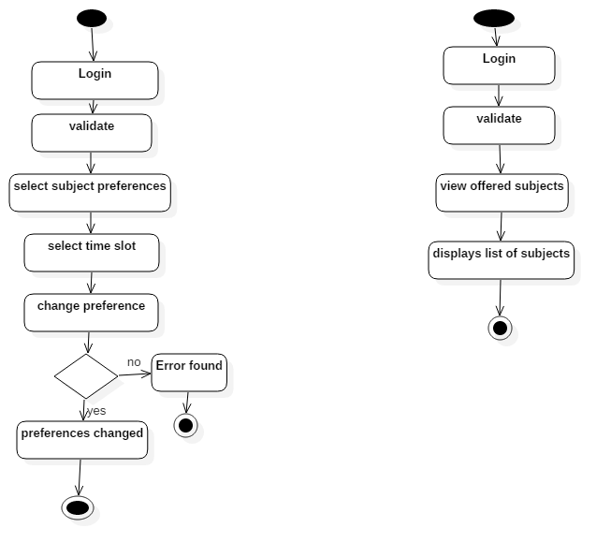

**View List of Offered Subject**

**Edit Subject Preferences**

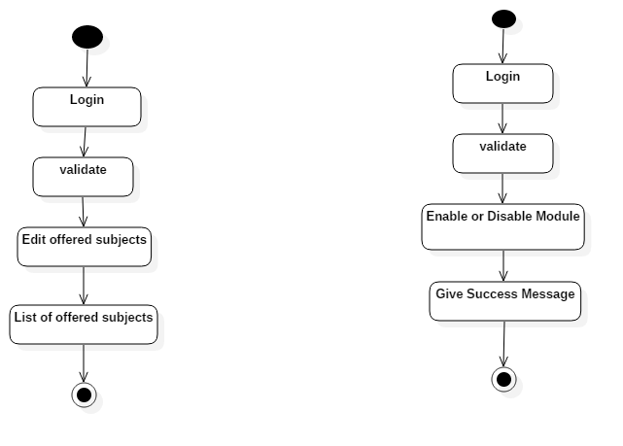

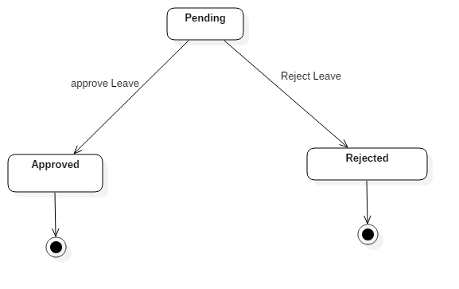

**Enable or Disable Subject Preferences Module**

**EmployeeLeaveRequest State**

**3.5 State Diagram**

**Edit Offered Subject**

**3.6 ER-Diagram**

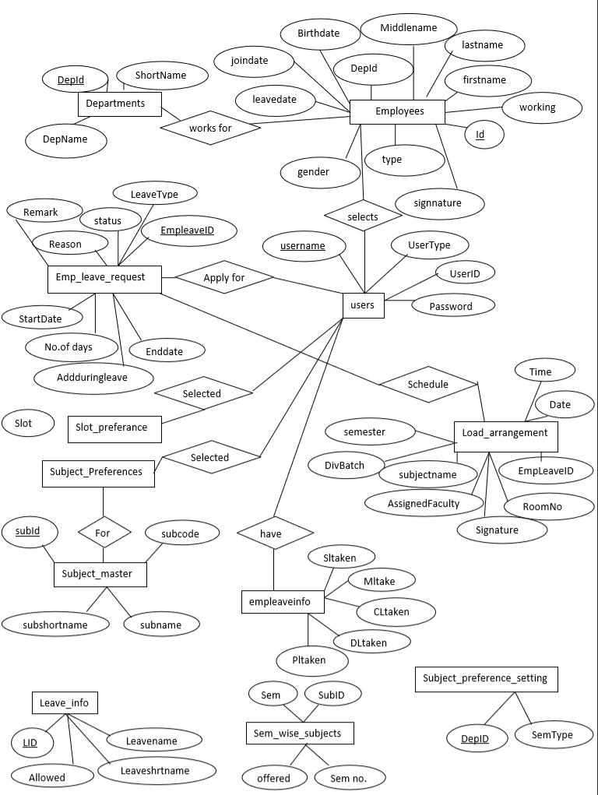

**3.7 Data Dictionary**

users

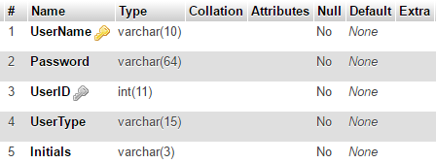

department

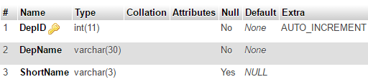

employees

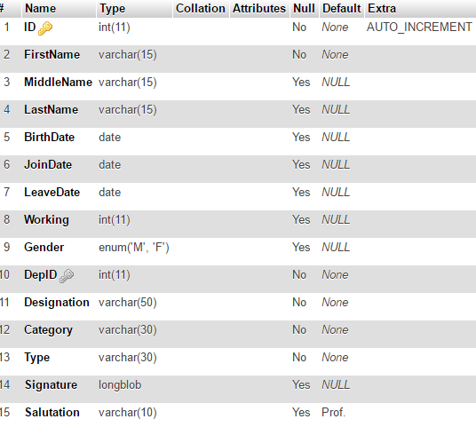

subject_master

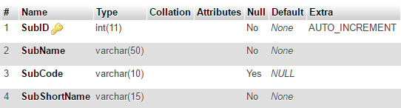

subject_prefrence_setting

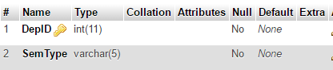

subject_preferences

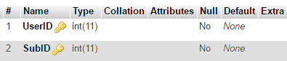

slot_preferences

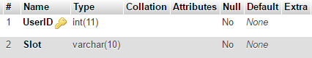

semester_wise_subjects

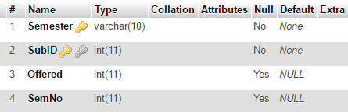

leave_info

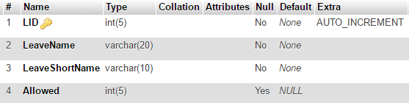

emp_leave_info

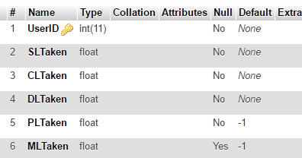

emp_leave_request

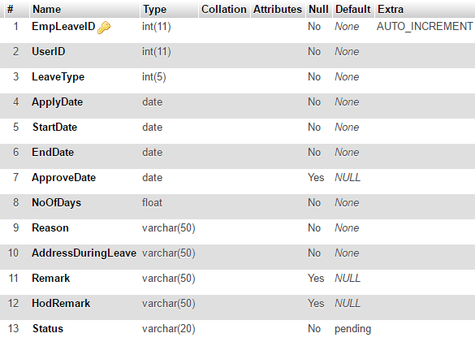

load_arrangement

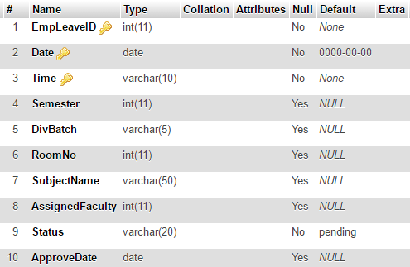

**Chapter 4**

**Testing**

**4.1 Testing Plan**

The testing is a technique that is going to be used in the project is white box testing as well as black box testing.

**4.2 Testing Strategy**

The development process repeats this testing sub process a number of lines for the following phases.

• Unit Testing

• Integration Testing

Unit Testing tests a unit of code after coding of that unit is completed. Integration Testing tests whether the previous programs that make up a system, interface with each other as desired. System testing ensures that the system meets its stated design specifications. Acceptance testing is testing by users to ascertain whether the system developed is a correct implementation of the software requirements specification. Testing is carried out in such a hierarchical manner to that each component is correct and the assembly/combination of component is correct. Merely testing a whole system at end would most likely throw up errors in component that would be very costly to trace and fix. I have performed both Unit Testing and System Testing to detect and fix errors.

**4.3 Testing Methods**

I have performed Black-box testing as well as White-box testing for this project. Integration testing and System testing is also performed in Faculty Portal project.

**4.4 Test Cases**

|  |  |  |  |  |  |
| --- | --- | --- | --- | --- | --- |
| **Testcase ID** | **Test**  **Module** | **Test Scenario** | **Test Data** | **Expected Result** | **Decision** |
| T01 | Login | Login | Username and password | Successful login | Pass |
| T02 | Subject preferences | Select subject preference | Subjects list | Subject selected successful | Pass |
| T03 | Subject preferences | Enable/Disable Module | Subjects list | Successful enabled/disabled | Pass |
| T04 | Subject preferences | View Offered Subjects | Subjects list | Sem wise list of subjects | Pass |
| T05 | Subject preferences | Print Subjects preferences list | Subject wise / Faculty wise/ Slot wise list | Printed list | Pass |
| T06 | Subject preferences | Edit offered subjects | Subjects list | Successfully Edited subjects | Pass |
| T07 | Change password | Enter current and old password | Password | Successful changed password | Pass |
| T08 | Leave Management | Apply for leave | Leave details | Successful application | Pass |
| T09 | Leave Management | Show my leave | List of leaves | List of faulty leaves | Pass |
| T10 | Leave Management | View all Leave | List of pending or approved/ rejected leaves | List of leaves taken | Pass |
| T11 | Leave Management | Leave History | Leave Details | List of leaves as per constraints | Pass |
| T12 | Leave Management | Reset leave | - | Succesful reseting of leave | Pass |
| T13 | Logout | logout | - | Successful logout | Pass |
| T14 | Add User | Add user | User Details | User added successfully | Pass |
| T15 | Reset Password | For single User | Username and new password | Password changed for particular user | Pass |
| T16 | Reset Password | For all | New Password | Password changed for all user | Pass |

**Chapter 5**

**Screenshots**

**Login Page**

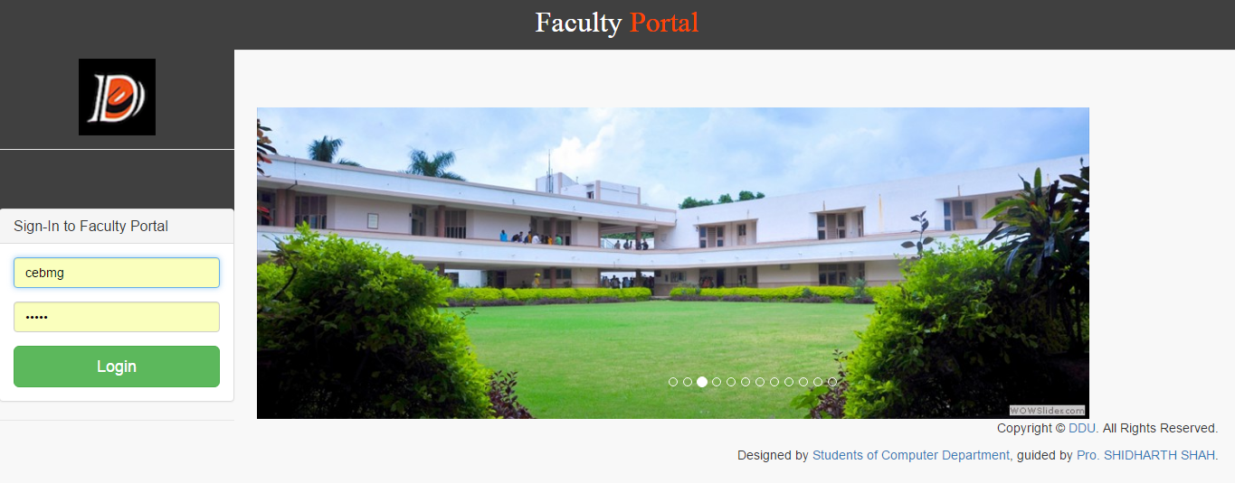

**Home Page**

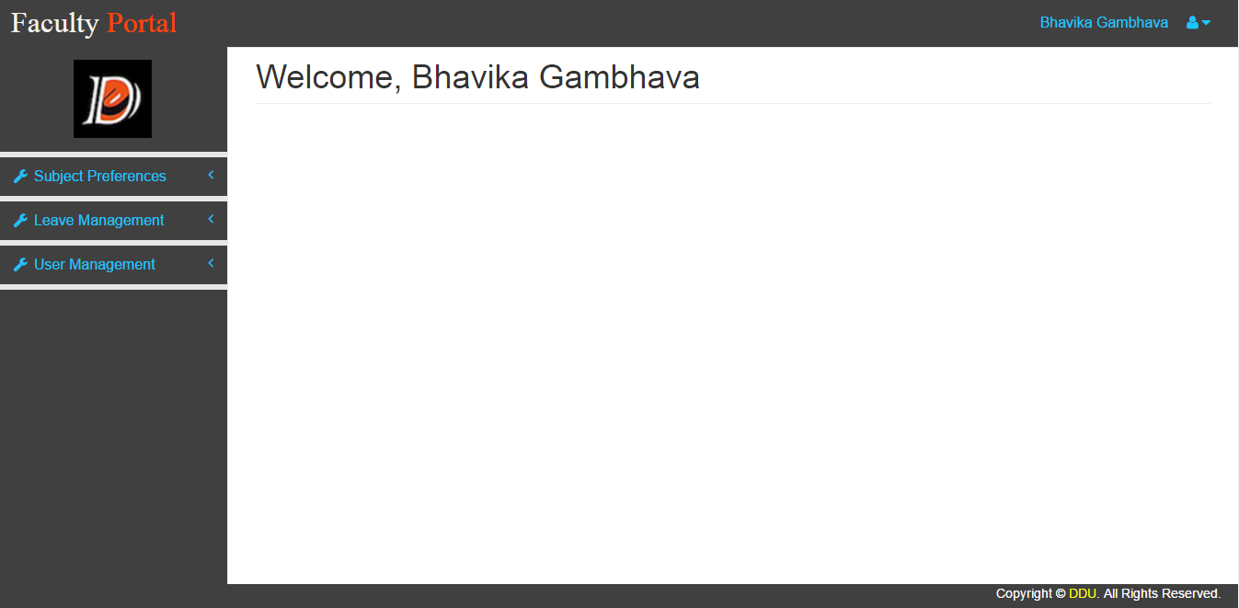

**Note** : In this home page given navigation is for Admin, So all navigation including User Module are active.

**Edit Subject Preferences**

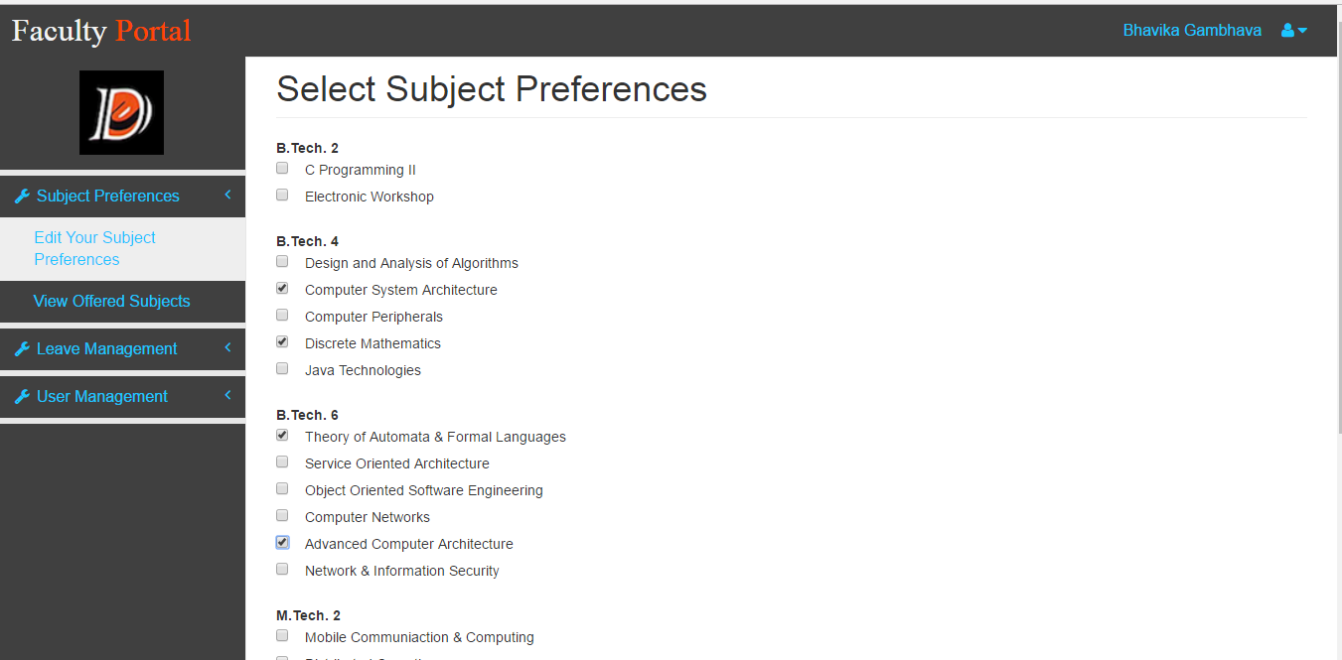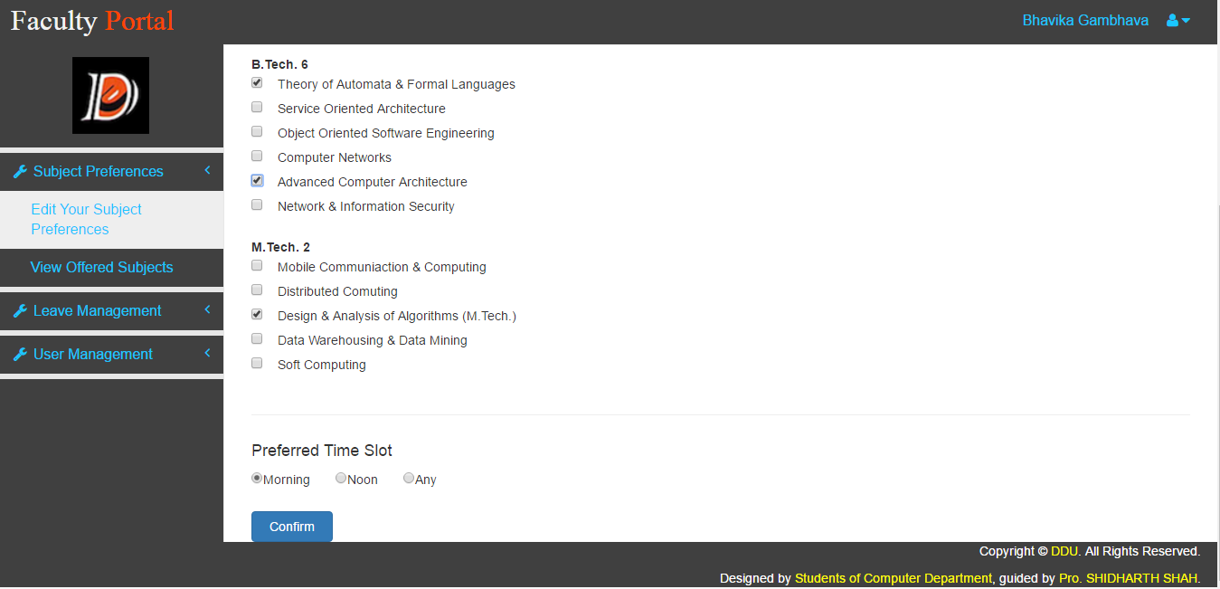

**View Offered Subjects** 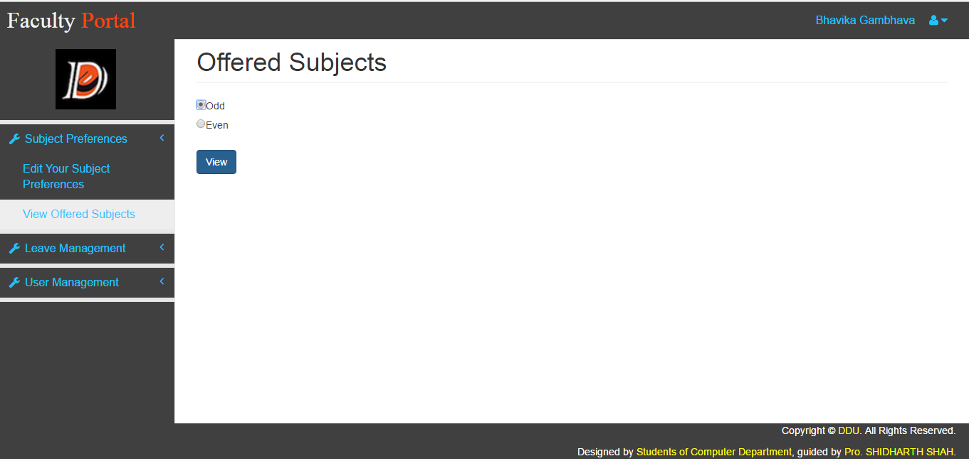

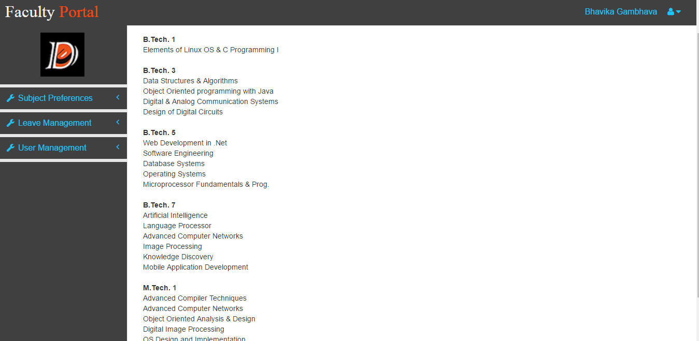

**Enable / Disable Subject Preferences Module (Admin)**

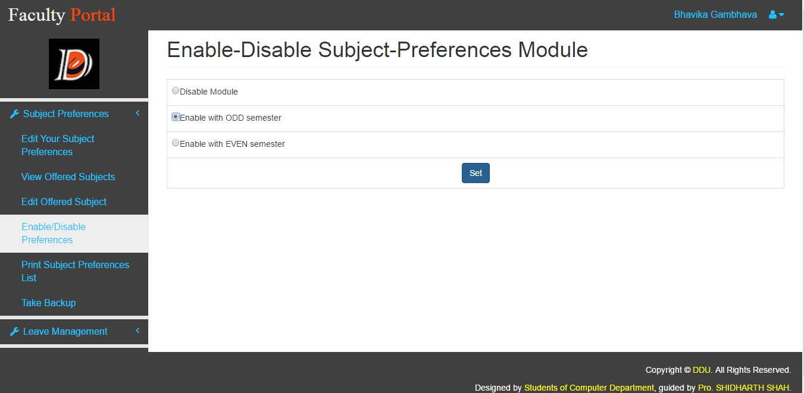

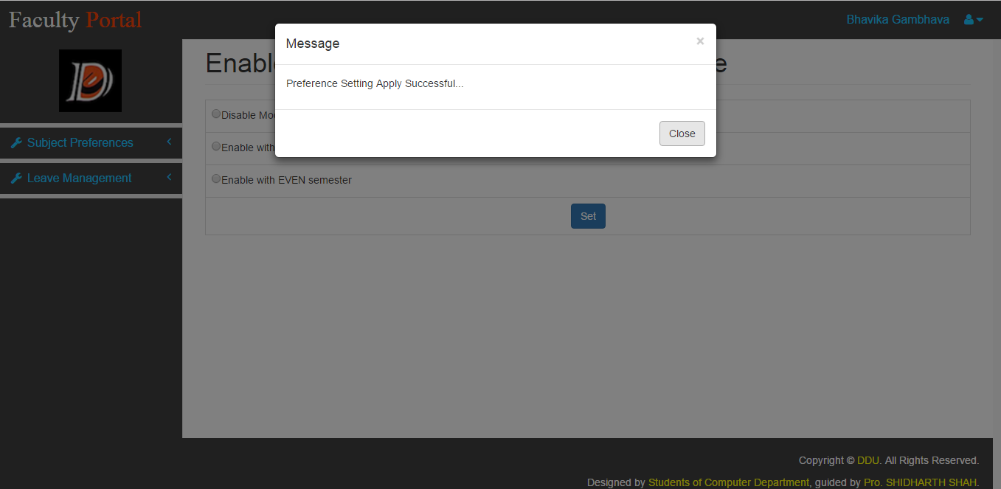

**Print Subject Preferences List (Admin)**

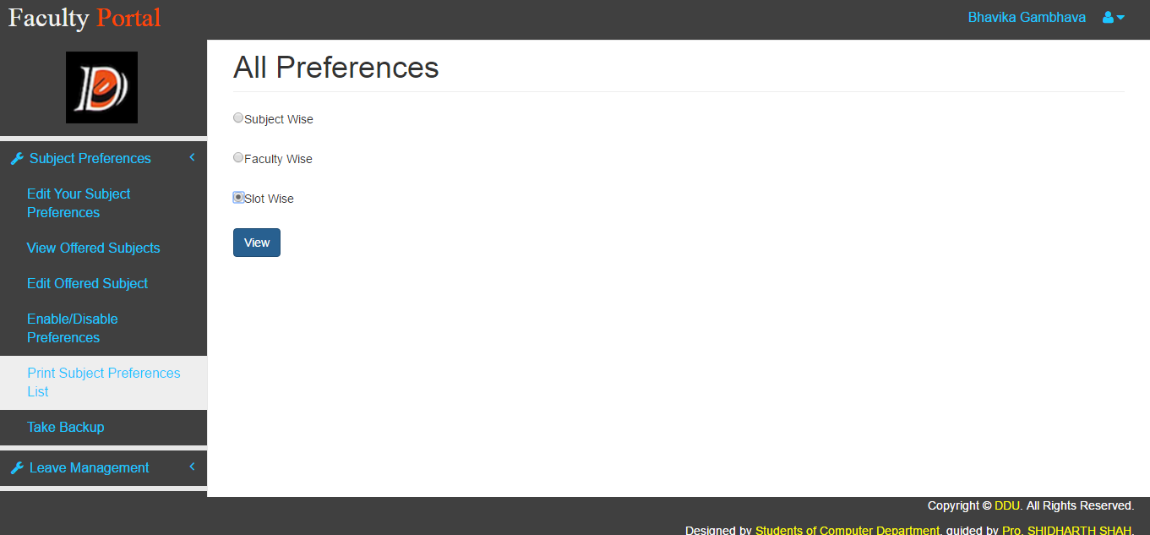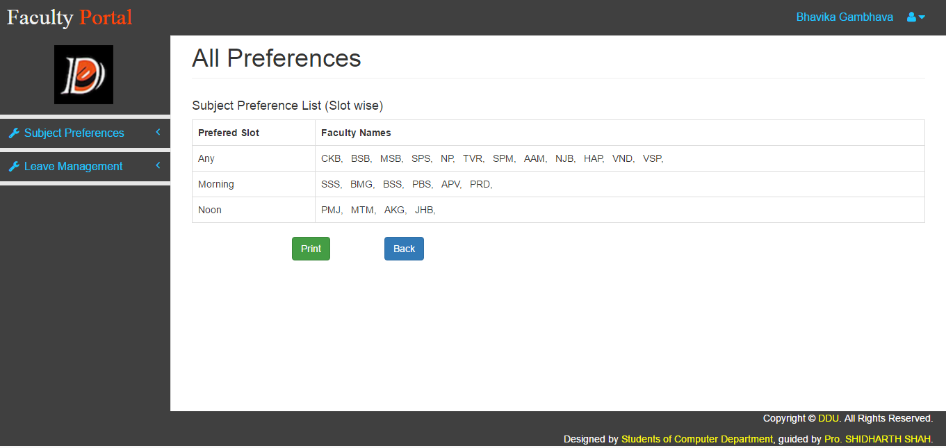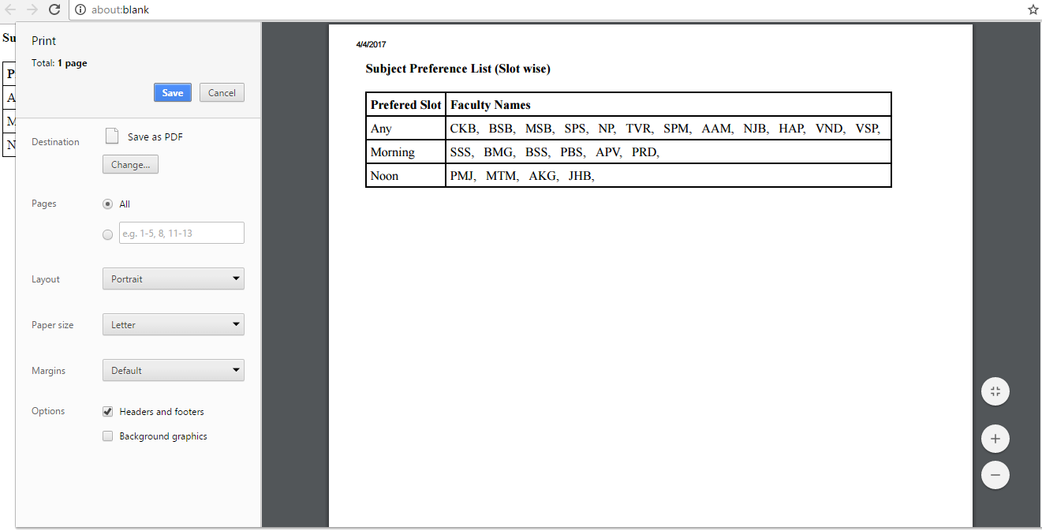

**Backup of Subject Preferences Module (Admin)**

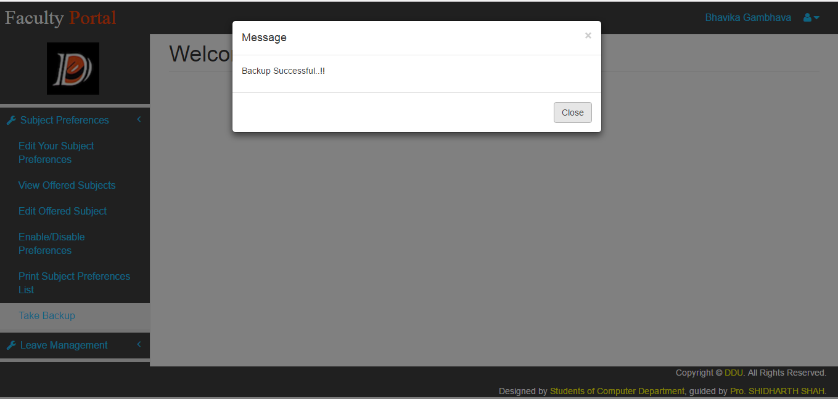

**Apply For Leave**

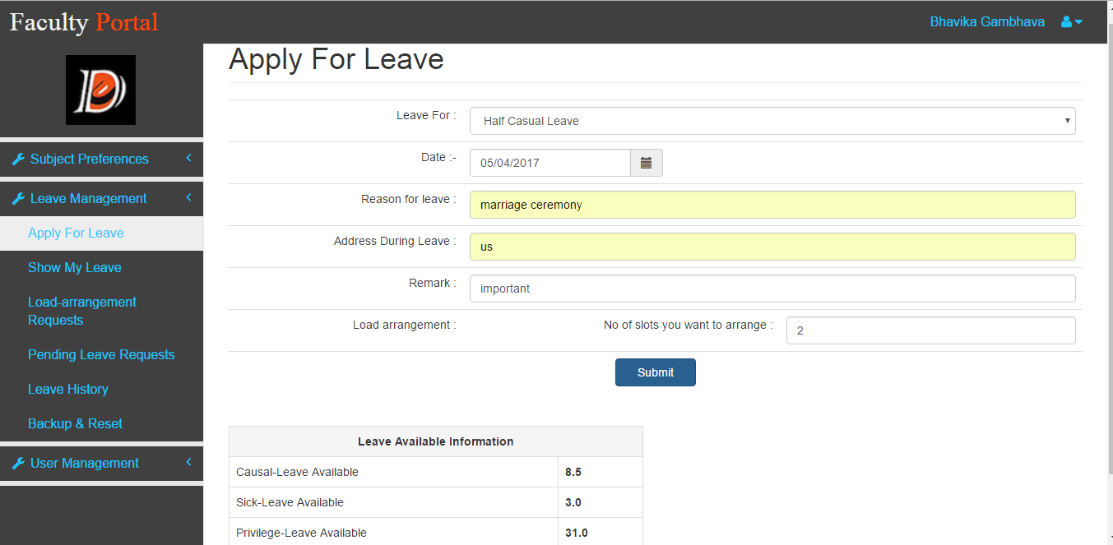

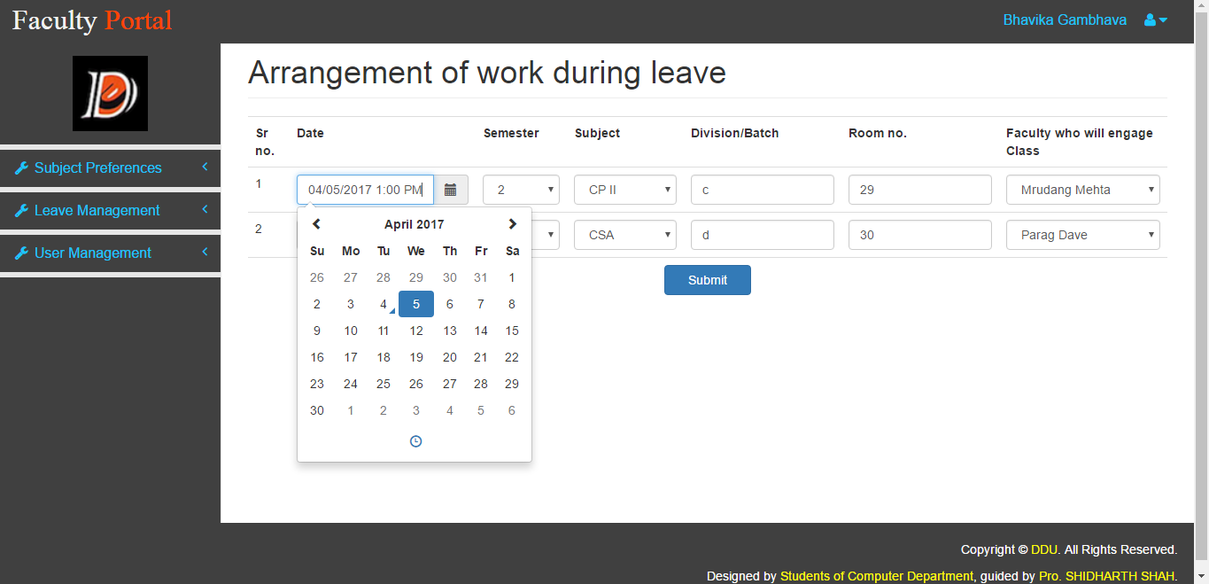

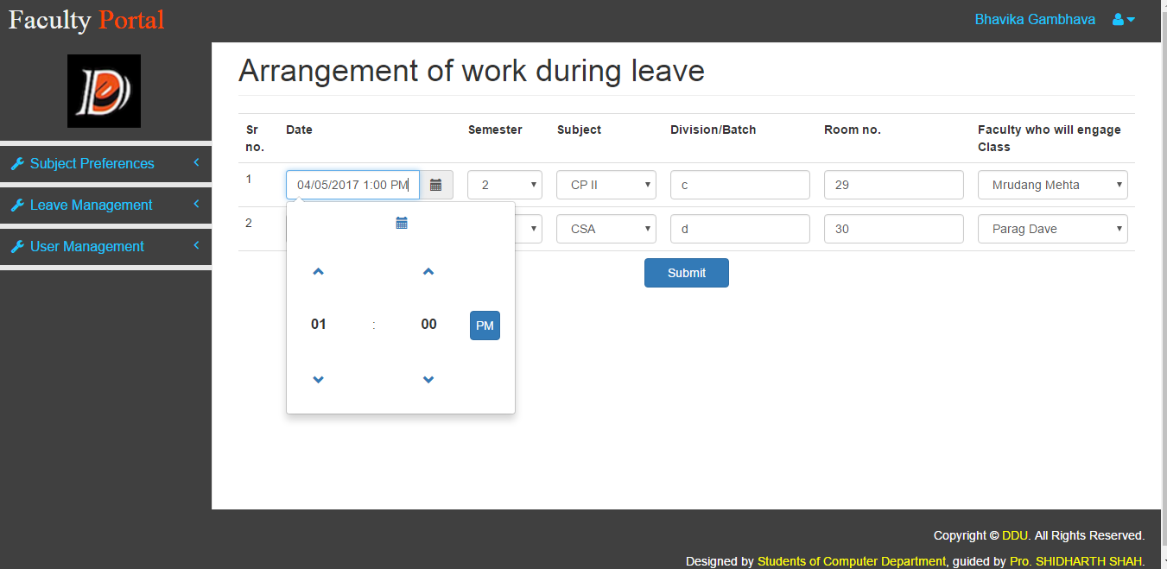

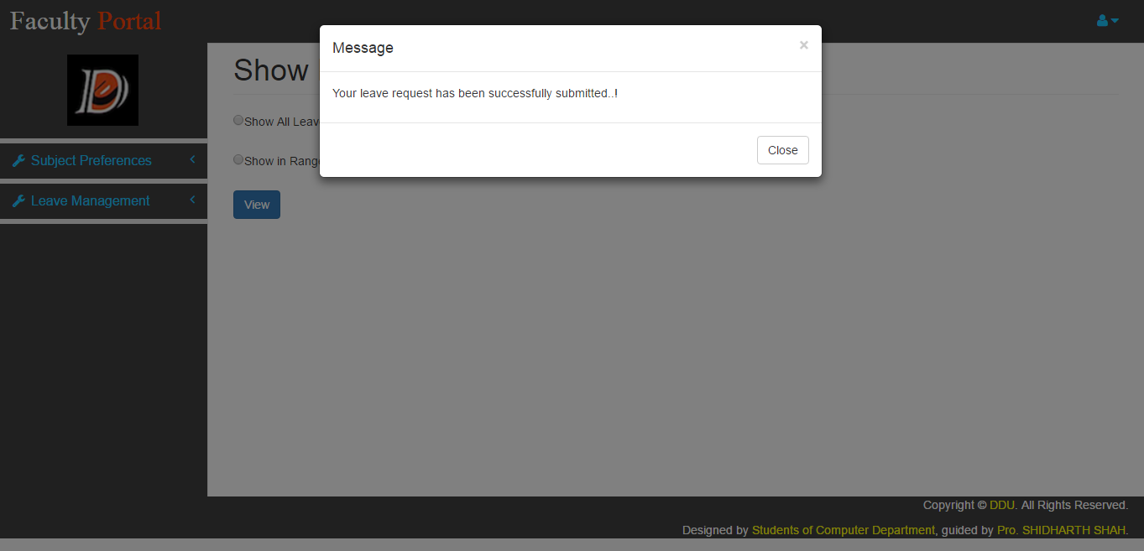

**Show My Leaves**

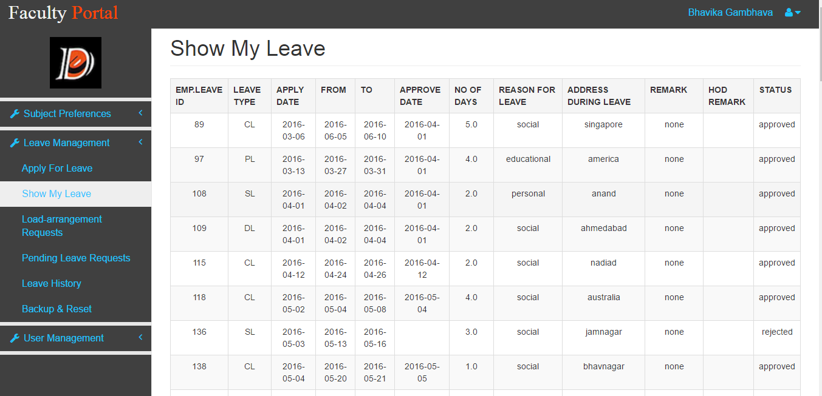

**Load Arrangement Requests From Other Faculties**

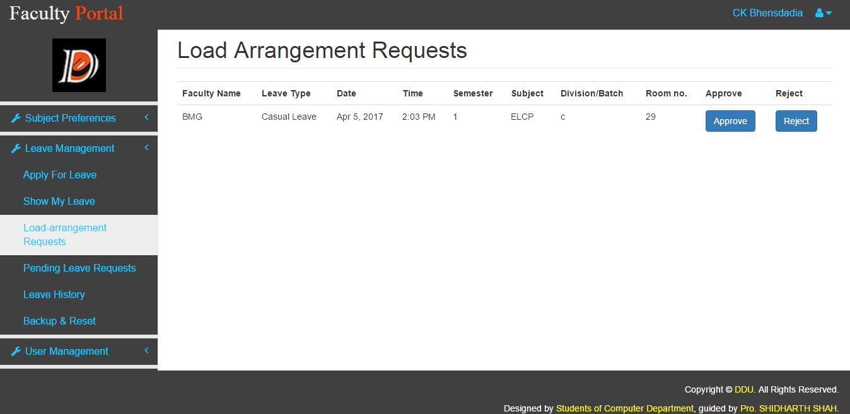

**Pending Leave Requests (Admin)**

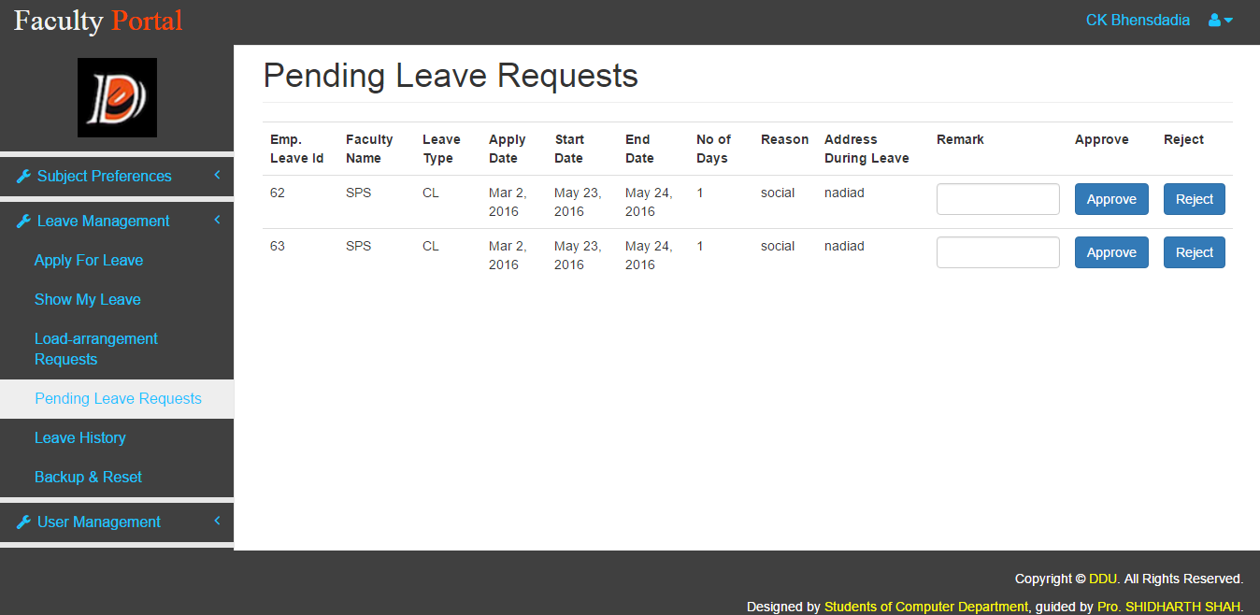

**Leave History For Any Faculty (Admin)**

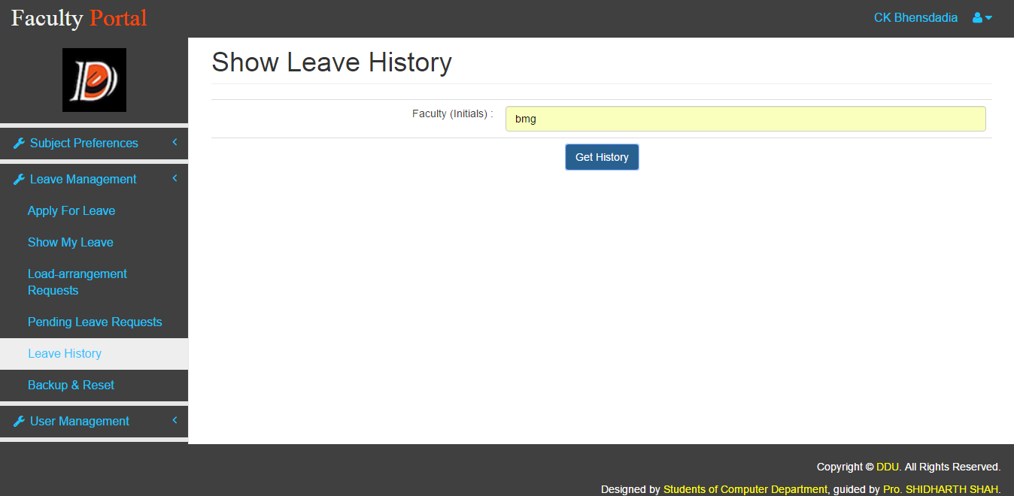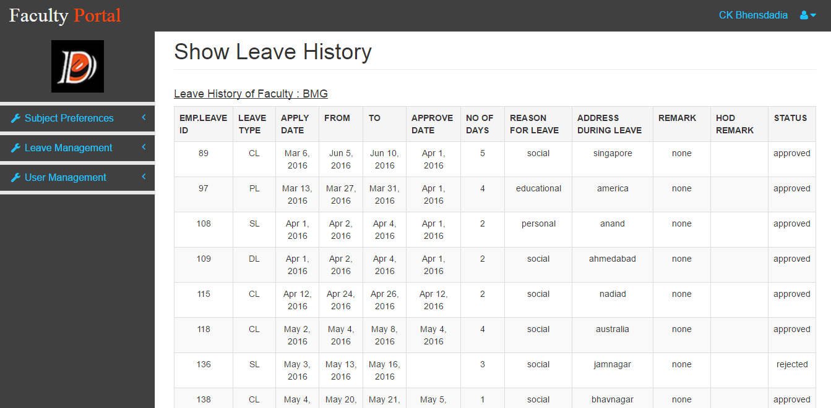

**Add New User**

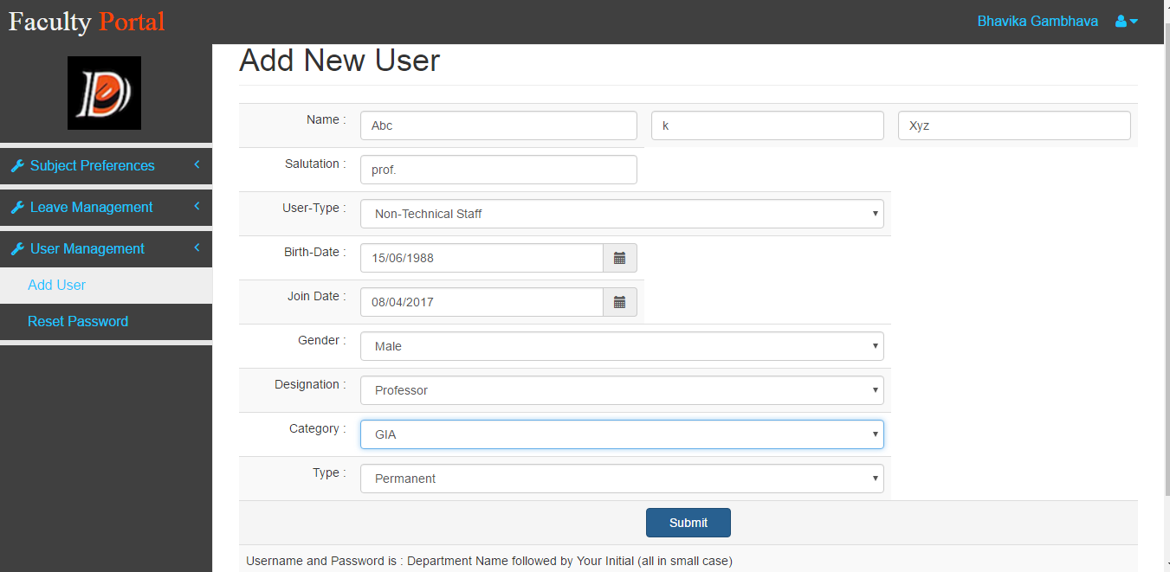

**Change Password**

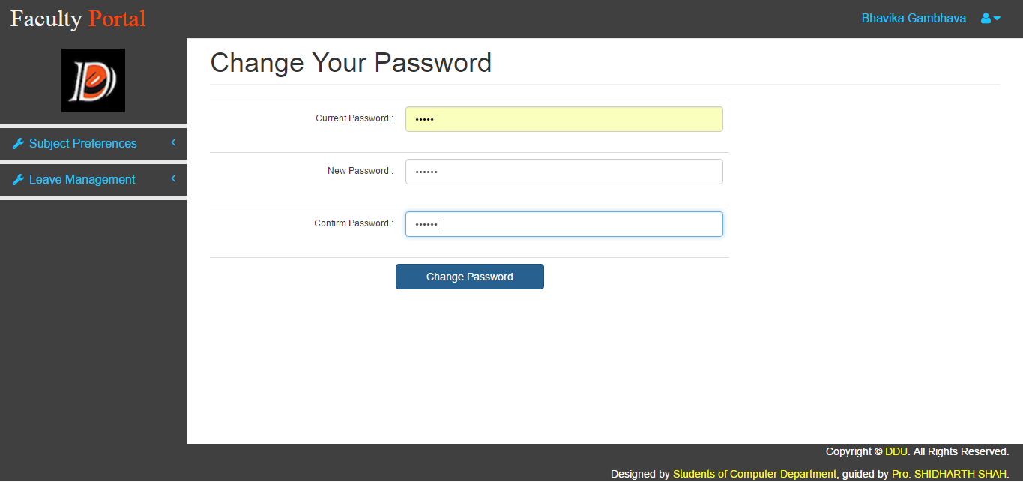

**Reset Password (Admin)**

For Single User

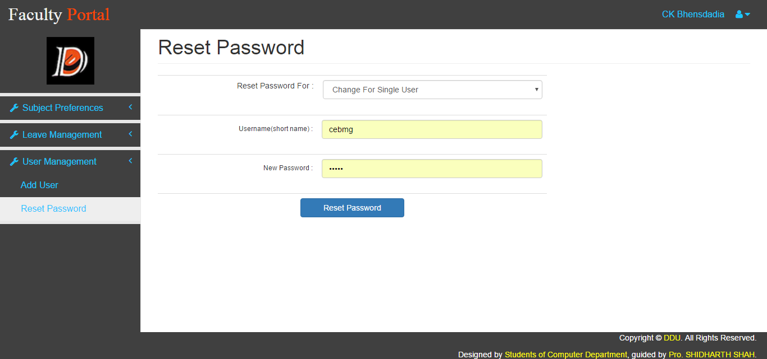

For All User at one click

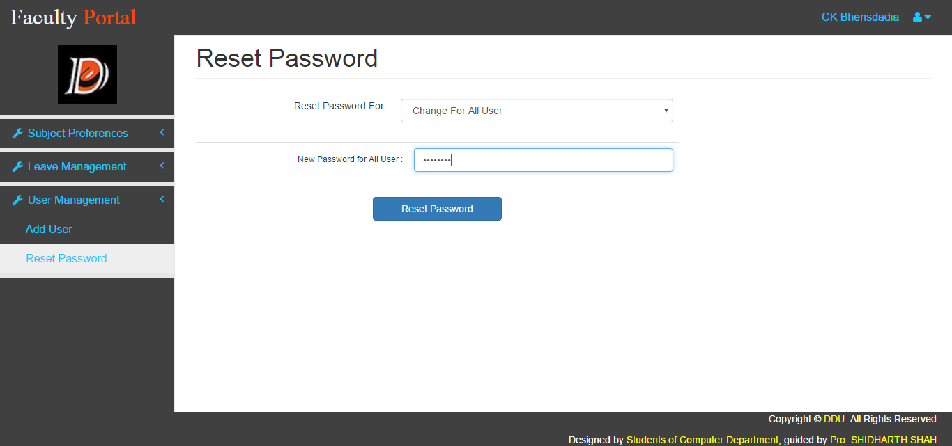

**Chapter 6**

**Conclusion**

FP provides automation for subject preference and leave management process. An overview of features is enlisted below:

* Faculty can provide their subject preferences in the subject preference module. Also admin is provided special rights of enabling/disabling the preferences, editing and viewing offered subjects and printing subject preference list faculty-wise/slot-wise/subject-wise. Functionality of taking backup is available in Subject preferences module.
* Faculty can apply for leave as per their requirements, and can allot the load and admin is given special rights of approving/rejecting the leave requests. Also admin can view the leave history of all the faculties, and faculties can view their own leave history too. Functionality of taking backup is available in Leave Management module. And we can also view history from previous years records.
* Portal Admin (Head of Department) can add new user (Faculty) to system, and also can reset password in two ways, by resetting password for single user or can reset password for all user of same department.

**Chapter 7**

**Limitations and Future Extension**

**Limitations**

Use of Ajax can give better performance which is not included.

Ex. In load_arrangement_page (For all semester, all subjects are shown that can be more user friendly..)

**Future Extension**

Above limitations can be remove by the use of AJAX.

System shall provide functionality to edit and remove faculty details from system.

In Leave management module after load arrangement if some faculty reject request then again arrange new slots shall be possible.

In subject preference module we shall include the functionality of admin allocating lab and lectures to respective faculties after they have preferred the subjects.

Notice automation shall include in future extension.

**Bibliography**

* + [www.w3schools.com](http://www.w3schools.com/)
  + https://docs.oracle.com/javase
  + www.wikipedia.com
  + Servlet and JSP by HeadFirst-Reference book
  + [www.java2s.com](http://www.java2s.com) (For library included extra)
  + [www.tutorialspoint.com](http://www.tutorialspoint.com)
  + www.getbootstrap.com
  + www.hibernate.org/orm/documentation
  + www.javatpoint.com
  + www.quora.com