Math behind success_score:
1. TF-IDF (Term Frequency-Inverse Document Frequency)
TF-IDF is used to convert textual data (e.g., startup descriptions, pitches, success stories) into numerical vectors for similarity comparison.
Formula for Term Frequency (TF):
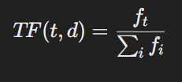
where:
- fi​ = Number of times term ttt appears in document ddd.
- ∑ifi = Total number of terms in document ddd.
Formula for Inverse Document Frequency (IDF):
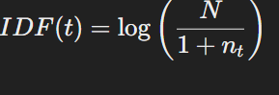
where:
- N = Total number of documents.
- nt​ = Number of documents containing term ttt.
- 1 is added in the denominator to prevent division by zero.
TF-IDF Weight Calculation:
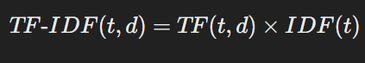

2. Cosine Similarity
After transforming startup descriptions into TF-IDF vectors, we compute their similarity using Cosine Similarity.
Cosine Similarity Formula:
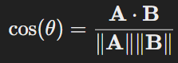
where:
- A and B are the TF-IDF vectors of two startup descriptions.
- A⋅B = Dot product of the vectors.
- ∥A∥ and ∥B∥ = Euclidean norms (magnitudes) of vectors A and B, given by:
- 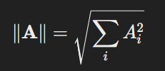
A similarity score close to 1 indicates high similarity, while a score near 0 suggests no similarity.

3. LLM-Powered Pattern Recognition & Scoring
Using a large language model (LLM), we can analyze historical success and failure patterns by extracting semantic relationships beyond TF-IDF and cosine similarity. This involves:
- Embedding Representation: Converting text into dense vector embeddings (e.g., using OpenAI's GPT, BERT, or Sentence Transformers).
- Pattern Matching & Clustering: Identifying successful vs. failed startups based on clusters of similar embeddings.
- Success Prediction Score: Using machine learning models (e.g., logistic regression, neural networks) trained on past success/failure data.
For LLM-powered success scoring, a typical logistic regression model formula is:
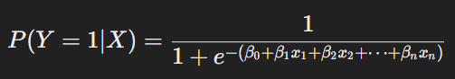
where:
- P(Y=1∣X) = Probability of startup success.
- X = Feature vector (e.g., TF-IDF values, similarity scores, funding history, market data).
- β0​ = Bias term.
- βn​ = Model weights learned from past data.

