Photometric Redshift Prediction of Galaxies using SDSS Data
Unit 4 Mini-Project: AI-assisted Analysis of Physics Data using Supervised Learning in R
18 October 2026
Table of Contents

Abstract
We predict the redshift of galaxies, a measure of their distance, from their brightness in the five SDSS filters. The data are 100 galaxies from the Sloan Digital Sky Survey (DR18) with spectroscopic redshifts between 0.025 and 0.221. They were cleaned with AI assistance and split into 80 training and 20 test galaxies. Four supervised models (linear regression, k-nearest neighbours, random forest and support vector regression) were tuned by repeated cross-validation in R and compared with a mean-prediction baseline. In cross-validation the best model was M4 SVR (RMSE 0.0208 vs 0.0419 for the baseline). On the held-out test set the best model was M3 Random Forest (RMSE 0.0331, σ_{NMAD} 0.0285, no catastrophic outliers). The colour g − r is by far the most important predictor, and predicted redshift rises steadily with it. This is the signature of the 4000 Å break moving through the g filter as galaxies recede.

1 Introduction and physics background

1.1 Redshift
Light from a receding galaxy is stretched to longer wavelengths:
$$z=\frac{λ_{\text{obs}}−λ_{\text{emit}}}{λ_{\text{emit}}}, λ_{\text{obs}}=(1+z) λ_{\text{emit}}.$$
At low redshift, Hubble’s law gives $v≈cz=H_{0}d$, so the redshift measures distance.

1.2 Spectroscopic versus photometric redshift
A spectroscopic redshift comes from the shift of spectral lines. It is very precise but slow and expensive to obtain. A photometric redshift estimates z from the brightness in a few broad filters. It is less precise but works for billions of galaxies, which is essential for surveys such as LSST, Euclid and DES. Galaxies that have both measurements let us learn the mapping from photometry to redshift: a supervised regression problem.

1.3 Why colours encode redshift: the 4000 Å break
Older stellar populations produce a sharp drop in galaxy spectra blueward of 4000 Å. As z increases, the break appears at $4000(1+z)$ Å and removes flux from the bluer filter, so the colour (magnitude difference) between filters changes. Figure F20 shows that, for the redshift range of this sample, the break always lies inside the g band. We therefore expect g − r to redden with redshift and to be the most informative feature. The r magnitude adds distance information because, in a flux-limited sample, more distant galaxies look fainter (inverse-square law).
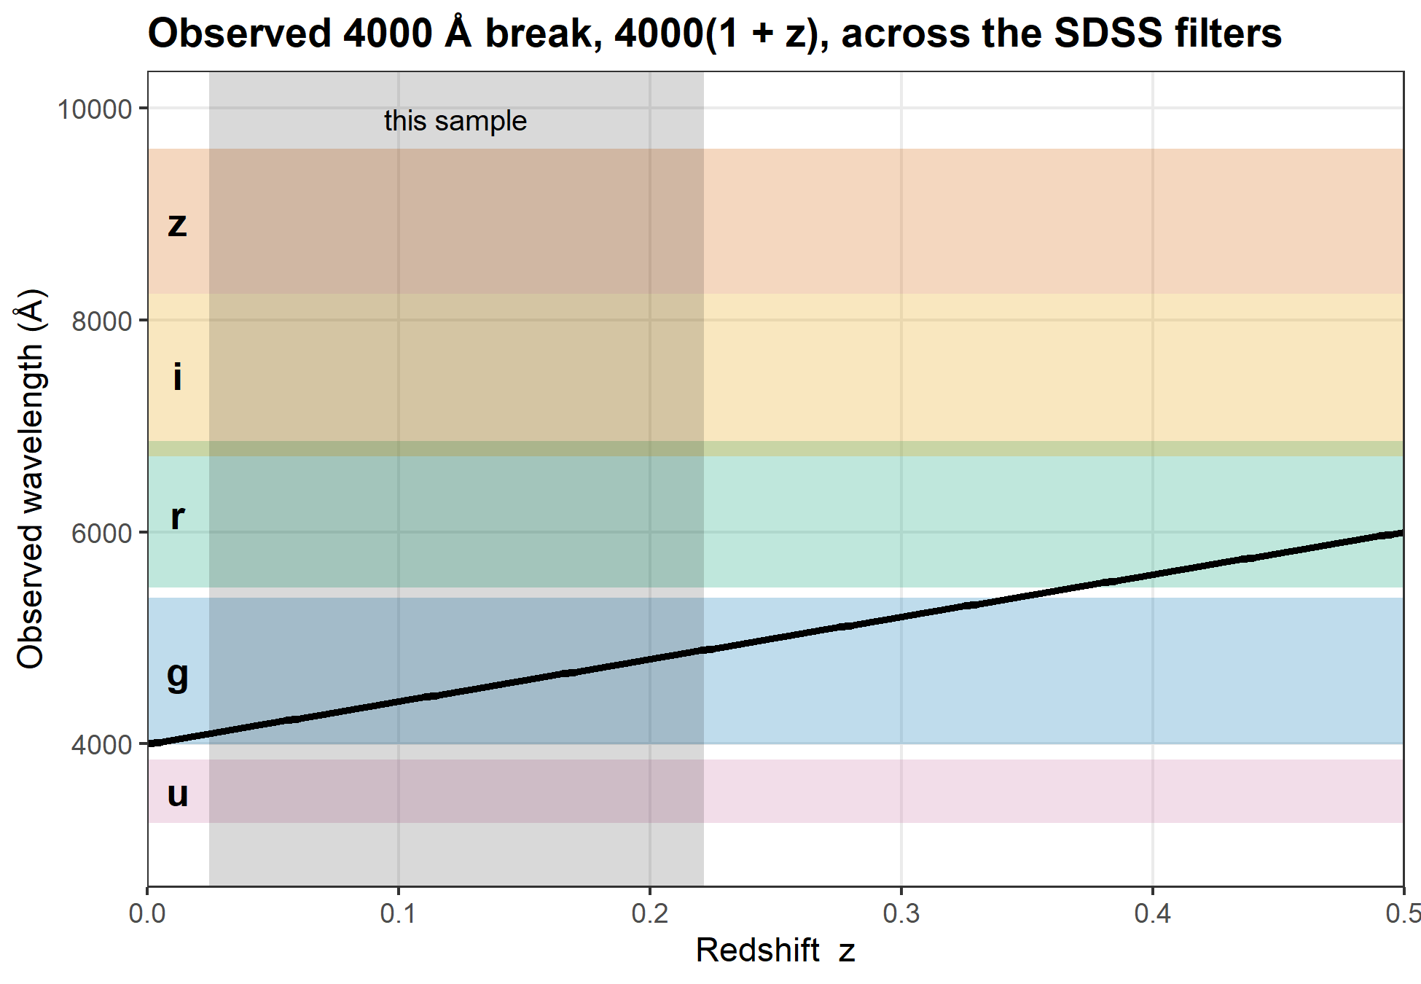
Figure F20. Observed wavelength of the 4000 Å break, 4000(1 + z) Å (black line), over the SDSS filter bands (shaded: effective wavelength ± FWHM/2, approximate). The grey band marks this sample (z = 0.025–0.221), where the break lies at 4098–4885 Å, inside the g band. It would leave g only at z ≈ 0.34.

1.4 Aim and hypotheses
Can a galaxy’s colours predict its redshift? We test four hypotheses:
- H1: g − r is the most important predictor.
- H2: predicted redshift rises monotonically with g − r.
- H3: non-linear models (k-NN, random forest, SVR) beat linear regression.
- H4: all models beat the mean-prediction baseline.

2 Data

2.1 Acquisition
120 random galaxies were retrieved from SDSS DR18 with a SkyServer SQL query (data/sql/sdss_query.sql) by R/01_acquire.R. The query keeps spectroscopically confirmed galaxies with reliable redshifts (zWarning = 0), clean photometry, the Main Galaxy Sample flux limit 14 ≤ r ≤ 17.77, 0.01 < z < 0.5 and magnitude errors below 0.2. Magnitudes are corrected for Milky Way dust (dered_*). The raw file is frozen and recorded with an MD5 checksum in data/raw/ACQUISITION.md.

2.2 AI-assisted inspection and cleaning
Following workflow step 2, an AI assistant (Claude Code) inspected the raw data’s structure, missing and sentinel values, duplicates, ranges and colour outliers, then proposed cleaning rules. The student reviewed every rule. Each rule logs its row counts (Table T02), and every AI interaction is recorded in the appendix. The data contained no missing values, sentinels or duplicates. The colour-outlier rule (median ± 5·MAD) removed 2 galaxies that were blue in all colours. The AI suggested keeping them as probably real star-forming galaxies; the student chose to apply the planned rule. A random sample of 100 galaxies (seed 42) forms the analysis set.
Table T02. Cleaning log: each rule and the rows it removed.
Step | Rule | Rows before | Rows after | Removed
1 | Read raw CSV with explicit column types; clean_names() | 120 | 120 | 0
2 | Inspect structure, summary, NA, sentinels, duplicates | 120 | 120 | 0
3 | Remove duplicate objid | 120 | 120 | 0
4 | Remove rows with NA or sentinel (±9999) values | 120 | 120 | 0
5 | Magnitudes in [10, 30]; 0 < redshift < 1 | 120 | 120 | 0
6 | Remove colour outliers beyond median ± 5·MAD (any colour) | 120 | 118 | 2
7 | Derive colours u_g, g_r, r_i, i_z | 118 | 118 | 0
8 | Random sample to 100 rows | 118 | 100 | 18
9 | Assert 30 ≤ n ≤ 100, no NA, unique objid; write sdss_clean.csv | 100 | 100 | 0

2.3 Summary statistics
Table T01. Summary statistics of the analysis dataset.
Variable | n | Mean | SD | Min | Median | Max
u | 100 | 19.474 | 0.792 | 16.762 | 19.498 | 20.995
g | 100 | 17.779 | 0.720 | 14.938 | 17.910 | 18.798
r | 100 | 16.916 | 0.693 | 14.167 | 17.176 | 17.764
i | 100 | 16.506 | 0.691 | 13.783 | 16.748 | 17.361
zmag | 100 | 16.203 | 0.704 | 13.486 | 16.424 | 17.189
u_g | 100 | 1.695 | 0.315 | 0.933 | 1.751 | 2.350
g_r | 100 | 0.863 | 0.200 | 0.344 | 0.882 | 1.301
r_i | 100 | 0.410 | 0.056 | 0.266 | 0.407 | 0.527
i_z | 100 | 0.303 | 0.065 | 0.084 | 0.312 | 0.442
redshift | 100 | 0.110 | 0.043 | 0.025 | 0.101 | 0.221
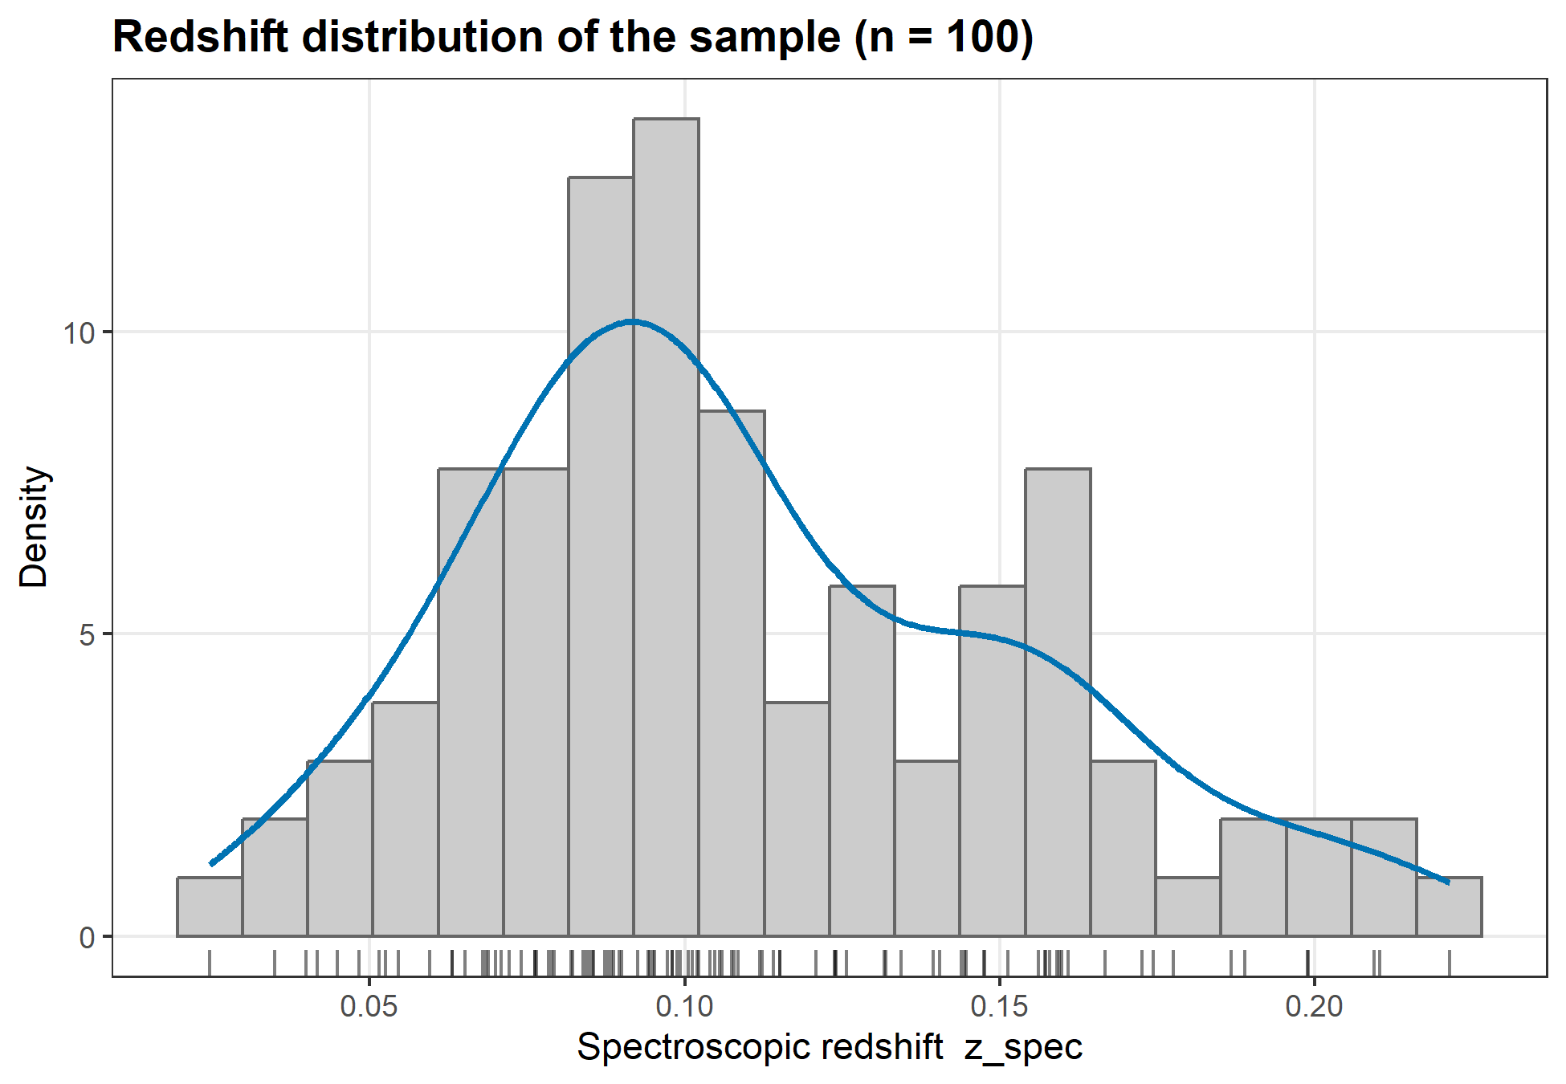
Figure F01. Spectroscopic redshifts of the 100 SDSS galaxies: histogram, kernel density and rug. Range 0.025–0.221, median 0.101.
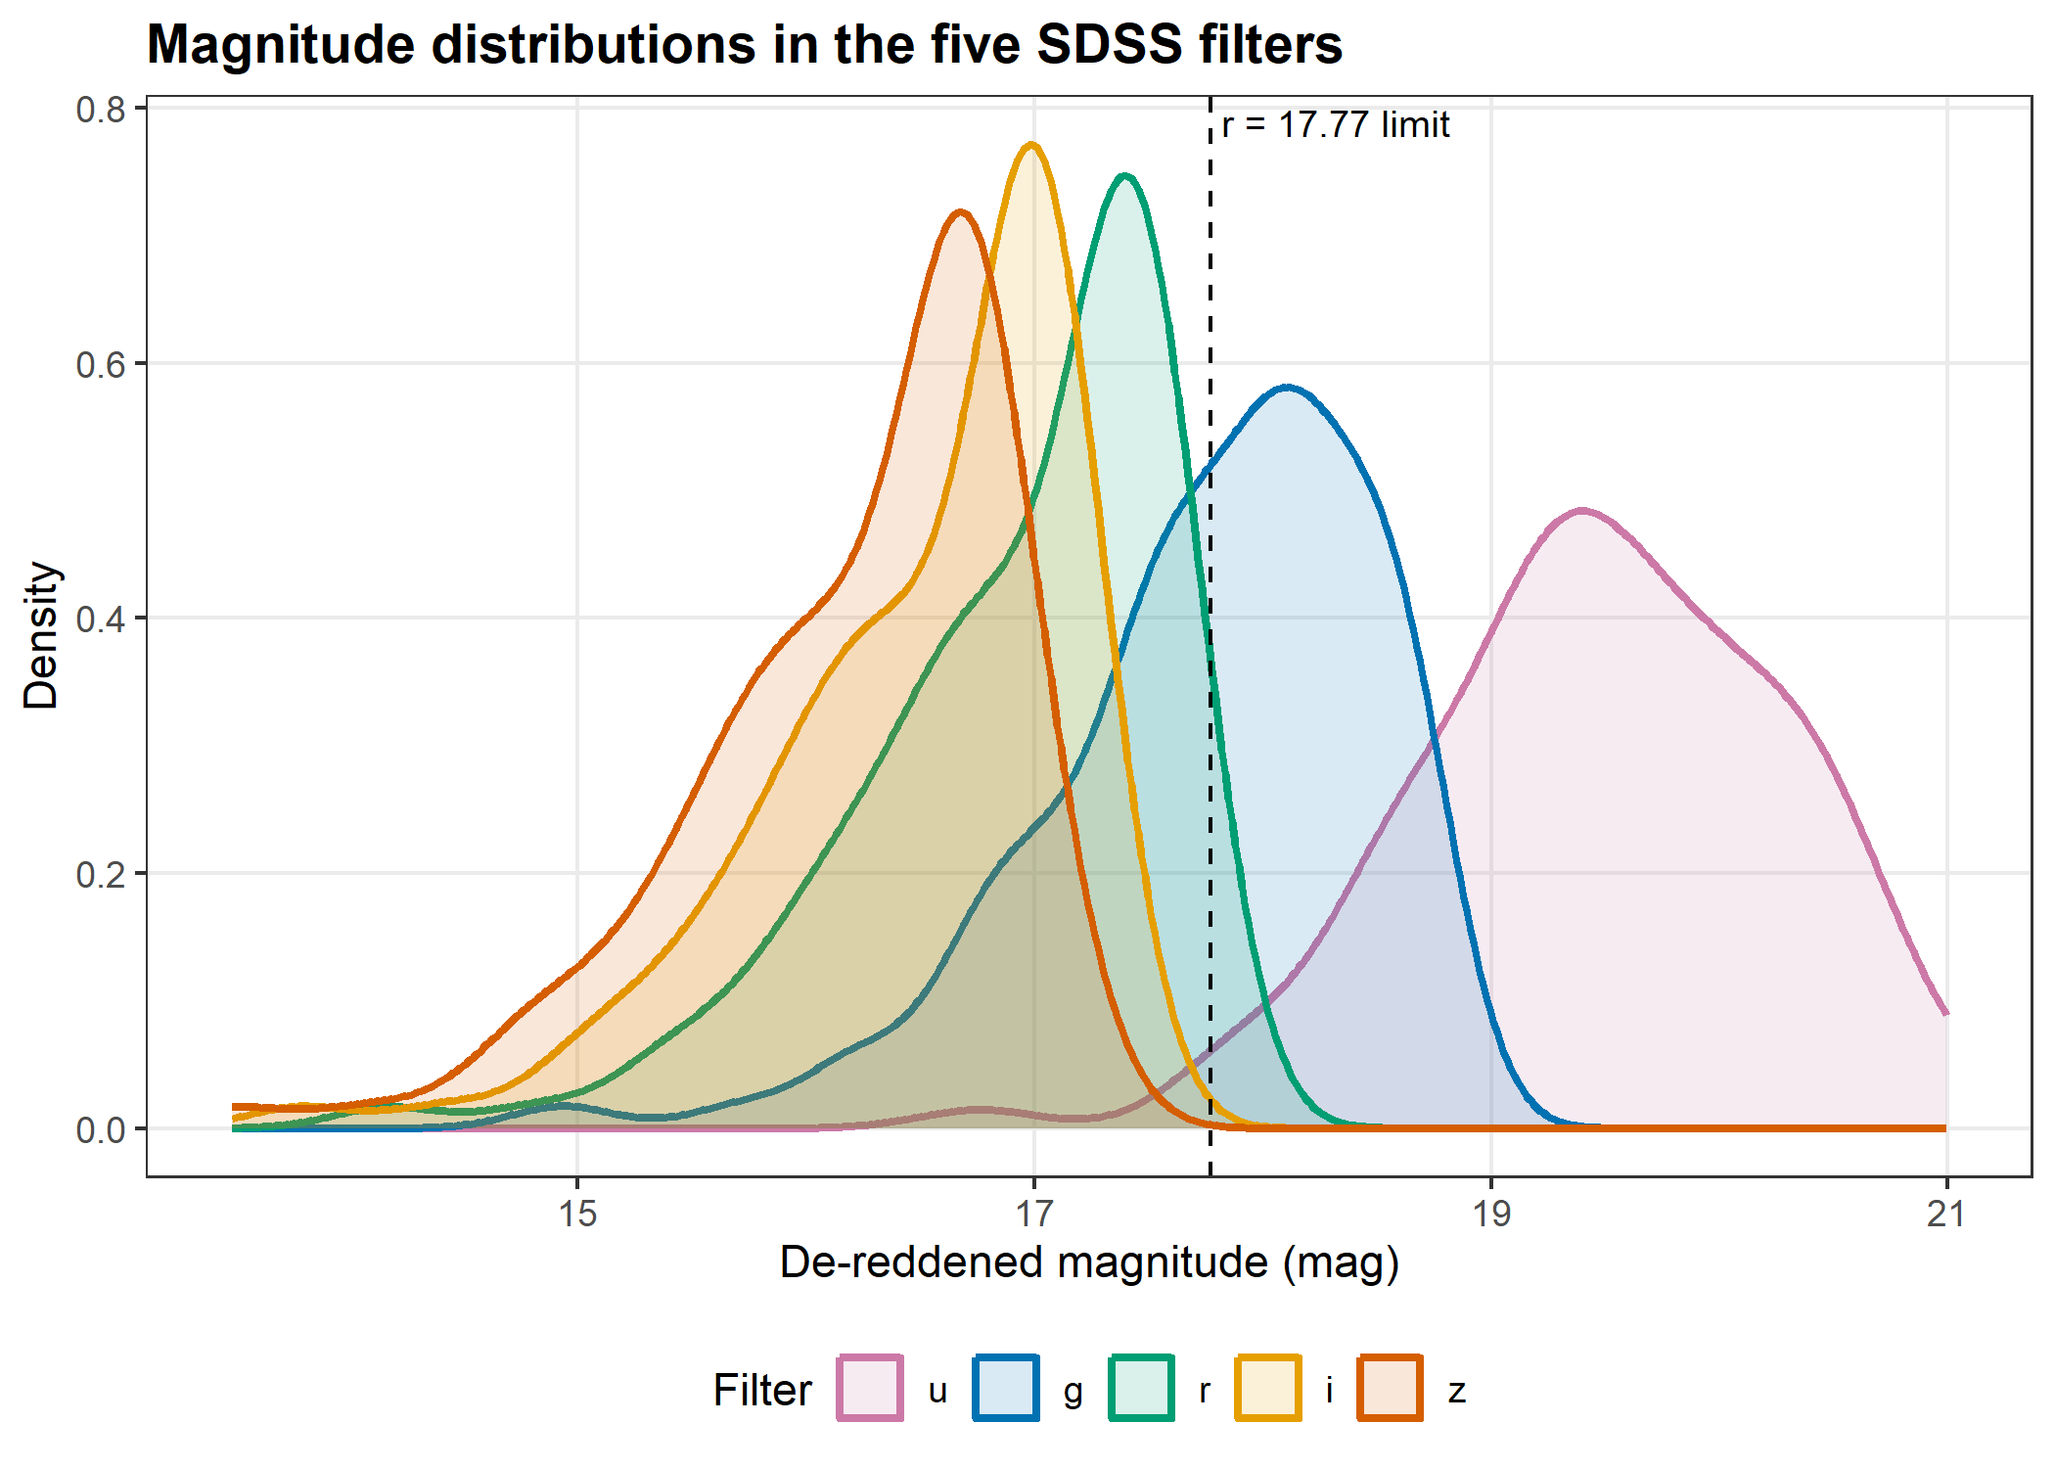
Figure F02. Distributions of de-reddened u, g, r, i, z magnitudes for the 100 galaxies. Galaxies are fainter in u (larger magnitude) and brighter towards the red. The dashed line marks the Main Galaxy Sample limit r = 17.77 used in the query.

2.4 Exploratory physics
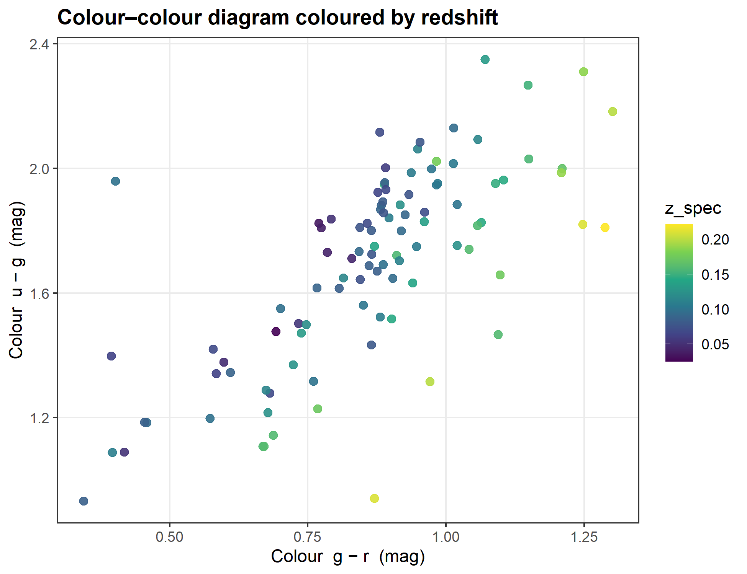
Figure F03. u − g versus g − r for the 100 galaxies, coloured by spectroscopic redshift. Higher-redshift galaxies sit at redder g − r.
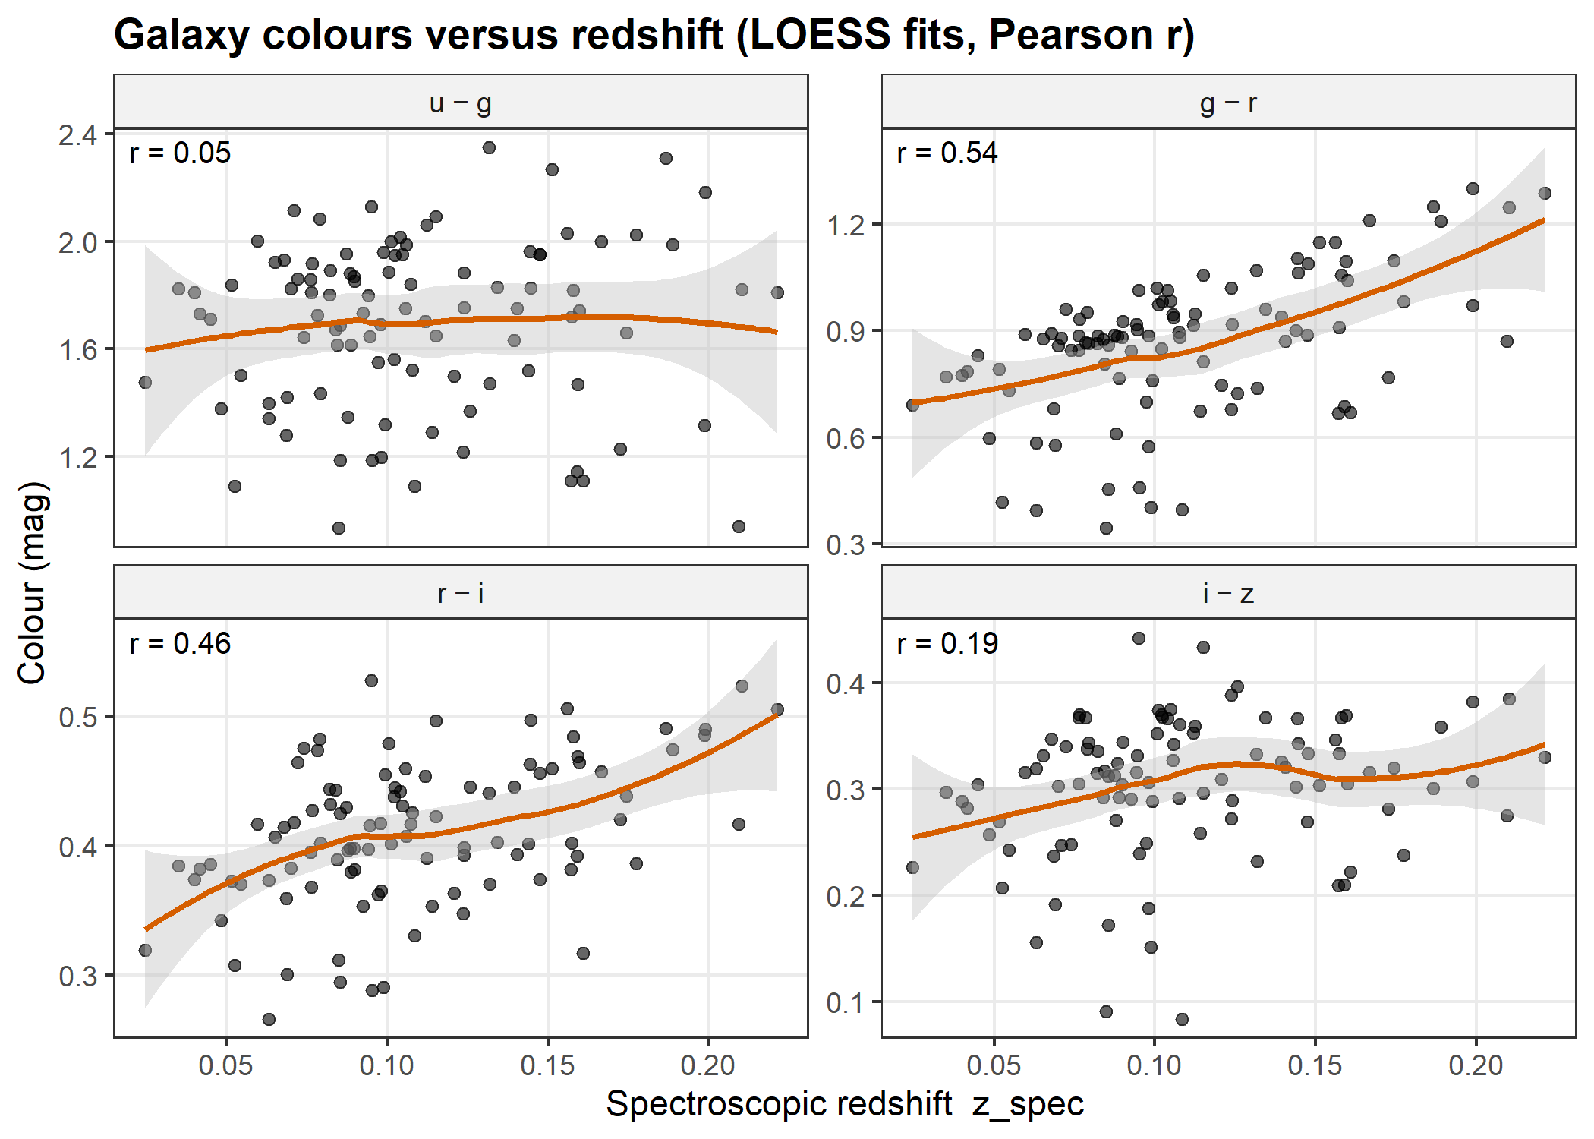
Figure F04. Colours of 100 SDSS galaxies versus spectroscopic redshift. Solid lines are LOESS fits with 95% bands; r is the Pearson correlation. g − r has the strongest correlation (r = 0.54): it reddens as the 4000 Å break moves through the g band.
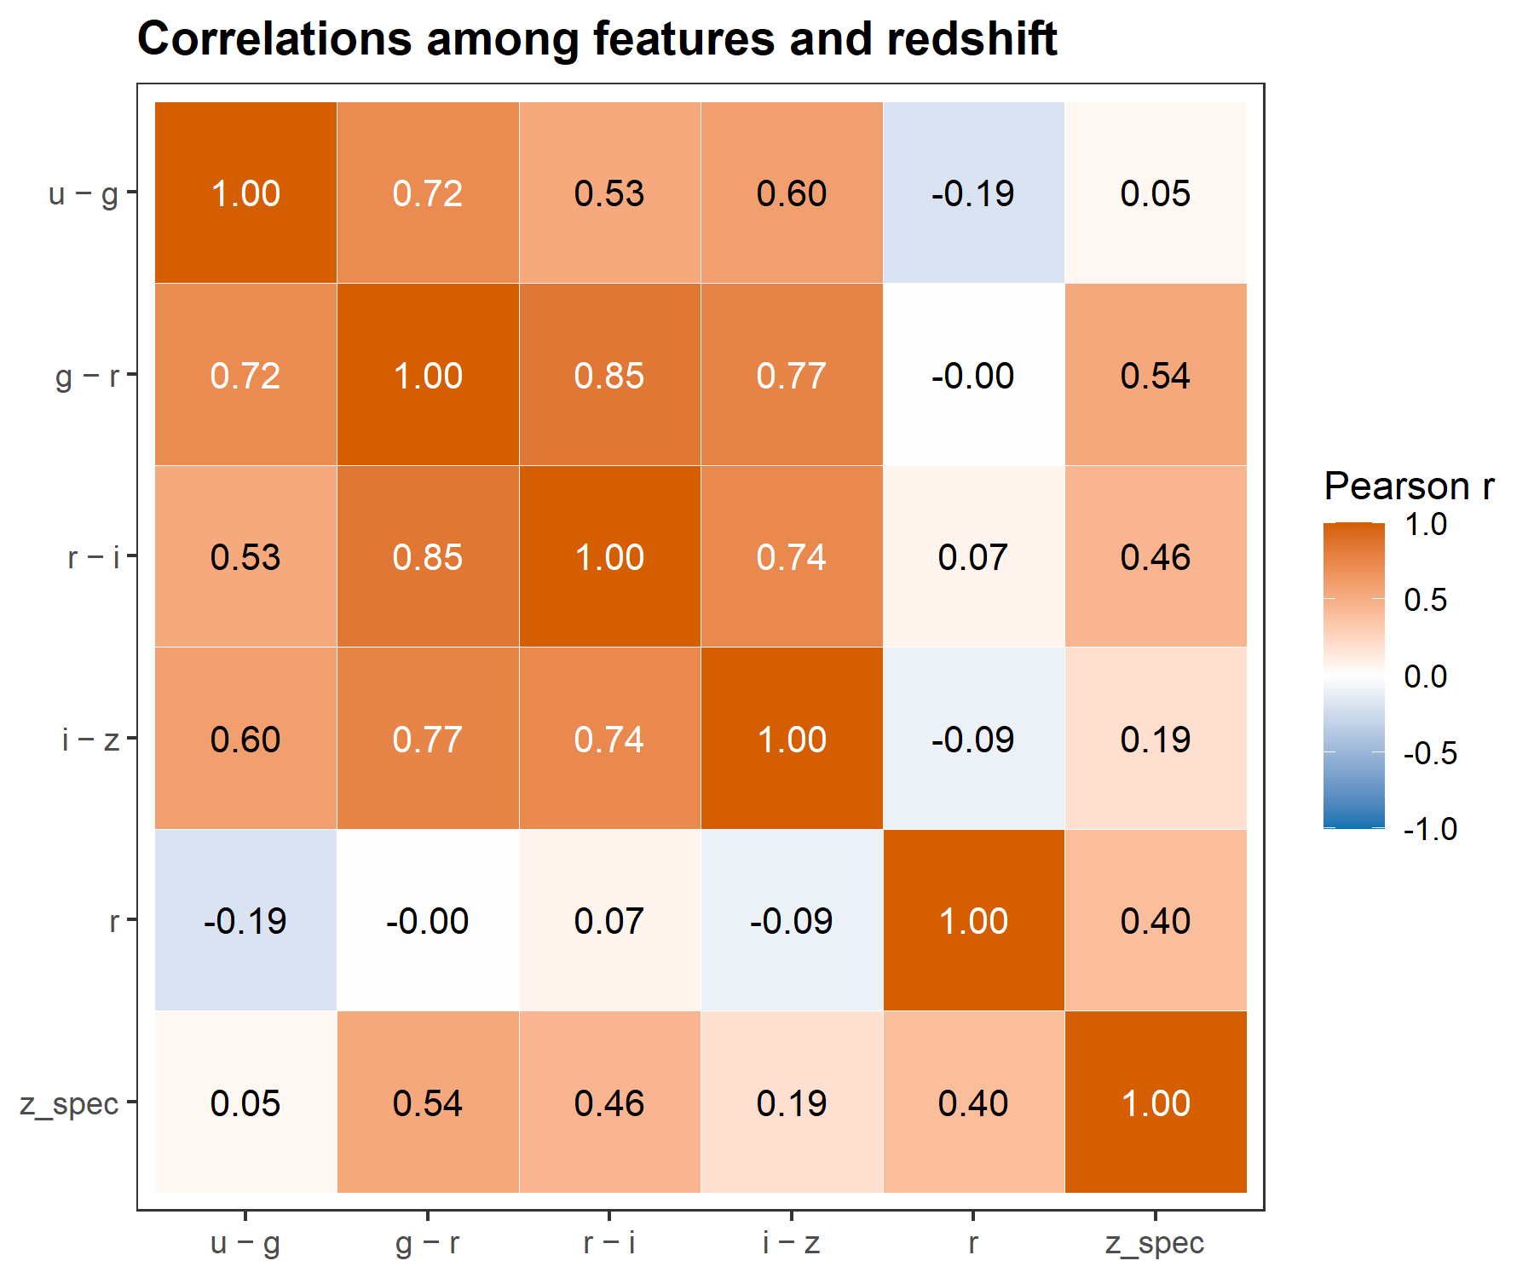
Figure F05. Pearson correlations among the five features and z_spec. The feature most correlated with redshift is g − r (r = 0.54).
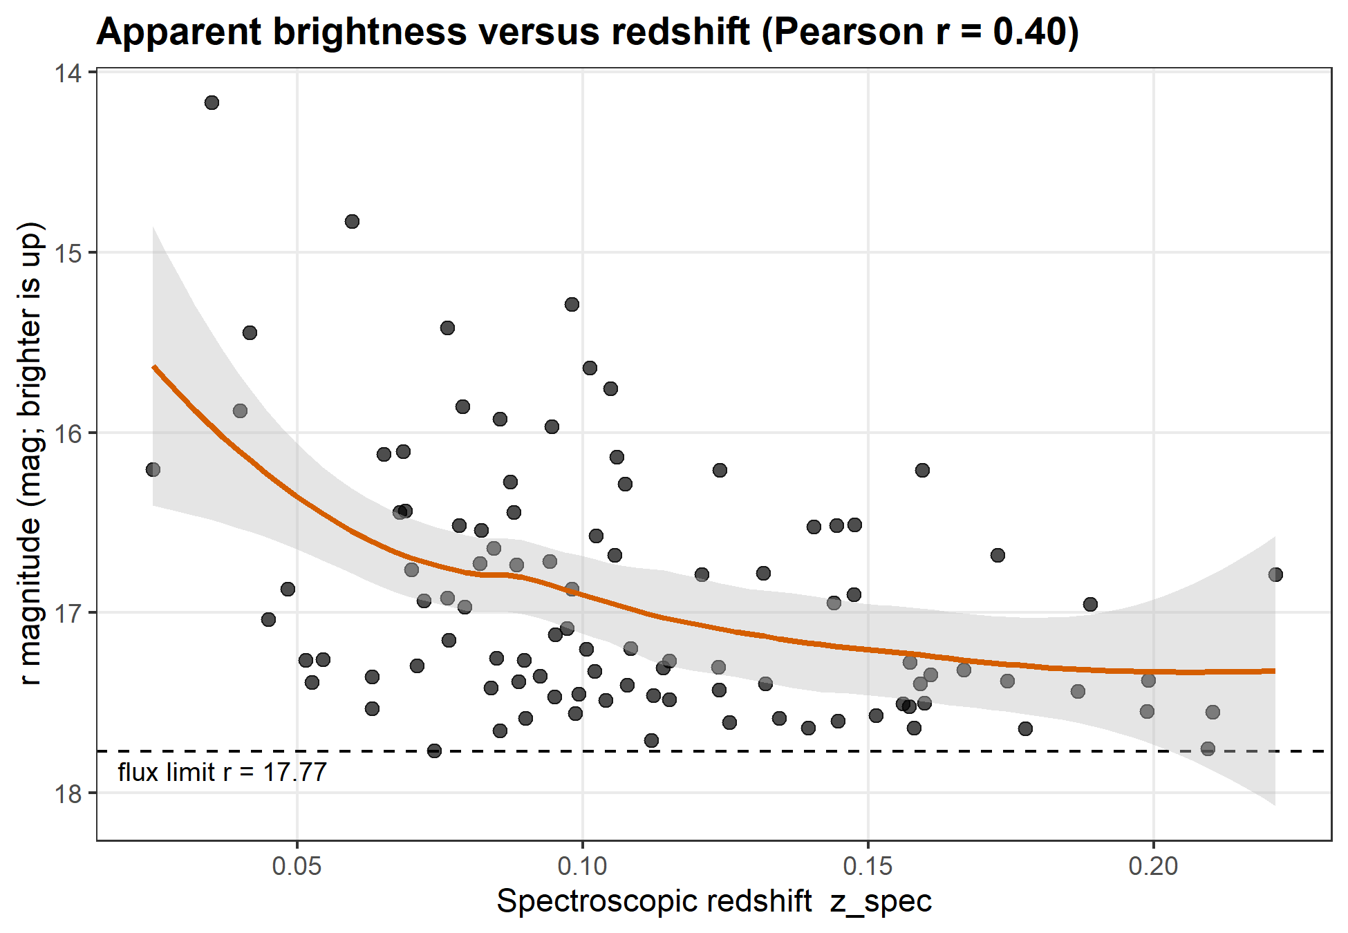
Figure F06. r-band magnitude versus spectroscopic redshift with a LOESS fit. More distant galaxies are fainter on average (inverse-square law); the dashed line is the r = 17.77 flux limit of the sample. Pearson r = 0.40.

3 Methods

3.1 Features and target
The target is the spectroscopic redshift. The features are the four colours u − g, g − r, r − i, i − z and the r-band magnitude. Colours remove the overall brightness and keep the shape of the spectrum, while r carries the brightness–distance information.

3.2 Train/test split
A stratified split on redshift (caret::createDataPartition, seed 42) gives 80 training and 20 test galaxies. A two-sample KS test finds no difference between their redshift distributions (D = 0.088, p = 0.999, Figure F07). The test set was not used for any training, tuning or preprocessing decision.
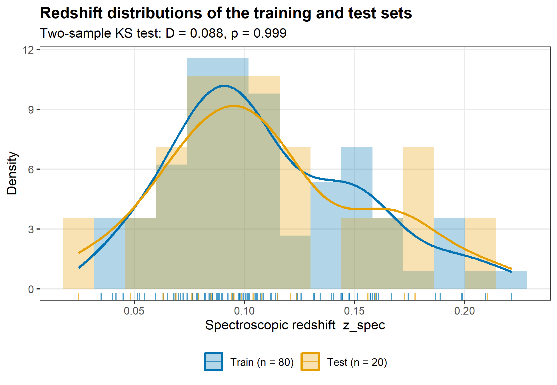
Figure F07. Spectroscopic redshift of the 80 training and 20 test galaxies (histograms, kernel densities and rugs) after a stratified 80/20 split (seed 42). Two-sample KS test: D = 0.088, p = 0.999, so there is no evidence that the two distributions differ.

3.3 Models and tuning
All models use redshift ~ u_g + g_r + r_i + i_z + r and the same 25 resamples (5-fold cross-validation repeated 5 times) on the training set. Hyperparameters were chosen by the lowest mean CV RMSE (Table T03). Centring and scaling were fitted inside each training fold.
Table T03. Hyperparameter grids and selected values.
Model | Parameter | Search grid | Selected
M0 Baseline | (none) | predicts the training mean | —
M1 Linear | (none) | ordinary least squares | —
M2 k-NN | k | 1, 2, …, 20 | 8
M3 Random Forest | mtry | 1, 2, …, 5 | 5
M3 Random Forest | ntree | fixed | 500
M4 SVR | C | 2^-2, 2^-1, …, 2^6 | 32
M4 SVR | sigma | 0.01, 0.05, 0.1, 0.5, 1 | 0.01

3.4 Metrics
With $Δz=(z_{\text{phot}}−z_{\text{spec}})/(1+z_{\text{spec}})$ we report RMSE, MAE, $R^{2}=1−SS_{\text{res}}/SS_{\text{tot}}$, bias = mean(Δz), the robust scatter $σ_{\text{NMAD}}=1.4826×\text{median}(|Δz−\text{median}(Δz)|)$ and the catastrophic-outlier fraction η = fraction with |Δz| > 0.15. Test metrics carry 95% percentile bootstrap confidence intervals (2000 resamples).

4 Results

4.1 Training
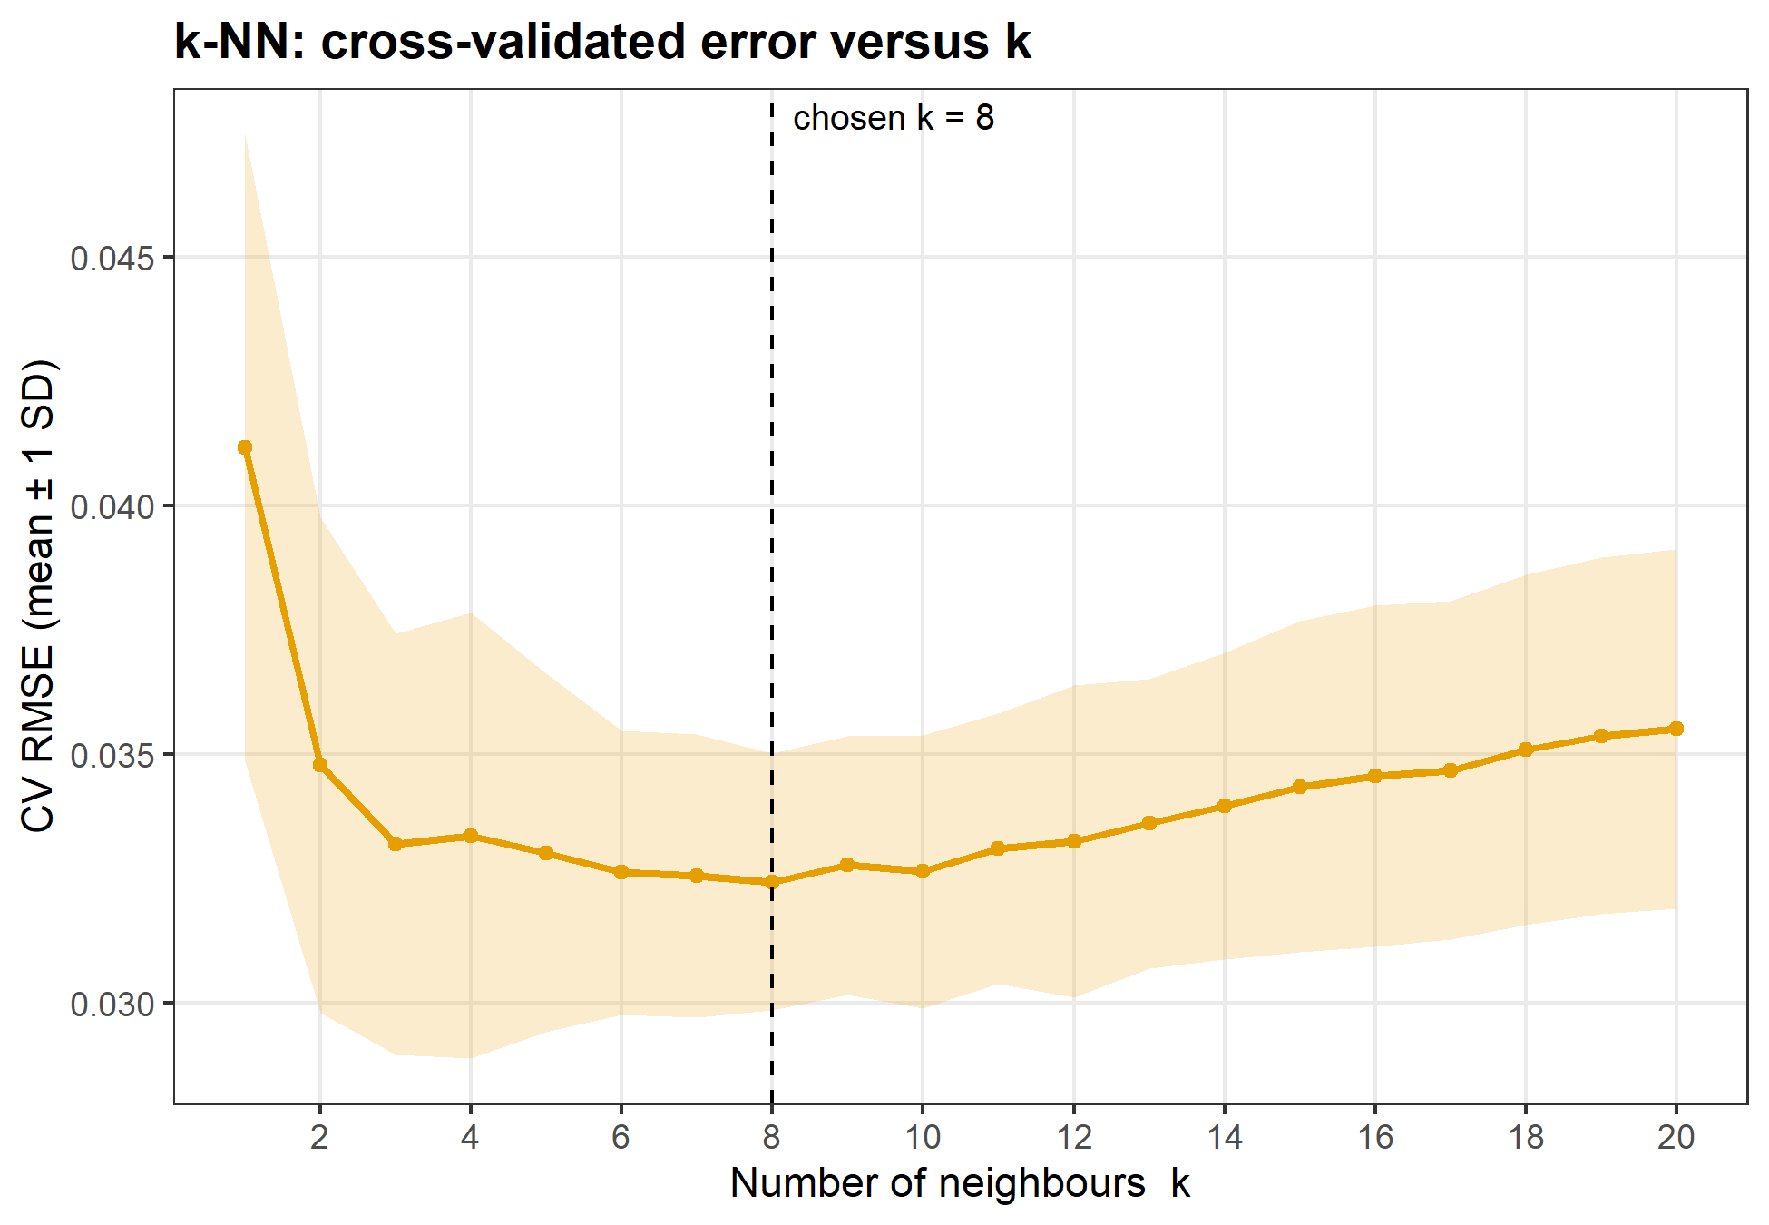
Figure F08. k-NN tuning: mean CV RMSE over 25 resamples (5-fold × 5) versus k, with a ±1 SD band. The chosen k = 8 has the lowest mean RMSE (0.0324).
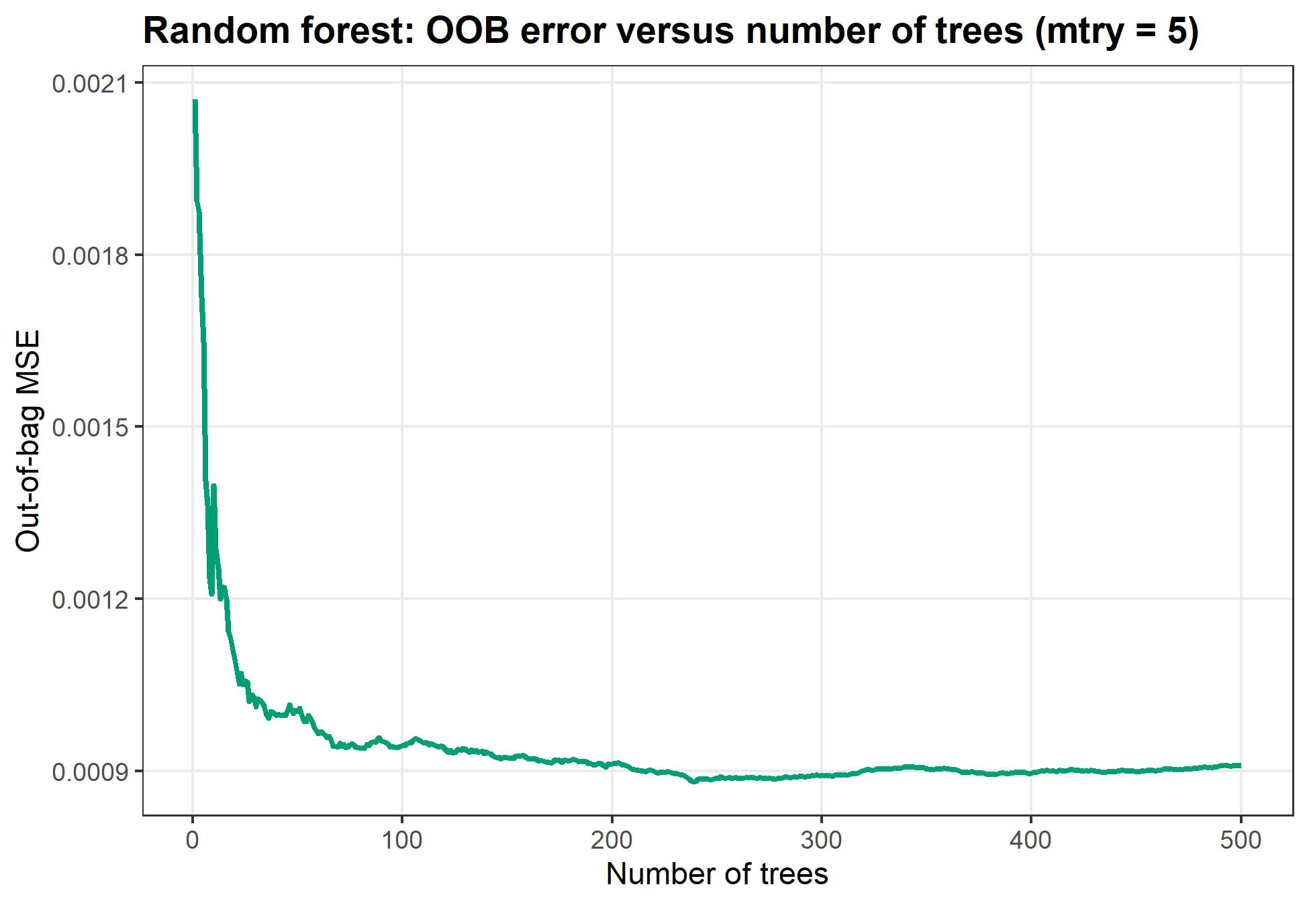
Figure F09. Out-of-bag mean squared error of the final random forest (mtry = 5, 80 training galaxies) as trees are added. The curve is flat well before 500 trees, so 500 is enough.
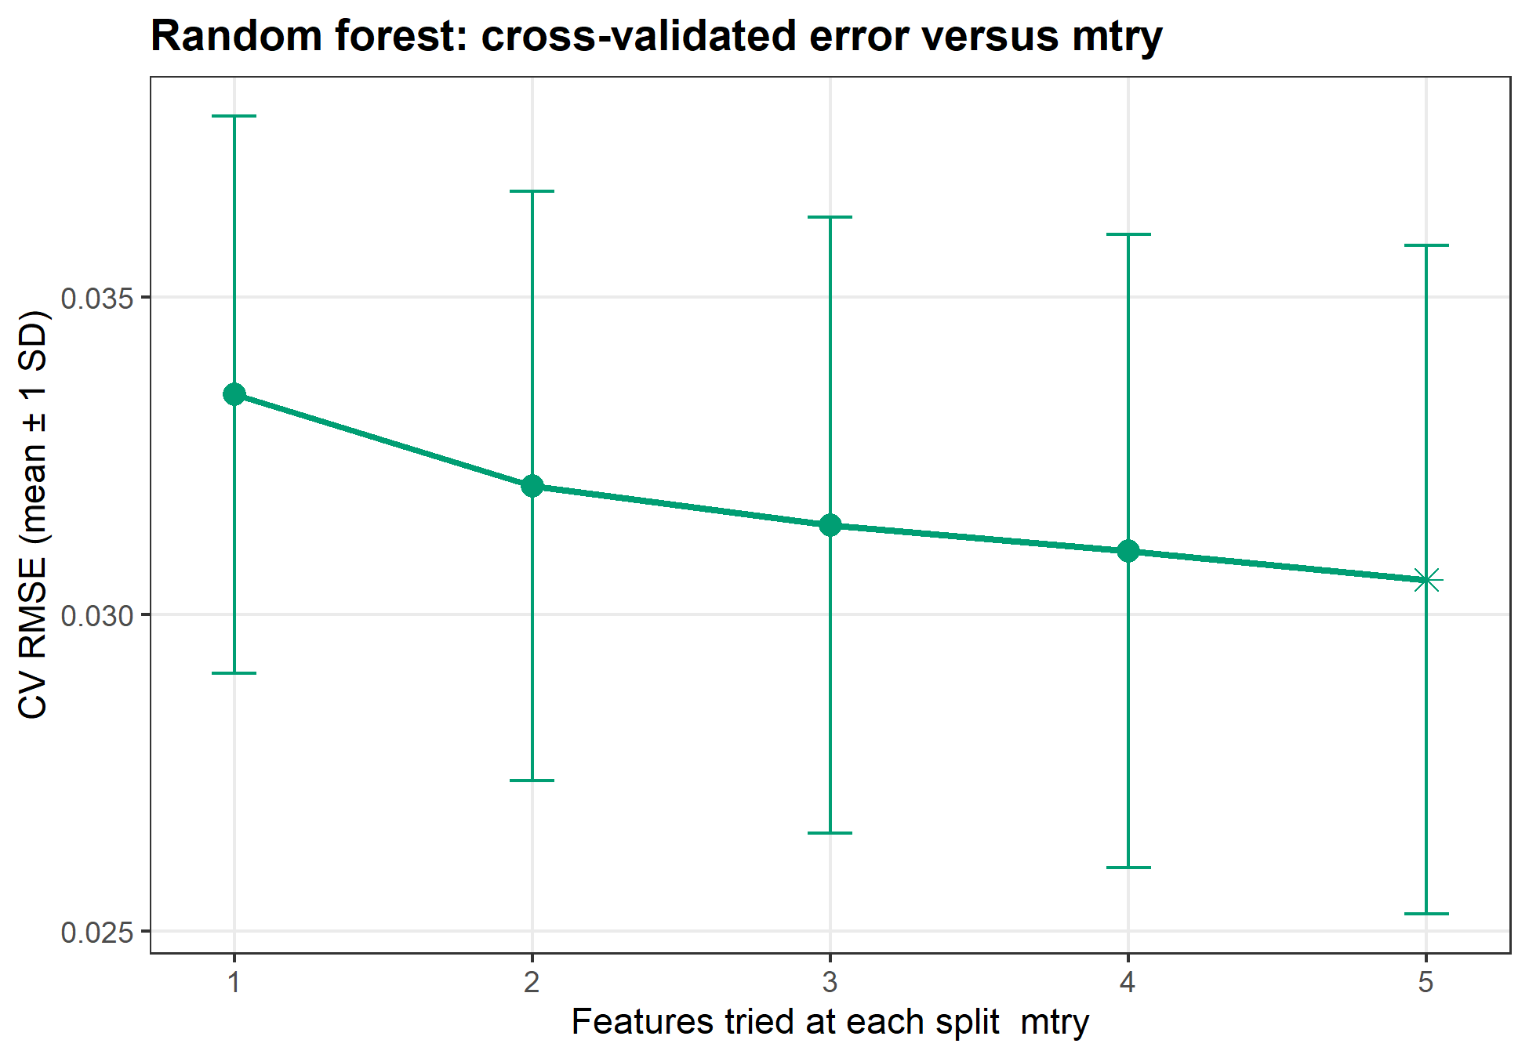
Figure F10. Random-forest tuning: mean CV RMSE (±1 SD, 25 resamples) versus mtry. The star marks the chosen mtry = 5.
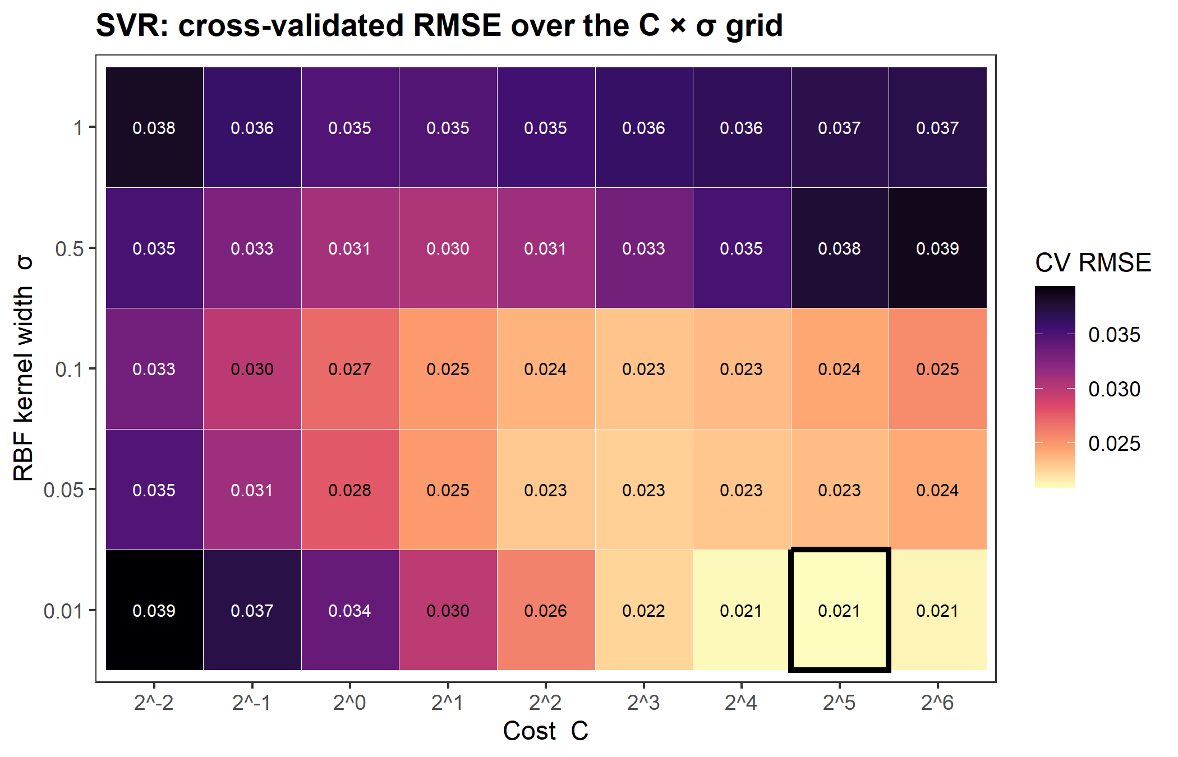
Figure F11. SVR (RBF kernel) tuning: mean CV RMSE for each (C, σ) pair. The outlined cell is the chosen C = 32, σ = 0.01.
Table T04. Cross-validated metrics on the training set (mean and SD over 25 resamples).
Model | RMSE mean | RMSE SD | R² mean | R² SD | MAE mean
M0 Baseline | 0.0419 | 0.0051 | -0.0140 | 0.0159 | 0.0344
M1 Linear | 0.0226 | 0.0039 | 0.6689 | 0.2097 | 0.0178
M2 k-NN | 0.0324 | 0.0026 | 0.3608 | 0.2172 | 0.0260
M3 Random Forest | 0.0305 | 0.0053 | 0.4186 | 0.2618 | 0.0234
M4 SVR | 0.0208 | 0.0038 | 0.7157 | 0.1974 | 0.0160
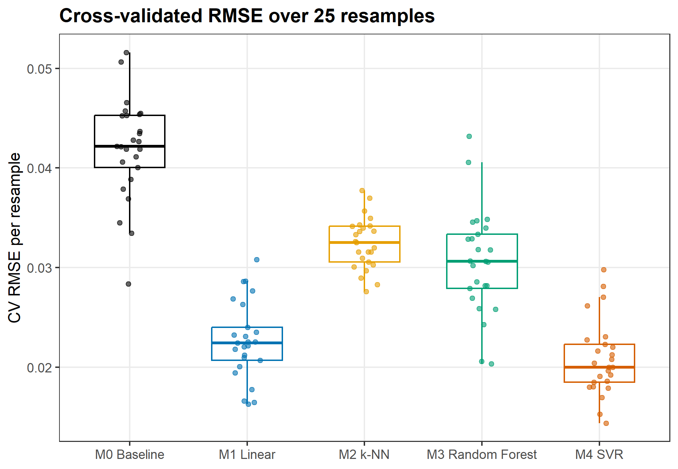
Figure F13. Distribution of CV RMSE over the same 25 resamples (5-fold × 5) for each model. Lowest mean CV RMSE: M4 SVR (0.0208); baseline 0.0419.
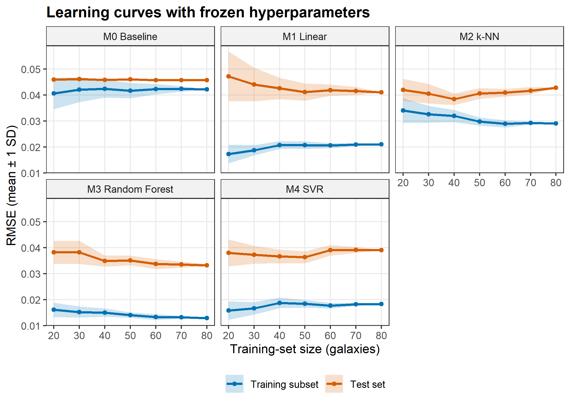
Figure F12. Learning curves: mean training and test RMSE (±1 SD over 20 random subsets) versus training-set size, for each model with its tuned hyperparameters frozen.

4.2 Test-set performance
Table T05. Test-set metrics (n = 20) with 95% bootstrap confidence intervals.
Model | RMSE [95% CI] | MAE | R² [95% CI] | Bias | σ_NMAD [95% CI] | η
M0 Baseline | 0.0457 [0.0330, 0.0576] | 0.0365 | -0.000 [-0.321, -0.000] | 0.0022 | 0.0327 [0.0179, 0.0652] | 0%
M1 Linear | 0.0410 [0.0231, 0.0580] | 0.0303 | 0.193 [-1.582, 0.738] | -0.0029 | 0.0320 [0.0116, 0.0475] | 0%
M2 k-NN | 0.0428 [0.0299, 0.0545] | 0.0333 | 0.123 [-0.401, 0.423] | 0.0028 | 0.0308 [0.0134, 0.0604] | 0%
M3 Random Forest | 0.0331 [0.0222, 0.0428] | 0.0256 | 0.474 [0.022, 0.721] | 0.0030 | 0.0285 [0.0123, 0.0435] | 0%
M4 SVR | 0.0391 [0.0232, 0.0547] | 0.0295 | 0.266 [-1.340, 0.749] | -0.0019 | 0.0282 [0.0116, 0.0472] | 0%
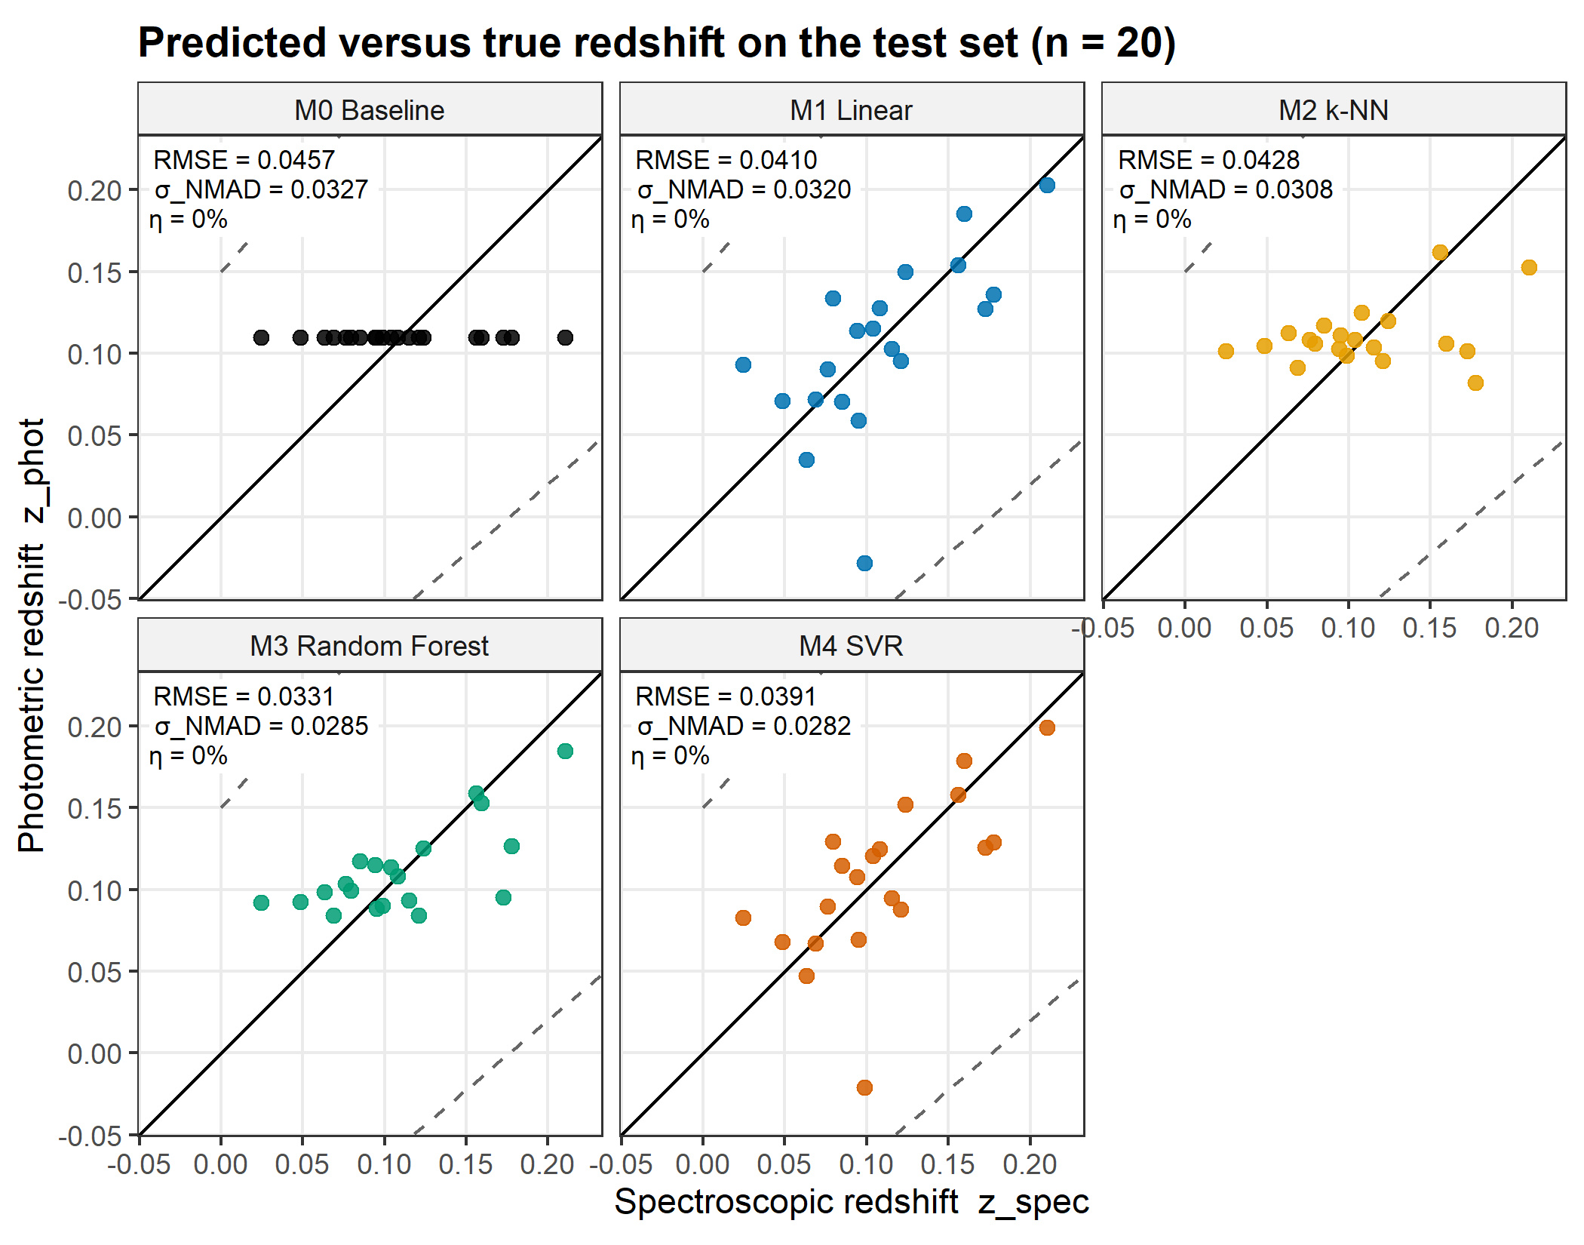
Figure F14. Photometric versus spectroscopic redshift for the 20 test galaxies. The solid line is perfect agreement; dashed lines mark the catastrophic-outlier threshold |Δz| = 0.15(1 + z). Best learner by test RMSE: M3 Random Forest (RMSE 0.0331, σ_NMAD 0.0285); baseline RMSE 0.0457.
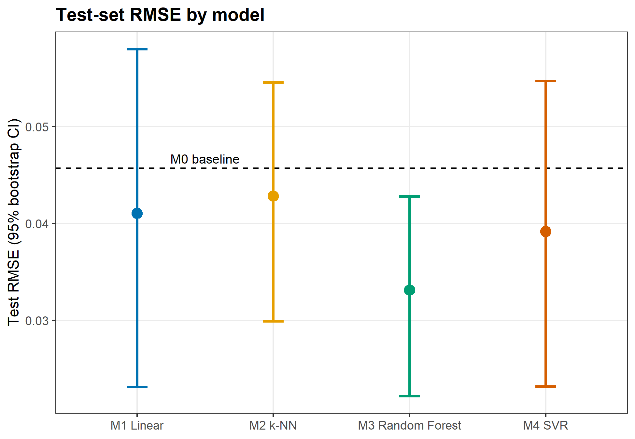
Figure F17. Test-set RMSE for each model with 95% percentile bootstrap confidence intervals (2000 resamples of the 20 test galaxies). The dashed line is the mean-prediction baseline (RMSE 0.0457).

4.3 Error analysis
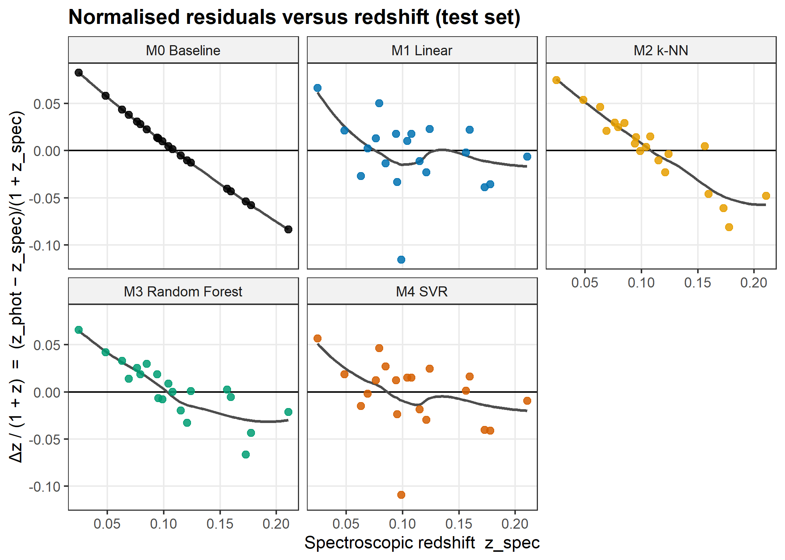
Figure F15. Normalised residuals Δz/(1 + z) versus spectroscopic redshift for each model on the test set, with a LOESS trend. A trend from positive at low z to negative at high z means predictions are pulled towards the mean redshift.
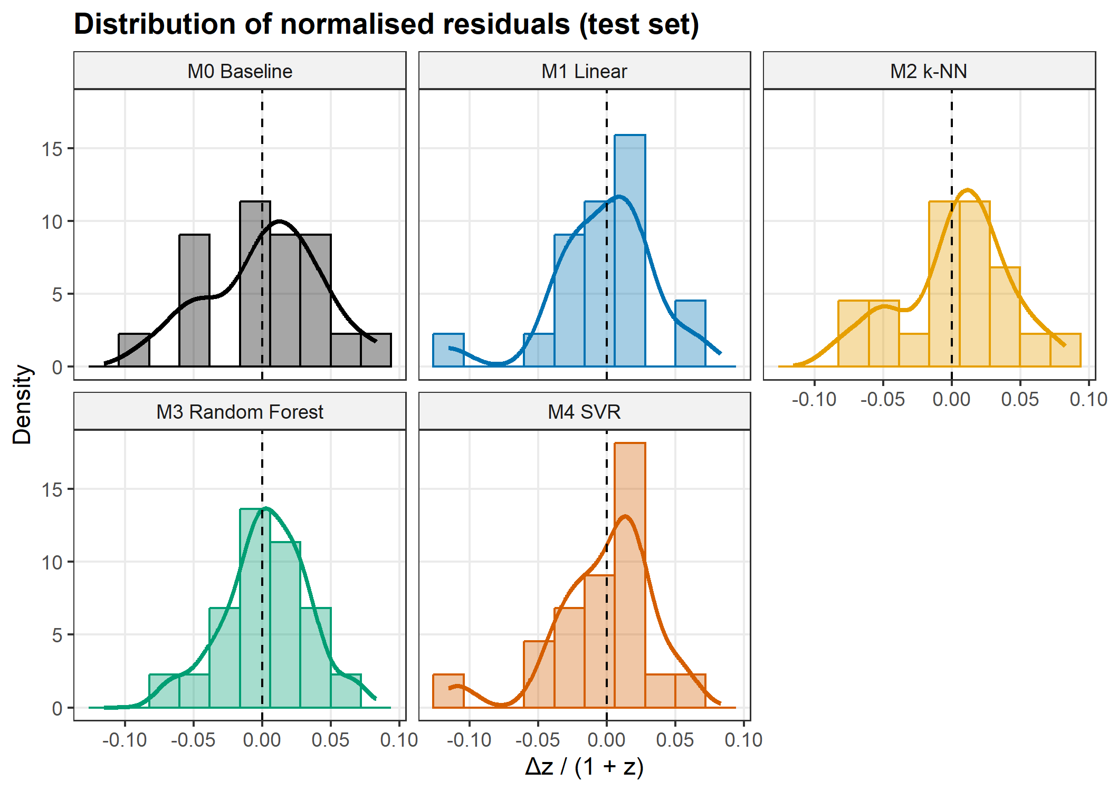
Figure F16. Distributions of the normalised residual Δz/(1 + z) on the 20 test galaxies for each model (histogram and kernel density); the dashed line is zero.

5 Discussion: physics interpretation

5.1 Which features matter and why
Table T06. Feature importance: random-forest permutation importance and standardised linear-regression coefficients with 95% CIs.
Feature | RF %IncMSE | RF rank | LM std. coef. | LM CI low | LM CI high | LM rank
g − r | 44.2704 | 1 | 0.0611 | 0.0504 | 0.0719 | 1
u − g | 13.6076 | 2 | -0.0352 | -0.0438 | -0.0266 | 2
r (mag) | 8.9287 | 3 | 0.0085 | 0.0031 | 0.0139 | 4
i − z | 7.5409 | 4 | -0.0095 | -0.0170 | -0.0019 | 3
r − i | 4.7368 | 5 | -0.0076 | -0.0163 | 0.0011 | 5
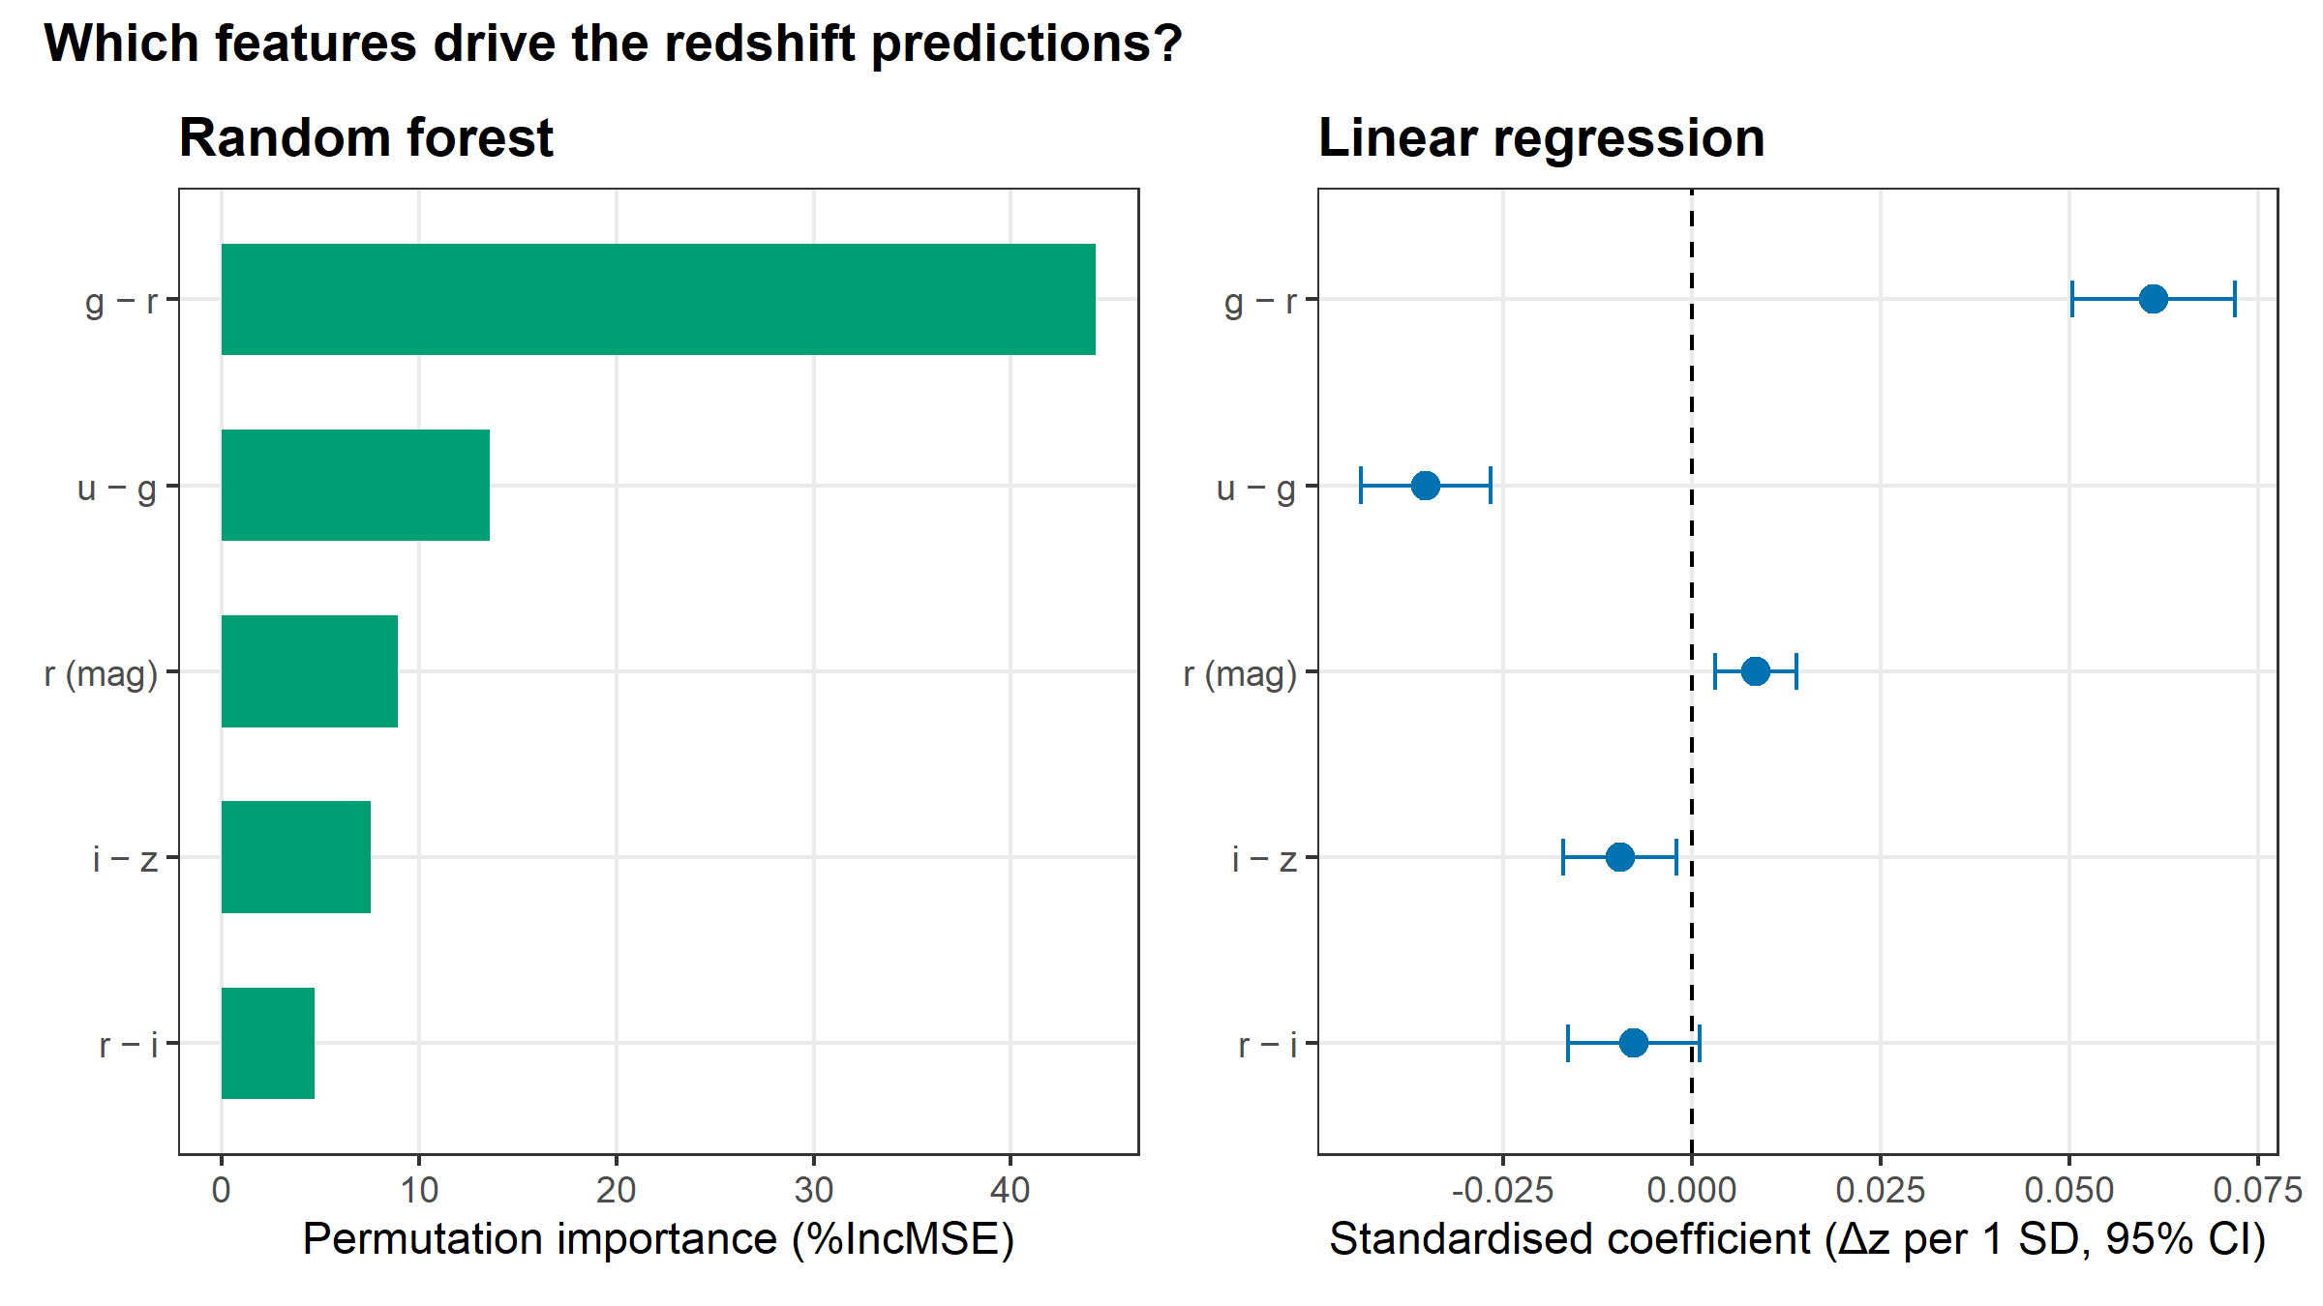
Figure F18. Feature importance. Left: random-forest permutation importance (%IncMSE). Right: standardised linear-regression coefficients with 95% CIs (change in predicted z per 1 SD of each feature). Most important: g − r (RF) and g − r (LM).
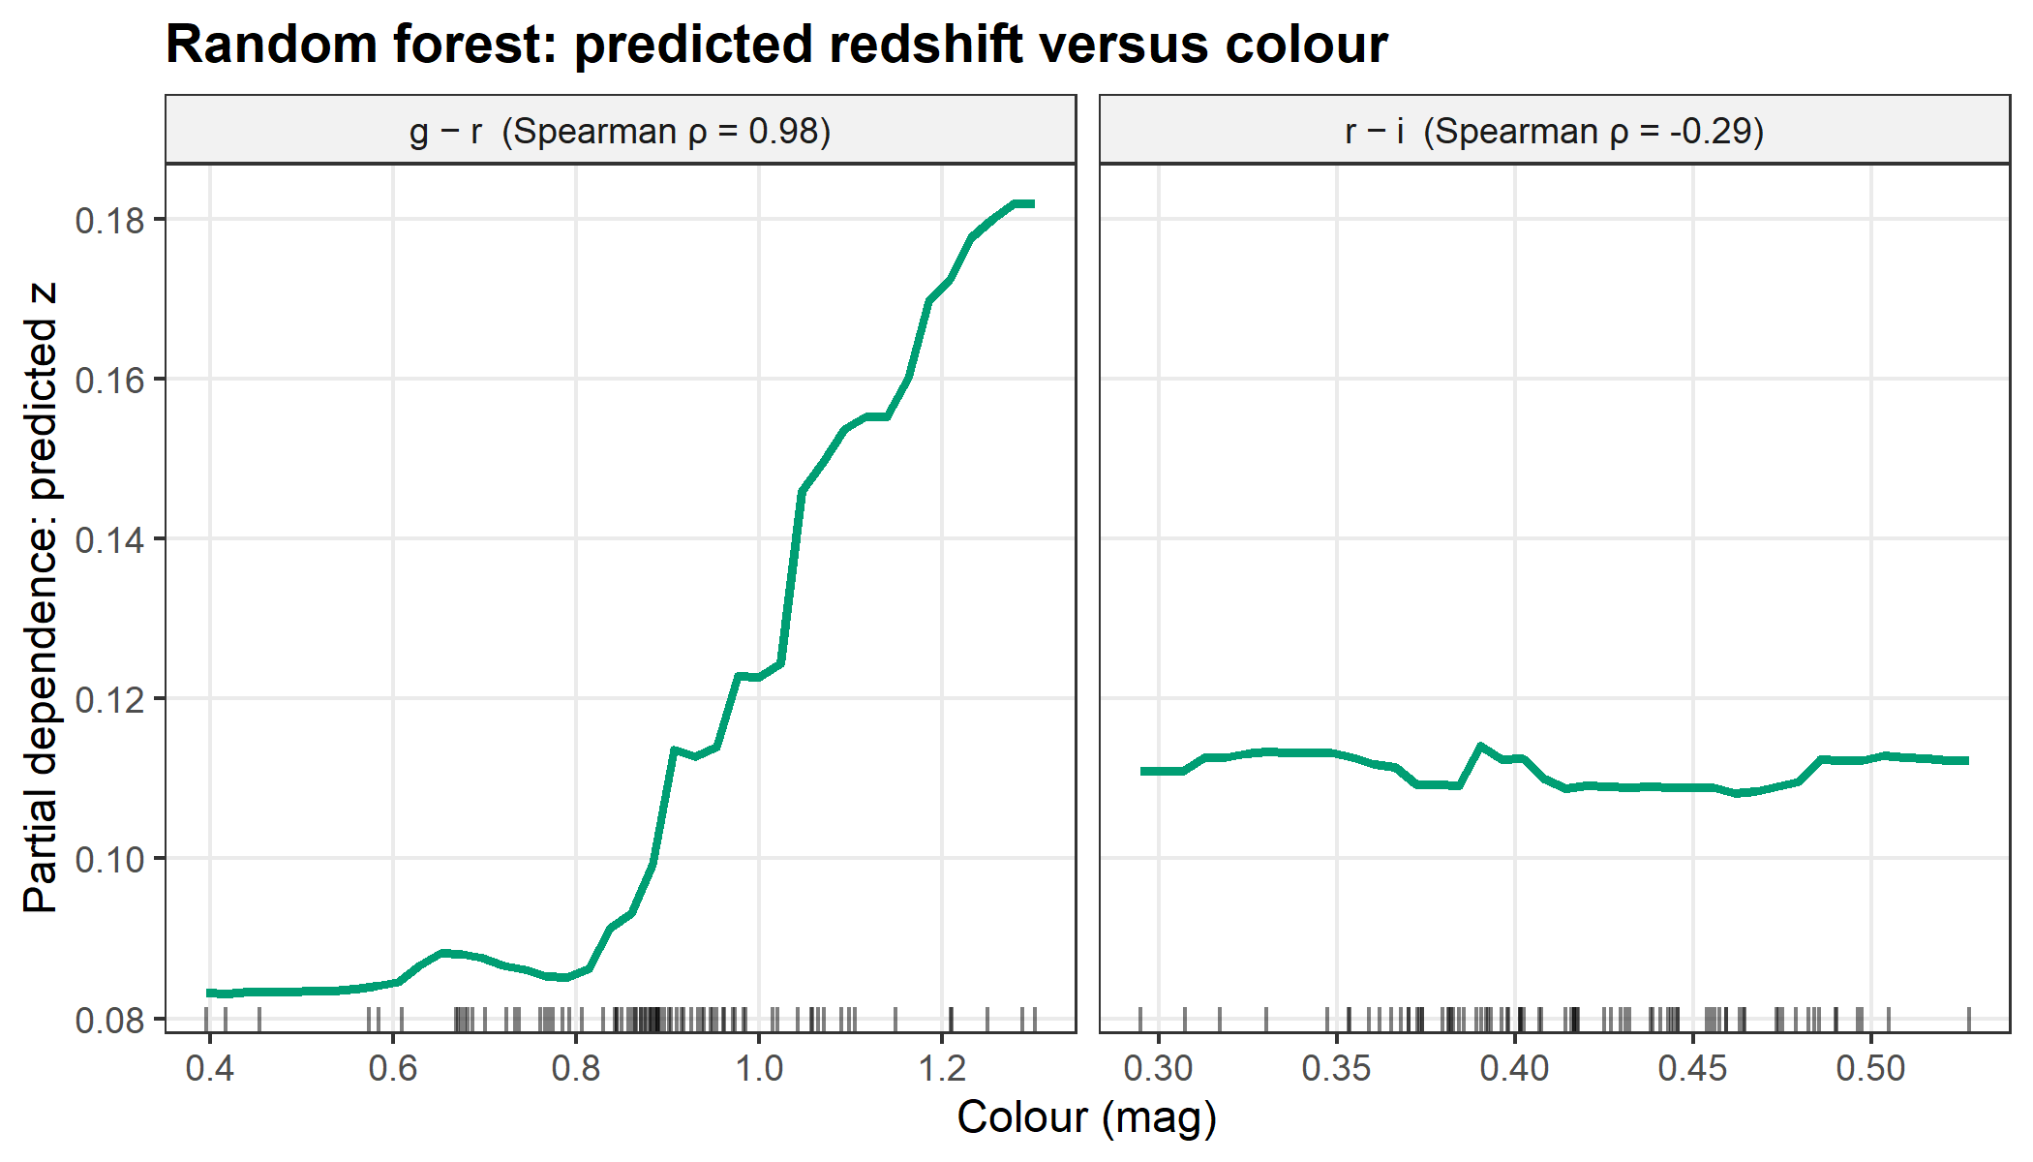
Figure F19. Partial dependence of the random-forest redshift prediction on g − r and r − i (training data; rugs show the observed values). Over the observed range, predicted z changes by 0.099 with g − r (Spearman ρ = 0.98).
The random forest ranks g − r first (%IncMSE 44.27), and the partial dependence (Figure F19) shows predicted redshift climbing steadily with g − r. This is the behaviour expected from the 4000 Å break moving redward through the g filter: the galaxy loses flux in g relative to r and its g − r colour reddens. r − i correlates with z on its own (Figure F04) but adds little once g − r is known, because the two colours are strongly correlated (Figure F05).
- Random-forest ranking: 1. g − r (%IncMSE 44.3); 2. u − g (%IncMSE 13.6); 3. r (mag) (%IncMSE 8.9); 4. i − z (%IncMSE 7.5); 5. r − i (%IncMSE 4.7).
- Most important feature: g − r (random forest), g − r (largest |standardised coefficient| in the linear model).
- r magnitude: RF rank 3 of 5; LM coefficient 0.0085 [95% CI 0.0031, 0.0139]: positive, so fainter galaxies are predicted at higher z, as the inverse-square law expects.
- u − g: almost no correlation with z on its own (training r = -0.02) but RF rank 2 and LM coefficient -0.0352 [-0.0438, -0.0266] at fixed g − r. Interpretation: u − g traces galaxy type (old/red vs star-forming/blue), which lets the models tell an intrinsically red galaxy from one reddened by redshift in g − r.
- The colours are strongly correlated with each other (F05), so individual linear coefficients can trade off against each other; their CIs are wide.

5.2 Hypotheses
- H1 (g − r is the most important predictor): supported by both RF and LM.
- H2 (predicted z rises monotonically with g − r): supported. Spearman ρ of the RF partial-dependence curve = 0.98 (threshold 0.8).
- H3 (non-linear models beat linear regression): CV partly supported (only M4 SVR beat LM); test partly supported (only M3 Random Forest, M4 SVR beat LM). CV RMSE: LM 0.0226, k-NN 0.0324, RF 0.0305, SVR 0.0208. Test RMSE: LM 0.0410, k-NN 0.0428, RF 0.0331, SVR 0.0391.
- H4 (all models beat the mean baseline): CV supported, test supported (point estimates; baseline CV 0.0419, test 0.0457). The test CIs in T05 overlap the baseline for 3 of 4 learners.

5.3 Where the models fail
Cross-validation ranks M4 SVR first, but on the test set M3 Random Forest is best. The difference comes from a few test galaxies whose colours lie outside the range seen in training (4 of 20). One of them has a red u − g but unusually blue g − r, r − i and i − z. The linear model and the near-linear SVR extrapolate for it and predict a negative, unphysical redshift (2 predictions below zero in total). A random forest predicts averages of training redshifts and cannot leave the training range, so it is more robust to such galaxies. Every model also pulls the lowest- and highest-redshift galaxies towards the mean redshift (Figure F15), a typical effect of a small training set.
With only 20 test galaxies the confidence intervals in Table T05 overlap strongly, so no model is clearly better than another on this test set. The robust scatter σ_{NMAD} of 0.0285 (95% CI 0.0123–0.0435) falls within the ≈ 0.02–0.03 reported for SDSS photo-z trained on hundreds of thousands of galaxies. With only 80 training galaxies and a narrow redshift range this is encouraging, but the wide interval means the comparison is not precise. The learning curves (Figure F12) show the gap between training and test error for each model as the training set grows.
- Test galaxies with at least one feature outside the training range: 4 of 20.
- Negative (unphysical) test predictions: 2 (M1 Linear, M4 SVR). Linear and kernel models can extrapolate beyond the training redshifts; random-forest predictions are averages of training redshifts and cannot.
- Over this sample’s redshift range (0.025–0.221) the 4000 Å break stays inside the g band (F20), so the redshift signal is the break moving within g, which reddens g − r.

6 Limitations
- Small sample. n = 100 is set by the assignment brief. Real photo-z work uses 10⁵–10⁶ training galaxies.
- Small test set. With 20 galaxies, metrics have wide confidence intervals and η can only change in steps of 5%.
- Narrow redshift range. The models are valid only for 0.025 ≤ z ≤ 0.221 and r ≤ 17.77. In this range the break never leaves the g band.
- Very blue galaxies excluded. The 5·MAD cleaning rule removed galaxies that are blue in every colour, so the models have not learned such objects.
- Unphysical extrapolation. The linear model and SVR can predict z < 0 for galaxies with colours outside the training range.
- Unused information. Magnitude errors were not used as weights or inputs.

7 Conclusion
Five-band SDSS photometry predicts galaxy redshift better than a mean-value baseline, even with only 80 training galaxies. On the test set the best model, M3 Random Forest, reaches RMSE 0.0331 against 0.0457 for the baseline. Every learner beats the baseline on the point estimate, but only M3 Random Forest has a 95% confidence interval entirely below it, so with 20 test galaxies the improvement is clear only for that model. The models learn the physics: g − r, which tracks the 4000 Å break moving through the g filter, dominates the predictions, and predicted redshift rises monotonically with it. Smooth models (linear regression, SVR) do best in cross-validation, while the random forest is the most robust on unusual test galaxies because it cannot extrapolate to unphysical values.

8 References
- York, D. G. et al. (2000). The Sloan Digital Sky Survey: Technical Summary. AJ, 120, 1579.
- Strauss, M. A. et al. (2002). Spectroscopic Target Selection in the SDSS: The Main Galaxy Sample. AJ, 124, 1810.
- Csabai, I. et al. (2003). The Application of Photometric Redshifts to the SDSS Early Data Release. AJ, 125, 580.
- Collister, A. A. & Lahav, O. (2004). ANNz: Estimating Photometric Redshifts Using Artificial Neural Networks. PASP, 116, 345.
- Beck, R. et al. (2016). Photometric redshifts for the SDSS Data Release 12. MNRAS, 460, 1371.
- Salvato, M., Ilbert, O. & Hoyle, B. (2019). The many flavours of photometric redshifts. Nature Astronomy, 3, 212.
- Bruzual, G. (1983). Spectral evolution of galaxies. I. Early-type systems. ApJ, 273, 105.
- Kuhn, M. (2008). Building Predictive Models in R Using the caret Package. J. Stat. Softw., 28(5).
- Breiman, L. (2001). Random Forests. Machine Learning, 45, 5–32.
- SDSS SkyServer DR18: https://skyserver.sdss.org/dr18.
Funding for SDSS has been provided by the Alfred P. Sloan Foundation, the Participating Institutions, the National Science Foundation, and the U.S. Department of Energy Office of Science.

Appendix A: AI usage log

8.0.0.1 Summary table (keep updated)
ID | Date | Stage | Tool | What the AI did | Owner decision | Code / output
AI-001 | 2026-10-18 | Planning | Claude (claude.ai) | Proposed project, features, models, metrics, query cuts; drafted project docs | Accepted (D-001–D-016) | This doc pack
AI-002 | 2026-10-18 | Acquisition (code) | Claude Code (Claude Opus 5.5) | Tested the SkyServer web API, wrote the setup, utility and download scripts | Accepted | R/00_setup.R, R/utils_*.R, R/01_acquire.R
AI-003 | 2026-10-18 | Inspection | Claude Code (Claude Opus 5.5) | Checked structure, NA, sentinels, duplicates, ranges, errors, colour outliers; flagged 2 very blue galaxies | Noted | outputs/logs/02_inspection.txt
AI-004 | 2026-10-18 | Cleaning | Claude Code (Claude Opus 5.5) | Implemented rules 1–9; suggested flag-only for the 2 blue galaxies | Rejected the suggestion: removed them as planned | R/02_inspect_clean.R, T02_cleaning_log.csv
AI-005 | 2026-10-18 | Preprocessing | Claude Code (Claude Opus 5.5) | Derived colours, seeded sample to 100, column order | Accepted (scaling deferred to caret, D-010) | R/02_inspect_clean.R
AI-006 | 2026-10-18 | EDA (code) | Claude Code (Claude Opus 5.5) | Wrote the EDA script; checked every figure visually; captions generated from the data | Accepted (committed) | R/03_eda.R, T01, F01–F06, F20
AI-007 | 2026-10-18 | Split (code) | Claude Code (Claude Opus 5.5) | Wrote the stratified 80/20 split with leakage assertions and F07 + KS test | Accepted (committed) | R/04_split.R, F07
AI-008 | 2026-10-18 | Modelling (code) | Claude Code (Claude Opus 5.5) | Wrote training with shared CV folds, T03, T04, learning curves, F08–F13 | Accepted (committed) | R/05_train.R
AI-009 | 2026-10-18 | Evaluation (code) | Claude Code (Claude Opus 5.5) | Wrote test evaluation with bootstrap CIs, T05, F14–F17; diagnosed the CV/test gap | Accepted (committed) | R/06_evaluate.R
AI-010 | 2026-10-18 | Interpretation (code) | Claude Code (Claude Opus 5.5) | Wrote feature importance, partial dependence and auto-generated hypothesis verdicts | Accepted (committed) | R/07_interpret.R, T06, F18–F19
AI-011 | 2026-10-18 | Report | Claude Code (Claude Opus 5.5) | Drafted report.Rmd with all numbers read from tables; filled README §12 from T04–T06 | Pending owner review | report/report.Rmd, README §12

8.0.0.2 Entries

8.0.0.2.1 AI-001 — Project planning and documentation
- Date: 2026-10-18
- Stage: Planning
- Tool / model: Claude (claude.ai)
- Input given to AI: Unit 4 brief (PDF), the chosen topic “Photometric redshift prediction using SDSS data”.
- AI output / suggestion: a SkyServer SQL query with quality cuts; colour features (u−g, g−r, r−i, i−z) + r magnitude; models (baseline, LM, kNN, RF, SVR, optional XGBoost); photo-z metrics (σ_NMAD, η); repository structure, figure list and these guidance documents.
- Owner decision: Accepted, pending instructor confirmation of topic (D-001).
- Resulting code: none yet (data/sql/sdss_query.sql, docs).
- Linked decision: D-001 to D-016.

8.0.0.2.2 AI-002 — Data acquisition scripts
- Date: 2026-10-18
- Stage: Acquisition (code)
- Tool / model: Claude Code (Claude Opus 5.5)
- Input given to AI: the project docs and data/sql/sdss_query.sql. No data values were given.
- Prompt (short): “Write the data collection scripts.”
- AI output / suggestion:
  - Tested the SkyServer SqlSearch web service with throw-away TOP 3 and TOP 5 queries, outside the repository. Findings: DR18 accepts the project query unchanged and returns all 15 expected columns in about 15 s. The response starts with a #Table1 line before the CSV header. objid values have 19 digits, so they must be read as text. SQL errors come back as HTTP 500 with a JSON ErrorMessage.
  - Wrote R/00_setup.R (packages, SEED, paths, data contract), R/utils_metrics.R, R/utils_plot.R and R/01_acquire.R. The acquisition script downloads via the web service (DR18, then DR17), strips #Table1, checks the header and row count, writes ACQUISITION.md with an MD5 checksum, and on later runs refuses to download again and stops if the raw file’s MD5 has changed (D-015).
  - Added a .here file. The git repository root is the parent folder (Kavya-jini/), so without it here::here() would resolve paths there instead of inside sdss-photoz-r/.
- Owner decision: Accepted. The owner reviewed the scripts and committed them.
- Resulting code: files above
- Effect on data: R/01_acquire.R downloaded 120 rows × 15 columns from DR18 on 2026-10-18 (see data/raw/ACQUISITION.md for the MD5). A second run skipped the download and confirmed the MD5.
- Linked decision: D-003, D-004, D-005, D-015

8.0.0.2.3 AI-003 — Inspection of the raw data
- Date: 2026-10-18
- Stage: Inspection
- Tool / model: Claude Code (Claude Opus 5.5)
- Input given to AI: output of str(), summary(), NA, sentinel and duplicate counts, colour summaries and MAD outlier counts for data/raw/sdss_raw.csv. The full output is saved in outputs/logs/02_inspection.txt.
- Prompt (short): “Inspect the raw data and flag anything the cleaning rules must handle.”
- AI output / suggestion:
  - 120 rows × 15 columns. No NA, no sentinel values (±9999), no duplicate objid, no fully duplicated rows, and no repeated sky positions.
  - All objid values have 19 digits and are intact as text.
  - All magnitudes lie well inside [10, 30] and redshift inside (0, 1). All magnitude errors are below the query’s 0.2 cut.
  - The redshift range (about 0.025–0.22) is narrower than D-005 expected. At these redshifts the 4000 Å break stays inside the g band, which matters for the physics discussion.
  - With the 5·MAD rule, 2 galaxies are flagged, both on i_z: 1237665548892962975 (z = 0.031) and 1237657769630695800 (z = 0.050). Both are blue in all four colours, not just one. The first has typical photometric errors; the second has errors about 2–4× the sample median but well under the 0.2 cut. The AI judged them to be real blue star-forming galaxies rather than bad photometry, since bad photometry usually shifts a single colour.
- Owner decision: Noted. See AI-004 for how the outliers were handled.
- Resulting code: inspection block (step 2) of R/02_inspect_clean.R
- Effect on data: none (inspection only)
- Linked decision: D-012

8.0.0.2.4 AI-004 — Cleaning rules
- Date: 2026-10-18
- Stage: Cleaning
- Tool / model: Claude Code (Claude Opus 5.5)
- Input given to AI: the AI-003 findings and the rules in README §6.
- Prompt (short): “Implement the cleaning pipeline; ask before changing any planned rule.”
- AI output / suggestion: implemented rules 1–9 from README §6, with one row per rule in T02 (including rules that remove nothing). For rule 6 it suggested flagging the two blue galaxies without removing them: they look physically real, and removing them leaves the model with almost no blue galaxies to learn from.
- Owner decision: Rejected the flag-only suggestion. Rule 6 was applied as planned and both galaxies were removed. Every other rule was accepted as written.
- Resulting code: R/02_inspect_clean.R, steps 3–6
- Effect on data (from T02): 120 → 120 (rules 3–5 removed nothing) → 118 (rule 6 removed 2)
- Linked decision: D-012
- Note for the report: after this cut the sample has no very blue galaxies, so the models are not tested on them. Mention this in Limitations.

8.0.0.2.5 AI-005 — Preprocessing
- Date: 2026-10-18
- Stage: Preprocessing
- Tool / model: Claude Code (Claude Opus 5.5)
- Input given to AI: the cleaned 118 rows (no data values beyond what AI-003 lists).
- Prompt (short): “Derive features and produce the 100-row analysis set.”
- AI output / suggestion: derive the colours u_g, g_r, r_i, i_z; sample exactly 100 rows with set.seed(42); sort by objid and fix the column order; assert 30 ≤ n ≤ 100, no NA and unique objid. Centring and scaling are not done here. They run inside caret::train() on each training fold, so the test set cannot leak into them.
- Owner decision: Accepted
- Resulting code: R/02_inspect_clean.R, steps 7–9
- Effect on data (from T02): 118 → 100 rows (random sample); 4 colour columns added (19 columns in total). Verified: colours equal magnitude differences, values match the raw file, and a re-run gives a byte-identical sdss_clean.csv.
- Linked decision: D-003, D-006, D-010, D-014

8.0.0.2.6 AI-006 — Exploratory data analysis
- Date: 2026-10-18
- Stage: EDA (code)
- Tool / model: Claude Code (Claude Opus 5.5)
- Input given to AI: data/processed/sdss_clean.csv (via the script) and the figure specification in docs/REPORT_GUIDE.md.
- Prompt (short): “Write and run R/03_eda.R for T01 and figures F01–F06 and F20.”
- AI output / suggestion:
  - Wrote R/03_eda.R. It is descriptive only: no model is fitted and nothing is selected from these plots. It produces T01 and F01–F06 and F20 as PNG (300 dpi) and PDF, plus draft captions whose numbers and claims are computed from the data.
  - Added the SDSS filter constants (SDSS_FILTERS, BREAK_REST) to 00_setup.R and the band colours and colour labels to utils_plot.R.
  - Built F05 with plain ggplot2 instead of ggcorrplot, which avoids a package dependency.
  - Viewed every figure and fixed two layout issues: the F20 band labels overlapped the break line, and the F06 title showed one decimal place.
  - Physics observation for step 7: over this sample’s redshift range, the break stays inside the g band (F20).
- Owner decision: Accepted. The owner committed it.
- Resulting code: R/03_eda.R, R/00_setup.R, R/utils_plot.R
- Effect on data: none (read-only)
- Linked decision: D-006

8.0.0.2.7 AI-007 — Train/test split
- Date: 2026-10-18
- Stage: Split (code)
- Tool / model: Claude Code (Claude Opus 5.5)
- Input given to AI: data/processed/sdss_clean.csv (via the script).
- Prompt (short): “Write and run R/04_split.R (80/20 stratified split, F07 with KS test).”
- AI output / suggestion: wrote R/04_split.R. It splits the data with caret::createDataPartition(redshift, p = 0.8) and seed 42, then asserts 80/20 sizes, no objid in both sets, and that every galaxy is used. It writes train.csv and test.csv and makes F07 with a two-sample KS test. Added caret to renv.lock. A re-run gives byte-identical files.
- Observation for the report: the lowest-redshift galaxy of the sample went to the test set, below the training minimum. At that point the models have to extrapolate slightly (see the split summary printed by the script).
- Owner decision: Accepted. The owner committed it.
- Resulting code: R/04_split.R
- Effect on data: 100 → 80 train + 20 test rows
- Linked decision: D-009, D-014

8.0.0.2.8 AI-008 — Model training and tuning
- Date: 2026-10-18
- Stage: Modelling (code)
- Tool / model: Claude Code (Claude Opus 5.5)
- Input given to AI: train.csv (via the script). test.csv is used only to score the learning-curve refits after tuning.
- Prompt (short): “Write and run R/05_train.R (baseline, LM, kNN, RF, SVR with shared repeated-CV folds, T03, T04, F08–F13).”
- AI output / suggestion:
  - One fixed set of 25 resamples (createMultiFolds, 5-fold × 5, seed 42) is passed to every model through trainControl(index = ...), so all models are compared on identical folds.
  - The baseline uses caret’s built-in "null" model (predicts the training mean), so it goes through the same folds as the learners.
  - A custom summaryFunction scores CV with the same RMSE, MAE and R² = 1 − SS_res/SS_tot definitions as the test evaluation. caret’s default R² is the squared correlation, which is undefined for the constant baseline.
  - Grids exactly as in D-008/D-010. XGBoost (optional M5) was not added.
  - Learning curves: 7 sizes × 20 repeats × 5 models = 700 refits with frozen hyperparameters (D-016).
  - Checked every figure visually. The F11 labels were unreadable on dark cells, so they now switch to white.
  - Re-running gives identical T03, T04 and learning-curve tables. Runtime is about 40 s.
- Observations for the report (no modelling choice was changed):
  - SVR’s best σ = 0.01 is the smallest value in the grid (a smooth, nearly linear kernel), and RF’s best mtry = 5 uses all features. Both sit at the edge of their grids.
  - In the learning curves (F12), test-set RMSE at n = 80 is clearly higher than CV RMSE for the linear and SVR models. Phase 7’s residual plots should show whether one or two test galaxies cause this.
- Owner decision: Accepted. The owner committed it.
- Resulting code: R/05_train.R; randomForest and kernlab added to renv.lock
- Effect on data: none (models saved to outputs/models/, git-ignored)
- Linked decision: D-008, D-010, D-014, D-016

8.0.0.2.9 AI-009 — Test-set evaluation
- Date: 2026-10-18
- Stage: Evaluation (code)
- Tool / model: Claude Code (Claude Opus 5.5)
- Input given to AI: the saved models and test.csv (via the script).
- Prompt (short): “Write and run R/06_evaluate.R (test metrics with bootstrap CIs, T05, test_predictions.csv, F14–F17).”
- AI output / suggestion:
  - Wrote R/06_evaluate.R. It predicts with the saved models unchanged, computes RMSE, MAE, R², bias, σ_NMAD and η (utils_metrics.R) and 95% percentile bootstrap CIs (2000 resamples, seed 42) for RMSE, R² and σ_NMAD. It writes T05 and test_predictions.csv and draws F14–F17. A re-run gives byte-identical tables.
  - Checked every figure visually and fixed label overlaps in F14 and F17.
  - Diagnosed why test RMSE is higher than CV RMSE for the linear model and SVR, using the largest-|Δz| list the script prints and a one-off check of feature ranges (not part of the pipeline). One test galaxy (1237661950779588703) has a red u − g but g − r, r − i and i − z at the blue edge of the training set, with r − i below the training minimum. The linear model and the near-linear SVR extrapolate and predict a negative redshift for it. Random-forest predictions are averages of training redshifts, so they cannot leave the training range, which is why RF has the lowest test RMSE. In total, 4 of the 20 test galaxies have at least one colour outside the training range.
  - All learners predict the lowest-z test galaxy too high: no training galaxy is that close, so predictions are pulled towards the mean (F15).
- Owner decision: Accepted. The owner committed it. No modelling choice was changed after seeing the test results (AGENTS.md R5).
- Notes for the report: the 95% CIs overlap heavily, so with only 20 test galaxies no model is clearly better than another. The CV ranking (SVR ≈ LM > RF > k-NN) differs from the test ranking (RF best). Report both and explain the extrapolation effect. Negative z_phot is unphysical, and that belongs in Limitations.
- Resulting code: R/06_evaluate.R
- Effect on data: none (read-only)
- Linked decision: D-011, D-014

8.0.0.2.10 AI-010 — Physics interpretation
- Date: 2026-10-18
- Stage: Interpretation (code)
- Tool / model: Claude Code (Claude Opus 5.5)
- Input given to AI: the saved LM and RF models, the train/test CSVs and T04, T05 and test_predictions.csv (via the script).
- Prompt (short): “Write and run R/07_interpret.R (T06 feature importance, F18, F19 partial dependence, interpretation_notes.md).”
- AI output / suggestion:
  - T06 combines RF permutation importance (%IncMSE) with standardised LM coefficients, their 95% CIs and p-values, and ranks each. F18 shows both side by side, built with patchwork. F19 shows the RF partial dependence on g − r and r − i (pdp, training data only).
  - interpretation_notes.md turns H1–H4 into verdicts computed from the tables, so the report does not depend on typed-in numbers. H3 has three outcomes (supported, partly supported, not supported) and names the models, rather than a single yes or no.
  - Added an interpretation line about u − g. It barely correlates with z on its own but is the second most important feature, with a negative coefficient at fixed g − r. The AI’s explanation: u − g traces galaxy type, which separates intrinsic redness from redshift reddening in g − r. This is a physical interpretation for the owner to check, not a tested result.
  - Checked F18 and F19 visually. The script runs without warnings, and a re-run gives byte-identical T06 and notes.
- Owner decision: Accepted. The owner committed it.
- Resulting code: R/07_interpret.R; pdp and patchwork added to renv.lock
- Effect on data: none (read-only)
- Linked decision: D-006, D-008

8.0.0.2.11 AI-011 — Report and README results
- Date: 2026-10-18
- Stage: Report
- Tool / model: Claude Code (Claude Opus 5.5)
- Input given to AI: all tables in outputs/tables/, the figure captions and this log.
- Prompt (short): “Write report/report.Rmd (HTML + Word) with numbers read from tables, and fill README §12 Results from T05/T06.”
- AI output / suggestion:
  - Drafted report/report.Rmd following docs/REPORT_GUIDE.md §3. Every number is an inline R expression reading outputs/tables/ or the processed data. Captions come from captions.md, the hypothesis verdicts from interpretation_notes.md, and this log is included as Appendix A. It renders to HTML and Word without warnings, with all 20 figures in each.
  - During the AI’s own review of the rendered text it found and fixed two claims that had been written as fixed text. The draft said σ_NMAD was “larger than” the literature 0.02–0.03 when it falls within that range, and it overstated how far the models beat the baseline. Both sentences are now computed from T05, including which models have a CI entirely below the baseline.
  - Filled README §12 with rows printed by an R snippet from T04, T05 and T06 and pasted unchanged.
- Owner decision: pending review. The prose is a draft for the owner to rewrite in their own words. The physical interpretations (4000 Å break, u − g as a galaxy-type indicator) should be checked against course material.
- Resulting code: report/report.Rmd, report/report.html, report/report.docx, README §12 and §14
- Effect on data: none (read-only)
- Linked decision: TASK.md §5 (Definition of Done)

Appendix B: Software environment
## R version 4.6.1 (2026-06-24 ucrt)
## Platform: x86_64-w64-mingw32/x64
## Running under: Windows 11 x64 (build 26300)
##
## Matrix products: default
## LAPACK version 3.12.1
##
## locale:
## [1] LC_COLLATE=English_India.utf8 LC_CTYPE=English_India.utf8
## [3] LC_MONETARY=English_India.utf8 LC_NUMERIC=C
## [5] LC_TIME=English_India.utf8
##
## time zone: Asia/Calcutta
## tzcode source: internal
##
## attached base packages:
## [1] stats graphics grDevices datasets utils methods base
##
## other attached packages:
## [1] here_1.0.2 dplyr_1.2.1 readr_2.2.0
##
## loaded via a namespace (and not attached):
## [1] bit_4.6.0 jsonlite_2.0.0 compiler_4.6.1 renv_1.3.1
## [5] crayon_1.5.3 tidyselect_1.2.1 parallel_4.6.1 tidyr_1.3.2
## [9] jquerylib_0.1.4 yaml_2.3.12 fastmap_1.2.0 R6_2.6.1
## [13] generics_0.1.4 knitr_1.52 tibble_3.3.1 rprojroot_2.1.1
## [17] bslib_0.12.0 pillar_1.11.1 tzdb_0.5.0 rlang_1.3.0
## [21] cachem_1.1.0 xfun_0.62 sass_0.4.10 bit64_4.8.6
## [25] otel_0.2.0 cli_3.6.6 withr_3.0.3 magrittr_2.0.5
## [29] digest_0.6.39 vroom_1.7.1 hms_1.1.4 lifecycle_1.0.5
## [33] vctrs_0.7.3 evaluate_1.0.5 glue_1.8.1 purrr_1.2.2
## [37] rmarkdown_2.32 tools_4.6.1 pkgconfig_2.0.3 htmltools_0.5.9

