1. Create a virtual network.

1. Create a Virtual network gateway.

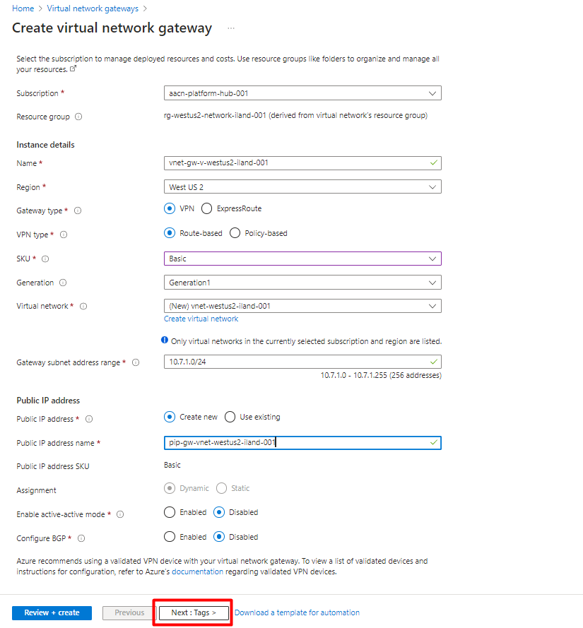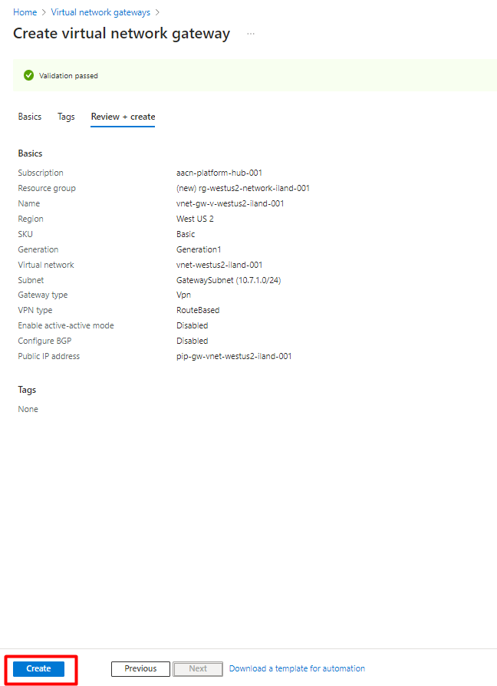

* Virtual network gateway public ip.

1. Create a local network gateway.Graphical user interface, text, application, email

   Description automatically generatedGraphical user interface, text, application, email

   Description automatically generatedGraphical user interface, text, application, email

   Description automatically generated

* Now go to virtual network gateway.

1. Create a virtual machine.Graphical user interface, text, application, email

   Description automatically generatedGraphical user interface, text, application

   Description automatically generatedGraphical user interface, text, application, email

   Description automatically generatedGraphical user interface, text, application

   Description automatically generatedGraphical user interface, application

   Description automatically generated

