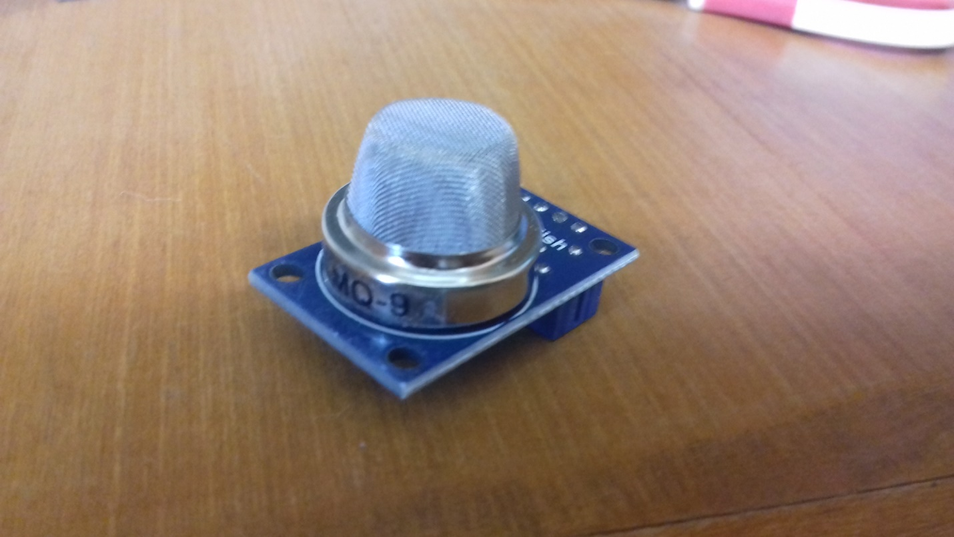

Connections:

|  |  |
| --- | --- |
| Above Diagram | Arduino Mega board |
| AO | A0 |
| Vcc | 5V |
| Gnd | GND |

Experiment:

1. Use the (Arduino IDE) code given, and then check the serial monitor for raw sensor values.