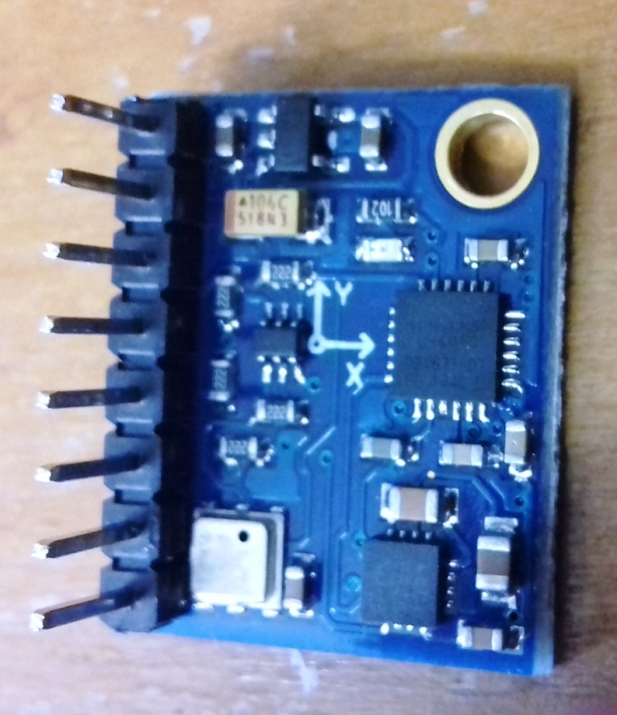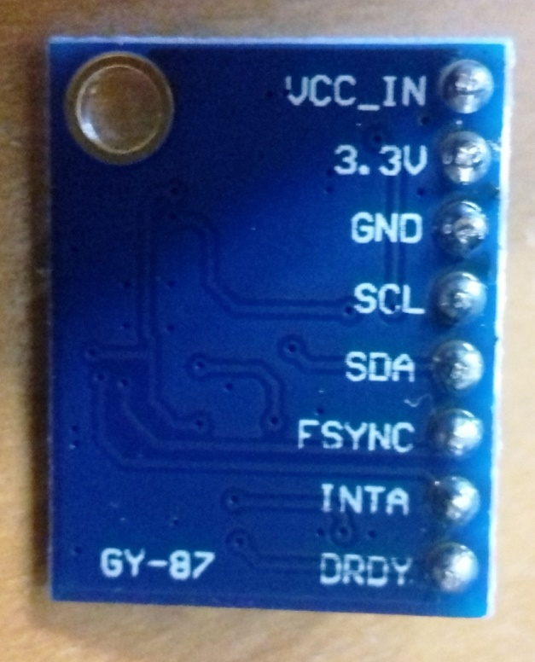

Connections:

|  |  |
| --- | --- |
| Above Diagram | Arduino Mega board |
| Vcc_in | 5V |
| 3.3V | 3.3V |
| GND | GND |
| SCL | 21 |
| SDA | 20 |
|  |  |
|  |  |
|  |  |

Experiment:

1. Use the (Arduino IDE) code given, and then check the serial monitor for raw sensor values.