Secure Multi signature Generation
For Group Communication

Dissertation Report Submitted
to



In partial fulfillment of the requirements of the award of the degree of
Master of Technology
in
Computer Science & Engineering
by
Ravi shankar jha
Roll No. 190130003
Under the Supervision
of

Mrs HOOR FATIMA

Department of CSE
Department of Computer Science & Engineering
School of Engineering and Technology, Sharda University
Greater Noida, U.P.-201306

ABSTRACT

Secure Multisignature

Generation For Group Communication

Threshold Multisignature schemes combine the properties of threshold group-oriented signature schemes and Multisignature schemes to yield a signature scheme that allows more group members to collaboratively sign an arbitrary message.

In contrast to threshold group signatures, the individual signers do not remain anonymous, but are publicly identifiable from the information contained in the valid Multisignature. The main objective of our project is to propose such a secure and efficient Multisignature scheme. Our project shows that the proposed scheme eliminates the latest attacks to which other similar schemes are subject.

Multisignature is based on distributed-key management infrastructure (DKMI), which consists of distributed-key generation (DKG) protocol and distributed-key redistribution/updating (DKRU) protocol. The round optimal DKRU protocol solves a major problem with existing secret redistribution/ updating schemes by giving group members a mechanism to identify malicious or faulty share holders in the first round, thus avoiding multiple protocol executions.
TABLE OF CONTENTS

CHAPTER NO TITLE PAGE NO

 | ABSTRACT | IV
 | LIST OF FIGURES | VII
 | LIST OF ABBREVATIONS | VIII
1 | INTRODUCTION | 1
 | 1.1Introduction | 1
 | 1.2Benefits of Multisignature | 1
 | 1.3Properties of Multisignature | 2
 | 1.3.1 Correction | 2
 | 1.3.2 Threshold Property | 2
 | 1.3.3 Traceability | 2
 | 1.3.4 Coalition Resistance | 3
 | 1.3.5 Break Resistance | 3
2 | SYSTEM ANALYSIS | 4
 | 2.1Existing System | 4
 | 2.2Proposed System | 4
 | 2.3Efficiency Analysis | 5
3 | PROBLEM FORMULATION | 9
 | 3.1Hardware Specification | 9
 | 3.2Software Specification | 9
 | 3.3Software Description | 10
4 | SYSTEM DESIGN | 25
 | 4.1Design Overview | 25
 | 4.2Data Flow Diagram | 29
5 | 4.3Architecture Diagram  IMPLEMENTATION | 33  34

6 | SYSTEM TESTING  6.1Types of Tests | 43  43
 | 6.2Unit Testing | 45
 | 6.3Integration Testing | 46
 | 6.4Acceptance Testing | 46
7 | CONCLUSION | 47
 | APPENDIX | 48
 | Screen Shots | 47
 | REFERENCES | 59

LIST OF FIGURES

FIGURE NO.  1 | NAME OF THE FIGURE  Java Platform Description | PAGE NO  18
2 | TCP/IP Stack | 21
3 | Total Address | 23
4 | DFD for Signature Generation | 29
5 | DFD for Signature Verification | 30
6 | DFD for Encryption | 31
7 | DFD for Decryption | 31
8 | DFD for Unicasting Message | 32
9 | DFD for Multicasting Message | 32
10 | Architecture Diagram | 33

LIST OF ABBREVIATIONS

DKG - Distributed-key generation

DKMI - Distributed-key management infrastructure

DKRU

TTP
- Distributed-key redistribution/updating

- Trusted third party

DES

DFD
- Data encryption standard

- Data flow diagram

OMT

CRC
- Object modeling technique

- Class responsibility collabarator

JDBC - Java database connectivity

JVM GUI
TCP UDP
- Java virtual machine

- Graphical user interface

- Transmission control protocol

- User datagram protocol

CHAPTER 1

INTRODUCTION

1. Introduction

In distributed systems it is sometimes necessary for users to share the power to use a cryptosystem. The system secret is divided up into shares and securely stored by the entities forming the distributed cryptosystem. The main advantage of a
distributed cryptosystem is that the secret is never computed, reconstructed, or stored in a single location, making the secret more difficult to compromise.

Investigations within the fields of threshold group-oriented signature schemes, threshold group signature schemes, Multisignature schemes, and Threshold- Multisignature schemes resulted in explicitly defining the properties of Threshold- Multisignature schemes.

2. Benefits of Multisignature

The various benefits of using Selfish Routing are listed below,  This routing is used to reduce to the latency
 It increase the throughputs in network

Not cost oriented.

Reduced administrative costs. Lower error rates.
Increased Productivity.

Better services to clients.
3. Properties of Multisignature

The secure Multisignature schemes must satisfy the following five main properties

1. Correctness

All Multisignatures on an arbitrary message, generated by an honest authorized subset of group members, forming subgroup P, can be verified by any outsider V (with respect to the group). This implies that the group-oriented signature is publicly verifiable.

2. Threshold property

Only a threshold of ‘t’ or more authorized group members are able to collaboratively generate a valid Multisignature. This property thus incorporates unforgeability.

3. Traceability

Any outsider V can learn the identities of the individual signers belonging to P from the Multisignature on ‘m’ without interaction with any of the group members and/or a group manager. This implies that the signers are publicly
traceable with public information. Traceability implies accountability, the individual signers participating in the Multisignature scheme can be held accountable for their contribution to the group oriented signature.

1.3.4 Coalition-resistance
No colluding subset of group members can generate a valid Multisignature not satisfying the traceability property. Coalition-resistance subsumes framing- resistance, i.e., no subset of group members can sign on behalf of any other subset of group members.

1.3.5 Break-resistance

An adversary in possession or control of the group secret key and/or the individual secret shares of any number of group members cannot generate a valid Multisignature and/or partial/ individual signatures. Thus, although the underlying
threshold cryptosystem has been broken, the Multisignature signature scheme should not be breakable.
CHAPTER 2

SYSTEM ANALYSIS

1. Existing System

In many applications, a threshold or more shareholders are required to cooperatively generate a digital signature, in contrast to the conventional single signer. This may also be seen as a distribution of trust since the shareholders must collaborate and contribute equally to produce a valid multiparty signature.

Threshold Multisignature schemes combine the properties of threshold group-oriented signature schemes and multisignature schemes. In the literature, Multisignature schemes are also referred to as threshold signature schemes with traceability. The combined properties guarantee the signature verifier that at least t members participated in the generation of the group-oriented signature and that the identities of the signers can be easily established. The majority of the existing Multisignature schemes belong to variants of the single signatory, generalized ElGamal signatures extended to a group/multiparty setting.

2. Proposed System

This project is to propose a new Multisignature scheme without a trusted third party (TTP), based on a round optimal, publicly verifiable DKG protocol. The proposed scheme can be easily adapted to incorporate a TTP; a version of the proposed scheme with the assistance of a TTP will therefore not be presented.
The proposed discrete logarithm-based Multisignature scheme is also proactively secure, allowing for DKR to a new access structure and periodic DKU to mitigate attacks from an active/mobile adversary. The proposed discrete logarithm-based Multisignature scheme is made proactively secure by periodically updating secret shares and facilitating changes in group membership by allowing an authorized subset of existing group members to redistribute secret shares to a new access structure.

The scheme fulfills all the fundamental properties of generic Multisignature schemes given in the properties of Multisignature and resists attacks to which other similar schemes are subject.

2.3 Efficiency Analysis

The efficiency of Multisignatures may be based on the following four criteria,

Group Public Key Length

The Multisignature scheme avoids conspiracy attacks without attaching a random secret to shares. The group public key is dependent on the number of group members, as the signature verifier needs the individual public values of all
group members to compute the subgroup public key that is required to verifying the signature. Difficulty will be experienced with this scheme when trying to eliminate the need for a trusted authority to distribute the initial group key shares.

A robust authentication mechanism is essential for securing a distributed system against active adversaries and central to ensure the traceability of individual signers.The proposed Multisignature scheme uses the long-term private keys of the
members, provided by a public key infrastructure, to avoid conspiracy attacks even if colluding members derive or control the group secret . As a result of members including their private keys in their individual signatures, the public key of the scheme consists of the public key of the subgroup that collaborated to generate the threshold signature. The public key of the subgroup is a function of the long-term public keys of the group members.

Although the group public key may be perceived to be dependent on the group size , the scheme does not introduce any additional storage requirements since the public keys used in the calculation is publicly known (traceable) and primarily required for authentication purposes.

Group-Oriented Signature Size

The main contribution to the communication overhead, post signature generation, is made by the size of the group signature. The signature size of Multisignature schemes is bound to be dependent on the threshold parameter. This conclusion is drawn from the traceability property of Multisignature schemes, which specifies that any outsider must be able to retrieve the identities of the individual signers from the threshold signature.

The threshold signature must thus be bound to information explicitly linked to each of the signers that collaborated to generate the threshold signature. In the case of the proposed scheme, the information is the identities of the individual signers . The individual identities of the group members can be carefully chosen to significantly reduce the size of the Multisignature.

Communication Cost of Signature Generation and Verification

In terms of communication cost, the individual and threshold signature generation mechanisms of all the existing Multisignature schemes and the proposed scheme are almost equivalent. Multiparty signature schemes constructed
from ElGamal type (discrete logarithm-based) signature variants are bound to be interactive.

In round one, each participant generates a commitment and in the second round, generates an individual signature on an arbitrary message . In the third round, participants send their contribution to a combiner or designated clerk which constructs the threshold signature.

Assume the authorized subset of group members collaborate to sign a message. This yields a three round protocol for existing schemes, which requires broadcast messages and unicast messages. The proposed Multisignature scheme, is to the best of all other schemes.The proposed scheme also eliminates the need for a combiner. Assume that the group contains at least one malicious or faulty participant, the proposed protocol will still require three rounds and only two rounds if all individual signatures are verified.

Computational Cost of Signature Generation and Verification

To make a feasible comparison between the computational cost of the proposed Multisignature scheme and similar schemes it is assumed that the system parameters are chosen to yield the same time complexity for exponentiations, multiplications, and summations. Although summations and, in some cases,
multiplications contribute to an insignificant fraction of the overall time complexity, these operations are still included for the sake of completeness.

Values that remain constant between different signature generations can be precomputed and are therefore not included in the analysis. The computational cost of the schemes will be given in terms of the minimum members required to collaboratively sign an arbitrary message .The computational overhead that causes the most concern is the number of exponentiations in the individual signature verification and in Multisignature verification , which are anticipated to
contribute the bulk of the verification time complexity.

The justification for looking critically at the verification processes is substantiated by the notion that a signature is normally generated only once, but verified many times. The optimum number of exponentiations for an ElGamal type signature variant is 2 .It can thus be concluded that the proposed Multisignature scheme is superior to existing schemes since it requires only two exponentiations for Multisignature verification, while guaranteeing break-resistance. For individual signature verification, three exponentiations are required, one more than the
optimal two exponentiations. The additional exponentiation is as a consequence of

satisfying the stronger break-resistance property.
CHAPTER 3

PROBLEM FORMULATION

3.1 Hardware Specification

Processor : Any Processor above 500 Mhz.

Ram : 128Mb. Hard Disk : 10 Gb. Compact Disk : 650 Mb.
Input device : Standard Keyboard and Mouse.

Output device : VGA and High Resolution Monitor.

3.2 Software Specification

Operating System : Windows 2000 server Family.

Techniques : JDK 1.5

Data Bases : MS SQL-Server 2000
3.3 Software Description

JAVA

Java is conceived by James Gosling, Patrick Naughton, Chris Warth, Ed Frank, and Mike Sheridan at sun Microsystems, inc 1991. It took 18 months to develop the first working version. This language was initially called
“oak” but was renamed into “JAVA” in 1995. Between the implementation of oak in the fall of 1992 and public announcement of java in the spring of 1995, many more people contributed to the design and the evolution of language. Bill Joy, Arthur van Hoff,Jonathan Payn, Frank Yellin, and Tim Lindholm were key contribution to the maturing of the original prototype.

Somewhat surprisingly, the original impetus for java was not the internet! Instead, the primary motivation was need for a platform –independent language that could be used to create software to be embedded in various consumer electronics devices, such as microwave oven and remote control.

Java is a programming language that is well suited to designing software that works in conjunction with in internet. Java: a simple, object-oriented, distributed, interpreted, robust, secure, architecture neutral, portable, high performance, multithreaded and dynamic language.

JAVASWING
This introduction to using Swing in Java will walk you through the basics of

Swing. This covers topics of how to create a window, add controls, position the controls, and handle events from the controls.

The Main Window
Almost all GUI applications have a main or top-level window. In Swing, such window is usually instance of JFrame or JWindow. The difference between those two classes is in simplicity – JWindow is much simpler than JFrame (most noticeable are visual differences - JWindow does not have a title bar, and does not put a button in the operating system task bar). So, your applications will almost always start with a JFrame.

Though you can instantiate a JFrame and add components to it, a good practice is to encapsulate and group the code for a single visual frame in a separate class. Usually, I subclass the JFrame and initialize all visual elements of that frame in the constructor.

Always pass a title to the parent class constructor – that String will be displayed in the title bar and on the task bar. Also, remember to always initialize frame size (by calling setSize(width, height)), or your frame will not be noticeable on the screen.

packagecom.neuri.handsonswing.ch1; importjavax.swing.JFrame; publicclassMainFrameextendsJFrame
{

publicMainframe()

{

super("Mytitle");

setSize(300,300);
}

}

Now you have created your first frame, and it is time to display it. Main

frame is usually displayed from the main method – but resist the urge to put the main method in the frame class. Always try to separate the code that deals with visual presentation from the code that deals with application logic – starting and initializing the application is part of application logic, not a part of visual presentation. A good practice is to create an Application class that will contain initialization code.

packagecom.neuri.handsonswing.ch1;

publicclass Application {
Public static void main (String [] args)
{

// perform any initialization
MainFrame mf = new MainFrame();
mf.show();

}

}
If you run the code now, you will see an empty frame. When you close it,

something not quite obvious will happen (or better said, will not happen). The application will not end. Remember that the Frame is just a visual part of application, not application logic – if you do not request application termination
when the window closes, your program will still run in the background (look for it in the process list). To avoid this problem, add the following line to the Mainframe constructor:

SetDefaultCloseOperation (JFrame.EXIT_ON_CLOSE);

Before Java2 1.3, you had to register a window listener and then act on the
window closing event by stopping the application. Since Java2 1.3, you can specify a simple action that will happen when a window is closed with this shortcut. Other options are HIDE_ON_CLOSE (the default – window is closed but application still runs) and DO_NOTHING_ON_CLOSE (rather strange option that ignores a click on the X button in the upper right corner).

Adding Components
Now is the time to add some components to the window. In Swing (and the

Swing predecessor, AWT) all visual objects are subclasses of Component class. The Composite pattern was applied here to group visual objects into Containers, special components that can contain other components. Containers can specify the order, size and position of embedded components (and this can all be automatically calculated, which is one of the best features of Swing).

JButton is a component class that represents a general purpose button – it

can have a text caption or an icon, and can be pressed to invoke an action. Let’s add the button to the frame (note: add imports for javax.swing.* and java.awt.* to the MainFrame source code so that you can use all the components).

When you work with JFrame, you want to put objects into it’s content pane

– special container intended to hold the window contents. Obtain the reference to that container with the getContentPane () method.
Containercontent= getContentPane (); Content. add (new JButton ("Button 1"));

If you try to add more buttons to the frame, most likely only the last one added will be displayed. That is because the default behavior of JFrame content pane is to display a single component, resized to cover the entire area

Grouping Components

To put more than one component into a place intended for a single component, group them into a container. JPanel is a general purpose container that is perfect for grouping a set of components into a “larger” component. So, let’s put
the buttons into a JPanel:

JPanel panel=new JPanel ();

panel.add (new JButton ("Button 1")); panel.add (new JButton ("Button 2")); panel.add (new JButton ("Button 3")); content. add (panel);

Layout Management Basics

One of the best features of Swing is automatic component positioning and resizing. That is implemented trough a mechanism known as Layout management. Special objects – layout managers – are responsible for sizing, aligning and positioning components. Each container can have a layout manager, and the type of layout manager determines the layout of components in that container. There are several types of layout managers, but the two you will most frequently use are FlowLayout (orders components one after another, without resizing) and BorderLayout (has a central part and four edge areas – component in the central part is resized to take as much space as possible, and components in edge areas are not resized). In the previous examples, you have used both of them. Flow Layout is the default for a JPanel (that is why all three buttons are displayed without
resizing), and Border Layout is default for JFrame content panes (that is why a
single component is shown covering the entire area).

Layout for a container is defined using the setLayout method (or usually in the constructor). So, you could change the layout of content pane to FlowLayout and add several components, to see them all on the screen.

The best choice for the window content pane is usually a BorderLayout with a central content part and a bottom status (or button) part. The top part can contain a toolbar, optionally

Now, let’s combine several components and layouts, and introduce a new component – JTextArea. JTextArea is basically a multiline editor. Initialize the frame content pane explicitly to BorderLayout, put a new JTextArea into the
central part and move the button panel below. package com.neuri.handsonswing.

import java.awt.*

import javax.swing.*;

public class MainFrame extends JFrame

{

public MainFrame()

{ super("My title");

setSize(300,300); setDefaultCloseOperation(JFrame.EXIT_ON_CLOSE); Container content = getContentPane();

content.setLayout(new BorderLayout())

JPanel panel = new JPanel(new FlowLayout());
panel.add(new JButton("Button 1"));

panel.add(new JButton("Button 2"));

panel.add(new JButton("Button 3"));

content.add(panel,

BorderLayout.SOUTH);

content.add(new JTextArea(), BorderLayout.CENTER);

}

}

Notice that the layouts for content pane and the button panel are explicitly defined. Also notice the last two lines of code – this is the other version of add method, which allows you to specify the way the component is added. In this case, we specify the area of BorderLayout layout manager. Central part is called BorderLayout.CENTER, and other areas are called BorderLayout.NORTH (top), BorderLayout.SOUTH (bottom),

BorderLayout.WEST (left) and BorderLayout.EAST (right). If you get confused about this, just remember land-maps from your geography classes.

Scrolling
Now, type a few lines of text into the text area – once you type enough lines

(or press Enter enough times), the cursor will disappear from the screen. Swing is different from other GUI toolkits, and visual components do not support scrolling unless you tell them to – but, on the other hand, this way you can put scrollbar around almost anything. To enable scrolling, just put the component (or a container with other components) into a JScrollPane – this is a special container that adds
scrollbars to it’s content. Change the last line of the previous class to
Content.add(newJScrollPane(newJTextArea()),

BorderLayout.CENTER); see a scrolling text area inside your window.

Java Features

The Virtual Machine

A "real" machine runs machine code for that machine only. A "virtual" machine runs its own sort of binary data
The Java Virtual Machine (JVM) is a normal program on each architecture

It takes Java Byte code as its input language

Using non-native machine code as the input is called "interpreting".

Program Portabilty

a) The Java Virtual Machine (JVM) is a normal program on each architecture b) It takes Java Byte code as its input language
c) A single Java program will run on any platform

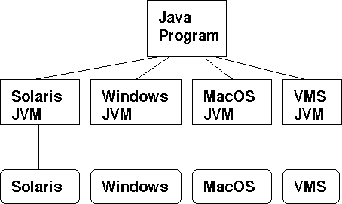

Fig 1 Java Platform Description

The Big Idea

a) If the JVM has been ported to a platform then that platform can run any Java

program.

b) If a program is written in Java then it can be run on any platform with a JVM.

JDBC

In an effort to set an independent database standard API for Java, Sun Microsystems developed Java Database Connectivity, or JDBC. JDBC offers a generic SQL database access mechanism that provides a consistent interface to a
variety of RDBMSs. This consistent interface is achieved through the use of “plug- in” database connectivity modules, or drivers. If a database vendor wishes to have JDBC support, he or she must provide the driver for each platform that the database and Java run on.

To gain a wider acceptance of JDBC, Sun based JDBC’s framework on ODBC. As you discovered earlier in this chapter, ODBC has widespread support on a variety of platforms. Basing JDBC on ODBC will allow vendors to bring
JDBC drivers to market much faster than developing a completely new connectivity solution.

JDBC was announced in March of 1996. It was released for a 90 day public review that ended June 8, 1996. Because of user input, the final JDBC v1.0 specification was released soon after.

The remainder of this section will cover enough information about JDBC for you to know what it is about and how to use it effectively. This is by no means a complete overview of JDBC. That would fill an entire book.

JDBC Goals

Few software packages are designed without goals in mind. JDBC is one that, because of its many goals, drove the development of the API. These goals, in conjunction with early reviewer feedback, have finalized the JDBC class library into a solid framework for building database applications in Java.

The goals that were set for JDBC are important. They will give you some insight as to why certain classes and functionalities behave the way they do. The eight design goals for JDBC are as follows:

1. SQL Level API

The designers felt that their main goal was to define a SQL interface for Java. Although not the lowest database interface level possible, it is at a low enough level for higher-level tools and APIs to be created. Conversely, it is at a high enough level for application programmers to use it confidently. Attaining
this goal allows for future tool vendors to “generate” JDBC code and to hide many of JDBC’s complexities from the end user.

2. SQL Conformance

SQL syntax varies as you move from database vendor to database vendor. In an effort to support a wide variety of vendors, JDBC will allow any query statement to be passed through it to the underlying database driver. This allows
the connectivity module to handle non-standard functionality in a manner that is suitable for its users.

3. JDBC must be implemental on top of common database interfaces

The JDBC SQL API must “sit” on top of other common SQL level APIs. This goal allows JDBC to use existing ODBC level drivers by the use of a software interface. This interface would translate JDBC calls to ODBC and vice
versa.

4. Provide a Java interface that is consistent with the rest of the Java system
Because of Java’s acceptance in the user community thus far, the designers feel that they should not stray from the current design of the core Java system.

Finally we decided to proceed the implementation using Java networking.

Networking

TCP/IP stack

The TCP/IP stack is shorter than the OSI one:
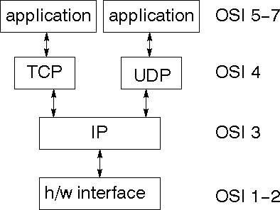

Fig 2 TCP/IP Stack

TCP is a connection-oriented protocol; UDP (User Datagram Protocol)

is a connectionless protocol.

IP datagram’s

The IP layer provides a connectionless and unreliable delivery system. It considers each datagram independently of the others. Any association between datagram must be supplied by the higher layers. The IP layer supplies a checksum that includes its own header. The header includes the source and destination addresses. The IP layer handles routing through an Internet. It is also responsible for breaking up large datagram into smaller ones for transmission
and reassembling them at the other end.

UDP

UDP is also connectionless and unreliable. What it adds to IP is a

checksum for the contents of the datagram and port numbers. These are used to

give a client/server model

TCP

TCP supplies logic to give a reliable connection-oriented protocol

above IP. It provides a virtual circuit that two processes can use to communicate.

Internet addresses

In order to use a service, you must be able to find it. The Internet uses an address scheme for machines so that they can be located. The address is a 32 bit integer which gives the IP address. This encodes a network ID and more addressing. The network ID falls into various classes according to the size of the network address.

Network address

Class A uses 8 bits for the network address with 24 bits left over for other addressing. Class B uses 16 bit network addressing. Class C uses 24 bit network addressing and class D uses all 32.

Subnet address

Internally, the UNIX network is divided into sub networks. Building 11 is currently on one sub network and uses 10-bit addressing, allowing 1024 different hosts.

Host address

8 bits are finally used for host addresses within our subnet. This places a limit of 256 machines that can be on the subnet.

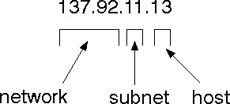
Total address

Fig 3 Total Address

The 32 bit address is usually written as 4 integers separated by dots.

Port addresses

A service exists on a host, and is identified by its port. This is a 16 bit number. To send a message to a server, you send it to the port for that service of the host that it is running on. This is not location transparency! Certain of these
ports are "well known".

Sockets

A socket is a data structure maintained by the system to handle network

connections. A socket is created using the call socket. It returns an integer that is like a file descriptor. In fact, under Windows, this handle can be used with Read File and Write File functions.

#include <sys/types.h>
#include <sys/socket.h>
int socket(int family, int type, int protocol);

Here "family" will be AF_INET for IP communications, protocol will be zero, and type will depend on whether TCP or UDP is used. Two processes wishing to communicate over a network create a socket each. These are similar to two ends of a pipe - but the actual pipe does not yet exist.

CHAPTER 4

SYSTEM DESIGN

4.1 Design Overview

Design involves identification of classes, their relationships as well as their collaboration. In objectory, classes were divided into Entity classes ,interface classes and the control classes. The Computer Aided Software Engineering tools that are available commercially do not provide any assistance in this transition. CASE tools take advantage of meta modeling are helpful only after the construction of class diagram is completed.

In the Fusion method ,it used some object-oriented approaches like Object Modeling Technique(OMT) ,Class Responsibility Collaborator(CRC) and Objectory,used the term Agents to represent some of the hardware and software systems .In Fusion method, there was no requirement phase ,where in a user will supply the initial requirement document. Any software project is worked out by both analyst and designer. The analyst creates the Use case diagram. The designer creates the Class diagram. But the designer can do this only after the analyst has created the Use case diagram. Once the design is over it is need to decide which software is suitable for the application.

The proposed Multisignature scheme is based on a multiparty extension of the ElGamal type signature variant: GES. The proposed Multisignature scheme can equally use any other secure and efficient signature variant of the ElGamal type signature scheme.

The main reason for using the defined GES is to minimize the computational cost of generating and verifying the individual signatures and group-oriented signature in a multiparty setting without compromising security.

In the proposed Multisignature scheme, it is enough to show that the scheme fulfills all of the fundamental properties of generic threshold-multisignature schemes and resists attacks to which other similar schemes are subject.

MODULE DESCRIPTION SIGNATURE

Signature Generation

In this module we are going to generate signatures for the group members. The signature is generated with Participants long-term private key. Participants broadcasts the message and the signature to all protocol participants. The encryption of the secret shadow for protocol participant is performed using an appropriate publicly verifiable encryption scheme. Using the ElGamal type signature variant GES, generates a signature using its long-term private key. And they broadcasts to all protocol participants.

Any subset β of t or more members can represent the group and sign an arbitrary message m. To sign a message, m, choose a random integer, k, such that 0
< k < P-1 (where k has not been used before AND is relatively prime to (P-1)), and compute r = g^k mod P and s = k^-1 (m - xr) mod (P-1) [where k^-1 is the multiplicative inverse of k mod (P-1) ] The message signature is then r and s.

This module having two sub modules they are

i) Individual Signature Generation ii) Multiple Signature Generation

Signature Verification

In this module we are going to verify the group member’s signatures with generated signatures. On receiving all of the signatures, we performs the functionality of a clerk and uses the public key set to authenticate the individual signature of Pi by verifying if fails to hold, the individual signature of Pi on message m is invalid. Participants are disqualified if their individual signatures are found to be invalid. The remaining honest participants form the set and repeat the individual signature generation. The protocol aborts if it contains less than exact members.

The recipient can use the public key y to compute y^r * r^s mod P and determine that it is equivalent to g^m mod P (this is when the recipient wants to be sure that the message has been sent by the claimed sender -- so it's like the sender is the private-key holder and is signing the message; then the recipient can use that sender's public info to verify that the sender did *indeed* send (and sign) that message).

CRYPTOGRAPHY Encryption
In this project encryption is mainly used for security purpose. Here we are message convert to unknown format. Then only intermediate person can’t understand the message. The user messages is encrypted by the received Private Key and append the public key with that encrypted message, then transmit the whole information to the corresponding receiver.

Decryption

It is the process of retrieving the original format from the encrypted message. After the Decryption we can read the message by using public key. This key is deliberately attached with encrypted message. Then this message will be shown to user.

MESSAGE TRANSMISSION

In this module we are going to transmit our encrypted message to the selected group members. Then the encrypted message will be decrypt at the other end of group member with the proper verification of the signature. In most of these applications, users typically receive identical information from a single or multiple senders. This module having two sub modules they are
i) Unicasting and ii) Multicasting

Unicasting sub module is used to transfer our message from one to one recipient. Multicasting sub module is used to transfer our message from one to many
recipient.
4.2 Data Flow Diagram

The DFD is also called as bubble chart.It is a simple graphical formalism that can be used to represent a system in terms of the input data to the system,various processing carried out on these data,and the output data is
generated by the system.

Signature Generation

User
ELGAMAL AlgorithGmenerating Key pairs (Private and Public key) Process

Providing private key as Input and get the hash value
Using (SHA)

From that hash value
We generate the Signature

.
Fig 4 DFD for Signature Generation

Signature Verification

ELGAMAL Algorithm
Process
Rehashing the Signature
And get the Hash Value

From the hash value we get our sender Private Key

Compare the Private Key with the received Key

User

Fig 5 DFD for Signature Verification

Encryption

User Message
Using private key to encrypt the message

To send the encrypted message
to the receiver

Fig 6 DFD for Encryption

Decryption

Using public key to Decrypt the message

Encrypt
Message
View the original
Message

Fig 7 DFD for Decryption

Message Transmission

Unicasting

Transfer Encrypted Message with our Signature to the receiver

Client

MultiCasting
Fig 8 DFD for Unicasting Message

Transfer Encrypted Message with our Signature to the re Client-1
ceivers
Client-2
Client - Client-N

Fig 9 DFD for Multicasting Message

4.3 Architecture Diagram:

Secure Multisignature Generation for Group Communication

Signature Generation Cryptography
Message Transmission

Signature Generation
Encryption
Multicasting

Signature verification
Decryption
Unicasting

Fig 10 Architecture Diagram

CHAPTER 5

IMPLEMENTATION

Implementation is the stage of the project when the theoretical design is turned out into a working system. Thus it can be considered to be the most critical stage in achieving a successful new system and in giving the user, confidence that the new system will work and be effective.

The implementation stage involves careful planning, investigation of the existing system and it’s constraints on implementation, designing of methods to achieve changeover and evaluation of changeover methods.

Implementation is the process of converting a new system design into operation. It is the phase that focuses on user training, site preparation and file conversion for installing a candidate system. The important factor that should be considered here is that the conversion should not disrupt the functioning of the organization.
CODING Login.java package signature;
import java.awt.*; import java.awt.event.*; import javax.swing.*;
public class Login extends JFrame

{

// Variables declaration private JLabel jLabel1; private JLabel jLabel2;
private JLabel jLabel3;

private JLabel jLabel4;
private JLabel jLabel5; private JLabel jLabel6; private JLabel jLabel7; private JLabel jLabel8; private JLabel login;
private JComboBox grpinfo; private JTextField userid; private JPasswordField sctkey; private JSeparator jSeparator1; private JLabel signup;
private JPanel contentPane; DBClass db=new DBClass();
// End of variables declaration public Login()
{

super(); initializeComponent(); this.setVisible(true);
}

private void initializeComponent()

{

jLabel1 = new JLabel();

jLabel2 = new JLabel(); jLabel3 = new JLabel(); jLabel4 = new JLabel(); jLabel5 = new JLabel(); jLabel6 = new JLabel(); jLabel7 = new JLabel(); jLabel8 = new JLabel();
grpinfo = new JComboBox();
grpinfo.setFont(new Font("Garamond",Font.BOLD,15));
grpinfo.addItem("Group 1");
grpinfo.addItem("Group 2");
login = new JLabel();
userid = new JTextField();
userid.setFont(new Font("Garamond",Font.BOLD,15));
sctkey = new JPasswordField();
sctkey.setFont(new Font("Garamond",Font.BOLD,15));
jSeparator1 = new JSeparator();
signup = new JLabel();
contentPane = (JPanel)this.getContentPane();

DBClass.java package signature; import java.sql.*;
import java.math.BigInteger;
public class DBClass
{
Connection con,c1; Statement st,st1; ResultSet rs; DBClass()
{

try
{

Class.forName("sun.jdbc.odbc.JdbcOdbcDriver");

con=DriverManager.getConnection("jdbc:odbc:signature","sa","");
st=con.createStatement();
}
catch(Exception e)
{
System.out.println("Database Connectivity Error "+e);
}
}
public int getResult(String id,String pass,String gid) throws Exception
{

rs=st.executeQuery("select * from UsersInfo where UserId = '"+id+"'

and Password = '"+pass+"' and GrpId = '"+gid+"'");
if(rs.next())
{

}
else

}
System.out.println("The Values are Found");
return 1;

return 0;

public int getResultInfo(String id,String pass,String gid) throws Exception
{
String tableName = "";
if(gid.equalsIgnoreCase("Group 1")){
tableName = "tree1";

}
else{

}

tableName = "tree2";

System.out.println("The Selected Group Table = "+tableName);
rs=st.executeQuery("select * from "+tableName+" where memname =

'"+id+"' and pass = '"+pass+"'");
if(rs.next())
{

}
else

}
System.out.println("The Values are Found");
return 1;

return 0;

ElGamalkey.java
package signature;
import java.math.BigInteger;
public class ElGamalKey implements java.security.Key
{
protected ElGamalKey()
{
}
protected ElGamalKey(BigInteger p, BigInteger g)

{
this.p = p;
this.g = g;
}
public String getFormat()
{
return null;
}
public byte[] getEncoded()
{
return null;
}
public java.lang.String getAlgorithm()
{
return "ElGamal";
}

protected BigInteger getP()
{
return p;
} // end getP
protected BigInteger getG()
{
return g;
} // end getG
protected void setP(BigInteger p){
this.p = p;
}
protected void setG(BigInteger g){
this.g = g;
}
private static BigInteger p;
private static BigInteger g;
}
DESalgorithm.java
package signature;
public class DESalgorithm{
public int [][]key= new int[16][56];
public int[] enc_dec(int[]keyblock, int[]datablock,char ED){
int[] retblock= new int[64]; int[] IPblock = new int[64]; int[] roundret= new int[64]; int[] initkey = new int[56]; initkey=PC1(keyblock);
roundret=InitialPerm(datablock);
keyGenerator(initkey,ED);
for(int r=1;r<=16;r++){
roundret=SingleRound(r,roundret,ED);
} IPblock=Swap32bit(roundret); retblock=InitialPermInv(IPblock); return retblock;
}
public int[] PC1(int[] keyblock){
int[] pc1ret= new int[56];
int index=0;
int[] refPC1={57,49,41,33,25,17,9,1,58,50,42,34,26,18,10,2,59,51,43,35,
27,19,11,3,60,52,44,36,63,55,47,39,31,23,15,7,62,54,46,38,
30,22,14,6,61,53,45,37,29,21,13,5,28,20,12,4};

for(int i=0;i<56;i++){
index= refPC1[i];
pc1ret[i]= keyblock[index-1];
}
return pc1ret;
}
public int[] InitialPerm(int[] datablock){
int index;
int[] IPblockret=new int[64];
int[] refIP={58, 50, 42, 34, 26, 18, 10, 2,60, 52, 44, 36, 28, 20, 12, 4,
62, 54, 46, 38, 30, 22, 14, 6,64, 56, 48, 40, 32, 24, 16, 8,
57, 49, 41, 33, 25, 17, 9, 1,59, 51, 43, 35, 27, 19, 11, 3,
61, 53, 45, 37, 29, 21, 13, 5,63, 55, 47, 39, 31, 23, 15, 7};
for(int i=0;i<64;i++){
index= refIP[i];
IPblockret[i]= datablock[index-1];
}
return IPblockret;
}
public void keyGenerator(int[] initkey,char ED){
int shiftblock[][]= {
{1,1},{2,1},{3,2},{4,2},
{5,2},{6,2},{7,2},{8,2},
{9,1},{10,2},{11,2},{12,2},
{13,2},{14,2},{15,2},{16,1}
}
CHAPTER 6

SYSTEM TESTING

The purpose of testing is to discover errors. Testing is the process of trying to discover every conceivable fault or weakness in a work product. It provides a way to check the functionality of components, sub assemblies, assemblies and/or a finished product It is the process of exercising software with the intent of ensuring that the Software system meets its requirements and user expectations and does not fail in an unacceptable manner. There are various types of test. Each test type addresses a specific testing requirement.

6.1 TYPES OF TESTS

Unit testing

Unit testing involves the design of test cases that validate that the internal program logic is functioning properly, and that program input produce valid outputs. All decision branches and internal code flow should be validated. It is the testing of individual software units of the application .it is done after the completion of an individual unit before integration. This is a structural testing, that relies on knowledge of its construction and is invasive. Unit tests perform basic tests at component level and test a specific business process, application, and/or system configuration. Unit tests ensure that each unique path of a business process performs accurately to the documented specifications and contains clearly defined inputs and expected results.
Integration testing

Integration tests are designed to test integrated software components to determine if they actually run as one program. Testing is event driven and is more concerned with the basic outcome of screens or fields. Integration tests demonstrate that although the components were individually satisfaction, as shown by successfully unit testing, the combination of components is correct and consistent. Integration testing is specifically aimed at exposing the problems that arise from the combination of components.

Functional test

Functional tests provide a systematic demonstrations that functions tested are available as specified by the business and technical requirements, system documentation , and user manuals.

System Test

System testing ensures that the entire integrated software system meets requirements. It tests a configuration to ensure known and predictable results. An example of system testing is the configuration oriented system integration test. System testing is based on process descriptions and flows, emphasizing pre-driven process links and integration points.
White Box Testing

White Box Testing is a testing in which in which the software tester has knowledge of the inner workings, structure and language of the software, or at least its purpose. It is used to test areas that cannot be reached from a black box level .

Black Box Testing

Black Box Testing is testing the software without any knowledge of the inner workings, structure or language of the module being tested . Black box tests, as most other kinds of tests, must be written from a definitive source document, such as specification or requirements document, such as specification or requirements document. It is a testing in which the software under test is treated, as a black box, you cannot “see” into it. The test provides inputs and responds to outputs without considering how the software works.

2. Unit Testing:

Unit testing is usually conducted as part of a combined code and unit test phase of the software lifecycle, although it is not uncommon for coding and unit testing to be conducted as two distinct phases.

Test objectives

• All field entries must work properly.

• Pages must be activated from the identified link.

• The entry screen, messages and responses must not be delayed.
Features to be tested

• Verify that the entries are of the correct format

• No duplicate entries should be allowed

All links should take the user to the correct page.

3. Integration Testing

Software integration testing is the incremental integration testing of two or more integrated software components on a single platform to produce failures caused by interface defects.
The task of the integration test is to check that components or software applications, e.g. components in a software system or – one step up – software applications at the company level – interact without error.

Test Results: All the test cases mentioned above passed successfully. No defects encountered.

4. Acceptance Testing

User Acceptance Testing is a critical phase of any project and requires significant participation by the end user. It also ensures that the system meets the functional requirements.

Test Results: All the test cases mentioned above passed successfully. No defects encountered.

CHAPTER 7
CONCLUSION

The main aim of this project is to introduce a secure Multisignature scheme. To reach this objective, the secure and optimally efficient ElGamal type signature variant, GES, was extended to a multiparty setting to yield a Multisignature scheme, which provides a guaranteed traceability property. The proposed Multisignature scheme was shown to satisfy all of the specified security requirements and fulfills the stronger break-resistant property. The Multisignature signature scheme thus remains secure, even if the threshold cryptosystem has been broken, i.e., the group secret or individual secret shares are known or controlled by an adversary.

The efficiency analysis showed that the proposed Multisignature scheme outperforms other existing schemes and is optimal in terms of exponentiations with respect to threshold signature verification and near optimal for individual signature verification, while providing break resistance.

Use of the DKRU mechanism makes the proposed fully distributed Multisignature scheme proactively secure, allows for dynamic group membership, and gives the group members the capability of adjusting the security trade-off by redistributing the existing access structure to a new access structure.

APPENDIX

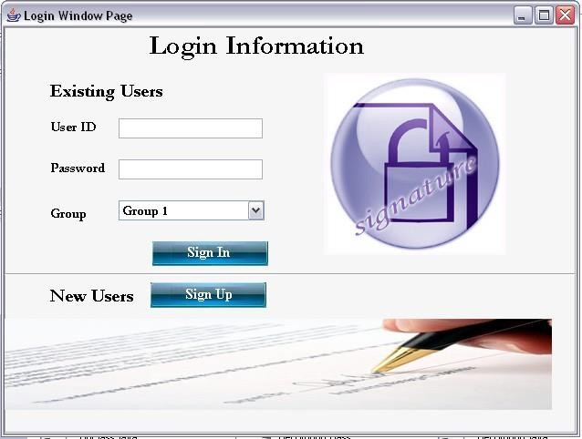

LOGIN WINDOW

51

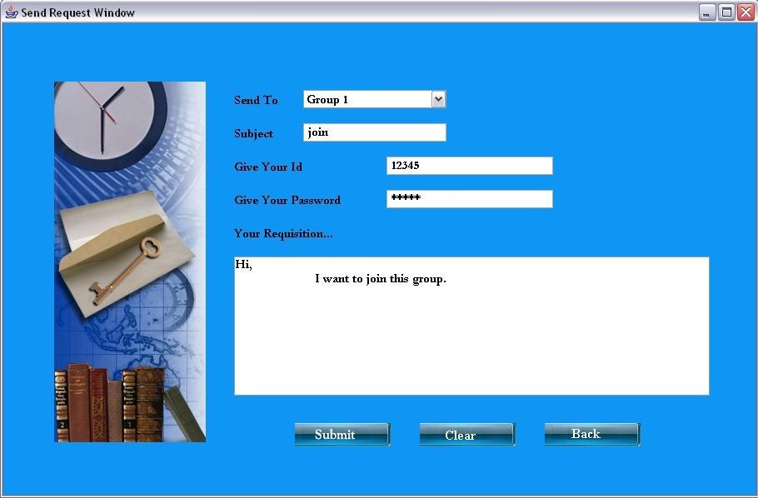

REQUEST SEND TO THE ADMINISTRATOR

52
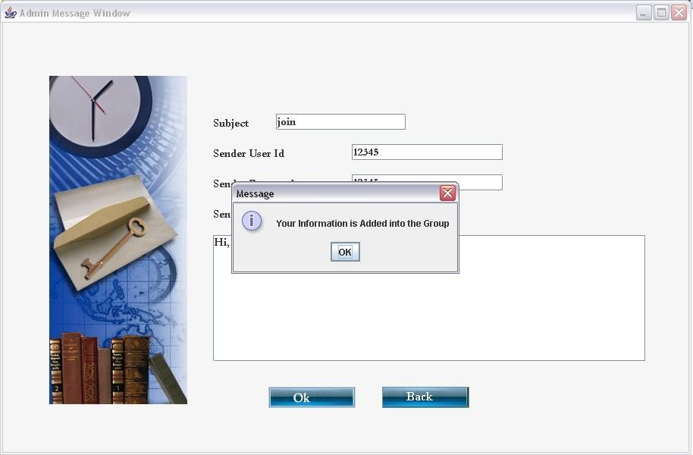

ADMINISTRATOR ACCEPTS THE REQUISITION

53

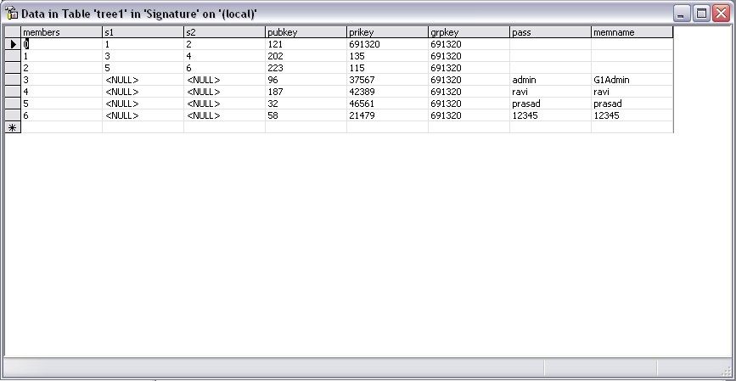

GROUP KEY IS GENERATED AND STORED IN THE DATABASE

54
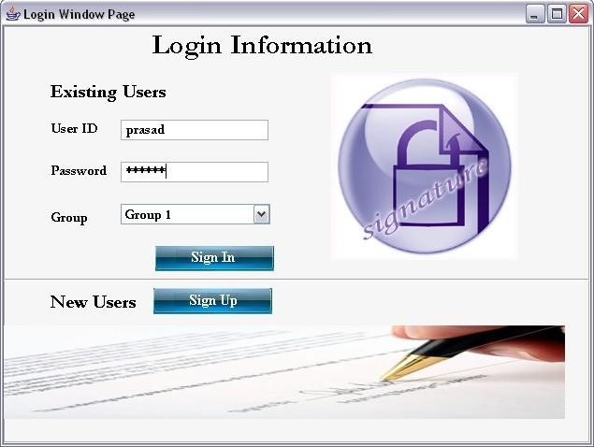

EXISTING USER

55

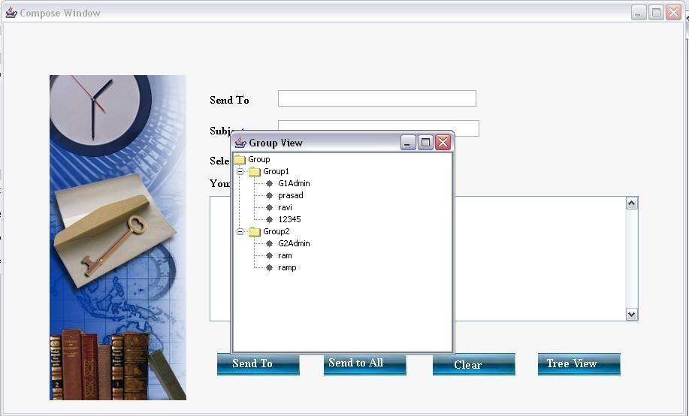

TREE VIEW OF THE MEMBERS

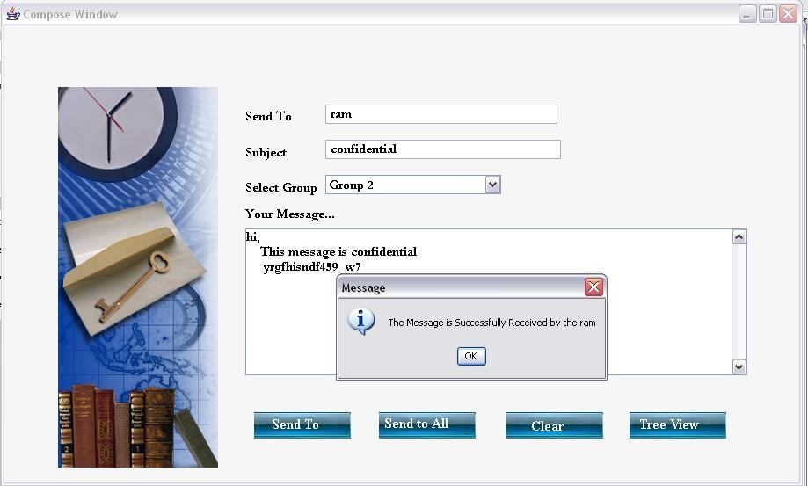

56
SENDING AMESSAGE

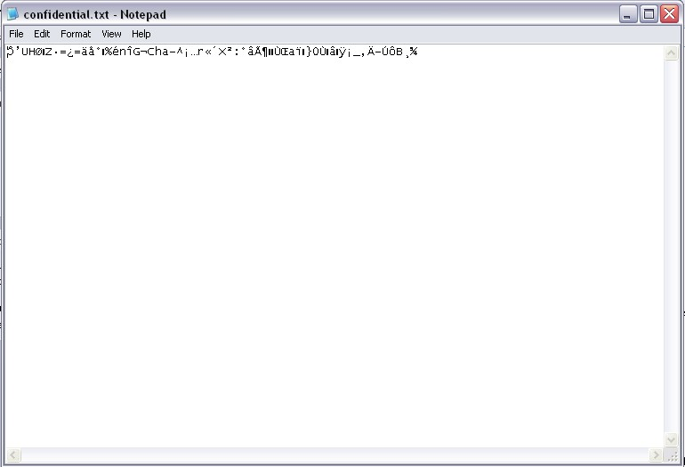

ENCRYPTED MESSAGE

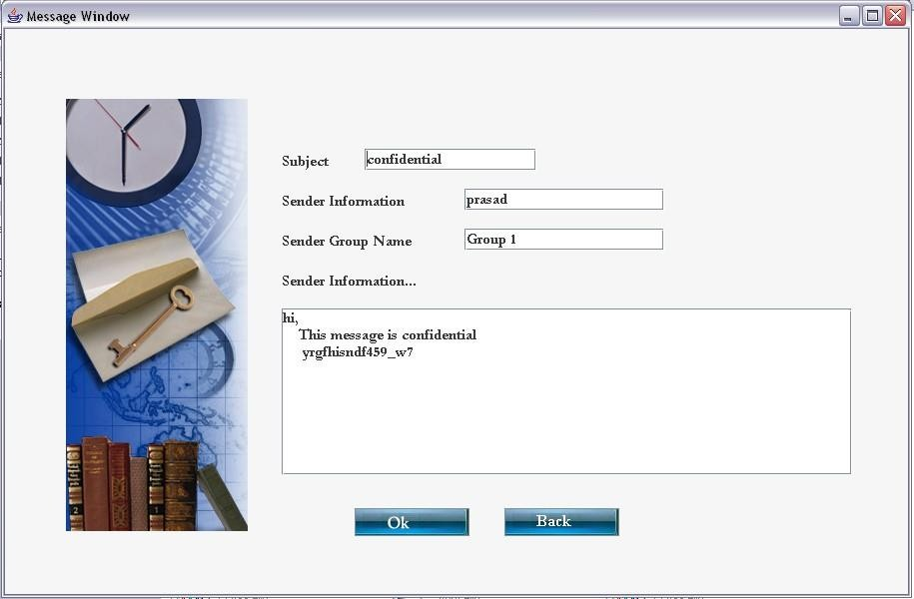

MESSAGE RECEIVED BY THE RECEIVER

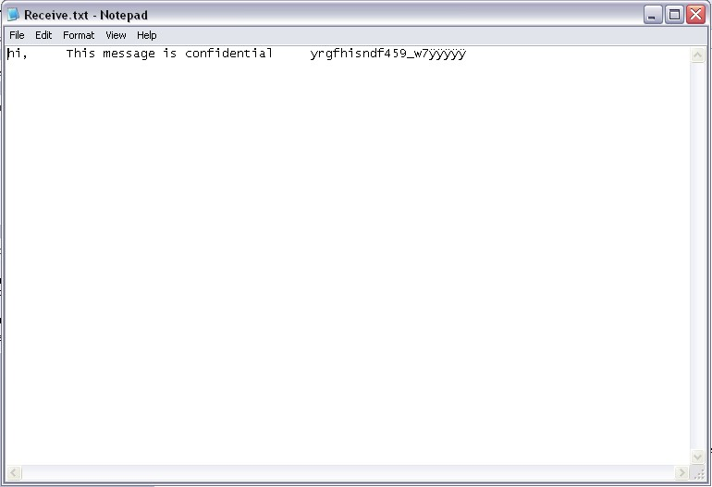

RECEIVED MESSAGE WITH MULTISIGNATURE

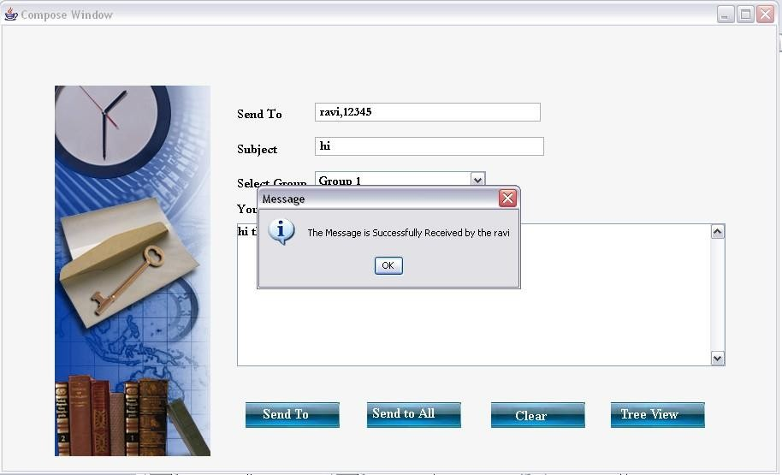

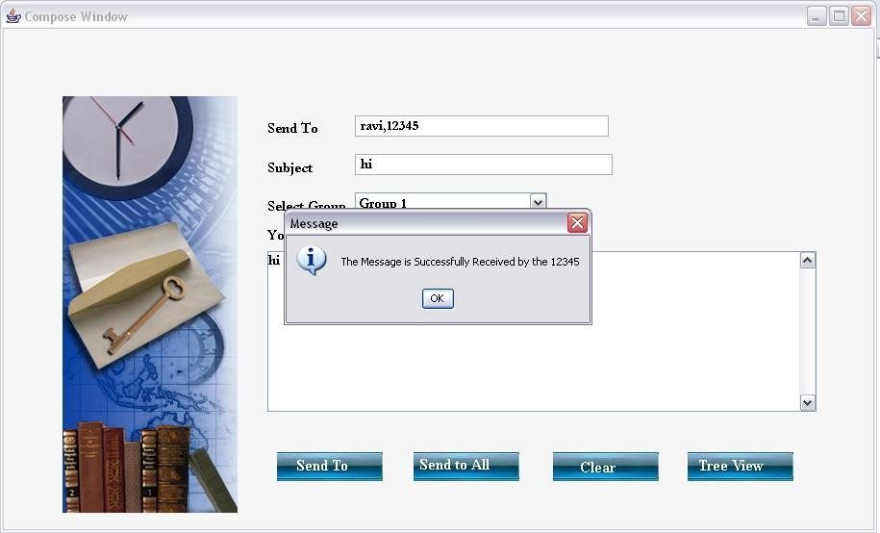

MESSAGE SEND TO ALL

59
REFERENCES

1Y. Desmedt, “Society and Group Oriented Cryptography: A New Concept,” Proc. Advances in Cryptology—CRYPTO ’87, 1987.

2Y. Desmedt, “Threshold Cryptography,” European Trans. Telecomm., vol. 5, no. 4, pp. 449-457, 1994.

3R. Gennaro, S. Jarecki, H. Krawczyk, and T. Rabin, “Secure Distributed Key

Generation for Discrete-Log Based Cryptosystems,” Proc. Advances in Cryptology

—EUROCRYPT ’99, May 1999.

4C.-M. Li, T. Hwang, and N.-Y. Lee, “Threshold-Multisignature Schemes where Suspected Forgery Implies Traceability of Adversarial Shareholders,” Proc. Advances in Cryptology—EUROCRYPT ’94, May 1994.

5A. Boldyreva, “Threshold Signatures, Multisignatures and Blind Signatures Based on the Gap-Diffie-Hellman-Group Signature Scheme,” Proc. Public Key Cryptography—PKC ’03, 2003.

6C.-T. Wang, C.-H. Lin, and C.-C. Chang, “Threshold Signature Schemes with Traceable Signers in Group Communications,” Computer Comm., vol. 21, no. 8, pp. 771-776, 1998.
7W.-B. Lee and C.-C. Chang, “(t, n) Threshold Digital Signature with Traceability

Property,” J. Information Science and Eng., vol. 15, no. 5, pp. 669- 678, 1999.

8Z.-C. Li, J.-M. Zhang, J. Luo, W. Song, and Y.-Q. Dai, “Group- Oriented (t, n) Threshold Digital Signature Schemes with Traceable Signers,” Proc. Second Int’l Symp. Topics in Electronic Commerce (ISEC ’01), Apr. 2001.

9P. Horster, M. Michels, and H. Petersen, “Generalized ElGamal Signatures for

One Message Block,” Proc. Second Int’l Workshop ITSecurity, Sept. 1994.

10L. Harn and Y. Xu, “Design of Generalised ElGamal Type Digital Signature

Schemes Based on Discrete Logarithms,” Electronics Letters, vol. 30, no. 24, pp.

2025-2026, 1994.

SITES REFFERED


http://java.sun.com
http://www.networkcomputing.com/

