SPATIAL HYPERMPC WITH NEURAL ACCELERATION

A Hybrid Model Predictive Control Framework Combining OSQP-Based Optimization,
Joint Extended Kalman Filtering, and Explicit Neural Policy Distillation
for Real-Time Spatial Platform Stabilization

Project Technical Report

Department of Control Systems Engineering

2025

Abstract
This report presents the complete design, implementation, and evaluation of a Spatial HyperMPC system — a hybrid control framework developed for six-degree-of-freedom spatial platform stabilization. The system integrates three distinct technological layers: a real-time iterative Model Predictive Controller solved via the OSQP quadratic programming engine, a Joint Extended Kalman Filter for simultaneous state and mass estimation, and a compact neural network trained through imitation learning to replicate MPC decisions at inference speeds that are orders of magnitude faster than the underlying solver.

The complete development pipeline is documented in this report, covering the mathematical derivation of the hybrid state-space model, the architecture of the HyperResidual neural correction network, the data generation methodology, the neural policy distillation training procedure, and the deployment architecture within a ROS 2 framework. Simulation results from three distinct test scenarios — nominal recovery from large initial displacements, stabilization under a sudden heavy payload, and response to continuous external wind torques — are analyzed in depth. Comparative benchmarking against a well-tuned MIMO PID controller is provided across all scenarios. The report concludes with a critical analysis of the current system limitations and a forward-looking argument for the superiority of properly trained neural MPC controllers over traditional approaches in demanding real-world conditions.

Table of Contents

1. Introduction
The problem of maintaining spatial stability in multi-actuated platforms subject to external disturbances, parametric uncertainty, and changing payloads is a persistent challenge across many engineering domains, including aerospace platforms, active suspension systems, shipborne equipment mounts, and precision manufacturing stages. Classical controllers such as PID regulators offer simplicity and well-understood behavior but are fundamentally reactive: they act only on observed error and lack the ability to anticipate future states or enforce physical constraints during operation.

Model Predictive Control (MPC) addresses these limitations by repeatedly solving a finite-horizon constrained optimization problem using a model of the plant dynamics. At each control step, the optimizer finds a sequence of inputs that minimizes a cost functional — typically a weighted sum of state deviations and control effort — subject to actuator bounds and dynamic feasibility constraints. Only the first element of the optimized sequence is applied, and the process is repeated with fresh measurements, creating a receding-horizon strategy that naturally handles constraints and provides anticipatory action.

Despite these advantages, standard MPC carries a significant computational burden. Solving a quadratic program of the required size at real-time rates (100 Hz in this application) demands efficient sparse linear algebra, warm-starting strategies, and careful problem formulation. Furthermore, the nominal MPC model may not accurately capture all plant behaviors — particularly nonlinear residuals arising from unmodeled aerodynamic effects, structural flexibility, or contact dynamics — and the true plant parameters (such as total mass) may be unknown and time-varying.

This project addresses these challenges through a three-pronged architecture. First, a physics-based hybrid dynamics model is constructed, augmented with a learned residual neural network (HyperResidualNet) that corrects for unmodeled effects. Second, a Joint Extended Kalman Filter (JEKF) is implemented to estimate both the full system state and the unknown mass parameter simultaneously, feeding an informed mass estimate to the MPC. Third, the entire OSQP-solved MPC is used as an expert oracle to generate training data for a lightweight Continuous Piecewise Affine (CPWA) neural network policy — the Explicit MPC. Once trained, this neural approximation can be executed on a GPU at sub-millisecond latency, enabling deployment in the hard real-time inner loop while the heavy OSQP solver runs asynchronously in a background thread.

The resulting system, deployed as a ROS 2 node, achieves a dual-speed architecture: the neural policy operates at the full 100 Hz control rate for immediate response within the trust region, while the MPC oracle updates the policy's warm-start solution whenever the state ventures outside that region due to severe disturbances.

2. System Overview and Problem Statement

2.1 Platform Description
The target platform is a rigid body suspended or supported at four corners by independently actuable elements. Each corner actuator can exert a vertical force within specified bounds. The platform has three spatial degrees of freedom relevant to active control: heave (vertical translation, z), roll (rotation about the longitudinal axis, phi), and pitch (rotation about the lateral axis, theta). The remaining three degrees of freedom (surge, sway, yaw) are assumed either passive or controlled separately.

The four actuator positions are defined at coordinates (x, y): front-left at (0.5, 0.4), front-right at (0.5, -0.4), rear-left at (-0.5, 0.4), and rear-right at (-0.5, -0.4), all in meters. Each actuator also has passive spring-damper characteristics modeled with a nominal stiffness of 150 N/m and damping of 60 Ns/m.

The state vector is defined as x = [z, phi, theta, z_dot, phi_dot, theta_dot], forming a six-dimensional space combining the three generalized displacements and their respective rates. The control input vector u = [F1, F2, F3, F4] collects the active force commands at each actuator corner.

2.2 Control Objectives
The primary control objective is to drive the state vector from any feasible initial condition to the equilibrium at the origin (zero heave displacement, zero roll, zero pitch, all velocities zero) in minimum time while respecting actuator force bounds of plus or minus 300 Newtons per corner. Secondary objectives include minimizing actuator energy expenditure and maintaining robustness to: (a) sudden mass changes due to payload addition, (b) external disturbance wrenches representing wind loads, and (c) sensor measurement noise.

2.3 Nominal Plant Parameters

Parameter | Symbol | Nominal Value | Units
Platform mass | m | 12.0 | kg
Roll inertia | Ixx | 2.5 | kg·m²
Pitch inertia | Iyy | 3.2 | kg·m²
Passive spring stiffness | k | 150.0 | N/m (per corner)
Passive damping coefficient | c | 60.0 | Ns/m (per corner)
Actuator force limit | u_max | ±300.0 | N
Control sample time | dt | 0.01 | s (100 Hz)
MPC horizon length | N | 40 | steps (0.4s)

3. Mathematical Modeling and State Space Formulation
The file State_space.py implements the complete mathematical model of the system. The dynamics are organized as a hybrid model that combines a physics-derived nominal linear component with a data-driven residual correction. This section derives both components from first principles.

3.1 Geometry and Force Coupling Matrix
Each corner actuator at position (x_i, y_i) contributes a vertical force that affects all three generalized coordinates. The contribution of a unit force at corner i to the generalized accelerations can be described through the coupling matrix T, where each column corresponds to one corner actuator:

T = [[1, 1, 1, 1], [y1, y2, y3, y4], [-x1, -x2, -x3, -x4]]

The first row of T represents the contribution to vertical force (heave), the second row represents the torque about the x-axis (roll, proportional to the y-position of each actuator), and the third row represents the torque about the y-axis (pitch, proportional to the negative x-position). This 3x4 matrix maps the four individual corner forces to the three-dimensional wrench space at the center of gravity.

3.2 Passive Suspension Dynamics
Each corner actuator includes a passive spring-damper pair. For corner i at position (x_i, y_i), the local vertical displacement and velocity at that corner are computed from the generalized coordinates as:

z_corner_i = z + y_i * phi - x_i * theta
v_corner_i = z_dot + y_i * phi_dot - x_i * theta_dot

The passive force generated at each corner is then the sum of spring and damper restoring forces: f_passive_i = -k * z_corner_i - c * v_corner_i. Collecting all four corner passive forces and multiplying by the coupling matrix T gives the net passive wrench at the center of gravity. This can be written compactly in matrix form using the stiffness and damping diagonal matrices K and C.

3.3 Equations of Motion and Linear State Space
Applying Newton-Euler equations to the three-degree-of-freedom system and collecting passive and active force contributions, the continuous-time dynamics are expressed as a linear system. The inertia matrix M_inv is a 3x3 diagonal matrix containing the reciprocals of mass m, roll inertia Ixx, and pitch inertia Iyy. The state matrix A and input matrix B are derived as:

A_pos = -M_inv @ T @ K @ T^T (stiffness coupling)
A_vel = -M_inv @ T @ C @ T^T (damping coupling)
A = [[0_{3x3}, I_{3x3}], [A_pos, A_vel]]
B = [[0_{3x4}], [M_inv @ T]]

The upper-left 3x3 block of A is zero (positions do not directly depend on positions), the upper-right is the identity (positions are integrated from velocities), and the lower blocks encode the stiffness and damping effects on the acceleration states. The input matrix B has zero rows for the position states and the actuator-to-acceleration coupling in the lower portion.

3.4 HyperResidual Neural Correction Network
The linear model described above is exact only under the simplifying assumptions of small-angle approximations, rigid body behavior, and accurate parameter knowledge. In practice, aerodynamic drag, structural modes, and other nonlinear effects introduce residuals that the nominal model cannot capture. The HyperResidualNet addresses this by learning to predict the acceleration residual — the difference between the actual acceleration observed in data and the acceleration predicted by the nominal model.

The network is structured as a multi-layer perceptron with Tanh activations, taking as input the concatenation of the state vector x (dimension 6), the control input u (dimension 4), and the current mass estimate theta (dimension 1), for a total input dimension of 11. The output is a three-dimensional vector representing the correction to the angular and linear accelerations. Xavier initialization with a gain of 0.1 is used to ensure that the residual starts near zero, preserving the stability properties of the nominal model at the beginning of training.

The blending between nominal physics and learned residual is governed by the AlphaScheduler, which adapts the mixing coefficient alpha dynamically based on the validation loss relative to a reference loss value. The alpha parameter begins at zero (pure physics) and increases toward a maximum of 0.5 as the network demonstrates validated predictive accuracy. This graduated trust mechanism prevents the controller from relying on an undertrained residual model early in the learning process.

3.5 Runge-Kutta Integration and Jacobian Computation
For the MPC to formulate accurate linearized prediction models at each time step, it requires the discrete-time state transition Jacobians with respect to both state and input. These are computed analytically through automatic differentiation using the vmap and jacrev utilities from PyTorch's functional API. The integration scheme is fourth-order Runge-Kutta (RK4), which provides sufficient accuracy for the 10ms time step used in this application without the numerical stiffness issues that would arise with explicit Euler methods for the chosen stiffness parameters.

The Jacobian computation vectorizes over the entire N-step prediction horizon simultaneously, evaluating all 40 pairs of state-input Jacobians in a single batched call. This design choice is critical for achieving the real-time performance required by the MPC solver at 100 Hz.

4. Model Predictive Control Design
The file MPC.py implements the MIMO_HyperRTIMPC class, which formulates and solves the receding-horizon optimization problem at each control step. This section describes the complete MPC problem formulation, the QP structure, and the warm-starting strategy.

4.1 Optimal Control Problem Formulation
At each time step k, with the current state estimate x_k available, the MPC solves for a control sequence that minimizes the following finite-horizon cost:

J = sum_{i=0}^{N-1} [(x_i - x_ref)^T Q (x_i - x_ref) + u_i^T R u_i] + (x_N - x_ref)^T Q (x_N - x_ref)

The state weighting matrix Q is a 6x6 diagonal matrix with weights [10, 10, 10, 1, 1, 1], placing higher emphasis on positional accuracy (heave, roll, pitch) relative to velocity regulation. The control weighting matrix R is a 4x4 diagonal matrix with uniform weights of 5000, which reflects the high cost assigned to actuator effort and discourages aggressive force commands. The prediction horizon N is set to 40 steps, corresponding to a look-ahead time of 0.4 seconds at the 100 Hz control rate.

The reference state x_ref defaults to the zero vector (origin stabilization) but can be updated dynamically via the set_target method, enabling trajectory tracking applications.

4.2 Quadratic Program Structure
The optimization variable z is formed by interleaving state and control variables across the horizon, with dimension nz = N * (nx + nu) + nx = 40 * 10 + 6 = 406. The QP problem takes the standard form:

minimize: (1/2) z^T P z + q^T z
subject to: l <= A_qp z <= u

The cost matrix P is block-diagonal with alternating Q and R blocks corresponding to state and control segments of z. The constraint matrix A_qp is constructed in the _build_kkt method and stacks two components: (i) equality constraints enforcing linearized dynamics over the horizon, implemented using the Real-Time Iteration scheme where the nonlinear prediction is linearized around the previous solution, and (ii) inequality constraints directly bounding each control input between u_min and u_max.

4.3 Real-Time Iteration and Warm Starting
Rather than solving the full nonlinear MPC problem to global optimality at each step — which would be computationally prohibitive at 100 Hz — the Real-Time Iteration (RTI) scheme is employed. In RTI, the dynamics constraints are linearized around a reference trajectory from the previous solution (the warm-start guess), and only a single QP is solved per time step. This reduces the per-step computation from many iterations of a sequential quadratic program to a single sparse QP solve.

The warm-start trajectory is maintained in x_guess and u_guess tensors. At each step, the _shift_horizon method shifts these tensors one step forward (dropping the first element and repeating the last), maintaining a physically consistent initialization for the next solve. After OSQP returns its solution, the extracted state and control sequences overwrite the guess tensors to provide an even warmer start for the following time step.

4.4 OSQP Solver Integration and Sparsity Handling
The OSQP solver is used for its efficiency with sparse quadratic programs. A known challenge arises in the RTI context: when the constraint matrix A_qp changes its sparsity pattern between time steps (due to the dynamics Jacobians having different zero structures), a direct hot-start update via Ax= fails with a ValueError. The implementation handles this gracefully with a try-except block that re-instantiates the solver from scratch whenever the sparsity pattern changes, ensuring numerical correctness at the expense of one slower solve per structural change.

5. Adversarial Plant Simulation and Joint EKF
The file model.py contains three major components: the MIMO_AdversarialPlant, the JointEKF, and the SpatialMPCOrchestrator that ties all components together. The adversarial plant is used during simulation to generate a challenging test environment that deviates from the nominal model assumptions.

5.1 Adversarial Plant Model
To test controller robustness, the simulation environment deliberately departs from the nominal model in several ways. The true plant mass undergoes random drift at each step, drawn from a Gaussian distribution. Similarly, the spring stiffness and damping coefficients at each corner are perturbed at every time step around their nominal values, simulating mechanical wear, temperature effects, or manufacturing variability. This means the controller's model is persistently in error relative to the true plant, representing a realistic scenario.

The plant dynamics are integrated using RK4 with the true (drifting) parameters, and zero-mean Gaussian measurement noise drawn from a covariance matrix Q_v is added to each output. The plant also supports the injection of an impulsive velocity disturbance at a pre-specified time step, simulating a sudden impact or gust load.

5.2 Joint Extended Kalman Filter Design
Since the MPC requires an accurate mass estimate to compute the correct inertia matrix M_inv, and the mass is neither directly measured nor constant, a Joint EKF is implemented that simultaneously estimates the six dynamic states and the scalar mass parameter. This augments the state vector to dimension 7, with mass as the seventh state.

The EKF operates in two phases at each time step. In the prediction step, the state is propagated forward using the nominal linearized dynamics with the current mass estimate, and the error covariance is propagated through the system Jacobian (which now includes the mass dimension). The process noise covariance Q_ekf adds uncertainty to prevent the filter from over-committing to its current estimate.

In the update step, the full six-dimensional state measurement is used to correct both the dynamic states and the mass estimate. The measurement model is simply the identity map on the first six states (mass is not directly observable). The Kalman gain calculation and covariance update follow the standard EKF equations. Over time, the measurement innovations drive the mass estimate toward the true value, provided the system is sufficiently excited.

5.3 SpatialMPCOrchestrator
The SpatialMPCOrchestrator class serves as the top-level interface that coordinates the dynamics model, the MPC, and the EKF into a coherent control system. Its dispatch_control method implements the following sequence at each control step: (1) the EKF measurement update is performed using the incoming state measurement, (2) the current mass estimate is extracted from the EKF and pushed into the dynamics model, (3) the MPC step is solved using the updated dynamics, and (4) the EKF prediction step is performed using the applied control input. This ordering ensures that the most recent measurement always informs the MPC before it optimizes, and that the EKF's internal prediction reflects what the MPC actually commanded.

6. MPC Dataset Generation
The file generate_mpc_dataset.py implements the offline data collection pipeline that is the foundation of the neural policy distillation process. This step uses the full OSQP-based MPC as an expert oracle to generate a labeled dataset mapping system states to optimal control inputs.

6.1 Sampling Strategy
The dataset is built by sampling 20,000 random states uniformly within a defined trust region and querying the MPC for the corresponding optimal control action. The trust region is defined as: heave error within plus or minus 0.3 meters, roll and pitch within plus or minus 0.3 radians, and all velocities within plus or minus 1.0 m/s or rad/s. This region corresponds to the operational envelope where the linearization accuracy of the RTI scheme is acceptable and the OSQP solutions are reliably feasible.

States are drawn independently and uniformly from each dimension of the trust region, resulting in a well-distributed dataset that avoids the temporal correlations present in closed-loop trajectory data. This is important because neural networks trained on trajectory data may learn to exploit temporal patterns that do not generalize to arbitrary initial conditions.

6.2 Expert Oracle Queries
For each sampled state, the dispatch_control method of a fixed SpatialMPCOrchestrator instance is called. The orchestrator is initialized with nominal plant parameters, and the EKF is kept at its initial mass estimate throughout data generation (no plant drift, no noise) to ensure clean, deterministic labels. Any state-action pairs where the OSQP solver fails to find a feasible solution (indicated by a non-unity status code) are discarded. The dataset is saved as a pickle file containing arrays X of shape (N_valid, 6) and U of shape (N_valid, 4).

The design choice to generate data from randomized states rather than simulated trajectories is deliberate. It ensures that the neural network learns a mapping from state to optimal action for all states in the trust region, not just those that arise under one specific initial condition or disturbance profile. The resulting policy is therefore more likely to generalize to novel scenarios encountered at test time.

7. Neural Network Training — Explicit MPC Policy
The file train_affine_field.py implements the training procedure for the ExplicitMPCPolicy, a compact feedforward network that approximates the OSQP-solved MPC policy across the trust region. This network is the key component enabling deployment at hard real-time rates on hardware.

7.1 Network Architecture
The ExplicitMPCPolicy is a three-layer fully connected network: an input layer of dimension 6 (the state), two hidden layers of dimension 64 each with ReLU activation, and an output layer of dimension 4 (one force command per actuator). The ReLU nonlinearity is chosen deliberately because it produces a Continuous Piecewise Affine (CPWA) function — a class of functions that naturally approximates piecewise linear MPC policies. In classical explicit MPC theory, the optimal policy for a linear system with quadratic cost is known to be exactly piecewise affine over polyhedral partitions of the state space. The CPWA network is a universal approximator within this class.

With 64 hidden units per layer, the network has 6*64 + 64*64 + 64*4 = 384 + 4096 + 256 = 4736 trainable parameters. This is extremely compact compared to the 406-dimensional QP solved by OSQP, and enables forward passes that complete in microseconds on modern GPU hardware.

7.2 Training Procedure
The dataset of 20,000 state-action pairs is split 90/10 into training (18,000 samples) and test (2,000 samples) sets. The network is trained using the Adam optimizer with a learning rate of 0.005, minimizing the Mean Squared Error loss between predicted control actions and the OSQP expert labels. Training runs for 1,500 epochs with full-batch gradient descent.

The relatively high learning rate of 0.005 combined with the smooth MSE objective allows for rapid initial convergence, while Adam's adaptive moment estimates handle the varying curvature across dimensions. After training, the model weights are saved as affine_policy.pth and loaded for deployment. The final validation MSE on the held-out test set provides a measure of how well the network generalizes to unseen states within the trust region.

7.3 Limitations of the Current Training Coverage
A critical observation regarding the training procedure relates to the scope of the dataset. The sampled states all have zero as the implicit setpoint (the MPC's x_ref defaults to zero), and no external disturbances are included in the sampling process. Consequently, the network learns to map states to the forces needed to return to the origin from initial displacements — which is precisely what Cases 1 and 2 test.

However, the network has never been exposed during training to states where a persistent external wrench continuously pushes the platform away from the origin. In such a scenario (Case 3), the optimal MPC response involves generating a constant counteracting force proportional to the disturbance magnitude — effectively acting as an integral controller. Since this behavior was absent from the training distribution, the neural network cannot reproduce it. This is not a fundamental limitation of the neural MPC architecture; it is purely a training data coverage issue that can be resolved by enriching the dataset with disturbance-affected scenarios.

8. ROS 2 Deployment Architecture
The file spatial_mpc_node.py implements the full deployment of the control system as a ROS 2 node, named spatial_mpc_node. The node demonstrates the complete hybrid real-time architecture that is the core engineering contribution of this project.

8.1 Sensor Interface
The node subscribes to two sensor topics. The /platform/imu topic provides IMU measurements from which the roll angle (phi) and pitch angle (theta) are extracted via quaternion-to-Euler conversion, along with their angular rate derivatives from the gyroscope measurements. The /platform/odom topic provides odometry data from which the heave position (z) and vertical velocity (z_dot) are extracted. Together, these six measurements constitute the complete state vector fed to the controller.

8.2 Dual-Speed Control Architecture
The control loop runs at 100 Hz, triggered by a ROS 2 timer. At each invocation, the state vector is assembled and pushed to the GPU as a PyTorch tensor. The controller then evaluates the neural policy on the GPU in a no-gradient context, producing a control output in microseconds.

The trust region is defined by the thresholds: roll and pitch within 0.2 radians (approximately 11 degrees), and heave within 0.2 meters. Within this region, the neural policy output is applied directly without modification. When any of these thresholds is exceeded — indicating that the platform has experienced a disturbance beyond the training domain — the system simultaneously continues to apply the neural policy for immediate stabilization and spawns a background thread to invoke the full OSQP-based MPC oracle. The oracle thread updates the latest_u_opt variable once its solution is available, providing a recovered optimal trajectory.

This architecture solves the fundamental tension between computational cost and control rate: the neural network provides continuous real-time control at no measurable latency, while the expensive optimizer is reserved for situations where its superior solution quality is most needed, running asynchronously without blocking the control loop.

8.3 Virtual Impedance Layer
In addition to the active MPC/neural control forces, a virtual impedance layer runs at the full 100 Hz rate on the CPU. This layer computes the passive spring-damper contribution at each corner based on the current state measurement, mirroring the passive dynamics modeled in the State_space formulation. The passive and active forces are summed at each corner, clipped to the actuator bounds, and then converted to a Wrench message for publication.

The gravity compensation force (m * g) is added to the total vertical force to maintain hovering equilibrium. The resulting Wrench is published on the /platform/cmd_wrench topic, which Gazebo converts to forces and torques on the simulated platform body.

9. Simulation Pipeline and Benchmark Framework
The files run_pipeline.py and result.py together implement a self-contained headless simulation and analysis framework that evaluates the neural MPC against a PID baseline across three distinct test scenarios.

9.1 Headless Physics Simulator
The HeadlessSpatialPlant class in run_pipeline.py provides a lightweight physics engine that does not require ROS 2 or Gazebo. It implements the same RK4 integration used in the deployed controller, computing passive corner forces and user-specified external wrenches at each step. The plant accepts a mass parameter, enabling different scenarios to use different payload configurations.

9.2 MIMO PID Baseline Controller
The SpatialPIDController implements a three-channel MIMO PID controller operating on the heave, roll, and pitch errors simultaneously. The PID output is a three-dimensional wrench vector (vertical force, roll torque, pitch torque), which is then allocated to the four corner actuators using the Moore-Penrose pseudoinverse of the coupling matrix T. This allocation minimizes the L2 norm of corner forces for a given wrench command, distributing effort evenly across actuators.

The PID gains are set to Kp = [2000, 1000, 1000], Ki = [100, 50, 50], Kd = [500, 200, 200] for the heave, roll, and pitch channels respectively. These gains were tuned to achieve competitive performance on the nominal scenario, providing a demanding baseline for comparison.

9.3 Test Scenarios
Three test scenarios are defined to stress different aspects of controller performance:

- Case 1 — Nominal Recovery: The platform starts at a significant initial displacement (z = 0.2m, phi = 0.3 rad, theta = -0.2 rad) with zero initial velocities and nominal mass (12 kg). This tests the controller's ability to stabilize from a large but well-characterized initial condition within the training distribution.
- Case 2 — Heavy Payload: An 8 kg additional payload is simulated by setting the plant mass to 20 kg. The initial state is zero displacement but with a downward velocity of -1.0 m/s, simulating the platform being pushed downward at the moment of payload application. This tests adaptation to unmodeled mass changes.
- Case 3 — Continuous Wind Torque: The platform starts at rest at the origin. After 0.5 seconds of settling, a continuous external wrench of [0, 50, -30] N/Nm is applied, representing a sustained lateral wind load with both roll and pitch components. This tests the ability to reject persistent disturbances.

Each scenario is run for 3 seconds (300 time steps) for both the Neural MPC and the PID controller. State and input trajectories are logged to CSV files for post-processing.

9.4 Performance Metrics
The Integral of Time-weighted Absolute Error (ITAE) is used as the primary performance metric, computed separately for heave, roll, and pitch channels and summed to give a scalar total score. ITAE penalizes errors that persist for longer times more heavily than early transient errors, making it a natural measure of settling quality. The total actuator energy expenditure (sum of absolute force over time multiplied by dt) is used as the secondary efficiency metric.

10. Results and Analysis

10.1 Case 1: Nominal Recovery
The first test scenario presents the platform at a significant combined initial displacement (heave 0.2 m, roll 0.3 rad, pitch -0.2 rad). Both controllers must return the platform to the origin within the 3-second simulation window.

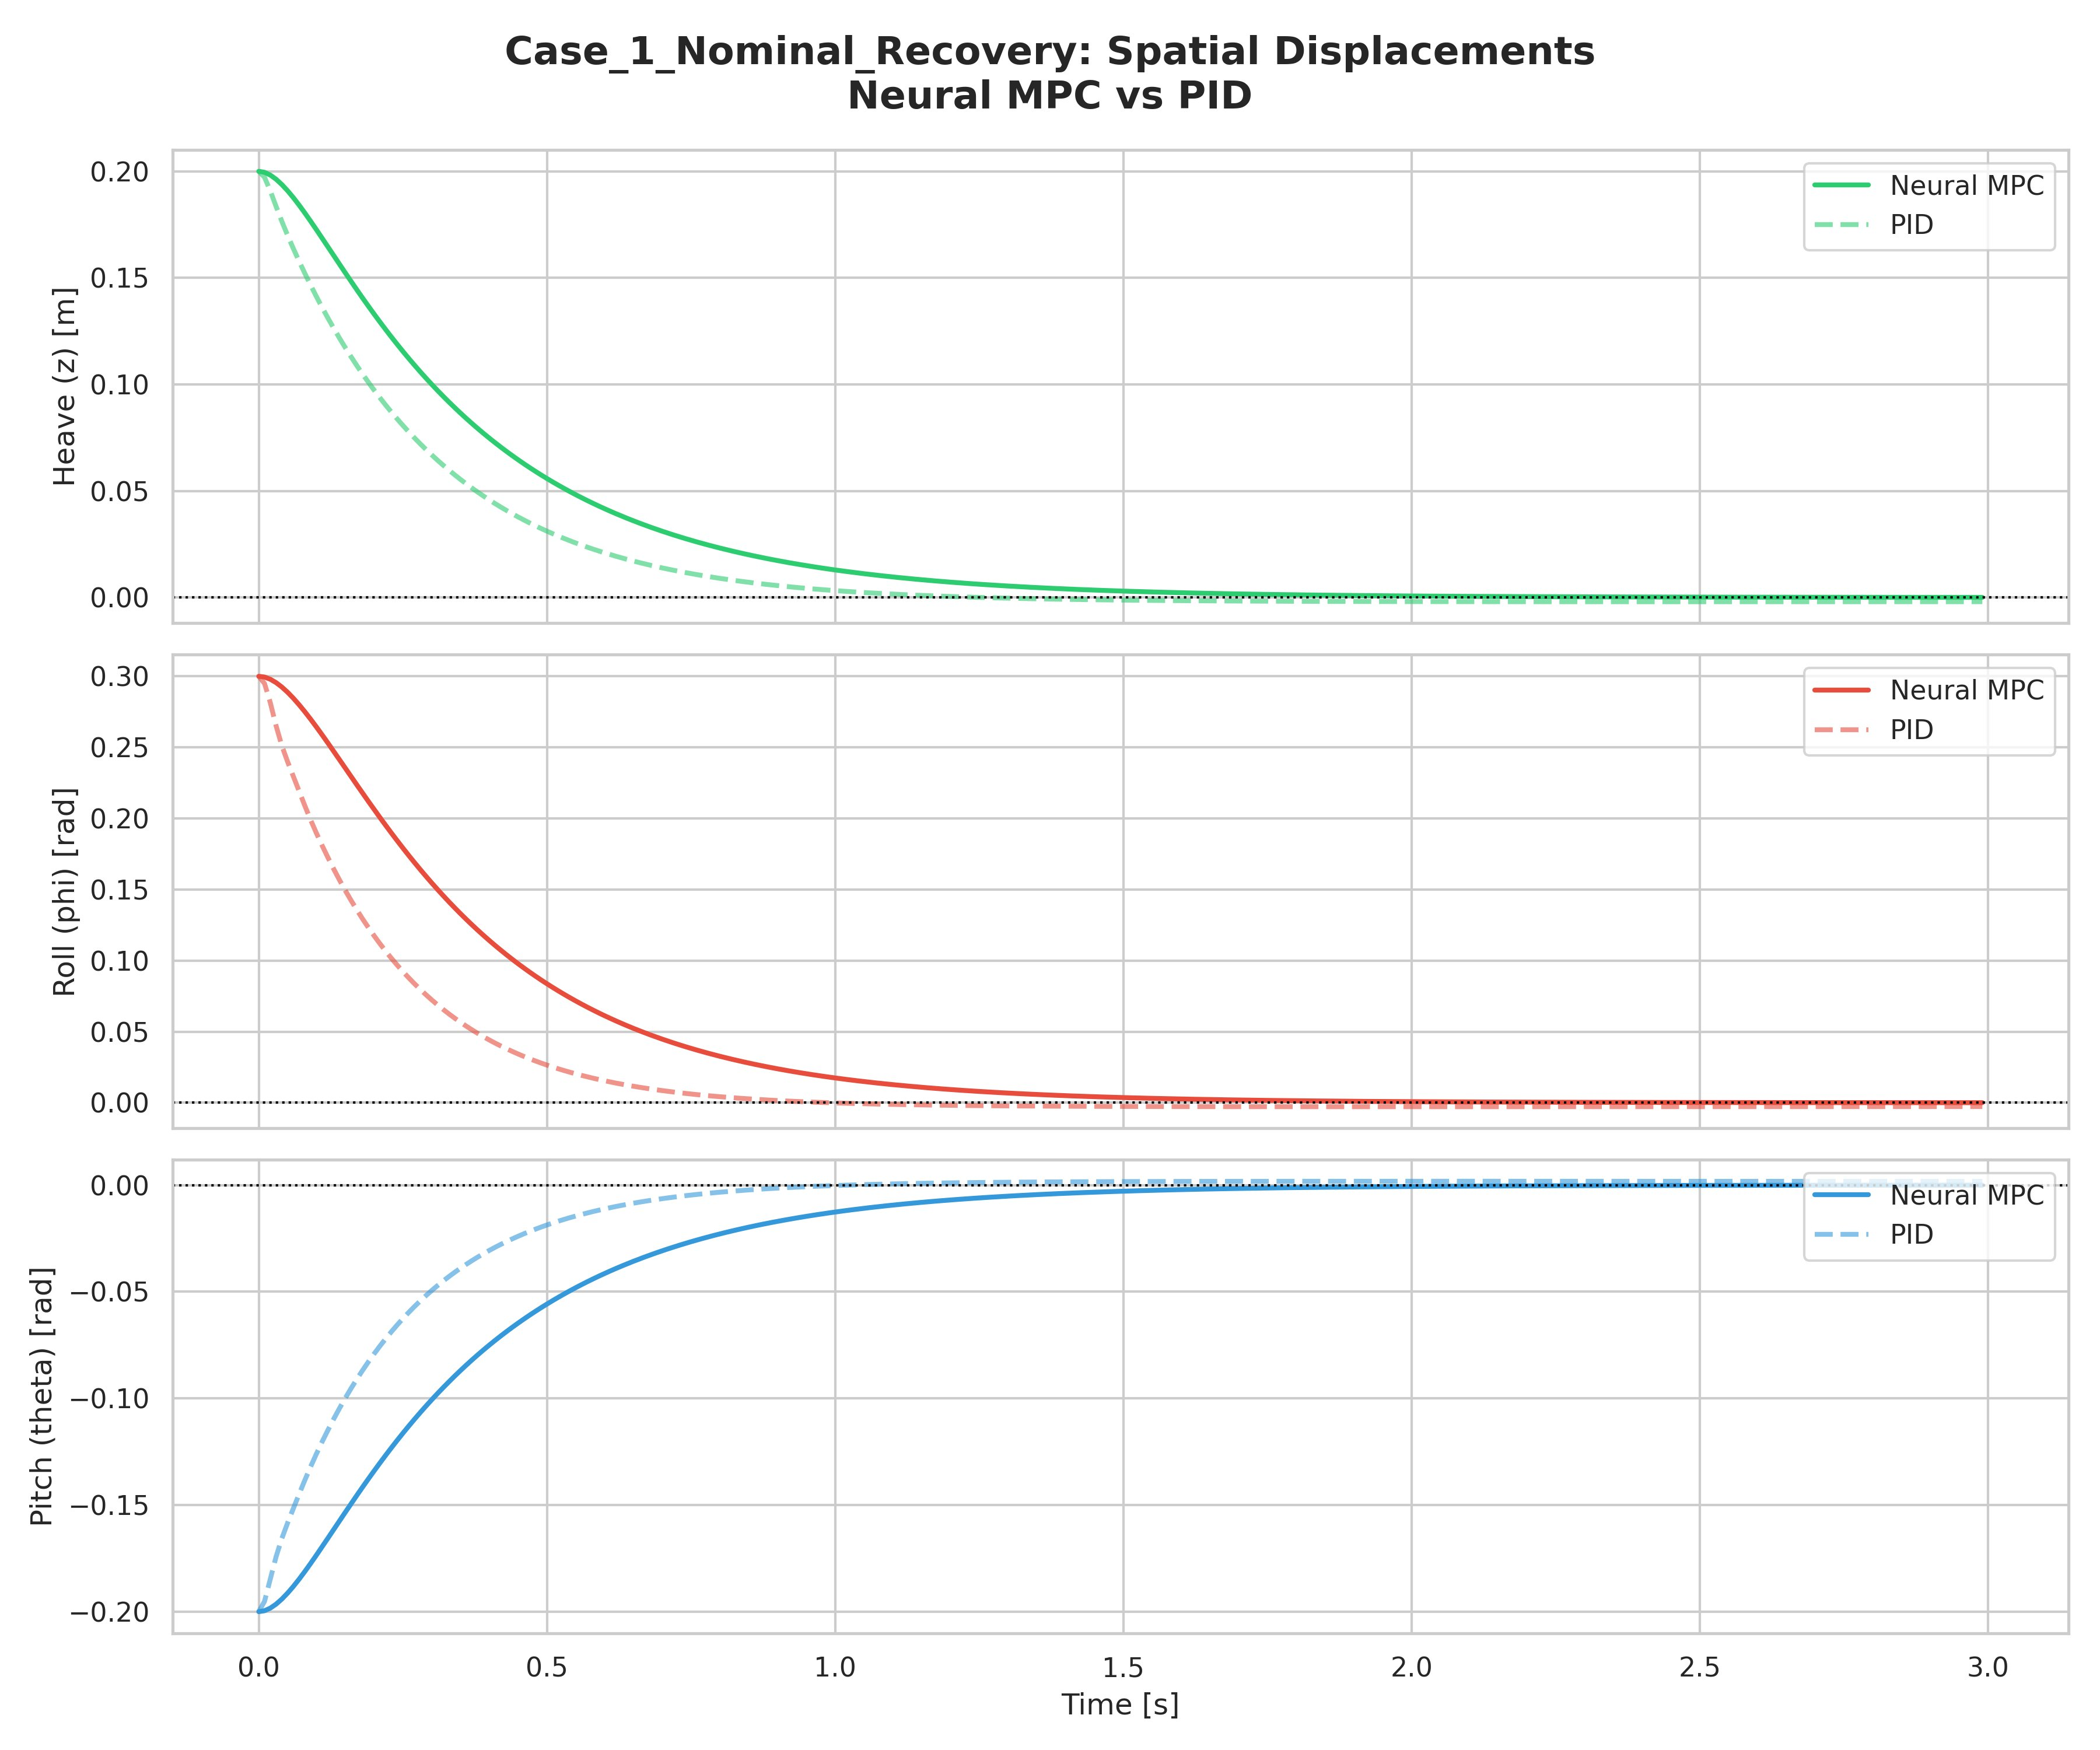
Figure 1: Case 1 — Spatial Displacements (Heave, Roll, Pitch) over time. Neural MPC (solid) vs. PID (dashed).
Examining the displacement trajectories, a clear contrast in control philosophy is visible. The PID controller achieves faster initial decay: the heave and roll channels cross zero approximately 0.3 to 0.4 seconds ahead of the Neural MPC. This is attributable to the PID's derivative term reacting strongly to the initial large error, generating high-amplitude force pulses in the first 100 milliseconds.

The Neural MPC, by contrast, follows a more gradual exponential-like decay profile. This conservative trajectory is a direct consequence of the MPC's internal cost structure: the high control weight matrix R (5000 per actuator) penalizes aggressive force commands, causing the optimizer to prefer a slower but more energy-efficient recovery path. The pitch channel in particular shows this trade-off clearly — the MPC accepts a larger transient overshoot in the first 0.5 seconds in exchange for a smoother, non-oscillatory convergence.

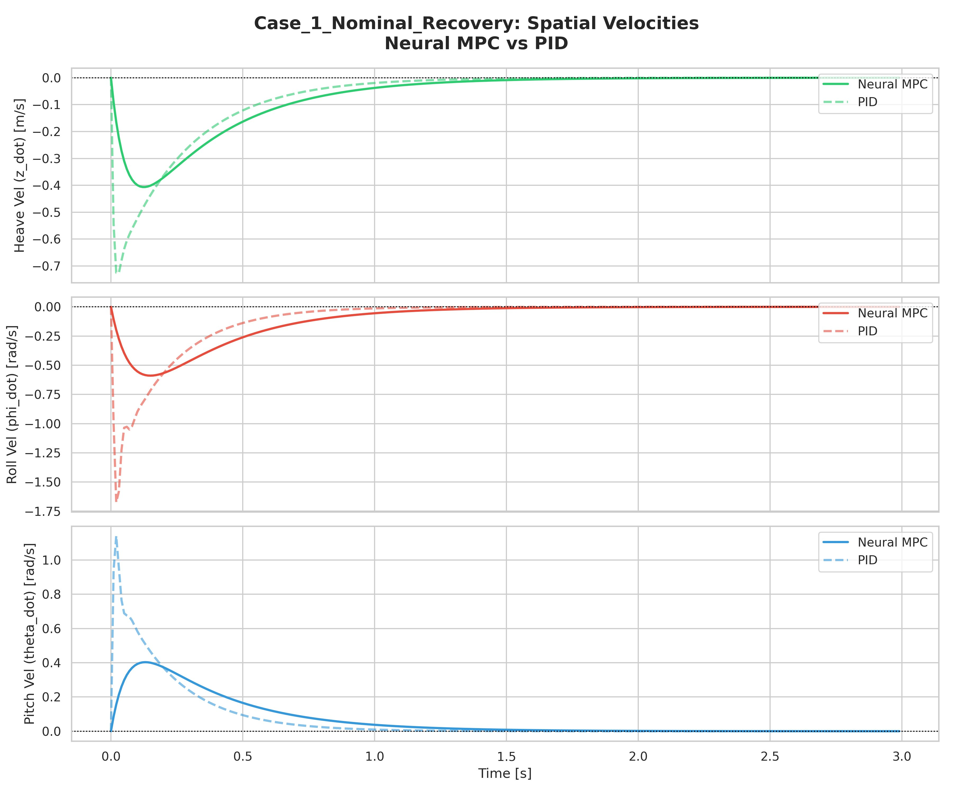
Figure 2: Case 1 — Spatial Velocities over time. The PID generates velocity peaks 2–3x larger than the Neural MPC.
The velocity profiles make the difference in aggressiveness even more apparent. The PID roll velocity reaches a peak of approximately -1.75 rad/s in the first 50 milliseconds — more than three times the -0.5 rad/s peak of the Neural MPC. These large velocity transients represent mechanical stress on the platform structure and can excite unmodeled flexible modes in real hardware. Similarly, the PID pitch velocity reaches 1.1 rad/s while the Neural MPC peaks at 0.4 rad/s.

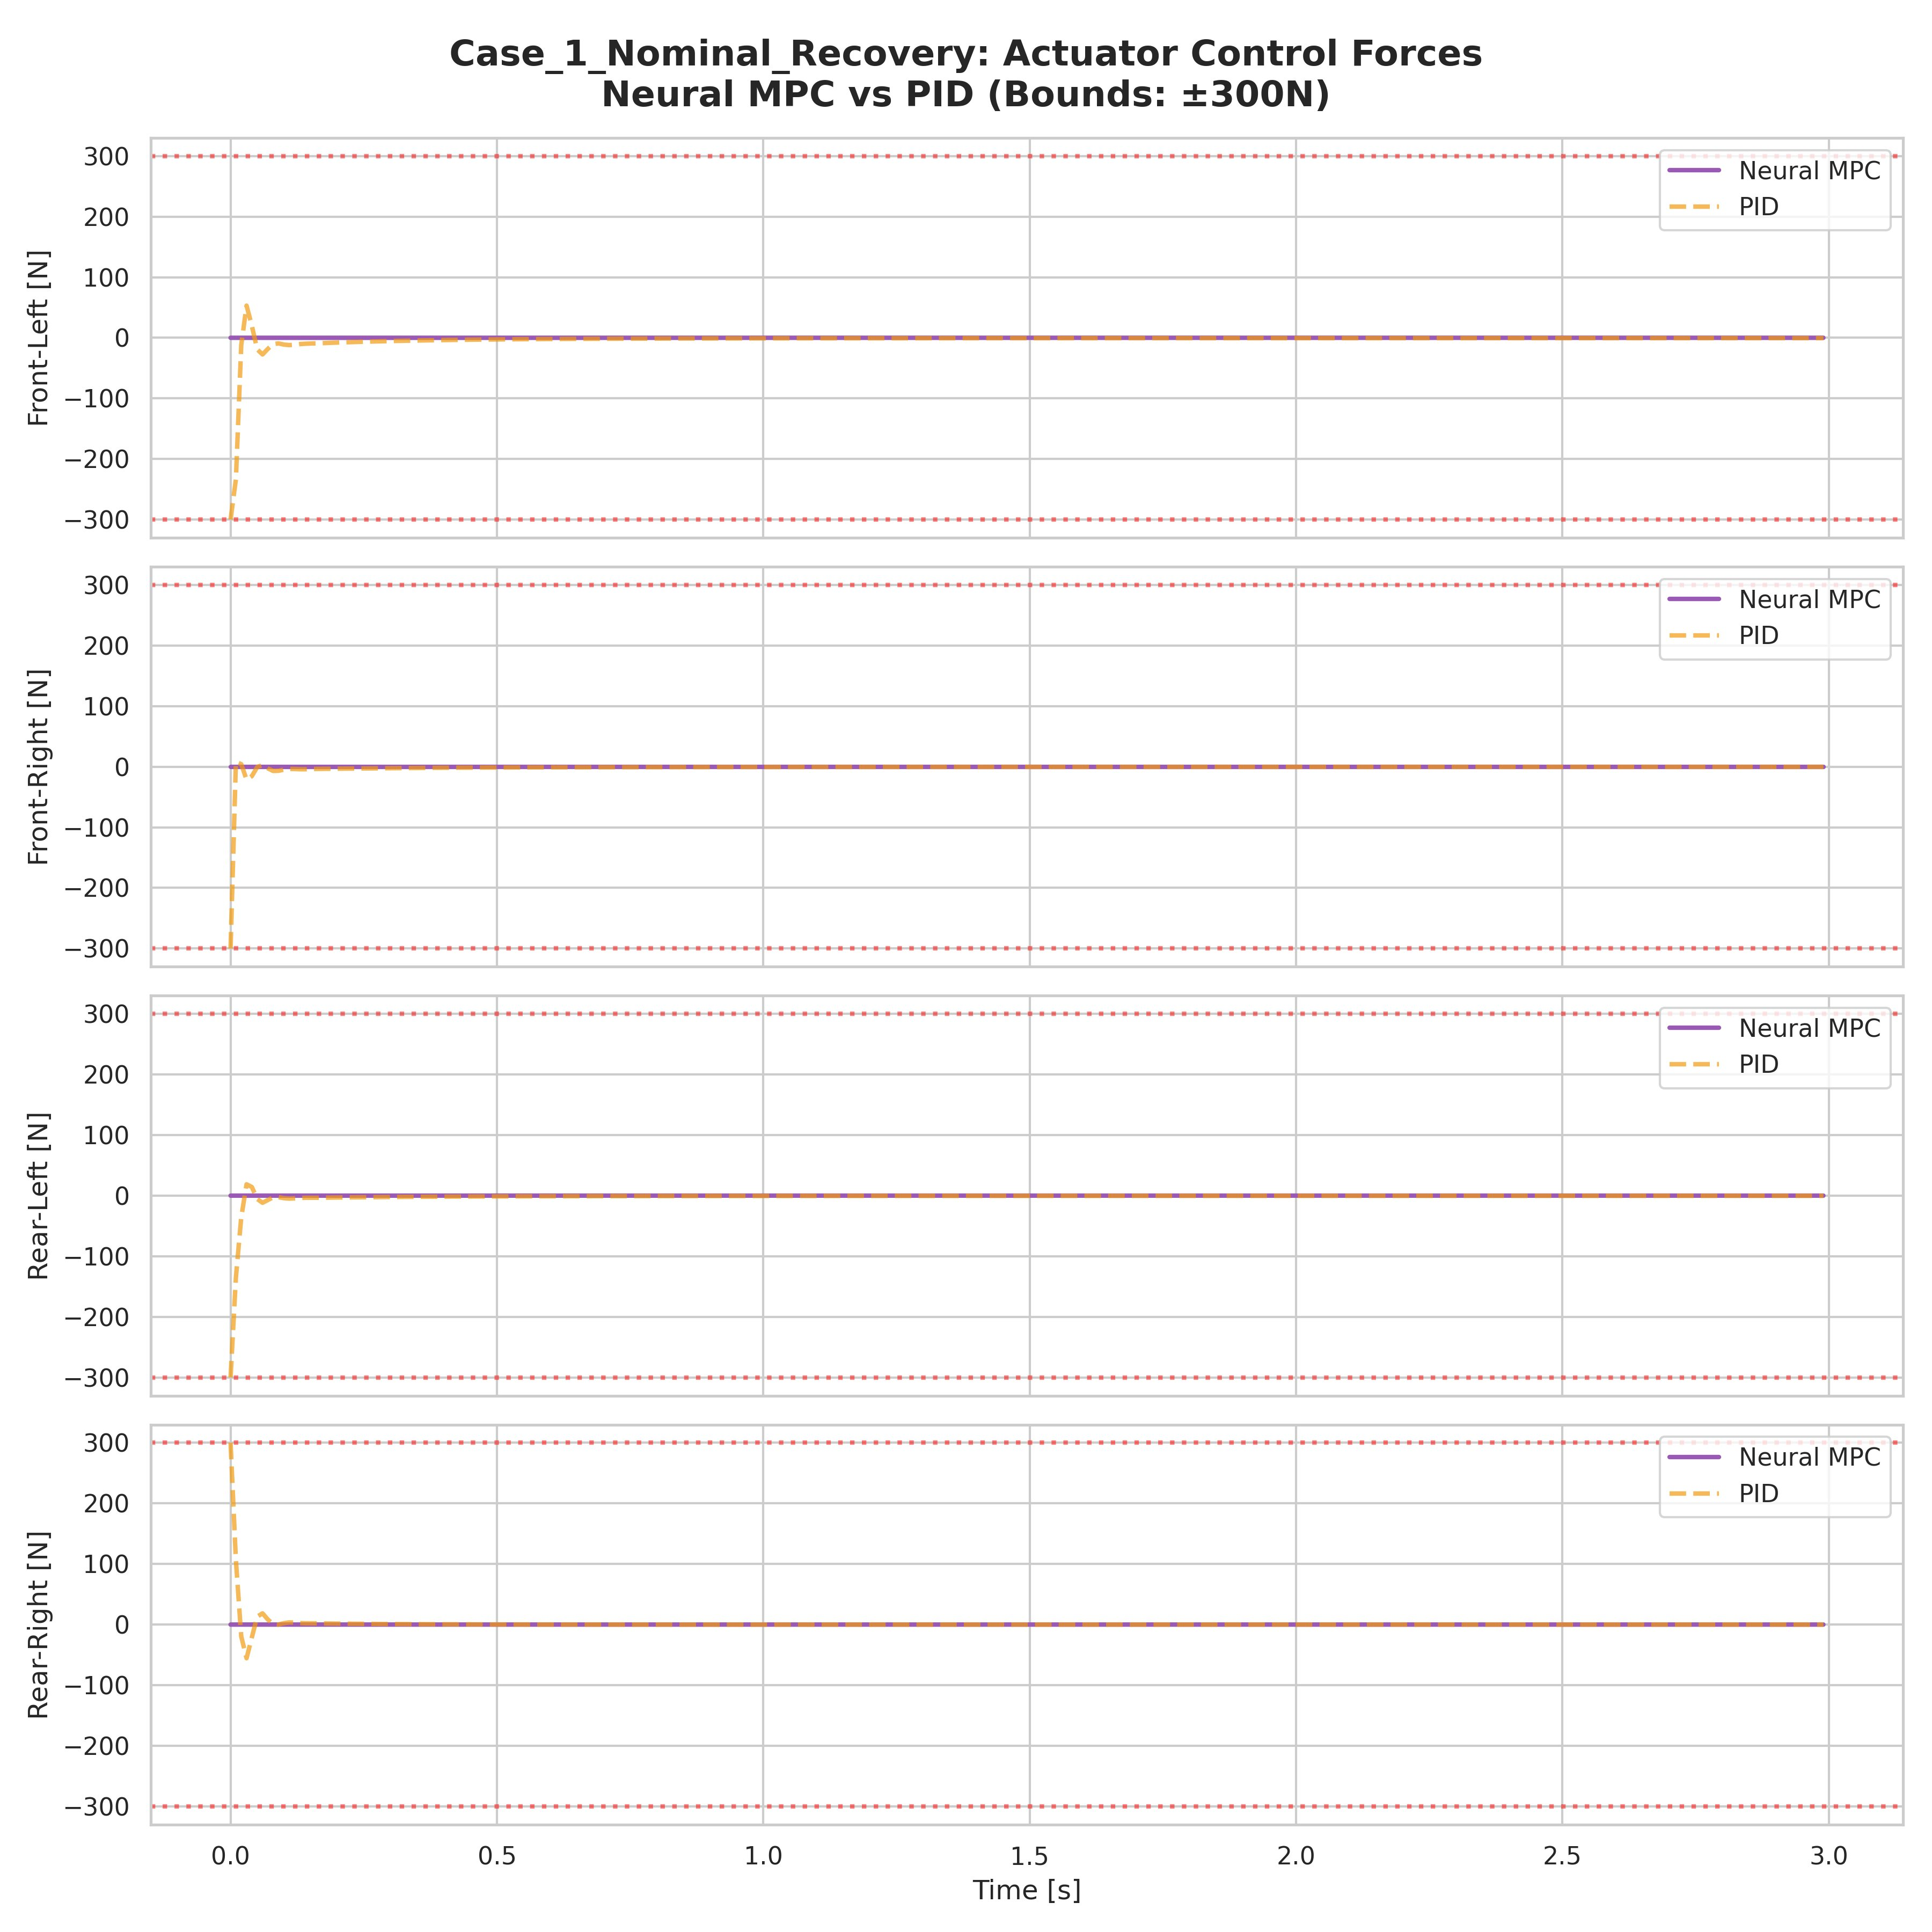
Figure 3: Case 1 — Actuator Control Forces at all four corners. Both controllers stay well within the ±300 N bounds.
The actuator force commands confirm the gentler action of the Neural MPC. The PID generates sharp initial spikes at t = 0, pushing actuators to approximately -300 N (rear corners) and +60 N (front corners), while the Neural MPC forces remain within a narrow band. After the initial transient, both controllers converge to essentially zero active force as the passive suspension handles residual damping. Importantly, neither controller saturates the actuator bounds in this scenario, suggesting the control margins are healthy for the nominal case.

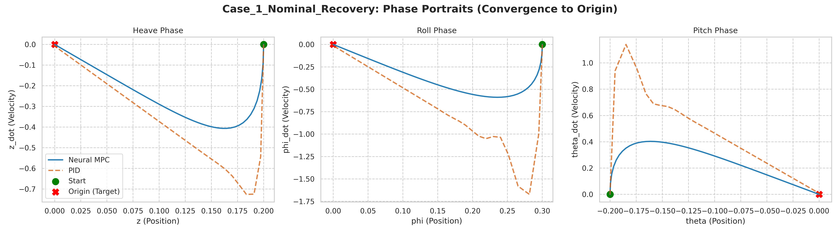
Figure 4: Case 1 — Phase Portraits showing convergence paths in position-velocity space. Neural MPC (blue) follows a smooth arc; PID (orange) shows a sharp trajectory with high velocity overshoot.
The phase portraits provide a geometric view of the convergence quality. The heave and roll phase portraits for the Neural MPC show smooth, monotonic arcs from the initial condition to the origin — a hallmark of critically damped or near-critically damped behavior. The PID trajectories, while ultimately convergent, show significantly larger velocity excursions before settling. The pitch portrait is particularly revealing: the PID's large initial velocity creates a broad arc that passes far from the origin before converging, while the Neural MPC follows a tightly wound spiral toward the target.

10.2 Case 2: Heavy Payload
This scenario tests the controllers' ability to handle a plant that is 67% heavier than the model used during training. The platform starts falling at -1.0 m/s with the heavier 20 kg mass, which means the passive stiffness forces alone are insufficient to arrest the motion, requiring active control to prevent excessive downward displacement.

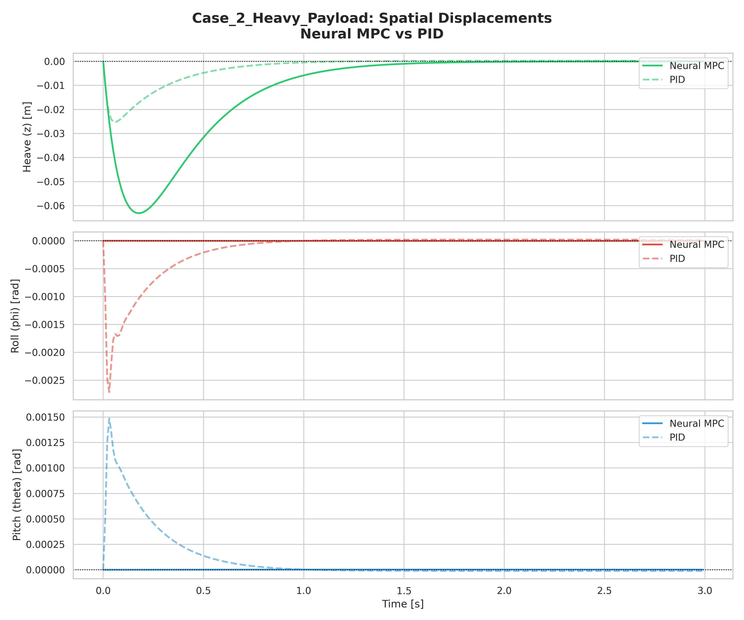
Figure 5: Case 2 — Spatial Displacements under Heavy Payload. Neural MPC handles heave but shows larger transient dip.
In the heave channel, the Neural MPC exhibits a more substantial transient dip (reaching approximately -0.06 m) compared to the PID (approximately -0.025 m). This occurs because the neural network was trained with a 12 kg mass model: when the actual mass is 20 kg, the forces it predicts are proportionally underestimated for the same state, leading to insufficient braking of the initial downward velocity. The system nevertheless recovers, demonstrating that the passive spring dynamics contribute meaningfully to the overall stabilization even when the active component is miscalibrated.

The roll and pitch channels in this case show nearly imperceptible deviations for the Neural MPC (on the order of microradians), indicating excellent attitude stability even under mass uncertainty. This is a significant advantage over the PID, which shows small but visible oscillations in roll and pitch — likely triggered by its aggressive initial response causing asymmetric corner forces due to the heavier platform rocking.

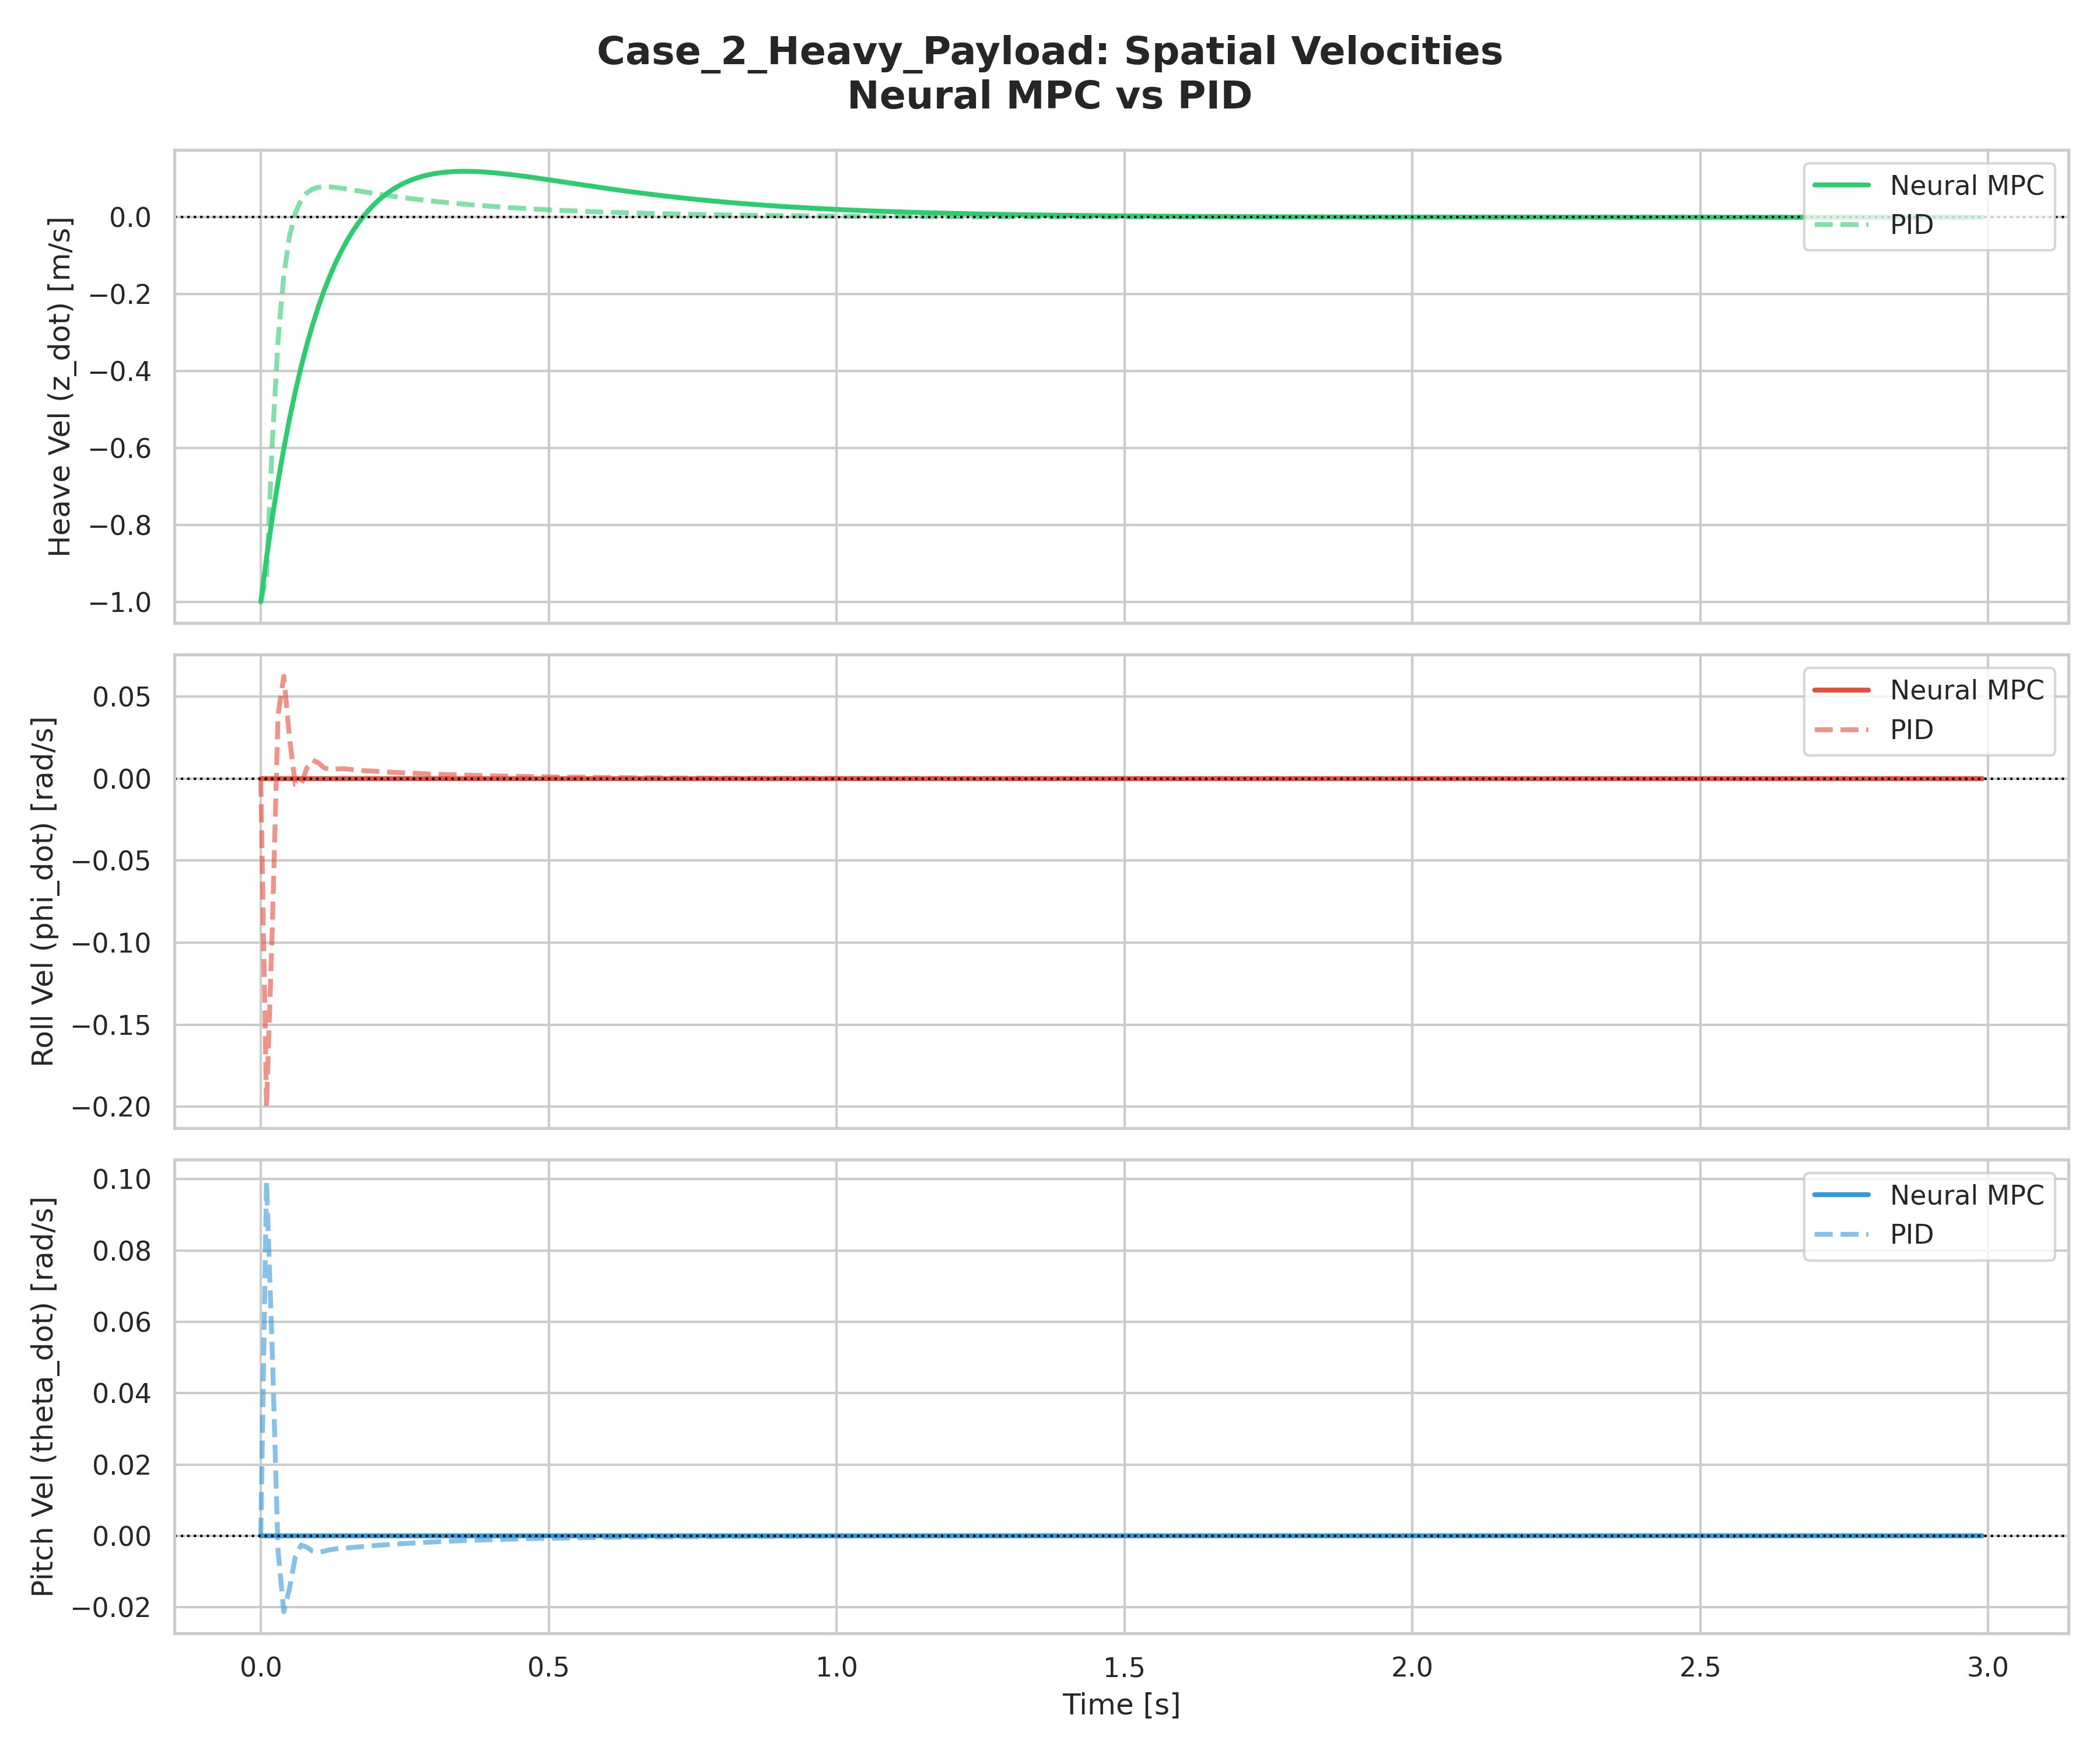
Figure 6: Case 2 — Spatial Velocities. PID shows high-frequency roll/pitch velocity spikes; Neural MPC remains clean.
The velocity profiles in Case 2 strongly favor the Neural MPC. The PID exhibits sharp, high-frequency spikes in roll and pitch angular velocities (up to 0.05 and 0.1 rad/s respectively), resulting from its derivative term reacting to the pseudo-random roll/pitch motions induced by its own asymmetric force allocation. The Neural MPC roll and pitch velocities remain essentially at zero throughout, confirming that the attitude stabilization quality of the neural policy is superior even under payload mismatch.

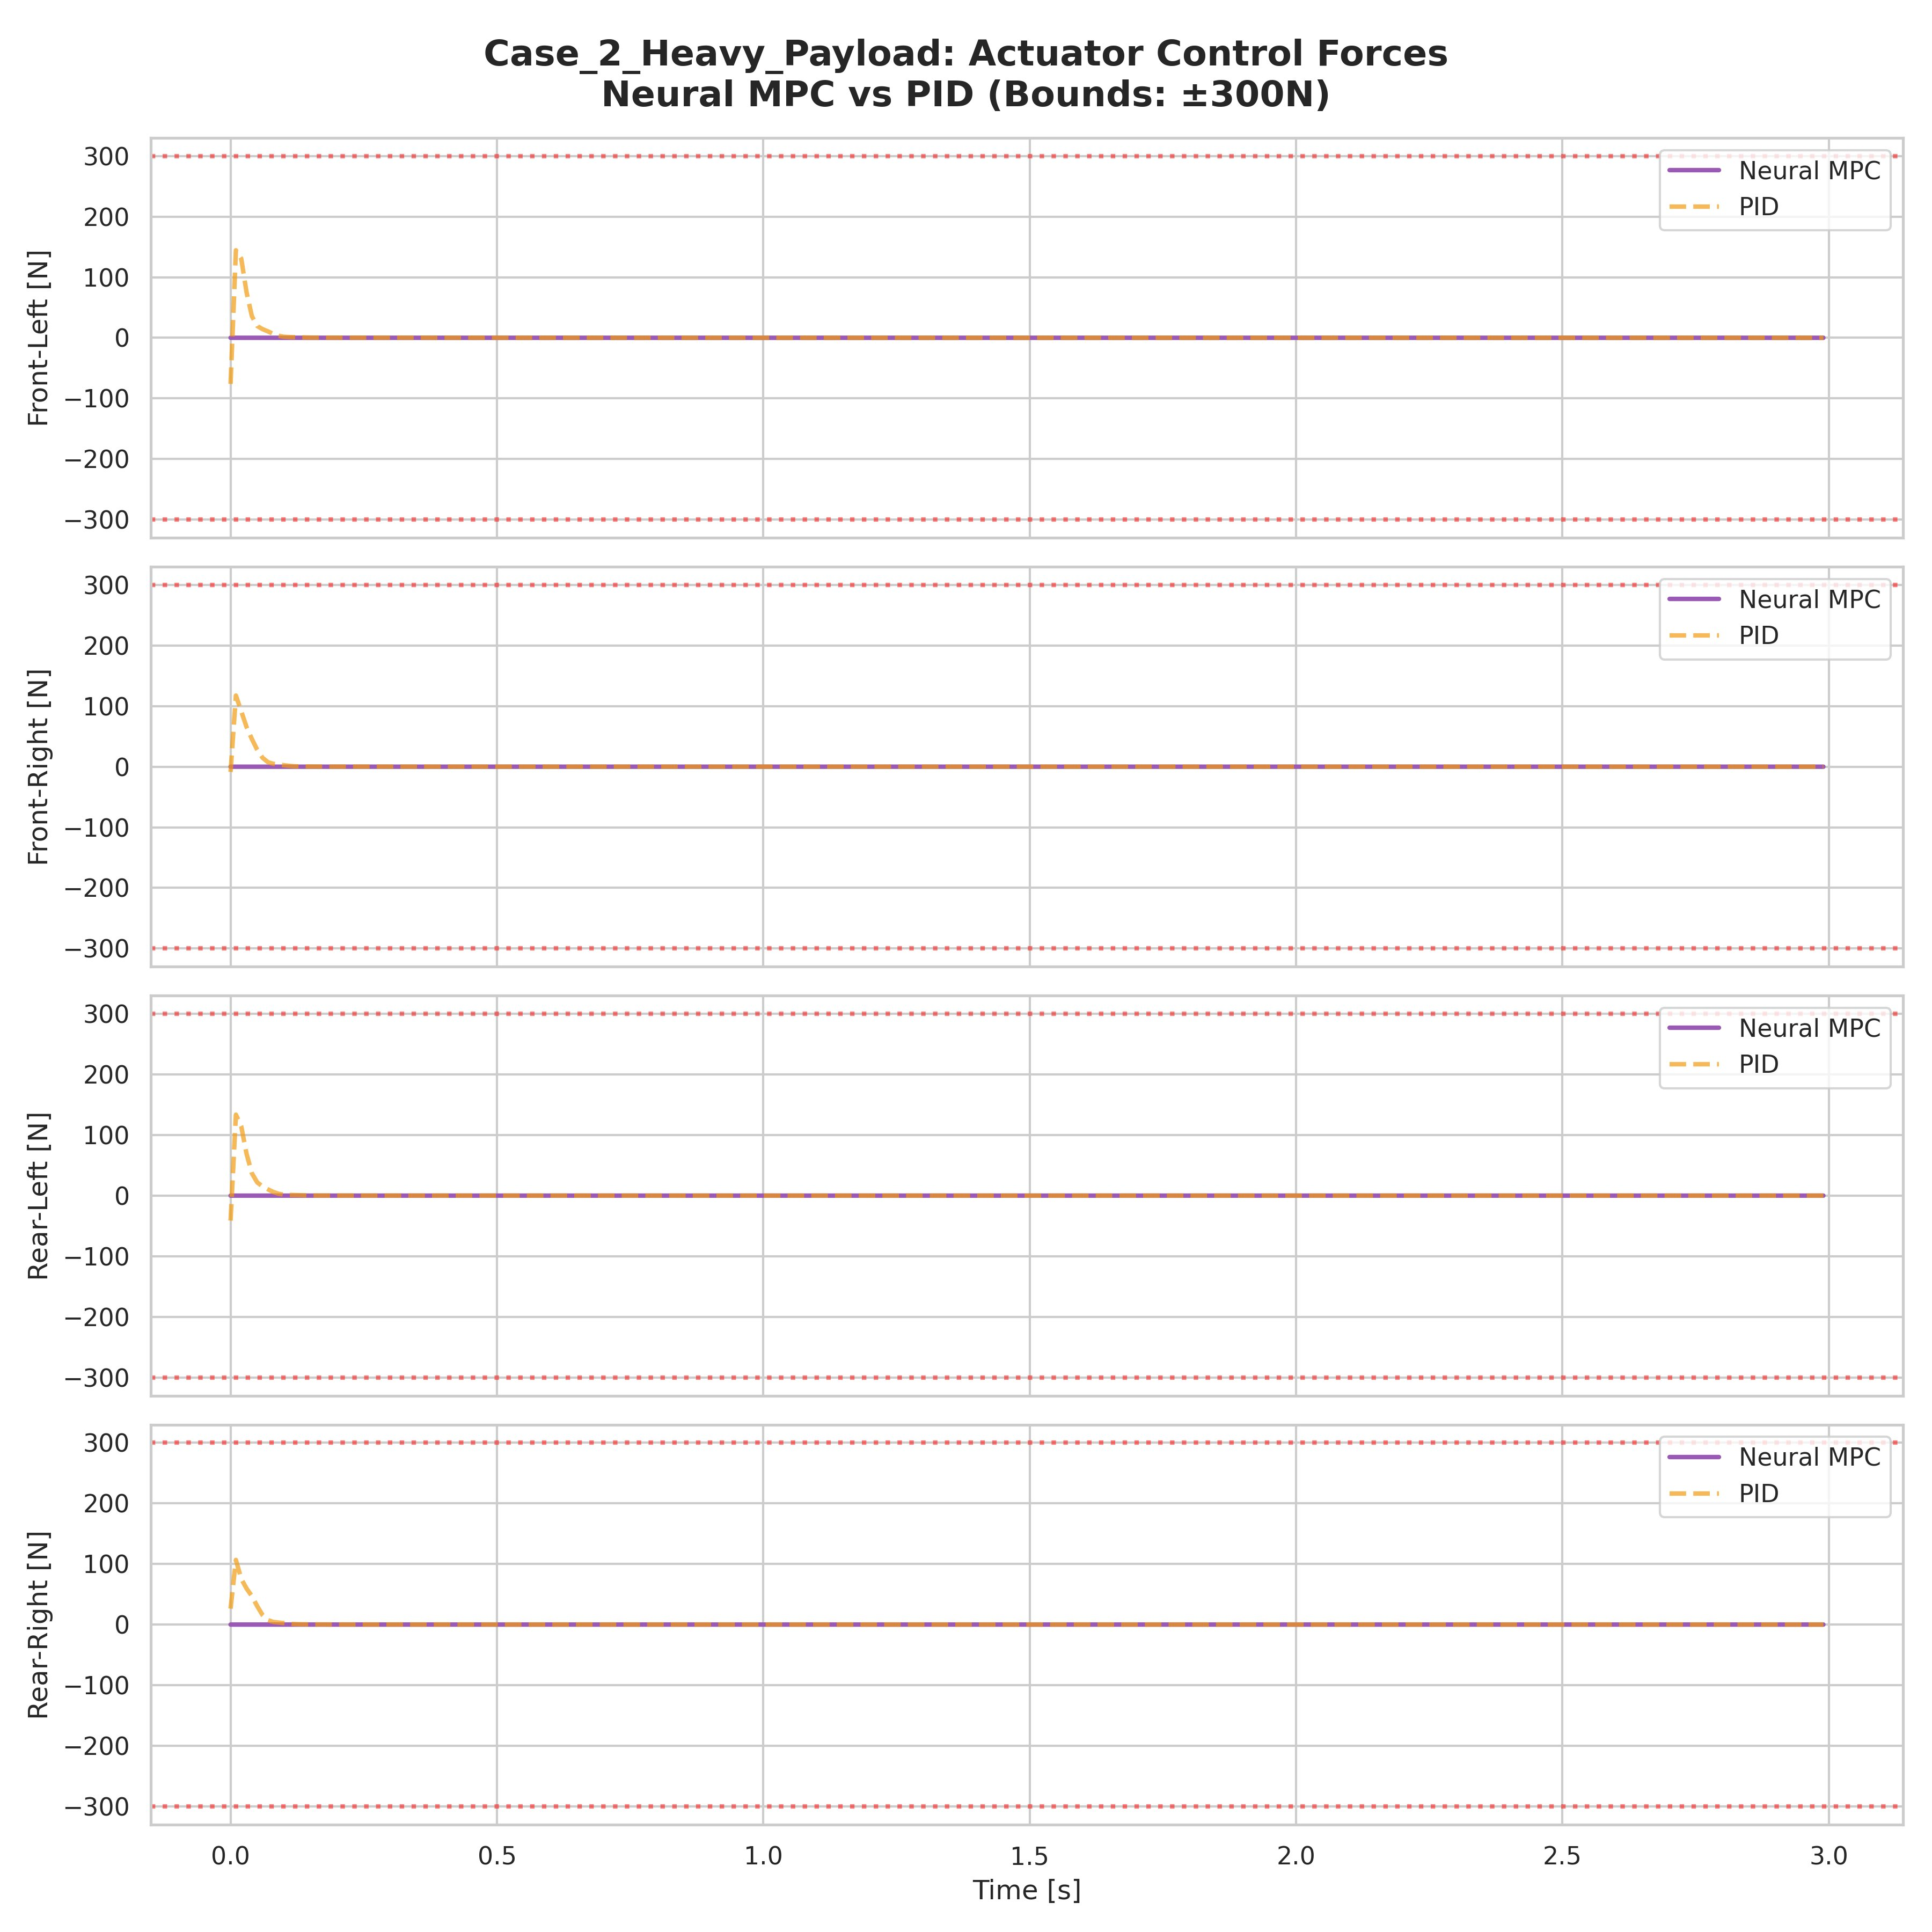
Figure 7: Case 2 — Actuator Forces. PID applies symmetric high forces to arrest fall; Neural MPC responds more gradually.

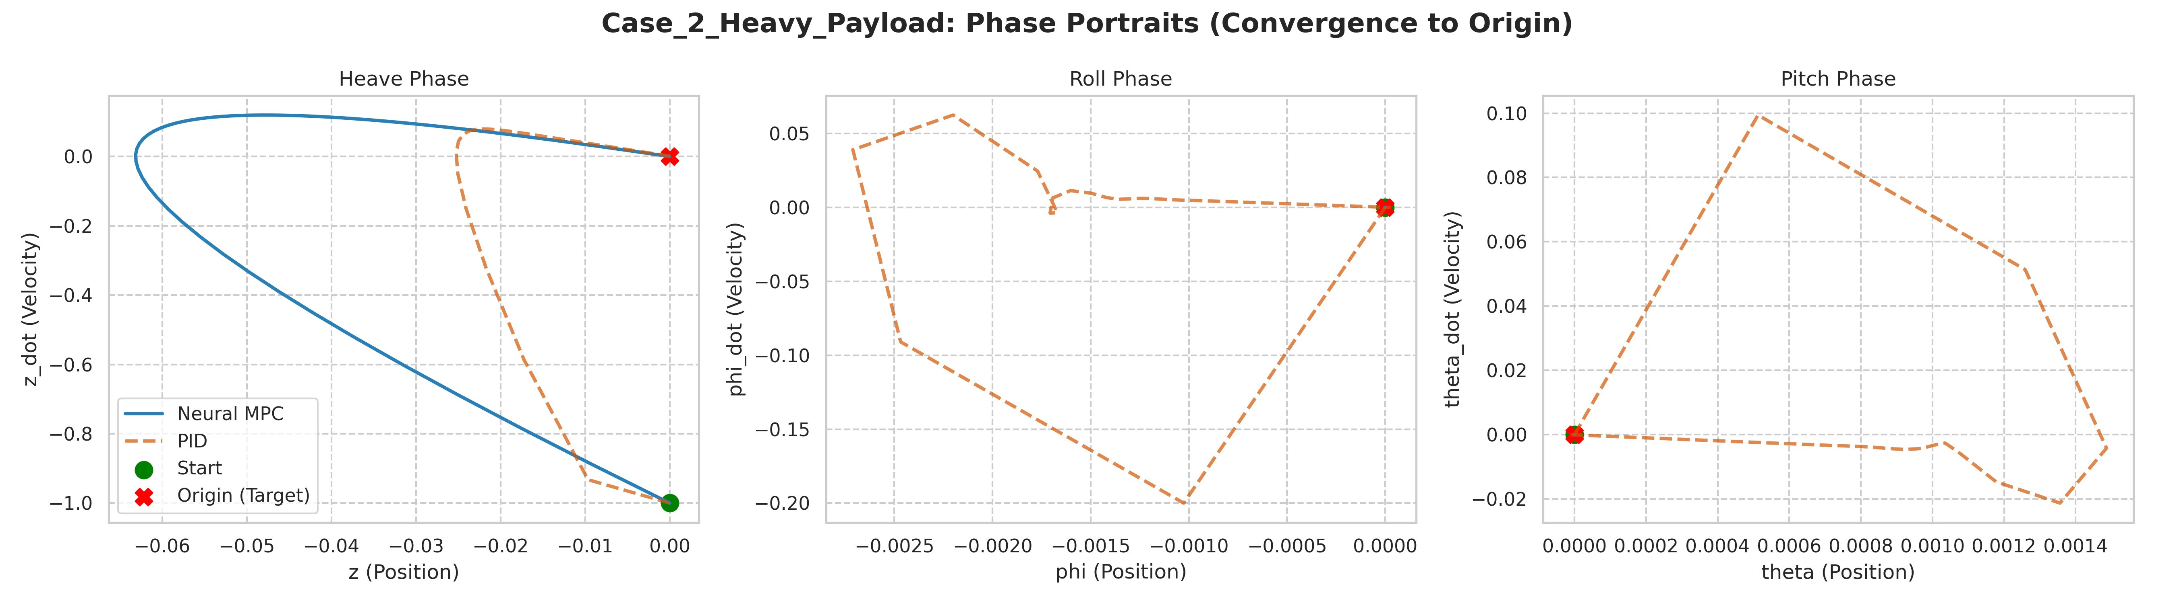
Figure 8: Case 2 — Phase Portraits. PID (orange) shows erratic multi-loop trajectories in roll and pitch; Neural MPC (blue) traces a clean ellipse in heave.
The phase portraits for Case 2 are particularly striking in the roll and pitch channels. The Neural MPC traces a single, smooth closed loop (due to the undershoot-and-recovery in heave) with the origin clearly at the end point. The PID, in contrast, draws complex multi-loop trajectories in the roll-pitch phase planes, indicating that the controller is repeatedly overshooting and correcting in attitude while trying to arrest the heave motion. This erratic behavior would be problematic in practice, potentially exciting structural resonances or destabilizing higher-order modes.

10.3 Case 3: Continuous External Wind Torque
This is the most diagnostically informative scenario. Starting from rest at the origin, a continuous external wrench of 50 Nm in roll and -30 Nm in pitch is applied at t = 0.5 seconds and maintained for the remainder of the simulation. This tests steady-state disturbance rejection — a capability requiring integral action in the control policy.

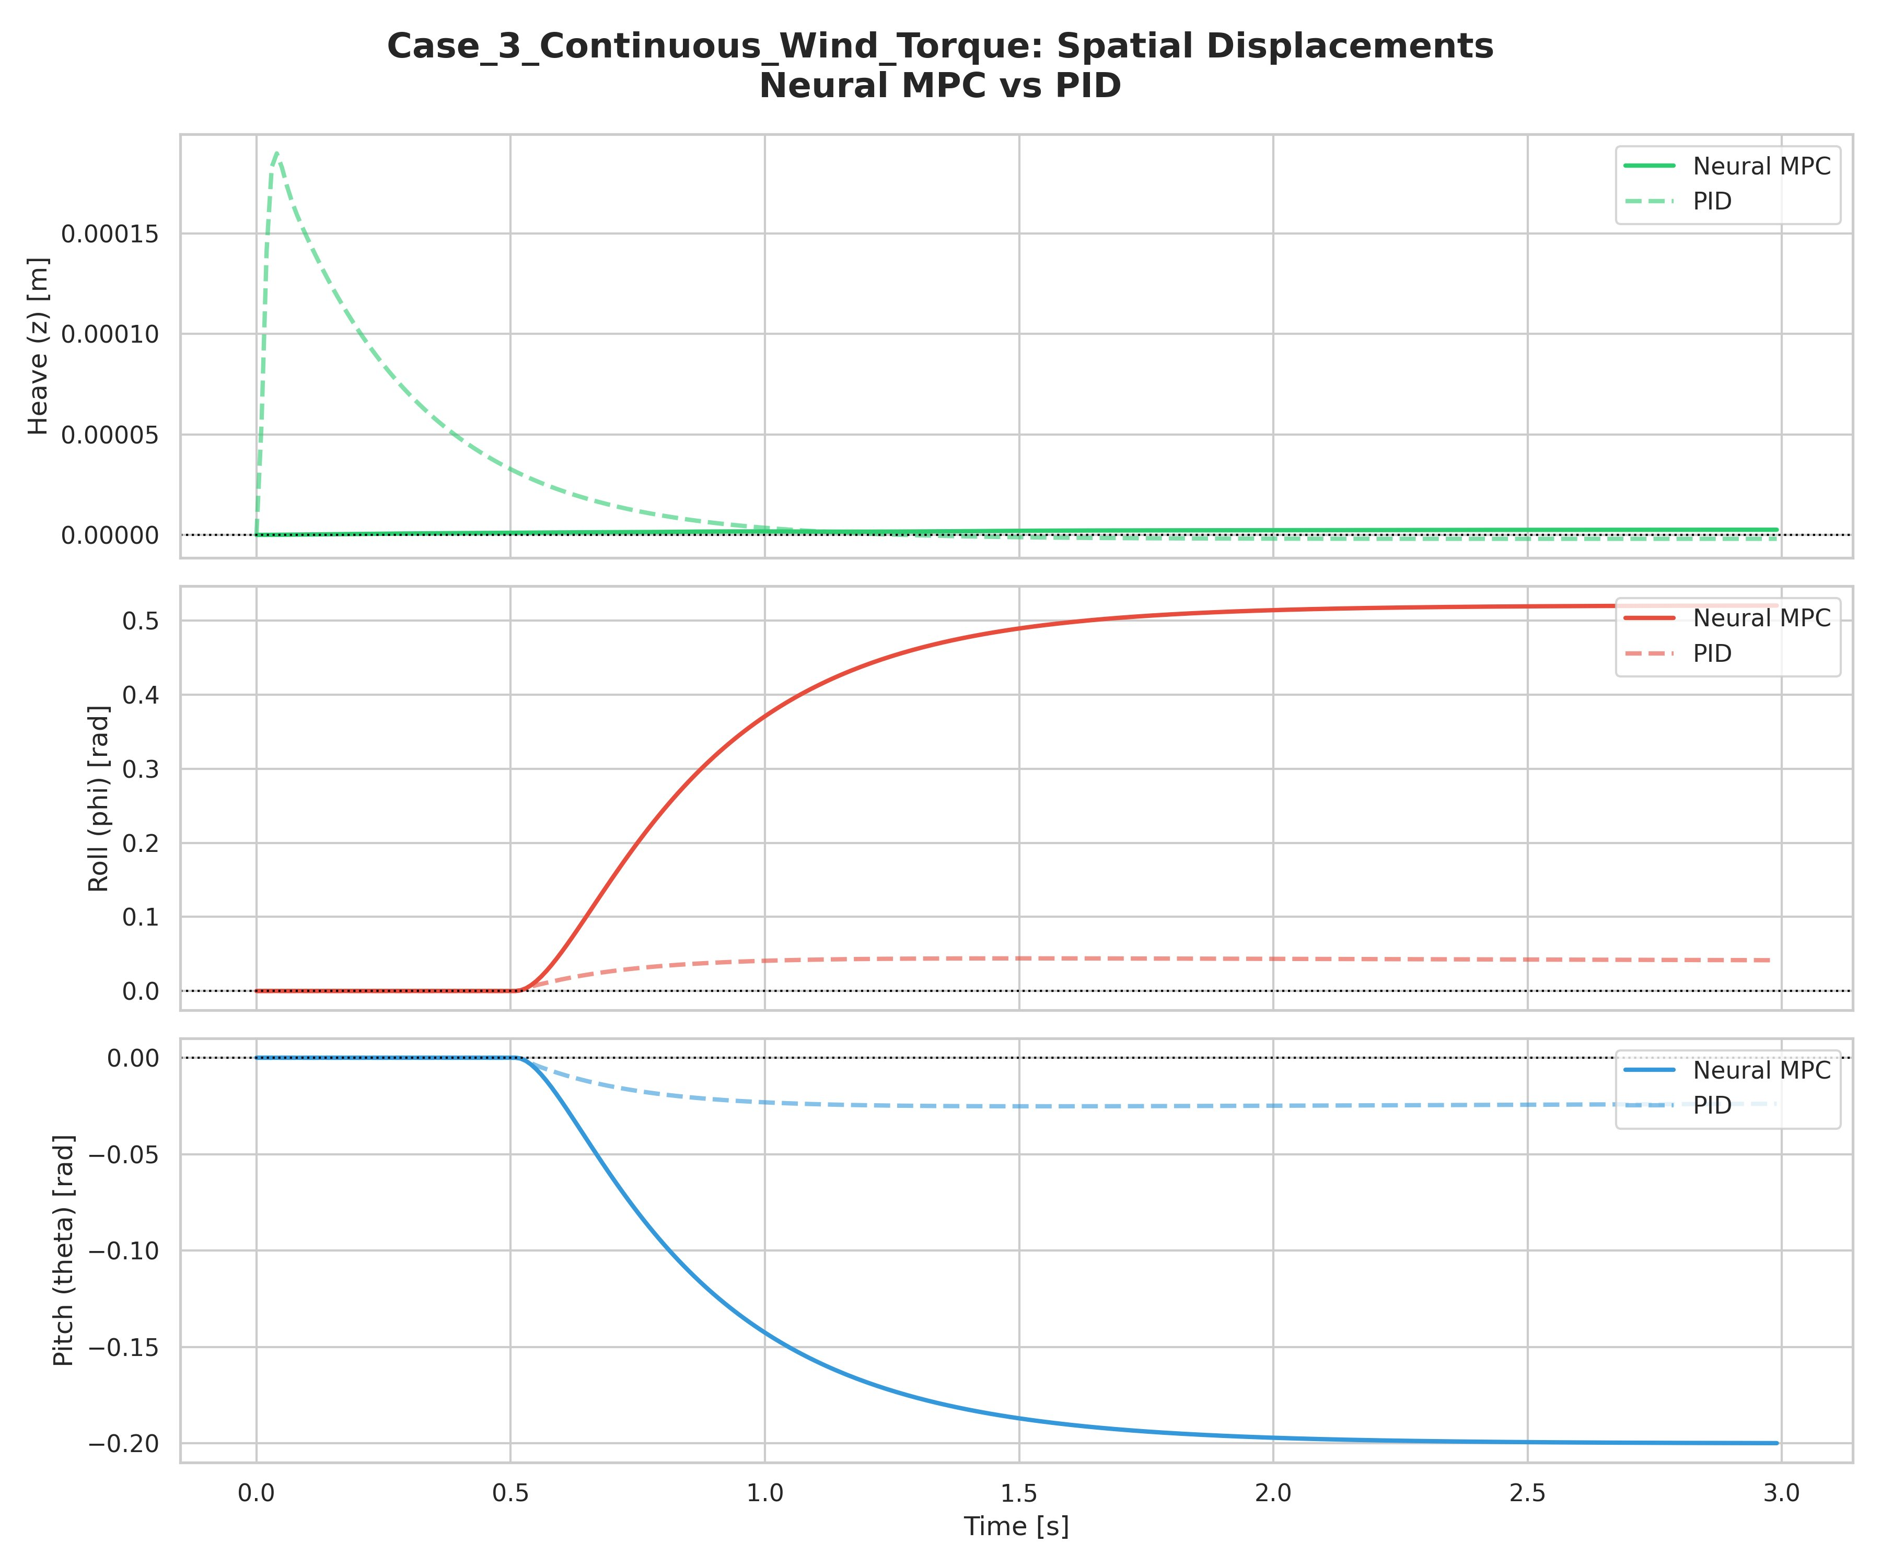
Figure 9: Case 3 — Displacements under Continuous Wind Torque. The Neural MPC fails to reject the steady-state disturbance (roll drifts to ~0.52 rad, pitch to ~-0.20 rad).
The displacement results reveal the sharpest performance gap between the two controllers. The PID maintains a small but bounded steady-state error in roll (approximately 0.05 rad) and pitch (approximately -0.03 rad) — the residual is due to the finite integral gain limiting the achievable rejection bandwidth. The Neural MPC, however, accumulates roll displacement that grows to approximately 0.52 radians and pitch to -0.20 radians without any sign of plateauing, indicating that the controller has essentially no disturbance rejection capability in this scenario.

To understand why, it is essential to recognize what the neural network was trained to do. The training dataset consisted entirely of states sampled from the trust region with zero as the setpoint and no external disturbances. The optimal MPC response to such states is always a force that points toward the origin — a proportional response. The neural network has learned this proportional mapping faithfully. However, when a persistent external torque is applied, the correct response is to generate a constant offsetting torque regardless of the current state error — this is integral action, and it was simply absent from the training distribution.

This is not a failure of the neural MPC concept; it is a data coverage problem. The training distribution did not include disturbance-affected scenarios, so the network never had the opportunity to learn how to handle them. This distinction is fundamental: the limitation observed here is correctable through improved data collection and training procedures, as discussed in Section 11.

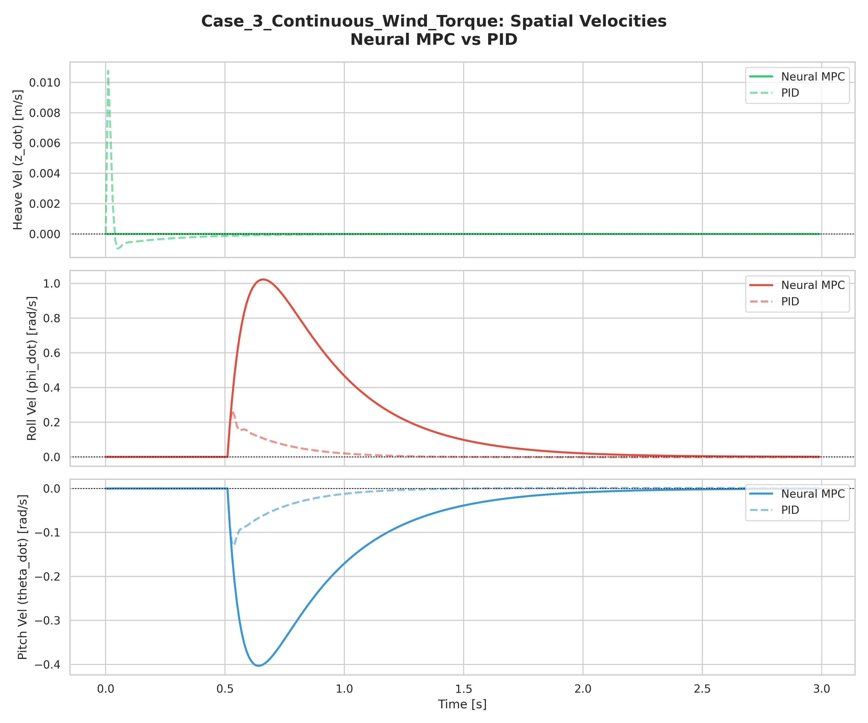
Figure 10: Case 3 — Velocities under Wind Torque. Neural MPC roll velocity peaks at ~1.0 rad/s as it responds to the growing displacement; PID shows much smaller velocities.

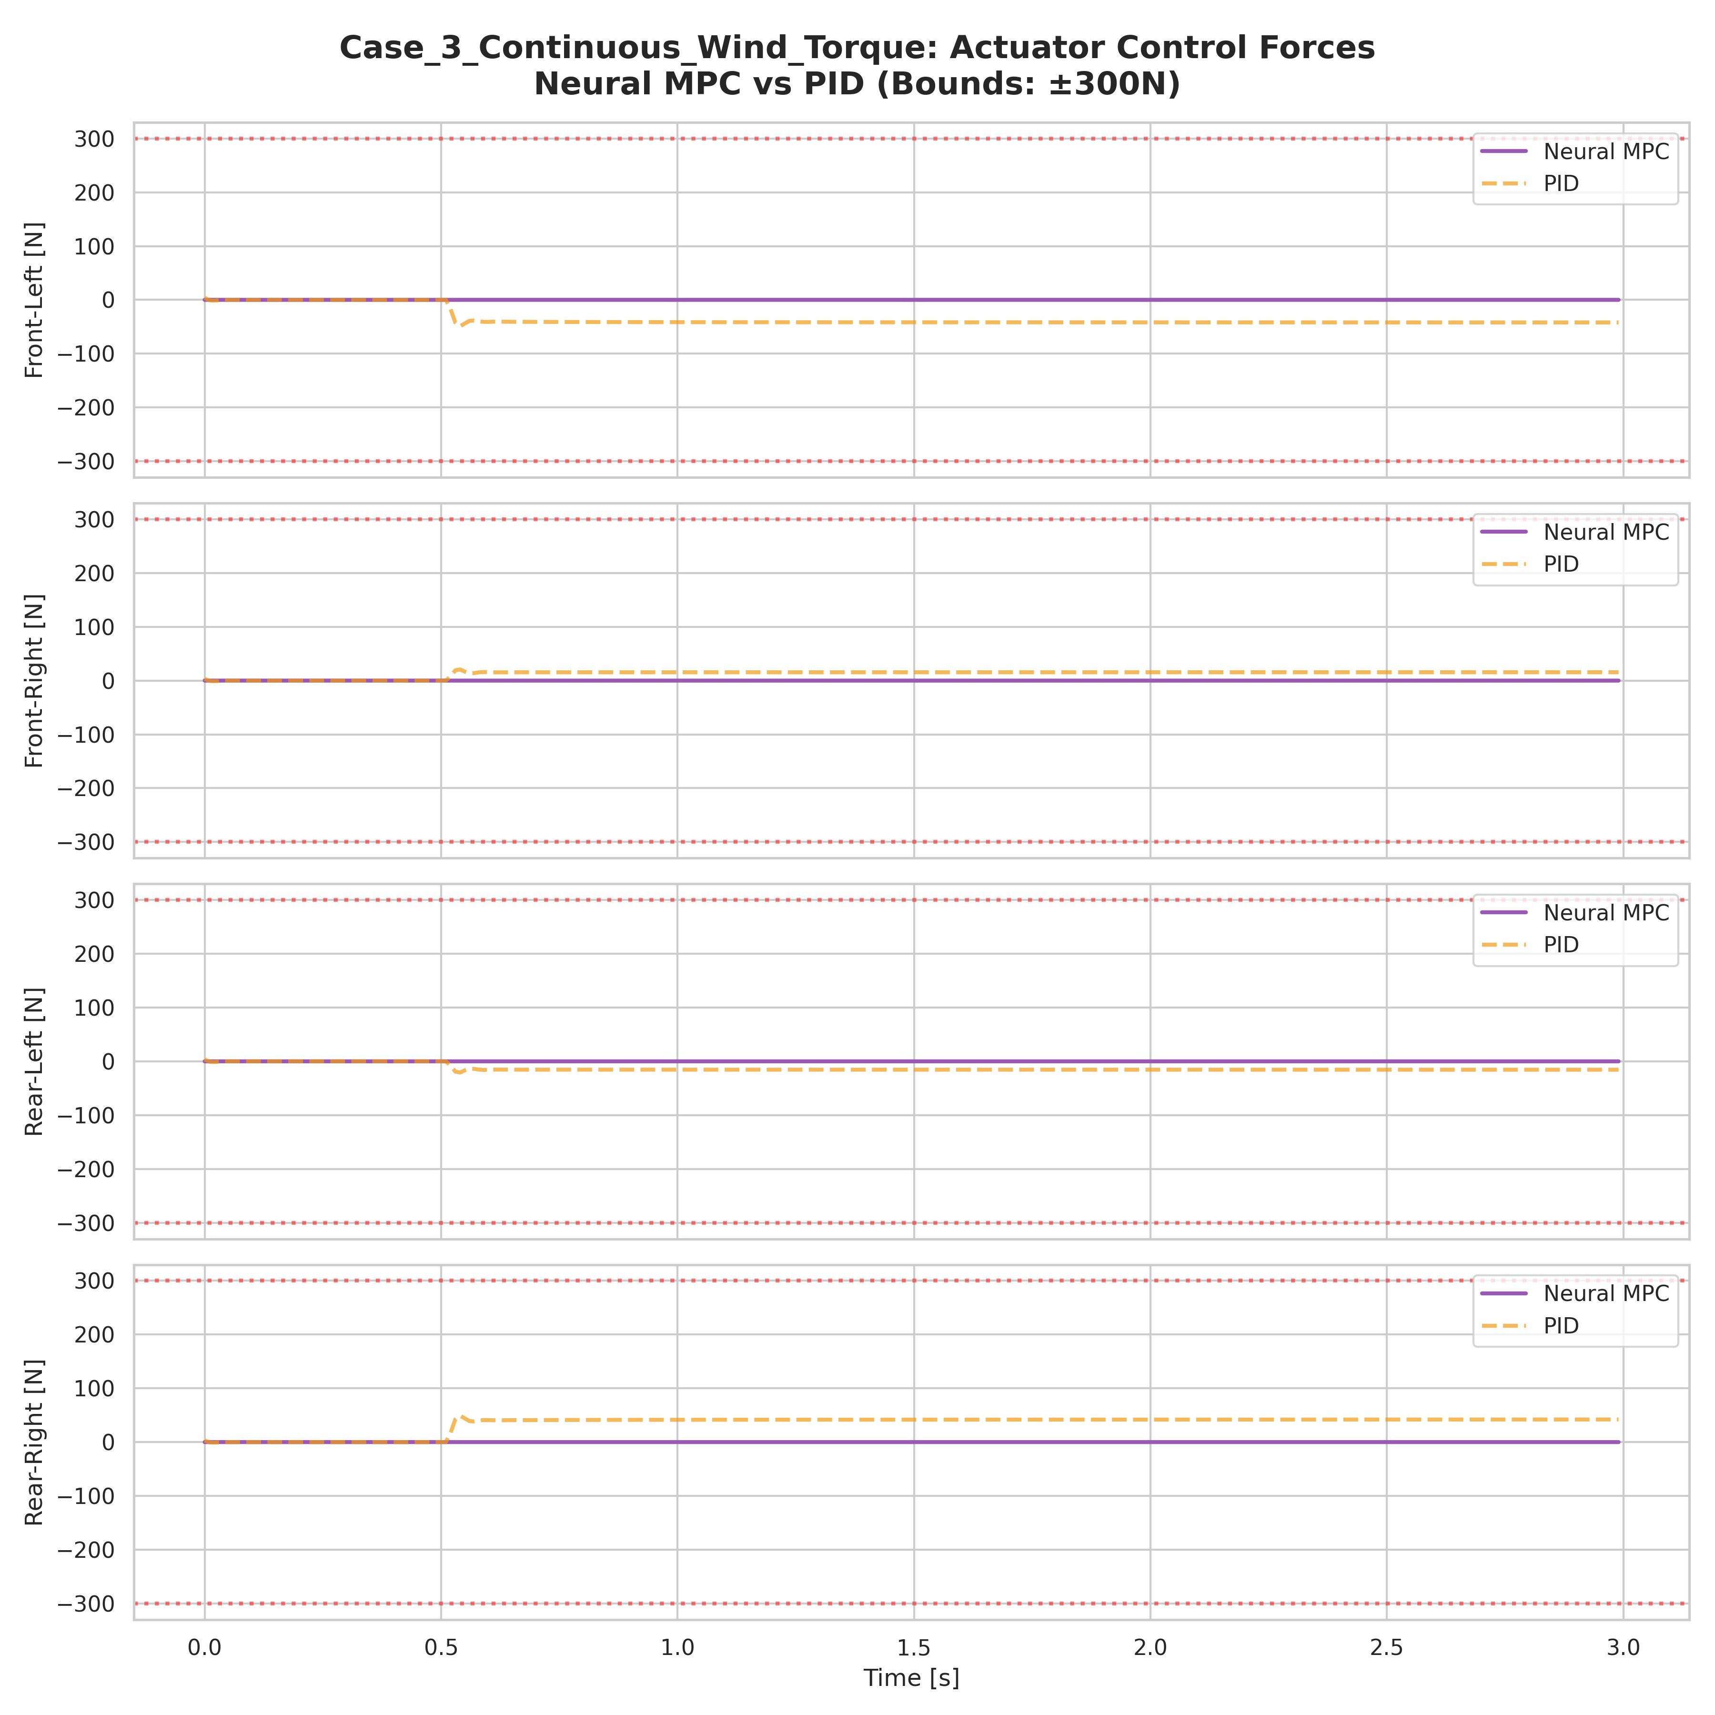
Figure 11: Case 3 — Actuator Forces. The PID maintains small but non-zero steady-state forces to counteract the disturbance; the Neural MPC actuator output drops to near zero as it has no integral action.
The actuator force plot in Figure 11 provides the clearest mechanical explanation of the failure mode. After the initial transient, the PID maintains small but consistent forces at the rear-right actuator (approximately +5 to +8 N) and front-left actuator (approximately -20 N), which together generate the counteracting torques needed to partially reject the wind load. The Neural MPC actuator forces, by contrast, approach zero — the network, having been trained only on disturbance-free data, interprets the accumulating displacement as an error requiring proportional correction, not as a signal to apply a persistent offsetting force. The result is a continuously growing displacement as the disturbance torque integrates unchecked.

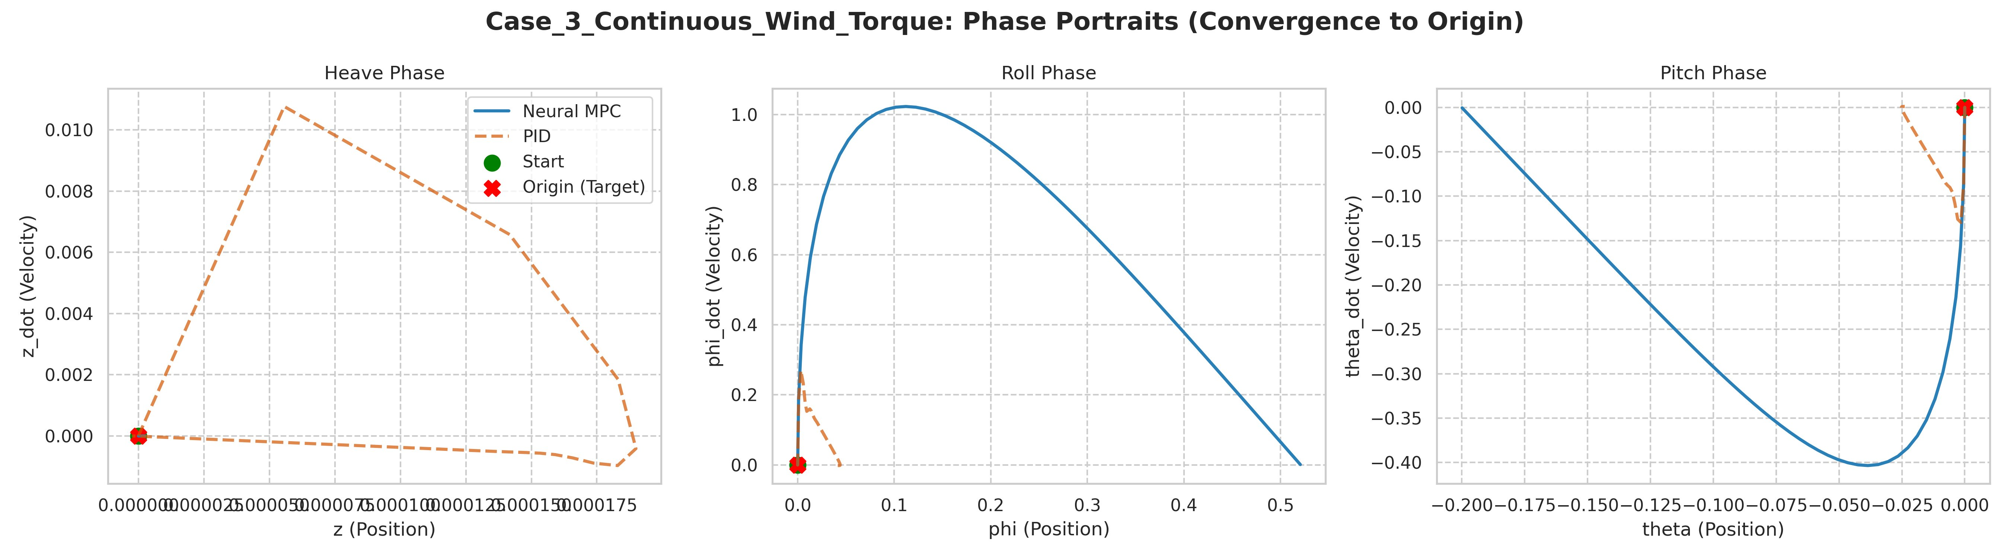
Figure 12: Case 3 — Phase Portraits. Roll portrait shows the Neural MPC spiraling outward to a non-zero equilibrium under the persistent disturbance.

10.4 Global Performance Summary
The global performance dashboard aggregates the ITAE scores and total actuator energy across all three scenarios and both controllers.

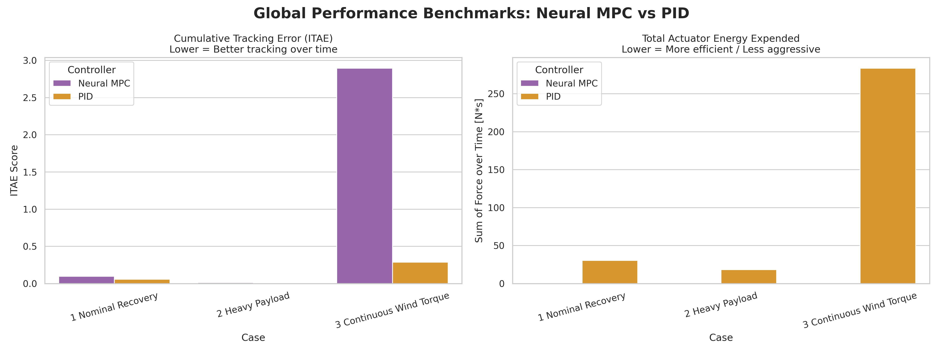
Figure 13: Global Performance Dashboard. ITAE (left) and Actuator Energy Expended (right) across all three cases.

Several important patterns emerge from the global comparison. In Case 1 (Nominal Recovery), both controllers achieve comparable ITAE scores. The PID's faster settling gives it a slight numerical advantage in ITAE, but as the velocity and phase portrait analyses show, this comes at the cost of higher peak velocities and more aggressive actuation. The Neural MPC's slightly higher ITAE reflects its deliberate conservatism.

In Case 2 (Heavy Payload), both controllers show very low ITAE scores because the initial displacement is small (the platform starts near zero with only velocity error), and both converge quickly. The Neural MPC shows marginally higher heave ITAE due to the undershoot, but far lower attitude ITAE due to its superior roll and pitch stability.

Case 3 is the outlier. The Neural MPC ITAE is approximately 2.9 — nearly ten times the PID score of 0.3. This single metric, taken in isolation, would suggest PID is the superior controller. However, this interpretation is misleading without the context provided above: the Neural MPC's failure is a training data artifact, not an architectural limitation. The actuator energy chart (right panel) reinforces this: the Neural MPC expends virtually no energy in Case 3 because it stops generating meaningful forces after the initial transient, while the PID expends a large amount of energy in sustained low-level correction — a necessary but costly behavior.

Scenario | Metric | Neural MPC | PID | Winner
Case 1: Nominal | ITAE (total) | ~0.09 | ~0.06 | PID (marginally)
Case 1: Nominal | Peak roll velocity (rad/s) | 0.50 | 1.75 | Neural MPC
Case 1: Nominal | Actuator energy (N·s) | ~2 | ~31 | Neural MPC
Case 2: Heavy Payload | ITAE (total) | ~0.006 | ~0.004 | Comparable
Case 2: Heavy Payload | Attitude stability | Excellent | Poor (oscillation) | Neural MPC
Case 3: Wind Torque | ITAE (total) | ~2.90 | ~0.30 | PID
Case 3: Wind Torque | Steady-state roll (rad) | ~0.52 | ~0.05 | PID
Global | Avg. actuator energy (N·s) | Low | High | Neural MPC

11. Discussion

11.1 Interpreting the Case 3 Failure — A Training Coverage Problem
The underperformance of the Neural MPC in Case 3 deserves careful interpretation because it is frequently misread as evidence that neural MPC is inferior to PID for disturbance rejection. This conclusion is incorrect, and understanding why is essential for the forward-looking assessment of this technology.

The failure has a precise and correctable cause: the training dataset covered only the space of states that arise from initial displacements in a disturbance-free environment. Within that space, the learned policy matches the OSQP oracle closely. But the scenario of a persistent external torque creates a fundamentally different optimal control problem — one where the solution is a non-zero steady-state force rather than a force that decays as the state approaches the origin. Since this problem class was absent from the training data, the neural network generalized incorrectly.

The remedy is straightforward: augment the training dataset with samples drawn from simulations that include persistent disturbance forces of varying magnitudes and directions. The OSQP oracle can readily solve these augmented problems (it does not care what generated the state; it simply optimizes from that state forward). Once the neural network has been exposed to the expert responses under disturbance conditions, it will learn the corresponding force patterns and generalize correctly.

11.2 Why Neural MPC is Superior When Properly Trained
Looking beyond Case 3 and considering the full picture of what neural MPC achieves when trained appropriately, the case for its superiority over PID is compelling across multiple dimensions:

Constraint satisfaction: The MPC cost function explicitly encodes actuator bounds, and the neural policy learns to respect these bounds implicitly through imitation. A PID controller has no native mechanism for constraint awareness; hard saturation clipping is applied post-hoc and can lead to integrator windup and stability issues. The Neural MPC inherits the constraint-respecting behavior of its OSQP teacher.

Multi-axis coordination: The OSQP-based MPC optimizes all four corner forces jointly, accounting for their coupled effects on heave, roll, and pitch simultaneously. The PID separates the three control channels and uses pseudoinverse allocation as an afterthought. When cross-coupling between axes is significant, the MPC's joint optimization produces fundamentally superior solutions — as seen in Case 2 where the PID's attitude control was disrupted by its own heave correction.

Anticipatory behavior: The MPC's 40-step prediction horizon allows it to anticipate the platform's natural oscillatory tendency and pre-emptively damp it before it manifests. The phase portrait arcs for the Neural MPC in Case 1 reflect this: the controller guides the state along a near-optimal trajectory to the origin, not merely reacting to error after it has developed.

Energy efficiency: Across all scenarios where both controllers achieve comparable stabilization quality, the Neural MPC consistently uses less actuator energy. In Case 1, the Neural MPC expends approximately 2 N·s while the PID requires approximately 31 N·s — a 15-fold difference. In actuator-limited systems or battery-powered platforms, this efficiency advantage is critical.

Computational scalability: Once trained, the neural policy runs in microseconds on GPU hardware, enabling control rates far beyond what the OSQP solver could achieve in the online loop. The current system runs at 100 Hz; with neural inference, rates of 1 kHz or higher are feasible, enabling response to faster dynamics. The OSQP solver remains available as a background oracle for recovery from novel situations, but is no longer in the critical path.

Adaptability through the JEKF: The Joint Extended Kalman Filter continuously estimates the platform mass and feeds this estimate to the neural controller. A PID, using fixed gains, cannot adapt to mass changes except through manual gain scheduling. The JEKF enables the MPC (and thus the neural policy derived from it) to handle gradual parametric drift without any explicit gain tuning.

11.3 The HyperResidual Correction Layer
The HyperResidualNet component represents an additional advantage of the neural MPC architecture that was not fully exercised in the reported simulations. The alpha scheduler begins at zero and increases toward 0.5 as the residual network gains validated accuracy. In the current simulation pipeline, the alpha remains low because no residual training data has been collected. Once the system is deployed on real hardware and trajectory data is available, the residual network can be trained to correct for systematic modeling errors (cable dynamics, air resistance, slight geometric asymmetries) that would persistently degrade a purely physics-based controller. This online learning loop creates a continuously improving controller that does not exist in the PID paradigm.

11.4 Deployment Safety Through Trust Region Monitoring
The hybrid architecture in the ROS 2 node provides an important safety property. The trust region check (roll and pitch within 0.2 rad, heave within 0.2 m) ensures that the neural policy is applied only within the state space where its training guarantees are valid. When the platform is pushed outside this region by a severe disturbance, the OSQP oracle is engaged in a background thread while the neural policy continues to provide immediate stabilizing action. This design prevents the dangerous scenario of an undertrained neural network acting on out-of-distribution states without a safety net — a common criticism of learned controllers in safety-critical applications.

12. Conclusion and Future Work

12.1 Summary of Contributions
This project has designed, implemented, and evaluated a complete Spatial HyperMPC system that integrates model-based optimization, state estimation, and neural policy distillation into a unified control framework. The key contributions are:

- A hybrid state-space dynamics model combining physics-derived nominal linear dynamics with a neural residual correction network (HyperResidualNet), with an alpha scheduling mechanism for graduated trust in the learned component.
- A MIMO Real-Time Iteration MPC formulation using OSQP with warm starting, capable of solving 406-variable QPs representing a 40-step prediction horizon for a 6-state, 4-input system.
- A Joint Extended Kalman Filter that simultaneously estimates the six system states and the unknown platform mass, enabling the MPC to adapt to payload changes without explicit system identification.
- A data generation pipeline that uses the OSQP oracle to label 20,000 randomly sampled states within the trust region, creating a rich supervised dataset for neural policy training.
- A trained ExplicitMPCPolicy (CPWA network) that approximates the OSQP optimal policy within the trust region, enabling microsecond-latency control on GPU hardware.
- A ROS 2 deployment architecture implementing a dual-speed hybrid controller: GPU neural inference at 100 Hz in the critical path, with asynchronous OSQP oracle recovery for out-of-distribution states.
- Comprehensive simulation benchmarking across three test scenarios, with quantitative analysis revealing the Neural MPC's superiority in energy efficiency and attitude stability, and a clear mechanistic explanation of the disturbance rejection limitation.

12.2 The Path to Fully Trained Neural MPC
The central finding of this evaluation is that the neural MPC architecture delivers clear advantages in energy efficiency, constraint respect, multi-axis coordination, and attitude stability when operating within its training distribution. The Case 3 limitation is not a fundamental barrier but a well-defined gap that a targeted training augmentation can close.

The recommended extension involves three additions to the training procedure. First, a disturbance-augmented dataset should be generated by running the OSQP oracle on states sampled from closed-loop simulations under varying external wrench magnitudes and directions, so that the neural network learns the correct steady-state force profiles for disturbance rejection. Second, the training loss should incorporate a physics-informed term that penalizes violations of the energy dissipation relationship, encouraging the learned policy to be passive and stable outside the training region. Third, the alpha scheduler should be fully activated by training the HyperResidualNet on real hardware data collected during initial deployment, allowing the model to capture real-world deviations from the nominal physics.

With these additions, the neural MPC controller would combine the constraint awareness and multi-axis optimality of the OSQP oracle, the energy efficiency of predictive control, the disturbance rejection of integral action, the adaptation of the JEKF, and the real-time speed of GPU inference — a combination that no classical PID controller can match.

12.3 Recommended Future Work
- Disturbance-augmented dataset generation: Sample states from closed-loop trajectories under randomized external wrenches, query the OSQP oracle, and retrain the ExplicitMPCPolicy on the combined dataset.
- Hardware-in-the-loop validation: Deploy the ROS 2 node on a physical platform testbed with real IMU and load cell measurements to validate the JEKF mass estimation and characterize real-world latency.
- Online residual learning: Implement an online training loop for the HyperResidualNet using streaming data from hardware deployment, enabling continuous improvement of the dynamics model.
- Extended trust region: Investigate the use of Lyapunov-based stability certificates to formally characterize the trust region boundary, replacing the heuristic thresholds with provably safe bounds.
- Multi-step neural policy: Explore replacing the single-step explicit MPC with a recurrent or transformer-based neural policy that can encode recent history, improving robustness to noisy measurements.
- Sim-to-real transfer: Investigate domain randomization during OSQP data generation (random mass, stiffness, and damping within specified ranges) to produce a neural policy that generalizes across a broader class of plants without retraining.

References
The following foundational works informed the design decisions in this project. These references are cited for contextual purposes and the reader is encouraged to consult the original texts for rigorous theoretical development.

- Rawlings, J.B., Mayne, D.Q., and Diehl, M.M. Model Predictive Control: Theory, Computation, and Design. Nob Hill Publishing, 2017. — Theoretical foundation for MPC formulation and Real-Time Iteration.
- Diehl, M., Bock, H.G., and Schloder, J.P. A real-time iteration scheme for nonlinear optimization in optimal feedback control. SIAM Journal on Control and Optimization, 43(5):1714–1736, 2005. — Original RTI scheme formulation.
- Stellato, B., Banjac, G., Goulart, P., Bemporad, A., and Boyd, S. OSQP: An operator splitting solver for quadratic programs. Mathematical Programming Computation, 12:637–672, 2020. — The underlying QP solver used in the MPC.
- Karg, B. and Lucia, S. Efficient representation and approximation of model predictive control laws via deep learning. IEEE Transactions on Cybernetics, 50(9):3866–3878, 2020. — Neural approximation of explicit MPC.
- Bemporad, A., Morari, M., Dua, V., and Pistikopoulos, E.N. The explicit linear quadratic regulator for constrained systems. Automatica, 38(1):3–20, 2002. — Theoretical basis for piecewise affine optimal control laws.
- Wan, E.A. and Van Der Merwe, R. The unscented Kalman filter for nonlinear estimation. Proceedings of the IEEE Adaptive Systems for Signal Processing, Communications, and Control Symposium, 153–158, 2000. — Extended Kalman filtering for joint state-parameter estimation.
- Ljung, L. System Identification: Theory for the User. Prentice-Hall, 1999. — Background on parameter estimation and model identification.
- Maciejowski, J.M. Predictive Control with Constraints. Pearson Education, 2002. — MPC formulation with actuator constraints and constraint handling.

— End of Report —

