Solutions LINFO2144 - TP6

Made by students from TPs notes. Nothing has been corrected by teachers or TAs so there is no guarantee of correctness and completeness.
Generative AI has been used, be aware that there might be mistakes. At least this is still better than not having any solutions at all !

1. Spacial Bounds
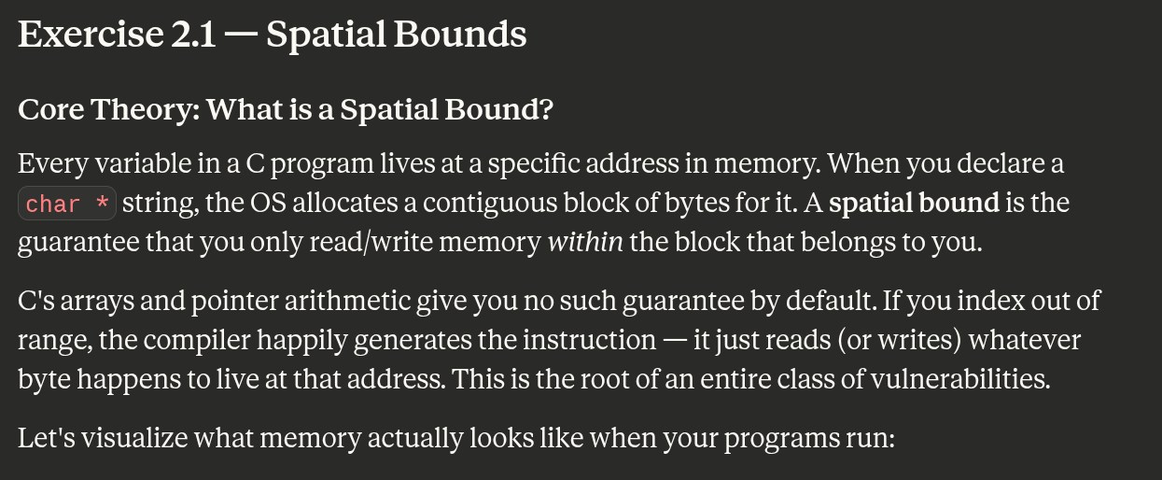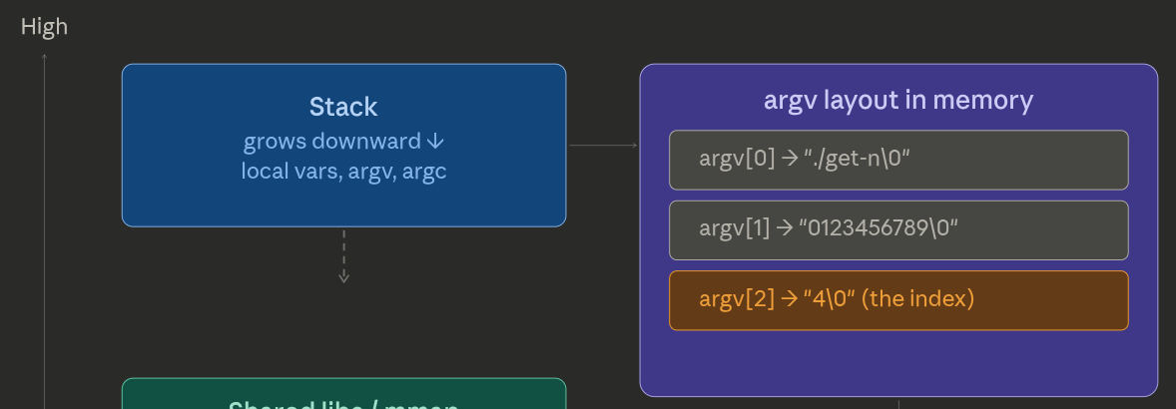
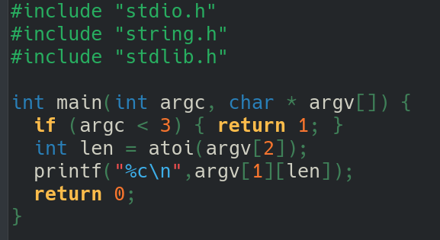
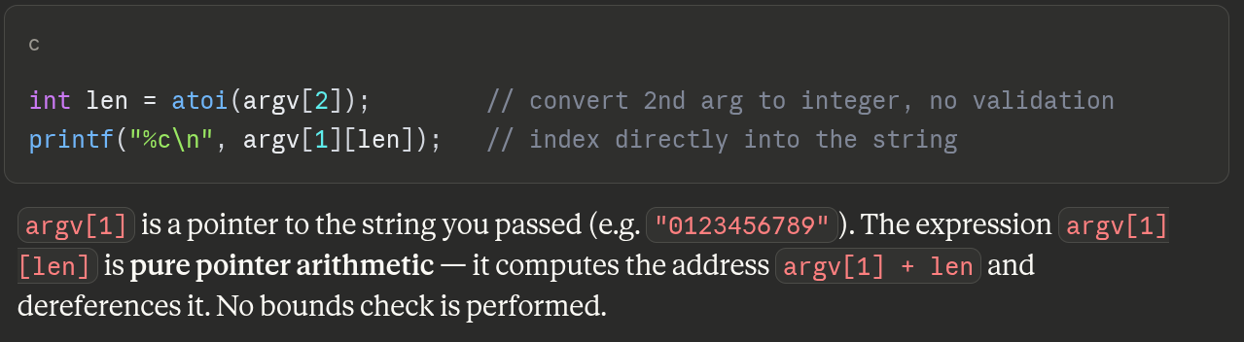
So if we gives a too big index, we read past the provided string, into other data on the stack. This is information leakage. To fix validate the lower bound (reject negatives) and validate the upper bound (reject anything ≥ strlen(argv[1])).
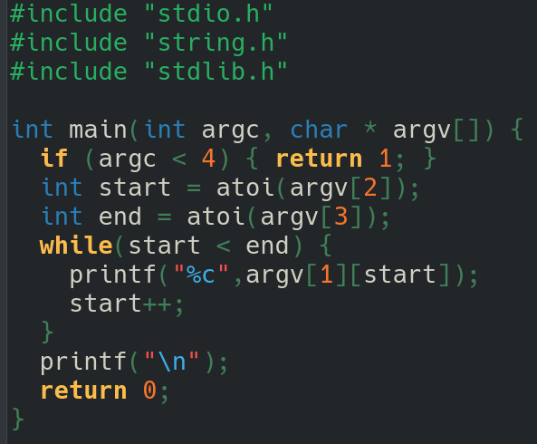
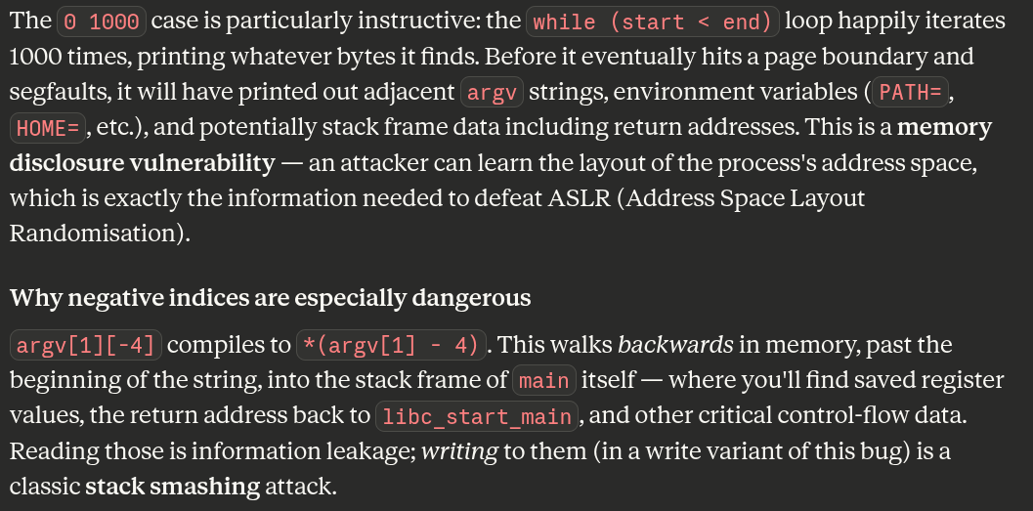
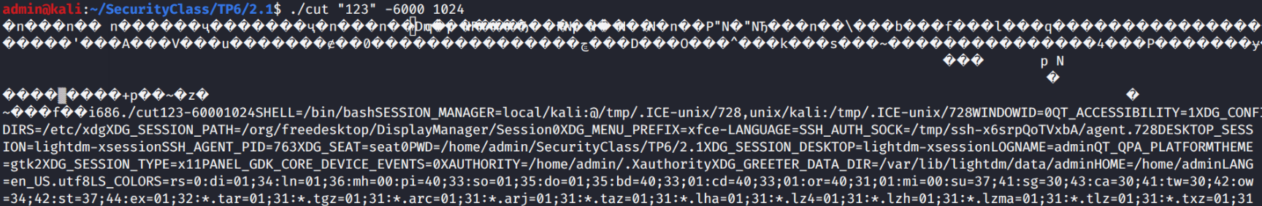
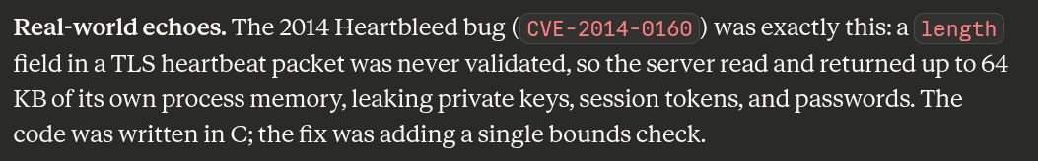
From this we can see that memory safety is not only a serious concern, but we can even see things well outside the memory space we should be looking at.
The examples above only read this space, but we could of course write into this space in most cases, leading to potentially serious vulnerabilities.

2. Use After free
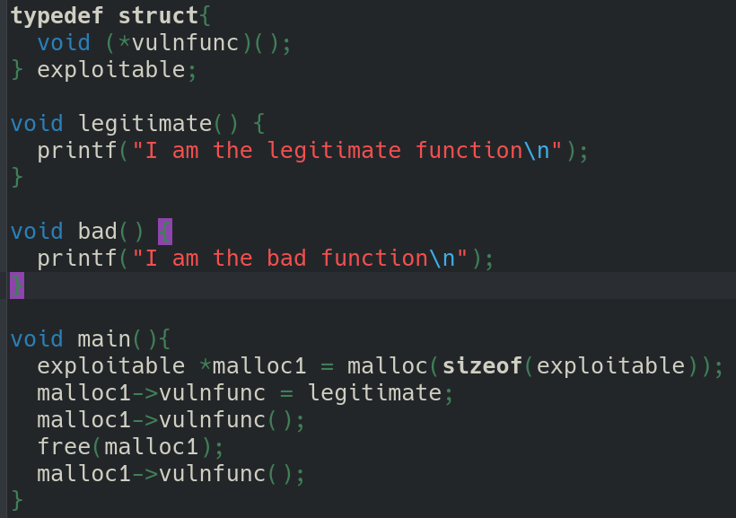
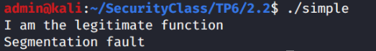
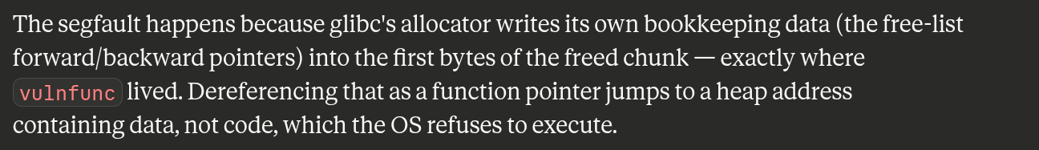
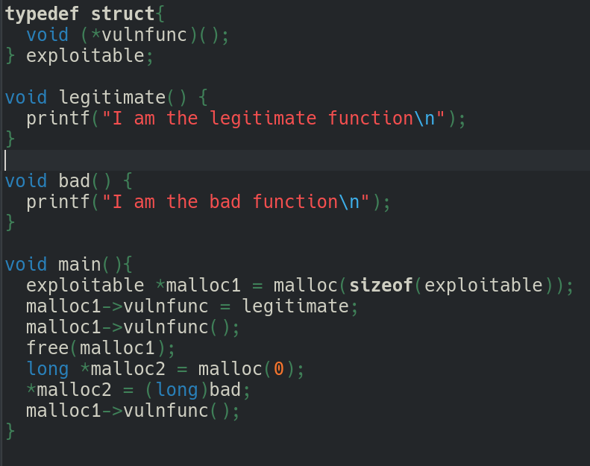
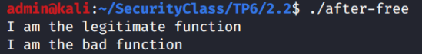
When we use the memory after the free we have a segmentation fault (we cannot use this memory segment, it's been freed)! But if we add in a new allocation that can reuse the same memory segment, we are able to inject the bad function behaviour into the "legitimate" function memory space of "malloc1".
As described in the lecture, the (re)allocation of memory has allowed us to replace the "malloc1" function with the "bad" function via malloc2. This works because the memory is immediately reused. Malloc1 and malloc2 stores the same memory location !
Malloc(0) : glibc returns a pointer to something of the minimum allocatable size. This is what makes the exploit work.
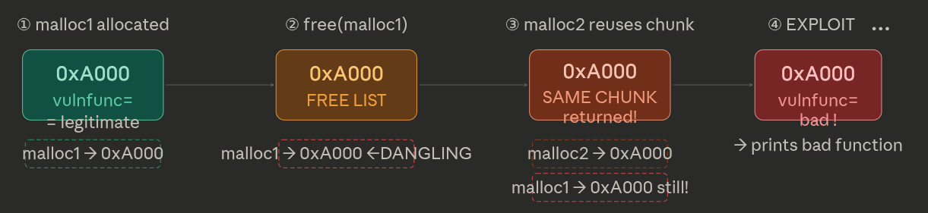

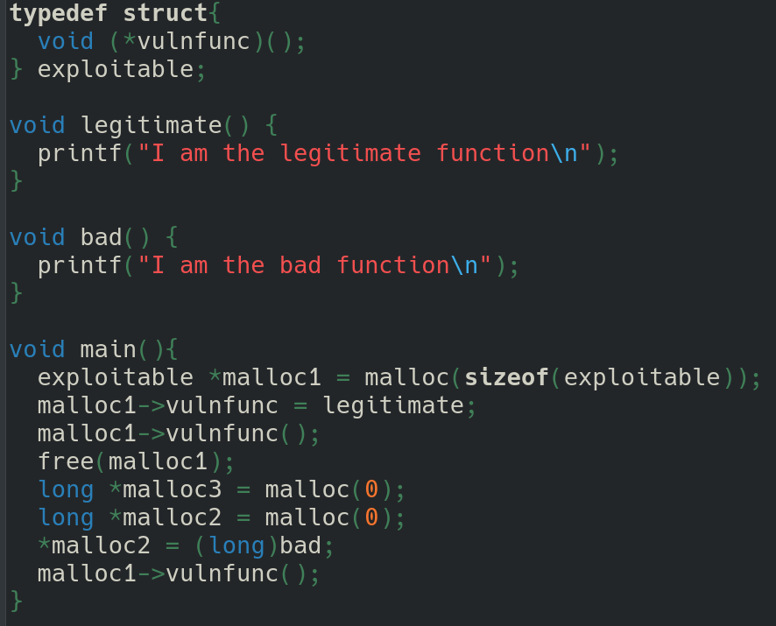
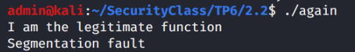
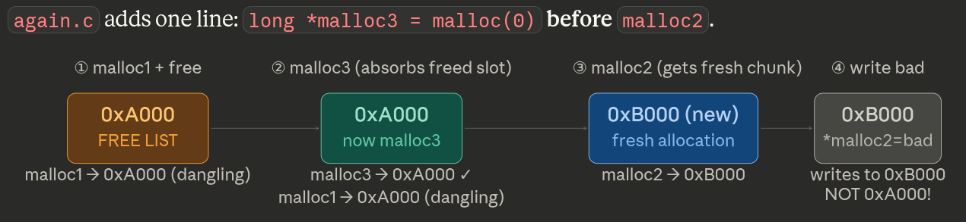
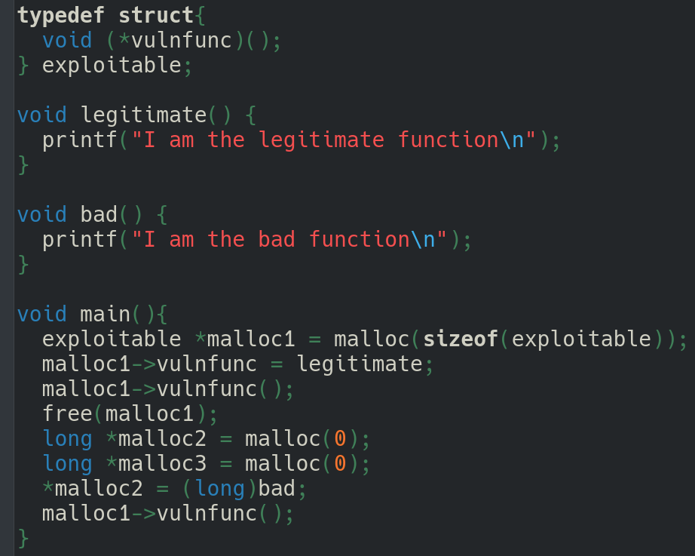
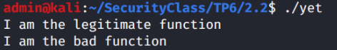
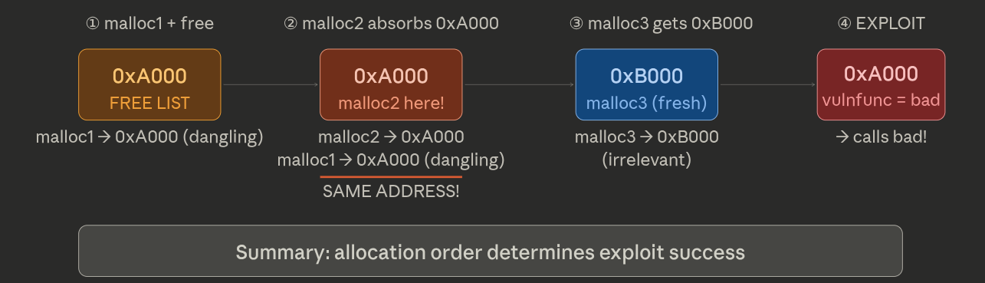

3. Double Free
Observe that before the same memory was reallocated. The memory management doesn't want to keep creating new memory segments, instead giving one that was "freed" back to the same program again when the program asks for another small segment of about the same size.
Let’s see what happens when we free twice
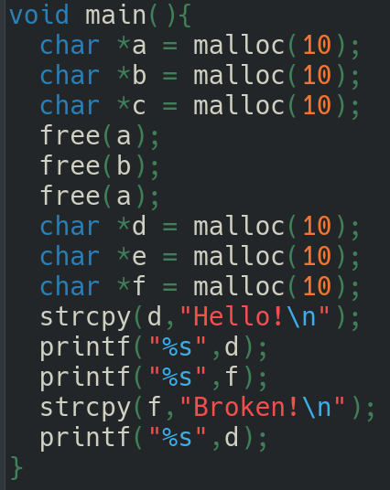
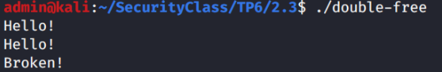
See that despite never assigning anything to "f" initially, we are still able to see a well formatted output. Similarly, editing "f" has effects on "d", despite them (supposedly) being different memory chunks.
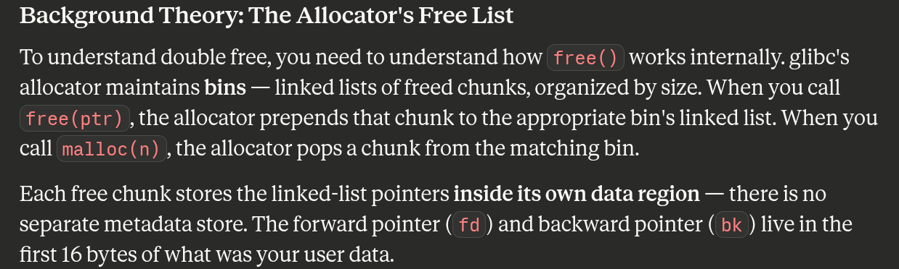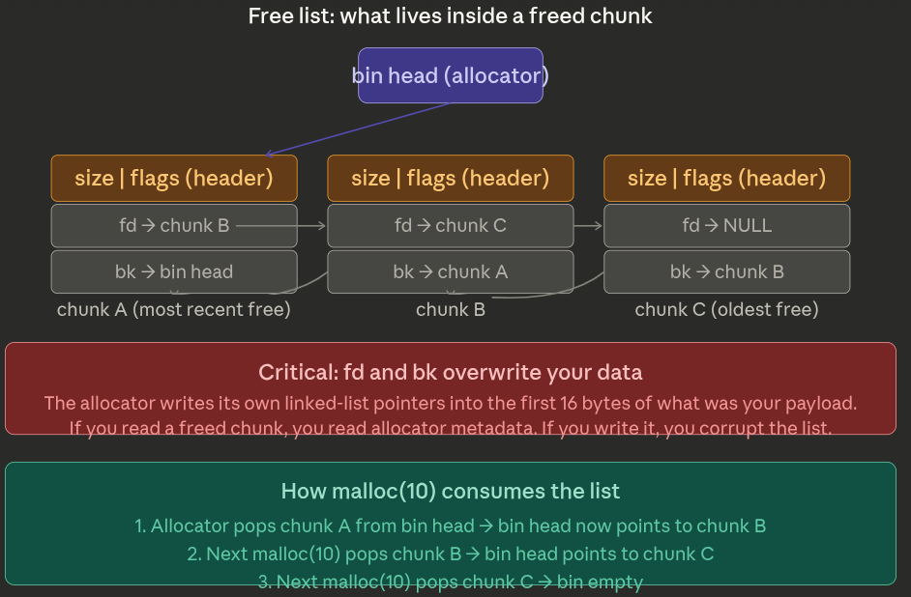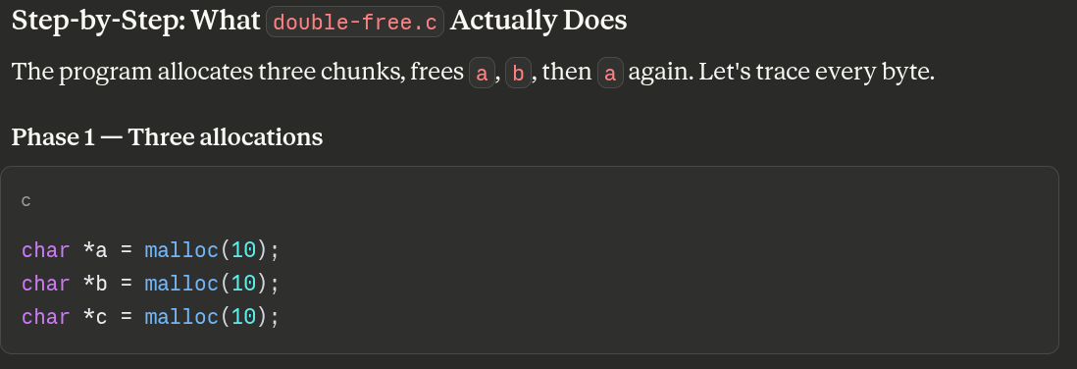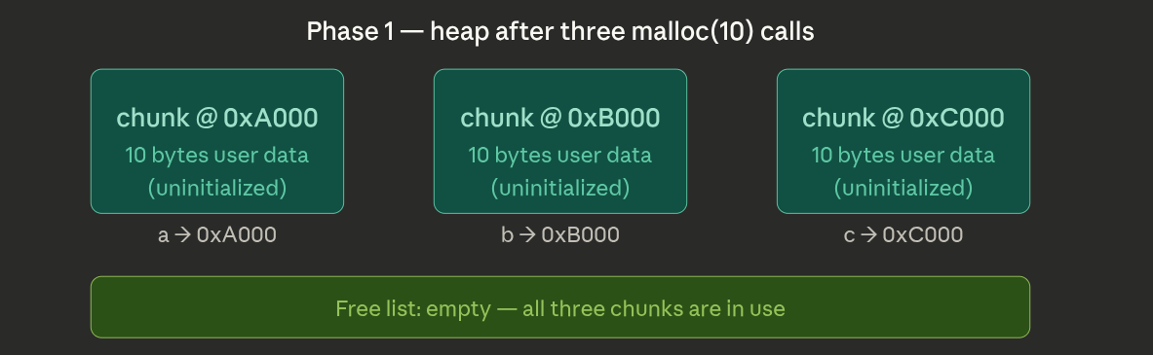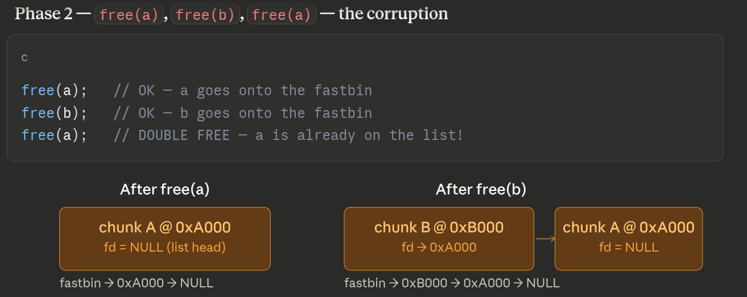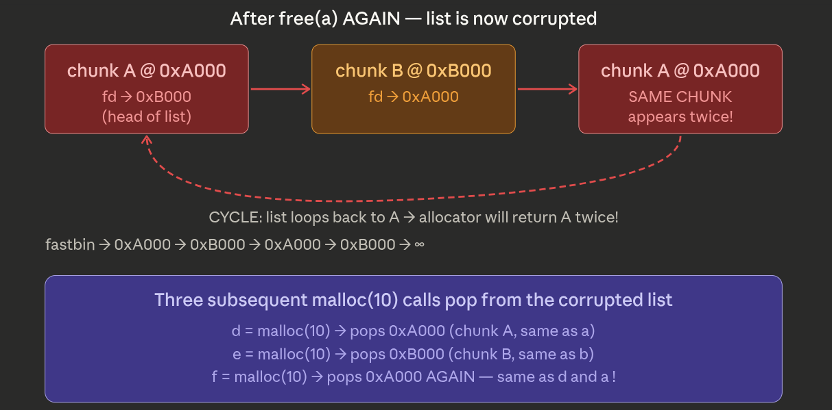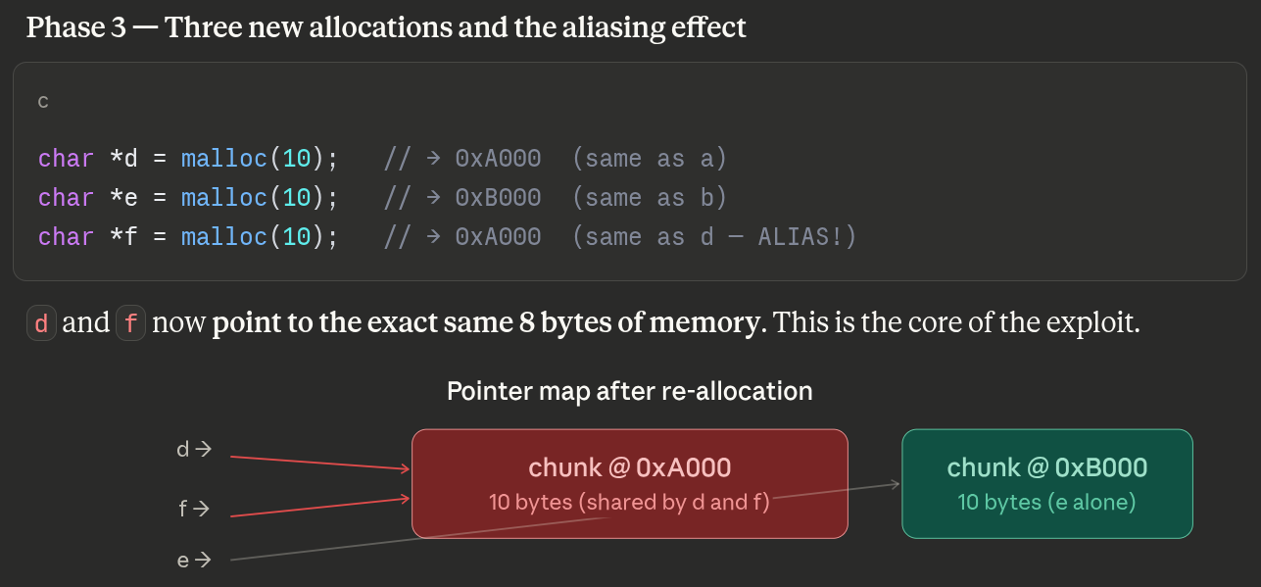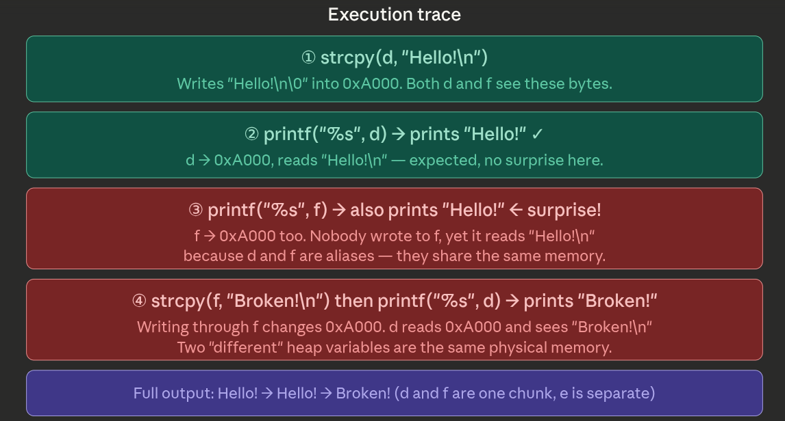

4 Uninitialised Pointers and compiler support
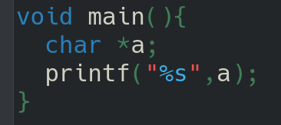
The code defines a pointer and then prints the string at that pointer. This prints out some part of memory that we never initialised. Clearly this is not the "correct" way to use a pointer, but the compiler doesn't care.
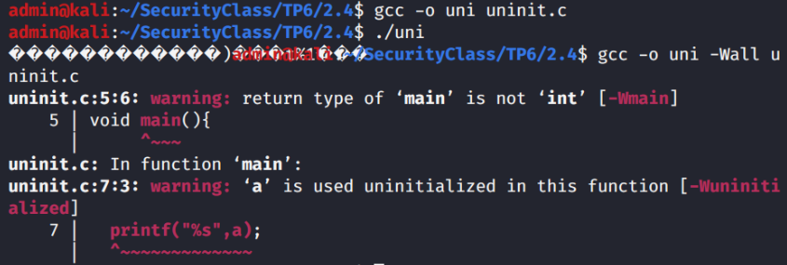
Now we see that the uninitialisd variable "a" is detected by the compiler.
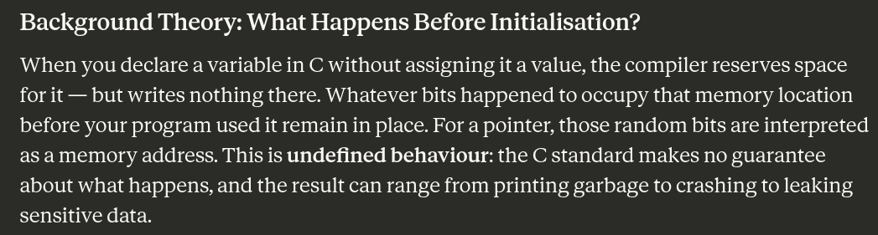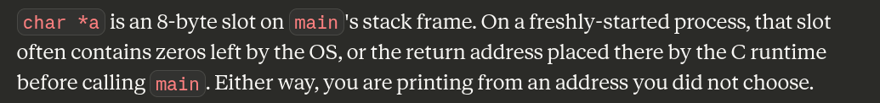
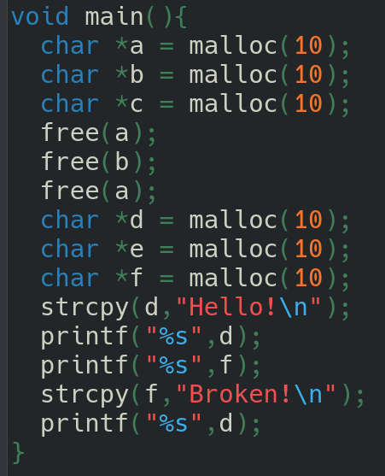
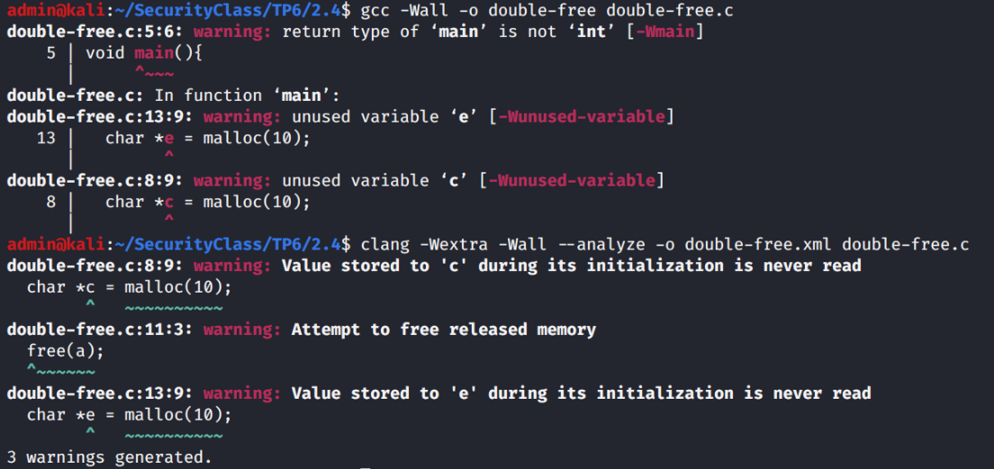
Here gcc can detect the uninitialised variables, but not the double free of "a". Other compilers (or tools) can detect this at compile time.

5 NULL Pointers
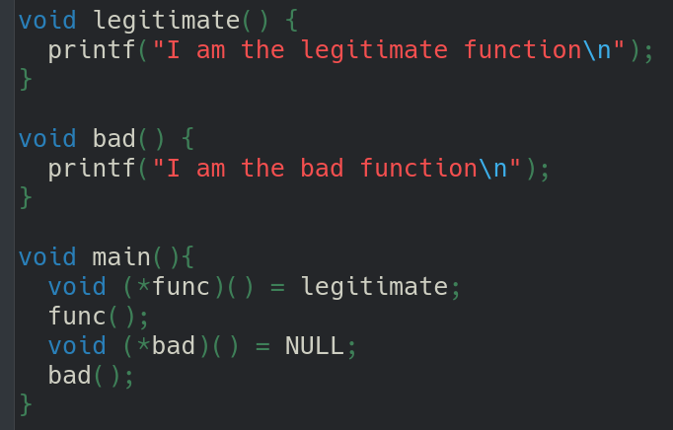
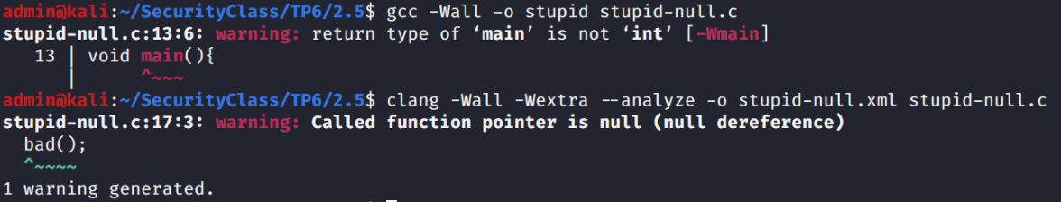
Another approach used in many languages is to not allow any pointer to be "uninitialized" to random values or addresses. Instead, the language (or compiler) sets all pointers to the NULL value (typically 0) when they are defined.
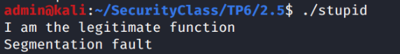
Clearly the second "bad" function pointer will be NULL when we try to call the function. As we can see trying to use NULL as a function doesn't work very well. Notice that even with all warnings gcc doesn't detect this! We can see that clang does a little better than gcc.
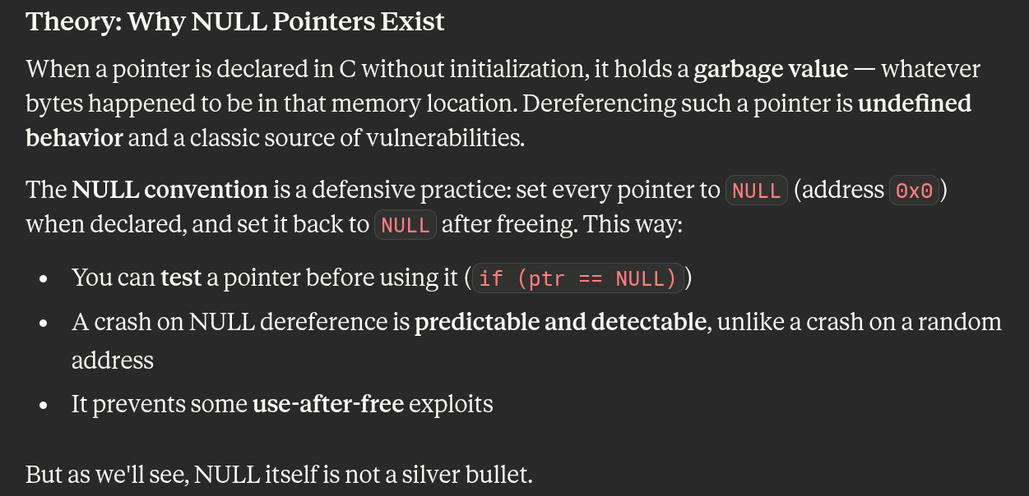
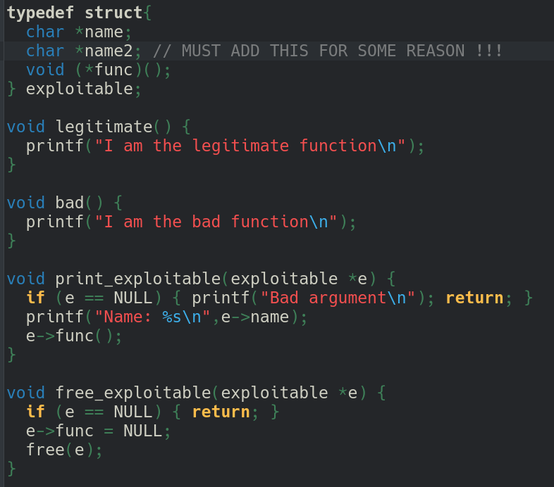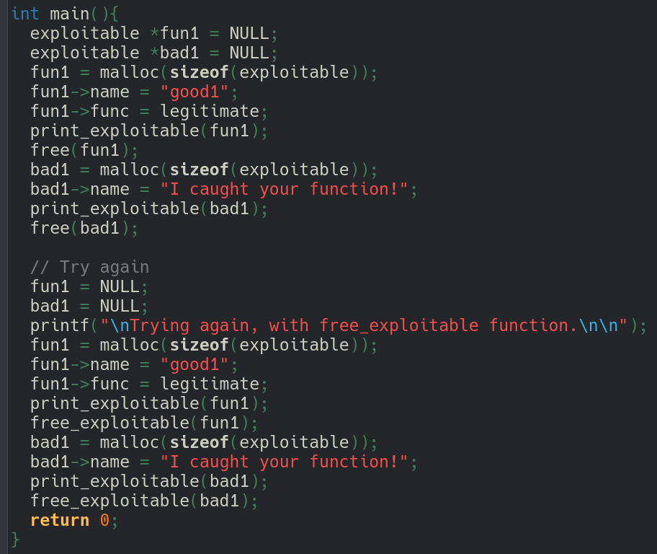

First part : Use After Free
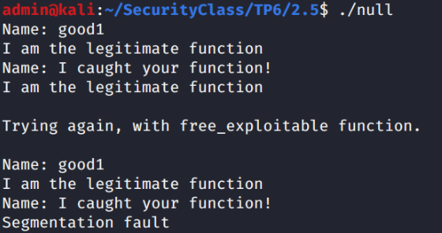
Observe that gcc does not report any warnings for this code, but when we run it we can see evidence of a memory capture or use after free.
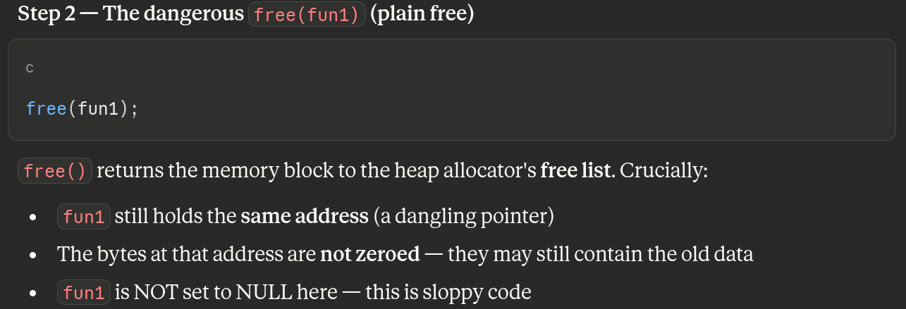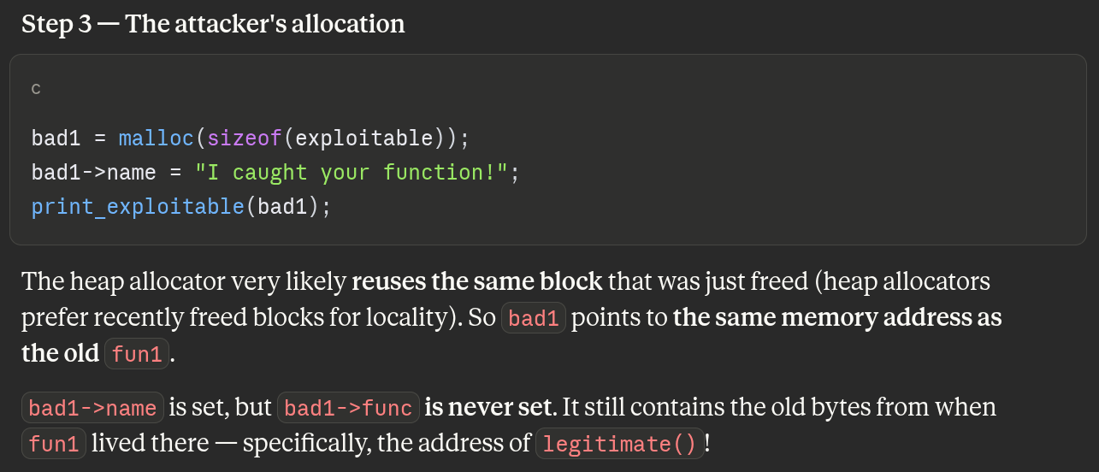

Further, even when an improved "free_exploitable" function is used to (better) clean up on free, this does not prevent a different exploit (null dereference).
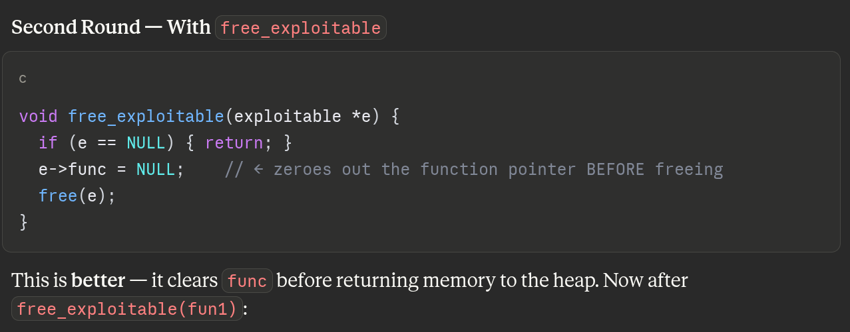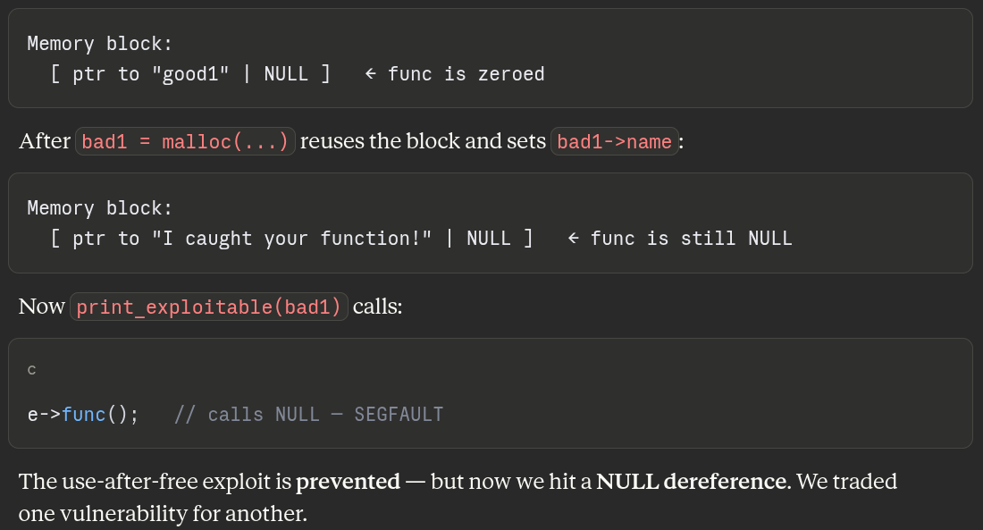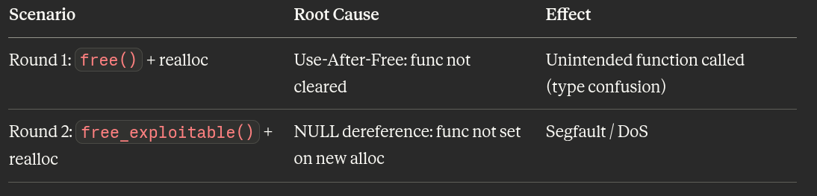
Note that in the code for null-use.c pointers are generally initialised to NULL, and set to NULL upon free inside objects. Also the printing and freeing functions check their argument is not NULL before proceeding. This is the beginnings of standard coding practices in many languages to try and avoid the problems illustrated here.

6 Uninitialized Memory
Have a look at the source code racing.c and try to find a way to get your prize ! For this question, the objective is to find how to make a call to the function getYourPrize() without any modification of the source code.
We want to call this function :
It is called in the menu by pressing 2 and if the car title == WIN
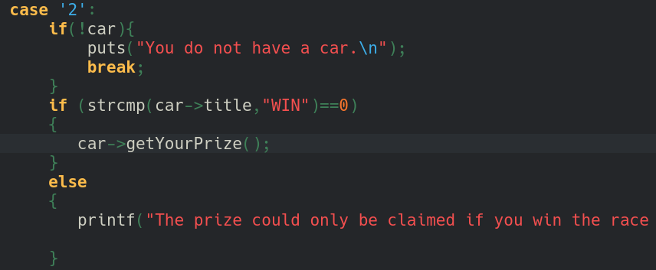
There is no way in the code to set the title field to WIN.
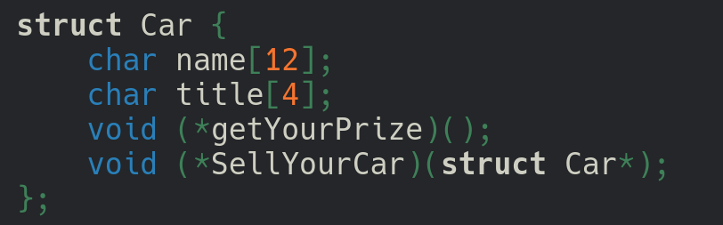
The car is allocated with a malloc, so it does not zero-out the memory it provides. Plus the field title is not initialized. This means that the previous data at this memory location will keep what was previously there.If we can control what is in that memory chunk before the car is allocated, we can trick the program into thinking our title is "WIN".
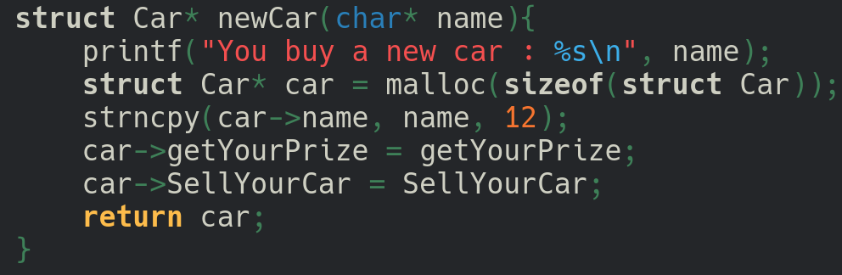
To control the chunk, we can use the other provided function to allocate a struct Circuit, fill it with our malicious data, and then free it.
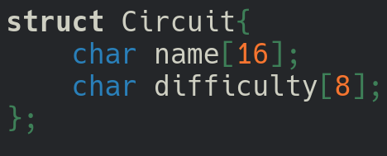
Notice that the last 4 bytes of circuit->name (Offsets 12 to 15) fall exactly over the 4 bytes of car->title. So if we create a circuit with a name with 12 dummy char + “WIN”, we can pre-load the "WIN" string exactly at offset 12 for the title field of a char.
Solution :
- Enter 4 to build a training circuit.
- For difficulty, enter anything
- For the name, enter exactly 12 padding characters followed by WIN.
- Input: AAAAAAAAAAAAWIN
- Enter 6 to remove the training circuit. (This frees the memory chunk but leaves the data intact).
- Enter 1 to buy a new car. (This re-allocates the chunk).
- For the car name, enter whatever you want.
- Enter 2 to get the prize!

