Solutions LINFO2144 - TP7

Made by students from TPs notes. Nothing has been corrected by teachers or TAs so there is no guarantee of correctness and completeness.
Generative AI has been used, be aware that there might be mistakes. At least this is still better than not having any solutions at all !

1 Environment Configuration
On most Linux systems and with most compilers there are protections built in to prevent various exploits. For today's tutorial we may have to turn some of these off. One is the randomisation of memory segments (Address Space Layout Randomization (ASLR))by the Linux kernel. We can see the current value with
sudo cat /proc/sys/kernel/randomize_va_space
To turn this off for the rest of the sessions by setting the value to "0" we can run
echo 0 | sudo tee /proc/sys/kernel/randomize_va_space
Afterwards, confirm we have turned off memory segment randomisation with
sudo cat /proc/sys/kernel/randomize_va_space
The compiler can also insert various protections into code that is compiled. For the stack, gcc includes some stack protection by default on many versions. We can force this to be turned off (remove Stack Canaries) with the argument
-fno-stack-protector
At times we may also wish to force gcc to compile code with executable instructions on the stack, we can enable this with
-z execstack

2 Buffer Overflow on the Stack
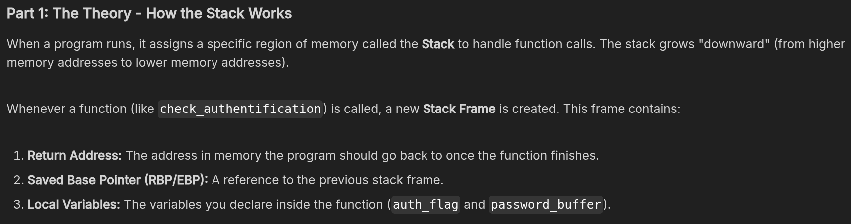
- The register ‘ESP’ is used to point to the next item on the stack and is referred to as the ‘stack pointer’.
- EBP aka the ‘frame pointer’ serves as an unchanging reference point for data on the stack. This allows the program to work out how far away something in the stack is from this point. So if a variable is two ‘building blocks’ away then it is [EBP+8] as each ‘block’ in the stack is 4 bytes.
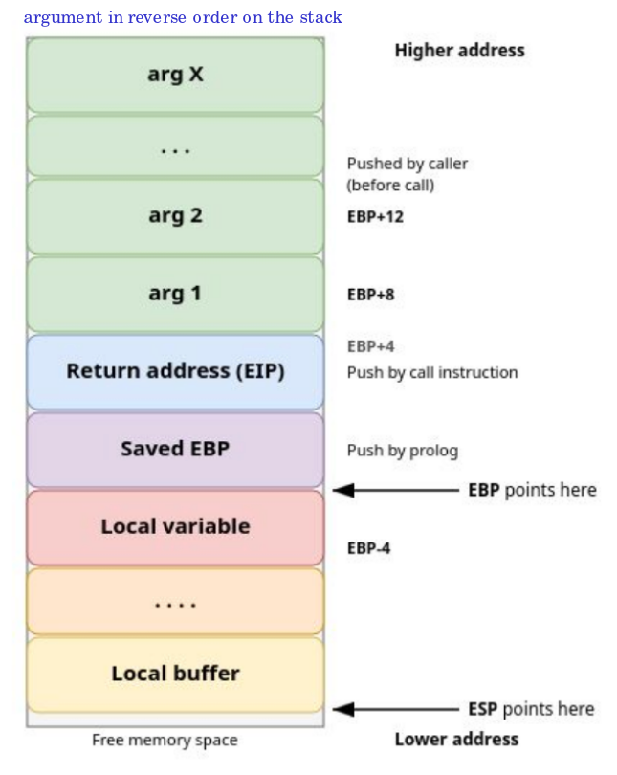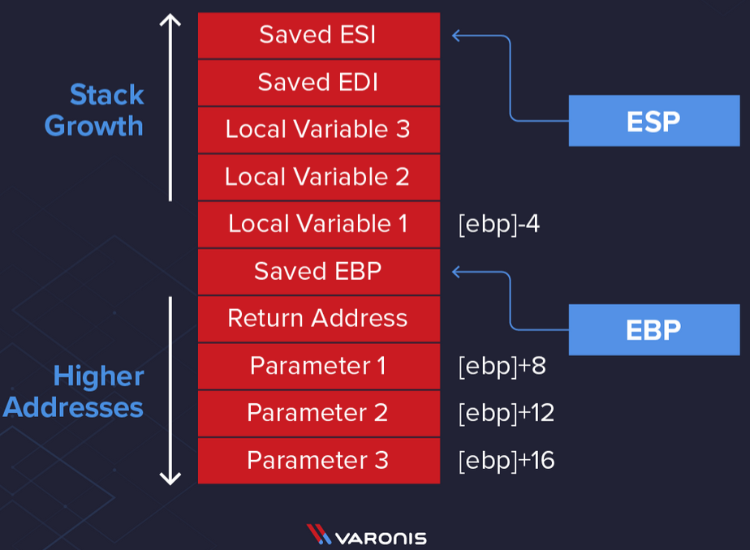
- Each function will generate its own stack frame, so the stack frame in the example above could be on top of another frame on the stack which is being used for another function.
- EBP as mentioned earlier is stored as an unchanging reference point on the stack, this is done by moving the value of ESP into EBP. We do this as ESP will change as it always points to the top of the stack, storing it in EBP gives us an unchanging reference point in the stack and now the function can reference its variables and parameters on the stack from this location.
- In this example parameters that have been passed to the function are stored in ‘[EBP]+8’, ‘[EBP]+12’ and ‘[EBP] +16’. So when we see ‘[EBP]+8’ that is the distance on the stack from EBP.
- Variables will be stored after the function has begun executing so these will be stored higher up the stack but in lower address space, so in this example, this will be shown as ‘[EBP]-4’.
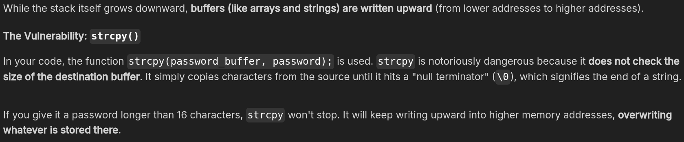
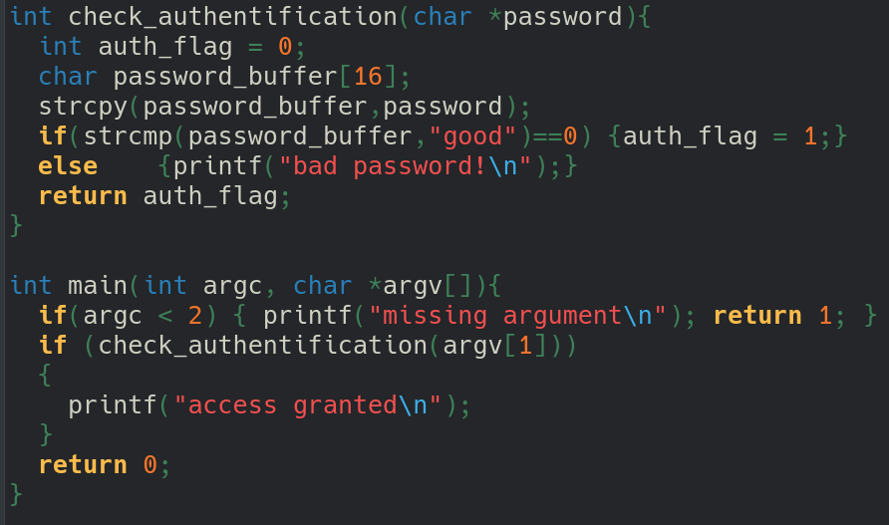
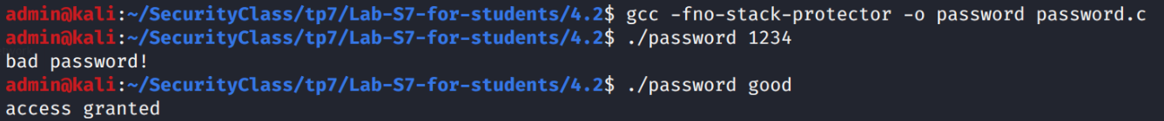
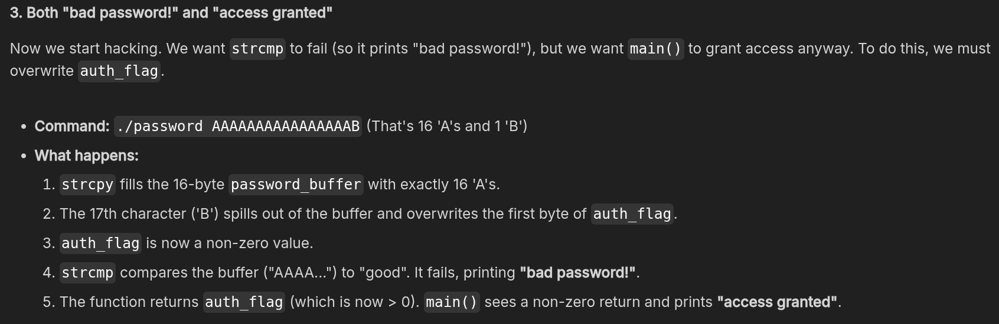

A Segmentation Fault happens when a program tries to read or write to an illegal memory address. We can cause this by overflowing the buffer so much that we overwrite the Return Address. Overflowing 24 bytes (overwriting buffer + flag + EBP) don’t produce a segfault. But as soon as we overwrite the 25th bytes (return address), it produce a segfault.

Exercise with GDB
(I compile with -g because I’m a noob)
- Launch GDB with the compiled binary :
  - gdb ./password
- Optional, show code :
  - layout next
- Set a Breakpoint and Run :
  - (gdb) break check_authentification
  - (gdb) run AAAAAAAAAAAAAAAAAAAA
- ask GDB where our variables live in memory :
  - (gdb) print &password_buffer
  - (gdb) print &auth_flag
- Step through the code command to execute the code line-by-line :
  - (gdb) next
- look at the actual memory of auth_flag using the x (examine), eXamine 1 block of heXadecimal Words at the address of auth_flag :
  - (gdb) x/1xw &auth_flag
- let the program finish and see the result, type:
  - (gdb) continue

3 Buffer Overflow Minor Variations
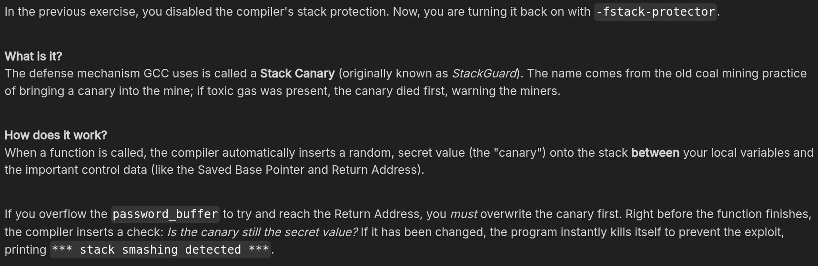
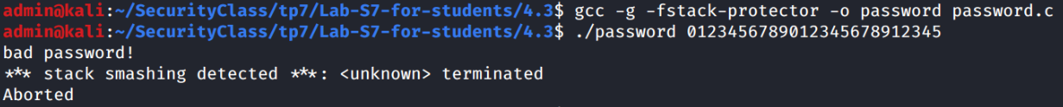
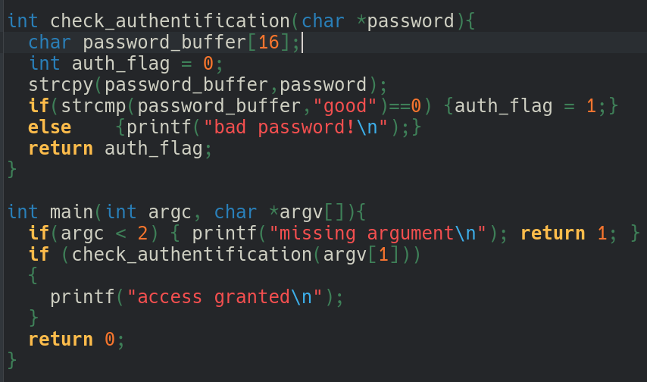
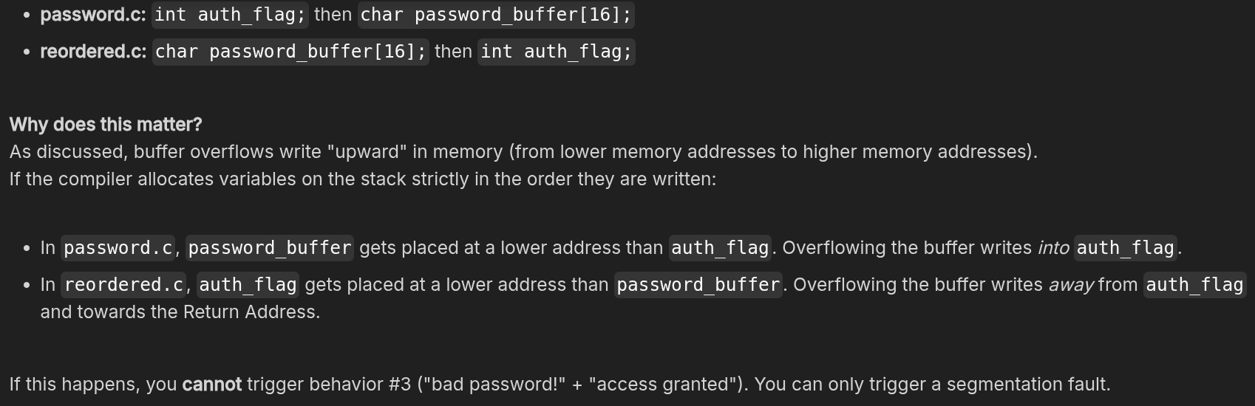
This code may or may not also have the same vulnerability, test on your system and with your compiler(s) to see what happens. Note that you may experience different results with different compilers !

