Solutions LINFO2144 - TP4

Made by students from TPs notes. Nothing has been corrected by teachers or TAs so there is no guarantee of correctness and completeness.
Generative AI has been used, be aware that there might be mistakes. At least this is still better than not having any solutions at all !

1 Toy DNSSEC
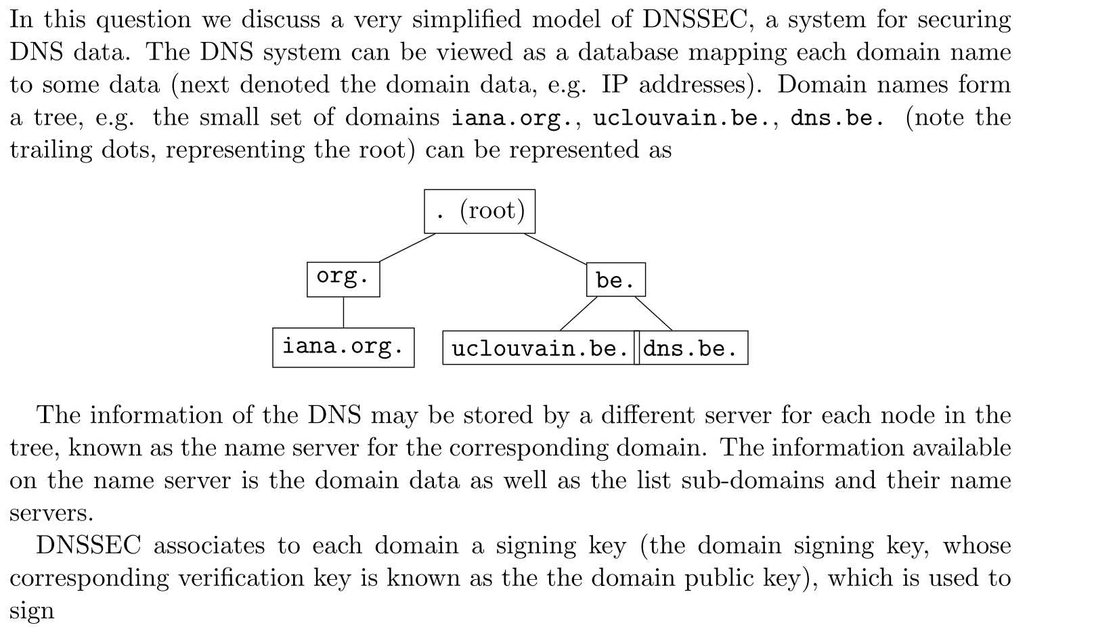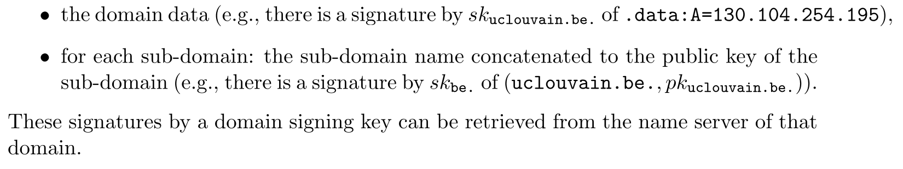
- Authenticity : proves that the DNS response actually originated from the authoritative name server $→$ prevent addition of malicious nodes. An attacker can not add a new nodes because it will not be signed by a parent.
- Data Integrity: proves that the data has not been altered $→$ prevents MITM attacks.
- The client must know the pk of the root, this is the base of the whole chain of trust (pk can be hardcoded in the client)
- The client ask the root for the pk of .be and the IP address of it, answer signed with root private key.
- Client check the root answer using the root pk
- Client goes to .be server and ask for the dns.be and the IP of it
- Client check the answer using th pk of .be
- Ask the name server of dns.be the record for the address and verify the response

If we just let a domain sign new data, or a parent stop serving a deleted domain, we are vulnerable to a Replay Attack. Previously signed IP addresses and domains will still be valid and accepted.
To securely support changes, the system must guarantee freshness by adding timestamps / expiration dates. For every data exchange we add a expiration date along side it. Both the data and exp date must be signed.
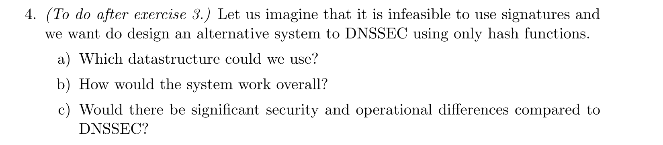

2 TLS 1.3 and replay
It’s the 0-RTT feature of TLS1.3 (that allows session resumption) that can be exploited to do replay attacks. The client and server have communicated previously and established a Pre-Shared Key via a session ticket. The client decides it doesn't want to wait for the server's response to start sending encrypted data. It encrypts the first HTTP request using the old PSK and sends it attached to the first message (ClientHello). An attacker captures this initial packet and sends copies of it to the server. The main reason of this feature is performances.
Mitigation :
- Allow 0-RTT only for “non critical” request. Like idempotent GET request that has the same effect if send once or 10 times. But you will block 0-RTT POST request.
- When the server issues a Session Ticket (PSK) to the client for future resumption, the server stores a unique identifier for that ticket. When a client connects using 0-RTT, the server checks its db for the ticket. If the ticket is valid, the server accepts the early data and immediately deletes the ticket.

3 Merkle tree
