Solutions LINFO2144 - TP2

Made by students from TPs notes. Nothing has been corrected by teachers or TAs so there is no guarantee of correctness and completeness.
My plots for Question 1 does not use standard notation (if there is any). I have never learn it. I just wrote plots as they were making sense to me on the moment, without writing unnecessary stuff. Don’t study the way I made them :)
Generative AI has been used, be aware that there might be mistakes. At least this is still better than not having any solutions at all !

2 Confidentiality beyond standard definition

TLS traffic sniffing.
Assume you are monitoring the IP traffic between a user’s device and the server of a messaging app, which is encrypted with TLS.
You make the following observations: At regular intervals, a couple tiny packets are sent. At some point, one of the packets sent by the device is a bit (e.g. 200 bytes) larger than usual.
What can you conclude? In particular, assume you are running an online advertising business, and you just displayed an ad to that user.
What are the communication protocol’s characteristics that are exploited in this attack? What can a protocol do in order to protect against such attacks?
Answer :
- Regular tiny packet : probably ping / keep alive packets to keep the socket open and ensure real-time push notifications can be received.
- On big packet : You can suppose a message has been send or received or another event. You don’t know the content but you know when it has been send, the IP source and IP dest (maybe a server and not an end-user).
Like Whatsapp, you can analyze the behavior of the user (message frequency, contacts,...) even though you don’t know the content of the message.
If you are running an advertisement business, you know if you have just served an add to the user. If you observe a 200-byte packet sent by the user's device immediately after displaying the ad or interacting with it, you can perform a Timing and Length Correlation Attack :
- You know the exact size (200 bytes) and the exact time it was sent.
- You can conclude that this 200-byte packet is likely a telemetry/analytics event ("ad_viewed" or "ad_clicked") being sent back to the messaging app's servers.
- By fingerprinting the exact byte size of different actions (a text message might average 50 bytes, while an "ad clicked" API call might consistently be exactly 200 bytes once encrypted), the attacker can perfectly map out user behavior without ever breaking the TLS encryption.
The attack exploits the following protocol’s characteristics:
- Length Preservation (Deterministic Ciphertext Length): TLS provides confidentiality of the payload, but it does not hide the length of the data. If the length of the ciphertext is almost exactly the length of the plaintext (plus a small fixed overhead), observing the packet size leaks the exact size of the application-layer data.
- Event-Driven Timing: The protocol transmits data exactly when an event occurs. This immediate transmission creates a timing side-channel.
- Lack of Metadata Protection: IP addresses (source/destination) and port numbers remain unencrypted in the network and transport layers. TLS only encrypts the application layer.
To mitigate Traffic Analysis (Side-Channel) attacks :
- Fixed packet size using padding and splitting the payloads data,
- Generate dummy traffic at random intervals,
- Schedule packets transmission to avoid sending packet immediately when an event occurs.

Interactive SSH.
When typing on a keyboard, the delay between consecutive keystrokes is highly dependent on the person typing and the characters being typed. Moreover,when using a remote shell over SSH, keystrokes need to be send with low latency, otherwise the usability is degraded. Assume a naive SSH client implementation, how is this a security issue? What is a typical sensitive piece of data interactively sent over SSH?
Analyze the countermeasure introduced by OpenSSH 9.5 using the release notes (https://www.openssh.org/txt/release-9.5) and the configuration description (ObscureKeystrokeTimin man 5 ssh config). What are the trade-off of the parameters?
Answer :
A naive SSH client sends one network packet the exact millisecond a user presses a key. Because SSH and TLS only encrypt the content of the packet but preserve the timing and length, an eavesdropper can see the exact delay between keystrokes.
Because of the physical layout of keyboards (AZERTY), the time it takes to type certain pairs of letters varies deterministically. For example, typing "s" then "d" (adjacent fingers) is significantly faster than typing "a" then "p" (opposite hands). By feeding these microsecond timings into a statistical model (like a Hidden Markov Model), an attacker can predict the exact sequence of characters typed, completely bypassing the encryption.
The most critical sensitive data sent interactively over SSH is a Password. Users frequently type passwords into remote shells like for the initial login ! If an attacker can deduce the keystrokes via timing analysis, they can recover the user's plaintext passwords.
We can guess when the user is behind the computer typing in its shell or not. We may be able to identify patterns and map them to different commands. Therefore we can get information on what is the user doing.
We can also distinguish between users based on the typing speed.

Mitigation :
OpenSSH 9.5 introduced the ObscureKeystrokeTiming configuration to mitigate this specific vulnerability. It employs two main techniques:
- Traffic Shaping (Fixed Intervals): Instead of sending a packet immediately upon a key press, the SSH client sends interactive traffic at fixed intervals (default is every 20ms). The real keystroke is delayed and shoved into the next available 20ms "slot".
- Chaffing (Dummy Packets): The client sends fake keystroke packets ("chaff") for a random interval after the user stops typing.
- Batching, send packets periodically that contains more than 1 keystroke.
The trade-offs are:
Security vs. Usability (Latency): A higher interval (e.g., 80ms or 100ms) provides mathematically stronger security because it forces all keystrokes into heavily delayed buckets, fully destroying timing patterns. However, a remote shell requires low latency. If the interval is too high, the user will experience highly degraded usability.
Security vs. Network Performance (Bandwidth/Overhead): To hide the typing, OpenSSH sends constant fixed-interval packets and generates fake chaff packets. This means a single typed character might result in more than one packets being sent instead of just one. This increases network overhead, bandwidth usage, ...

3 Timing Side-Channel Attack
In this exercise, you will have to perform a timing side-channel attack to retrieve a pin code. Instead of doing a simple brute force, find a way to retrieve the pin code with fewer requests. For this exercise, we propose you to build a docker to have a ”black box”to query. You can also make a virtual environment or install all Python modules needed on your laptop. All the files are available in the folder 1-Timing_Attack. For the docker, run the commands
docker build . -t timing_attack
docker run -d --network host timing_attack:latest
The website is available at http://localhost:5000/.
- As a first step, try to guess the length of the PIN, without guessing the PIN itself. Looking at the server.py code, how will the verification time for a PIN of the correct length compare to the time for an incorrect length?

- As a second step, try to guess the PIN.
  - How many attempts will you need if you brute-force the PIN?
  - How many attempts will you need if you guess digits one-by-one?
  - How can you find the first digit of the PIN?
  - How can extend this attack to all digits?

- Once your attack is successful, change the pin code and try again with your solution. It should still work even if the length changes.
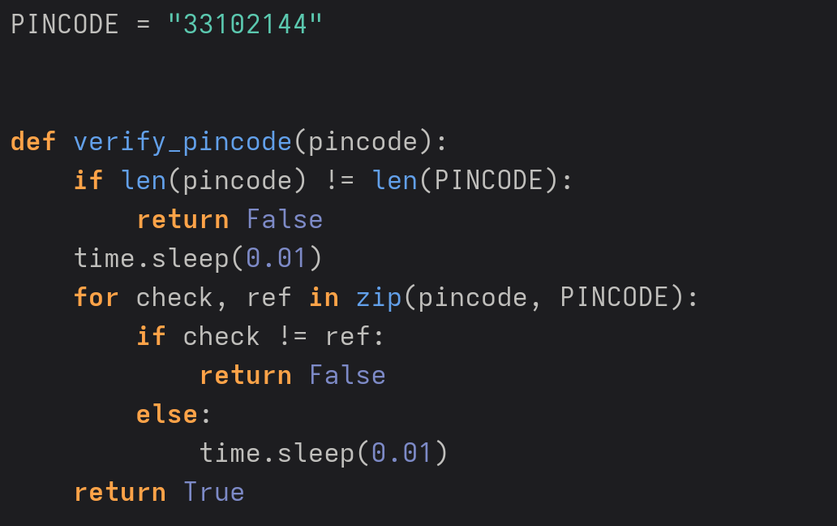
Answer :

- If we try incorrect length, the server response will be really fast. Right now on localhost, we can check the response time in the browser by clicking F12 then going into the network tab. So as soon as we get a slower answer we can suppose it's the password length. In practice an attacker would write a Python script using the requests library to send PINs of length 1, 2, 3... and measure the response time. Because network latency fluctuates, the script would send each length 10 or 20 times and take the average to filter out noise.

- Guessing pin:
  - To brute force, supposing it's only decimal numbers (0 to 9), their is 10^(size of the password) = 10^8 possibilities.
  - 80 possibilities in the worst case : 10 attempts to find the first digit, 10 for the second, ...
  - When we find the first digit, the server will check the second number we provided, making the respond slower. Therefore we try a 8 digits number and change the first digit until we get a slower. We know no what is the first digit.
  - Yes we can extend this by keeping the first digit found and then try all possibilities for the second digits until we can a slower answer. We keep going until we have found all of them.

4 SSH with compression security
In this exercise, you will use SSH with compression. All the files needed for this exercise are in the folder 2-ssh_compression. You have a client and a server. The client compresses the data before encrypting it. As an attacker, in this scenario, you are able to ask the client to add an evil string that will be concatenated with a secret that the client sends to the server. So the client will send evil+secret to the server. The secret is composed of five capital cities chosen at random in a list and serialized into a JSON
object. For example:
{
"city0": "Victoria, Seychelles",
"city1": "Seoul, South Korea",
"city2": "Paris, France",
"city3": "Vatican City, Vatican City",
"city4": "Paramaribo, Suriname",
}
As a first step, let us look at the behavior of compression algorithms. Using zlib compression (zlib.compress in Python), compare the length of a string of 2n distinct characters versus the concatenation of 2 identical strings composed of n characters (e.g. the alphabet vs twice half the alphabet). Can you extend your observations to the concatenation of evil and secret, for some well-chosen evil? How can you mount an attack using a compressed message length oracle?
Next, your goal is to modify attack.py to perform an attack and find the secret. You will need to call the function (bytes_out, bytes_in) = client_fn(<evil_string>). This function causes the client to send a message to the server. It returns the number of bytes sent to the server (bytes_out) and the number of bytes received from the server (bytes_in).
For this exercise, we propose you to build a docker. You can also make a virtual environment or install all Python modules needed on your laptop. For the Docker version, you can build the Docker with docker build . -t ssh_compression. To launch the Docker, you can use the command docker run --mount type=bind,src=./attack.py,dst=/app/attackFinally, in a new terminal, connect to the docker with docker exec -it <docker_name> /bin/bash and execute the command python3 main.py to test your attack. You can change attack.py without rebuilding the Docker.
Finally, can you imagine an hypothetical practical setting where such an attack could be applicable (you may assume a different protocol, such as HTTPS)? Which adversary could be interested in recovering a list of cities (or another list of words)? How could an adversary have control of an evil string?
Answer :
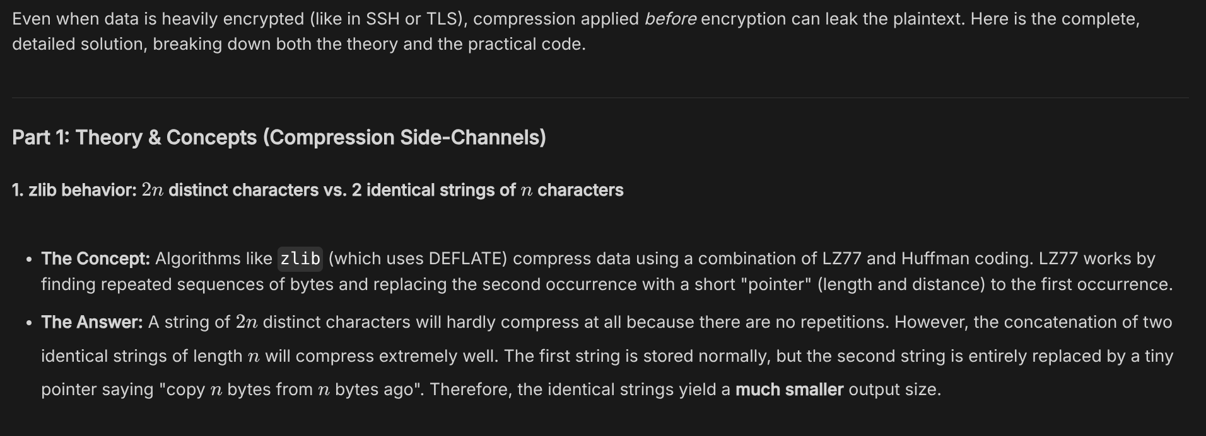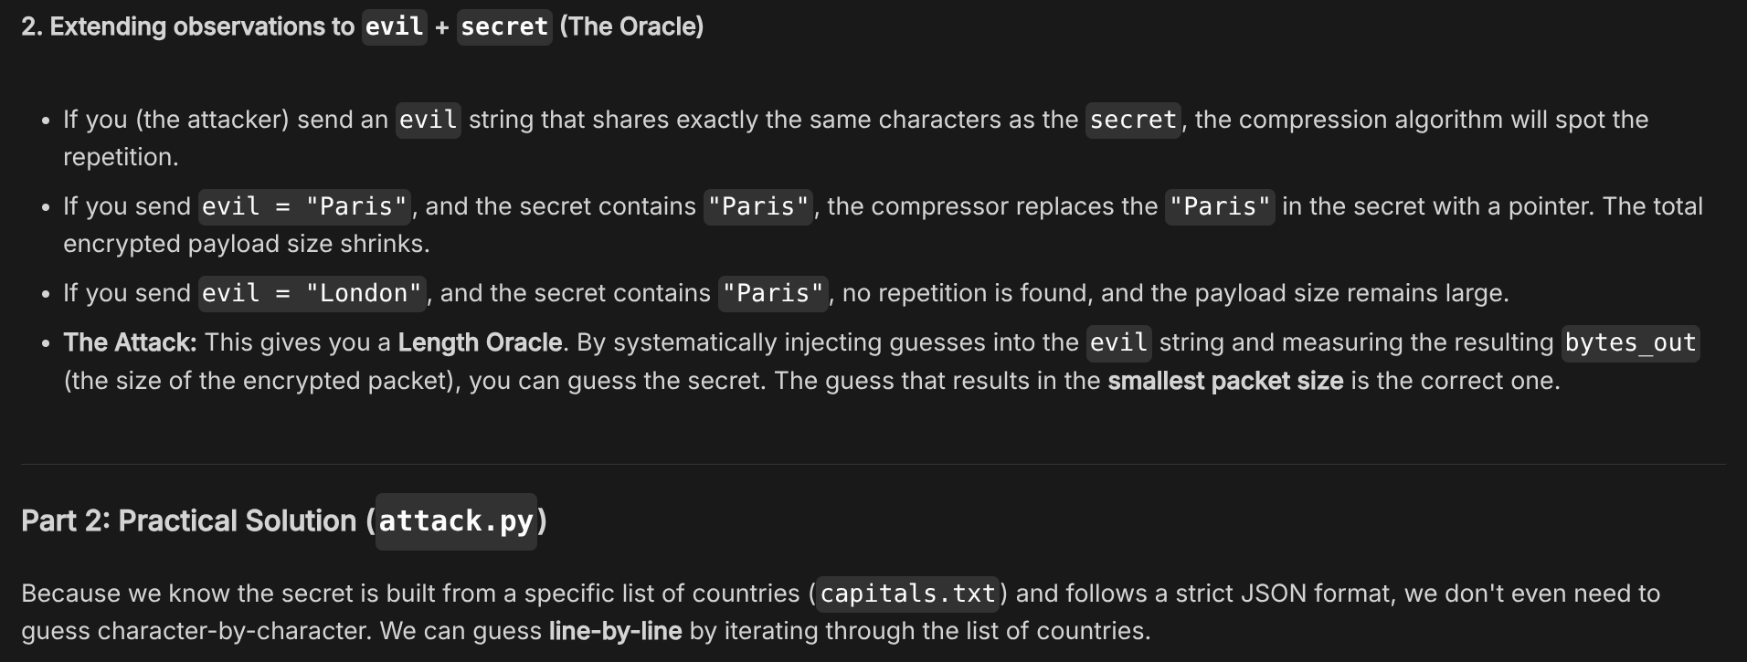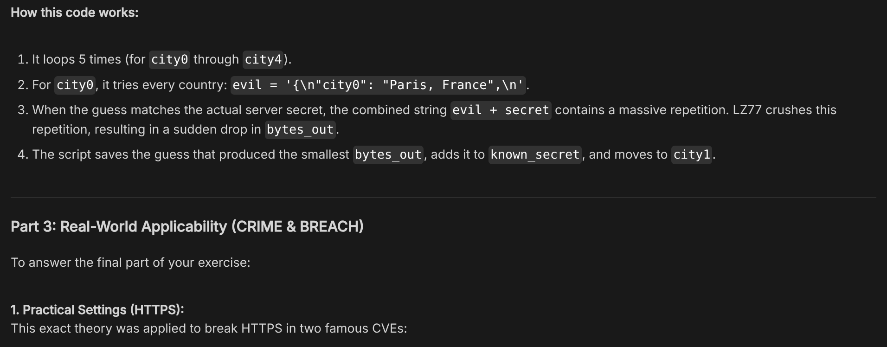

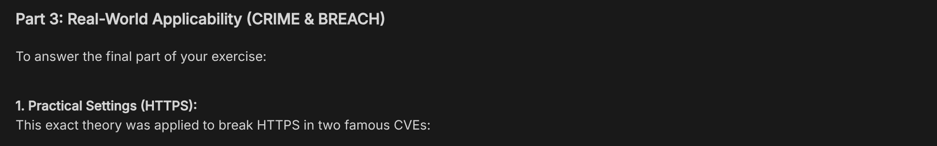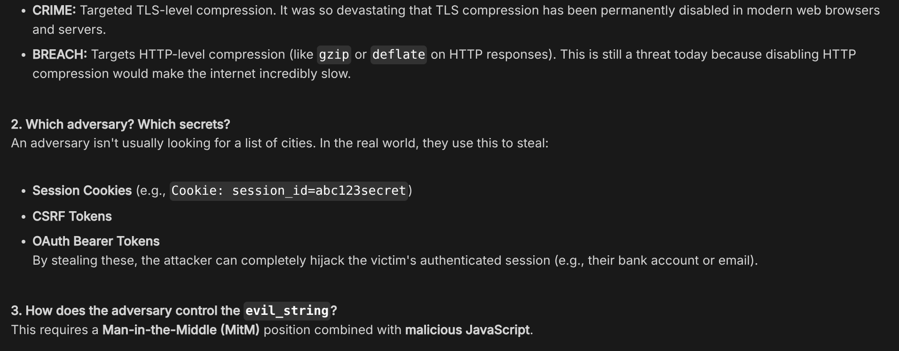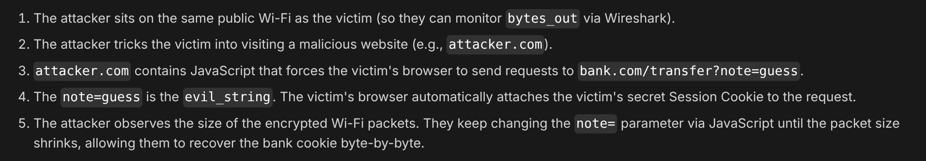

5 Performance comparison
In this exercise, you will have a look at the performance of various hashing and encryption algorithms. Use the VM if you do not have OpenSSL installed on your laptop. To compare the performance of hashing and encryption algorithms, we will use OpenSSL. The VM runs with the version 1.1.1d. The current stable version is 3.4.1 with many vulnerabilities fixed.
The command openssl help shows the different standard, message digest and cipher commands. The command openssl speed <algorithm> performs a speed test.
In the first instance, we are interested in the message digest SHA (Secure Hash Algorithm). Draw a graph comparing the performance of the different versions (SHA2 in its variants sha256 and sha512, SHA3 in the variant sha3-256). Discuss your results. For each algorithm, explain why or why not you would use it. Give a short example of the context where you could use it.
In a second step, we are interested in authenticated encryption algorithms and more specifically the AES (Advanced Encryption Standard) encryption with GCM (Galois Counter Mode). As previously, compare the aes-128-gcm and aes-256-gcm algorithms and explain in which context you should use which one.
Beyond the comparison, in which practical situations are these functions likely to be (or not be) performance bottlenecks?
Run benchmarks for asymetric cryptography algorithms, e.g. using Curve 25519 for ECDHE (X25519) and for signature (Ed25519). Would those be bottelnecks in practice?
Cryptographic engineering is undergoing a transition towards new algorithms that resist cryptanalysis by quantum computers (so-called “post-quantum cryptography”). Which of the algorithms discussed above are PQ-secure? How to the PQ algorithms recently-standardized by the NIST compare to non-PQ algorithms in terms of performance? (Performance is not only about computation time, but also about the size of the data.) Wikipedia can be a good starting point for your investigations.
Answer :
Todo

