Solutions LINFO2144 - TP9

Made by students from TPs notes. Nothing has been corrected by teachers or TAs so there is no guarantee of correctness and completeness.
Generative AI has been used, be aware that there might be mistakes. At least this is still better than not having any solutions at all !

2 Evading Stack Protection
Compiled with Stack protection enabled but allowing stack execution.
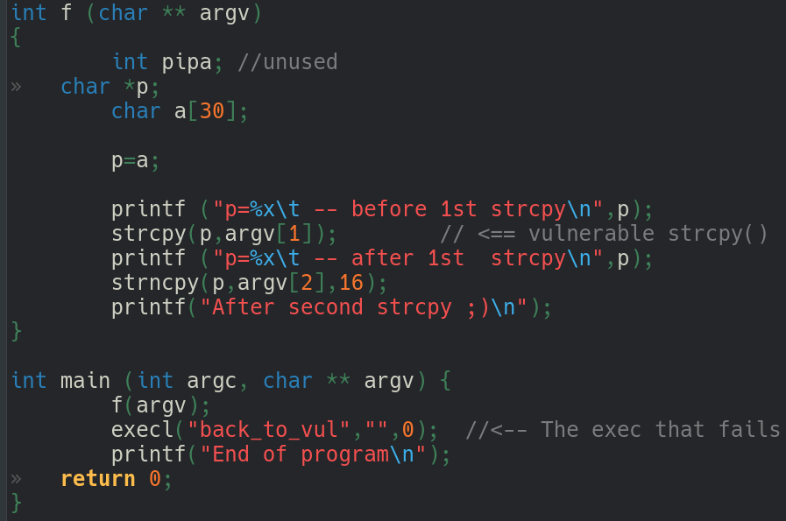
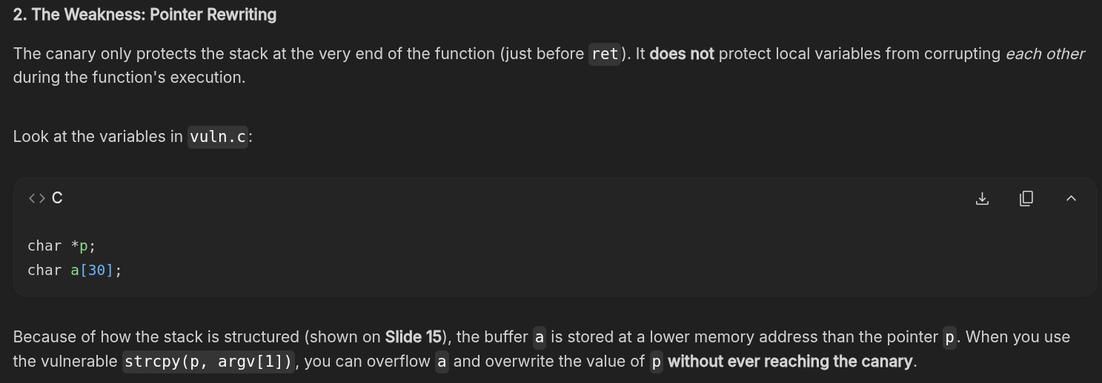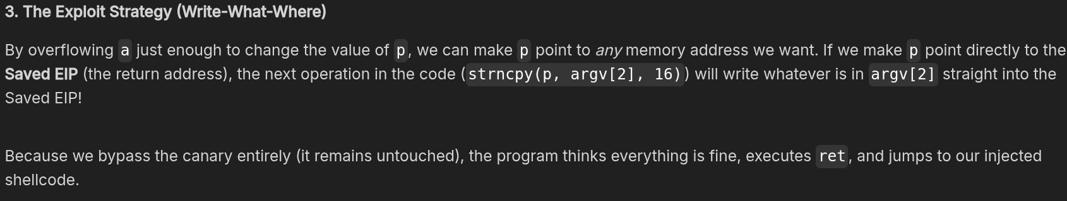
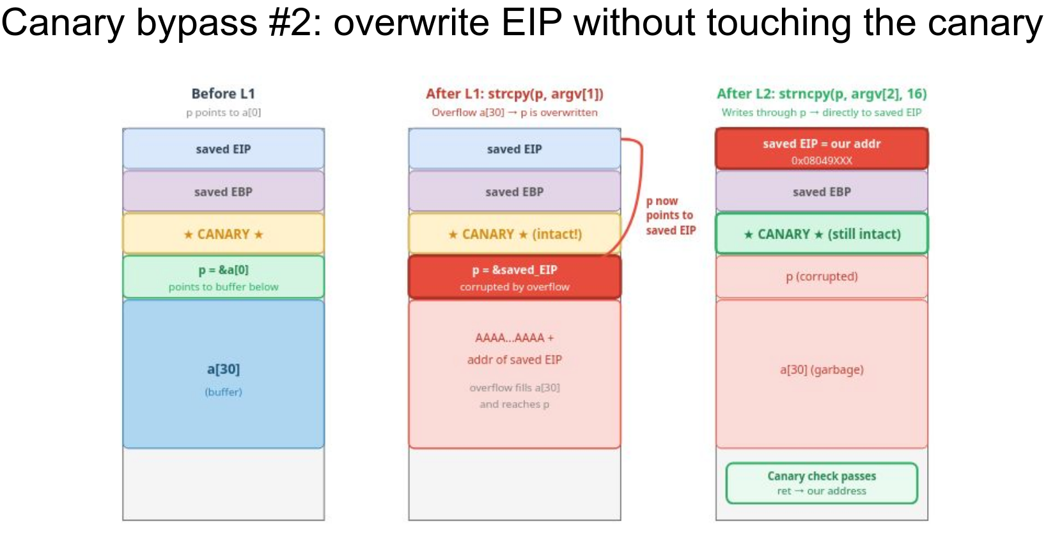
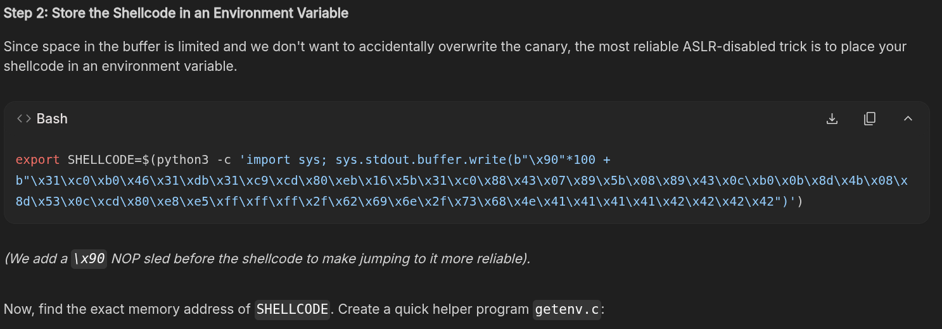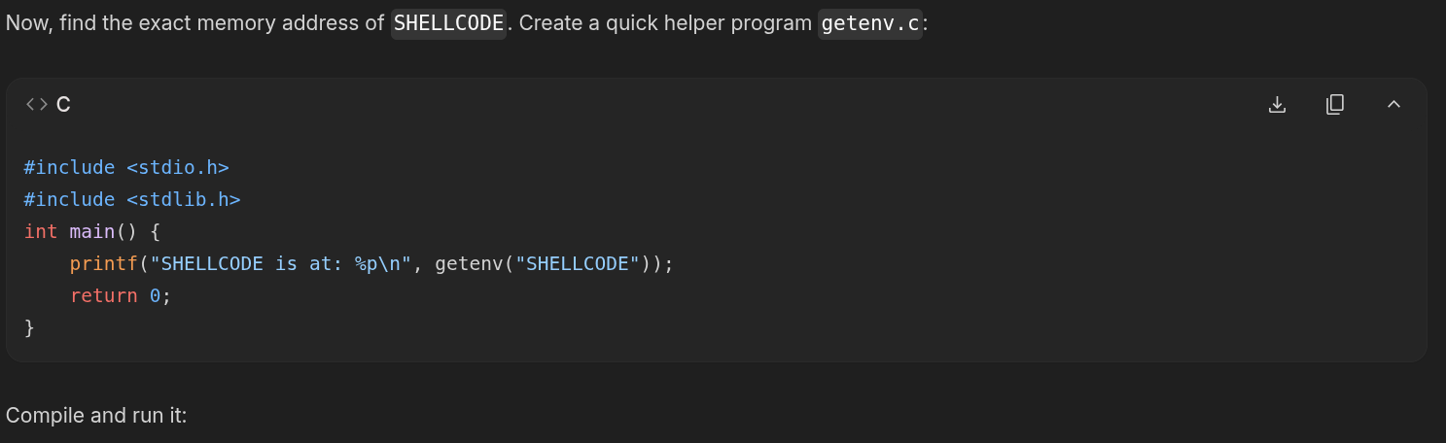
- Then in gdb we find the offset that separates the pointer p and the array a. (It should be 30 bytes here) so we know how much to overflow and write in p.
- If we want to run the code in gdb, we can directly find the address of Saved EIP with “info frame”. Remember the address will modify with the size of the arguments passed !
- Compute the offset between saved EIP and p in gdb, the offset will be the same outside gdb. Run the program one time to get the address of p thanks to the print statement.
- Now we know the address of saved EIP and of our shellcode (in current env). Run the program with the found addresses and correct offset :
./vuln $(python3 -c "import sys; sys.stdout.buffer.write(b'A'*30 + b'\x5c\xd1\xff\xff')") $(python3 -c "import sys; sys.stdout.buffer.write(b'\x88\xdf\xff\xff')")
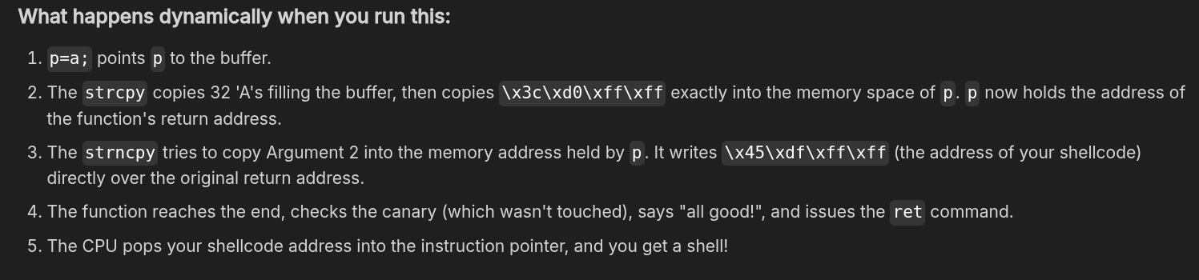

3 Breaking ASLR
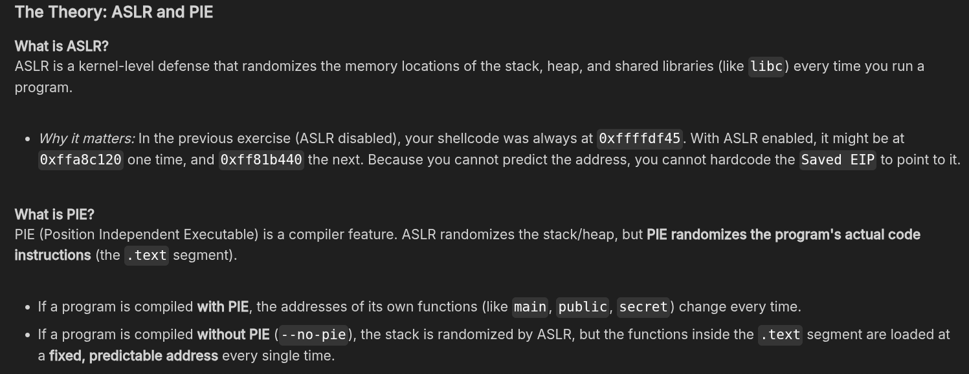

Part 1: Exploiting ret2text.c
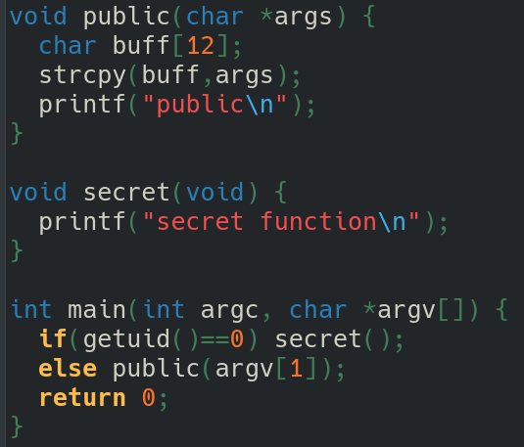
- Compile the program exactly as requested (—no-pie)
- Find the fixed address of secret() :Since PIE is disabled, we can easily find where secret() lives. You can use GDB, nm, or objdump.
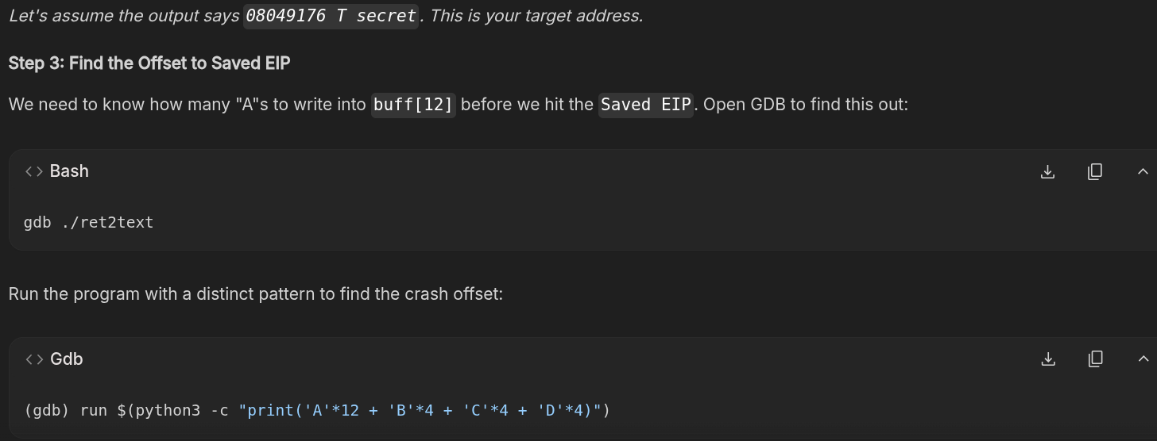
Look at the segmentation fault address to find the offset.
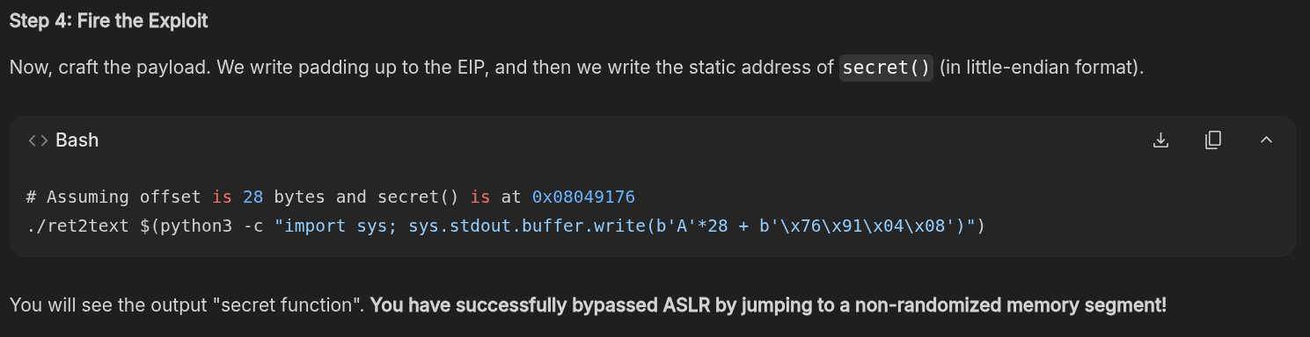

Part 2: Exploiting vulnerable.c (Injecting Shellcode with ASLR)
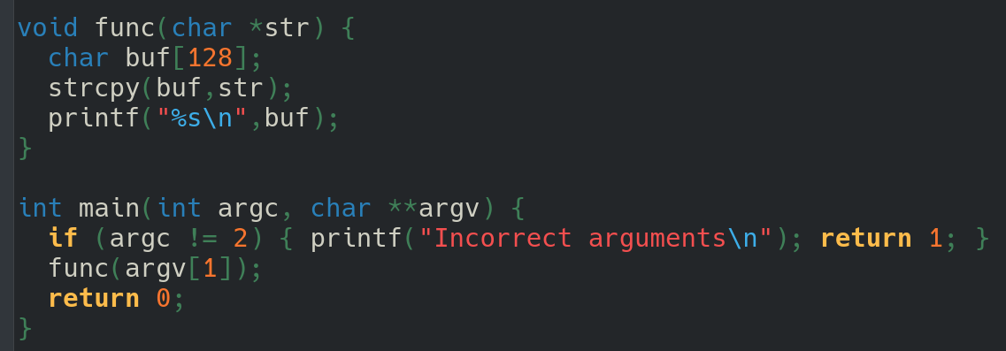

4 Evaluating Defenses

Part1 : table
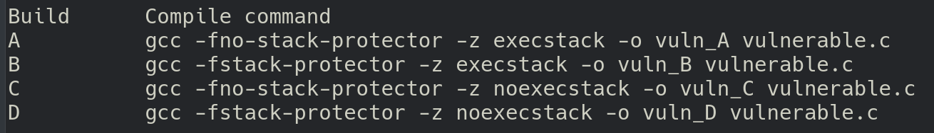
For each of the 8 combinations (4 builds × ASLR on/off), try:
- (a) a simple overflow with "A"x200,
- (b) the full shellcode injection from previous practical session.
Record what happens: clean crash, *** stack smashing detected ***, Segmentation fault, Illegal instruction, or shell spawned. Overflow detected? Shellcode runs? Addr. stable?
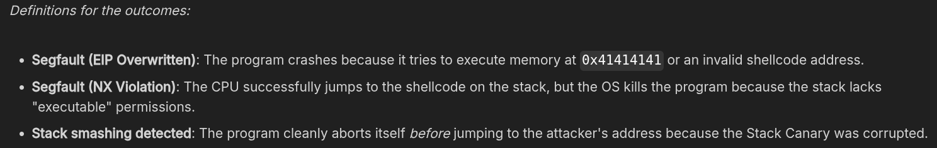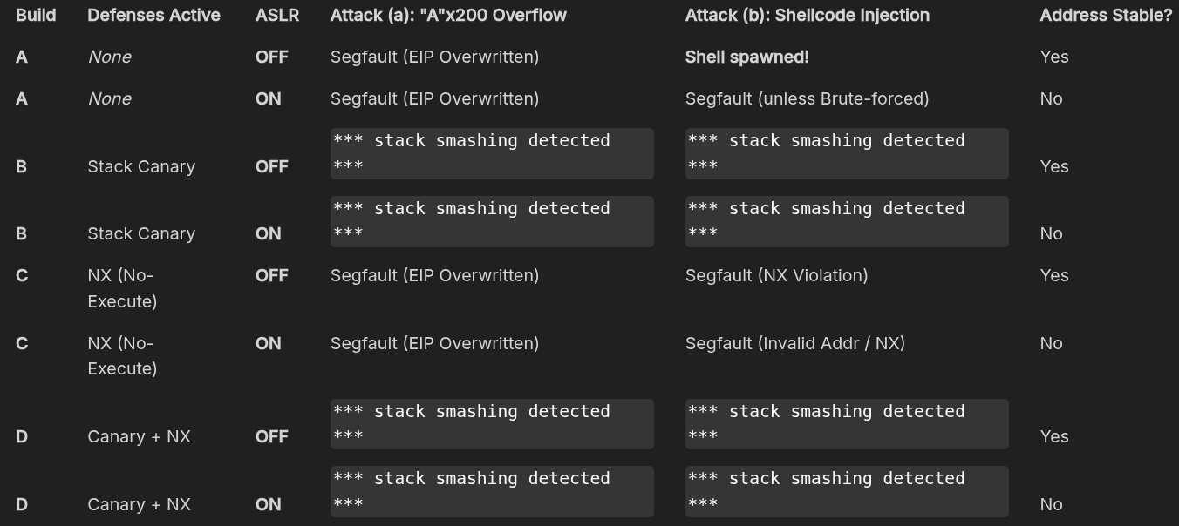

Part2 : questions
