Solutions LINFO2144 - TP8

Made by students from TPs notes. Nothing has been corrected by teachers or TAs so there is no guarantee of correctness and completeness.
Generative AI has been used, be aware that there might be mistakes. At least this is still better than not having any solutions at all !

1 EBP abuse
When a buffer is too small to fit our payload, or when we can only overwrite a single byte (Off-By-One), we can't easily overwrite the Saved EIP. Instead, we target the Saved EBP. This technique is called Stack Pivoting or creating a Fake Stack Frame.
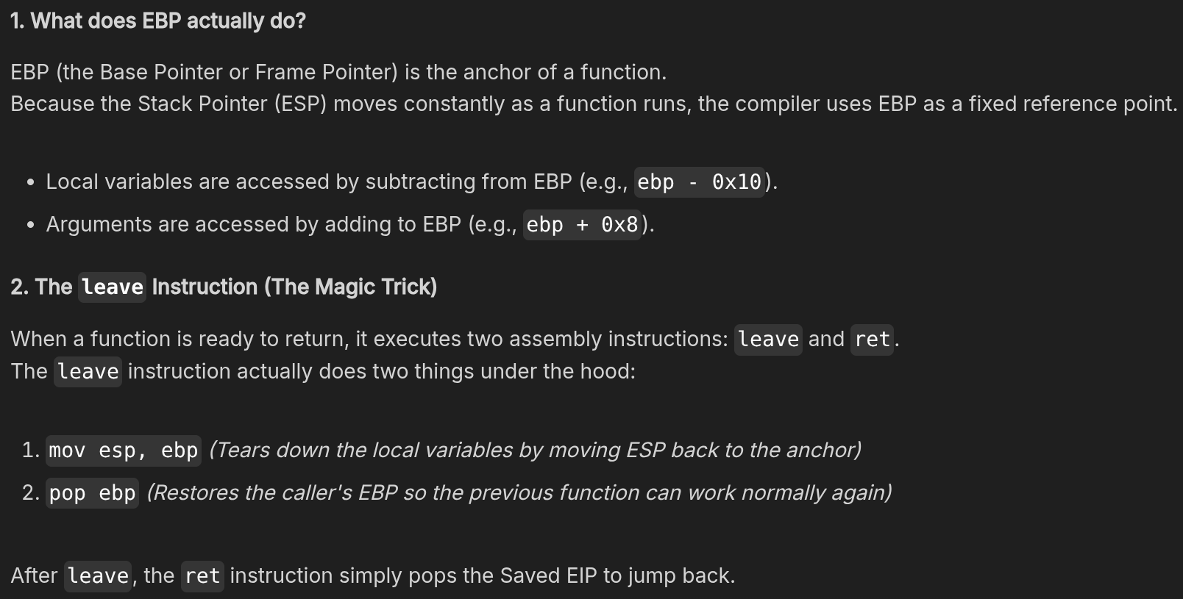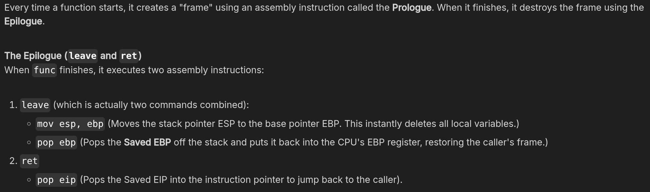
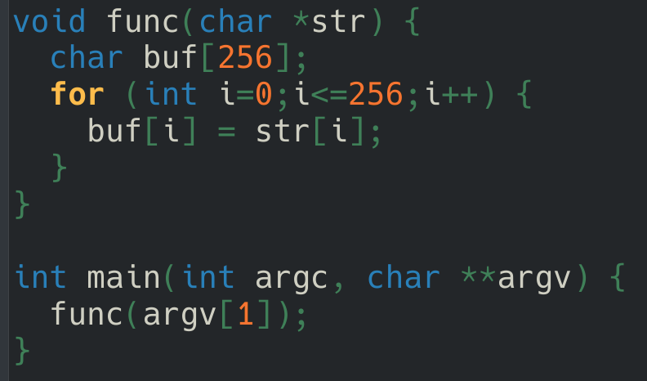
Compared to exercise 4 of TP7, i is not declared above the buffer so we can not overflow and write into it to create an infinite loop.
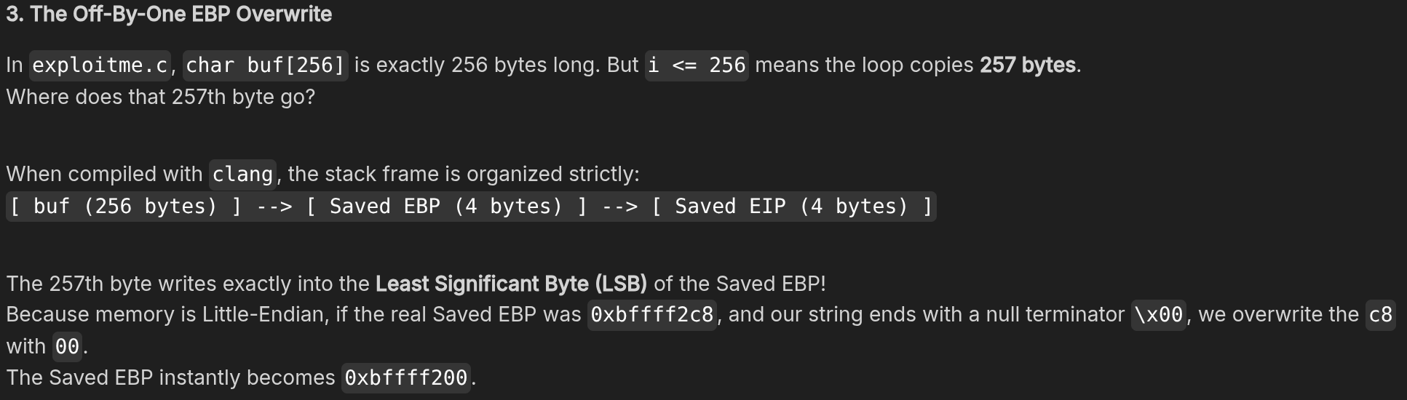
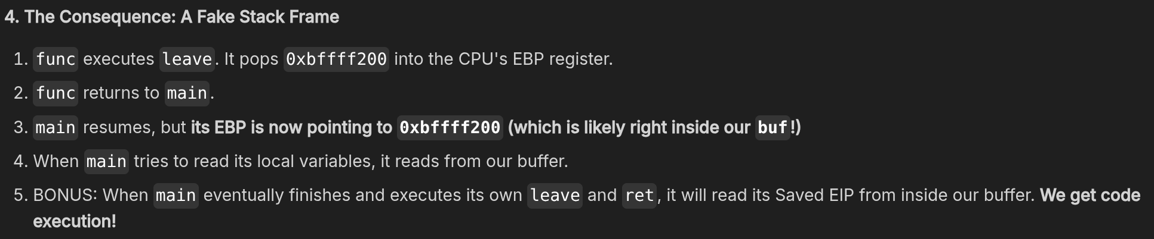
Unlike GCC, Clang typically places the Saved EBP immediately after buf, so we compile with it and all stack protection disabled.
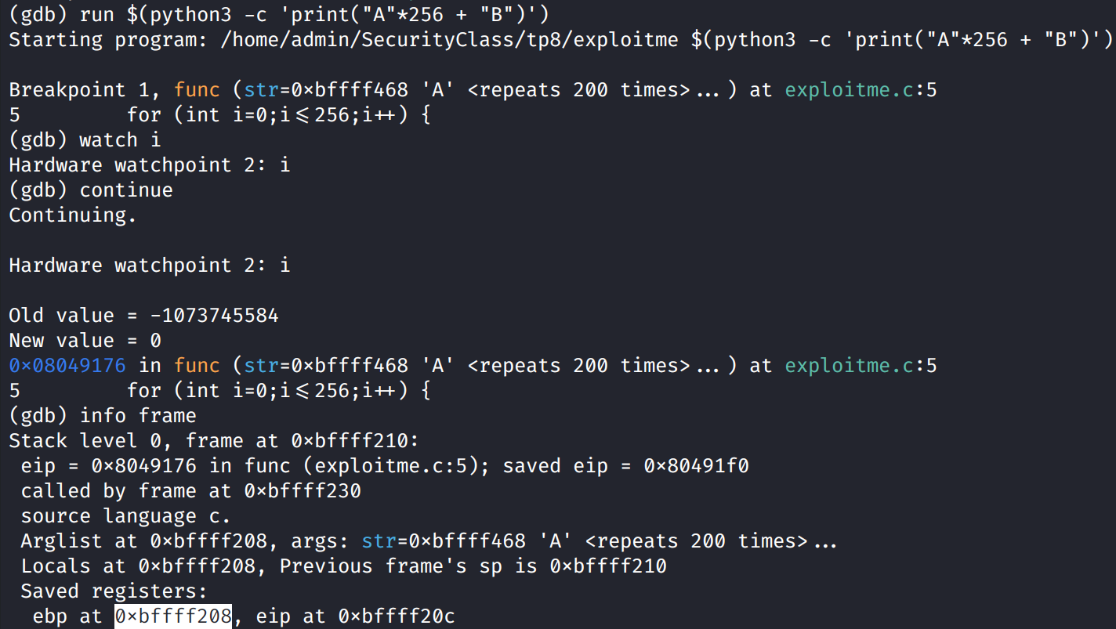
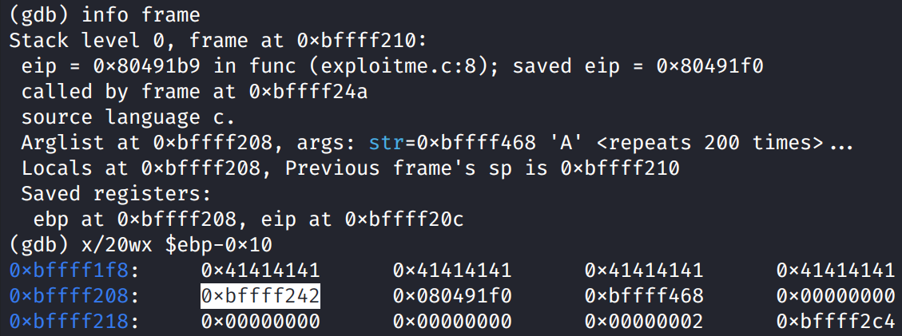
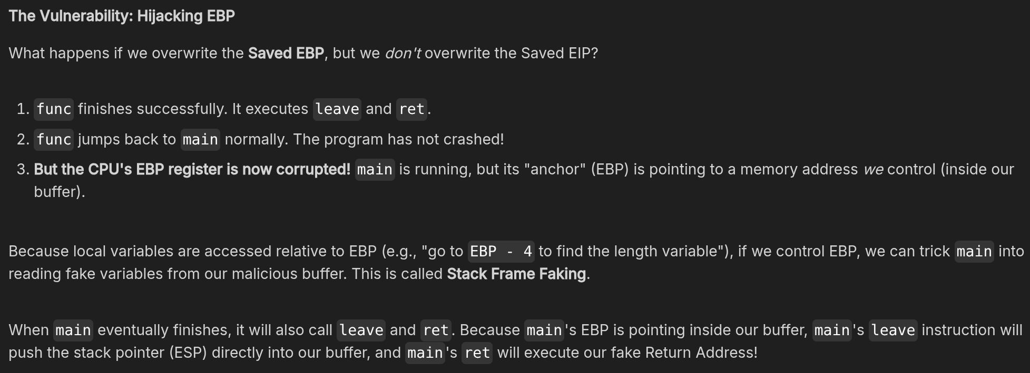

Exploit
The code in "vulnerable.c" allows you to overflow the buffer much more generously. Here you should be able to manipulate the stack (in particular EBP) to alter the state of the program after the return in a more complex way.
Observe that the program prints the length of the argument. You should be able to overflow and overwrite the EBP so that it points somewhere else. Then in your argument that overflows, create a fake stack frame so that the rest of the main function prints an incorrect value (hiding that your argument was long enough to overflow by over-writing the value stored from "strlen").
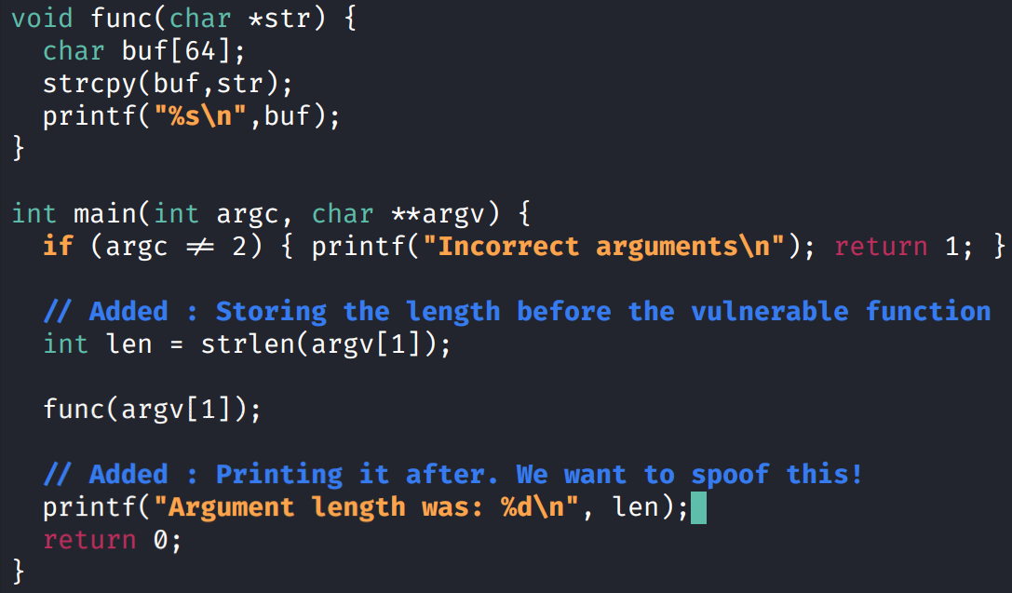
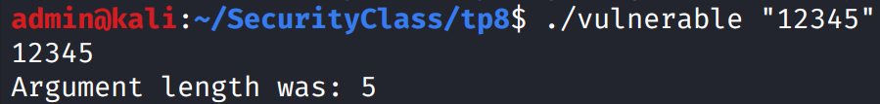
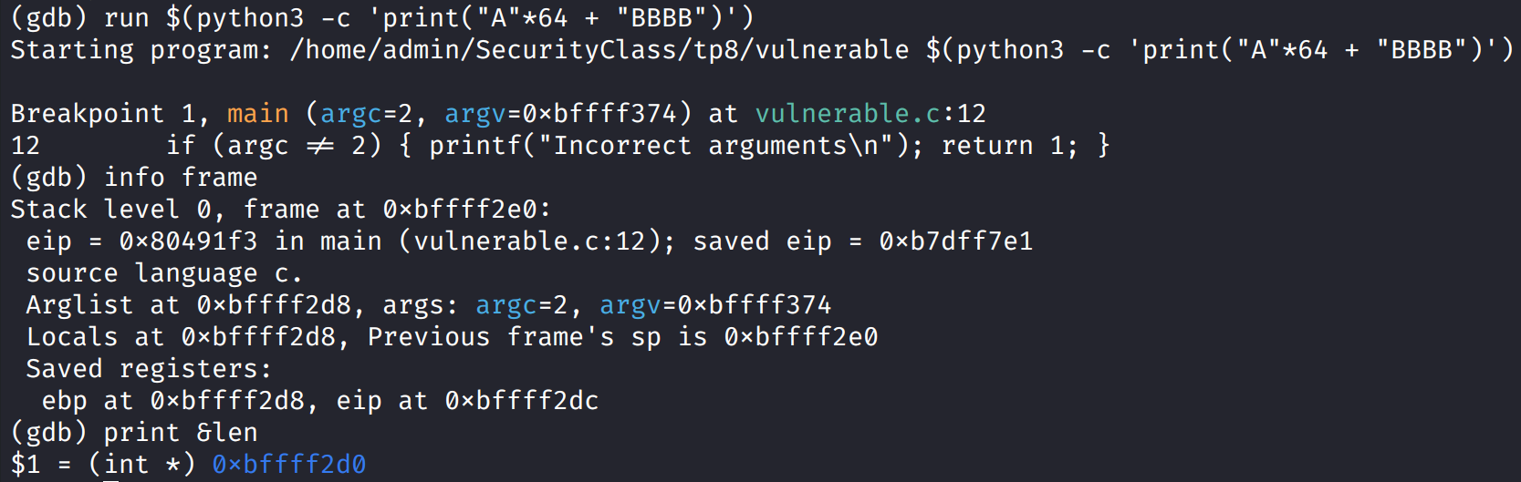
In the stack frame of main, we can see that there is 8 bytes between len and ebp address.
Todo

2 Shellcode analysis

