**Step 1: Defining the model.**

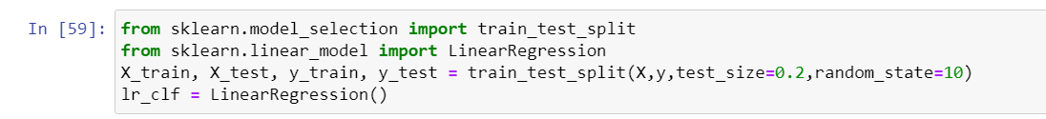

**Step 2: Fitting the model.**

**Step 3: Exporting the model to be utilize in development**



**Step 4: Using K Fold cross validation to measure accuracy of our LinearRegression model.**

**Step 5: Importing the model That was created using python in Jupyter notebook.**



**Step 6: Setting up the Python flask server to be able read the home prices model.**

**Step 7: Setting up the utilities in order to get the data endpoints from the model**

* **Loading the saved artifactsText

  Description automatically generated**
* **Getting estimated prices**

* **Getting location names and data columns**

**Step 8: Running the flask server**

**Step 9: Connecting the endpoint to JavaScript to be able to use for web development.**

