The Magnetic Field in a Coil
When an electric current flows through a wire, a magnetic field is produced around the wire. The magnitude and direction of the field depends on the shape of the wire and the direction and magnitude of the current through the wire. If the wire is wrapped into a loop, the field near the center of the loop is perpendicular to the plane of the loop. When the wire is looped a number of times to form a coil, the magnetic field at the center increases.
In this activity, you will examine how the magnetic field is related to both the number of turns in a coil and the current through the coil. A Magnetic Field Sensor will be used to detect the field at the center of the coil. A complication that must be considered is that the sensor will also detect the Earth’s field and any local fields due to electric currents or some metals in the vicinity of the sensor.
OBJECTIVES
- Use a Magnetic Field Sensor to measure the field at the center of a coil.
- Determine the relationship between magnetic field and the number of turns in a coil.
- Determine the relationship between magnetic field and the current in a coil.
- Explore the Earth’s magnetic field in your room.

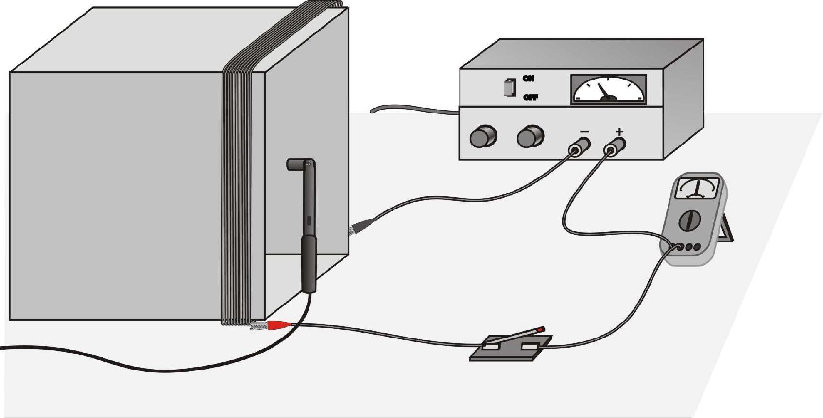
Figure 1
MATERIALS
computer | square or circular frame
Vernier computer interface | ammeter
Logger Pro | momentary-contact switch
Vernier Magnetic Field Sensor | magnetic compass
adjustable power supply | long spool of insulated wire (at least 12 m)

INITIAL SETUP
1. Connect the Vernier Magnetic Field Sensor to Channel 1 of the interface. Set the switch on the sensor to 0.3 mT (high amplification).
2. Using the long spool of wire, loop the wire ten times around a frame or box creating a coil of ten turns.
3. Connect the coil, switch, ammeter, and power supply, as shown in Figure 1. If your power supply has an accurate internal ammeter you do not need an additional external ammeter.
4. Open the file “25 Magnetic Field in a Coil” in the Physics with Vernier folder.
PRELIMINARY QUESTIONS AND ADDITIONAL SETUP
1. Hold the plastic rod containing the Magnetic Field Sensor vertically and move it completely away from the coil. Click  to begin data collection. Rotate the rod around a vertical axis. Look at the graph. What do you observe? What is causing the variation of field reading?
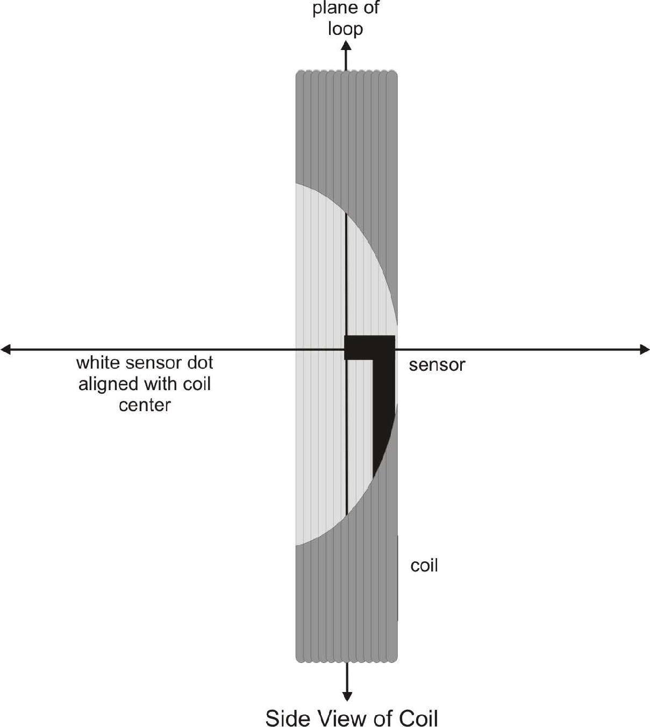
2. Determine the orientation of the sensor when the magnetic field is at a maximum, and compare the direction that the dot on the sensor is pointing with the direction that the magnetic compass needle points. What did you discover? How much does the reading change in one rotation?
3. Set the power supply so that the current will be 3 A when the switch is closed. Place the sensor in a vertical position at the center of the coil, with the white dot facing along the axis of the coil as shown here. Click . Wait 2 to 3 seconds and then close the switch. What did you observe? Warning: This lab requires fairly large currents to flow through the wires. Do not leave the switch on except when taking measurements. The wire and possibly the power supply may get hot if you leave current flowing continuously.
4. Repeat Step 3, but this time, rotate the Magnetic Field Sensor while you are holding the switch closed. Determine the orientation of the sensor that gives the maximum reading. How much does the reading change in one rotation of the sensor?
PROCEDURE
Part I How Is The Magnetic Field In A Coil Related To The Current?
For the first part of the experiment you will determine the relationship between the magnetic field in the center of a coil and the current through the coil. Use the loop with all ten turns for all of Part I. As before, leave the current off except when making a measurement.
1. Set the power supply so that the current will be 3 A when the switch is closed.
2. Place the Magnetic Field Sensor in a vertical position so that the flat end is at the center of the coil. With the switch closed, rotate the sensor about a vertical axis and observe the magnetic field values in the meter. Find the position that indicates a maximum positive magnetic field. The flat end of the sensor should be in the plane of the coil. Keep the sensor in the same position for the remainder of the experiment.
3. We will first zero the sensor when no current is flowing; that is, we will remove the effect of the Earth’s magnetic field and any local magnetism. With the switch open, click .
4. Click  to begin data collection. Wait a few seconds and then close the switch until data collection ends.
5. View the field vs. time graph and determine when the current was flowing in the wire. Select this region on the graph, by dragging over it. Determine the average field while the current was on by clicking on the Statistics button, 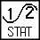. Record the average field and the current through the coil in the data table.
6. Briefly close the switch and decrease the current by 0.5 A and repeat Steps 4 and 5.
7. Repeat Step 6 down to a minimum of 0.5 A.
Part II How Is The Magnetic Field In A Coil Related To The Number Of Turns?
For the second part of the experiment you will determine the relationship between the magnetic field at the center of a coil and the number of turns in the coil. The Magnetic Field Sensor should be oriented as before. Use a current of 3.0 A for all of part II. Leave the current off except when making a measurement.
8. We will first zero the sensor when no current is flowing. That is, we will remove the effect of the Earth’s magnetic field and local magnetism. With the switch open, click on .
9. Set the power supply so that the current will be 3 A when the switch is closed. Click . After a few seconds, close and hold the switch for at least 10 s during the data collection.
10. View the field vs. time graph and determine where the current was flowing in the wire. Select this region of the graph by dragging over it with the mouse cursor. Determine the average field while the current was on by clicking on the Statistics button, . Record the average field and the number of turns on the coil (10) in the data table.
11. Remove one loop of wire from the frame to reduce the number of turns by one and repeat Steps 9–10. If you move the frame or the sensor, make sure that you get it back to the same orientation as the previous measurement.
12. Repeat Step 11 until you have only one turn of wire on the frame. Keep the current at 3.0 A.
DATA TABLE
Part I
Current in coil | Magnetic field
(A) | (mT)
3.0
2.5
2.0
1.5
1.0
0.5
Part II
Number of turns | Magnetic field | Number of turns | Magnetic field
 | (mT) |  | (mT)
10 |  | 5
9 |  | 4
8 |  | 3
7 |  | 2
6 |  | 1

ANALYSIS
Part I
1. Plot a graph of magnetic field vs. current through the coil. Use Logger Pro or another graphing tool. Page 2 of the experiment file is set up for this graph. What is the relationship between the current in a coil and the resulting magnetic field at the center of the coil?
2. Determine the equation of the best-fit line through the data points. Explain the significance of the constants in your equation. What are the units of the constants?
Part II
3. Plot a graph of magnetic field vs. the number of turns on the coil. Page 3 of the experiment file is set up for this graph. How is magnetic field related to the number of turns?
4. Determine the best-fit line through the data points. Explain the significance of the constants in your equation. What are the units of the constants? Remember that you zeroed the sensor before taking data in this lab. Should the line you fit in Step 6 go through the origin?
EXTENSIONS
1. How does the diameter of the coil loop affect the magnetic field? Design and conduct an experiment to answer this question.
2. Remove the coil and hold the Magnetic Field Sensor horizontally. Collect data while rotating it smoothly about a horizontal axis. Explain where the maximum and minimum readings occur and where zero or near-zero readings occur. Compare your pattern to the data you collect while rotating about a vertical axis.

