The Magnetic Field of a
Permanent Magnet
A bar magnet is called a dipole since it has two poles, commonly labeled North and South. Breaking a magnet in two does not produce two isolated poles; each fragment still has two poles. Similarly, two magnets together still exhibit only two poles. Since to our knowledge there are no magnetic monopoles, the dipole is the simplest possible magnetic field source.
The dipole field is not limited to bar magnets, for an electrical current flowing in a loop also creates this common magnetic field pattern.
The magnetic field B_{axis} (measured in tesla) of an ideal dipole measured along its axis is
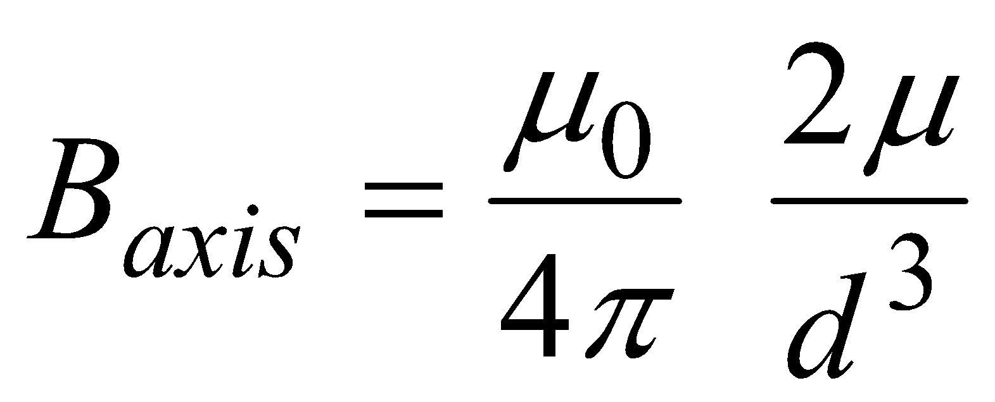
where μ₀ is the permeability constant (4π⋅10^{–7} T m/A), d is the distance from the center of the dipole in meters and μ is the magnetic moment. The magnetic moment μ measures the strength of a magnet, much like electrical charge measures the strength of a electric field source. Note that the distance dependence of this function is an inverse-cube function, which is different from the inverse-square relationship you may have studied for other situations.
In this lab, you will examine how the magnetic of a small, powerful magnet varies with distance, measured along the axis of the magnet. A Magnetic Field Sensor will be used to measure the magnitude of the field.
Simple laboratory magnets are approximately dipoles, although magnets of complex shapes will exhibit more complex fields. By comparing your field data to the field of an ideal dipole you can see if your magnet is very nearly a dipole in its behavior. If it is nearly a dipole, you can also measure its magnetic moment.
OBJECTIVES
- Use a Magnetic Field Sensor to measure the field of a small magnet.
- Compare the distance dependence of the magnetic field to the magnetic dipole model.
- Measure the magnetic moment of a magnet.

MATERIALS
computer | masking tape
Vernier computer interface | strong disk magnets (2)
Logger Pro | tape measure or meter stick
Vernier Magnetic Field Sensor | index card

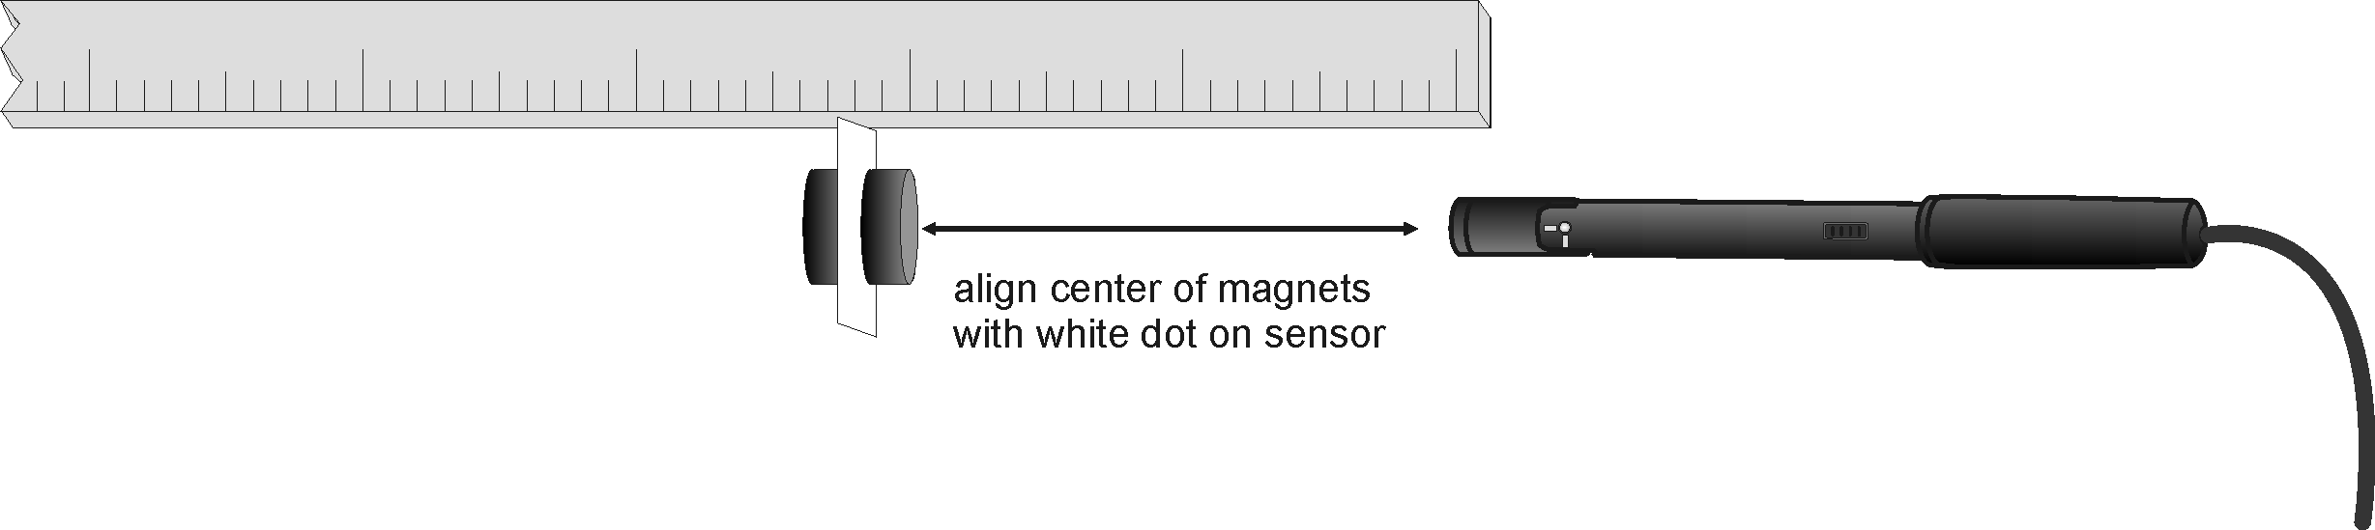
Figure 1
PRELIMINARY QUESTION
- Place one magnet on a table and hold the other in your hand, well above the first. From directly above, slowly lower the upper magnet toward the first. Watch for the moment when the lower magnet jumps up to meet the upper. Separate the magnets and try again. From the sudden jump of the lower magnet, what can you conclude about the way the magnetic force between the magnets varies with distance?
PROCEDURE
- Tape the measuring tape or meter stick to the table, and tape the Magnetic Field Sensor to a convenient location. The clear plastic rod should be perpendicular to the stick, with the white spot inside the rod facing along the meter stick in the direction of increasing distance. Carefully measure the location of the sensor on the meter stick. This will be your origin for all distance measurements.
- As a convenient way to measure to the center of the magnet, and to ease handling of the small magnets, allow the two magnets to attract one another through the card, about 0.5 cm from either edge near the corner. The magnets should stay in place on the card. The card itself will serve to mark the center of the magnet pair.
- Connect the Vernier Magnetic Field Sensor to Channel 1 of the computer interface. Set the switch on the sensor to 6.4 mT (low amplification).
- Open the file “31 Mag Field Magnet” in the Physics with Vernier folder.
5. We will first zero the sensor when the magnets are far away from the sensor in order to remove the effect of the Earth’s magnetic field and any local magnetism. The sensor will be zeroed only for this location, so instead of moving the sensor in later steps, you will move the magnets.
- Move the magnets far away from the sensor.
- When the reading in the meter is stable, click .

6. Now you are ready to collect magnetic field data as a function of distance.
- Click  to begin data collection.
- Place the card with the magnets against the meter stick, 2.0 cm from the Magnetic Field Sensor, so the card is perpendicular to the meter stick. Measure from the card to the center of the Magnetic Field Sensor.
- The current magnetic field measurement is shown in the meter. If necessary, reverse the magnets so the reading is positive, and reposition the card 2.0 cm from the sensor. If the reading is more than 6 mT, then increase the distance until the reading is below 6 mT.
- Carefully measure the distance of the card to the sensor.
- Click  to record the magnetic field.
- To make later calculations easier, on the computer enter the distance in meters, e.g., 2 cm is 0.02 m. Click  to complete the entry.

7. For the next ten points collect field and distance data as you did before.
- Keeping the Magnetic Field Sensor stationary, increase the distance to the magnet by 0.25 cm.
- Click  to record the magnetic field.
- Enter the distance in meters on the computer.
- After the last point, click  to end data collection.

The graph you see is the magnetic field vs. the distance from the magnet. The field should drop off rapidly.
DATA TABLE
Model parameter A

Magnetic moment
μ (A m²)

ANALYSIS
- To compare your data to the inverse-cube model
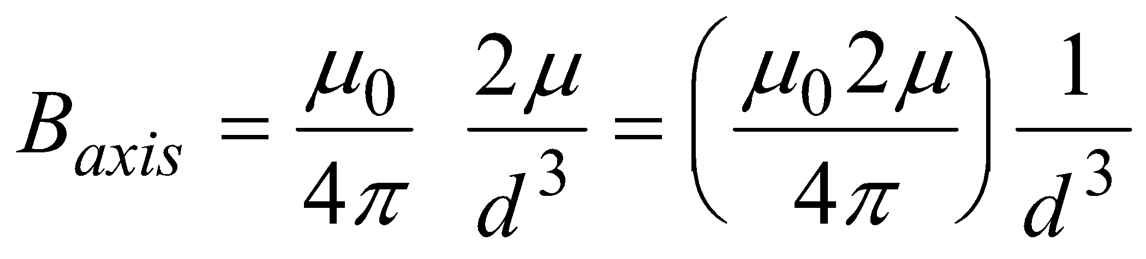
you can plot the equation y = A/x³ along with your data. To plot your data and the inverse-cube model on the graph at the same time
- Select Curve Fit from the Analyze menu. A new dialog box will open.
- Select Variable Power from the General Equation list.
- Enter – 3 in the Power field. This setting adjusts the fitted function to an inverse-cube relationship.
- Click  to see the fitted function.
- Click  to return to the main graph.
- Record the numeric value of A in your data table.

2. How well does the inverse-cube model fit your experimental data? From the comparison, does your magnet show the magnetic field pattern of a dipole?
3. The computer adjusted the parameter A so the equation’s curve comes as close as possible to your data points. Relating the parameter A to the field expression for a magnetic dipole, we see that A = (μ₀ 2 μ 10³) / (4π). The factor of 10³ is present because the magnetic field was measured in mT rather than T. Use your value of A to determine the magnetic moment μ of your magnet, if the inverse-cube model fits your experimental data.
EXTENSIONS
- Find other magnets such as refrigerator magnets, horseshoe magnets, and disk magnets, and see if they also show the magnetic field of a dipole.
- Measure the dipole moment of just one neodymium magnet, or four stuck together. Is the dipole moment additive when you use two or more magnets attracted together?
- Show that the units of the magnetic moment are A m² (ampere meter²).
- The units of μ may suggest a relationship of a magnetic moment to an electrical current. In fact, a current flowing in a closed loop is a magnetic dipole. A current I flowing around a loop of area πr² has a magnetic moment μ = I πr². If a single current loop had the same radius as your permanent magnet, what current would be required to create the same magnetic field? (You will be surprised.) Are there currents flowing in loops in the permanent magnet?

