
Name: ___________________________

Class: ___________________________

Atwood’s Machine
A classic experiment in physics is the Atwood’s machine: Two masses on either side of a pulley connected by a light string. When released, the heavier mass will accelerate downward while the lighter one accelerates upward at the same rate. The acceleration depends on the difference in the two masses as well as the total mass.
In this lab, you will determine the relationship between the two factors which influence the acceleration of an Atwood’s machine using a Photogate for measuring acceleration.
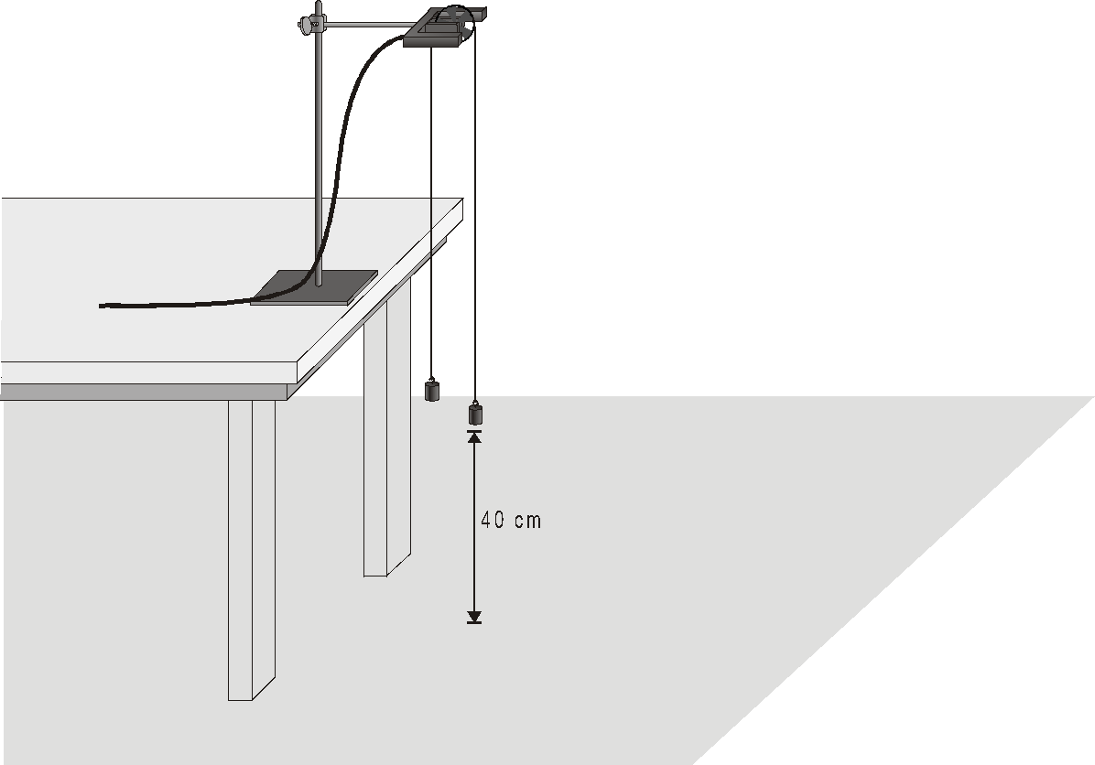
Figure 1
OBJECTIVES
- Use a Photogate to study the acceleration of an Atwood’s machine.
- Determine the relationships between the masses on an Atwood’s machine and the acceleration.

MATERIALS
computer | Vernier Photogate with Ultra Pulley
Vernier computer interface | mass set
Logger Pro | string

PRELIMINARY QUESTIONS
1. If two equal masses are suspended from either end of a string passing over a light pulley (an Atwood’s machine), what kind of motion do you expect to occur? Why?
2. For an Atwood’s machine, how would you expect the acceleration to change if you:
- Move mass from one side to the other, keeping the total mass constant?
- Gradually increase the mass of both sides?

3. Why do the two masses have the same acceleration?
4. Draw a free-body diagram of the left side mass. Draw another of the right side mass. Include all forces acting on each mass.
PROCEDURE
Part I Constant Total Mass
For this part of the experiment:
- Independent Variable (what you are altering): Difference between m₁ and m₂
- Dependent Variable (what you are measuring): Acceleration
- Control Variable (what you keep the same): Total Mass
1. Set up the Atwood’s machine apparatus as shown in Figure 1. Be sure the heavier mass can move at least 40 cm before striking the floor.
2. Open the file “10 Atwoods Machine” in the Physics with Vernier folder. A graph of velocity vs. time will be displayed.
4. Arrange a collection of masses totaling 200 g on m₂ and a 200 g mass on m₁. What is the acceleration of this combination? Record your values for mass and acceleration in the data table.
5. Move 5 g (or your smallest increment) from m₂ to m₁. Record the new masses in the data table.
6. Position m₁ as high up as it can go. Click  to begin data collection. Steady the masses so they are not swinging. Wait one second and release the masses. Catch the falling mass before it strikes the floor or the other mass strikes the pulley.
7. Select the region of the graph where the velocity was increasing at a steady rate. Click the Linear Fit button 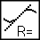 to fit the line y = mt + b to the data. Record the slope, which is the acceleration, in the data table.
8. Continue to move masses from m₂ to m₁ in 5 g increments (or your smallest increment), changing the difference between the masses, but keeping the total mass constant. Repeat Steps 6–7 for each mass combination. Repeat this step until you get at least five different combinations
9. For each trial, calculate the difference between m₁ and m₂. Enter the result in the column labeled Δm.
10. For each trial, calculate the total mass in grams. Enter the result in the column labeled m_{T}.
Part II Constant Mass Difference
For this part of the experiment:
- Independent Variable (what you are altering): Total Mass
- Dependent Variable (what you are measuring): Acceleration
- Control Variable (what you keep the same): Difference between m₁ and m₂
9. Put 120 g on m₁ and 100 g on m₂.
10. Repeat Steps 6–7 to collect data and determine the acceleration.
11. Add mass in 20 g increments to both sides, keeping a constant difference of 20 grams. Record the resulting mass for each combination in the data table. Repeat Steps 6–10 for each combination. Repeat the procedure until you get at least five different combinations.
DATA TABLE
Part I: Total Mass Constant
Trial | m₁ | m₂ | Acceleration | Δm | m_{T}
 | (g) | (g) | (m/s²) | (g) | (g)
1
2
3
4
5
Part II: The Mass Difference Constant
Trial | m₁ | m₂ | Acceleration | Δm | m_{T}
 | (g) | (g) | (m/s²) | (g) | (g)
6
7
8
9
10

GRAPHS
- For Part I, plot a graph of independent vs. dependent variables (remember, dependent variable goes on the y-axis). Be sure to add a title Graph I, and label axes, add a trendline, and show equation of the trendline.
- For Part II, plot a graph of independent vs. dependent variables (remember, dependent variable goes on the y-axis). Be sure to add a title Graph II, and label axes, add a trendline, and show equation of the trendline.
ANALYSIS
- Draw a free body diagram of m₁ and another free body diagram of m₂. Using these diagrams, apply Newton’s second law to each mass. Assume that the tension is the same on each mass and that they have the same acceleration.
- From the FBD and equations, find a singular expression/equation for the acceleration in terms of m1, m2, and g.
- Based on your analysis of Graph I, what is the relationship between the mass difference and the acceleration of an Atwood’s machine? Write a few sentences comparing your graph and your data, and explain the relationship using scientific language.
- Based on your analysis of Graph II, what is the relationship between total mass and the acceleration of an Atwood’s machine? Write a few sentences comparing your graph and your data, and explain the relationship using scientific language.
- Determine the theoretical values for what acceleration should have been in each of the 10 trials, based upon your equation for acceleration from step 2.
  - Find the percent difference between each theoretical and experimental value.
    - <5% = Very Good
    - 5% - 10% = Good
    - >10% = Not Good
  - Add the theoretical values and percent difference as added columns to your final data chart.
  - Compare your theoretical values with your experimental values in a few well written, scientifically appropriate and analytical sentences.
- Evaluate your data determined from step 5 above. Are the experimental acceleration values low or high? What do you think was the greatest variable which contributed to percent error? Why?

