Static and Kinetic Friction
If you try to slide a heavy box resting on the floor, you may find it difficult to get the box moving. Static friction is the force that is counters your force on the box. If you apply a light horizontal push that does not move the box, the static friction force is also small and directly opposite to your push. If you push harder, the friction force increases to match the magnitude of your push. There is a limit to the magnitude of static friction, so eventually you may be able to apply a force larger than the maximum static force, and the box will move. The maximum static friction force is sometimes referred to as starting friction. We model static friction, Fstatic, with the inequality Fstatic μs N where μs is the coefficient of static friction and N the normal force exerted by a surface on the object. The normal force is defined as the perpendicular component of the force exerted by the surface. In this case, the normal force is equal to the weight of the object.
Once the box starts to slide, you must continue to exert a force to keep the object moving, or friction will slow it to a stop. The friction acting on the box while it is moving is called kinetic friction. In order to slide the box with a constant velocity, a force equivalent to the force of kinetic friction must be applied. Kinetic friction is sometimes referred to as sliding friction. Both static and kinetic friction depend on the surfaces of the box and the floor, and on how hard the box and floor are pressed together. We model kinetic friction with Fkinetic = μk N, where μk is the coefficient of kinetic friction.
In this experiment, you will use a Force Sensor to study static friction and kinetic friction on a wooden block. A Motion Detector will also be used to analyze the kinetic friction acting on a sliding block.
OBJECTIVES
- Use a Dual-Range Force Sensor to measure the force of static friction.
- Determine the relationship between force of static friction and the weight of an object.
- Measure the coefficients of static and kinetic friction for a particular block and track.
- Use a Motion Detector to independently measure the coefficient of kinetic friction and compare it to the previously measured value.
- Determine if the coefficient of kinetic friction depends on weight.

MATERIALS
computer | string
Vernier computer interface | block of wood with hook
Logger Pro | balance or scale
Vernier Motion Detector | mass set
Vernier Force Sensor

PRELIMINARY QUESTIONS
1. In pushing a heavy box across the floor, is the force you need to apply to start the box moving greater than, less than, or the same as the force needed to keep the box moving? On what are you basing your choice?
2. How do you think the force of friction is related to the weight of the box? Explain.
PROCEDURE
Part I Starting Friction
1. Measure the mass of the block and record it in the data table.
2. Connect the Dual-Range Force Sensor to Channel 1 of the interface. Set the range switch on the Force Sensor to 50 N.
3. Open the file “12a Static Kinetic Frict” from the Physics with Vernier folder.
4. Tie one end of a string to the hook on the Force Sensor and the other end to the hook on the wooden block. Place a total of 1 kg mass on top of the block, fastened so the masses cannot shift. Practice pulling the block and masses with the Force Sensor using this straight-line motion: Slowly and gently pull horizontally with a small force. Very gradually, taking one full second, increase the force until the block starts to slide, and then keep the block moving at a constant speed for another second.
5. Sketch a graph of force vs. time for the force you felt on your hand. Label the portion of the graph corresponding to the block at rest, the time when the block just started to move, and the time when the block was moving at constant speed.
6. Hold the Force Sensor in position, ready to pull the block, but with no tension in the string. Click 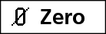 to set the Force Sensor to zero.
7. Click  to begin collecting data. Pull the block as before, taking care to increase the force gradually. Repeat the process as needed until you have a graph that reflects the desired motion, including pulling the block at constant speed once it begins moving. Print or copy the graph for use in the Analysis portion of this activity.
Part II Peak Static Friction and Kinetic Friction
In this section, you will measure the peak static friction force and the kinetic friction force as a function of the normal force on the block. In each run, you will pull the block as before, but by changing the masses on the block, you will vary the normal force on the block.
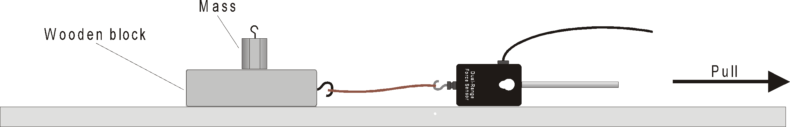
Figure 1
8. Remove all masses from the block.
9. Click  to begin collecting data and pull as before to gather force vs. time data.
10. Examine the data by clicking the Statistics button, 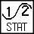. The maximum value of the force occurs when the block started to slide. Read this value of the maximum force of static friction from the floating box and record the number in your data table.
11. Drag across the region of the graph corresponding to the block moving at constant velocity. Click on the Statistics button again and read the average (or mean) force during the time interval. This force is the magnitude of the kinetic frictional force.
12. Repeat Steps 9-11 for two more measurements and average the results to determine the reliability of your measurements. Record the values in the data table.
13. Add masses totaling 250 g to the block. Repeat Steps 9–12, recording values in the data table.
14. Repeat for additional masses of 500, 750, and 1000 g. Record values in your data table.
Part III Kinetic Friction Again
In this section, you will measure the coefficient of kinetic friction a second way and compare it to the measurement in Part II. Using the Motion Detector, you can measure the acceleration of the block as it slides to a stop. This acceleration can be determined from the velocity vs. time graph. While sliding, the only force acting on the block in the horizontal direction is that of friction. From the mass of the block and its acceleration, you can find the frictional force and finally, the coefficient of kinetic friction.

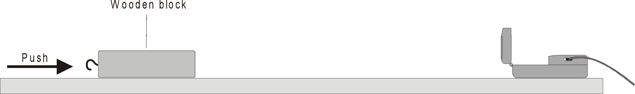
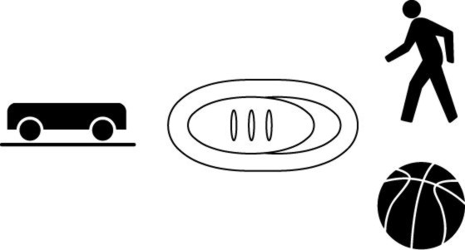
Figure 2
15. Connect the Motion Detector to DIG/SONIC 1 of the Vernier computer interface. If the Motion Detector has a switch, set it to Track.
16. Open the “12b Static Kinetic Frict” in the Physics with Computers folder.
17. Place the Motion Detector on the lab table 2–3 m from a block of wood, as shown in Figure 2. Position the Motion Detector so that it will detect the motion of the block as it slides toward the detector.
18. Practice sliding the block toward the Motion Detector so that the block leaves your hand and slides to a stop. Minimize the rotation of the block. After it leaves your hand, the block should slide about 1 m before it stops and it must not come any closer to the Motion Detector than 0.4 m.
19. Click  to start collecting data and give the block a push so that it slides toward the Motion Detector. The velocity graph should have a portion with a linearly decreasing section corresponding to the freely sliding motion of the block. Repeat if needed.
20. Select a region of the velocity vs. time graph that shows the decreasing speed of the block. Choose the linear section. The slope of this section of the velocity graph is the acceleration. Drag the mouse over this section and determine the slope by clicking the Linear Fit button, 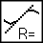. Record this value of acceleration in your data table.
21. Repeat Steps 19–20 four more times.
22. Place masses totaling 500 g on the block. Fasten the masses so they will not move. Repeat Steps 19–20 five times for the block with masses. Record acceleration values in your data table.
DATA TABLE
Part I Starting Friction
Mass of block | kg

Part II Peak Static Friction and Kinetic Friction
 |  | Peak static friction |  |  | Average
Total mass (m) | Normal force (N) | Trial 1 | Trial 2 | Trial 3 | peak static friction  (N)

 |  | Kinetic friction |  |  | Average
Total mass (m) | Normal force  (N) | Trial 1 | Trial 2 | Trial 3 | kinetic  friction  (N)
Part III Kinetic Friction
Data: Block with no additional mass
Trial | Acceleration  (m/s2) | Kinetic friction force  (N) | μk
1
2
3
4
5
Average coefficient of kinetic friction:

Data: Block with 500 g additional mass
Trial | Acceleration  (m/s2) | Kinetic friction force  (N) | μk
1
2
3
4
5
Average coefficient of kinetic friction:

ANALYSIS
1. Inspect the printout or sketch of force vs. time graph from Part I. Label the portion of the graph corresponding to the block at rest, the time when the block just started to move, and the time when the block was moving at constant speed.
2. Still using the force vs. time graph you created in Part I, compare the force necessary to keep the block sliding compared to the force necessary to start the slide. How does your answer compare to your answer to question 1 in the Preliminary Questions section?
3. The coefficient of friction is a constant that relates the normal force between two objects (blocks and table) and the force of friction. Based on your graph (Run 1) from Part I, would you expect the coefficient of static friction to be greater than, less than, or the same as the coefficient of kinetic friction?
4. For Part II, calculate the normal force of the table on the block alone and with each combination of added masses. Since the block is on a horizontal surface, the normal force will be equal in magnitude and opposite in direction to the weight of the block and any masses it carries. Fill in the Normal Force entries for both Part II data tables.
5. Plot a graph of the maximum static friction force (vertical axis) vs. the normal force (horizontal axis). Use either Logger Pro or graph paper.
6. Since Fmaximum static = μs N, the slope of this graph is the coefficient of static friction μs. Find the numeric value of the slope, including any units. Should a line fitted to these data pass through the origin?
7. In a similar graphical manner, find the coefficient of kinetic friction μk. Create a plot of the average kinetic friction forces vs. the normal force. Recall that Fkinetic = μk N. Should a line fitted to these data pass through the origin?
8. Your data from Part III also allow you to determine μk. Draw a free-body diagram for the sliding block. The kinetic friction force can be determined from Newton’s second law, or ΣF = ma. From the mass and acceleration, find the friction force for each trial, and enter it in the data table.
9. From the friction force, determine the coefficient of kinetic friction for each trial and enter the values in the data table. Also, calculate an average value for the coefficient of kinetic friction for the block and for the block with added mass.
10. Does the coefficient of kinetic friction depend on speed? Explain, using your experimental data.
11. Does the force of kinetic friction depend on the weight of the block? Explain.
12. Does the coefficient of kinetic friction depend on the weight of the block?
13. Compare your coefficients of kinetic friction determined in Part III to that determined in Part II. Discuss the values. Do you expect them to be the same or different?
EXTENSIONS
1. How is the force of friction or the coefficient of friction affected by the surface area of the block? Devise an experiment that can test your hypothesis.
2. Examine the force of static friction for an object on an incline. Find the angle that causes a wooden block to start to slide. Calculate the coefficient of friction and compare it to the value you obtain when the angle of the incline is 0°.
3. Try changing the coefficient of friction by using wax or furniture polish on the table. How much does it change?

