Centripetal Acceleration on a Turntable
As a child, you may remember the challenge of spinning a playground merry-go-round so you could scare the unfortunate riders as they traveled around a circular path. You worked especially hard to push the merry-go-round to increase its angular velocity. As the angular velocity of the riders increased, so did their centripetal acceleration. The challenge for the riders was to compete with the centripetal acceleration to maintain their balance—and their stomachs. The faster the merry-go-round was spun, the more difficult it became to stay on the ride. It may have disappointed you when the riders “cheated” and moved toward the center of the merry-go-round to reduce the acceleration. In this activity, you will investigate centripetal acceleration on a phonograph turntable. You will use a Low-g Accelerometer attached to the turntable to determine the relationship between centripetal acceleration, angular velocity, and the radius of the circular path.
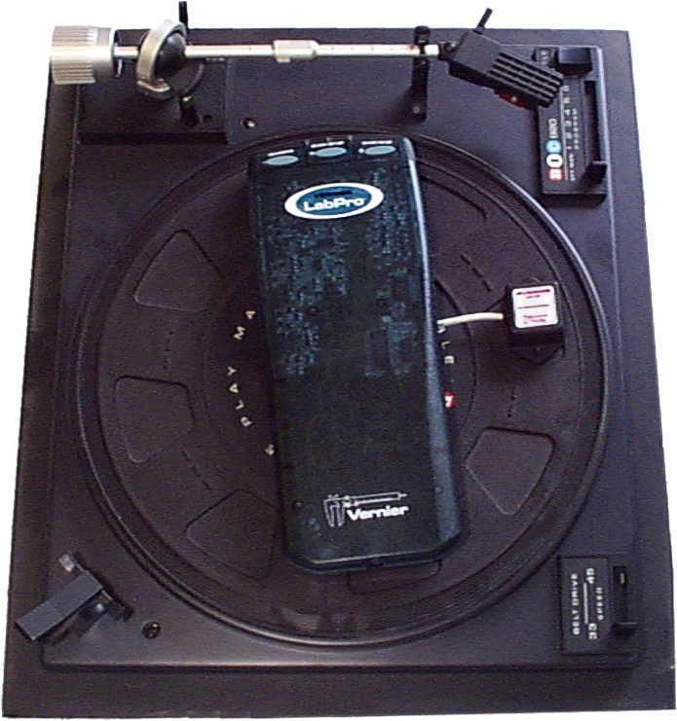
OBJECTIVES
- Measure centripetal acceleration on a record turntable.
- Determine the relationship between centripetal acceleration, radius, and angular velocity.
- Determine the direction of centripetal acceleration.

MATERIALS
computer | masking tape
Vernier computer interface | meter stick
Logger Pro | 20 g slotted mass
Vernier Low-g Accelerometer | level
turntable with 33 1/3, 45, 78 rpm settings
PRELIMINARY QUESTIONS
- Place a 20 g mass about 5 cm from the center of the turntable. Set the turntable to run at 33 1/3 rpm, and turn it on. Observe the motion of the mass. Is the speed of the mass constant or changing? Is the velocity of the mass constant or changing? Using your last answer, is the acceleration of the mass constant, zero, or changing? If the acceleration is not zero, what is its direction?
- Place a 20 g mass 5 cm from the center of the turntable. Set the angular velocity to 33 1/3 rpm and turn on the turntable. After a few rotations, switch to 45 rpm. Is the mass now undergoing less, the same, or more acceleration? Propose a mathematical relationship between centripetal acceleration and angular velocity.
PROCEDURE
- Connect the Accelerometer to the interface.
- Open the file “20a Centripetal Acceleration” from the Physics with Vernier folder.
3. Next you will zero the Accelerometer so that it reads zero when it is horizontal and the turntable is not spinning.
- Rest the Accelerometer on a table with the arrow level and horizontal.
- With the sensor motionless, click 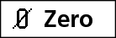 to mark the zero condition.
Part I
What is the direction of the centripetal acceleration? To answer this question, you will need to understand the measurements of your Accelerometer. In particular, what direction, relative to the arrow on the Accelerometer, corresponds to a positive measurement? In this section, you will determine how to interpret the sign of your acceleration measurements by moving the Accelerometer through a known acceleration direction.
4. For motion along a line, does speeding up while moving in the positive direction correspond to a positive or a negative acceleration? Does slowing down while moving in the positive direction correspond to a positive or a negative acceleration? Answer based on the definitions of position, velocity, and acceleration. Record your answers in the data table.
5. Rest the Accelerometer on a smooth tabletop so that the arrow is horizontal and pointing to your right. Click  to begin collecting data. Start with the Accelerometer at rest. Without tilting it, sharply move the Accelerometer in the direction of the arrow for about 30 cm and stop. In other words, make the Accelerometer start from rest, speed up and then slow down, finally stopping. All motion must be along the line of the arrow.
6. Inspect your graph of acceleration vs. time. Since the Accelerometer had to speed up in the direction of the arrow before later slowing down, is an acceleration in the direction of the arrow read as positive or negative? Use your answer to question 6 to guide your conclusion. Record your result.

Part II
7. Place the turntable on a level surface. Check that the turntable platter is horizontal using the level. Tape the interface and calculator to the turntable platter. Tape the Low-g Accelerometer to the platter near the outer edge so that the arrow is pointing directly inwards toward the spindle. Also tape down the cable connecting the Accelerometer and data-collection interface. Set the turntable speed to 33 1/3 rpm.
8. Set up the interface for remote data collection.
- Verify that the interface, Low-g Accelerometer, and cables are taped down so that nothing will get hung up when the turntable spins.
- Choose Remote  Remote Setup from the Experiment menu. A summary of your setup will be displayed.
- Click . The interface can now be disconnected from the computer. Important: (1) Be very careful not to press the START/STOP button on the interface until you are ready to begin collecting data, and (2) do not close the Logger Pro computer program.

Using LabQuest
Use the following instructions if you are using LabQuest for data collection.
9. You are now ready to collect centripetal acceleration data at three different angular velocities.
- When everything is ready, press the COLLECT button on LabQuest.
- Wait 20 seconds.
- Turn on the turntable, letting it rotate at 33 1/3 rpm.
- Wait about 20 seconds and increase the speed to 45 rpm.
- Wait another 20 seconds and increase the speed to 78 rpm.
- After another 20 seconds turn off the turntable, allowing it to slow to a stop.
- Continue with Step 11.

Using LabPro
Use the following instructions if you are using LabPro for data collection.
10. You are now ready to collect centripetal acceleration data at three different angular velocities.
- When everything is ready, press the START/STOP button on the LabPro interface. The green light on LabPro will begin to blink.
- Wait 20 seconds.
- Turn on the turntable, letting it rotate at 33 1/3 rpm.
- Wait about 20 seconds and increase the speed to 45 rpm.
- Wait another 20 seconds and increase the speed to 78 rpm.
- After another 20 seconds turn off the turntable, allowing it to slow to a stop.

11. When data collection is finished, reattach the interface to the computer. If a Remote Data Available window appears, simply click the YES button and choose to retrieve remote data into the current file. If a window does not appear when the interface is reconnected, choose Remote  Retrieve Remote Data from the Experiment menu.
12. Examine the graph of acceleration vs. time.
13. Next, determine the average centripetal acceleration for each angular velocity.
- Zoom in on the portion of the acceleration graph when the turntable was rotating at
33 1/3 rpm. To do this, use the mouse to drag a rectangle around the useful portion of the data, then click the Zoom In button, .
- Click the Statistics button, 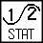, to calculate the average acceleration. Record the value in your data table.
14. Repeat Step 13 for the 45 and 78 rpm portions of the graph. Record the values.
15. Measure the distance from the center of the Accelerometer to the center of the turntable, and record the value.
Part III
For this part, you will see how centripetal acceleration varies with radius by taking data at varying radii while keeping the angular velocity constant at 78 rpm. The 78 rpm point from Part II will serve as your first data point for this part.
16. Copy your acceleration and radius values from Part II to the first line of the data table for Part III.
17. Move the Accelerometer about 3 cm inward toward the center of the turntable. Fasten it securely with the arrow pointing directly toward the center of the turntable. Measure the distance from the center of the Accelerometer to the center of the turntable. Record the distance.
18. Set the turntable speed to 78 rpm.
19. Open the file “20b Centripetal Acceleration” from the Physics with Computers folder.
20. As before, you can collect data with the interface detached from the computer.
- Verify that the interface, Low-g Accelerometer, and cable are taped down so that nothing will get hung up when the turntable spins.
- Choose Remote  Remote Setup from the Experiment menu. A summary of your setup will be displayed.
- Click . The interface can now be disconnected from the computer. Important: (1) Be very careful not to press the START/STOP button on the interface until you are ready to begin collecting data, and (2) do not close the Logger Pro computer program.

Using LabQuest
21. Collect acceleration data.
- When everything is ready, press the COLLECT button on LabQuest.
- Wait 5 seconds.
- Turn on the turntable.
- Wait at least 25 seconds and turn off the turntable.
- Continue with Step 23.

Using LabPro
22. Collect acceleration data.
- When everything is ready, press the START/STOP button on the LabPro interface. The green light on LabPro will begin to blink.
- Wait 5 seconds.
- Turn on the turntable.
- Wait at least 25 seconds and turn off the turntable.

23. When data collection is finished, reattach the interface to the computer. If a Remote Data Available window appears, simply click the YES button and choose to retrieve remote data into the current file. If a window does not appear when the interface is reconnected, choose Remote  Retrieve Remote Data from the Experiment menu.
24. Examine the graph of acceleration vs. time.
25. Next, determine the average centripetal acceleration.
- Zoom in on the portion of the acceleration graph when the turntable was rotating at
78 rpm. To do this, use the mouse to drag a rectangle around the useful portion of the data, then click the Zoom In button, .
- Click the Statistics button, , to calculate the average acceleration. Record the value in your data table.
26. Move the accelerometer inward about 3 cm and tape it to the turntable with the arrow pointed toward the center. Repeat data collection for the new radius.

DATA TABLE
Speeding up in + direction
Slowing down in + direction
Acceleration in direction of arrow reads

Radius (m)
Angular speed |  | Radius (m) | Centripetal acceleration (m/s²)
(rpm) | (rad/s)
33 ¹/₃
45
45
78

Angular speed (rpm)
Angular speed (rad/s) | Radius (m) | Centripetal acceleration (m/s²)
ANALYSIS
- Convert your angular speed values from rpm (revolutions per minute) to radians per second. Remember that one revolution corresponds to 2π radians. Record the new values in the data table.
- Plot a graph of the centripetal acceleration (y axis) vs. the square of angular speed (x axis). Use Logger Pro, the graphing calculator, or graph paper.
- Fit a straight line that passes through the origin to your data points. What are the units of the slope? Does this value correspond to any dimension on your apparatus?
- Plot a graph of the centripetal acceleration vs. the radius. Use Logger Pro, the graphing calculator, or graph paper.
- Fit a straight line that passes through the origin to your data points. What are the units of the slope? Does this value correspond to any parameter in your experiment? Note that rad/s and 1/s have the same dimensions, since the radian is dimensionless. Does the slope value correspond to any parameter in your experiment? How about the square root of the slope?
- From your graphs, propose a relationship between centripetal acceleration, the square of angular velocity, and radius. Be certain it is dimensionally consistent.
- Confirm your proposal by looking up the relationship for centripetal acceleration in your physics textbook.
- What was the sign of the centripetal acceleration as measured by the Accelerometer? Given the sign your Accelerometer reads when accelerating in the direction of the arrow, is the centripetal acceleration directed inward or outward?
EXTENSIONS
- Investigate the centripetal acceleration as a car rounds a corner on a flat road. Collect data at different speeds.

