
Name: ___________________________

Class: ___________________________

Circular Motion Lab
Airplane on a String (sample video)

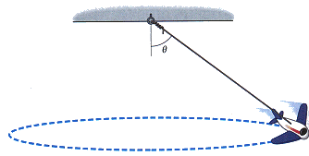
For this experiment you are provided with a toy battery powered airplane that is suspended from the ceiling. You can easily set it in motion by turning on the motor, hold it out at some angle from the vertical (from the pivot point at the ceiling) and giving it a good push. Your job is to make appropriate measurements of distances that can be used to determine the speed of the plane. There will be two parts - the first part of the lab you may use a timing device, and the second part you may not use a timing device.

- Experimental Velocity - Using a meter stick AND timer
  - Measure the length, L as the plane hangs vertically
    - Best practice - measure to the center of the plane, not just the string. (consider why)
  - Get the airplane going in a stable circle
  - Measure the period, T
    - Measure the time for 1 revolution using a timer (your phone will do)
    - Best practice: to get a more accurate measurement of the time, measure the time of 5 revolutions and simply divide by 5. Doing this twice or 3 times gives an even better value for period, T.
  - Measure the radius, r
    - Best practice: figure it out.
  - Calculate the velocity of the plane using simple circular motion formulas:
    - $v = \frac{distance}{time}=\frac{2πr}{T}$
- Theoretical Velocity - Using a meter stick ONLY
  - Math Manipulation Challenge: Now that you have an indication of what the velocity should be, derive a theoretical expression governing the motion and solve for the value of v in terms of variables and length measurements.
    - Algebraically derive an expression for velocity using only the variables $r, g, θ, m$. (You may not have F_{T} in your final equation, nor F_{T,X} nor F_{T,Y} , etc).
      - Your final answer should be in the form $v =$_______________
    - Hint: Use a free body diagram and steps from the forces unit, rather than circular motion formulas.
- Compare your theoretical to your experimental calculations for velocity.
  - Approximately 5% error is the goal.

