Back and Forth Motion
Lots of objects go back and forth; that is, they move along a line first in one direction, then move back the other way. An oscillating pendulum or a ball tossed vertically into the air are examples of things that go back and forth. Graphs of the position vs. time and velocity vs. time for such objects share a number of features. In this experiment, you will observe a number of objects that change speed and direction as they go back and forth. Analyzing and comparing graphs of their motion will help you to apply ideas of kinematics more clearly.
In this experiment you will use a Motion Detector to observe the back and forth motion of the following five objects:
- Oscillating pendulum
- Dynamics cart rolling up and down an incline
- Student jumping into the air
- Mass oscillating at the end of a spring
- Ball tossed into the air

OBJECTIVES
- Qualitatively analyze the motion of objects that move back and forth.
- Analyze and interpret back and forth motion in kinematics graphs.
- Use kinematic graphs to catalog objects that exhibit similar motion.

MATERIALS
computer | incline with dynamics cart
Vernier computer interface | rubber ball (15 cm diameter or more)
Logger Pro | protective wire basket for Motion Detector
Vernier Motion Detector | protractor
pendulum with large bob | meter stick
spring with hanging mass

PRELIMINARY QUESTIONS
1. Do any of the five objects listed above move in similar ways? If so, which ones? What do they have in common?
2. What is the shape of a velocity vs. time graph for any object that has a constant acceleration?
3. Do you think that any of the five objects has a constant acceleration? If so, which one(s)?
4. Consider a ball thrown straight upward. It moves up, changes direction, and falls back down. What is the acceleration of a ball on the way up? What is the acceleration when it reaches its top point? What is the acceleration on the way down?
PROCEDURE
These five activities will ask you to predict the appearance of graphs of position vs. time and velocity vs. time for various motions, and then collect the corresponding data. The Motion Detector defines the origin of a coordinate system extending perpendicularly from the front of the Motion Detector. Use this coordinate system in making your sketches. After collecting data with the Motion Detector, you may want to print the computer graphs for use later in the analysis.
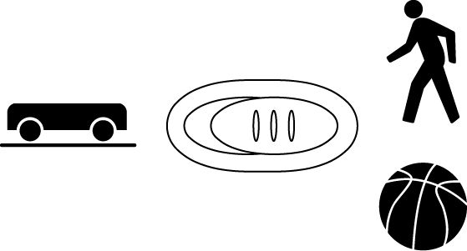
Part I Oscillating Pendulum
1. Connect the Motion Detector to the DIG/SONIC 1 channel of the interface. If the Motion Detector has a switch, set it to Normal.
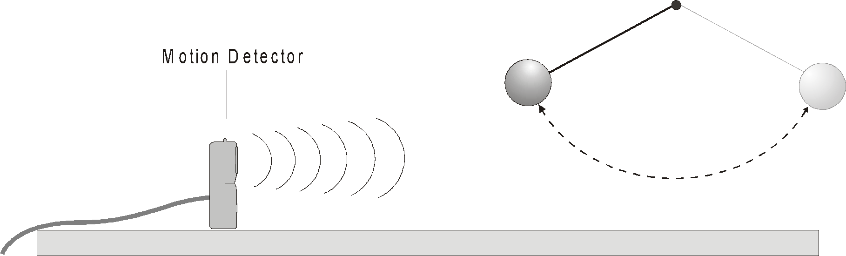
Figure 1
2. Open the file “02 Pendulum” from the Physics with Vernier folder.
3. Sketch your prediction of the position vs. time and velocity vs. time graphs of a pendulum bob swinging back and forth. Ignore the small vertical motion of the bob and measure position along a horizontal line in the plane of the bob’s motion. Based on the shape of your velocity graph, do you expect the acceleration to be constant or changing? Why? Will it change direction? Will there be a point where the acceleration is zero?
4. Place the Motion Detector near a pendulum with a length of 1 to 2 m. The Motion Detector should be level with the pendulum bob and about 1 m away when the pendulum hangs at rest. The bob should never be closer to the detector than 0.15 m.
5. Pull the pendulum about 15 cm toward the Motion Detector and release it to start the pendulum swinging.
6. Click  to begin data collection.
7. If you do not see a smooth graph, the pendulum was most likely not in the beam of the Motion Detector. Adjust the aim and repeat Steps 5–6.
8. Answer the Analysis questions for this Part I before proceeding to Part II.
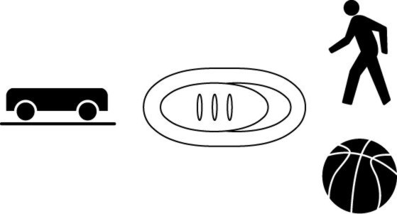
Part II Dynamics Cart on an Incline
9. If the Motion Detector has a switch, set it to Track.
10. Open the experiment file “02 Cart.” Two graphs will appear on the screen.
11. Place the Motion Detector at the top of an incline that is between 1 and 2 m long. The angle of the incline should be between 5° and 10°.
12. Sketch your prediction of the position vs. time and velocity vs. time graphs for a cart rolling freely up an incline and then back down. The cart will be rolling up the incline and toward the Motion Detector initially. Will the acceleration be constant? Will it change direction? Will there be a point where the acceleration is zero?
13. Hold the dynamics cart at the base of the incline. Click  to begin taking data. When you hear the clicking, give the cart a push up the incline. Make sure that the cart does not get closer than 0.15 m to the Motion Detector and keep your hands away from the track as the cart rolls.
14. Zoom in on the portion of each graph that represents the time that the cart was freely rolling. To do this, use the mouse to drag a rectangle around the useful portion of the data, then click the Zoom In button, . Answer the Analysis questions for Part II before proceeding to Part III.

Part III Student Jumping in the Air
15. If the Motion Detector has a switch, set it to Normal.
16. Open the experiment file “02 Jump.”
17. Secure the Motion Detector at least 3 m above the floor, pointing down.
18. Sketch your predictions for the position vs. time and velocity vs. time graphs for a student jumping straight up and falling back down. Will the acceleration be constant? Will it change direction? Will there be a point where the acceleration is zero?
19. Stand directly under the Motion Detector.
20. Click  to begin taking data. When you hear the clicking, bend your knees and jump. Keep your arms still while in the air.
21. Zoom in on the portion of the graph representing the jump. Include everything from the bending of the knees to the landing. To do this, use the mouse to drag a rectangle around the useful portion of the data and click the Zoom In button, . Answer the Analysis questions for Part III before proceeding to Part IV.

Part IV A Mass Oscillating at the End of a Spring
22. If the Motion Detector has a switch, set it to Normal.
23. Open the experiment file “02 Spring.”
24. Place the Motion Detector so it is facing upward, about 1 m below a mass suspended from a spring.
25. Sketch your prediction for the position vs. time and velocity vs. time graphs of a mass hanging from a spring as the mass moves up and down. Will the acceleration be constant? Will it change direction? Will there be a point where the acceleration is zero?
26. Lift the mass about 10 cm (and no more) and let it fall so that it moves up and down.
27. Click  to begin data collection.
28. If you do not see a smooth graph, the mass most likely was not in the beam of the Motion Detector. Adjust the aim or look for interfering objects and try again.
29. Zoom in on the portion of each graph that represents one cycle of the mass. To do this, use the mouse to drag a rectangle around the useful portion of the data and click the Zoom In button, . Answer the Analysis questions for Part IV before proceeding to Part V.
Part V Ball Tossed into the Air
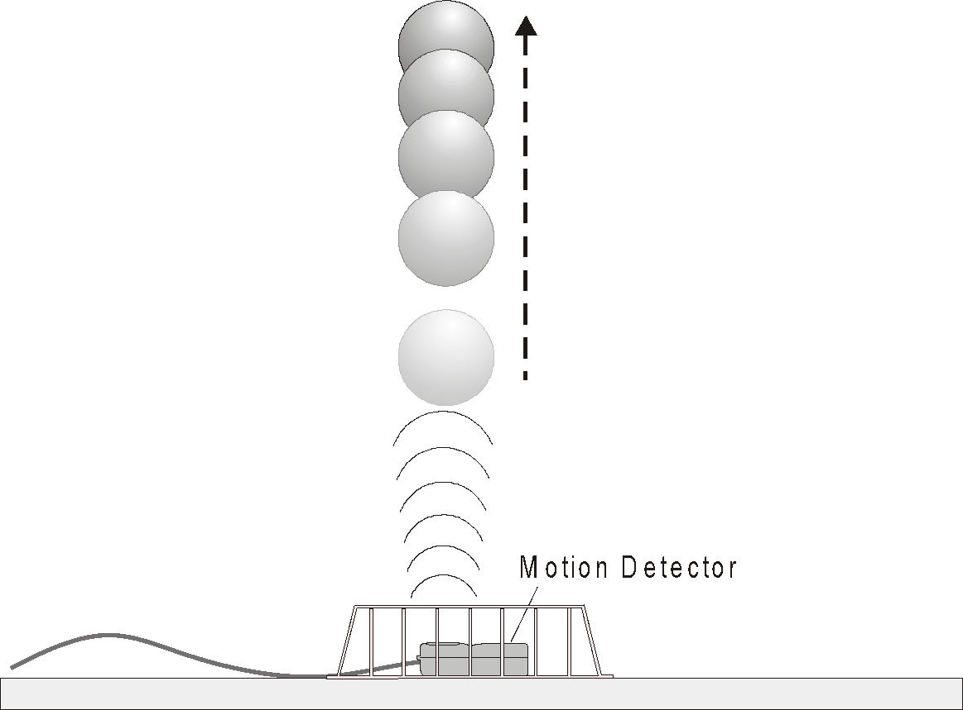

Figure 2
30. If the Motion Detector has a switch, set it to Normal.
31. Open the experiment file “02 Ball.”
32. Sketch your predictions for the position vs. time and velocity vs. time graphs of a ball thrown straight up into the air. Will the acceleration be constant? Will it change direction? Will there be a point where the acceleration is zero?
33. Place the Motion Detector on the floor pointing toward the ceiling as shown in Figure 2. Place a protective wire basket over the Motion Detector.
34. Hold the rubber ball in the palm of your hand, about 0.3 m above the Motion Detector.
35. Click  to begin data collection.
36. When you hear the Motion Detector clicking, gently toss the ball straight up over the Motion Detector. Move your hands quickly out of the way so that the Motion Detector tracks the ball rather than your hand. Catch the ball just before it reaches the wire basket.
37. Zoom in on the portion of each graph that represents the time that the ball was in the air. To do this, use the mouse to drag a rectangle around the useful portion of the data and click the Zoom In button, .

ANALYSIS
Part I Oscillating Pendulum
1. Print or sketch the position and velocity graphs for one oscillation of the pendulum. Compare these to your predicted graphs and comment on any differences.
2. Was the acceleration constant or changing? How can you tell?
3. Was there any point in the motion where the velocity was zero? Explain.
4. Was there any point in the motion where the acceleration was zero? Explain.
5. Where was the pendulum bob when the acceleration was greatest?
6. Return to the procedure and complete the next part.
Part II Dynamics Cart on an Incline
7. Print or sketch the portions of the position and velocity graphs that represent the time that the cart was going up and down the incline. Compare these to your predicted graphs and comment on any differences.
8. Was the acceleration constant or changing? How can you tell?
9. Logger Pro can display the tangent line to a curve, as well as display the slope numerically. To turn on this function, click on the Tangent button, . Use the tangent line and the velocity graph to determine the acceleration of the cart when it was on the way up, at the top, and on the way down the incline. What did you discover?
10. Was there any point in the motion where the velocity was zero? Explain.
11. Was there any point in the motion where the acceleration was zero? Explain.
12. Return to the procedure and complete the next part.
Part III Student Jumping in the Air
13. Print or sketch the portions of the position and velocity graphs that represent the time from the first bend of the knees through the landing. Compare these to your predicted graphs and comment on any differences.
14. Use the Tangent button, , to determine where the acceleration was greatest. Was it when the student was pushing off the floor, in the air, or during the landing?
15. When the student was airborne, was the acceleration constant or changing? How can you tell?
16. Was there any point in the motion where the velocity was zero? Explain.
17. Was there any point in the motion where the acceleration was zero? Explain.
18. Return to the procedure and complete the next part.
Part IV Mass Oscillating on a Spring
19. Print or sketch the position and velocity graphs for one vibration of the mass. Compare these to your predicted graphs and comment on any differences.
20. Was the acceleration constant or changing? How can you tell?
21. Was there any point in the motion where the velocity was zero? Explain.
22. Was there any point in the motion where the acceleration was zero? Explain.
23. Where was the mass when the acceleration was greatest?
24. How does the motion of the oscillating spring compare to the pendulum?
25. Return to the procedure and complete the next part.

Part V Ball Tossed into the Air
26. Print or sketch the portions of the position and velocity graphs that represent the time the ball was in the air. Compare these to your predicted graphs and comment on any differences.
27. Was the acceleration constant or changing? How can you tell?
28. Use the tangent line and the velocity graph to determine the acceleration of the ball when it was on the way up, at the top, and on the way down. What did you discover?
29. Was there any point in the motion where the velocity was zero? Explain.
30. Was there any point in the motion where the acceleration was zero? Explain.
Analysis of all Parts
31. State two features that the five position graphs had in common. State two ways that the five position graphs were different from one another.
32. State two features that the five velocity graphs had in common.
33. State two ways that the five velocity graphs were different from one another.

EXTENSIONS
1. Investigate other back-and-forth motions such as:
- Bouncing balls
- A dynamics cart with a plunger bouncing off a solid object
- A yo-yo

2. Attach an accelerometer to your belt and use it to analyze your motion when you jump up. Compare your landing acceleration when you bend your knees upon impact and when you do not bend your knees. Safety warning: Jump only a few inches when you do not bend your knees.
3. Use a force sensor to measure the force in the vibrating spring and relate this to the kinematic graphs that you observed in this experiment.

