Cart on a Ramp
INTRODUCTION
This experiment uses a ramp and a low-friction cart. If you give the cart a gentle push up the ramp, the cart will roll upward, slow and stop, and then roll back down, speeding up. A graph of its velocity vs. time would show these changes. Is there a mathematical pattern to the changes in velocity? What is the accompanying pattern to the position vs. time graph? What would the acceleration vs. time graph look like? Is the acceleration constant?
In this experiment, you will use a Motion Detector to collect position, velocity, and acceleration data for a cart rolling up and down a ramp. Analysis of the graphs of this motion will answer these questions.
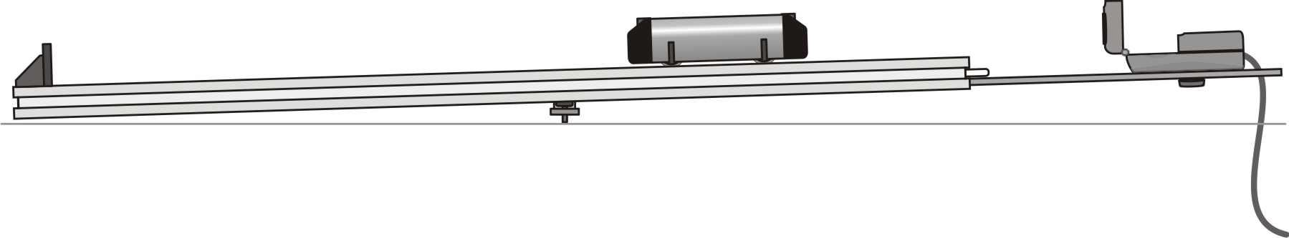
OBJECTIVES
- Collect position, velocity, and acceleration data as a cart rolls up and down a ramp.
- Analyze the position vs. time, velocity vs. time, and acceleration vs. time graphs.
- Determine the best fit equations for the position vs. time and velocity vs. time graphs.
- Determine the mean acceleration from the acceleration vs. time graph.
MATERIALS
computer | Vernier Motion Detector
Vernier computer interface | Vernier Dynamics System
Logger Pro

PRELIMINARY QUESTIONS
1. Consider the changes in motion a cart will undergo as it rolls up and down a ramp. Make a sketch of your prediction for the position vs. time graph. Describe in words what this graph means.
2. Make a sketch of your prediction for the velocity vs. time graph. Describe in words what this graph means.
3. Make a sketch of your prediction for the acceleration vs. time graph. Describe in words what this graph means.
PART I
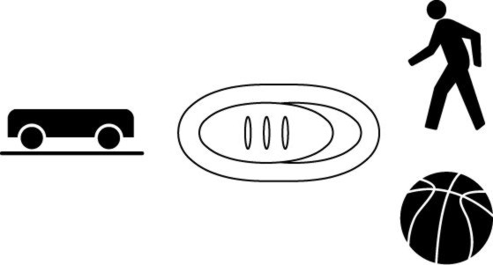
1. Connect the Vernier Motion Detector to the DIG/SONIC 1 channel of the interface. If the Motion Detector has a switch, set it to Track.
2. Confirm that your ramp, end stop, and Motion Detector bracket are assembled as shown in the figure. Adjust the head of the detector so that it is pointing straight down the track, or angled up just a little.
3. Open the file “03 Cart on a Ramp” from the Physics with Vernier folder.
4. Place the cart on the track near the bottom end stop. If your cart has a plunger, face the plunger away from the Motion Detector. Click  to begin data collection. You will notice a clicking sound from the Motion Detector. Wait about a second, then briefly push the cart up the ramp, letting it roll freely up nearly to the top, and then back down. Catch the cart as it nears the end stop.
5. Examine the position vs. time graph. Repeat Step 4 if your position vs. time graph does not show an area of smoothly changing position. Check with your instructor if you are not sure whether you need to repeat data collection.
ANALYSIS I
1. Either print or sketch the three motion graphs. The graphs you have recorded are fairly complex and it is important to identify different regions of each graph. Click the Examine button, , and move the mouse across any graph to answer the following questions. Record your answers directly on the printed or sketched graphs.
a) Identify the region when the cart was being pushed by your hand:
- Examine the velocity vs. time graph and identify this region. Label this on the graph.
- Examine the acceleration vs. time graph and identify the same region. Label the graph.

b) Identify the region where the cart is rolling freely:
- Label the region on each graph where the cart was rolling freely and moving up the ramp.
- Label the region on each graph where the cart was rolling freely and moving down the ramp.

c) Determine the position, velocity, and acceleration at specific points.
- On the velocity vs. time graph, decide where the cart had its maximum velocity, just as the cart was released. Mark the spot and record the value on the graph.
- On the position vs. time graph, locate the highest point of the cart on the ramp. Note that this point is the closest approach to the Motion Detector. Mark the spot and record the value on the graph.
- What was the velocity of the cart at the top of its motion?
- What was the acceleration of the cart at the top of its motion?

2. The motion of an object in constant acceleration modeled by x = v0t + ½ at2, where x is the position, v0 is the initial velocity, t is time, and a is the acceleration. This is a quadratic equation whose graph is a parabola. If the cart moved with constant acceleration while it was rolling, your graph of position vs. time will be parabolic. To fit a quadratic equation to your data, click and drag the mouse across the portion of the position vs. time graph that is parabolic, highlighting the free-rolling portion.
3. Click the Curve Fit button, 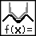, select Quadratic fit from the list of models and click . Examine the fit of the curve to your data and click  to return to the main graph. Is the cart’s acceleration constant during the free-rolling segment?
4. The graph of velocity vs. time will be linear if the acceleration is constant. To fit a line to this data, click and drag the mouse across the free rolling region of the motion. Click the Linear Fit button, 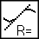. How closely does the slope correspond to the acceleration you found in the previous step?
5. The graph of acceleration vs. time should appear to be more or less constant during the freely-rolling segment. Click and drag the mouse across the free-rolling portion of the motion and click the Statistics button, 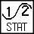. How closely does the mean acceleration value compare to the values of a found in Steps 3 and 4?
PART II
1. Your cart can bounce against the track end stop using the plunger and end stop. Practice starting the cart so it bounces at least three times during the ten-second data collection.
2. Collect another set of Motion Detector data showing two or more bounces.
ANALYSIS II
1. Determine the cart’s acceleration during the free rolling segments using the velocity graph. Are they the same?
2. Determine the cart’s acceleration during the free rolling segments using the position graph. Are they the same?
EXTENSIONS
1. Use the modeling feature of Logger Pro to superimpose a linear model on the velocity graph. To insert a model, choose Model from the Analyze menu. Select the linear function, and click . On the floating box for the model, click the slope or intercept label and adjust using the cursor keys or by typing in new values until you get a good fit. Interpret the slope you obtain. Interpret the y-intercept.
2. Adjust the angle of the track to change the acceleration, and measure the new value. How closely does the coefficient of the t2 term in the curve fit compare to ½ g sin θ, where θ is the angle of the track with respect to horizontal?
3. Even though the cart has very low friction, the friction is not zero. From your velocity graph, devise a way to measure the difference in acceleration between the roll up and the roll down. Can you use this information to determine the friction force in Newtons? The cart has a mass of 500 g.

Logger Pro tip: if a graph is currently selected, you can start data collection by tapping the Space bar.

