
Name: ___________________________

Class: ___________________________

Determining g on an Incline
During the early part of the seventeenth century, Galileo experimentally examined the concept of acceleration. One of his goals was to learn more about freely falling objects. Unfortunately, his timing devices were not precise enough to allow him to study free fall directly. Therefore, he decided to limit the acceleration by using fluids, inclined planes, and pendulums. In this lab exercise, you will see how the acceleration of a cart depends on the ramp angle. Then, you will use your data to extrapolate to the acceleration on a vertical “ramp;” that is, the acceleration of a ball in free fall.
If the angle of an incline with the horizontal is small, a cart rolling down the incline moves slowly and can be easily timed. Using time and position data, it is possible to calculate the acceleration of the cart. When the angle of the incline is increased, the acceleration also increases. The acceleration is directly proportional to the sine of the incline angle, (θ ). A graph of acceleration versus sin(θ ) can be extrapolated to a point where the value of sin(θ ) is 1. When sinθ is 1, the angle of the incline is 90°. This is equivalent to free fall. The acceleration during free fall can then be determined from the graph.
Galileo was able to measure acceleration only for small angles. You will collect similar data. Can these data be used in extrapolation to determine a useful value of g, the acceleration of free fall? We will see how valid this extrapolation can be. Rather than measuring time, as Galileo did, you will use a Motion Detector to determine the acceleration. You will make quantitative measurements of the motion of a cart rolling down inclines of various small angles. From these measurements, you should be able to decide for yourself whether an extrapolation to large angles is valid.
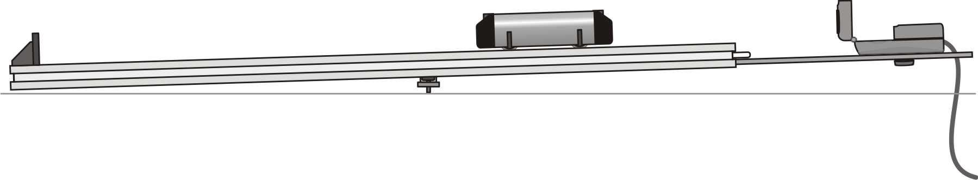
Figure 1
objectives
- Use a Motion Detector to measure the motion of a cart rolling down an incline.
- Determine the mathematical relationship between the angle of an incline and the acceleration of a cart rolling down the ramp.
- Determine g by extrapolating the acceleration vs. sine of track angle graph.
- Determine if an extrapolation of the acceleration vs. sine of track angle is valid.

Materials
Vernier computer interface | dynamics cart
Logger Pro | meter stick
Vernier Motion Detector | books
ramp | computer

Procedure
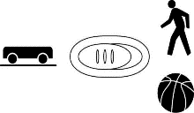
- Setup the track
  - Connect the Motion Detector to the DIG/SONIC 1 channel of the interface. If the Motion Detector has a switch, set it to Track.
  - Place a single book under one end of the track so that it forms a small angle with the horizontal.
  - Place the Motion Detector at the top of an incline. Place it so the cart will never be closer than 0.15 m.
- Ready the computer
  - On your computer, open Logger Pro software. Go to File → Open... → Physics with Vernier → “04 Determining g”
- Collect Data

  - Hold the cart on the incline about 0.15 m from the Motion Detector.
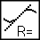
  - Click the “Collect” icon to begin collecting data; release the cart after the Motion Detector starts to click. You may have to adjust the position and aim of the Motion Detector several times before you get it right. Adjust and repeat this step until you get a good run showing approximately constant slope on the velocity vs. time graph (v-t graph) during the rolling of the cart.
  - Logger Pro can automatically fit a straight line to a portion of your data. First indicate which portion is to be used by dragging across the graph to indicate the starting and ending times. Then click on the “Linear Fit” icon, shown to the right , to perform a linear regression of the selected data. Use this tool to determine the slope of the velocity vs. time graph (ie. acceleration) using only the portion of the data for when the cart had a constant slope on the v-t graph. From the line created by Logger Pro, record the slope (acceleration) of the cart.
  - Record the value of acceleration in your data table.
  - Repeat steps a - d two more times.
- Record data on your sheet
  - Measure the length of the incline plane, x, which is the distance between the two contact points of the ramp. See Figure 1.
  - Measure the height, h, the height of the book(s). These last two measurements will be used to determine the angle of the incline.
- Repeat at different heights
  - Raise the incline by placing a second book under the end. Adjust the books so that the distance, x, is the same as the previous reading.
  - Repeat above for 2, 3, 4, and 5 books.

Data Table

Data using cart
 |  |  |  | Acceleration
Number of books | Height of books, h (m) | Length of incline, x  (m) | sin(θ ) (h ÷ m) | trial 1  (m/s²) | trial 2  (m/s²) | trial 3  (m/s²) | Average acceleration  (m/s²)
1 |  |  |  | 1.104
2
3
4
5
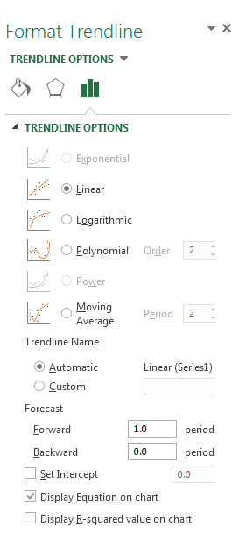
Analysis
- Plot a scatter plot graph of the average acceleration (y axis) vs. sin(θ). Be careful that you do not plot acceleration vs. θ ; we want acceleration vs. sin(θ ).
- Add a best-fit trendline to the data. The slope can be used to determine the acceleration of the ball on an incline of any angle.
- Extend the x-axis to 1.2, and the y-axis to 12, so that the intersection of (1, 9.8) is visible and clear. The reader should clearly be able to see where the trendline passes in regards to (1,9.8).
Conclusion
- How well does the extrapolated value agree with the accepted value of free-fall acceleration (g = 9.8 m/s²)?
- Discuss the validity of extrapolating the acceleration value to an angle of 90.
Extensions
- Use the Motion Detector to measure the actual free fall of a ball. Compare the results of your extrapolation with the measurement for free fall.Compare your results in this experiment with other measurements of g.
- Investigate how the value of g varies around the world. For example, how does altitude affect the value of g? What other factors cause this acceleration to vary from place to place? How much can g vary at a school in the mountains compared to a school at sea level?

