Projectile Motion
You have probably watched a ball roll off a table and strike the floor. What determines where it will land? Could you predict where it will land? In this experiment, you will roll a ball down a ramp and determine the ball’s velocity with a pair of Photogates. You will use this information and your knowledge of physics to predict where the ball will land when it hits the floor.
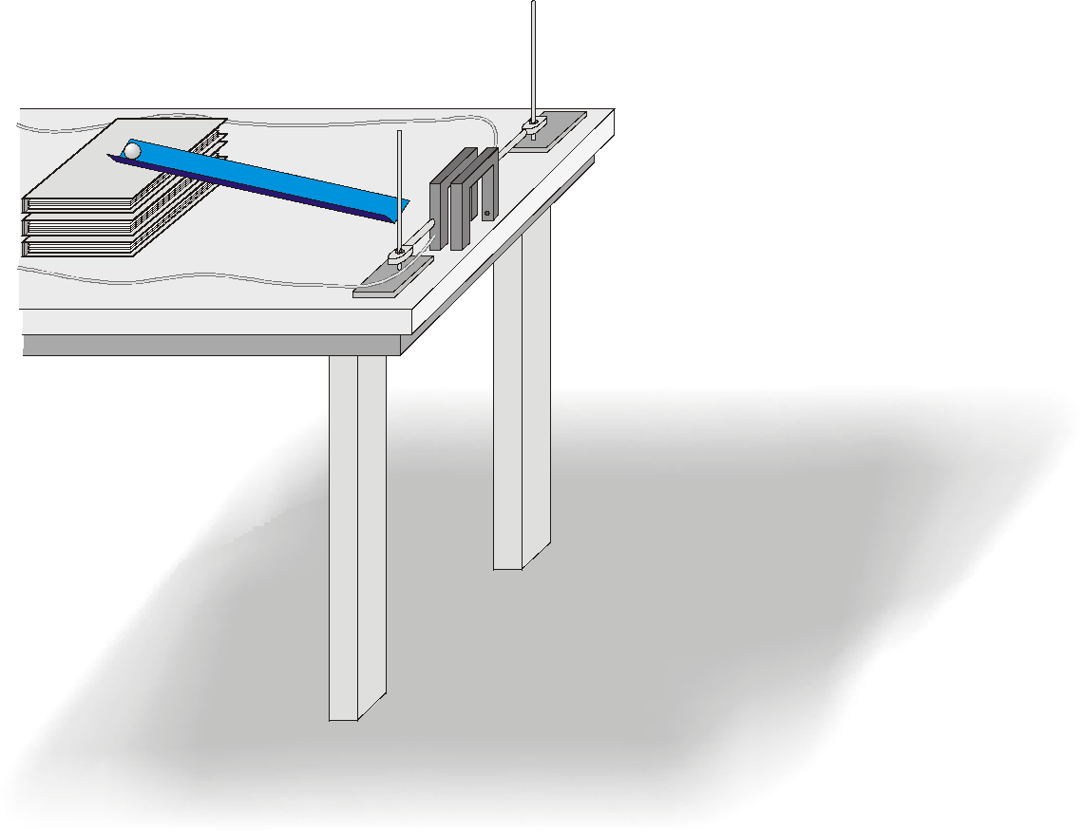
Figure 1
OBJECTIVES
- Measure the velocity of a ball using two Photogates and computer software for timing.
- Apply concepts from two-dimensional kinematics to predict the impact point of a ball in projectile motion.
- Take into account trial-to-trial variations in the velocity measurement when calculating the impact point.

MATERIALS
computer | plumb bob
Vernier computer interface | ramp
Logger Pro | two ring stands
two Vernier Photogates | two right-angle clamps
ball (1 to 5 cm diameter) | meter stick or metric measuring tape
masking tape | target

PRELIMINARY QUESTIONS
1. If you were to drop a ball, releasing it from rest, what information would be needed to predict how much time it would take for the ball to hit the floor? What assumptions must you make?
2. If the ball in Question 1 is traveling at a known horizontal velocity when it starts to fall, explain how you would calculate how far it will travel before it hits the ground.
3. A pair of computer-interfaced Photogates can be used to accurately measure the time interval for an object to break the beam of one Photogate and then another. If you wanted to know the velocity of the object, what additional information would you need?
PROCEDURE
1. Set up a low ramp made of angle molding on a table so that a ball can roll down the ramp, across a short section of table, and off the table edge as shown in Figure 1.
2. Position the Photogates so the ball rolls through each of the Photogates while rolling on the horizontal table surface (but not on the ramp). Approximately center the detection line of each Photogate on the middle of the ball. Connect Photogate 1 to DIG/SONIC 1 of the interface and Photogate 2 to the corresponding second port. To prevent accidental movement of the Photogates, use tape to secure the ring stands in place.
3. Mark a starting position on the ramp so that you can repeatedly roll the ball from the same place. Roll the ball down the ramp through each Photogate and off the table. Catch the ball as soon as it leaves the table. Note: Do not let the ball hit the floor during these trials or during the following velocity measurements. Make sure that the ball does not strike the sides of the Photogates. Reposition the Photogates if necessary.
4. Open the file “08 Projectile Motion” in the Physics with Vernier folder. A data table and two graphs are displayed; one graph will show the time required for the ball to pass through the Photogates for each trial and the other will display the velocity of the object for each trial.
5. You must enter the distance, Δs, between Photogates in order for Logger Pro to calculate the velocity. The program will divide this distance by the time interval Δt it measures to get the velocity (v = Δs/Δt). Carefully measure the distance from the beam of Photogate 1 to the beam of Photogate 2. (It may be easier to measure from the leading edge of Photogate 1 to the leading edge of Photogate 2.) To successfully predict the impact point, you must enter an accurate measurement. Adjust the gate separation using the control on the Logger Pro screen. | 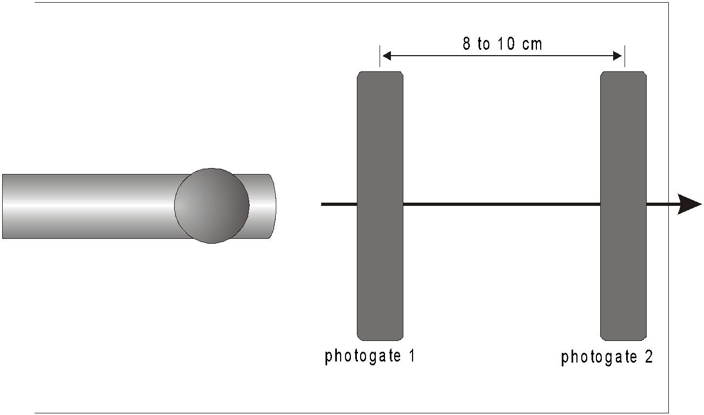  Figure 2
6. Click . Check to see that the Photogates are responding properly by moving your finger through Photogate 1 and then Photogate 2. Logger Pro will plot a time interval (Δt) value for each instance you run your finger through Photogate 1 or Photogate 2. Click , then click  again, to clear the trial data and prepare for data collection.
7. Roll the ball from the mark on the ramp, through both Photogates, and catch the ball immediately after it leaves the table. Repeat nine times. Take care not to bump any of the Photogates, or your velocity data will not be precise. Data collection will stop after two minutes. If you need more time, click  to restart, choosing Append. After the last trial, click  to end data collection. Record the velocity for each trial number in the data table.
8. Inspect your velocity data. Did you get the same value every time? Determine the average, maximum, and minimum values by clicking once on the velocity vs. time graph and then clicking the Statistics button, 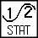. What one value would be most representative of all ten measurements?
9. Carefully measure the distance from the table top to the floor and record it as the table height h in the data table. Use a plumb bob to locate the point on the floor just beneath the point where the ball will leave the table. Mark this point with tape; it will serve as your floor origin.
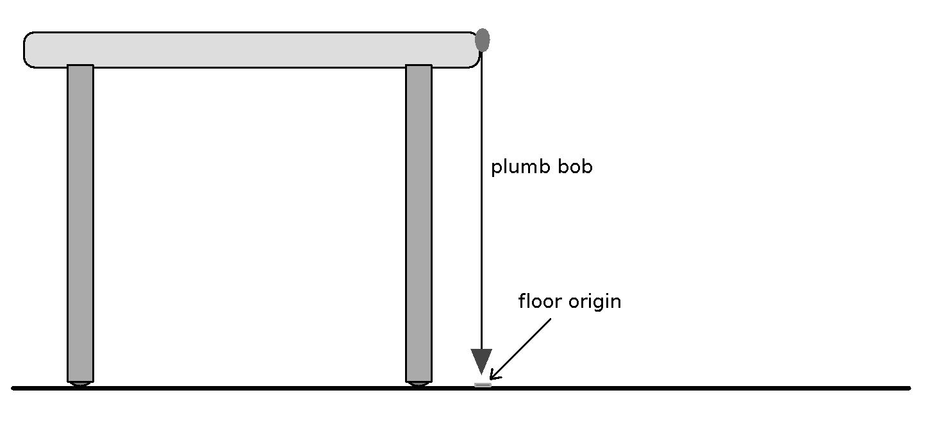
Figure 3

10. Use your velocity value to calculate the distance from the floor origin to the impact point where the ball will hit the floor. You will need to algebraically combine relationships for motion with constant acceleration
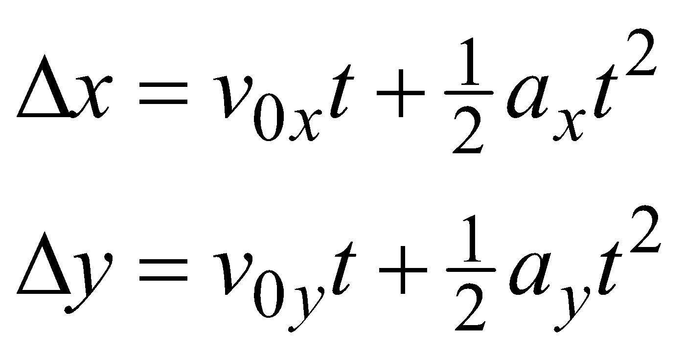
First, simplify the equations above. What is the value of the initial velocity in the vertical direction (voy)? What is the acceleration in the horizontal direction (ax)? What is the acceleration in the vertical direction (ay)? Remember that the time the ball takes to fall is the same as the time the ball flies horizontally. Use this information and the simplified equations to calculate how far the ball should travel horizontally during the fall.
Mark your predicted impact point on the floor with tape and position a target at the predicted impact point. Be sure the impact point is along the line of the track.
11. To account for the variations you saw in the Photogate velocity measurements, repeat the calculation in Step 10 for the minimum and maximum velocity. These two additional points show the limits of impact range that you might expect, considering the variation in your velocity measurement. Mark these points on the floor as well.
12. After your instructor gives you permission, release the ball from the marked starting point, and let the ball roll off the table and onto the floor. Mark the point of impact with tape. Measure the distance from the floor origin to the actual impact and enter the distance in the data table.

DATA TABLE
Trial | Velocity
 | (m/s)
1 |  |  | Maximum velocity |  | m/s
2 |  |  | Minimum velocity |  | m/s
3 |  |  | Average velocity |  | m/s
4 |  |  | Table height |  | m
5 |  |  | Predicted impact point |  | m
6 |  |  | Minimum impact point distance |  | m
7 |  |  | Maximum impact point distance |  | m
8 |  |  | Actual impact point distance |  | m
9
10

ANALYSIS
1. Should you expect any numerical prediction based on experimental measurements to be exact? Would a range for the prediction be more appropriate? Explain.
2. Was your actual impact point between your minimum and maximum impact predictions? If so, your prediction was successful.
3. You accounted for variations in the velocity measurement in your range prediction. Are there other measurements you used which affect the range prediction? What are they?
4. Did you account for air resistance in your prediction? If so, how? If not, how would air resistance change the distance the ball flies?
EXTENSIONS
1. Derive one equation for the horizontal and vertical coordinates of the ball’s motion in this experiment.
2. Repeat the experiment, using a table that is not horizontal.
3. Derive a general formula for projectile motion with the object launched at an angle.
4. Calibrate the velocity of the ball when released from various positions along the ramp. Given a specific distance to the target by the instructor, determine where the ball must be released to achieve the needed velocity. Release the ball from that position and determine whether the target is hit.
5. Increase the challenge by placing a ring on a ring stand part way to the eventual target. The ball must pass through the ring successfully and then hit the target. The students are required to position the ring as well as the target on the floor.

