
Name: _______________________

Date: _______________________

Acceleration of a Cart down a Ramp
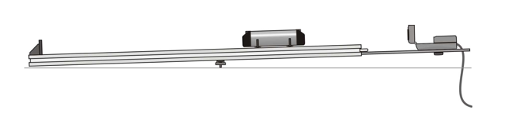
Today we are going to investigate the motion of a cart on a flat ramp, and down an inclined ramp. We will be using a Pasco Smart Cart connected to a laptop, gathering digital data using the SparkVue software.

Some of the key questions for today will be:
- What do the motion graphs look like for constant, positive acceleration?
  - Consider Position-Time, Velocity-Time, and Acceleration-Time
- What is the mathematical relationship between acceleration of the cart and ramp angle?

Using the following tools, try to determine the theoretical formula:
- Smart Cart (shown above)
- Ramp
- SparkVue software
- Google Sheets

Procedure:
- Set up the computer, connecting to Sparkvue using the steps below
- Open up the Google sheets template to record data
- Set 1 textbook under the ramp to create a small incline, and measure the height
  - Using the length of the ramp, measure the angle in inclination in degrees
  - Record the angle in your data chart
- Release the cart “from rest” and send the cart down the incline, measuring the slope of the velocity/time graph (which gives acceleration) and record it in your data chart.
  - Repeat 3 times for precision testing (values should be quite close together, ie “precise”)
- Repeat steps 2 through 4, raising the angle of inclination up to 5 books.
- Place all data in data chart
- Calculate Average Acceleration and Range
- Create a graph
- Submit Google Sheets to Google classroom.

Good practice is to take screenshots / pictures / videos of your lab work and submit with your assignment.

  - Focusing on the Velocity / Time graph, click on the color in the “Run” box to make sure that SparkVue knows you want to collect data of Velocity / Time, not Position / time or Acceleration/Time
    - 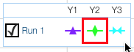
  - Highlight the section where the cart is gaining speed, and ignore the sections before and after
    - 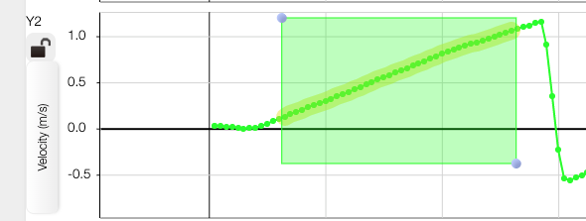
  - Click on “Best Fit Trendline” to find the slope of the V/T graph, which gives you acceleration:
    - 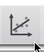
    - 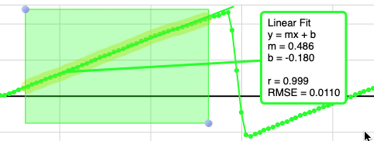
  - Record the slope, m, of the velocity time graph, which gives you acceleration
  - Record 3 trials for each angle, and record at least 5 angles

Data Analysis
- You are going to make a graph to determine the mathematical relationship between incline angle and acceleration.
- Make a graph of comparing your two variables:
  - Independent Variable x-axis Angle (Degrees)
  - Dependent Variable y-axis Acceleration (m/s²)

Discussion questions:
- If we double the angle, does the acceleration double? Why or why not?
- Can we draw a clear diagram to show why this would be? Can we visualize the problem?

Problem Solving | Beginning | Emerging | Proficient | Advanced
HS.06.04  Attend to precision in calculation, graphing, measuring, and labeling. | I am learning to show precision in calculation, graphing, measuring, and/or labeling.  I have one or more patterns of errors that detract from the accuracy of my work. | I can show precision in my work but have minor errors in calculation, graphing, measuring, and/or labeling.  These errors detract from the accuracy or communication of my work. | I can show precision in my work despite minor errors in calculation, graphing, measuring, and/or labeling.  These errors do not detract from the accuracy or communication of my work. | I can independently show precision and accuracy in my work.  There are no errors in calculation, graphing, measuring, and/or labeling.
1. Data Charts | Chart layout is sloppy  Poor chart organization  Many cells are improperly formatted;  No regard for significant figures  Multiple trials not shown  Data missing | Chart layout is unclear  Chart is missing some organization  Some cells are improperly formatted;  Cells have the different significant figures  Multiple trials are missing  Major suggestions for improvement | Chart layout is clear  Chart is organized with headings and units  Cells are properly formatted; no mixing letters and numbers  Cells have the same significant figures  Multiple trials are shown  Minor suggestions for improvement | Chart layout is clear and labelled well  Chart is organized with accurate headings and units  Cells are properly formatted and color coded with reasoning  Cells have the same significant figures with reasoning  Multiple trials are shown  No suggestions for improvement
2. Mathematical Analysis | Uses no mathematical analysis  No specific data cited  Precision and accuracy not discussed | Uses little mathematical analysis  Some data cited, but needed more  Precision and accuracy analysis needs clear improvement | Uses mathematical analysis to show relationships between variables  Cite specific data  Precision and accuracy analyzed with % range or % error or both | Uses advanced mathematical analysis to show clear purpose  Cites multiple data sets with pointed commentary  Precision and accuracy analyzed in depth
3. Graphs | Acceptable graph type, but not the best choice  Graph provided is poorly sized or  Missing 3 or more components  Graph is clearly incorrect | Acceptable graph type, but not the best choice  Graph provided is poorly sized or  Missing up to 2 components  Errors detract from communication | Correct graph type  Appropriate size graph (should be page width)  All components provided: Title, Labelled axes, appropriate scale, trendline of graph  Minor suggestions for improvement | Correct graph type  Appropriate size graph, and further improvements show depth of analysis  All components provided, and formatted for precision and clarity  No suggestions for improvement
4. Trendline | No trendline given, or no analysis given to trendline | Trendline given, but might not have the appropriate type of trendline or % error not calculated | Trendline is provided, accurate type, % error is calculated | Trendline is provided, accurate type, % error is calculated and strategically analyzed

