Accelerations in the Real World
The portability of LabQuest and the LabPro interfaces make them ideal tools for studying accelerations that occur outside the physics laboratory. Some interesting situations are the automobile and amusement park rides, as well as high-speed elevators, motorcycles, and go-carts.
The Accelerometer measures the acceleration in a specific direction. You will need to choose an appropriate time scale and direction to hold the Accelerometer to obtain meaningful information. Obtaining acceleration data from independent kinematics measurements can transform an informal study into a scientific inquiry.
This lab highlights several situations where you can collect real-world acceleration data. A general procedure is given which you will modify, depending upon which study is performed. After the general procedure you will find several suggestions for acceleration investigations. You will need to plan an experiment around the motion to be studied, adjusting data collection parameters as needed.
OBJECTIVES
- Measure acceleration in a real-world setting.
- Compare the acceleration measured to the value calculated from other data.

MATERIALS
computer | Logger Pro
Vernier computer interface | Vernier Low-g Accelerometer

GENERAL PROCEDURE
The following steps will guide you through configuring the LabPro interface to collect acceleration data so that you need to carry only the interface and sensor. After collecting data, the computer is reconnected and data are then transferred to the computer for analysis.
You will probably need to modify either the time between samples or the number of points collected for your particular circumstances. Adjust these values as you design your experiment.
- Connect the Vernier Low-g Accelerometer to Channel 1 on the LabPro interface.
2. Set up LabPro for remote data collection.
- Put fresh batteries in the LabPro.
- Open the file “21 Real World Accelerations” from the Physics with Vernier folder. Change the experiment length as needed by clicking the Data Collection button, and entering the desired experiment length. Click  to accept the change.
- Instead of clicking the  button, choose Remote  Remote Setup  LabPro from the Experiment menu. A warm-up message may be displayed. Click on it to dismiss it. Then, a summary of your setup will be displayed.
- Click  to prepare the LabPro.
- Disconnect the LabPro from the computer. The Lab Pro will be ready to collect data when the amber LED is illuminated.
- If it has not already been saved, save the experiment file so it can be used to later retrieve the data from LabPro.

3. Collect data.
- Check to see that the amber LED is illuminated on the LabPro
- When you are ready to collect data, press the START/STOP button.
- When data collection is complete, the yellow LED will flash briefly. You can also stop data collection early by pressing the START/STOP button before data collection is finished.

4. Retrieve the data.
- Start Logger Pro if it is not already running.
- Open the experiment file used to set up LabPro.
- Attach LabPro to the computer.
- If a Remote Data Available window appears, click the YES button. Click  to accept the default to retrieve remote data into the current file. If a window does not appear when the interface is reconnected, choose Remote  Retrieve Remote Data from the Experiment menu and follow the on-screen instructions.
- The data will be retrieved.

AUTOMOBILES AND MOTORCYCLES
Linear Acceleration on a Straight Road
The accelerometer and interface can record the acceleration of a motor vehicle. A good motion to study is speeding up from rest, followed by slowing to a stop. Initially program the interface to collect data for 30 seconds, although you may find that this time should be shortened or extended. Zero the Accelerometer with the arrow held horizontally.
Place the Accelerometer in a horizontal direction with the arrow of the Accelerometer aligned with the direction of the motion. Press START/STOP just before starting the vehicle. Accelerate to a safe speed, and then slow to a stop. Keep the vehicle moving in a straight line and keep it on a level section of roadway for this experiment.
Ask the driver to maintain a constant acceleration while speeding up, as well as a constant acceleration when slowing down. Compare different vehicles; compare acceleration patterns with automatic and manual transmissions. For an independent acceleration measurement, take velocity vs. time data during the trial, either by calling out times and recording the instantaneous velocities, or perhaps by videotaping the speedometer. Compare the accelerations you obtain with the accelerations that are recorded by the interface.
Centripetal Acceleration in Corners
When a vehicle turns a corner, a centripetal acceleration is present. By placing the axis of the Accelerometer horizontally and perpendicular to the forward direction, you can record the accelerations in curvilinear motion. Initially program the interface to collect data for 30 seconds, although you may find that this time should be shortened or extended. Set up a path that has several curves of measured radii as well as straight sections. A parking lot not used on weekends would be best. Practice until the driver can maneuver through the course while maintaining a steady speed. Place the Accelerometer in the horizontal direction so it is stable relative to the vehicle and perpendicular to its motion, arrow pointing to the inside of curve. Accelerate to the planned speed and keep the vehicle moving at a constant speed. Press START/STOP just before entering the test section containing the curves.
For an independent acceleration measurement from kinematics, you will need to know both the radii of the turns and the speed of the vehicle. During turns, a motorcyclist must lean the bike towards the center of the turn to successfully complete the turn. In this case, the experimenter must take care to hold the axis of the Accelerometer level with the ground throughout the trial.
Questions
1. For the motion along a straight line, is the acceleration of a motorized vehicle constant? If not, why do you suspect the rate is larger during part of the run than another part? How does the acceleration while speeding up compare to the deceleration while stopping? Why do you suppose this pattern is true? Characterize the ability of your driver to accelerate the vehicle at a constant rate.
2. For the cornering motions, how do the calculated accelerations from kinematics (v²/R) compare to the accelerations measured with the interface? How do the measured accelerations compare to the acceleration due to gravity, or g?
ELEVATORS
Take the interface and Accelerometer to a building that has a high-speed elevator and a height of six stories or more. Zero the Accelerometer with the arrow vertical. Initially program the interface to collect data for 90 seconds. You will want to adjust this time depending on the transit time of your elevator.
Enter the elevator and place the Accelerometer against the elevator wall with its arrow pointing upward. Do not hold it in your extended hand, because the motion of your arm will change the acceleration measurement.
Program the elevator to stop at two floors on the way up, then program it to stop at two floors on the way back down. Press START/STOP to start data collection when the doors close on the elevator.
Other Data
If you can determine the height of a single story, you can collect data on floor vs. time to obtain velocities while the elevator is ascending or descending. A video camera could be used to record these data. Compare the velocity you obtain this way with the area under the acceleration vs. time graph.
Questions
3. How large is the acceleration when the elevator begins? How large is the acceleration when the elevator has been underway for a few seconds? How large is the acceleration when the elevator is slowing to a stop on its way up? What does the sign of the acceleration indicate?
4. (requires calculus) How does the area under the acceleration graph while speeding up compare to the area under the graph while it is slowing down? Why should these two areas be equal magnitude but of opposite signs?
5. Can you determine which direction the elevator is moving (upwards or downwards) by the size or direction of the accelerations? Explain your answer.
6. If you make a run while holding the Accelerometer in your hand (arm in front of your body), how does the resulting acceleration compare to that recorded while the Accelerometer is fixed rigidly to the elevator itself?
AMUSEMENT PARKS
Many amusement parks feature a Physics Day where students take instruments on the rides and perform calculations. Using the interface, the data collection can be extended so that the ride characteristics can be studied in more detail than is possible with traditional methods. Several categories of study are suggested below.
For any ride it is essential that you plan your data collection carefully. It is best to concentrate on a single portion of a ride, such as a particular loop or corner of a roller coaster. Decide which part of the ride you want to study, and estimate the length of time you will need to collect data. You may want to measure the time interval while watching others on the ride. The time between samples can then be calculated by dividing the desired time interval by the number of points you want to collect.
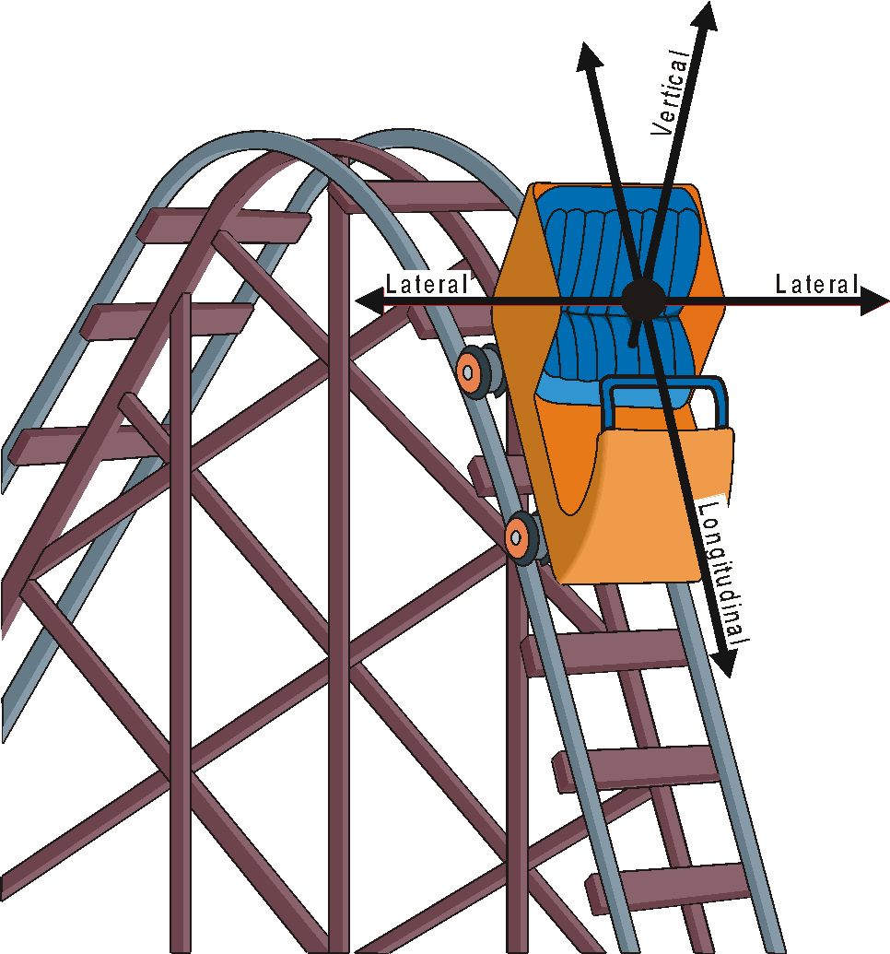
Along with planning the data collection parameters, you must plan the orientation of the Accelerometer during the ride. Which axis of the acceleration do you want to record? Hold or fasten the Accelerometer so the arrow is parallel to this axis. The direction of the arrow will correspond to positive acceleration.
When describing the directions of accelerations on an amusement park ride, it is convenient to have a common vocabulary. The diagram defines the terms vertical, lateral and longitudinal. These designations are from the frame of reference of the rider.
Dips: Most roller coasters feature a dip following the first major climb, as well as several others during the course of the ride. If you know the speed of the train at the top of the hill and the vertical distance to the bottom, the speed of the train at the bottom can be calculated using conservation of energy. Knowing the radius of the curve at the bottom, the acceleration due to circular motion can be calculated using kinematics.
Using the interface, the acceleration during such a dip can be measured as the train descends into the dip, and the maximum acceleration can be determined by tracing along the graph.
To record a single dip, first zero the Accelerometer with the arrow upward. On the ride, hold the Accelerometer vertically with the arrow upward relative to the rider. Set the data collection time to 15 seconds. Press START/STOP just before the car starts over the edge of the first drop. Compare the readings obtained at the front of the train as compared to those at the center or at the back of the train. Explain any differences.
Vertical Loops: Many modern roller coasters feature vertical loops. To record acceleration data during loops, first zero the Accelerometer with the arrow upward. On the ride, hold the Accelerometer with the arrow upward relative to the rider. Set the data collection time to approximately 15 seconds and press START/STOP just before the car enters the loop.
7. How does the acceleration at the bottom of the loop compare to the value at the top of the loop? How does the value at the top compare to the acceleration due to gravity? What does the reading you get at the top mean? Is the loop circular in shape? If not, why not?
Corners: Most roller coasters have the cars riding on rails, and so the corners are nearly horizontal. If the axis of the Accelerometer is held level and perpendicular to the direction of the motion, the lateral acceleration will be recorded. Zero the Accelerometer while the axis is horizontal.
Set the time for 15–30 seconds, as determined by your study of the ride in advance. Press START/STOP just before the train enters the horizontal curve.
8. By measuring the speed of the ride, and estimating the radius of curvature, you can calculate an independent value for the centripetal acceleration using kinematics. Compare this value with the measured value. What aspect of the ride could lead to the two accelerations being different?
Barrels: Some rides at amusement parks and carnivals feature a barrel in which the riders appear to be held to the inside surface by an outward force. In fact, there is no outward force. Instead, the inward normal force from the wall keeps the riders moving in a circular path. To take data in a barrel ride, first zero the Accelerometer with the axis held horizontally. Collect data for the radial acceleration.
9. Because this type of ride is rotating at a constant angular velocity, the physics is that of uniform circular motion. The acceleration is radially inward and should be equal to 4π²R/T². Calculate an acceleration from measurements of R and the period T for comparison to the acceleration measured while on the ride. The changes in this value while the ride is starting up and also while slowing down can be studied using the interface.
Starts And Stops: Many rides feature large accelerations. If the direction is forward or back, the reference is to longitudinal acceleration, while if it is up or down, it is vertical.
Rapid starts and stops are usually short lived. A data collection time period of 10–15 seconds is usually enough to capture the entire acceleration, allowing you to start the interface just before the ride begins. If you wish to record the stopping of the car, again a short time is needed, possibly as short as 10 seconds. Study the ride in advance to choose an appropriate data collection time.
Some parks feature rides that have vertical rises and falls. Recording data on such a ride consists of choosing an appropriate time and holding the axis of the Accelerometer in a vertical direction throughout the ride. Zero the Accelerometer while the arrow is vertical.
10. Which is larger, the starting or the stopping acceleration? Why might one be larger than the other? Is the vertical acceleration experienced during the ride ever that of free fall?
Scrambler: Some parks have rides known as scramblers. In the scrambler the rider’s seat rotates about a pivot point with a small radius while that point is being carried around in a larger radius by the overall ride. If the axis of the Accelerometer is held so it is directed to the side of the rider, it will record the lateral acceleration throughout the ride. If the Accelerometer is pointed forward or backward relative to the rider, it will record the longitudinal acceleration. For these rides, zero the Accelerometer while the arrow is held horizontally. Some scramblers may even have vertical accelerations.
A time of 60–80 seconds is usually needed to record a complete ride. A decision on which axis to record should be made before getting on the ride.
11. How close are the radial accelerations of the scrambler to that of the acceleration of an object in free fall?
EXTENSIONS
- For any of the applications discussed in this activity a Vernier 3-Axis Accelerometer can be used. The vector sum of the three acceleration components can be calculated to give the acceleration magnitude. For the 3-Axis Accelerometer, use the file “21b 3Axis Accelerations.”
- Carry an Accelerometer while snow skiing or snowboarding. Make several turns while recording the lateral acceleration. A procedure similar to the one described above could be employed to study the turning accelerations as the rider makes sharp and gradual turns.
- Have a skier, skateboarder or a bicyclist go over a vertical jump and record the acceleration in the vertical direction during the jump. Video analysis measurements could be used to compare to the interface measurements.
- Have a rider on a skateboard, ice skates or roller blades execute a series of turns while carrying an Accelerometer and interface. Video analysis measurements could be used to compare to the interface measurements.
- Other carnival and amusement park rides can be studied using techniques similar to the ones described above. Most have a preferred direction of acceleration that can be ascertained by studying the motion of the ride.
- Strap an Accelerometer to a bungee jumper to record the accelerations during a jump. Typically, the jumper tumbles while in the air. As a result, better quality data may be obtained by recording the three orthogonal acceleration axes using three Accelerometers. (The Vernier 3-Axis Accelerometer could also be used.) Then, the vector sum of the three is the magnitude of the acceleration of the jumper.
- Use a Vernier Barometer to measure air pressure during the motion of an elevator or roller coaster ride, and convert air pressure data to altitude.

