Energy in Simple Harmonic Motion
We can describe an oscillating mass in terms of its position, velocity, and acceleration as a function of time. We can also describe the system from an energy perspective. In this experiment, you will measure the position and velocity as a function of time for an oscillating mass and spring system, and from those data, plot the kinetic and potential energies of the system.
Energy is present in three forms for the mass and spring system. The mass m, with velocity v, can have kinetic energy KE
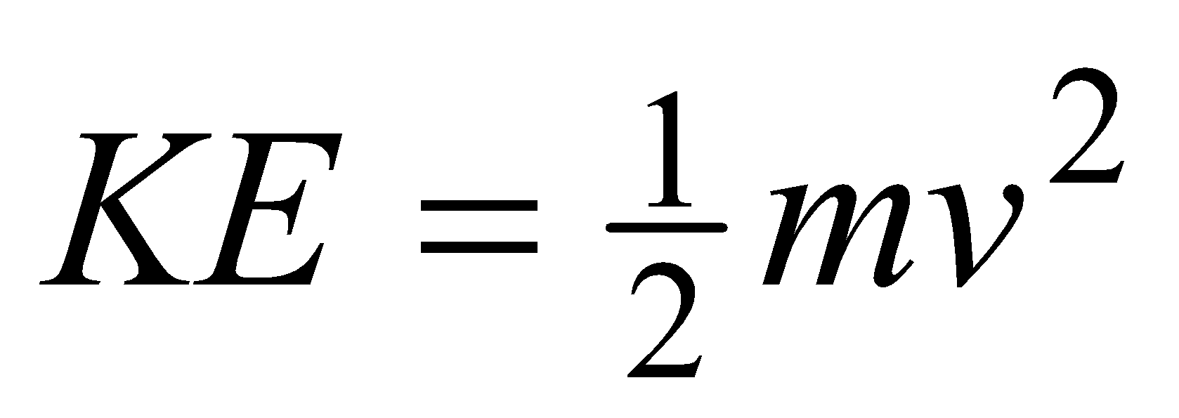
The spring can hold elastic potential energy, or PEelastic. We calculate PEelastic by using
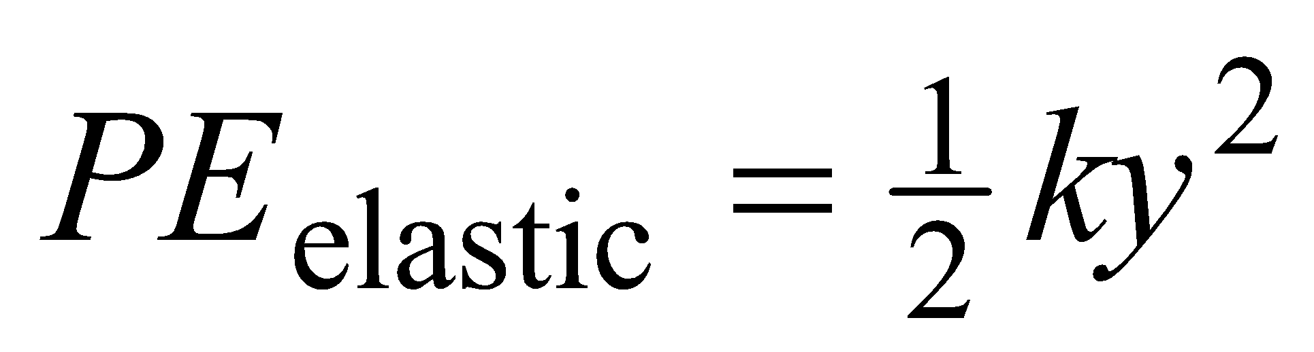
where k is the spring constant and y is the extension or compression of the spring measured from the equilibrium position.
The mass and spring system also has gravitational potential energy (PEgravitational = mgy), but we do not have to include the gravitational potential energy term if we measure the spring length from the hanging equilibrium position. We can then concentrate on the exchange of energy between kinetic energy and elastic potential energy.
If there are no other forces experienced by the system, then the principle of conservation of energy tells us that the sum ΔKE + ΔPEelastic = 0, which we can test experimentally.
OBJECTIVES
- Examine the energies involved in simple harmonic motion.
- Test the principle of conservation of energy.
MATERIALS
computer | slotted mass set, 50 g to 300 g in 50 g steps
Vernier computer interface | slotted mass hanger
Logger Pro | spring, 1-10 N/m
Vernier Motion Detector | ring stand
wire basket

PRELIMINARY QUESTIONS
1. Sketch a graph of the height vs. time for the mass on the spring as it oscillates up and down through one cycle. Mark on the graph the times where the mass moves the fastest and therefore has the greatest kinetic energy. Also mark the times when it moves most slowly and has the least kinetic energy.
2. On your sketch, label the times when the spring has its greatest elastic potential energy. Then mark the times when it has the least elastic potential energy.
3. From your graph of height vs. time, sketch velocity vs. time.
4. Sketch graphs of kinetic energy vs. time and elastic potential energy vs. time.
PROCEDURE
1. Set up the experiment.  - Mount the 200 g mass and spring as shown in Figure 1.  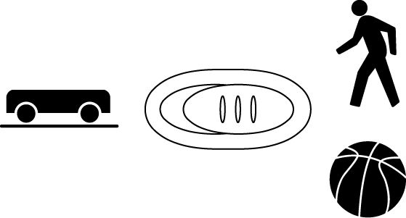  - Connect the Motion Detector to the DIG/SONIC 1 channel of the interface. If the Motion Detector has a switch, set it to Normal.  - Position the Motion Detector directly below the hanging mass, taking care that no extraneous objects could send echoes back to the detector. Protect the Motion Detector by placing a wire basket over the detector. The mass should be about 30 cm above the detector when it is at rest. Using amplitudes of 10 cm or less will then keep the mass outside of the 15 cm minimum distance of the Motion Detector.  2. Open the file “17a Energy in SHM” from the Physics with Vernier folder.  3. Start the mass moving up and down by lifting it 10 cm and then releasing it. Take care that the mass is not swinging from side to side. Click  to record position and velocity data. Print your graphs and compare to your predictions. Comment on any differences.  4. To calculate the spring potential energy, it is necessary to measure the spring constant k. Hooke’s law states that the spring force is proportional to its extension from equilibrium, or F = –kx. You can apply a known force to the spring, to be balanced in magnitude by the spring force, by hanging a range of weights from the spring. The Motion Detector can then be used to measure the equilibrium position. Open the experiment file “17b Energy in SHM.” Logger Pro is now set up to plot the applied weight vs. position. | 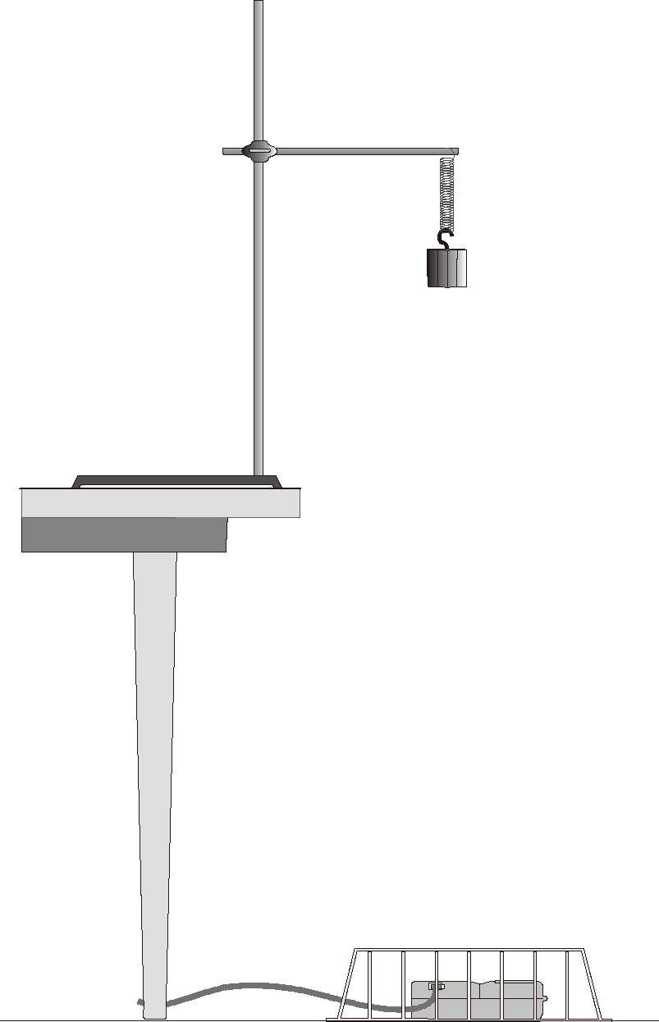  Figure 1
5. Click  to begin data collection. Hang a 50 g mass from the spring and allow the mass to hang motionless. Click  and enter 0.49, the weight of the mass in newtons (N). Press ENTER to complete the entry. Now hang 100, 150, 200, 250, and 300 g from the spring, recording the position and entering the weights in N. When you are done, click  to end data collection.
6. Click on the Linear Fit button, 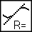, to fit a straight line to your data. The magnitude of the slope is the spring constant k in N/m. Record the value in the data table below.
7. Remove the 300 g mass and replace it with a 200 g mass for the following experiments.
8. Open the experiment file “17c Energy in SHM.” In addition to plotting position and velocity, three new data columns have been set up in this experiment file (kinetic energy, elastic potential energy, and the sum of these two individual energies). You may need to modify the calculations for the energies. Adjust the parameter for mass and spring constant as appropriate.
9. With the mass hanging from the spring and at rest, click  to zero the Motion Detector. From now on, all distances will be measured relative to this position. When the mass moves closer to the detector, the position reported will be negative.
10. Start the mass oscillating in a vertical direction only, with an amplitude of about 10 cm. Click  to gather position, velocity, and energy data.
DATA TABLE
Spring constant | N/m

ANALYSIS
1. Click on the y-axis label of the velocity graph to choose another column for plotting. Click on More to see all of the columns. Uncheck the velocity column and select the kinetic energy and potential energy columns. Click  to draw the new plot.
2. Compare your two energy plots to the sketches you made earlier. Be sure you compare to a single cycle beginning at the same point in the motion as your predictions. Comment on any differences.
3. If mechanical energy is conserved in this system, how should the sum of the kinetic and potential energies vary with time? Choose Draw Prediction from the Analyze menu and draw your prediction of this sum as a function of time.
4. Check your prediction. Click on the y-axis label of the energy graph to choose another column for plotting. Click on More and select the total energy column in addition to the other energy columns. Click  to draw the new plot.
5. From the shape of the total energy vs. time plot, what can you conclude about the conservation of mechanical energy in your mass and spring system?
EXTENSIONS
1. In the introduction, we claimed that the gravitational potential energy could be ignored if the displacement used in the elastic potential energy was measured from the hanging equilibrium position. First write the total mechanical energy (kinetic, gravitational potential, and elastic potential energy) in terms of a coordinate system, position measured upward and labeled y, whose origin is located at the bottom of the relaxed spring of constant k (no force applied). Then determine the equilibrium position s when a mass m is suspended from the spring. This will be the new origin for a coordinate system with position labeled h. Write a new expression for total energy in terms of h. Show that when the energy is written in terms of h rather than y, the gravitational potential energy term cancels out.
2. If a non-conservative force such as air resistance becomes important, the graph of total energy vs. time will change. Predict how the graph would look, then tape an index card to the bottom of your hanging mass. Take energy data again and compare to your prediction.
3. The energies involved in a swinging pendulum can be investigated in a similar manner to a mass on a spring. From the lateral position of the pendulum bob, find the bob’s gravitational potential energy. Perform the experiment, measuring the horizontal position of the bob with a Motion Detector.
4. Set up a laboratory cart or a glider on an air track so it oscillates back and forth horizontally between two springs. Record its position as a function of time with a Motion Detector. Investigate the conservation of energy in this system. Be sure you consider the elastic potential energy in both springs.

