Newton’s Law of Cooling
A container of hot water at temperature, T, placed in a room of lower temperature Troom, will result in an exchange of heat from the hot water to the room. The water will eventually cool to the same temperature as the room. You observe this cooling process every time you wait for a hot drink to cool. In this experiment you will examine the cooling of hot water, with the goal of creating a model that describes the process. You can also predict the time it takes for the hot water to cool to room temperature.
Isaac Newton modeled the cooling process by assuming that the rate at which thermal energy moved from one body to another is proportional (by a constant k) to the difference in temperature between the two bodies, Tdiff. In the case of a sample of water cooling in room temperature air
cooling rate = –kTdiff
From this simple assumption he showed that the temperature change is exponential in time and can be predicted by
T = T0 e–kt + Troom
where T0 is the initial temperature difference. Exponential changes are common in science. When a rate of change is proportional to the changing quantity the behavior is exponential.
To complete this experiment in a short time, you will use a small quantity of hot water, at a temperature about 30°C above room temperature. A temperature sensor connected to a computer will record the water’s temperature as it cools.
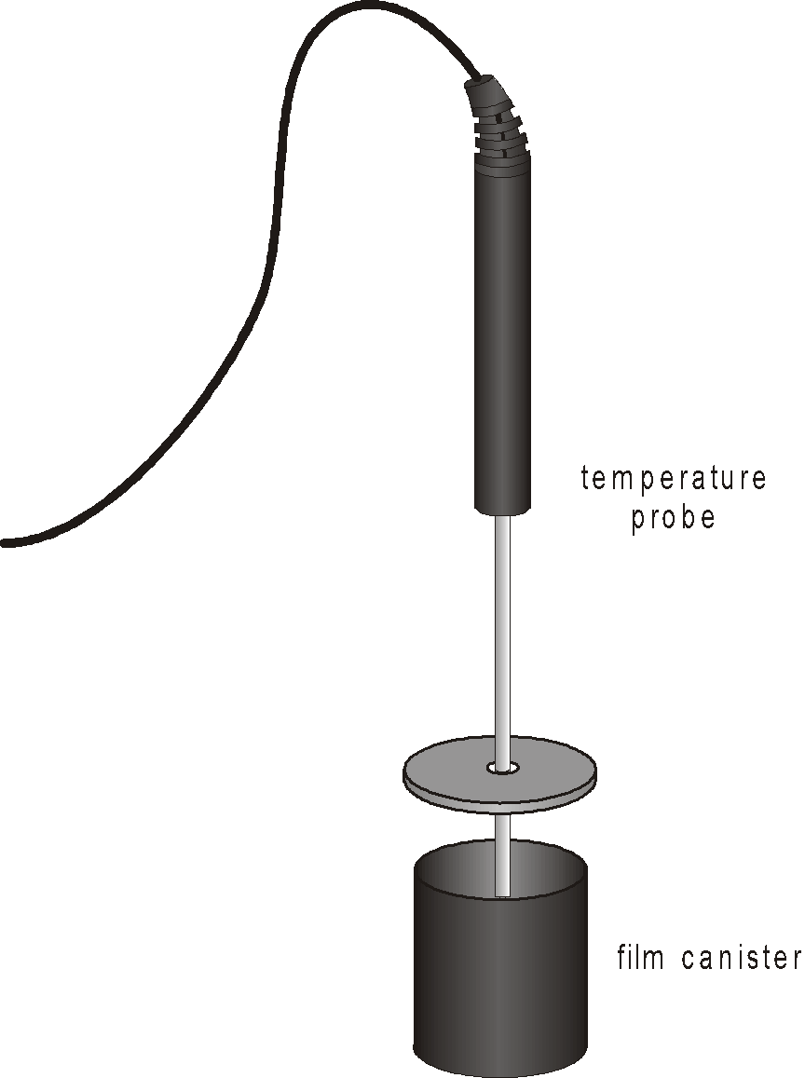
Figure 1
OBJECTIVES
- Use a Temperature Probe to record the cooling process of hot water.
- Test Newton’s law of cooling using your collected water temperature data.
- Use Newton’s law of cooling to predict the temperature of cooling water at any time.
MATERIALS
computer  Vernier computer interface | Temperature Probe  35 mm film canister with top
Logger Pro | hot water

PROCEDURE
1. Connect a Temperature Probe to Channel 1 of the interface.
2. Open the file “30 Newtons Law Cooling” from the Physics with Vernier folder.
3. Determine room temperature. To do this, hold the sensor in the air away from heat sources and sunlight. Click  to begin data collection Once the temperature reading is nearly constant, click  to end data collection. Record this value in your data table.
4. Push the Temperature Probe through the hole in the cap so that the end of the probe will be submerged in the water when the cap is on the canister. Do not let the end of the probe rest against the bottom of the canister.
5. Obtain some water at about 55°C. You should be able to get water this hot from a hot water faucet. If necessary, heat water to this temperature.
6. Carefully fill the canister about three-fourths full with the hot water. Place the cap containing the sensor onto the canister and press until it is sealed with a click.
7. Wait about 15 s for the temperature sensor to reach the temperature of the water. Click  to begin data collection. Data will be collected for 20 minutes.
DATA TABLE
Average room temperature (°C)

ANALYSIS
1. Use Logger Pro to fit an exponential function to the data. Do this by clicking the Curve Fit button, 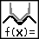, and choosing the Natural Exponential function (y=A*exp(–Ct)+B) from the scrolling list. Click  to perform the fit, then click .
2. Newton’s cooling law was given above as
T = T0 e–kt + Troom
Match the variables x, y, A, B, and C in the fitted equation to terms T, Troom, k, and t in the expression of Newton’s Cooling Law. What are the units of A, B and C? Compare your value for B to the room temperature you recorded earlier. During data collection was the sensor ever at room temperature?
3. When t = 0, what is the value of e–kt?
4. When t is very large, what is the value of temperature difference? What is the temperature of the water at this time?
5. What could you do to your experimental apparatus to decrease the value of k in another run? What quantity does k measure?
6. Use your equation to calculate the temperature after 800 seconds. Compare your calculated value with the actual data value.
7. Use your equation to predict the time it takes the water to reach a temperature 1°C above room temperature.
8. If the starting temperature difference is cut in half, does it take half as long to get to 1°C above room temperature?
EXTENSIONS
1. Take data for a longer period of time so that the water cools to nearly room temperature. This may take more than 30 minutes. Does the exponential model still fit the data?
2. A coffee drinker is faced with the following dilemma. She is not going to drink her hot coffee with cream for ten minutes, but wants it to still be as hot as possible. Is it better to immediately add the room-temperature cream, stir the coffee, and let it sit for ten minutes, or is it better to let the coffee sit for ten minutes and then add and stir in the cream? Which results in a higher temperature after ten minutes? Use your Temperature Probe to examine this dilemma. Explain your results in terms of the assumptions Newton made about cooling.
3. Use the Temperature Probe to experiment with coffee cups made of different material. Does a drink cool faster in a ceramic cup than in a Styrofoam cup? What variables must you hold constant in order to guarantee that the difference in the data is due to the cup? What part of the exponential equation is related to the cup?
4. The mathematical model for the cooling of a liquid can also be used to explain other phenomena in nature. For example, radioactivity and RC circuits behave in a similar fashion. Find other phenomena that are modeled by exponential functions. If possible make a measurement of the phenomenon in your physics lab.

