Sound Waves and Beats
Sound waves consist of a series of air pressure variations. A Microphone diaphragm records these variations by moving in response to the pressure changes. The diaphragm motion is then converted to an electrical signal. Using a Microphone and a computer interface, you can explore the properties of common sounds.
The first property you will measure is the period, or the time for one complete cycle of repetition. Since period is a time measurement, it is usually written as T. The reciprocal of the period (1/T) is called the frequency, f, the number of complete cycles per second. Frequency is measured in hertz (Hz). 1 Hz = 1 s–1.
A second property of sound is the amplitude. As the pressure varies, it goes above and below the average pressure in the room. The maximum variation above or below the pressure mid-point is called the amplitude. The amplitude of a sound is closely related to its loudness.
When two sound waves overlap, their air pressure variations will combine. For sound waves, this combination is additive. We say that sound follows the principle of linear superposition. Beats are an example of superposition. Two sounds of nearly the same frequency will create a distinctive variation of sound amplitude, which we call beats. You can study this phenomenon with a Microphone, lab interface, and computer.
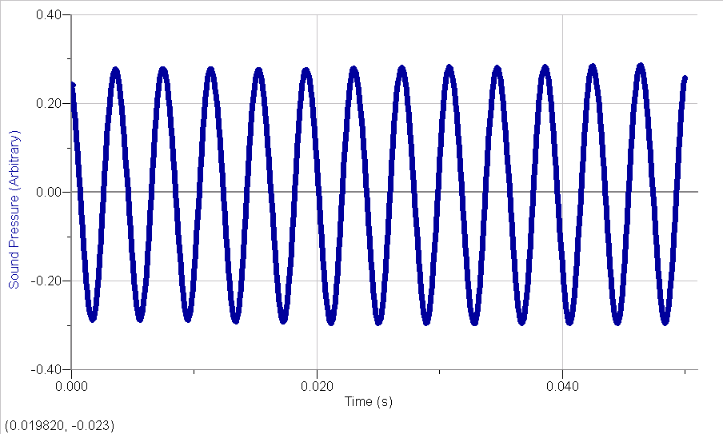
OBJECTIVES
- Measure the frequency and period of sound waves from tuning forks.
- Measure the amplitude of sound waves from tuning forks.
- Observe beats between the sounds of two tuning forks.

MATERIALS
computer | Logger Pro
Vernier computer interface  Vernier Microphone | 2 tuning forks or electronic keyboard
PRELIMINARY QUESTIONS
1. Why are instruments tuned before being played as a group? In which ways do musicians tune their instruments?
2. Given that sound waves consist of series of air pressure increases and decreases, what would happen if an air pressure increase from one sound wave was located at the same place and time as a pressure decrease from another of the same amplitude?
PROCEDURE
1. Connect the Microphone to Channel 1 of the computer interface.
2. Open the “32 Sound Waves” file in the Physics with Vernier folder. The computer will take data for just 0.05 s to display the rapid pressure variations of sound waves. The vertical axis corresponds to the variation in air pressure and the units are arbitrary. Click 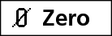 to center waveforms on the time axis.
Part I Simple Waveforms
3. Produce a sound with a tuning fork or keyboard, hold it close to the Microphone and click . The data should be sinusoidal in form, similar to the sample on the front page of this lab. If you are using a tuning fork, strike it against a soft object such as a rubber mallet or the rubber sole of a shoe. Striking it against a hard object can damage it. If you strike the fork too hard or too softly, the waveform may be too rough; try again.
4. Note the appearance of the graph. Count and record the number of complete cycles shown after the first peak in your data.
5. Click the Examine button, 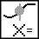. Drag the mouse between the first and last peaks of the waveform. Read the time interval Δt, and divide it by the number of cycles to determine the period of the tuning fork waveform.
6. Calculate the frequency of the tuning fork in Hz and record it in your data table.
7. In a similar manner, determine amplitude of the waveform. Drag the mouse across the graph from top to bottom for an adjacent peak and trough. Read the difference in y values, shown on the graph as Δy.
8. Calculate the amplitude of the wave by taking half of the difference dy. Record the value in your data table.
9. Make a sketch of your graph or print the graph.
10. Save your data by choosing Store Latest Run from the Experiment menu. Hide the run by choosing Hide Data Set from the Data menu and selecting Run 1 to hide.
11. Repeat Steps 3–9 for the second frequency. Store the latest run. It will be stored as Run 2. Then hide Run 2.
Part II Beats
12. Two pure tones with different frequencies sounded at once will create the phenomenon known as beats. Sometimes the waves will reinforce one another and other times they will combine to a reduced intensity. This happens on a regular basis because of the fixed frequency of each tone. To observe beats, strike your tuning forks at the same time (simultaneously) or simultaneously hold down two adjacent keys on the keyboard and listen for the combined sound. If the beats are slow enough, you should be able to hear a variation in intensity. If the beats are rapid a single rough-sounding tone is heard.
13. Collect data while the two tones are sounding. You should see a time variation of the sound amplitude. When using tuning forks, strike them equally hard and hold them the same distance from the Microphone. When you get a clear waveform, choose Store Latest Run from the Experiment menu. The beat waveform will be stored as Run 3.
14. The pattern will be complex, with a slower variation of amplitude on top of a more rapid variation. Ignoring the more rapid variation and concentrating in the overall pattern, count the number of amplitude maxima after the first maximum and record it in the data table.
15. Click the Examine button, . As you did before, find the time interval for several complete beats using the mouse. Divide the difference, Δt, by the number of cycles to determine the period of beats (in s). Calculate the beat frequency in Hz from the beat period. Record these values in your data table.
DATA TABLE
Part I Simple Waveforms
Tuning fork or note | Number of cycles | Δt (s) | Period (s) | Calculated frequency (Hz)

Tuning fork or note | Amplitude (V)

Tuning fork or note | Parameter A (V) | Parameter B (s-1) | f = B/2π (Hz)

Part II Beats
Number of cycles | Δt (s) | Beat (s) | Calculated beat frequency (Hz)

ANALYSIS
Part I Simple Waveforms
1. In the following analysis, you will see how well a sine function model fits the data. The displacement of the particles in the medium carrying a periodic wave can be modeled with a sinusoidal function. Your textbook may have an expression resembling this one:
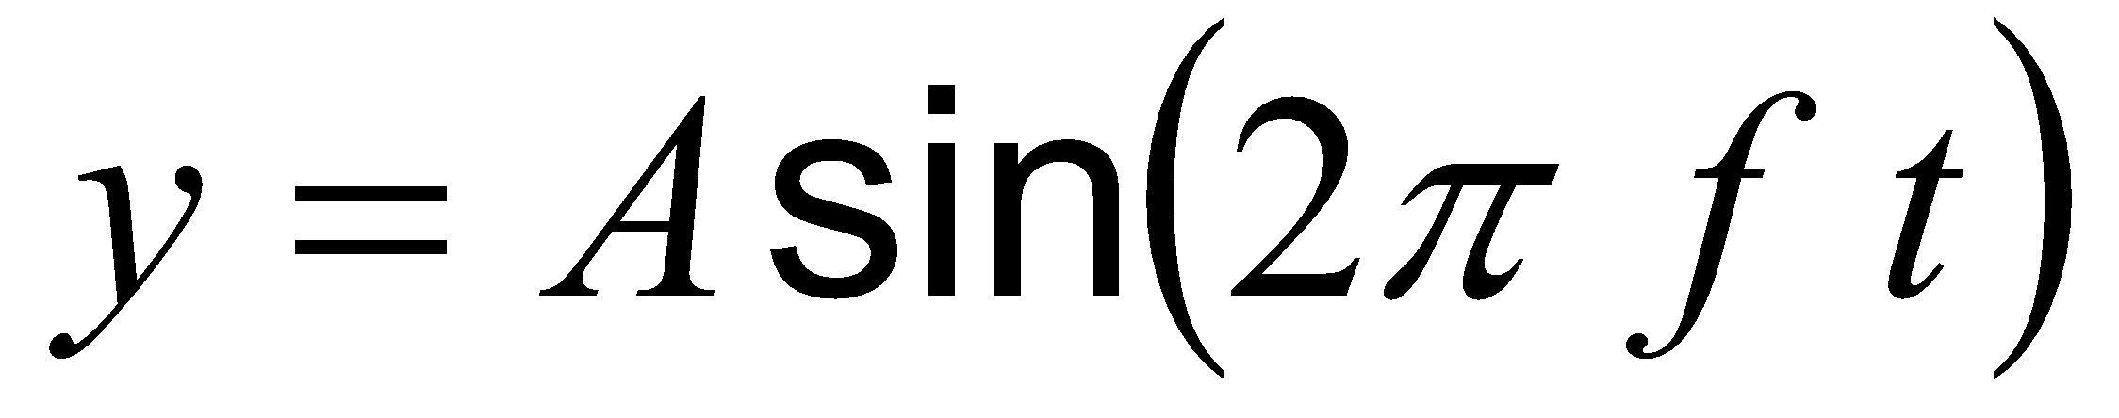
In the case of sound, a longitudinal wave, the y refers to the change in air pressure that makes up the wave. A is the amplitude of the wave (a measure of loudness), and f is the frequency. Time is represented with t and the sine function requires a factor of 2π when evaluated in radians.
Logger Pro will fit the function y = A * sin(B*t + C) + D to experimental data. A, B, C, and D are parameters (numbers) that Logger Pro reports after a fit. This function is more complicated than the textbook model, but the basic sinusoidal form is the same. Comparing terms, listing the textbook model’s terms first, the amplitude A corresponds to the fit term A, and 2π f corresponds to the parameter B. The time is represented by t, Logger Pro’s horizontal axis. The new parameters C and D shift the fitted function left-right and up-down, respectively and are necessary to obtain a good fit. Only the parameters A and B are important to this experiment. In particular, the numeric value of B allows you to find the frequency f using B = 2π f. Choose Show Data Set from the Data menu and select Run 1 to show the waveform from the first tone. Keep the other runs hidden. Click the Curve Fit button, 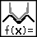, and select Run 1 from the list of columns. Select “A*sin(B*t +C) + D (Sine)” from the list of models. Click  to perform the curve fit.
Click  to return to the graph. The model and its parameters appear in a floating box in the upper left corner of the graph. Record the parameters A and B of the model in your data table.
2. Since B corresponds to 2 π f in the curve fit, use the curve fit information to determine the frequency. Enter the value in your data table. Compare this frequency to the frequency calculated earlier. Which would you expect to be more accurate? Why?
3. Compare the parameter A to the amplitude of the waveform. Hide Run 1 and show Run 2, the waveform of the second tone. Repeat Steps 1–4 for Run 2.
Part II Beats
4. Is there any way the two individual frequencies can be combined to give the beat frequency you measured earlier? Compare your conclusion with information given in your textbook.

EXTENSIONS
1. The beats you observed in Run 3 resulted from the overlap of sound waves from the two tuning forks. How would the data you recorded compare to a simple addition of the waveforms from the forks individually? If the sound waves combined in air by linear addition, then the algebraic sum of the data of the individual waveforms should be similar to data of the beats. The following steps will help you perform the addition:
- Show Run 3 only (the waveform of the actual beats).
- Choose New Calculated Column from the Data menu. Give the column the name of “Sum.”
- Click once in the equation field to place the cursor there. Choose Run1:Sound Pressure from the Variables (Columns): menu, type the addition symbol “+”, and choose Run2:Sound Pressure from the Variables (Columns) menu. The resulting equation will read “Run1:Sound Pressure”+ “Run2:Sound Pressure”.
- Click Done. Click No if Logger Pro asks if you want to select a specific Data Set.
- A new column, representing the sum of the two waveforms, will be created in each Data Set.
- Drag the Sum column header of Run 3 from the data table area to the y axis area to plot the Sum column.
- Click on the y-axis label to show the y-axis selection dialog and uncheck all but the Sum column in Run 3. Click . You now see the mathematical sum of the Runs 1 and 2. Rescale the graph if needed. Now use the y-axis label dialog to display only the actual data of the beats. (It is hard to see with both plots on screen at once, so look at one at a time.) How is the sum similar to the real data? How are they different? Do the graphs support the model of additive sound wave superposition? What if the superposition rule were multiplicative? Would that change the graph?

2. There are commercial products available called active noise cancellers, which consist of a set of headphones, microphones, and some electronics. Intended for wearing in noisy environments where the user must still be able to hear (for example, radio communications), the headphones reduce noise far beyond the simple acoustic isolation of the headphones. How might such a product work?
3. The trigonometric identity
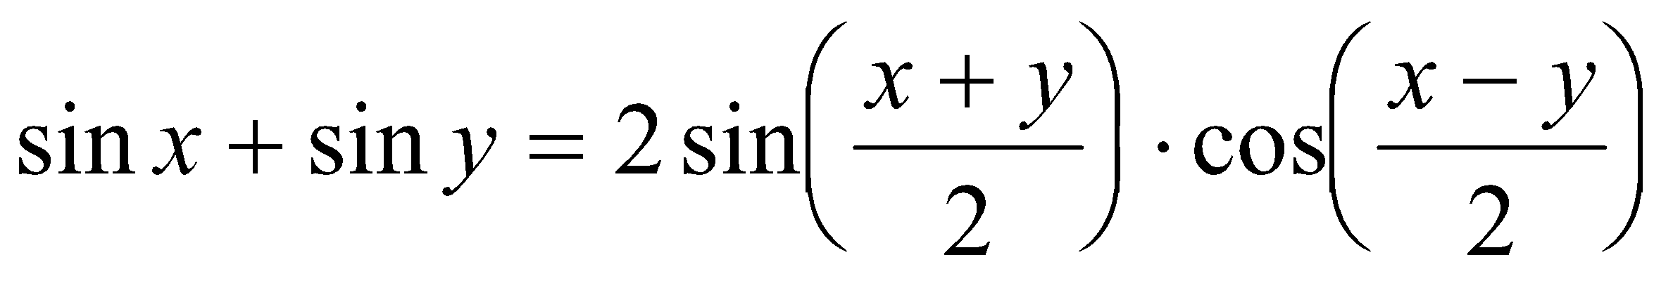
is useful in modeling beats. Show how the beat frequency you measured above can be predicted using two sinusoidal waves of frequency f1 and f2, whose pressure variations are described by sin(2π f1 t) and sin(2π f2 t).
4. Most of the attention in beats is paid to the overall intensity pattern that we hear. Use the analysis tools to determine the frequency of the variation that lies inside the pattern (the one inside the envelope). How is this frequency related to the individual frequencies that generated the beats?
5. Examine the pattern you get when you play two adjacent notes on a keyboard. How does this change as the two notes played get further and further apart? How does it stay the same?

