
Name: ________________

Class: ________________

Speed of Sound Lab
Resonance with Air Columns

Resonance with Air Columns

In this lab, you will use tuning forks and air columns to investigate standing sound waves and resonance. Using the equipment given, graphically determine the speed of sound and compare to the actual value.
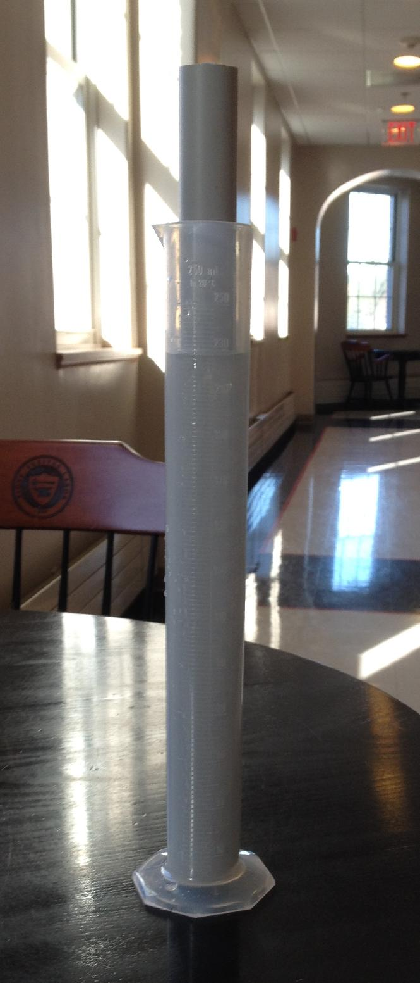

Equipment:
- A set of tuning forks of know frequencies
- 1 – 250 mL graduated cylinder filled with water (see figure)
- 1 – pvc pipe
- 1 – meter stick

Procedure:
By raising and lowering the inner pvc pipe in the water filled cylinder, you can adjust the length of the column of air in the pipe. The water level acts as a closed end while the top of the pvc pipe is open.

Hold a vibrating tuning fork 1 cm above the open end of the pvc pipe and adjust the length of the air column until you can hear a resonating sound which will indicate that you have produced a standing sound wave inside the pvc pipe.

Have one person move the tuning fork/pvc pipe and another person measure the distance from the water level to the fork. Repeat your measurement several times to improve accuracy. Using the data for all of your tuning forks, graphically determine the speed of sound.

Create a “Scatter Plot” graph of Frequency vs Speed (frequency on x-axis, speed on y-axis)

Analysis Questions:
- How closely did you get to the theoretical speed of sound?
- Write a short analysis of accuracy and precision of this experiment
- Write a short explanation of how this experiment could be improved

Extensions:

1. Add a tablet of alka seltzer to the water and re-measure the column length of one of your tuning forks. Did it change? If so, explain why.

2. Pick any three of your known tuning fork frequencies and calculate the length of the standing wave for the 3rd harmonic (or 1st overtone) for each. Could your experimental apparatus produce a standing wave with the third harmonic frequencies?

