James Raboin

Ruben Arutyunov

Game dev Step 1

Story - In Progress

Scene -

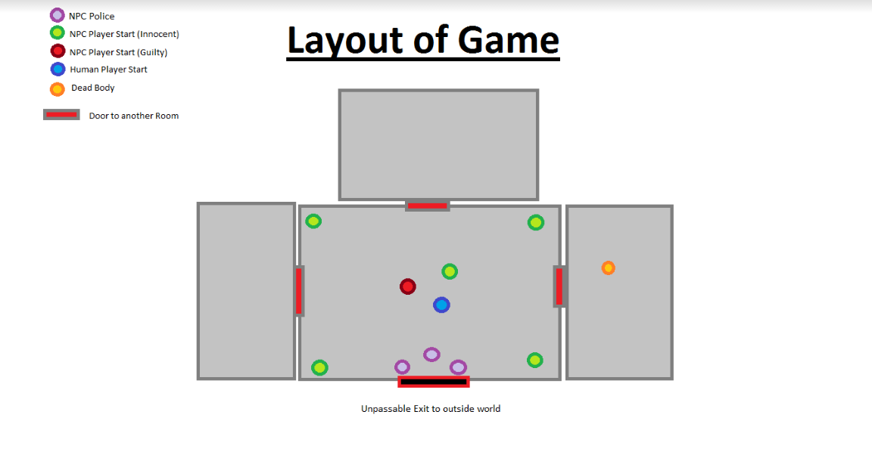

Players -

Human: (Jedi Investigator)

NPC’s: Vlad, Info Droid, Sasha, Garet, Cora, Trent, Police 1, Polce 2, Yohan

Character Outlines

Human 1: Jedi Investigator

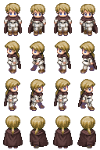

NPC 1 (Innocent): Vlad  
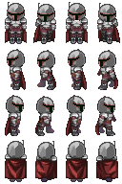

NPC 2 (Innocent): Info Droid  
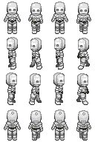

NPC 3 (Innocent): Sasha

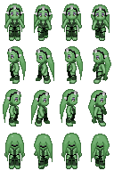

NPC 4 (Innocent): Garet

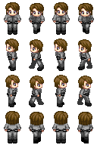

NPC 5 (Innocent): Cora

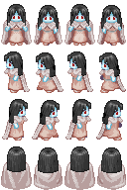

NPC 6 (Guilty) Trent:

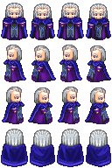 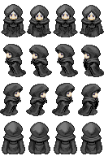

NPC 7 (Police):

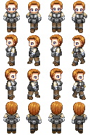

NPC 8 (Police):

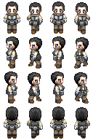

NPC 9 (Police Chief) Yohan:  
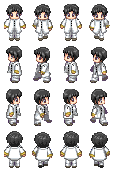

Objects - Collectible suspect items (Bloody Umbrella, footprints, a wad of fraudulent cash)

Physics - Door enter/exit, character collision detection, character movement

Events - Door open/close character/NPC interaction

Audio - Door open/close, background music

Rules/Objectives - Talk with NPC’s, collect items to advance story and find murderer.

Platform - PC/Keyboard/Mouse/Internet Browser

Something that will be different: Other rooms will be dark until entered. Only the room that human is in shall have light.