Alumni Profile

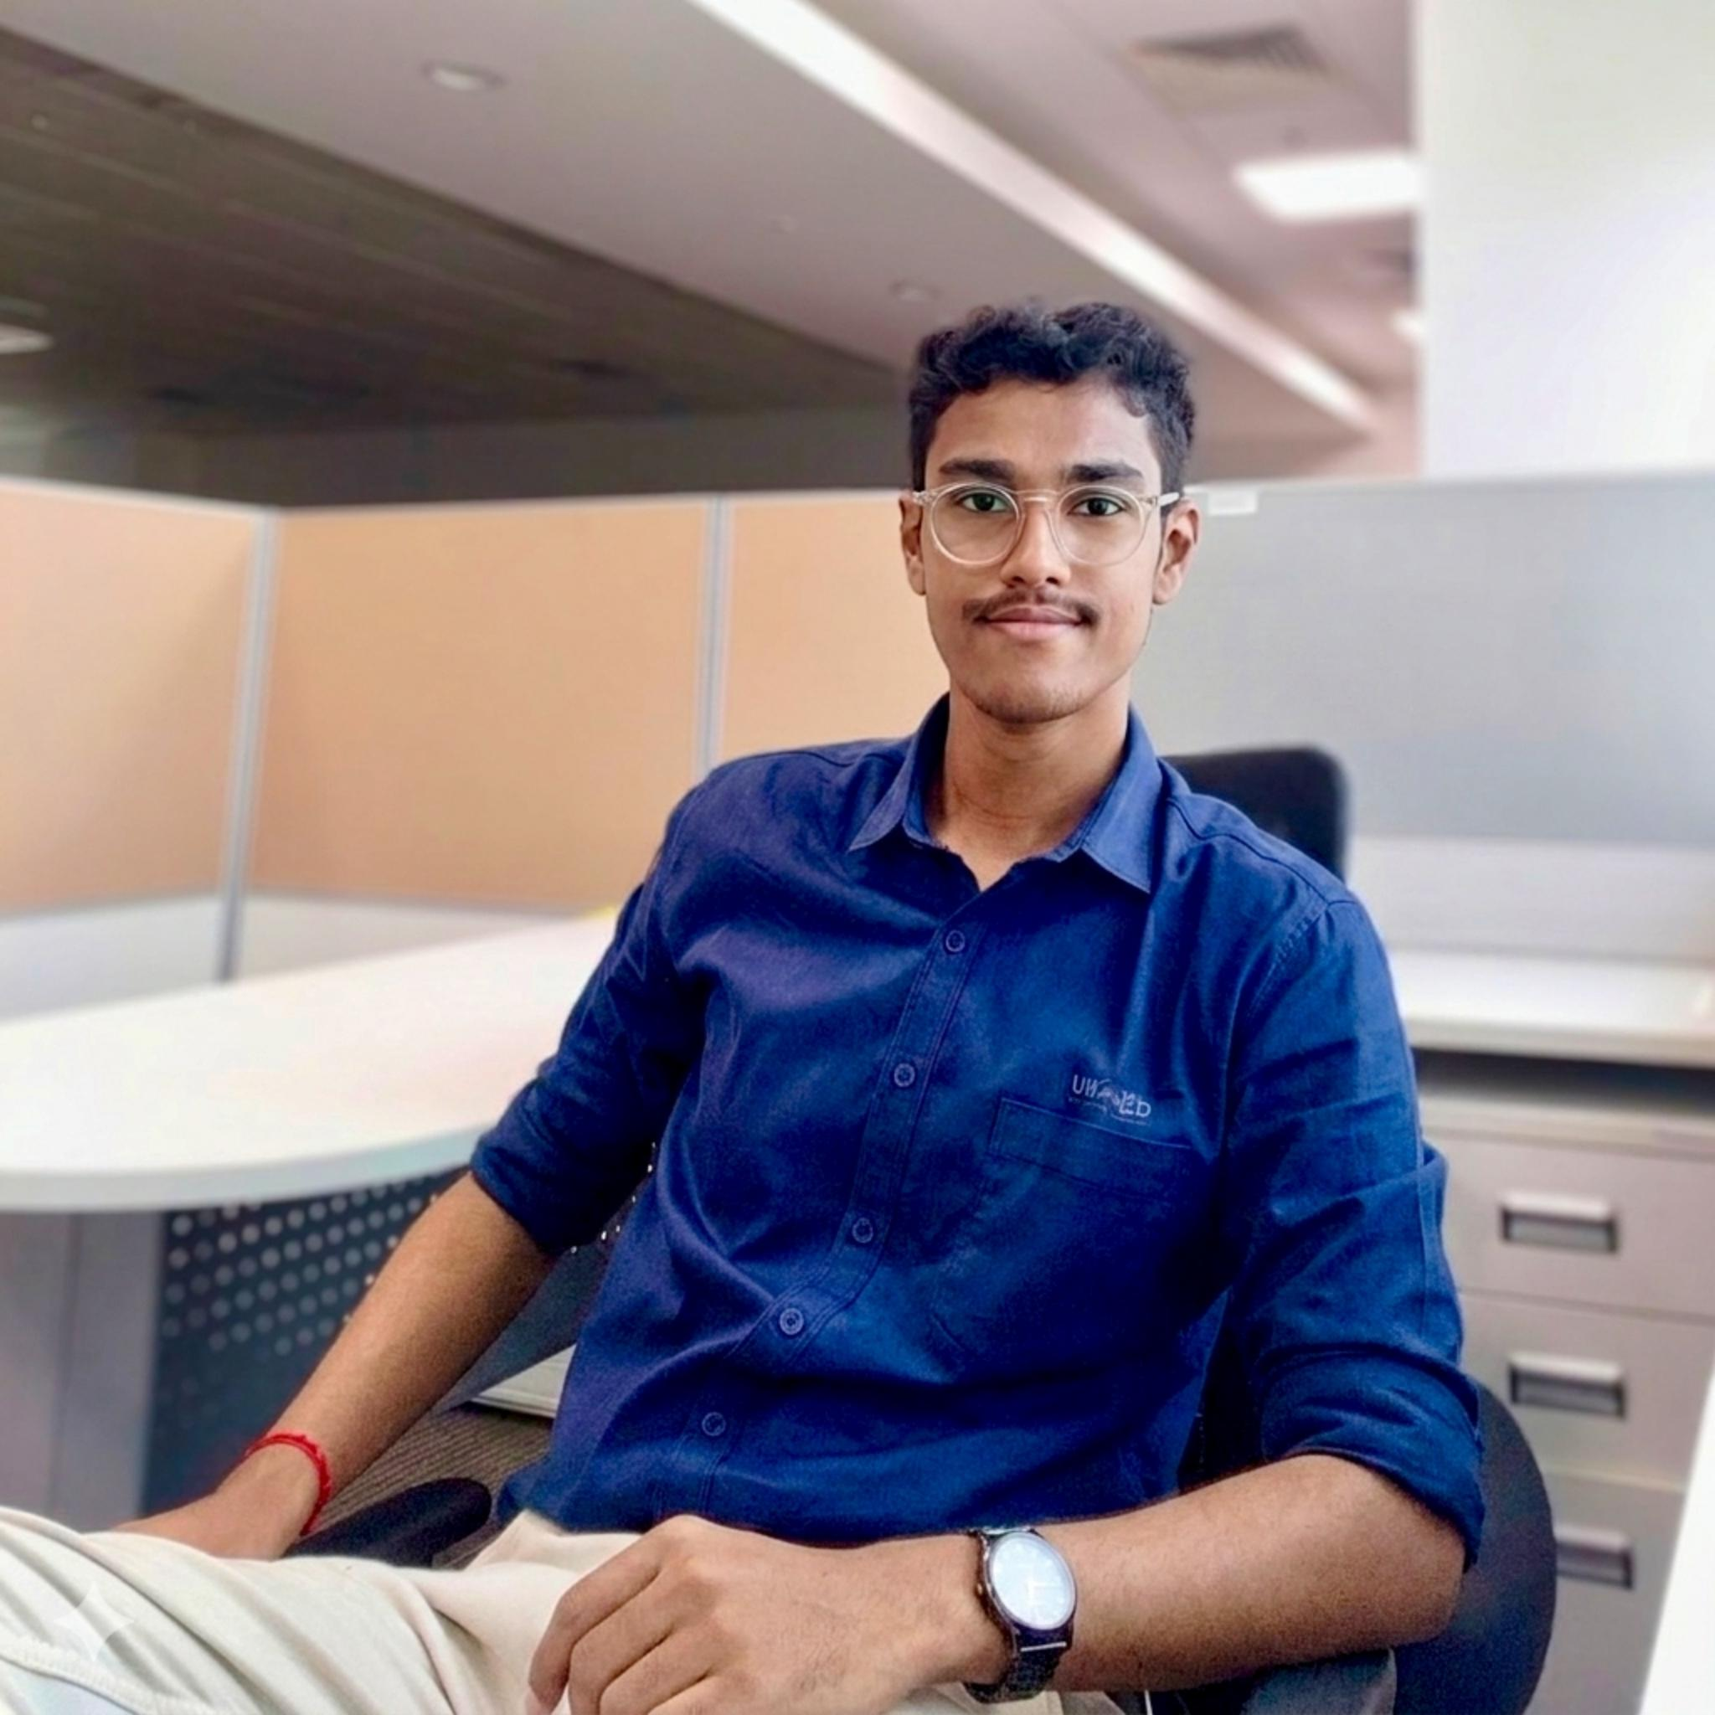 | Name: Rupesh Vavilla  Degree & Department: B. Tech in Computer Science & Engineering (2021 - 2025) |  CGPA: 9.3  Current Designation: Programmer Analyst Trainee - Automation Tester, Cognizant, Chennai  ORCID ID: 0009-0008-6081-3173  Connect: LinkedIn | GitHub | Email

Professional Summary
Rupesh is a Computer Science Engineering graduate, researcher, software professional, and technology enthusiast currently working as an Automation Tester at Cognizant in Chennai. During his undergraduate journey at Narayana Engineering College, he developed a diverse profile spanning Software Quality Assurance, Test Automation, Artificial Intelligence, Machine Learning, Cybersecurity, Research, Innovation, and Student Leadership.

Key Achievements & Highlights
- Research & Publications: 6+ publicly indexed research publications spanning Artificial Intelligence, Machine Learning, Healthcare Technology, Quantum-Secure Communication, and AI in Agriculture, including research published during his undergraduate period.
- National-Level Event Leadership: Served as a Lead/Core Organizer of Hackademia 2K24, a student initiative National-Level 24-Hour Hackathon hosted at Narayana Engineering College, which recorded 1,100+ registrations and 250+ teams.
- Competitive Excellence: Participated in 60+ competitions and hackathons, securing multiple top positions including 2nd Place - NEHathon (NRoleHub idea), 1st Place - iQonnect (₹10,000 Prize), 1st Place - Crack The Code & Code Fiesta, 1st Place - Aakruthi Short Film Competition, and advancing as National Qualifiers in the PSG iTech Hackathon.
- Innovation & Applied Projects: Developed solutions including NRoleHub, an Automated Certificate Generation & Email System, and ILawBot - an AI-powered legal information bot.
- Technical Portfolio: Proficient in Languages & Core: Python, JavaScript, Dart, Java, SQL, Git | Testing & Development: Test Automation, QA Frameworks, Flutter, Node.js, Express.js, React, HTML/CSS | Cloud & Databases: Firebase, Microsoft Azure, MySQL, MongoDB | Domain Expertise: Artificial Intelligence, Machine Learning, Data Science, Cybersecurity, Cloud Computing, and REST API Testing/Development.
- Certifications & Technical Learning: Pursued certifications/training in Microsoft Azure AI Fundamentals, Cloud Computing, Ethical Hacking, Python, Machine Learning & Data Science, Java Full Stack, and Cybersecurity.
- Industry Exposure: Participated in Tech Vision 2K24 at Microsoft's Luxor North Tower, Bengaluru, gaining exposure to technology and industry perspectives from professionals associated with organizations including Microsoft, Cisco, Zomato, and Accenture.
- Campus Leadership & Engagement: Actively contributed to NSS, CSI, IEEE Student Branch, Robotic Society of India, and NECN Coding Club, alongside academic, technical, and extracurricular activities.

From Campus Innovator to Cognizant Professional
Rupesh's journey reflects a combination of research, innovation, competitive excellence, technical curiosity, and leadership—progressing from an active student and national-level hackathon organizer at Narayana Engineering College to beginning his professional career in Quality Engineering and Test Automation with Cognizant.

