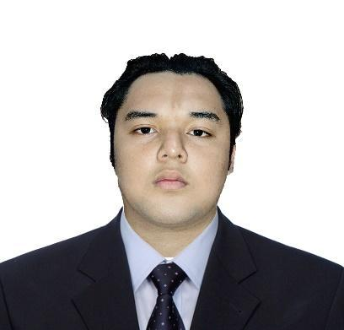
Mosqueda, Jericho D.
officialjerichom@gmail.com
Duraville Homes II blk.11 lot 25 Sacramento St.
Brgy. Mahabang Parang Angono, Rizal
Contact No: 0948-7221-139

Job Objective:
As a graduate of Information Technology, I am looking for a position where I can utilize my skills, abilities and knowledge in computer hardware and software, and develop my utmost potential in the field of information technology. I will do my very best to serve the company that I will work with.
Work Experience
OJT Trainee (September 2022 to December 2022)

- ICCT Colleges Foundation Inc.
- 534 hours rendered
- IT support/helpdesk
- Assisting the students/parents regarding information about ICCT Colleges
- Communicating with the students/parents about school activities, guidelines, and school requirements via telephone call.
- Managing the social media platforms of ICCT Colleges.
- Encoding student’s records using MS Excel.
- Install computers and other hardware peripherals, operation systems, software applications (images) as well as handle problem resolution.
Web Developer – .Net Developer (March 2023 up to May 31 2024)
- MNLeistung Incorporation.
- Develop and maintain customized data-centric web applications and services using ASP.NET CORE WEB APPLICATION, C#, MSSQL, and Agile/SCRUM methodologies
- Create and apply UI requirements utilizing ASP.NET, Ajax, JS/jQuery, HTML and CSS.
- Developed and optimized programs performance using ASP.NET, C#.Net, and MS SQL.
- Implemented business management applications.
- Programmed customized software solutions that helped customers to use their capital and manage risk more effectively.

Personal Data
Birthday: | June 16, 2001
Birthplace: | Pasig City
Age: | 23
Sex: | Male
Nationality: | Filipino
Educational Background

Name of School Year Attended
Elementary: Malasiqui Catholic School 2006
High School:

Junior High School: Carlos Botong V Francisco Memorial 2013
National High School
Senior Highschool: Sumulong College of Arts and Sciences 2017
Strand: Science Technology Engineering and Mathematics
(STEM)
College ICCT Colleges Antipolo Campus, Antipolo City, Philippines 2019-2023
Degree: BSIT (Bachelor of Science in Information Technology)
Skills and Personal Qualification
- Familiar in basic programming Language and scripting Language (HTML, CSS, Python, Java, Vb.net, ASP.Net, jQuery, React.js, JavaScript, C#).
- Familiar in using Visual Studio NuGet Package Mailkit SMTP for email-sending.
- Familiar in using Client-Side Library SignalR for real-time data.
- Familiar in using ADO.Net, Entity Framework Core, Dependency Injection, Auto-mapper, LINQ.
- Familiar in using DevExpress XtraReports.
- Installation and Configuration of Computer Operating System.
- Conversant in some essential applications like MS Office, Microsoft Visual Studio, MS SQL.
- Assembling, Troubleshooting and Maintaining a Computer Hardware/System Unit.
Achievements
Academic Excellence (With Honor) – Grade 11 S.Y. 2017-2018
Academic Excellence (With Honor) – Grade 12 S.Y. 2018-2019
Seminars Attended and Certificates
Partner: PCAP - Programming Essentials in Python
ICCT Colleges Foundation Inc.
Instructor(s): JORIZ CHIONG
Enrolled on: 03 Feb 2020
CCNAv7: Switching, Routing, and Wireless Essentials
ICCT Colleges Foundation Inc.
Instructor(s): Jerico Vilog
Completed on: 04 Apr 2022
CCNAv7: Introduction to Networks
ICCT Colleges Foundation Inc.
Instructor(s): Jerico Vilog
Completed on: 22 Jul 2021
Huawei 5G
ROBOTHINKS 2019 ver. 3.0
Dec 06 2019

References
Christian Dave Concepcion | Cel. No. 09458643650
Ryan Llacer | Cel. No. 09095766811

I hereby certify that the information above is true and correctly the best of any beliefs.

