**AUTOMOBILE MARKET IN ARMENIA**

By

**VAZGEN TADEVOSYAN**

BS, **ARMENIAN STATE UNIVERSITY OF ECONOMICS, 2016**.

A thesis submitted in partial satisfaction of

the requirements for the degree of

Master of Engineering

in

Industrial Engineering & Systems Management

in the

COLLEGE OF SCIENCE AND ENGINEERING

of the

AMERICAN UNIVERSITY OF ARMENIA

Supervisor: ____Habet Madoyan**_______**___ Date:_____________

Signature: __________________ Date:_____________

Committee Member: ____________________

Signature: __________________ Date:_____________

Committee Member: ____________________

Signature: __________________ Date:_____________



**Acknowledgement**

The project would not be possible without the help of Assistant Professor, Data Science Program Chair Habet Madoyan. I would like to express my gratitude to him, for his patient guidance, encouragement and useful comments on this capstone project. He was very supportive during whole process and helped me whenever I needed.

I would also like to thank Professor Davtyan, for his assistance in solving scraping problems and Lusine Zilfimyan for helping to build Shiny application .

My thanks are also extended to the staff of College of Science and Engineering department, whose services turned my project a success.

Finally, I must express my very deep gratitude to my parents and friends for providing me not only financial assistance but also moral and emotional support throughout my years of study. My accomplishments would not have been possible without them.

Thank you.

**Abstract**

In Armenia, we do not have a statistic-based study publicly available on the automobile market. Moreover, there is no reliable data on this market, hence this makes even more difficult to analyze the market and make accurate assumptions on the automobile market.

At the moment, people make conclusions based on approximate data. In majority of cases, people tend to compare their cars with several similar auto models or they set the price based on parameters of an automobile and their own experience. However, the noted approaches may cause errors both for the sellers and buyers and they are not able to predict if their cars are able to be sold for a certain price.

In this project we have collected the necessary data on the automobile market of Armenia and have analyzed it by using different statistical tools. With several extra techniques we have made the acquired data more reliable and have decreased possible deviations in the stage of analysis. As a result, we have created quite an effective tool for both sellers and buyers, which helps them to decide the market price of the car, calculates the possibility of the cars to be sold.

**Contents**

List of Figures 5

1. Introduction 6

1.1. Background 7

1.2. Project Objectives 9

1.3. Literature Review 10

2. Data collection and cleaning 13

2.1. Data scraping 14

2.2. Data cleaning 16

3. Visualization 17

4. Multilinear regression and other statistic methods 20

5. Classification 25

5.1. Logistic Regression 26

5.2. Decision tree 28

6. Results 30

7. Conclusion and suggestions 31

Reference 32

# List of Figures

*Figure 1* 14

*Figure 2* 15

*Figure 3* 17

*Figure 4* 17

*Figure 5* 18

*Figure 6* 19

*Figure 7* 21

*Figure 8* 22

*Figure 9* 25

*Figure 10* 27

*Figure 11* 29

*Figure 12* 30

# Introduction

The fluctuations in demand and the price of cars in different countries makes the automobile market an interesting area for research. Wide range of companies and [organizations](https://en.wikipedia.org/wiki/Organization) are involved in vehicle production and they design and manufacture new models with various features in order to maximize customers’ satisfaction and profits. Consequently, regardless of their taste people can buy a car appropriate to their needs because a wide variety of offers aids in decision making. Customer preferences for vehicles are diverse and while one may pay more attention to design, another may emphasize the engine power or other features of the car. Hence, generalization of preferences of customers of a certain country is necessary and may facilitate the decision making of importing companies. The level of demand of a certain model of car may differ here because of unique taste and social level and we can observe that the priorities of a certain nation may not match the current worldwide tendencies.

## Background

The number of cars is increasing in our country every year making Armenia 85th in the world by the number of road [motor vehicles](https://en.wikipedia.org/wiki/Motor_vehicle) per population. According to Armenian Motor Insurers' Bureau, the ratio of cars is estimated to 167 vehicles per 1000 people here[1]. Since, we do not have domestic automobile production, it is obvious that all the cars are imported from foreign countries. Both individuals and different companies are involved in importing cars from countries such as Georgia, Japan, South Korea, Russia, USA and Europe.

However, automobile market has a low organizational level in Armenia, which leads to some issues, such as the determination of market price and the collection of reliable data. People tend to make conclusions based on small data. For instance, while setting price, in some cases, they tend to compare their cars with several similar auto models and then decide an approximate price for it, but in most cases, there can be errors. The same approach can be observed for buyers, who usually decide the price based on parameters of an automobile and their own experience, which can be misleading and cause wrong estimation.

Having a reliable data is essential for future decisions as it has a potential to provide dealers with valuable information about the demand of certain models. Because of the lack of data, we cannot understand the importance of attributes that influence people while choosing a certain model. As much as I managed to find a reliable data on the demand of cars in Armenia, I have not obtained reliable and complete source of information. I found out, that it is very difficult to find publicly available reports about the sales of cars including their characteristics and features. In armstat.am ([Statistical Committee of RA](https://www.armstat.am/en/?nid=51)) it may only be found general information about the vehicle distribution of Armenia but not any additional information describing their characteristics.



Unfortunately, no similar studies conducted in Armenia could be found, therefore, the estimation of car prices more precisely may be done only based on what we have: the publicly available data which in my case is the website auto.am. This data can provide both sellers and buyers with valuable information and the statistical methods conducted on it can lead them to a better decision making. In other words, data is indispensable for Descriptive and Predictive analysis.

It is worth noting that entrepreneurs are risking losing money invested in the import of cars for the reason of not being aware of the existing demand. On the other hand, brand presenters, being aware of importance of different features of the cars they sell, have competitive advantage and can use that knowledge and concentrate on them while advertising an automobile. The deeper study in this field will contribute to the productivity of importing companies.

## Project Objectives

The objectives of my project are the following:

1. Discover the most popular car brands and models in Armenia,
2. Provide price estimation of a given car by its parameters,
3. Forecast vehicle’s possibilities for being purchased,
4. Explore automobile market profoundly and find valuable information that can lead people to make correct decisions and get rid of some financial risks.

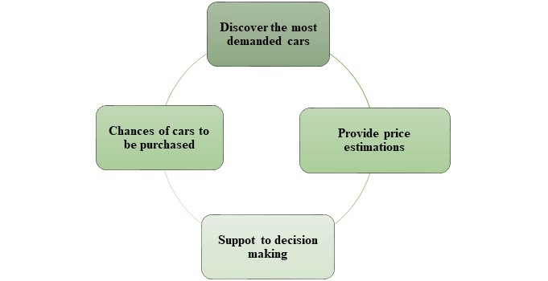

## Literature Review

Similar studies done in foreign countries show that the this research will have different results in Armenia because of the following reasons.

First and foremost, a research of automobile market of our neighbor countries has been made and an interesting article about a study conducted in Turkey[2] has been discovered. They used quarterly data on price, quantity, quality, country of origin and product characteristics of new automobiles. Modeling Feasible Generalized Least Squares (FGLS) on the data, they analyzed market demand for 1996-1999, tested the significance of each attribute and factor of vehicles contributed to estimating market demand and improved various tax and trade policies. The results state that variable “country of origin” was one of the most significant factors for automobile demand in Turkey. One of the controversial findings is that price of car is not significant for domestically produced vehicles, meaning that Turkish people pay less attention to the price if it is manufactured in their motherland. In Armenia, unfortunately, there is no domestic vehicle manufacturing company, therefore, the variable “country of origin” may have different influence here.

Moreover, another research conducted in USA states that “country of origin” variable provides value change, besides it also provides monetary change when an automobile is produced in foreign country. For example, an automobile manufactured in USA that cost $17,000 may have a decrease in price by $1,952 when it is produced in Mexico. There are other studies conducted in this field in USA but they have several drawbacks, for example, respondents were asked “how much more or less do you think he (the buyer) would be willing to pay for this car (built in . . .)”. Such a question is distinctly prone to demand artifacts (Sawyer 197.5), because the nature of the responses may have been affected by the questions asked by making respondents think about the location. The design of this research will solve the noted drawback. There were several requirements in this study that respondents should meet before participating such as:

a. owns or have access to an automobile;

b. has been personally involved in buying the automobile;

It seems, that the idea of the way selecting respondents was very smart, as they chose people who were aware of car prices and could evaluate importance of each factor unbiasedly which is essential for conjoint analysis. Moreover, if in previous studies people were supposed to answer just one question (would they buy car if it is made in.?), now they were able to rate the possibility of buying by 11-scale method. However, there can be multicollinearity between variables “Brand Name” and “Quality-Reliability” because quality of some car models can be perceived by brand name. So, researchers should explain variables more profoundly. Additionally, their study was done only for 4 brand names and I think they could have different results if they had opportunity to have more various brand names rather than only Ford, Mazda, Mitsubishi and Toyota.[3]

In a study conducted in Spain authors were interested in the relationships between demand, model turnover and age affects and the purpose of the study was to prove the existence of relationship between those variables. They aimed to explore the effects of the age of a model on automobile demand and have used techniques of the discrete-choice approach to market demand estimation. This study gives information about models life cycle. They found out that price does not have very significant influence on demand of new cars in the first 4 years. Equilibrium own-price elasticities are observed to decrease until the fourth year of a model life, and then to increase again. In other words, people aim to buy “new” cars and if it is used already for 4 years they start paying more attention to the other factors, including the price. This can be used by the firms while making decisions on prices, make them change the attributes before introducing turnover models. Regarding the demand of new cars, it is suggested to take into account the assumption that models invariably introduced to the market with relatively high sales, probably due to the advertising campaigns that precede their entry. In contrast to it, because of some economical and custom reasons, it is rare to see people buying brand new cars in our country.[4]

Armenia is a developing country and it is ranked only 130th by GDP according to the World Bank, most people can only afford to buy used cars. Consequently, observations of my project are mainly based on used cars. From my point of view, one of the most interesting parts of this work is that they have already classified cars before experiment by dividing them into categories from standard to luxury. This action decreased SSE (sum of squared errors) as the importance of various parameters are different among these groups.[5]

# Data collection and cleaning

Firstly, software tools like Python and R have been used to scrap the necessary data represented by various parameters. Secondly, the acquired data (solve problem of outliers, fill the missing values etc.) have been cleaned and a multilinear regression model on the data has been built in order to discover the effect of characteristics on car prices and to predict price of other cars based on their parameters. Finally, by making logistic regression and decision tree models on the data, we can predict the probability of a given car to be purchased.

## Data scrapping

First, data where each row is an observation of a certain car was needed. Data can be collected in several ways. Having into consideration the fact that getting active data is time consuming (ex. conducting a survey), passive data is prioritized. Unfortunately, there is no collected data about sold automobiles in Armenia, hence this problem was solved by using scraping tools. Web data may be collected by [writing a web scraper](http://docs.python-guide.org/en/latest/scenarios/scrape/). A web scraper is a computer program that takes the URL of a website as an input and pulls the data out in a structured format – usually in JSON or CSV format. The website Auto.am is the most well-known Armenian online market where people can buy and sell used cars. While putting an announcement, one can include parameters and other characteristics of the cars. Hence, scraper was used for acquisition of the data from the noted website, which was the “raw material” for statistical and machine learning models described below. In Figure 1, you can see an example of a published announcement of a car in the web-site and while the collected data in panda dataframe format is presented in Figure 2.

*Figure 1*

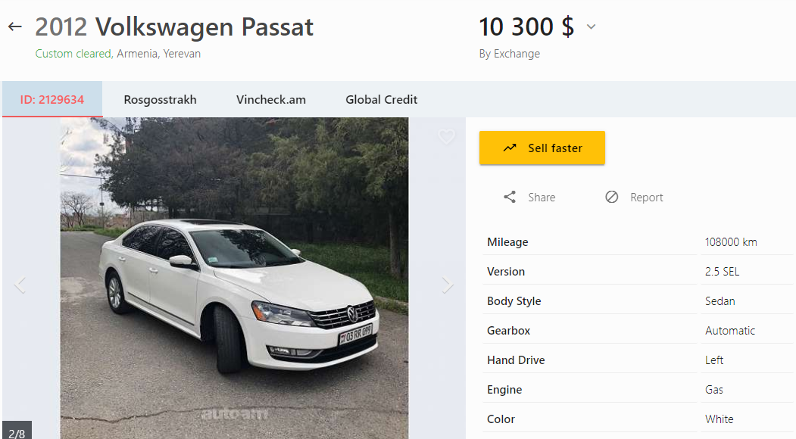

*Figure 2*

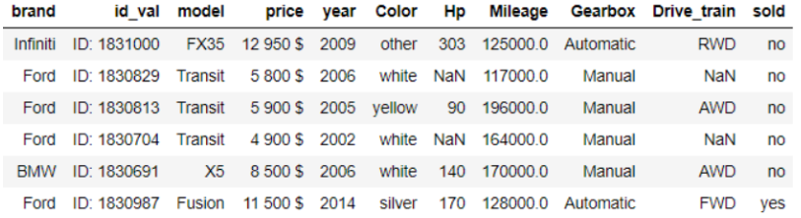

As auto.am does not provide information on sold cars, therefore a special method was implemented. The method included the usage of Id variables as they are unique and are given automatically for each announcement when users put them on the web site. I scraped the announcements with the needed attributes every two weeks and if one certain Id was absent in the list of the following week; it was assumed that the car under that absent Id was purchased. The research was based on an assumption that the sellers have not regretted selling their cars after publishing the announcement on the web site.

## Data cleaning

After collecting and merging each month’s data, it was clear that there are some cars that have extremely high prices compared to similar models. Probably many users had typing errors while writing the price or overestimated their automobiles. So, those observations became outliers. Several techniques could be used to handle these issues such as replacing the price with an average price of that car but method called Winsorizing was applied. This method is used to set outliers to a specified percentile of the given data; for example, a 90% winsorization will set all data below the 5th percentile exactly to 5th percentile, and data above the 95th percentile correspondingly will be changed to 95th percentile. As prices are different for each model, we wrote a code to “winsorize” outliers based on their model’s price range.

Another problem was missing values because some users ignored or forgot to fill non-mandatory parameters of their cars while publishing it. To cope with them machine learning model KNN (K nearest neighbor) was used. This model assigns the label for not available values, and this label is the most frequent one among the k training samples that are the nearest to that query point.

The finalized form of the data contained 62664 records and 18 variables.

# Visualization

The chart in Figure 3 shows the relationship between the price of a car and the horsepower, colored by gearbox.

*Figure 3*

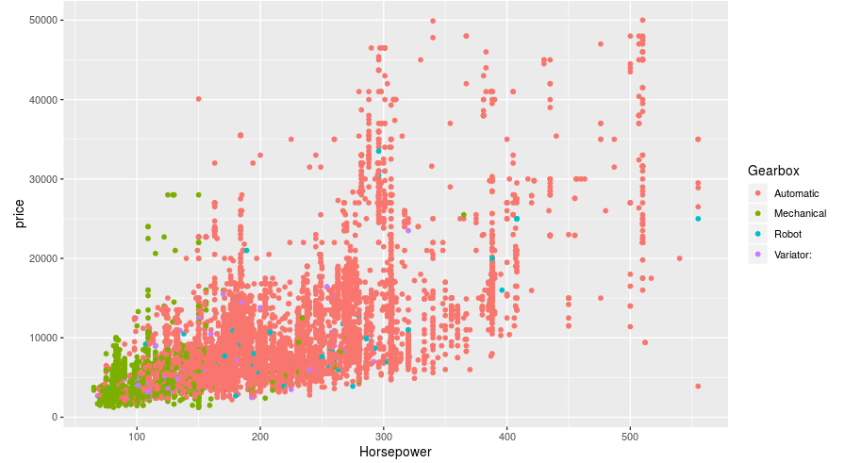

*Figure 4*

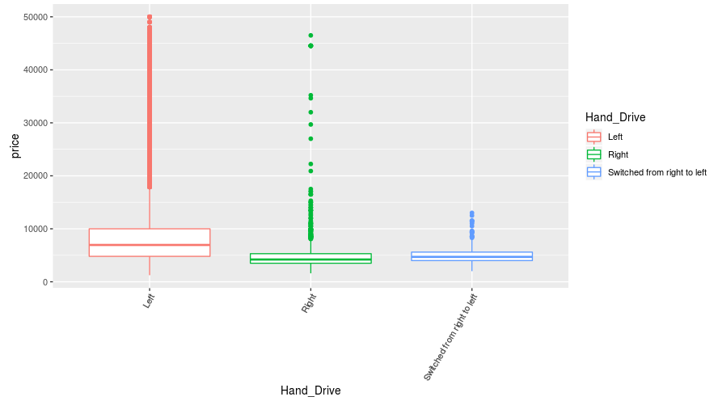

As the horsepower increases, the price increases as well. Moreover, cars with mechanical gearbox are mostly cheaper and have less horsepower. The majority of the cars have automatic gearbox.

The box plot in Figure 4 shows how the hand drive side of the car affects the price. Left hand drive cars are considerably more expensive than right hand drive cars, and way pricier than the ones that were switched.

The histogram in Figure 5 is imbalanced, right-skewed. The price is not normally distributed.

*Figure 5*

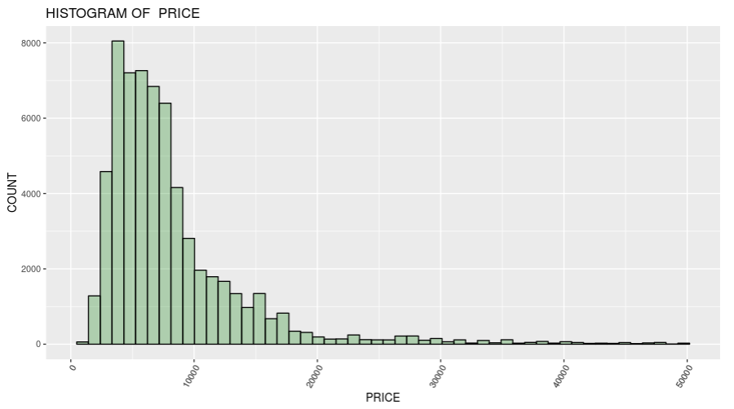

This bar chart in Figure 6 shows the distribution of sold and unsold cars by brand. Mercedes-Benz, Toyota and Nissan are the top 3 most sold car brands. Subaru, Jeep, Chevrolet and Audi are the worst performers in terms of sales. At the same time, Mercedes-Benz also has the largest amount of unsold cars, which can be caused by large import volumes and high demand of this brand. Most of the top 10 best selling car brands belong to Asian manufacturers (such as Japan, Korea).

*Figure 6*

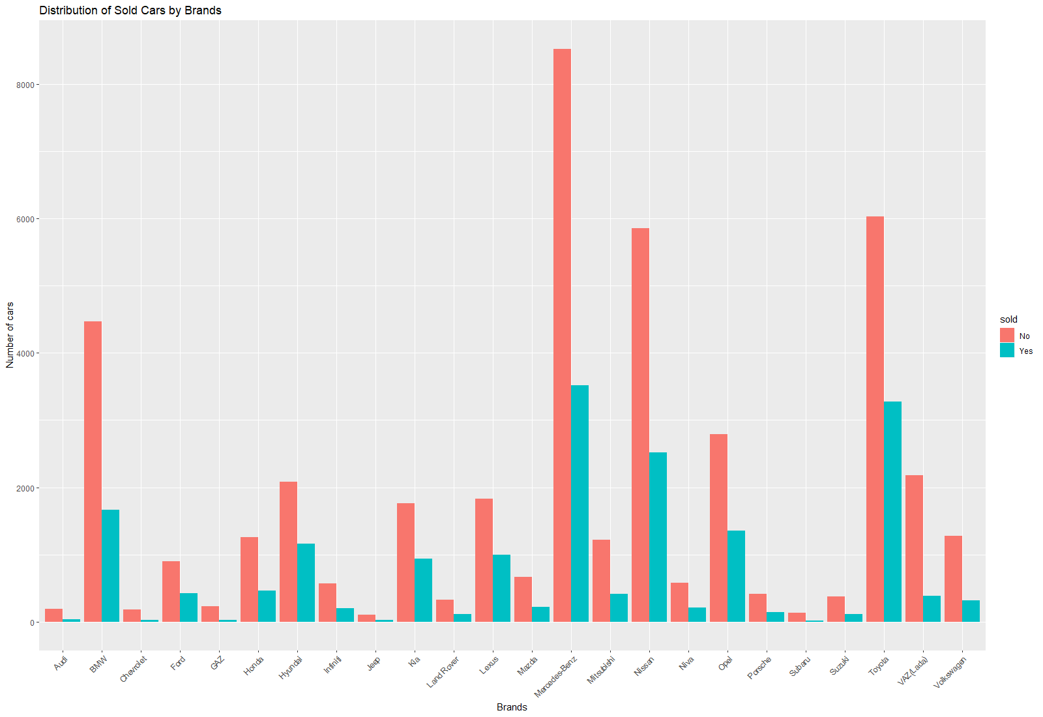

The other figures of the project are available in Shiny application.

# Multilinear regression and other statistic methods

Parameters that users include in their announcements such as the year of production, run, horsepower, color and so on became the explanatory variables used for making multilinear regression model and for estimation of the “response” variable, which will be the price of the car.



Multiple linear regression attempts to model the relationship between two or more explanatory variables and a response variable by fitting a linear equation to observed data. Every value of the independent variable x is associated with a value of the dependent variable.

Here is the formula of the model.

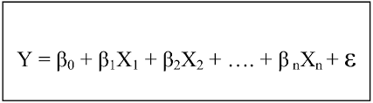

where,

a. Y = dependent/outcome variable, target (price)

b. X = independent variable, covariate, features for example color of a car, year of production.

c. ε = random error term

In order to have an estimate how good the model is we need to find out whether the following assumptions are met:

1. Linearity

2. Independence

3. Normality (the errors are normally distributed)

4. Equal variance (known also as homoscedasticity (or notheteroskedasticity) is the phenomena of having constant variance over different values of the independent variable).

The plot in Figure 7 shows the two most correlated numeric variables with the "Price": variables of “Horsepower” and “Engine Volume”. The plot was used to get all correlations to make an assumption about multicollinearity for further modeling. If threshold for correlation = 0.8, variables that are correlated with each other are "Horsepower", "Engine Volume" and "Engine Cylinders".

*Figure 7*

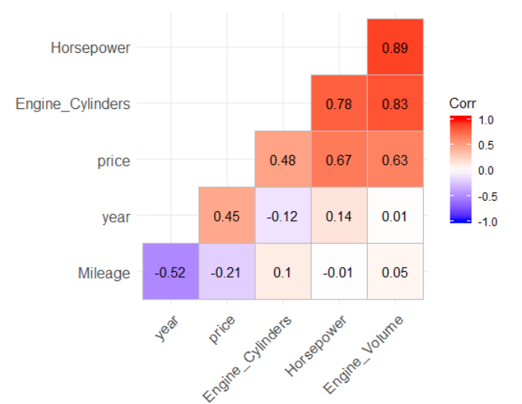

It is worth noting that the necessary variables shall not be used in the regression model, in order to handle multicollinearity problem, as presented in Figure 8. Nevertheless, “Horsepower” should be included because it has stronger correlation with “Price” than the others.

*Figure 8*

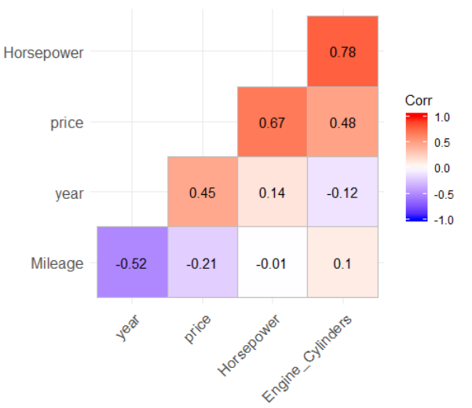

After excluding “Engine Volume” variable we do not have pairs that have stronger correlation than our threshold (0.8).

Before building a model it is interesting to find out whether the price of sold cars is significantly different from unsold ones. As for T test a sample should be distributed normally, but in our case it is not, wilcox test was conducted as it is a non-parametric statistical hypothesis test and compares medians of two samples.

Before conducting the test, we should set Null and Alternative hypothesis.

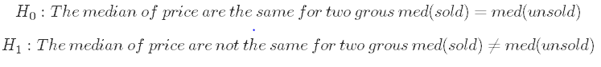

The test will provide a p-value which will be compared with an alpha: if p-value is greater than alpha then the Null hypothesis is failed to be rejected. Otherwise, Null hypothesis is rejected and alternative hypothesis is claimed to be true.

The significance level is the probability of rejecting the Null hypothesis when it is true. If the significance level is considered to be 0.1, this implies that we want to be 90% sure that we will not reject Null hypothesis when it is true. To be more confident, alpha can be set to 0.01. Confidence level is set 95% so the alpha is 0.05 in our case.



As p-value<α, H0 is rejected and price of sold cars is claimed to be less than the price of the unsold ones.

In a multilinear regression model we should have normally distributed variables so It was necessary to use logarithm transformation of Price and Mileage in our model.

Another assumption is the independence of variables (predictors) and in order to make the model meet that assumption the brand and the model had to be combined in one column.

After several attempts, the final model with the highest R square was defined as follows:

where,

is intercept

the other s are coefficients of corresponding variables (all the coefficients are provided in coefficients.csv file).

The result of the regression I is the following:

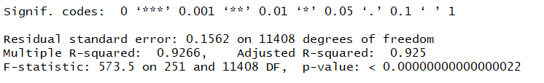

where,

R squared is 0.9269, which means that the predictors explain 92% variation of the price,

F-statistic: 564.5 on 256 and 11403 degrees of freedom, p-value: “F value’’ and ”Prob(F)’’ statistics test the overall significance of the regression model. The F value is the ratio of the mean regression sum of squares divided by the mean error sum of squares. Its value ranges from zero to an arbitrarily large number. The p-value provided with F-statistics is the probability that the Null hypothesis for the full model is true (all coefficients are equal to 0). As in our case it is less than alpha it is considered that at least one slope of variables is significantly different from 0. So, overall, the model is significant.

The output of the regression model can be used while determining the price of the car. For example, on average one-unit increase in year brings 0.06 increase in logarithm of price when all other variables are held constant. So, for prediction the response shall be transformed back by taking exponent of it.

An interesting discovery was the fact that the color of the car was not statistically significant in the model and had no impact on price, whereas the color of interior of the car influenced the price.

# Classification

Classification problems are similar to regression models with one important difference: The dependent/predicted variable is a categorical variable. In Figure 2 you can see that we created a column sold and when the value of the column is yes it means that an observation is sold. So, the dependent variable is “sold” in this case and the goal is to predict it based on the parameters.

After joining the data, we classified cars as sold whenever their Id variable was absent in the following the month. In the Figure 9 you can see the amount of the sold cars.

*Figure 9*

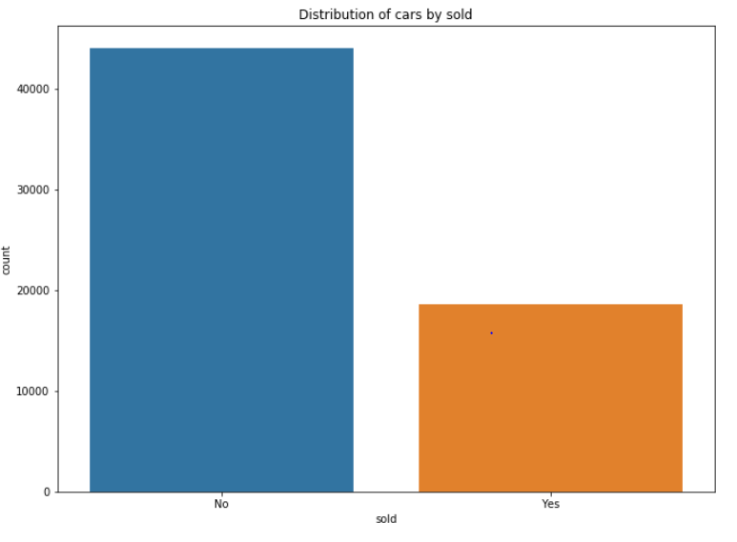

Sold cars are 29% of the sample, consequently, the probability of randomly picking a sold car is equal to 0.29. This number becomes the benchmark for the accuracy of predicting purchased cars.

For classification model the data was subsetted in a way that there are only columns without any missing values. Two classification models were considered for classification: Logistic Regression and Decision tree.

## Logistic Regression

Logistic regression is a predictive modelling algorithm that is used when the Y variable is binary categorical. That is, it can take only one of two values like 1 or 0. In this project 1 is when a car is sold while 0 is the opposite.

Using Machine learning techniques and steps the data was divided into training and testing parts. The algorithm was fitted on the training data and tested on “test” data.

Here is the result of the classification report.

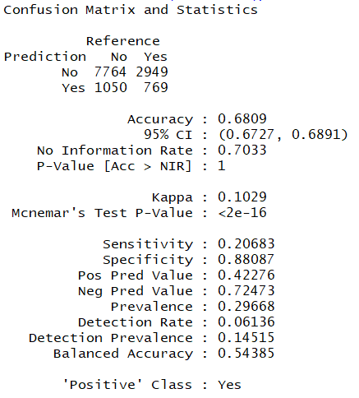

There are many metric scores that can be interpreted but as the main objective of the project was predicting the sold cars, “sensitivity” score should be considered as one of the important ones. Sensitivity is calculated as the number of correct “sold” predictions (True Positive) divided by the total number of “sold”.

As the sensitivity score is 0.2 the model does not pass the minimum requirements set by the benchmark (0.29). Besides overall accuracy is 0.68 which is lower than the proportion of unsold cars which indicates badness of the model.

Another indicator that represents the goodness of the model is ROC curve and AUC (area under the curve). AUC is always in the range between 0.5 and 1, where 0.5 is the value for a random guess. The closer AUC is to 1, the higher is the quality of the model.

For logistic regression the obtained value for AUC was 0.5901, which served as a reason to explore another classification model (Figure 10).

*Figure 10*

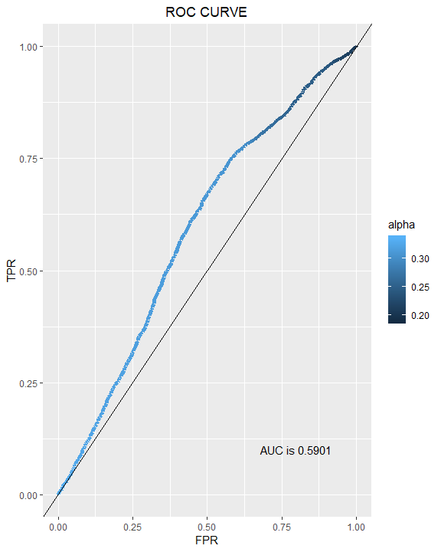

## Decision tree

The decision tree algorithm divides the predictor value space into a number of simple regions on the plane.

To classify a given observation, the algorithm takes into account the values of the independent variables of the new observation and compares them against the most frequent corresponding values in all regions and, based on that, it selects the most suitable region. Decision trees typically have overfitting problems, so we have to consider a range of hyper-parameters to handle such situations.

A machine-learning technique (grid-search) was used to determine the most optimal hyper-parameters, in order to get the accuracy scores for training and testing sets close to each other. The decision tree grew until the minimum number of observations in a region became about 100.

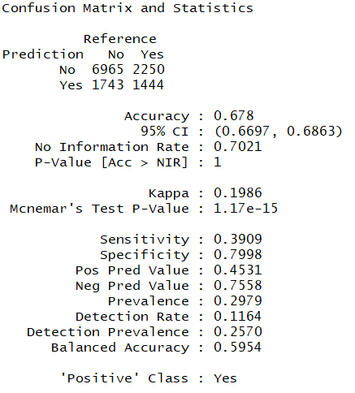

As we can see on the picture above, the model quality has improved from around 0.20 to over 0.39 (see Sensitivity value). In the current improved model, a higher level of specificity and sensitivity was observed, and at the same time the overall accuracy was lower by 2% compared to the random guess model (when the probability of observing an unsold car is 70%).

*Figure 11*

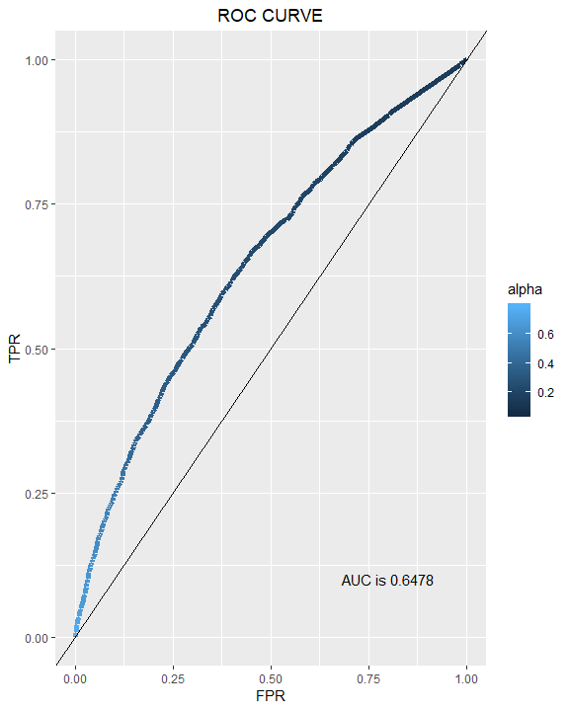

Area Under Curve for the new model was about 0.65 as presented in Figure 11, and higher by 0.6 compared to the AUC of the logistic regression model (test data results).

All of the above was the reasoning behind the selection of the Decision Tree as the main model for this research (predicting whether a car is sold or not).

# Results

As a result, we have a multinomial regression model which explains 92% variation in price depending on different features of a car. This tool can be used, for instance, in customs processing, although it may provide helpful information also for the public. By manipulating the scraped data sold and unsold cars (brands and models) were identified, and this data was further fed to a classification model. The classification model predicts the probability of a given car to be purchased, given specific parameters of the car. This information can also be used by various car importing organizations and other private parties. Figure 12 represents one of the results achieved with this project. The table represents the average price and the number of most sold car by model and year.

The results were also visualized using different plots to give the reader a better and complete understanding of the findings.

All of the works were summarized in a Shiny application based on the models, which allows the reader to input parameters and observe predictions in real time (click [here](https://tadevosianvazgen.shinyapps.io/Vazgen_Tadevosian_Project/) to access).

*Figure 12*

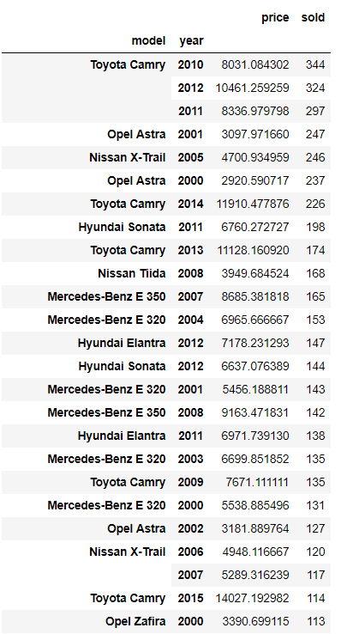

# Conclusion and suggestions

This research make use of scraped car data, and each separate car is associated with a unique Id. Judgement on whether a car was sold or not was made depending on whether the Id was available after some period of time. However, this does not guarantee that the car was sold (some sellers may potentially have removed their listings after simply deciding not to sell their car).

An important suggestion in this context is to have a clear indication of whether a car was sold either on the listings directory or elsewhere. Having this data available before starting the research would dramatically increase the accuracy of models and predictions. Additionally, this could be helpful not only to researchers, but also to governmental and other private organizations that are interested in tracking car sales.

Another important aspect in car sales research is that typically many buyers negotiate the price of the car and in most cases the real sale price is different from the listing price. Currently the car listing platform, that was researched, does not provide information on price changes and final sale price. Real sale price information would substantially increase the accuracy of the models.

Moreover, the listings of cars being sold contain a timestamp. Initially, these timestamps indicate the creation date of the listing, which is the same as the date when a seller started the sale. However, the listing platform (auto.am) provides a feature to renew the listing, and when the seller manually renews the car listing, the timestamp is changed to the time of renewal. This means that for most of the car listings, creation date is altered and does not represent actual time when a car went on sale. If the creation timestamp remained unchanged, that would allow to do survival analysis on car listings, which would be extremely helpful in determining average time to sale and other time-related details of the car market.

In general, there are more error-prone data pieces in car market research, which are out of control of the researcher, such as the fact that many sellers publish incorrect information (mileage, car condition) to mislead buyers and secure in-person car inspections.

Data mining is a very rewarding and valuable process not only for the researcher, but also for the market and its various players. Approaches and methods outlined in this research can be applied not only for car sales in Armenia, but also to different industries, product and service markets around the world.

# Reference

1. A. Mumcu and C. E. Alper, “Interaction between price, quality and country of origin when estimating automobile demand: The case of Turkey”, Applied Economics, Taylor & Francis Journals, 2007, vol. 39(14), pp. 1789-1796
2. M. J. Moral and J. Jaumandreu, “Automobile demand, model cycle and age effects”, Spanish Economic Review, September 2007, Volume 9, Issue 3, pp 193–218
3. F. B. Seaton and H. A. Laskey, “Effects of Production Location on Perceived Automobile Values”, Journal of Global Marketing, Volume 13, 1999 - Issue 1, pp. 71-85

1. <https://data.worldbank.org/indicator/NY.GDP.MKTP.CD?year_high_desc=true>
2. [www.armstat.am](http://www.armstat.am)

1. <http://paap.am/datas/zlawdocs/78eaf07bafa90a97efeb5aa523aba263.pdf>
2. A. Mumcu and C. E. Alper, “Interaction between price, quality and country of origin when estimating automobile demand: The case of Turkey”, Applied Economics, Taylor & Francis Journals, 2007, vol. 39(14), pp. 1789-1796
3. M. J. Moral and J. Jaumandreu, “Automobile demand, model cycle and age effects”, Spanish Economic Review, September 2007, Volume 9, Issue 3, pp 193–218
4. F. B. Seaton and H. A. Laskey, “Effects of Production Location on Perceived Automobile Values”, Journal of Global Marketing, Volume 13, 1999 - Issue 1, pp. 71-85
5. <https://data.worldbank.org/indicator/NY.GDP.MKTP.CD?year_high_desc=true>