МИНИСТЕРСТВО НАУКИ И ОБРАЗОВАНИЯ РОССИЙСКОЙ ФЕДЕРАЦИИ
МИРЭА – РОССИЙСКИЙ ТЕХНОЛОГИЧЕСКИЙ УНИВЕРСИТЕТ

Ялаева Н.В., Быстров Н.А., Кудинова Т.В.,
Чернова Н.И., Катахова Н.В.

ENGLISH FOR ENGINEERS
PART 1

УЧЕБНО-МЕТОДИЧЕСКОЕ ПОСОБИЕ

Москва – 2023
УДК 811.111(075.8)
ББК 81.432.1я73
English for Engineers, Part I [Электронный ресурс]: Учебно-методическое пособие / Н.В. Ялаева, Н.А.Быстров, Т.В.Кудинова, Н.И. Чернова, Н.В. Катахова. – М.: МИРЭА – Российский технологический университет, 2023. – 1 электрон. опт. диск (CD-ROM).
Учебно-методическое пособие содержит текстовой материал и лексико-грамматические упражнения, направленные на формирование и развитие коммуникативных навыков в на английском языке.
Пособие предназначено для организации аудиторной, внеаудиторной и самостоятельной работы студентов 1 курса по иностранному языку, обучающихся по направлениям 09.03.02 Информационные системы и технологии и 11.03.02 Инфокоммуникационные технологии и системы связи.
Учебно-методическое пособие издается в авторской редакции.
Рекомендовано к изданию на заседании кафедры иностранных языков, протокол № 3 от 16.10.2023 г.

Авторский коллектив:
Ялаева Наталья Вячеславовна, доцент каф. иностранных языков РТУ МИРЭА
Быстров Никита Александрович, ассистент каф. иностранных языков РТУ МИРЭА
Кудинова Татьяна Викторовна, старший преподаватель каф. иностранных языков РТУ МИРЭА
Чернова Надежда Ивановна, профессор каф. иностранных языков РТУ МИРЭА
Катахова Наталия Владимировна, доцент каф. иностранных языков РТУ МИРЭА
Рецензенты:
Васильев Андрей Георгиевич, д.ф-м.н., профессор, директор Института радиоэлектроники и информатики, «МИРЭА – Российский технологический университет» РТУ МИРЭА
Боровкова Марина Владимировна, к.ф.н., доцент кафедры русского, иностранных языков и культуры речи, Уральский государственный юридический университет им. В.Ф. Яковлева (Екатеринбург, Россия)

Системные требования:
Наличие операционной системы Windows, поддерживаемой производителем.
Наличие свободного места в оперативной памяти не менее 128 Мб.
Наличие свободного места в памяти постоянного хранения (на жестком диске) не менее 30 Мб.
Наличие интерфейса ввода информации.
Дополнительные программные средства: программа для чтения pdf-файлов (Adobe Reader).
Подписано к использованию по решению Редакционно-издательского совета
МИРЭА – Российского технологического университета от __ __________ 2023 г.
Объём: ___ Мб
Тираж 10
© МИРЭА – Российский технологический университет, 2023
CONTENTS
ВВЕДЕНИЕ 7
I AM AN ENGINEERING STUDENT 9
UNIT 1. About myself and my family 9
Theme 1.1. Family and Friends 9
LEAD IN 9
KEY WORDS AND WORD COMBINATIONS 9
PRONUNCIATION PRACTICE 10
VOCABULARY 11
GRAMMAR I 12
GRAMMAR II 14
READING 16
WATCHING AND LISTENING 19
SPEAKING 20
WRITING 21
Theme 1.2. Hobbies and Interests 23
LEAD IN 23
KEY WORDS AND WORD COMBINATIONS 23
PRONUNCIATION PRACTICE 24
VOCABULARY 24
GRAMMAR I 26
READING 27
GRAMMAR II 29
WATCHING AND LISTENING 30
GRAMMAR III 31
SPEAKING 33
WRITING 34
Theme 1.3. Life Stories 36
LEAD-IN 36
KEY WORDS AND WORD COMBINATIONS 36
PRONUNCIATION PRACTICE 37
VOCABULARY I 38
GRAMMAR REVISION Simple and Progressive Tenses 40
WATCHING AND LISTENING I 41
WATCHING AND LISTENING II 42
VOCABULARY II 43
READING 45
SPEAKING 48
WRITING 49
UNIT 2. Higher Education in Russia and Abroad 50
Theme 2.1. Higher Education in Great Britain 50
LEAD IN 50
KEY WORDS AND WORD COMBINATIONS 50
PRONUNCIATION PRACTICE 51
VOCABULARY I 54
GRAMMAR I 55
READING I 58
WATCHING AND LISTENING I 61
VOCABULARY II 62
READING II 64
WATCHING AND LISTENING II 65
SPEAKING 67
WRITING 68
Theme 2.2. Higher Education in the USA 70
LEAD IN 70
KEY WORDS AND WORD COMBINATIONS 70
PRONUNCIATION PRACTICE 71
VOCABULARY I 72
GRAMMAR 73
READING I 75
WATCHING AND LISTENING I 79
GRAMMAR REVISION 80
VOCABULARY II 81
READING II 82
LISTENING II 83
SPEAKING 84
WRITING 85
Theme 2.3. Higher Education in Russia 89
LEAD IN 89
KEY WORDS AND WORD COMBINATIONS 89
PRONUNCIATION PRACTICE 90
VOCABULARY 90
GRAMMAR 93
READING 95
WATCHING AND LISTENING 97
SPEAKING 99
WRITING 99
COUNTRY STUDIES 102
UNIT 3. Different Countries. Different Worlds. 102
Theme 3.1. The United Kingdom: General Outline and the Government 102
3.1.1. History, Geography, Environment, Climate, and Economy of the UK 102
LEAD IN 102
KEY WORDS AND WORD COMBINATIONS 103
VOCABULARY 104
READING 106
GRAMMAR 110
WATCHING AND LISTENING 112
SPEAKING 113
WRITING 113
3.1.2. The British Constitution. Parliament and Government 115
LEAD IN 115
KEY WORDS AND WORD COMBINATIONS 115
VOCABULARY 117
READING 119
WATCHING AND LISTENING 122
GRAMMAR 123
SPEAKING 125
Theme 3.2.The United States of America: Geography, Economy, Politics 126
3.2.1. History, Geography, Climate, Economy of the US 126
LEAD IN 126
KEY WORDS AND WORD COMBINATIONS 127
VOCABULARY 128
READING 130
GRAMMAR I 133
GRAMMAR II 134
WATCHING AND LISTENING 136
SPEAKING 137
WRITING 137
3.2.2. The US Political System 139
LEAD IN 139
KEY WORDS AND WORD COMBINATIONS 139
VOCABULARY 140
READING 143
GRAMMAR 147
WATCHING AND LISTENING 150
SPEAKING 151
WRITING 151
Theme 3.3. Russia: Country and State 153
LEAD IN 153
KEY WORDS AND WORD COMBINATIONS 153
VOCABULARY I 155
GRAMMAR 157
READING I 158
VOCABULARY II 161
READING II 162
WATCHING AND LISTENING 164
SPEAKING 166
WRITING 166
UNIT 4 Learning Foreign Languages 168
Theme 4.1. The Importance of Learning Languages 168
LEAD IN 168
KEY WORDS AND WORD COMBINATIONS 168
PRONUNCIATION PRACTICE 169
VOCABULARY 169
GRAMMAR 170
READING 173
WATCHING AND LISTENING 174
GRAMMAR REVISION 176
SPEAKING 177
WRITING 178
SUPPLEMENTARY EXERCISES 180
GRAMMAR REFERENCE 196
THE VERB “TO BE” 196
VERB TENSES – ACTIVE VOICE 196
THE VERB “TO HAVE” 197
THE VERB + -ING FORM 198
PROGRESSIVE (CONTINUOUS) ACTIVE 198
PASSIVE. SIMPLE AND CONTINUOUS 200
THE PERFECT TENSES 201
PERFECT PASSIVE 203
THERE + TO BE 204
COUNTABLE AND UNCOUNTABLE NOUNS 205
ARTICLES 207
ADJECTIVES. COMPARISON 211
MODALS 212
SOME/ANY/NO/EVERY 216
REPORTED SPEECH 219
WEBSITE RESOURCES 224
BIBLIOGRAPHY 226

ВВЕДЕНИЕ
Настоящее учебно-методическое пособие предназначено для студентов первого курса технических направлений подготовки, обучающихся по программам бакалавриата и специалитета, и предполагает владение студентами английским языком на уровне В1 для успешного продвижения к уровню В2.
Пособие отвечает требованиям ФГОС ВО (3++) к результатам освоения дисциплины “Иностранный язык.” Согласно ФГОС ВО (3++), компетенция, формируемая при овладении иностранным языком, относится к группе универсальных компетенций и формулируется одинаково для всех неязыковых направлений подготовки: в результате освоения курса студенты должны быть способны осуществлять деловую коммуникацию в устной и письменной формах на иностранном языке.
Цель пособия — заложить основы устной и письменной деловой коммуникации на английском языке в пределах общенаучной тематики, формирование у студентов позитивного отношения к различиям и многообразию культур через последовательное и взаимосвязанное развитие навыков и умений в таких видах речевой деятельности, как чтение, говорение, письмо и аудирование.
В результате освоения курса студенты должны:
Знать:
- способы словообразования в английском языке;
- способы перевода общей и специальной лексики с английского языка на русский язык;
- лексический минимум в рамках изученных тем, включающих сферы и ситуации общения повседневно-бытового, социально-культурного характера;
- грамматический минимум, необходимый для развития навыков говорения и аудирования, а также чтения и перевода текстов на русский язык;
- структурные особенности устных и письменных сообщений разного вида;
- основные коммуникативные стратегии диалогического общения (согласие, несогласие, аргументирование, доказательство).
Уметь:
- выстраивать устное речевое взаимодействие на английском языке в зависимости от коммуникативной стратегии;
- делать сообщение, доклад, презентацию на английском языке по заданной проблематике;
- создавать письменные сообщения разного вида (email, личное, деловое письмо, эссе и т.д.);
- извлекать определенную информацию из текста (полную, частичную);
- находить информацию на английском языке по заданной проблематике с помощью сети Интернет.
Владеть:
- приемами самостоятельной работы по развитию иноязычных языковых навыков и речевых умений;
- навыками использования справочной, учебной, научно-публицистической литературы для решения учебных и познавательных задач;
- навыками взаимодействия при работе в команде (паре);
- мотивацией к познанию нового с целью личностного и профессионального роста.
Данное пособие рекомендовано для студентов, обучающихся по специальностям «Информационные системы и технологии», «Инфокоммуникационные технологии и системы связи» и т.д.

I AM AN ENGINEERING STUDENT

UNIT 1.
About myself and my family

Theme 1.1. Family and Friends

LEAD IN

Work in pairs and explain how you understand this quotation:

Family is not an important thing. It's everything.
- Michael J. Fox

KEY WORDS AND WORD COMBINATIONS
enterprise (n) | ['entəpraɪz] | предприятие
first-year student (n) | [fɜ:st ˈjɪə ˈstju:dənt] | студент-первокурсник
Institute of Artificial Intelligence (n+adj.+n) | ['ɪnstɪtju:t ɔv ['ɑ:tɪ'fɪʃ(ə)lɪn'telɪʤ(ə)ns] | Институт Искусственного Интеллекта
jogging (n) | ['ʤɔgɪŋ] | бег трусцой
precious (adj) | [‘preʃəs] | драгоценный, любимый
programmer (n) | ['prəugræmə] | программист
robotics engineer (n+n) | [rə(u)'bɔtɪks 'enʤɪ'nɪə] | инженер-робототехник
support (n) | [sə'pɔ:t] | поддержка, помощь, опора
system analyst (n+n) | ['sɪstɪm'ænəlɪst] | системный аналитик
to follow the tradition (v+n) | [tu: 'fɔləu trə'dɪʃ(ə)n] | следовать традициям
to go hiking (v+n) | [tu: gəu 'haɪkɪŋ] | ходить в походы
to introduce (v) | [tu:ˌɪntrəˈdju: s] | знакомить, представлять
to share smth with smb (v+prep.+n) | [tu: ʃeə sʌmθɪŋ wɪð 'sʌmbədɪ] | делиться чем-то с кем-то
to solve problems (v+n) | [tu: sɔlv 'prɔbləms] | разрешать проблемы
to take pictures (v+n) | [tu: teɪk pɪkʧəz] | фотографировать
to work for a company (v+prep.+n) | [tu: wɜ:k fɔ: ə 'kʌmpənɪ] | работать в компании
understanding (n) | [ˌʌndəˈstændɪŋ] | понимание

PRONUNCIATION PRACTICE

Exercise 1
Practice saying the key words and word combinations.

Exercise 2
Reading rules. Read the words paying attention to the reading rules.
Letter “A”

[eɪ] | [æ] | [ɑ:] | [eə]
name | man | large | hair
make | family | task | fair
nature | travel | park | parents

Letter “E”

[i:] | [e] | [ɜ:] | [ɪə]
me | let | her | here
week | rest | term | dear
see | tennis | nerve | year

Letter “I”

[aɪ] | [ɪ] | [ɜ:] | [aɪə]
hiking | sister | girl | tire
enterprise | thing | first | fire
diving | consist | bird | liar

Letter “O”
[əʋ] | [ɒ] | [ɔ:] |  | [ʌ]
no | not | born | sports | love
hope | stop | port | more | company
most | jogging | for | before | become

Letter “U”

[ju:] | [ʌ] | [ɜ:] | [jʋə]
introduce | but | turn | pure
pupil | study | burn | cure
university | summer | hurt

Exercise 3
Read international words and translate them:
school, tradition, student, university, lecture, seminar, problems, speciality, park, sport, football, basketball, character, organized, disciplined.

VOCABULARY

Exercise 4
Continue the list of words and give a general term to each group.
Mother, father, sister, brother – family;
robotics engineer, computer programmer… - .
hiking, jogging,…. - .

Exercise 5
Make all possible word combinations and translate them into Russian.
- to be | - busy
- to work at | - four people
- to study at | - born
- to consist of | - a good time
- to have | - university
 | - enterprise

GRAMMAR I
Study grammar rules on the use of the verb TO BE (see GRAMMAR REFERENCE p.196)

Exercise 6
Write the correct form of the verb ‘to be’.
- My name ___ Tom and I ___ born in London.
- Our family ___ not large.
- His mother __ a writer.
- We___ first year students of the Russian Technological University.
- We ___busy yesterday.
- Mikhail Kalashnikov___ a Soviet and Russian inventor and military engineer.
- He____a computer programmer in 5 years.

Exercise 7
- Complete the dialogue with the correct forms of the verb ‘to be’.
A: Hello. What is your name?
B: Hello. My name _____Ivan.
A: And my name _____ Alina. ____ you a student of the Russian Technological University MIREA?
B: Yes, I _____ a first-year student. And you?
A: I ____ a second-year student of the Institute of Artificial Intelligence. Where ____you from?
B: I ____ from Moscow, but I ____ born in Perm.
A: ____ your parents engineers?
B: Yes, they ____. My mother ___ a systems analyst and my father __ a robotics engineer.
- Practice the dialogue with the partner.

Exercise 8
Rewrite the sentences below as questions.

Sentence | Yes/No-Question | Wh-Question  (What? When? Who? Why? Where?)
1. His name is Alex. | Is his name Alex? | What is his name?
2. We are first year students.
3. Olga is a second-year student.
4. My father is a systems analyst.
5. Her mother was born in Yekaterinburg.
6. We will be computer programmers.
7. My grandparents were engineers.

Exercise 9
Translate the following sentences.
- Our family is quite large by modern standards.
- My mother is a systems analyst.
- My family is the most precious thing for me, because this is where I find love, understanding and support.
- My sister Ann is five years younger than me.
- My dream is to become a computer programmer.
- My grandparents were engineers.
- He will be a robotics engineer.

GRAMMAR II
Study grammar rules on the use of VERB TENSES – ACTIVE VOICE (see GRAMMAR REFERENCE p.196)

Exercise 10
Give the infinitive form of the verb:
studied, gave, did, went, found, chose, consisted, worked, decided, helped, took, read

Exercise 11
Say that you did it before. Use the following word combinations:

yesterday morning (evening, afternoon); when I was…..; …days (years) ago; last night (week, year, month, Sunday)

- I watch movies.
- I study English at school.
- I do my homework.
- I go to the swimming pool.
- I play football.
- I have a lot of free time.
- I take guitar lessons.
- I give much time to exams preparation.

Exercise 12
Read pairs of sentences. Choose the correct one.
1. a. Where do you study?
b. Where you study?

2. a. She work at a big enterprise.
b. She works at a big enterprise.

3. a. Peter and Jane go hiking in summer.
b. Peter and Jane goes hiking in summer.

4. a. I don’t study at Moscow State University.
b. I no study at Moscow State University.

5. a. Alex liked when he was young jogging.
b. Alex liked jogging when he was young.

6. a. Did Ivan followed your family tradition?
b. Did Ivan follow your family tradition?

7. a. Do you play football every day?
b. You play football every day?

8. a. Will become you a computer programmer?
b. Will you become a computer programmer?

Exercise 13
Make the sentences opposite.

Model: I study at school. — I don’t study at school.
He did not know what to give his sister for her birthday. — He knew what to give his sister for her birthday.

- My family consists of five people.
- My mother does not work at a big enterprise.
- Egor did not decide to follow his family tradition.
- Mary chose the profession of a systems analyst.
- We will not study at Moscow State University.
- My friend will work as a robotics engineer.

Exercise 14
Open the brackets using the verb in the correct tense form.

- Kate (to study) at the University next year.
- My family (to consist) of four people.
- I (to be born) in 2005.
- Last year I (to go) to the swimming pool.
- Egor often (to play) basketball with his friends.
- She (to become) a computer programmer in a year.
- Last summer we (to travel) a lot.
- My sister (to enjoy) watching movies.

Exercise 15
Rewrite the sentences below as questions.
Sentence | Yes/No-Question | Wh-Questions
1. His mother works as a systems analyst for the leading IT company. | Does his mother work as a systems analyst for the leading IT company? | Who works as a systems analyst for the leading IT company? Where does his mother work?
2. He chose the profession of a robotics engineer.
3. He will become a computer programmer.
4. I play basketball every day.
5. He does his homework at the University.
6. Alex worked for the leading IT company three years ago.
7. We will go hiking next summer.
8. My friend likes swimming.

READING

Exercise 16
Read the text and find the names of the professions and adjectives describing people.

MY FAMILY
Let me introduce myself. My name is Egor Petrov. I was born in Moscow in the family of engineers. My family is the most precious thing for me, because this is where I find love, understanding and support.
Our family is quite large. It consists of four people- my parents, my younger sister Ann and me. My mother works as a systems analyst for the leading IT company. My father is a robotics engineer. He works at a big enterprise. My sister Ann is a pupil.
After school I decided to follow the family tradition and chose a speciality in engineering. I am a first-year student at the Russian Technological University MIREA. I study at the Institute of Artificial Intelligence. My dream is to become a computer programmer.
During the week I am very busy preparing for lectures and seminars, so I like to relax at weekends. One thing I enjoy is our evening dinners with my family when we all gather together. We watch movies, talk, joke, laugh, and have a good time. We share our problems with each other, try to solve them, and my parents often give my sister and me good advice.
In summer we go hiking or travel and visit different places of interest for example, national parks. We love to see beautiful scenery. We also enjoy taking pictures of wildlife and nature around us.
I do sports. Tastes differ, some people like football, diving or jogging. But I adore playing basketball and swimming. My sister is a swimmer too. On Sundays we go to the pool together. Sport helps us to become strong. It helps us to build up our characters, to be more organized and disciplined in our daily activities.
I am very happy to have such a wonderful family!

Exercise 17
Answer the questions.

- What does Egor Petrov think about his family?
- Are there good relations in the Petrovs family? Why?
- What family traditions do the Petrovs have?

Exercise 18
Find in the text sentences with the following words. Determine what part of speech the words are. Translate them into Russian: precious, understanding, love, support, quite, busy, leading, enterprise, talk, joke, share, organized, disciplined.

Exercise 19
Find words in the text that mean:
- an institution of higher education;
- a child or young person at school;
- someone who goes to a university;
- a person who is in his or her first year at university;
- classes at the university;
- a person skilled at analyzing data;
- functioning in an orderly way or according to a plan.

Exercise 20
Fill in the gaps using the prepositions:
in of at for on

- Egor was born …. Moscow.
- Our family consists … four people.
- During the week he is very busy preparing _____ lectures and seminars, so he likes to relax ____ weekends.
- My mother works as a systems analyst _____ the leading IT company.
- His father works ___a big enterprise.
- I chose a speciality ____ engineering.
- ____ Sundays we go to the pool together.
- I followed my family tradition and chose a profession ___ a computer programmer.

Exercise 21
a. Finish sentences about Egor Petrov.
- Egor Petrov is a _______.
- He studies at _________.
- His dream is to become a ______.
- Petrov’s family is ________.
- His parents are ______.
- His sister Ann _____.
- Egor plays _______.
- Egor enjoys____
- In summer his family goes _____.
- He is happy_____.

b. Make up your own sentences about yourself and your family.

WATCHING AND LISTENING

Exercise 22
You are going to watch a video “Talking about your family” at https://www.oxfordonlineenglish.com/talking-about-family (Accessed: 29 August 2023).

a. BEFORE YOU WATCH. Answer the questions:
- Do you have a big family?
- What do you like doing when you spend time with your family?

b. WHILE YOU WATCH.
Listen to Parts 1—5 of the video lesson, guess the meaning of the words immediate family and extended family. Complete the sentences about your family.
- There are _____ people in my family.
- I have a ____sister (brother).
- My immediate family consists of____ .
- _______________my extended family.
- We _______________ together.

- Listen to Part 6 of the lesson and make notes which will help you to speak about your family.

- AFTER YOU WATCH. Speak about your family traditions and the role of the family in your life using the plan of the lesson.

- Work in pairs. Write out the questions of the speaker, think of the answers. Ask each other the questions and answer them.
There are some more questions to discuss:
- What is your favorite family tradition?
- Who is the oldest member of your family?
- What do you usually do when you spend time with your family?
- What is your favorite memory with your family?
- What is one thing that makes your family unique?

SPEAKING

Exercise 23
  - Study the table.

Introductory Phrases | Formulas of Agreement | Formulas of Disagreement
As far as I know…  Насколько я знаю, … | I agree with you.  Я согласен с вами. | You are wrong.  Вы ошибаетесь.
I suppose …  Я полагаю… | Yes, you are right.  Вы правы. | I don’t think so!  Я так не думаю. Думаю, что нет.
As far as I remember … Насколько я помню, … | Quite so.  Совершенно верно. Вот именно. | You are mistaken.  Вы ошибаетесь.
I think …  Я думаю (считаю, полагаю), … | I am of the same opinion.  Я того же мнения. | Nothing of the kind.  Ничего подобного.
The way I see it……  На мой взгляд,… | That’s true / correct.  Вы правы/верно. | Far from it.  Сильно ошибаетесь!  Отнюдь нет.

b. Agree or disagree with the following statements about Egor Petrov (from the text “My family”) using formulas from a.

Model: Egor Petrov was born in the family of teachers. — That is not so. As far as I remember, he was born in the family of engineers.

- Egor decided to continue his parents’ career.
- Egor is very busy during the week.
- He likes playing basketball.
- He often goes to the swimming pool with his sister.
- Music makes people more organized.
- Egor does not share his problems with his parents.

Pair work. Make up 3 your own true / false statements about your groupmate and his/her family and ask him/her to agree or to disagree with them.

Model:
A: As far as I know, you are a first-year student of Kazan Federal University.
B: You are wrong. I study at the Russian Technological University MIREA.

WRITING

Exercise 24
a. Watch the video “How to address an envelope” at https://www.youtube.com/watch?v=8BSTLrX_lf4

  - Study the essential information about signing envelopes:
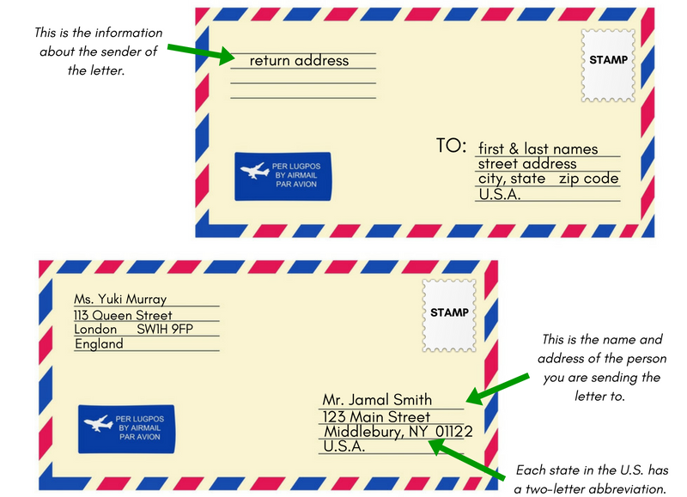

Exercise 25
Match the information under a particular letter on the envelope (A, B, C, D, E, F, G) with what it indicates.
(A) Cambridge School of Languages
119 (B) Mill Road
(C) Cambridge CB1 2 AZ
UK
(D) Newnham Language Centre
(E) 8 Grand Road
Oxford (F) OX 9DU
(G) UK

- The town the letter comes from
- The Zip Code in the mailing address
- The addressee’s house number
- The country in the mailing address
- The street name in the return address
- The addressee
- The sender

Theme 1.2. Hobbies and Interests


LEAD IN
Work in pairs and explain how you understand this quotation:
“Try new hobbies. Develop new interests. Pursue new experience. When you expand your interests, you increase your opportunities for happiness”.
Richelle E.Goodrich.

KEY WORDS AND WORD COMBINATIONS
benefits (n) | ['benɪfɪts] | преимущества
entertainment (n) | [entəˈteɪnmənt] | развлечение
fascinating (adj) | [ˈfæsɪneɪtɪŋ] | увлекательный, чрезвычайно интересный
hobby (n) | ['hɔbɪ] | хобби, любимое занятие
inner world (adj+n) | [ˈɪnə wɜːld] | внутренний мир
occupation (n) | [ɒkjʊˈpeɪʃn] | профессия, род занятий
pastime (n) | [ˈpɑːstaɪm] | приятное времяпрепровождение
rare (adj) | [reə] | редкий
rewarding (adj) | [rɪ’wɔ: dɪŋ] | приносящий внутреннее удовлетворение, дающий результат
sense of purpose (n+prep+n) | [sens ɒv ˈpɜːpəs] | целеустремленность
skills (n) | [skɪls] | навыки, умения
to be in high spirits (v+ adj+n) | [tu: biː ɪn haɪ ˈspɪrɪts] | быть в хорошем/ прподнятом настроении
to bring happiness (v+n) | [tu: brɪŋ ˈhæpɪnɪs] | приносить счастье
to collect (v) | [tu: kəˈlekt] | собирать
to enrich (v) | [tu: ɪn'rɪʧ] | обогащать
to have a passion for (v+n+prep) | [tu: hæv ɑ pæʃn] | увлекаться чем либо
to improve (v) | [tu: ɪmˈpruːv] | улучшать
to look forward to smth (v) | [[tu: lʊk ˈfɔːwəd tu:] | ждать с нетерпением
to master (v) | [tu: 'mɑ: stə] | овладевать, совершенствовать
to prefer (v) | [tu: prɪˈfɜː] | предпочитать
to stay focused on (v+part.+ prep) | [tu: steɪ ˈfəʊkəst ɒn] | сконцентрироваться на чем-то

PRONUNCIATION PRACTICE

Exercise 1
Practice saying the key words and word combinations.

Exercise 2
  - Choose the words with the stress on the first syllable:
hobby, to collect, to enrich, inner, to prefer, spirits,entertainment,improve

  - Say what parts of speech the words with the stress on the second syllable are.

VOCABULARY

Exercise 3
Word builing.
a. Form nouns from the given verbs.
Verb | Noun (suffix -tion)
to motivate | motivation
to occupy
to collect
to satisfy
to translate

b. Complete the sentences with a noun formed from the verbs in (a):
- Hobby is a person's favorite _________, something that he likes doing in free time.
- One can find great___________in a hobby.
- Book lovers usually have large _________of books.
- Some students do not have the__________ to study.
- He hopes his _____ skills will help to understand foreign cultures.

c. Form nouns from the verbs using -ing and translate them into Russian.

Verb | Noun + (-ing)
- to write | writing
- to learn
- to walk
- to collect
- to paint
- to watch

Exercise 4
Match the synonyms.
- pastime | - work
- purpose | - advantages
- occupation | - hobby
- benefits | - happiness
- well being | - goal

Exercise 5
Match the antonyms.
- important | - busy
- free | - outer
- inner | - widespread
- high | - old
- fascinating | - unimportant
- rare | - boring
- new | - low

Exercise 7
a. Make up all possible word combinations.
- to have | - in high spirits
- to be | - happiness
- to improve | - a passion for
- to bring | - time
- to spend | - skills
- to master | - joy
 | - satisfaction

b. Complete the sentences with the word combinations from (a):
- Sport helps me __________.
- A hobby also gives __________.
- Hobbies motivate us to learn more and ______our_____.
- A person who likes computer games has __________them.
- This pastime ____me much ______.
- Hobbies help a person to feel happy and _________with pleasure.

Exercise 8
a.Match the word combinations with their Russian equivalents.
- to enrich the inner world | - сосредоточиться на целях
- to have a passion for learning languages | - коллекционировать редкие (необычные) вещи
- to become a harmoniously developed person | - увлекаться изучением языков
- to stay focused on goals | - приносить счастье
- to collect rare items | - обогатить внутренний мир
- to bring happiness | - стать гармонично развитой личностью
b.Make your own sentences with the word combinations from (a).

GRAMMAR I

Study grammar rules on the use of the verb TO HAVE (see GRAMMAR REFERENCE p.197)

Exercise 10
Open the brackets using the correct form of the verb “to have”. Translate the sentences.
- On weekdays I (don’t / doesn’t) have much free time.
- My father (have / has) two sisters.
- (Do / Does) your friend have any brothers or sisters?
- First year students (have / has) lectures and seminars.
- (Do / Does) you have a hobby?
- Does your sister (have / has) free time on Saturdays?

Exercise 11
a. Make questions for the answers.
- I don’t have much free time on weekends.
- Our University has a cyber zone.
- Tom has a brother and two sisters.
- We have relatives in Kazan.
- My friend has a small dog.
- I have a very rare hobby.

b. Work in pairs. Ask your groupmates questions using the verb “to have”.

READING

Exercise 12

Read the text and give it a title.
Having a hobby is an important part of life. It is a way to relax, have fun and learn new things. A hobby can be anything that you enjoy doing in your free time. Some people like collecting things, such as stamps, books or coins. Others enjoy entertainments, like watching movies or listening to music. One is fond of extreme sports like snowboarding or parachuting.
There are many fascinating hobbies to choose from. Some people prefer gardening, while others have a passion for learning languages or playing computer games. Whatever you are interested in, there is always a hobby that suits you.
A hobby helps us to become harmoniously developed persons, enrich our inner world and bring happiness into our lives, and make friends sharing the same intrests.It is also a great way to spend our time productively and be in high spirits. Hobbies motivate us to learn more and improve our skills.
One great thing about having a hobby is that it can provide a sense of purpose. It gives us something to look forward to and helps us stay focused on our goals. Whether it's collecting rare items or mastering new skills, a hobby can be a rewarding occupation.
I believe hobby is essential for our well-being. It brings joy and satisfaction into our lives and helps us stay motivated. So why not to take a hobby that makes us happy and creative and start enjoying life benefits right now?

Exercise 13
  - Answer the questions:
- Why is having a hobby important?
- What hobbies do people usually enjoy?
- Can a hobby help us stay motivated? If so, how?
- What are the benefits of having a hobby?

- Find nouns in the text that are formed from the verb with -ing. Translate them into Russian.

- Say what hobbies you have or would like to have.

Exercise 14
Finish the sentences using information from the text:
- Having a hobby is ________.
- Some people like _________________.
- Watching movies or listening to music are______.
- Snowboarding or parachuting are__________.
- Hobby helps us____________.
- A hobby is_____________.

Exercise 15
Prove the following statements using information from the text.
- Hobbies can be different.
- Some people prefer entertainments.
- Some hobbies are extreme.
- You can always find a hobby you enjoy.
- Having a hobby makes your life more organised.

GRAMMAR II

Study grammar rules on the use of the “VERB + -ING form” (see GRAMMAR REFERENCE p.198)

Exercise 16
a.Study the list of the activities. Say what you like or dislike doing. Give your reasons.
Model: watching movies — I like watching movies.
- going to theatres
- playing computer games
- visiting other countries
- eating out
- reading
- surfing the internet
- having picnics

b. Read the statements with synonyns for like and dislike. Agree or disagree with the statements (see theme 1.1. for phrases of agreement and disagreement)
- I avoid showing my feelings.
- I can't stand cooking.
- I love finding solutions to problems.
- I enjoy helping people.
- I don’t mind listening to people’s problems.
- I’m interested in making websites.
- I dislike writing letters.
- I hate meddling with other people affairs.
- I’m keen on playing volleyball.
- I’m crazy about shopping.

c. How do you feel about these things? Use phrases from b.
Model: have parties — I love having parties.
learn about computers, watch movies, listen to rock music, walk in a rainy weather, go clubbing, write letters, chat on the phone.

d.Work in pairs. Make a list of your likes and dislikes and exchange information with your groupmates.

WATCHING AND LISTENING

Exercise 17
You are going to watch a video. It is a dialogue between two students about their hobbies at
https://www.youtube.com/watch?v=-UX0X45sYe4 (Accessed: 31 August 2023).

  - BEFORE YOU WATCH. Answer the question:
- Do you have any interesting hobbies?
- What kind of hobbies do you enjoy doing?
- Why do you think it's important to have hobbies?

b. WHILE YOU WATCH. Listen and complete the summaries of their talks. Use the following words and word combinations:

pastime; stamps; hobbies; science; to collect things; to go to those countries; to have a stamp; to read; all over the world; especially like

I have several _____ . I do like _____ . I like to collect __ . I collect stamps from ___ because I hope ____ from every country. I think I won’t be able ___ myself.
I like ___ a lot. I like to read about _____ . I ____ to read about nature and electronics. I think this …_____ exercises my brains.

  - AFTER YOU WATCH. Make up your own dialogues using the expressions from the video.

GRAMMAR III

Exercise 18
You are going to watch a video “Street talk with Emi K” at https://www.youtube.com/watch?v=ijewO__atOc

a. WHILE YOU WATCH. Listen and complete the summaries.
- Today's question is, what _____(1) you _____(2) these days?
- I ___(2)____a lot of thing these days.
- I___(3)_____to drive.
- I___(4)_____tennis lessons.
- I ___also (5)_____a good book.
- I______(6)_______French.
- I______(7)_______English here for a month.
- I _____(8)_______in a lot of great restaurants.
- I______(9)_____a lot of shopping,too.
- I_____(10)____ready for a trip to Brazil.

What grammar construction does Emi and the people she interviews use? What does this grammar construction consist of?
Check your answer in Grammar Reference (see Grammar Reference p.198).

- Review the rule for using the PRESENT PROGRESSIVE (CONTINUOUS) TENSE, read the sentences. Match the sentences with grammar rules and explain the use of this construction to your groupmates. In case of difficulty, refer to the Grammar Reference.

- She is doing her homework while I am drinking coffee. | - A change that has started to happen.
- We are moving into a new house. | - The situation is temporary.
- He is staying in Kazan for three months. | - The action takes place now but is not limited to the present moment.
- Your English is getting better. | - Speech is emotionally coloured, the speaker is annoyed or displeased.
- Next week we are buying a new car. | - The action is happening right now, at the moment.
- You are always interrupting me! | - The action is planned and certain to take place in the near future.

- Complete the rule for the Past Progressive and Future Progressive Tense.
Past | Future
I/She/He __________ French.  We/they/you ____________English. | I/She/He/they/you/we ___ be _____ English.
I _____not____French.  We_____not____English. | I/She/He/they/you/we ___ not be _____ English.
______you____English  What ___ they _____? | ____ I/She/He/they/you/we be ____ French?

Exercise 19
  - Make sentences from the given words in 3 tenses (Present Progressive, Past Progressive, Future Progressive:
to drive/ they/ to Moscow;
to watch/I/TV;
pizza/to cook/ Alex;
to rain/it;
to do homework/Helen;
Tom/hard/not/to work;
to learn/ French/I.
Model: to drive/ they/ to Moscow.

Present Progressive | They are driving to Moscow right now.
Past Progressive | They were driving to Moscow yesterday.
Future Progressive | They will be driving to Moscow at this time tomorrow.

  - Put the verbs in brackets in the correct form (Present, Past or Future Progressive):
- Please don’t make so much noise. I (to try) to work.
- The first year students (not to take) a test next week.
- Andrew started evening classes recently. He (to learn) Japanese.
- We (to play) computer games the whole evening.
- My family and I (to chat) on the phone tomorrow
- The climate (to get) warmer.
- It (to rain) the whole day yesterday.
- While Alan (to work) in his room, his friends (to swim) in the pool.
- She (to live) with her grandparents.
- I tried to tell them the truth but they (not to listen).
c. Ask questions to the sentences from b.

Exercise 20
Answer the questions:
- Are you having an English class?
- When do you usually have English classes?
- Are you learning to drive?
- Is your best friend learning English?
- Are you studying Engineering?
- What are you reading at the moment?
- Where were you living at the start of the year?
- What will you be doing at this time tomorrow?

SPEAKING

Exercise 21
Make your own similar ”Street talk” dialogues (see Ex.18) and present them with your partner.

WRITING

Exercise 22
Writing informal letter.
a. Read Informal Letter sample.

INFORMAL LETTER SAMPLE
Address (1)
September 23,2023 (2)

Dear Alex (3),
(4)I am very happy to introduce myself to you. My name is Egor Petrov. I live in Moscow, Russia. Would you like to be pen pals with me? We can write letters to each other and practice Engish.

I am seventeen years old. My hobbies are swimming, basketball, and music. I study at the Russian Technological University MIREA and I am going to be a computer programmer. My father is a robotics engineer, and my mother is a systems analyst. I have one sister. She is a pupil at school.

Is your family large? Do you have any brothers or sisters? Are you a student? Do you have any hobbies? Please write and tell me about yourself. Maybe someday we can visit each other.

(5)Sincerely,

(6) Egor Petrov

b. Study the rules of writing informal letters:
In the informal letter format, your address, date, the closing, signature, and printed name are all indented to the right half of the page. Also the first line of each paragraph is indented.
- Your Address: (Not needed if the letter is printed on paper with a letterhead already on it.): Write your street address on the first line and the city, state and zip on the second line.
- Date: Put the date on which the letter was written in the format Month Day Year i.e. August 30, 2003. Skip a line between the date and the salutation.
- Salutation: Start out with “Dear … and …”, or “Hi … and …”. Note: There is a comma after the end of the salutation (you can use an exclamation mark also if there is a need for some emphasis).
- Body: The body is where you write the content of the letter; the paragraphs should be single spaced with a skipped line between each paragraph. Skip 2 lines between the end of the body and the closing.
- Closing: Let the reader know that you finished your letter; end with “Sincerely”, “Sincerely yours”, “Thank you”, and so on. Note that there is a comma after the end of the closing and only the first word in the closing is capitalized.
- Signature: Your signature will go in this section, usually signed in black or blue ink with a pen. Skip a line after your signature and the P.S.
(Adapted from: https://www.studynlearn.com/blog/informal-letter-format/)

c. Use Informal Letter Sample from a. and write a letter to your friend.

Theme 1.3. Life Stories


LEAD-IN
Work in pairs. Choose the quote and explain how you understand it:
1. "Life is like riding a bicycle. To keep your balance, you must keep moving."
Albert Einstein
2. “Everyone is necessarily the hero of his own life story.”
John Barth

KEY WORDS AND WORD COMBINATIONS
acquired skills | [əˈkwaɪəd skɪlz] | приобретенные навыки
cheerful and positive attitude | [ˈʧɪəfʊl ənd ˈpɒzətɪv ˈætɪtjuːd] | радостный и позитивный настрой
contribute significantly | [kənˈtrɪbjuːt sɪɡˈnɪfɪkᵊntli] | сделать значительный вклад
equipment | [ɪˈkwɪpmənt] | оборудование
great sense of humor | [ɡreɪt sɛns əv ˈhjuːmə] | отличное чувство юмора
highest score | [ˈhaɪɪst skɔː] | высший балл
highly-educated | [ˈhaɪli-ˈɛʤʊkeɪtɪd] | высокообразованный
humanity | [hjuːˈmænəti] | человечность
merchant | [ˈmɜːʧᵊnt] | купец/торговец
native wit | [ˈneɪtɪv wɪt] | врожденное остроумие
secondary education | [ˈsɛkəndəri ˌɛʤʊˈkeɪʃᵊn] | среднее образование
staff | [stɑːf] | сотрудники
stringent requirements | [ˈstrɪnʤᵊnt rɪˈkwaɪəmənts] | строгие требования
to be engaged in | [tu: bi ɪnˈɡeɪʤd ɪn] | быть вовлеченным в
to pass away | [tu: pɑːs əˈweɪ] | скончаться
to surround | [tu: səˈraʊnd] | окружать
transmitting and receiving information | [trænzˈmɪtɪŋ ənd rɪˈsiːvɪŋ ˌɪnfəˈmeɪʃᵊn] | передача и получение информации
vivid example | [ˈvɪvɪd ɪɡˈzɑːmpᵊl] | живой пример
wealthy | [ˈwɛlθi] | богатый
wisdom | [ˈwɪzdəm] | мудрость

PRONUNCIATION PRACTICE

Exercise 1
Practice reading key words and word combinations.

Exercise 2
Read international words and translate them.
dissertation optimist extravert construction experiment seminary to demonstrate colleague laboratory talent gymnasium faculty to publish privilege

Exercise 3
Match the word with their Russian equivalents.
- contemporaries | - бакалавриат
- talent of a good public speaker | - современники
- undergraduate course | - электромагнитные волны
- PhD | - ораторский талант
- electromagnetic waves | - степень кандидата наук

Exercise 4
a. Make up word combinations and translate them into Russian.
- to make | - one’s passion for
- to get | - a thesis
- to be | - comfortable in new surroundings
- to awake | - ends meet
- to submit | - pretty easy to talk to

b. Complete the sentences with the words from a) using the necessary tense form.
- My father ________ my ________ cars and mechanics.
- What a pleasant young man! He ___________.
- They were poor and barely __________.
- I’m an extravert and it is easy for me __________.
- Ivan is a postgraduate and __________ next summer.

VOCABULARY I

Exercise 5
Explain these personality traits.
experienced capable romantic passionate wise serious talented witty
Model: A romantic person is the kind of person who enjoys dreaming and has a lot of ideas which don’t relate to the real life.

- to give good advice and make good decisions.
- to have some natural ability to do something.
- to be able to do something effectively and skillfully.
- to enjoy dreaming and have a lot of ideas which don’t relate to the real life.
- to know many things about something.
- to give things a lot of thought.
- to dedicate one’s life to only one thing and do everything to achieve results.
- to speak in a clever and amusing way.

Exercise 6
Look at the adjectives for discussing people and match them to the definitions.

- Outgoing
- Confident
- Warm-hearted
- Old-fashioned
- Sarcastic
- Boastful
- Determined
- Timid
- Energetic
- Single-minded

  - usually talking about or making obvious your own abilities and achievements too proudly
  - not modern; belonging to or typical of a time in the past
  - lacking in courage or self-confidence
  - openly friendly and responsive
  - only doing things that relate to one activity or interest
  - marked by ready affection, cordiality, generosity, or sympathy
  - very active physically and mentally
  - being certain of your abilities or having trust in people, plans, or the future
  - wanting to do something very much and not allowing anyone or any difficulties to stop you
  - having the character of sarcasm

Exercise 7
a. Match these words with the words with similar meanings.
- trustworthy | a) reserved
- upbeat | b) reliable
- introverted | c) honest
- humble | d) cheerful
- sincere | e) modest

b. Give your own examples of similar adjectives.
c. Choose one adjective from (a) to describe each of the following people.

Exercise 8
  - Match these words with their opposites
- introverted | a) unsociable
- shy | b) boring
- gregarious | c) quiet
- talkative | d) extraverted
- fun | e) friendly

b. Give your own examples of opposite adjectives.

c. Choose one adjective from (a) to describe each of the following people.
Model: Jack likes other people. He is always behaving in a pleasant and kind way towards them. – Jack is friendly.
- Kate doesn’t like being alone. She likes visiting crowded places.
- It is interesting to be around Jill. She knows many jokes and is always ready to try something new.
- Boris doesn’t usually talk much.
- Dorothy likes to talk to anyone who is ready to listen to her. It is very difficult to make her stop talking.
- Keith avoids people. When he has to be with people, he feels uncomfortable.

GRAMMAR REVISION
Simple and Progressive Tenses

Exercise 9
Choose the correct form in italics.
- My parents are/is visiting me next week.
- He listens/is listening to music in his free time.
- The movie is starting/starts in a few minutes.
- I have/has a pet dog named Max.
- My sister is/am reading a book in her room.
- I am wearing/was wearing a blue shirt today.
- He works/worked as a teacher.
- The sun is shining/shines brightly.
- We often eat/are often eating dinner together.
- The first lesson starts/will start at 8:30.

Exercise 10
Open the brackets and put the verbs into Simple or Progressive forms.
- He (to enjoy) ________ playing the guitar.
- He (not to listen) ________ to music while studying.
- Cats (to sleep) ________ on the couch at the moment?
- She (not to walk) ________to university every day.
- I (not to watch) ________ TV yesterday morning.
- The store (to open) ________ at 9 am?
- My sister (to read) books before bed.
- The bus (to arrive) ________ late yesterday?
- The sun (to rise) ________ in the east.
- I (to have) ________ a cup of tea.

Exercise 11
Translate the sentences from Russian into English.
- Чтобы видеть четко, я ношу очки.
- Птицы не щебечут на деревьях.
- Они пьют по утрам кофе?
- Прямо сейчас она плавает в бассейне.
- Автобус прибывает в 8 часов?
- Он работает над новым проектом?
- Сегодня магазин не закрывается рано.
- Каждую субботу Том играет в футбол.
- В этом месяце мои родители проживают во Франции.
- Ей нравится плавать в океане?

WATCHING AND LISTENING I

Exercise 12
Watch the video on how people describe their personalities at https://www.youtube.com/watch?v=gMU9tk7fhQI.

a. BEFORE YOU WATCH. Answer the questions:
Is it easy to characterize yourself?
Is there any difference in how the other people see us and how we see ourselves?

b. WHILE YOU WATCH. Listen to how three speakers characterize themselves. Fill in the gaps using the words from the video.
- _________ , I guess, some people would describe me as. I’m very ________. I will basically talk to anybody about anything, if they ask me.
- [It] takes me a little while to get comfortable in new ________. But then once I’m comfortable, I kind of ________ and I’m OK.
- They see me a little more ________ than I feel inside. But overall, no, I think they see me as a very ________, trustworthy person.
- I’m generally a happy person. I try to stay ________ and not let that much get me down, and I’m very ________.
- Just walking down the street you meet new people and friends, and things like that. So, yeah, pretty ________ in general.
- I probably see myself a little bit ________ than other people see me, but only in terms of, [be]’cause I know my ________ and people just see what they see, you know.
- I am very outgoing. I’m . . . fun. I’m very ________. And . . . gosh . . . I’m . . . sometimes I can be ________.
- I think I have a lot of ________ that an outgoing person would have, but I also have qualities that maybe a ________ person would have, so it kind of balances me out.
- Sometimes it depends on the environment; sometimes I’m ___ ___ ____, other times I’m a little more ________.

c. AFTER YOU WATCH. How would you characterize yourself? Tell your groupmates a couple of words about your personality.

WATCHING AND LISTENING II

Exercise 13
Watch the video about some colloquial English phrases used to describe personalities at https://www.youtube.com/watch?v=m1BsepAo854.

a. BEFORE YOU WATCH. Answer the questions:
Do you understand English slang? Internet slang? Do you encounter it often in your everyday life?

b. WHILE YOU WATCH. Listen to Hannah and explain what these words from the video mean.
- Klutz
- Homebody
- Arrogant

c. AFTER YOU WATCH. Try to remember what colloquial words or phrases you know. Share some useful words and phrases with your groupmates.

VOCABULARY II

Exercise 14
Write the numbers. Read them aloud.
two – 2 | 56 – | 14 – | 5 607 –
eleven – | 400 – | 601 – | 19 –
one thousand – | 342 – | 690 – | 509 –
3 – three | 677 – | 212 – | 782 –
17 – | eight hundred and twelve – | seven – | two hundred –
67 – | six hundred and ninety-nine | eighty-seven – | two thousand one hundred and thirty-two
12 – | two hundred and eleven – | zero – | a billion –
29 – | three thousand and one – | 1 000 000 – | 1 005 –

Exercise 15
Number dictation. Work in pairs. Write down 10 numbers. Dictate them to your groupmate

Exercise 16
a. Read the dates. What happened on these dates?
A. 2 November 1721
B. 27 June 1954
C. 12 April 1961
D. 9 May 1945
E. 25 December 1993
F. 6 June

b. Make your own list of dates. Let your groupmates guess what happened on them.

Exercise 17
Some numbers and dates in the sentences are false. Correct them.
- A fly has 5 eyes.
- Ivan Petrovitch Pavlov died on 17 December 1936.
- They opened The Crimean Bridge for motor vehicles on 16 May 2018.
- There are two suns in the Solar System.
- Yuri Dolgoruky founded Moscow in 1147.
- Dmitry Mendeleev presented the first variant of his Periodic Table on 27 March 1869.

Exercise 18
a. Study the rule about prepositions.
at | Time: 10:11, midnight, lunchtime  Holiday time: Christmas, Thanksgiving  Also: night, the weekend, the beginning/end, moment | Used for times and special holiday periods
on | Day: Tuesday  Part of specific day: Friday morning  Date: 14 July  Special day: Victory Day | Used for specific days and parts of specific days
in | Month: January  Year: 2022  Season: the winter  Part of the day: the morning, the evening | Used for long periods of time

b. Write at/on/in
- Let’s meet __ Monday!
- My brother graduated __ June.
- Alexander I was born __ 23 December 1777.
- Parents gave him a present __ Christmas Eve.
- Do you attend your English classes __ Sundays?
- I went to Siberia __ winter.
- I love listening to music __ Saturday evening.
- I woke up __ 8 o’clock __ the morning.

READING

Exercise 19
Jigsaw activity. Split into two groups. Group A reads Text A, Group B reads Text B. After reading, tell you groupmates from another group about a person from the text.

TEXT A
ALEXANDER STEPANOVICH POPOV, THE INVENTOR OF RADIO
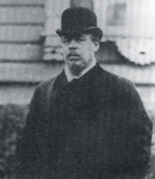
Alexander Stepanovich Popov was born on March, 16, 1859 in the village of Turinsky mines, named after the river Turya (in the Northern Urals).
A. S. Popov (1895-1906)
The most exciting game for him and his friends was building constructions, similar to those that surrounded him in his childhood. Acquired skills from childhood to do everything with his own hands turned out to be useful later. As a student he liked installation work and then he himself made the necessary equipment for the experiments.
The Popovs had a large family with seven children. They barely made ends meet, so A. S. Popov attended a religious school (1869), and then a seminary, which gave a full course of secondary education, where he could study for free.
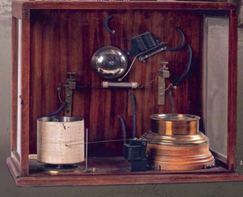
He received the highest score in all subjects and entered the St. Petersburg University on August 31, 1877 without exams. Due to his knowledge, as well as for the submitted thesis, he was found worthy of the PhD in Physics and Mathematics, awarded to him by the Council of the University on November 29, 1882.
The first radio receiver by A. S. Popov (1895)
In 1883 A. S. Popov started to work as a physics teacher in the Mine Officer Class in Kronstadt. Having become interested in Hertz’s experiments with electromagnetic waves, he perfected them by applying for transmitting and receiving information. On May, 7, 1895, he demonstrated his experiments publicly, that is why May, 7 is the birthday of radio.
His colleagues and contemporaries said that Alexander Popov was a brilliant and single-minded scientist. He spent all his spare time in his laboratory testing various theories and trying to make them better. He knew no rest and holidays. He was so passionate about what he did. Also, he was shy and timid, especially when he gave his public lectures. He lacked the talent of a good public speaker. He never promoted himself because of his inborn humbleness and modesty.
Alexander Stepanovich Popov died on January, 13, 1906. However, he had lived a short but amazing life of a scientist and an inventor, presenting his great invention – the Radio.

TEXT B
PROFESSOR ANDREI NIKOLAIEVITCH TIKHONOV
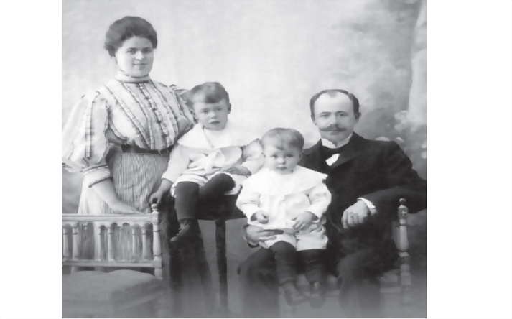
Andrei Nikolaevitch Tikhonov was born on Tuesday, October 30, 1906, in the town of Gagarin (previously Gzhatsk), in Smolensk region (West Russia) into a wealthy family. His father was a merchant. His mother was warm hearted, capable and energetic. She took care of their two sons, who grew up together and got the best education.
A. N. Tikhonov's family in 1910
In 1910 the Tikhonovs moved to Moscow, where the boys visited a city's gymnasium. When A. N. Tikhonov was 15 (in 1922), he went on to study at the Mathematics Department of Moscow State University of Faculty of Physics and Mathematics.
He published his first paper in 1925 while he was still 19, and in the middle of his undergraduate course. Tikhonov earned his PhD in 1927 under the supervision of P. S. Aleksandrov, who was only ten years older.
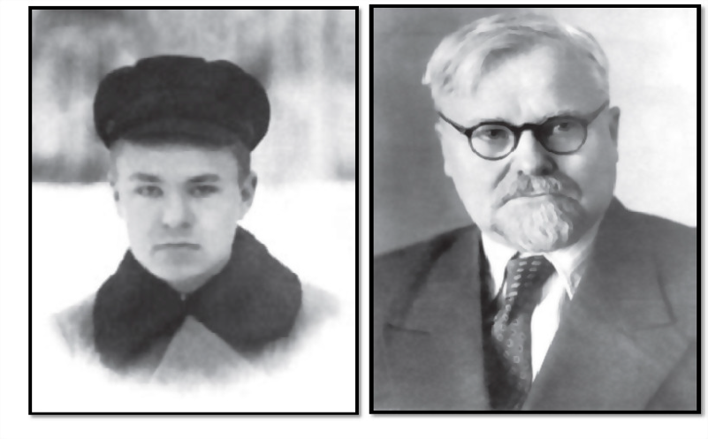
After successfully defending his thesis in 1936, Tikhonov was appointed as a professor of Moscow State University. A year later, in 1937, he was appointed the head of the Department of Mathematics of the Moscow State University Faculty of Physics. Tikhonov and his team contributed significantly to establishing and developing important tools used in modern mathematical physics. Also, he was the founder and the Dean of the Faculty of Computational Mathematics and Cybernetics of the Moscow Lomonosov State University from 1970 through 1990.
A. N. Tikhonov
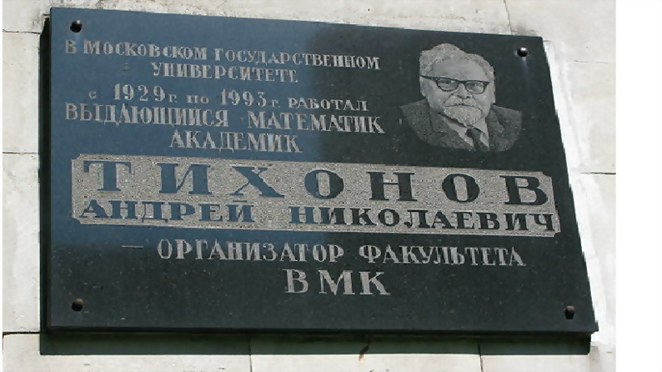
Professor A. N. Tikhonov passed away on November 8, 1993. Tikhonov was a vivid example of a talented personality devoted to mathematics, physics, and science, and the development of research and his country. It was a privilege to work alongside him. His seriousness, determination, and at the same time, stringent requirements on science and the work of his staff created a very special atmosphere at the institute. He always spoke with a cheerful and positive attitude. At the same time, he had a native wit, wisdom, humanity, self-irony, and a great sense of humor.
A. N. Tikhonov
Memorial plaque

Exercise 20
Answer the questions on the text A.
- What was A. S. Popov? Where was he born?
- What was his biggest passion when he was a child?
- What can you say about Popov's family? How did it influence his education?
- How did he enter the university?
- Did he manage to get a PhD degree?
- What did he invent?
- How did the A. S. Popov’ s contemporaries characterize him?

Exercise 21
Answer the questions on the text B.
- What was A. N. Tikhonov? Where was he born?
- What can you say about his family?
- When did A. N. Tikhonov go to study at Moscow State University?
- When did he publish his first paper?
- How old was he when he got a PhD degree?
- What big project did he participate in?
- How did A. N. Tikhonov’s colleagues characterize him?

SPEAKING

Exercise 22
a. Look at the timeline and say what events in the life of A. S. Popov it reflects
1859; 1869; 1877; 1882; 1895; 1906

b. Look at the timeline and say what events in the life of A. N. Tikhonov it reflects
1906, 1910, 1922, 1925, 1927, 1937, 1970, 1993

c. Make a timeline about your life. Include one false thing. Use the following words and expressions:
was born, went to kindergarten, started school, met my best friend, went on holiday to…, won a competition, was admitted to…, started to attend

d. Work in pairs. Use your timeline and tell your partner about your life. Guess the false information.
Model: A: I started school when I was 6.
B: False.
A: True. I really started school when I was six. I am seventeen now.

WRITING

Exercise 23
Write a short biography of a famous person. Read it to your groupmates but do not mention the person’s name. Let the others guess the person you wrote about.

UNIT 2.
Higher Education in Russia and Abroad

Theme 2.1. Higher Education in Great Britain

LEAD IN

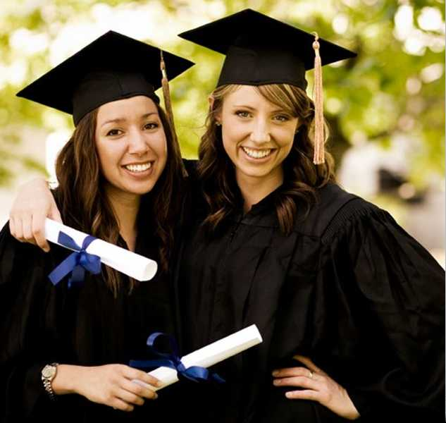
Work in pairs and explain how you understand this quotation:

"I cannot teach anybody anything; I can only make them think."
Socrates

KEY WORDS AND WORD COMBINATIONS
academic achievements | [ækəˈdemɪk əˈʧiːvmənts] | академическая успеваемость
academic research | [ækəˈdemɪk rɪˈsɜːʧ] | научное исследование
apprenticeship | [əˈprentɪsʃɪp] | ученичество, стажировка
bachelor’s degree | [ˈbæʧələ’es dɪˈgriː] | степень бакалавра
completion | [kəmˈpliːʃn] | завершение, окончание
conversion course | [kənˈvɜːʃn kɔːs] | курс переподготовки
employment | [ɪmˈplɔɪmənt] | трудоустройство
experience | [ɪksˈpɪərɪəns] | опыт
FE (Further education) college | [ˈfɜːðə edjʊˈkeɪʃn ˈkɒl.ɪdʒ] | колледж профессионального образования
to apply for (to) | [tuː əˈplaɪ fɔː] | подать заявление, записаться
to award | [tu: əˈwɔːd] | присвоить. присудить
to be referred to as | [biː rɪˈfɜːd tuː æz] | называться
to complete | [tə kəmˈpliːt] | получить, завершить
to enrol in (US enroll) | [tə ɪnˈrəʊl ɪn] | поступить, записаться
to enter | [tu: ˈentə] | поступить
to pursue | [tu: pəˈsjuː] | учиться с целью получения новой степени или знаний
Master’s course | [ˈmɑːstə’es kɔːs] | магистратура
postgraduate | [pəʊstˈgrædjʊɪt] | аспирант, лицо, имеющее базовое высшее образование
sandwich course | [ˈsænwɪʤ kɔːs] | курс, совмещающий теорию и практику
term | [tɜːm] | семестр
vocational | [vəʊˈkeɪʃnəl] | профессиональный

PRONUNCIATION PRACTICE

Exercise 1
Practice saying the key words and word combinations.

Exercise 2
Choose the words with the stress on the second syllable:
degree, bachelor, engineering, support, vocational, research, course, completion.

Exercise 3
a. Remember the reading rule and read the words below:

С
[s] only before e, i, y | [k]

completion, necessary, experience, course, vocational, apprenticeship

b. Remember that there are silent letters in English and read the words:
high, choice, known, training, offer, research.

Exercise 4
Study word-building rules.
- Nouns
Suffix | Examples
-er, -ee, -or, -ant/-ent, -ist | teacher, engineer, employee, degree, professor, educator, applicant, assistant, scientist
-ment, -ation, -(s)ion, -age, -ance,  -ing | employment, entertainment, examination, profession, importance, training

Compound nouns
Scheme | Examples
noun + noun, noun + verb, adjective + noun, verb + preposition/ adverb | website, network, classmate, dishwasher, dressmaker, high school, know how

Complete the sentences with a noun formed from the word in brackets.
- The university sends a ready studying invitation to the______. (to apply)
- Our main task is to provide the students with useful______ about universities. (to inform)
- I had no secretary or______. (to assist)
- We currently provide ______ to 17 young professionals. (to employ)
- For more information, please visit our _____. (… + site)

b. Verbs
Suffix | Examples
-ise/-ize, -(e)n, -(i)ate, -(i)fy | specialize, organize, broaden, listen, communicate, classify, qualify, notify
Prefix | Examples
re-, dis-, over-, un-, mis-, out | rewrite, retell, reopen, dislike, disagree, oversee, unpack, misunderstand, outgrow, oversleep

Complete the sentences with the suitable form of a verb.
- This is the reason I _____with you. (do not agree)
- How do computers _______ on a local network? (communication)
- We _____ in this area and offer a wide range of products. (specialization)
- Does that mean that I don't____as a programmer? (qualification)
- I am glad that our library has _____ and I can get books and magazines again. (to open)
- My friend told me a very interesting story, but I can’t _____ it, I don’t remember all the facts. (tell)

c. Adjectives and adverbs

Suffix | Examples
-al, -ful, -less, -able, -y, -ous, -ent,  -ive | vocational, practical, useful, careless, suitable, windy, famous, excellent, active
-ly | formally, typically

Prefix | Examples
dis-, un-, in-, -im, -ir-, il- | disloyal, unusual, incorrect, incomplete, impossible, irreplaceable, illegal

Compound adjectives
Scheme | Examples
number + adjective, adjective + noun,  noun + adjective, self + verb/ adjective | two-hour, full-time, high-quality, user-friendly, well-paid, self- employed, first-year, well known

Complete the sentences with the suitable form of an adjective.
- I have_____Internet connection. (high / quality)
- The purpose of_____ training is to equip people to lead active, productive, and satisfying lives. (vocation)
- Real life gives you_____ skills. (practice)
- This university attracts students from all over the world who seek to pursue____ courses. (to differ)
- I worked for a very____ university. (well/know)

Give opposites to these adjectives:
popular, practical, friendly, formal, polite, logical, irresponsible, satisfied, useless.

Exercise 5
Look through the text “Higher Education in the UK” (from Exercise 11) and find nouns formed with the following suffixes:

-ment | -or | -ion | -ing | -ee | -ship

VOCABULARY I

Exercise 6
a. Match the abbreviations with their translations.
- BA degree | - степень магистра
- BSc degree | - степень бакалавра технических наук
- MA degree | - докторская степень
- PhD degree | - степень магистра в области исследовательской деятельности
- BEng | - степень бакалавра естественных наук
- MRes | - степень бакалавра

b. Match the words with similar meaning.
- vocational | - to obtain
- to complete | - to finish
- to gain | - qualification
- degree | - study
- training | - professional
- research | - useful
- valuable | - education

Exercise 7
a. Make up all possible word combinations.
- to apply | - a degree
- to gain | - the university
- to award | - an application form
- to provide | - for a place
- to enter | - a course
- to complete | - information
- to open up | - practical skills
- to pursue | - opportunities

b. Complete the sentences with the word combinations from (a). Put the verbs in the correct tense form if necessary.
- Last year, 2,500 students ________________.
- In 1893 and 1894, Curie _______________in Physics and Maths respectively.
- His first aim after school was _______Russian Technological______.
- This section of the website ___________that will be useful to you.
- After high school, Steven Spielberg tried_________ of Southern California.
- Students have the opportunity not only to study theory but also __________.
- You will need _____________, give two references and attend an interview.

GRAMMAR

Study grammar rules on the use of SIMPLE AND PROGRESSIVE (CONTINUOUS) PASSIVE (see GRAMMAR REFERENCE p.200)

Exercise 8
Choose the correct variant in italics.
- Higher education in the UK is provided/provides by numerous universities and colleges.
- Innovative programs are being developed/develops to enhance the quality of higher education.
- The research project was discussed/ is being discussed by the research team at the moment.
- Higher education in Great Britain is offered/offers a wide range of options for students.
- The science lab is renovated / will be renovated over the summer break next year.
- A new online learning platform was used /will be used by the university last year.
- The exams will be taken/will take next week.

Exercise 9
Put the words in brackets in the correct form.
- The term "university" ____ (to use) often interchangeably with "higher education institution" in the UK.
- The homework _____ (to do) by the end of the week.
- A bachelor's degree _____ (to award) after three years of studies.
- London_____ (to know) for its beautiful architecture and art museums.
- The students _____ (to teach) by a renowned professor in the lecture hall right now.
- The pictures _____ (to take) during my vacation in Italy.
- Basic education ______ (to provide) by the State free of charge.
- The new language program _____ (to develop) by the language department for two months.
- Oxford and Cambridge____ (to refer) to as Oxbridge.

Exercise 10
Make sentences from the given words in 5 tenses (Present, Past and Future Simple Passive and Present and Past Progressive Passive:
do, cook, read, develop, answer, organize, translate.

Model:
The Listening, Reading, and Writing tests are done on the same day. | More and more jobs are constantly being done by robots and computers.
The work was done professionally and quickly. | Lots of work was being done to improve the park.
The job will be done properly.

Exercise 11
a. Translate sentences from Russian into English using Passive voice.
- В нашем университете постоянно разрабатываются новые курсы.
- Существует множество методик, которые используются при обучении студентов инженерных специальностей.
- По окончании курса присваивается степень "Бакалавр”.
- Для студентов первокурсников будут организованы трехмесячные курсы английского языка.
- К счастью, мы были подготовлены к подобной ситуации.
- Курс «Искусственный интеллект» будет преподаваться на английском языке.
- На этот вопрос правильно ответили все студенты.
- Книга нашего преподавателя была переведена на английский язык и издана в прошлом году.
- Студенты третьего курса прошли тестирование по техническим дисциплинам.
- Для студентов первокурсников запланированы развлекательные мероприятия.

b. There are Passives in the text (Ex.11). Find them and comment on their use.

READING I

Exercise 12
HIGHER EDUCATION IN THE UK
Education in the UK is high-quality and prestige. British universities have high graduate employment rates and good funding. The two most well-known universities are Oxford and Cambridge, which are often referred to as Oxbridge. These universities have a reputation for excellence in academic research and teaching because new course modules are constantly being developed and personalized teaching methods are continuously being used here.
In the UK, students enter the university after completing their secondary education. A bachelor's degree is awarded after three years of studies. Students have the choice of a number of courses to take, including vocational degrees, which prepare them for specific professions, or more general courses such as history or literature.
Further education (FE) colleges offer a range of courses, including vocational qualifications and apprenticeships. A lot of students who do not pursue a university degree choose to attend FE colleges to gain practical skills and experience. FE Colleges train IT, business, engineering, and healthcare support staff.
To enrol in university, students apply for a place through the UCAS* system. This involves completing an application form and providing information about their academic achievements and interests.
Undergraduate degree (BA, BEng) is an important milestone in a student's life, and it opens up many opportunities for future employment. Some educational institutions also provide conversion courses, which allow students to switch to a different field of study. Another popular option for students is a sandwich course, which involves a year of on job training between academic terms. This gives valuable practical experience and can help students to get employment after graduation.
After gaining their undergraduate degree, students may pursue a Master's course or a PhD, which requires further study and research. The duration of these courses is one year. Apart from MS in UK, other available degrees are MBA, MA, and MRes.
Higher education in Great Britain offers a wide range of options for students from vocational training to academic research. No wonder that students from all over the world opt for British universities.
Notes:
*UCAS – Universities and Colleges Admissions Service

Exercise 13
What do these abbreviations stand for?
- UK
- FE
- IT
- BA
- MS
- MBA
- MRes

Exercise 14
Find words in the text that mean:
- a qualification given for completing a university course;
- a university or college qualification which usually takes 3 to 4 years to complete;
- a programme of study that trains a graduate in a new subject and prepares them for a specific profession;
- a higher level degree which usually takes one or two years to complete;
- work-related qualification available in a wide range of career areas;
- a course which combines theory and practice;
- an advanced degree awarded to individuals who have demonstrated a high level of expertise in a specific field of study.

Exercise 15
Match the halves of sentences.
- Many students who do not pursue a university degree | - of the highest quality and prestige.
- Some educational institutions also offer conversion courses, which allow | - after completing their secondary education.
- In the UK, students can enter the university | - choose to attend FE colleges to gain practical skills and experience.
- A bachelor's degree is awarded | - after three years of studies.
- Another popular option for students is a sandwich course, which involves | - students to switch to a different field of study.
- British universities have | - high graduate employment rates and good funding.
- Higher education in the UK is | - a year of on job training between academic terms.

Exercise 16
a. Decide if the statements below are true or false.
- British universities have high graduate employment rates and good financial support.
- Oxford and Cambridge are the only universities in the UK.
- Oxford and Cambridge are recognised for their high achievements in both research and teaching.
- It is not possible to enter university until you have completed your secondary education.
- A bachelor's degree is awarded after five years of studies.
- FE colleges provide vocational qualifications.
- UCAS is the UK's service for students to apply to higher education.
- A conversion course is a programme of study that trains a graduate in a new subject and prepares them for a specific profession.
- A sandwich course is a course which combines theory and practice
- Pursuing a Master's course or a PhD does not involve further study and research.

b. Make up your own true or false statements.

c. Work in pairs. Read your statements to each other and agree or disagree with them. If you disagree, correct the statement.

Exercise 17
Complete the graph and speak about the stages of higher education in the UK.
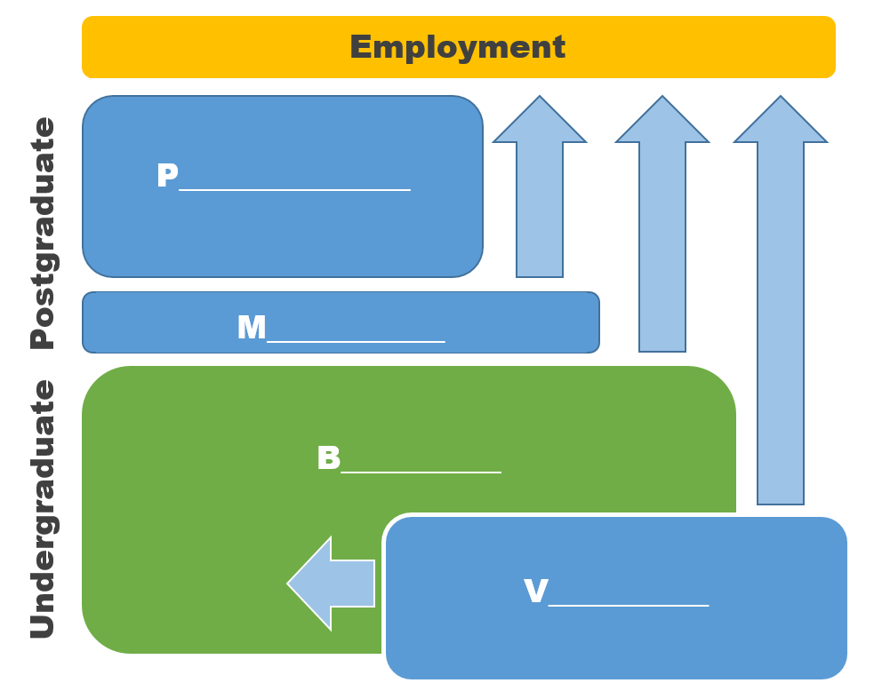
The stages of higher education in the UK

WATCHING AND LISTENING I

Exercise 18
You are going to watch a video about Oxbridge:
https://www.youtube.com/watch?v=Re3tfjcZBQk

a. BEFORE YOU WATCH. Answer the questions.
Have you ever heard of Oxbridge before?
What do you think are the advantages and disadvantages of studying at a collegiate university?

b. WHILE YOU WATCH. Listen and fill in the gaps with the suitable words.
1. Oxbridge is an ___________ of two distinct, but similar universities called Oxford and Cambridge.
2. One of the most defining features of both Oxford and Cambridge is that they are ___________ universities.
3. Cambridge is made up of _______ individual colleges, and Oxford is made up of _________. Some are postgraduates only.
4. Colleges do not specialize in specific subjects but some colleges ___________ in specific subjects. For example, Trinity College Cambridge is very well-known for _________.
5. Another thing that sets Oxbridge apart from other universities is that some of their classes called _______ at Cambridge or ______ at Oxford are in a very special format.

c. AFTER YOU WATCH. Answer the questions.
- When was Oxford founded?
- When was Cambridge founded?
- Why was Cambridge founded?
- Do Oxford or Cambridge have central university? If not, explain their system.
- Do all colleges offer the same courses?
- What is special about the teaching format at Oxford?
- Who are supervisors? Should they be from the same college?
- Can you apply to both Oxford and Cambridge the same year?
- What is an Open Application?

VOCABULARY II

Exercise 19
Match the terms with the definitions.
- research | - small group sessions where students can receive individualized instruction from a teacher or tutor.
- tuition fees | - money given by a university to pay for the studies of a person with great ability but little money.
- full time | - a course of study that allows you to work or attend classes for only some of the day or week.
- part time | - a place where someone lives or stays, especially when they are away from home.
- tutorials | - involves regular attendance of lectures and seminars on the schedule.
- scholarship | - money that students pay for their teaching.
- accommodation | - money given by the government to a person or organization for a special purpose.
- grant | - systematic investigation into and study of materials and sources in order to establish facts and reach new conclusions.

Exercise 20
a. Make up all possible word combinations and translate them.
- to provide | - topics
- to cover | - tutor
- to give | - information
- to meet with | - courses
- to discuss | - opportunities
- to debate | - hands-on experience
- to deliver | - costs
- to present

b. Complete the sentences with the word combinations from (a).
- This course _______ students _________ with C++.
- The magazine_____________ related to radio and radio communication.
- The Career Fair_____________ for direct communication between Yandex and RTU MIREA students.
- I'm going to study every day and _________ on Wednesday to prepare for Friday's test.
- Three important ________ ______ during our meeting.
- The_________________ to Moscow the same day.
- In the end, all their accommodation_____________.
c. Make your own sentences with the word combinations from (a).

READING II

Exercise 21
Read the text and give it a title.
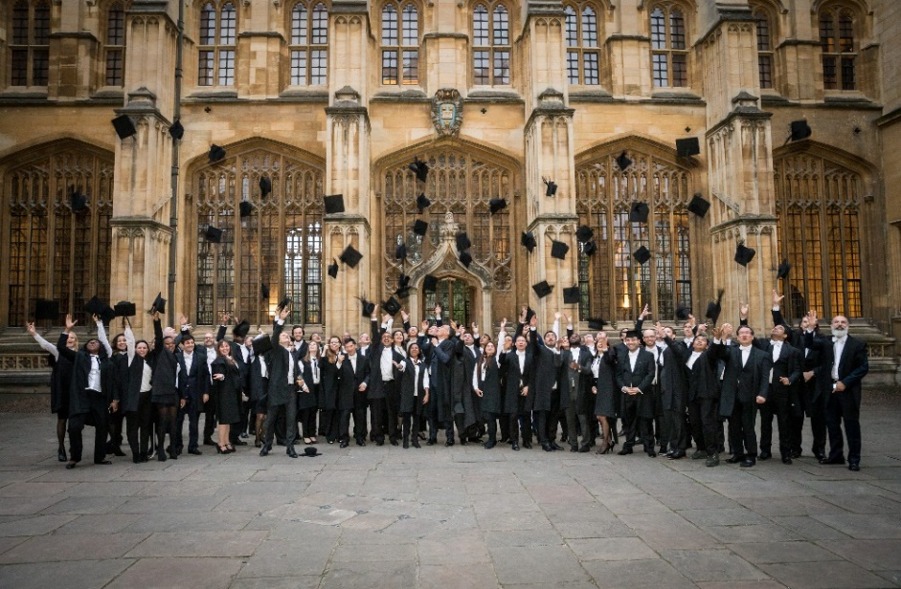
Studying engineering at Oxford can be a challenging but rewarding experience. The University of Oxford provides both undergraduate and postgraduate courses in engineering, with options for full-time or part-time study.
For undergraduates, there are two main degree options: the Bachelor of Arts (BA) in Engineering Science and the Bachelor of Engineering (BEng) in Engineering Science. The BA is a three-year course that covers a broad range of topics, while the BEng is a four-year course that allows for greater specialization. Both courses give opportunities to study abroad to apply theoretical knowledge in practice.
Postgraduates have a variety of options including MSc and DPhil degrees. These programs enable students to specialize in areas such as biomedical engineering, electrical engineering, or mechanical engineering, among others.
Teaching styles at Oxford are unique and involve a combination of tutorials, lectures, seminars, and practical work. Tutorials are small group sessions where students meet with their tutor to discuss and debate topics covered in lectures and readings. Lectures are traditional form of teaching, with professors delivering information to larger groups of students. Seminars give the opportunity for students to present their own research and ideas, while practical work provides hands-on experience with engineering concepts.
Tuition fees at Oxford are higher than at many other universities, but there are grants and scholarships available to help cover costs. Students have the option of accommodations on campus or in nearby apartment complexes, according to their preference.
Studying engineering at Oxford is a rigorous experience, but one that leads to exciting career opportunities. With a focus on both theoretical knowledge and practical application, students will graduate from the university with a strong foundation in engineering principles and the skills needed to succeed in the field.
Exercise 22
Answer the questions.
- What are the main undergraduate degree options in engineering at Oxford?
- What is the purpose of tutorials in engineering courses at Oxford?
- What is the teaching style like for engineering courses at Oxford?
- Are there grants and scholarships available to help cover tuition fees for engineering courses at Oxford?
- What career prospects can be achieved by studying engineering at Oxford?
- How would you yourself feel about studying engineering at Oxford?


WATCHING AND LISTENING II

Exercise 23
You are going to watch Cambridge University video about Engineering Course at
https://www.youtube.com/watch?v=qWijZcXRwDA

a. BEFORE YOU WATCH. Try to guess.
What does engineering course at Cambridge involve? Does it differ from Oxford course?
What are the career prospects of Cambridge graduates?
b. WHILE YOU WATCH. Listen and complete the summary of the video.
The first years are completely general, which is one of the reasons I was attracted to it because I had no idea which field I would ___________.
You can specialise in ______, ______, materials engineering, aerothermal engineering, _______, manufacturing, ______ studies.
My favourite thing about the course is ________.
In my second year the integrated design project was very interesting, it was_______ when it actually worked out.
We have four exchange schemes whereby our students in their third year will go ______ to various parts of Europe and do a year there.
The university has a requirement that we do eight weeks ______ work.
There's also the ______ which gives you a unique opportunity to study languages within your own department.
Most of our graduates do ______, either immediately on graduating or not too long afterwards.
_______really value the Cambridge degree.
We have companies picking up our students because they're known for their ______.

c. Watch the video for the second time and answer the questions.
- What is engineering?
- When do students have to decide which branch of engineering to specialize in?
- What branches of engineering can the students specialize in?
- How many exchange schemes are available for students in the third year? What are they?
- What is the most important thing to do during an engineering interview?

d. AFTER YOU WATCH. Answer the question:
What are similarities and differences between studying engineering at Oxford and at Cambridge?

Exercise 24
a. Read students' comments about the teaching methods at Oxford and Cambridge.

b. Fill in the blanks with the following words:
support personalized problem-solving skills tutors compare
teamwork critical thinking

“Tutorials are an excellent way for students to receive ________ attention and ______ in their studies. During these sessions, ______ can provide feedback on assignments, answer questions and help us develop our ________ skills. The Socrates method is often used in tutorials, which involves asking questions to encourage us to analyse and ________ different ideas. One of the main benefits of tutorials is that they offer a space for _____. This approach develops not only _________ but also helps us to learn how to articulate our thoughts more clearly”.
Freya, St. Catherine’s College

presenting respond to writing feedback analytical communication skills questions

“During a supervision, students may be asked to present their work or _______specific _____. This can be daunting at first, but for me it is an excellent opportunity to improve _________ and gain confidence in ______ ideas. Tutors will offer constructive ______ and suggestions for improvement, helping students to refine our ______ and _______skills.”
Alex, King’s College

SPEAKING

Exercise 25
Work in groups. Discuss the advantages and disadvantages of tutorials and supervisions. What teaching methods are used at your university? Do you have tutorials? Do you consider such methods useful? Why? Why not?
Use the following: student-centred; co-operation; teamwork; highly effective; individual work; critical thinking; problem solving; communication skills.

WRITING

Exercise 26
Writing Email to Your Professor.
- Read email sample.
drradley@unoxf.com
Subject: Request for notes
Dear Dr. Radley,
This is Tom White from your math class. I am sorry for missing class last Monday, but I had a family emergency that I needed to attend to. I regret missing your lecture and I hope that you give me notes for the material I missed. I would appreciate your help.

Thank you,
Tom White

b. Study the rules of email writing:
1. Use your academic email address.
Most universities provide students with an academic email address. If your school has provided you with one, use it. Using a personal email like skylarx3george@aol.com increases the chances of your email ending up in the spam folder or getting skipped.
2. Write a clear and concise subject line.
It’s always a good idea to give your professor a preview of what the email is about, and that’s what the subject line is for. Make sure the subject line is clear, concise, and informative.
3. Use a formal salutation.
Use Dear or Hello when starting an email to your professor.
4. Introduce yourself.
Professors can have numerous students. You can’t expect them to know who you are solely by your email. After the formal salutation, write your full name and the course you’re taking.
5. Write a brief message about why you’re emailing.
Professors are extremely busy people. Don’t ramble in your email. Instead, get straight to the point. Write your email as briefly as possible. Additionally, make sure to use the appropriate tone and language.
6. End the email with a formal closing.
Once you have asked your question or made your requests, end the email with a formal closing like Thank you, Best, or Sincerely. Then write your name.
7. Check for spelling and grammar errors.
Arguably the most important part of writing an email to your professor is checking for spelling and grammar mistakes. A message riddled with errors can make it seem as if you’re not taking the time to write a professional and proper email.

c. Write an email to your professor saying that you would like to retake a test or exam.

Theme 2.2. Higher Education in the USA

LEAD IN

Work in pairs and explain how you understand this quotation:

Education is the most powerful weapon which you can use to change the world.
- Nelson Mandela

KEY WORDS AND WORD COMBINATIONS
compulsory | [kəmˈpʌlsərɪ] | обязательный, общеобразовательный
credit hours | [ˈkredɪt ˈaʊəz] | единица учебной нагрузки, определённое количество которых необходимо набрать для получения зачёта
dedication | [dedɪˈkeɪʃn] | стремление, сосредоточенность, усердие
elective | [ɪˈlektɪv] | факультативный, элективный, по выбору
eligibility | [elɪʤəˈbɪlɪtɪ] | соответствие установленным требованиям, критериям
extensively | [ɪksˈtensɪvlɪ] | много, активно, в больших количествах
grades | [greɪds] | баллы, оценки
major | [ˈmeɪʤə] | ведущее направление подготовки, специальность, основной предмет
to achieve | [tu: əˈʧiːv] | достигать, добиваться, выполнять
to aim | [tu: eɪm] | стремиться, ставить целью
to determine | [tu: dɪˈtɜːmɪn] | определять, обуславливать
to evolve | [tu: ɪˈvɒlv] | развиваться, изменяться
to fulfil | [tu: fʊlˈfɪl] | выполнять, соответствовать
to major | [tu: ˈmeɪʤə] | специализироваться в изучении какого-либо предмета
to specialise in | [tu: ˈspeʃəlaɪz ɪn] | специализироваться на чем-то
to tailor | [tu: ˈteɪlə] | приспосабливать, проектировать, специально разрабатывать
requirements | [rɪˈkwaɪəmənt] | требования

PRONUNCIATION PRACTICE

Exercise 1
Practice saying the key words and word combinations.

Exercise 2
Give the correct word for each phonetic description.
[əˈsəʊʃ(ɪ)ət, əˈsəʊsɪət]
[kəmˈpʌlsərɪ]
[rɪˈsɜːʧ]
[ɪˈlektɪv]
[əˈʧiːv]
[sɪgˈnɪfɪkənt]

VOCABULARY I

Exercise 3
Match the word combinations with their Russian equivalents.
- intended career | - старшие классы средней школы
- job market | - вуз
- high school | - будущая карьера
- higher school | - окружной двухгодичный колледж, муниципальный колледж
- community college | - степень (диплом) младшего специалиста
- associate degree | - магистратура
- graduate school | - рынок труда

Exercise 4
Match the synonyms.
- to evolve | - to achieve
- to get | - to begin
- to fulfil | - to demand
- to tailor | - to develop
- to start | - to modify
- to require | - to obtain

Exercise 5
Match the antonyms.
- advanced | - lower
- higher | - optional
- pass | - obligatory
- compulsory | - basic
- elective | - insignificant
- significant | - narrow
- extensive | - fail

Exercise 6
a. Make word combinations.
- to meet | - exams
- to pass | - a particular field
- to fulfil | - critical thinking skills
- to tailor | - goals
- to specialize in | - requirements
- to practice | - a research
- to conduct | - demands
- to achieve | - education

b. Complete the sentences using word combinations from (a).
- The Master's program in Computer Science offers you a vast number of opportunities to ___________.
- Students learn to work together and _______ conflict resolution and______.
- The research ______ on the basis of Harvard University.
- Kate _____ her _____ to study at a US university.
- The full-time programme is designed ____ the growing _____ for graduates with analytical skills.
- This programme enables students to ________ of their national or state educational systems.
- He ______ his final _______ and got into college without difficulty.
- Elective courses allow students to____ their ___ to meet personal and professional goals.

GRAMMAR

Study grammar rules on the use of the PERFECT AND PERFECT PROGRESSIVE (Continuous) (see GRAMMAR REFERENCE p.201)

Exercise 7
Put the words in brackets in the correct form.
- She _____ the university of her dreams this year. (to enter)
- He _______ diligently all the semester, preparing for his final exams. (to study)
- By the time she entered the university, she ___ already ____ for a course in medicine and gained significant practical experience. (to apply)
- He plans to enter the university next year and believes that by the time he graduates, he ______ a degree that opens up opportunities for employment. (to obtain)
- They ____ diligently _____on their projects, pursuing their Master's degrees. (to work)
- By the time he retired, he _____ at the school for over 40 years. (to teach)
- In five years, he ____ at the university for twenty years. (to lecture)

Exercise 8
Make sentences from the given words in 6 tenses (Present, Past and Future Perfect and Present, Past, and Future Perfect Progressive):
do, send, make, study, graduate, award, prepare, complete, gain.

Model:
Amy has sent many emails this morning.  Amy has not sent many emails this morning.  Has Amy sent many emails this morning? | He has been studying mathematics for six years only.  He has not been studying mathematics.  Has he been studying mathematics for six years?
The student had done everything he could.  The student had not done everything he could.  Had the student done everything he could? | He had been doing everything the doctors told him to.  He had not been doing everything the doctors told him to.  Had he been doing everything the doctors told him to?
Tom will have graduated from the university in two years.  Tom will not have graduated from the university in two years.  When will Tom have graduated from the university? | I will have been studying for two hours by the time you arrive.  I will not have been studying for two hours by the time you arrive  How long will I have been studying by the time you arrive?

Exercise 9
a. Translate sentences from Russian into English using Perfect.
- Анна только что закончила первый год обучения на очном отделении.
- В этом году университет выдал дипломы тысячам выпускников, завершившим обучение на бакалавриате.
- Перед тем как перейти на курс профессиональной переподготовки, Диана прошла курс, совмещающий теорию и практику и приобрела ценный опыт.
- В течение 3 месяцев Том работает над своим исследовательским проектом.
- К концу следующего года Денис завершит обучение в магистратуре.
- Юлия путешествовала по миру в течение года, прежде чем поселиться в своем родном городе.

b. There are sentences with Perfect Tenses in the text “The system of higher education in the United States” (Ex.10). Find them and comment on their use.

READING I

Exercise 10
Read and translate the text.

THE SYSTEM OF HIGHER EDUCATION IN
THE UNITED STATES

The system of higher education in the United States has evolved significantly over the years. It has always aimed to prepare students for their intended careers, but the structure and offerings have changed to meet the demands of a dynamic job market.
Many students pursue higher education after completing their high school diploma, aiming to get a bachelor's degree or an advanced degree such as a Master's or PhD.
To gain a degree in the USA, students must pass exams and fulfill the requirements of their chosen program at a higher educational institution. These institutions are universities, community colleges, or other specialized schools. In some cases, certain courses are compulsory, while others are elective, allowing students to tailor their education to their interests and goals.
Community colleges are a popular option for students who want to start their higher education journey with lower costs or who are unsure of their major. They offer 2 year courses and programs that can lead to a certificate, associate degree, or transfer to a university to complete a bachelor's degree. As of January 2023, there were 935 public community colleges registered with the AACC* in the United States.
Universities are the most common choice for pursuing a bachelor's degree (BA, BSc, and BBA). There are more than 1000 universities in the USA. Students typically spend four years studying a variety of subjects and earning grades that will determine their eligibility for graduate school or a career. Many universities also offer master's courses (MSc degree) and PhD programs for those looking to specialize in a particular field.
Obtaining an advanced degree opens doors to more specialized careers and higher-paying jobs. However, it requires a significant amount of time and dedication to complete. Students practice critical thinking skills, conduct research, and write extensively.
Higher education is an important step towards achieving one's career goals in the USA. Whether pursuing a bachelor's degree, an advanced degree, or attending community college, students try to work hard, pass exams, and complete their degree requirements.
Notes*
AACC (The American Association of Community Colleges) – Американская ассоциация муниципальных колледжей

Exercise 11
a) What do these numbers refer to:
2023, 2, 935, 1000, 4?
b) What do these abbreviations stand for:
USA; AACC, MSc, PhD, BA, BSc, BBA?

Exercise 12
Find the words in the text that mean:
- required by law or a rule, obligatory;
- the highest degree awarded by a graduate school or department, usually after several years of original research culminating in a dissertation;
- an undergraduate academic degree awarded by colleges and universities upon completion of a course of study usually lasting three to five years;
- optional or chosen according to individual preference;
- two-year institutions of higher education that offer courses leading to an associate degree or certificate;
- a postgraduate academic degree such as a master's or doctoral degree;
- institution of higher education that typically consists of several colleges and graduate schools and are authorized to confer degrees in various fields.

Exercise 13
a. Decide if the statements below are true or false.
- The system of higher education in the United States has remained unchanged over the years.
- Students can only pursue a bachelor's degree in the USA.
- Students must pass exams and fulfill program requirements to gain a degree in the USA.
- Community colleges are not a popular option for students.
- Community colleges offer programs that can lead to a bachelor’s degree.
- There are more than 1000 universities in the USA.
- Students typically spend two years studying at community colleges.
- Obtaining an advanced degree requires less time and dedication than obtaining a bachelor's degree.
- Students at universities only study subjects related to their major.
- Higher education is not important for achieving career goals.

b. Make up your own true or false statements.

Exercise 14
a. Answer the questions:
- What are the requirements for completing a degree in the USA?
- What types of institutions offer higher education programs?
- What is the difference between compulsory and elective courses in higher education programs?
- Why are community colleges popular among students, and what types of degrees do they offer?
- What is the most common choice for pursuing a bachelor's degree in the USA, and how long does it typically take to complete?
- What opportunities are available to students who pursue advanced degrees like Master's or PhD programs?
- How can obtaining an advanced degree benefit one's career prospects?
- What skills do students practice when pursuing an advanced degree?

b. Retell the text in your own words. Say as much as you can recall for someone who has not read the text. Don’t look back at the text. Use the questions as a plan for retelling the text.

Exercise 15
British English and American English (Vocabulary on Education)
UK | USA
university | college / school
public school — частная школа | public school — государственная школа
tuition — обучение | tuition — плата за обучение
to read / to do a subject | to major in a subject
to revise for an exam | to review for an exam
practice/to practise | practice/to practice
marks | grades
first-year student  second-year student  third-year student | freshman (frosh)  sophomore  junior  senior
Staff:  Professor  Reader  Senior Lecturer  Lecturer | Faculty:  Full Professor  Associate Professor  Assistant Professor
letter of reference | letter of recommendation

Exercise 16
Decide if these statements are about the UK or the USA:
- Alex read History at the university.
- He majored in computer science at college.
- Tom was awarded high marks for his project.
- Examinations are graded honors, pass, low-pass or fail.
- Students attending full-time programs receive free tuition at state institutions.
- This scholarship not only covers tuition fees but also covers living expenses.
- Each year has a name: freshman, sophomore, junior, senior.
- She is a third year student.
- Applicants were asked to provide letters of reference.
- Our school is led by a diverse and dedicated group of faculty and scholars.

WATCHING AND LISTENING I

Exercise 17
You are going to watch a video about the U.S. higher education system at
https://www.youtube.com/watch?v=QcCJ8nZop-A
- BEFORE YOU WATCH. Answer the questions.
- How can you characterize the American higher education system?
- What are the distinctive features of the higher education system in the U.S.?

b. WHILE YOU WATCH. Listen and complete the summary of the video.
The U.S. higher education system is a bit like the American character. It celebrates ___, ________, ______, and _________.
The U.S. higher education system also has its own names for each year of an ______ degree, which you may or may not be familiar with. For example, the first year of a degree is known as the ______ year, the second as the _____ year, the third as the _____ year, and the final as the ______ year. A typical American student will complete 12 years of education before progressing to college ______ a bachelor's degree, which takes _____ years to complete.
Some students continue to graduate school to study for a ______, which takes an additional ___ to _____ years. U.S. undergraduate degrees usually require four years of ______ study.
The academic year runs for ___ months, with ____ semesters per year. Each semester, you'll study four or five courses, and each course you study will earn ________. There are usually three to four _____ per course, and you'll be expected to complete 120 to 130 credit hours in order to complete an undergraduate degree.

c. AFTER YOU WATCH. Answer the questions.
- What are the names of each year of an undergraduate degree in the US higher education system?
- How many years does it take to complete a bachelor's degree in the US?
- What is the typical educational background of an American student before pursuing a bachelor's degree?
- What is the duration of an academic year in the US higher education system?
- How many courses do students usually study per semester in the US higher education system?
- How many credits are usually earned per course in the US higher education system?
- How many credit hours are required to complete an undergraduate degree in the US?
- What is the duration of a master's degree program in the US?
- What are the values celebrated by the US higher education system?

GRAMMAR REVISION
Active vs Passive

Exercise 18
Choose the correct form of the verb.
- Stanford University Library houses/is housed a vast collection of books and digital resources.
- The digital catalog is updated/updated by Stanford University Library to enhance accessibility.
- The library's extensive archives utilize/are utilized for historical studies by researchers.
- The library staff was organized/organizes regular events to promote literacy and community engagement.
- The library's physical spaces are designed/designed to foster learning, creativity, and collaboration.
- The library continually invests/was invested in digital archives, specialized databases, and advanced research tools.
- Stanford University Library offers/is offered a welcoming and enriching environment that celebrates the pursuit of knowledge.

VOCABULARY II

Exercise 19
a.Match the word combinations with their Russian equivalents.
- to work your socks off | - нестандартный подход
- stellar reputation | - обеспечение высоких стандартов обучения
- academic excellence | - выдающиеся выпускники
- rigorous demands | - много работать
- to drink from a firehose | - студенческий состав
- accomplished alumni | - имеющий хорошую успеваемость
- student body | - безупречная репутация
- academically proficient | - любознательность
- intellectual curiosity | - жёсткие требования
- unconventional approach | - быть перегруженным информацией
- Make your own sentences with the word combinations from (a).

READING II

Exercise 20
Read and translate the text, find in the text sentences with Perfect.

WHAT'S IT LIKE TO STUDY AT MIT?

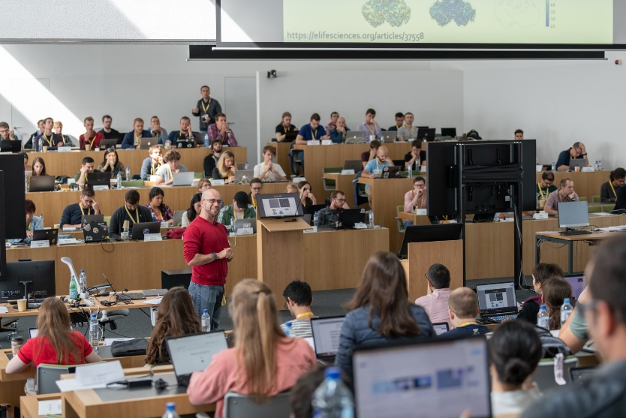
Studying at the Massachusetts Institute of Technology (MIT) is a dream come true for many aspiring minds. Named the number one university in the world in the latest QS* league table, MIT has earned a stellar reputation not only for its academic excellence but also for its rigorous demands. As the saying goes, "If you are considering studying at the best university in the world, you'd better be prepared to work your socks off."
The pace of learning at MIT has often been likened to "drinking from a firehose," and this reputation is well deserved.
The workload is intense. Amy Guyomard, a third-year maths major, shares her experience, mentioning that she had already submitted two problem sets and a writing assignment just four days into the semester. Her to-do list includes two more problem sets and a 20-minute presentation, not to mention reading "All The President's Men" by week's end.
MIT is known not only for its challenging workload but also for producing some of the brightest minds in the world. The university boasts a long list of accomplished alumni, including the fictional Tony Stark (Iron Man) and the character from "Good Will Hunting," played by Matt Damon.
Admission to MIT is highly competitive. The institute seeks exceptional students who are not only academically proficient but also exhibit initiative and intellectual curiosity.
MIT's student body is diverse, encompassing a wide range of personalities and interests. This diversity reflects the institute's philosophy that "MIT is as hard as you want to make it." While the journey may be challenging, MIT ensures that students come out better than they went in.
One of the remarkable aspects of MIT is its focus on fostering personal growth and individual learning styles. As Michael Plasmeier, a management and computer science student, notes, "Information is not spoon-fed*; you need to find your own personal style of learning." This emphasis on self-discovery and adaptability prepares students for the real world, where innovation and problem-solving often require unconventional approaches.
(Retrieved from: https://www.theguardian.com/education/)
Notes*:
QS – Quality Standards;
to be spoon-fed – to be given too much help or information.

Exercise 21
Answer the questions, use additional information from the Internet.
- What is MIT?
- Why is MIT considered one of the best universities in the world?
- How would you describe the pace of learning at MIT, and what kind of workload do students face?
- Who are some famous alumni of MIT?
- What are they famous for?
- Is admission to MIT competitive, and what qualities does the institute look for in applicants?
- What kind of student body does MIT have?
- What is MIT's focus?
- How does MIT prepare its students for the real life?

LISTENING II

Exercise 22
a. BEFORE YOU WATCH. You are going to watch a video “5 Signs you are an engineering student”. Look through the sentences and try to guess the missing words:
- You soon learn the true meaning of _____, pressure and strain.
- You still think _____ is the best kids toy ever.
- You're always trying to ____ things.
- Your family and friends like to make use of your _____ skills around the house.
- By the time your art student friends get out of bed, you've already been to two ____ and a ___ session.

b. WHILE YOU WATCH. Watch the video at https://www.youtube.com/watch?v=tNqyLJNie-s and check your predictions. What is the meaning of stress, pressure and strain in this video?

c. AFTER YOU WATCH. Answer the questions.
- What are some of the things that engineering students learn about?
- Do you agree that Lego is the best kids toy ever? Why or why not?
- How do your family and friends make use of your DIY skills?
- Do you think engineering is a difficult major? Why or why not?
- What are the benefits of studying engineering?
- How do you balance your academic workload with your personal life?
- What are some of the skills that you have developed as an engineering student?
- What advice would you give to someone who is considering studying engineering?
- What are some common stereotypes about engineering students?

SPEAKING

Exercise 23
a. Imagine that your dream is to enter MIT and you are talking to one of the MIT students. Prepare a list of questions. Some of them are done for you.
Student A: Hey, I heard you're studying computer science here at MIT. How's your experience been so far?
Student B: It's been amazing! The curriculum is rigorous, but I'm loving it. How about you?
Student A: __________________. Can you tell me ________?
Student B: Sure, MIT offers a wide range of subjects within the computer science department. There are mandatory curriculum courses that everyone takes, which provide a solid foundation. Then, there are optional subjects that allow you to specialize in areas you're interested in.
Student A: That sounds flexible. ________________?
Student B: Most lectures are full-time, but MIT does offer some part-time and distance courses to accommodate different schedules and preferences. It really depends on your needs.
Student A: That's good to know. What about ________? Have you applied for any __________?
Student B: Yes, MIT offers various scholarships and financial aid options for eligible students. It's a competitive process, but it's worth applying if you need assistance.
Student A: I see. And what about assessments? _________tests and exams?
Student B: We do have tests and exams, especially in the core subjects. But there are also assignments, essays, and projects that contribute to our grades. It's a balanced mix of assessment methods.
Student A: Sounds challenging but fair. _______________?
Student B: The sandwich course has been great for gaining practical experience. It involves apprenticeships, which are valuable for building your resume and network.
Student A: That's awesome. I'm really considering MIT now. Thanks for sharing your insights!
Student B: You're welcome! Feel free to ask if you have any more questions. MIT is a fantastic place to study computer science, and I'm sure you'll enjoy it if you decide to join.

b. Practice the conversation in pairs.

WRITING

Exercise 24
Writing a Motivation Letter for University.
- Read a Motivation Letter sample.

Motivation letter
Degree: Master
Major: Engineering
University: Harvard University, USA
Author: Peter Atkins, USA

Dear sir /Madam,

First of all, let me introduce myself, I am Peter Atkins and recently I have been working in Americatelecom as a Network Engineer. I have attended my B.Sc degree in Computer Science and Engineering (Software Engineering Stream) from Princeton University. The undergraduate curriculum in Computer Science and Engineering at institute of technology, Princeton University introduces me to a wide variety of engineering subjects.

Various courses like Artificial Intelligence, Programming Languages, Electronics, Software Engineering, System Programming, Micro Processor, Interfacing & Assembly, Algorithm Analysis and Design, Digital Signal Processing, Network and System Security, Computer graphics and multimedia, Computer Simulation and Modelling provided me with a strong footing in the theoretical concept of Computer Science and Engineering.

While offering both depth and breadth across this field, these courses put into perspective the importance and relevance of Computer Science and Engineering and the application of its fundamentals to the problems faced by the real world. So, I can realize that learning and developing my knowledge of Computer Science, I will have a great contribution to the society since our country begins to transfer manual system to computerize. I am much eager to adopt and know new technologies.

I am really enthusiastic to attend a Master of Computer Science in order to understand different Computer Science Concepts, because every industry needs the concept of Computer Science. Good reputation of high-quality education standards, an extremely distinguished faculty members and research facilities are the factors which have motivated me to choose for my M.Sc. studies at Harvard University. Moreover, I feel I am responsible for making a big move in this field and this scholarship will give me a big chance to be one day someone who is remembered for his innovations.

I think it is our duty as people sharing life in this world to make our future better because the future is not only ours. Our grandchildren should be proud of us one day when they look back and find how hard we worked to make the world a better place. I believe my qualification and your needs would be an excellent fit. I will be happy to provide any further information or documents if required. I look forward to your positive response.

Thank you for your time and consideration.

Yours faithfully.

b. Study the rules of Motivation Letter writing:
Writing a compelling motivation letter for university admission is crucial to making a positive impression on the admissions committee. Here are some important rules and guidelines to follow when crafting your motivation letter:
- Follow the University's Guidelines: Before you start writing, carefully review the university's admission requirements and any specific guidelines provided for the motivation letter. Follow any formatting, length, or content instructions provided.
- Address it Correctly: Use the appropriate salutation and address the letter to the correct department or individual, if possible. If you don't have a specific contact, use a general salutation such as "Dear Admissions Committee".
- Professional Tone: Maintain a professional and formal tone throughout the letter. It should be well-structured and free from slang or overly casual language.
- Introduction: Begin with a clear and engaging introduction that states your purpose for writing the letter. Express your enthusiasm for the program and university you're applying to.
- Highlight Your Qualifications: Explain why you are a suitable candidate for the program. Highlight your academic achievements, relevant experiences, skills, and any other qualifications that are pertinent to your application.
- Show Passion: Convey your genuine passion for the field of study and your eagerness to learn and contribute to the academic community. Explain what motivates you and how the program aligns with your goals.
- Provide Specific Examples: Use concrete examples from your past experiences to illustrate your qualifications and commitment. Describe relevant projects, internships, or research you've been involved in.
- Address Weaknesses: If you have any weaknesses in your application (e.g., low grades in certain courses), briefly address them but focus on how you have learned and grown from those experiences.
- Explain Why This University: Clearly articulate why you are interested in this specific university and program. Mention faculty members, research projects, or unique opportunities that attracted you to the institution.
- Tailor the Letter: Customize your motivation letter for each university and program you apply to. Avoid using a generic template that could apply to any institution.
- Be Concise: Adhere to the recommended word count or page limit. Keep the letter concise and focused on the most relevant information.
- Proofread and Edit: Carefully proofread your letter for grammar and spelling errors. You may even consider seeking feedback from professors, mentors, or peers to improve its quality.
- Honesty and Authenticity: Be honest and authentic in your writing. Avoid exaggerating or making false claims about your qualifications or experiences.
- Closing: End your letter with a strong conclusion that reiterates your enthusiasm for the program and expresses your hope for a positive outcome. Use a formal closing, such as "Sincerely" or "Yours faithfully."
- Include Relevant Enclosures: If the university requests additional documents (e.g., transcripts, CV, letters of recommendation), make sure to include them with your motivation letter.
Remember that a well-written motivation letter can be a crucial component of your university application. It provides the admissions committee with insight into your personality, motivations, and qualifications, helping them make informed decisions about your admission. Tailor each letter to the specific institution and program, and take the time to make it as compelling and authentic as possible.

c. Write a motivation letter to the university you would like to enter.

Theme 2.3. Higher Education in Russia

LEAD IN


Work in pairs and explain how you understand these quotations:
“You are always a student, never a master. You have to keep moving forward.”
Conrad Hall

“Knowledge is of no value unless you put it into practice. “
Anton Chekhov

KEY WORDS AND WORD COMBINATIONS
admission | [ədˈmɪʃn] | поступление, прием
competitive | [kəmˈpetɪtɪv] | на конкурсной основе
comprehensive | [kɒmprɪˈhensɪv] | общеобразовательный, всесторонний
contribution | [kɒntrɪˈbjuːʃn] | вклад, содействие
core subjects | [kɔːr səbˈʤekts] | основные, базовые предметы
сurriculum | [kəˈrɪkjʊləm] | учебная программа
high academic performance | [haɪ ækəˈdemɪk pəˈfɔːməns] | превосходная академическая успеваемость
highly skilled | [ˈhaɪlɪ skɪld] | высококвалифицированный
humanities | [hjuːˈmænɪtɪz] | гуманитарные предметы
opportunity | [ɒpəˈtjuːnɪtɪ] | возможность
to advance | [tuː ədˈvɑːns] | продвигать, развивать
to last | [tuː lɑːst] | продолжаться, длиться
to specialise in engineering in depth | [tuː ˈspeʃəlaɪz ɪn enʤɪˈnɪərɪŋ ɪn depθ] | углубляться в изучение инженерных наук /получить специализацию
training | [ˈtreɪnɪŋ] | обучение, подготовка
Uniform State Examination | [ˈjuːnɪfɔːm steɪt ɪgzæmɪˈneɪʃn] | Единый Государственный Экзамен
well-rounded education | [, wel’raundid] | всестороннее образование

PRONUNCIATION PRACTICE

Exercise 1
Practice saying the key words and word combinations.

Exercise 2
Which of the following words have the stress on the second syllable?
Research, curriculum, core, competitive, range, opportunities, humanities, performance, uniform, admission.

VOCABULARY

Exercise 3
Guess the meaning of these words:
National university, federal university, Uniform State Exam, Candidate of Sciences.

Exercise 4
Which word is odd?
Dissertation, Bachelor, Master, Specialist diploma, Candidate of Sciences;
Exam, degree, diploma, certificate;
Full-time, correspondence, application, part-time;
Thesis, research paper, dissertation, degree paper, admission.

Exercise 5
Match the words with similar meaning:
- core | - program
- admission | - promotion
- qualification | - possibility
- curriculum | - specialty
- opportunity | - acceptance
- advancement | - foundation

Exercise 6
a. Make up all possible word combinations.
- to fall into | - high academic performance
- to demonstrate | - highly skilled engineers
- to study | - opportunity
- to produce | - categories
- to provide | - research
- to be interested in | - humanities
 | - core subjects
 | - training

b. Make your own sentences with the word combinations from (a).

Exercise 7
Words with Latin Origin
Notes!
While it’s perfectly acceptable to use English phrases instead of Latin abbreviations, there’s a reason why these abbreviations have survived and continue to be used today: they contain a lot of meaning in a very small package. It takes less time and fewer characters to write e.g. than “for example.” As an added bonus, using Latin abbreviations correctly can make your writing sound more sophisticated and scholarly.
Even if you decide that you don’t want to use Latin abbreviations in your own writing, you’re still going to encounter them in other texts. Knowing what these abbreviations mean and how they are used is crucial to understanding and interpreting these works.

a. Study the following abbreviations:
Abbreviation | Latin | English
i.e. | id est | that is
i.a. | inter alia | among other things
e.g. | exempli gratia | for example
etc. | et cetera | and so on
et al. | et alii | and the others
N.B. | Nota Bene | pay attention
vs. or v. | versus | against
C.V. | curriculum vitae | course of life
P.S. | post scriptum | after what has been written
b. Read and translate the following sentences.
- Training is provided in more than 150 majors and areas, including the second stage of higher education, i.e. MA courses.
- You will be asked to listen to a short dialogue about everyday university life, e.g. a conversation between two students, and take notes on the questions asked.
- If you are interested, send us your C.V.
- Higher School of Economics offers international prospective students more than 30 English-taught programmes in different fields such as mathematics and mechanics, architecture, computer science etc.
- France vs Mexico and USA vs Belgium played the first games.

Exercise 8
Forming the Plural

a. Study the following examples:
Forming the Plural | Examples
-us →-i | alumnus  syllabus | alumni  syllabi
-um→-a | curriculum  datum  medium | curricula  data  media
-on→-a | criterion  phenomenon | criteria  phenomena
-is→-es | thesis  analysis | theses  analyses
-ix→-ices | appendix | appendices
-ex →-ices | index | indices

b. Choose the correct word.
- As alumni/ alumnus, we are now in a position to help younger students who are beginning their academic journey.
- The curricula/curriculum focuses on the concepts, methods and practical applications of information systems in the global workplace.
- Data/Datum from recent studies show that 67 percent of the population are Internet users.
- For the last 12 years, my work has been in media/medium projects, particularly Internet media/medium.
- Candidates interested in enrolling in the program must hold a bachelor’s degree from an accredited college or university and fulfill the academic criterion/criteria for admission.
- The in-depth study syllabus/ syllabi includes training in design techniques as well as other specialised courses.

Exercise 9
Complete the following sentences using words with Latin origin (in singular or plural form where necessary). The first letter is given.
- The c________ at MIT has a strong focus on technical and analytical skills, leadership and communication skills, and includes opportunities to engage deeply with top global companies.
- This research was a part of my master t_____.
- The study found that digital m_____ are becoming an increasingly large part of everyday life.
- Ilon Mask is an a_______ of the University of Pennsylvania.
- The p___________ of climate change continues to be a topic of intense scientific research.
- The team of scientists conducted in-depth a________ of the d______ to understand AI challenges.
- At the end of the book there are several helpful a__________.

GRAMMAR

Study grammar rules on the use of the PERFECT PASSIVE TENSES (see GRAMMAR REFERENCE p.203)

Exercise 10
Choose the correct variant in italics.
- All the demands of the project have met/have been met, ensuring its successful completion.
- By the time she completes her studies, Sarah will have gained/ had gained a degree in psychology, opening up exciting career opportunities.
- After years of hard work and dedication, their long-term goals had been achieved/ had achieved, bringing them a sense of fulfillment.
- Before publishing the article, extensive research will be conducted/had been conducted to gather substantial evidence.
- By the time graduation comes around, all the required exams will have been passed/had been passed, demonstrating the students' academic proficiency.
- A long process of publishing a new book in English has just been completed/had just completed.
- This issue has not been studied/has not studied experimentally.

Exercise 11
a. Put the words in brackets in the correct form.
- Will the car _______ by next month? (to sell)
- By 2022, however, none of these goals _______. ( to achieve)
- Will the program _______by tomorrow? (to install)
- The research __________ yet. (not to complete)
- Unfortunately the package _________ by Monday. (not to deliver)
- All the demands of the project _______. (to meet)
- This actor ________ for an Oscar last year. (not to nominate)
- The restaurant _______ by June 2024. (to open)

b. Make sentences from the given words in Present, Past and Future Perfect Passive: to achieve, to evolve, to develop, to aim, to specialize in, to determine, to tailor, to fulfill.

Exercise 12
a. Translate sentences from Russian into English using Passive voice.
- Письма будут отправлены всем первокурсникам к пяти часам.
- Вузом уже достигнут ряд важных целей, некоторые из них упомянуты в докладе ректора университета.
- В этом году образовательные программы нашего вуза были адаптированы к потребностям каждого студента.
- Команда студенческого исследовательского проекта успешно выполнила все требования и представила работу на конференции.
- Перед тем как поступить на работу, она получила диплом по специальности "компьютерные технологии", что значительно расширило ее карьерные возможности.
- Университетская библиотека будет открыта к сентябрю.
- ЕГЭ был сдан к середине лета.
- К началу сентября для проекта были разработаны три информационных интернет-портала.

b. There are Passives in the text (Ex.13). Find them and comment on their use.

READING

Exercise 13
Read and translate the text, pay attention to the words with Latin origin and abbreviations.

HIGHER EGINEERING EDUCATION IN RUSSIA
Higher education in Russia has a wide range of opportunities, including engineering programmes provided by both state and non-state accredited higher education institutions. These institutions fall into different categories such as national universities (e.g., Moscow State University and St. Petersburg State University), federal universities, national research universities, universities, academies, and institutes.
Admission to engineering universities is competitive and selection criteria are based on the results of the Uniform State Examination (USE). Future engineering students are required to demonstrate high academic performance, especially in subjects related to the chosen speciality, such as mathematics, physics, computer science etc.
According to the 2012 "Law on Education" there are such qualifications of higher engineering education in Russia as Bachelor's, Master’s, and Specialist's diploma.
Undergraduate programmes typically take four years of full-time study. Part-time and e-learning (or correspondence) are available for those who work but take more time to complete. The curriculum for engineering students in Russia is highly structured and challenging. Alongside core subjects such as maths and physics, students also study humanities such as history, philosophy, and foreign languages. This is because a well-rounded education is necessary to produce highly skilled engineers who are able to think critically and creatively. Undergraduate engineering programmes are practice-oriented with an emphasis on fundamental engineering disciplines. Graduates of Bachelor's programmes can work as engineers, project managers or technical consultants in various industries. After obtaining a bachelor's degree, graduates can continue their education by pursuing a master's degree. Master's programmes usually last two years and provide the opportunity to specialise in engineering in depth. However, some engineering professions may only require a specialist degree.
A Specialist degree programme is a traditional form of Russian higher education lasting for five years. It provides comprehensive and specialised training in engineering disciplines. Each stage of engineering education ends with a degree paper (a graduation thesis) and a final state examination.
For those who are interested in advanced engineering research, postgraduate studies are available, including Candidate of Science and Doctor of Science degrees. These degrees are awarded after the defence of a thesis in the form of a public presentation and scientific debates demonstrating original research results that significantly advance the engineering science.
Engineering education in Russia has always been characterized by competitive admissions and rigorous academic standards. Graduates have the opportunity to assist the development of various industries as engineers, researchers, and innovators, and to pursue higher education to make significant contributions to the advancement of engineering science.

Exercise 14
Find in the text terms for the definitions. What do we call:
- the courses offered by an educational institution;
- a department of a higher school where students study in the evening;
- exams in Russia that pupils take after finishing school;
- academic disciplines that are considered essential for students to learn;
- a department of a higher school where students study in the day time;
- an examination administered at the end of the university course;
- a department of a higher school at which students study on their own and only come to the school at the examination time;
- a research paper defended in order to obtain a doctoral degree;
- promotion or elevation to a higher rank or position;
- the act or process of accepting someone as a student at a school?

Exercise 15
Answer the questions.
- What are the different categories of higher education institutions in Russia?
- What is the admission procedure in Russian engineering universities?
- What qualifications of higher engineering education exist in Russia?
- How long does it typically take to complete an undergraduate programme?
- What do engineering students study?
- Where can graduates of bachelor's programmes in engineering work?
- How long do Specialist degree programmes last?
- Are there any postgraduate programs at Russian universities? What are they?

Exercise 16
a. Decide if the statements below are true or false. Use formulas of agreement and disagreement from Ex.23 p.17.
- Engineering programmes in Russia are provided only by state higher education institutions.
- Future engineering students are required to demonstrate high academic performance in subjects related to their chosen speciality.
- Undergraduate engineering programmes in Russia typically take three years of full-time study.
- The curriculum for engineering students in Russia is highly structured and includes only core subjects such as maths and physics.
- Graduates of Bachelor's programmes in engineering have excellent career prospects.
- After obtaining a Bachelor's degree, graduates cannot continue their education.
- Specialist programmes in engineering provide comprehensive and specialised training in engineering disciplines.
- There are no engineering postgraduate programmes in Russia.

b. Make up your own true or false statements.

c. Work in pairs. Read your statements to each other and agree or disagree with them. If you disagree, correct the statement.

WATCHING AND LISTENING

Exercise 17
You are going to watch a video about Peter the Great Saint Petersburg Polytechnic University.

a. BEFORE YOU WATCH. Answer the questions:
Have you ever heard of Peter the Great Saint Petersburg Polytechnic University before?
What do you think are the benefits of studying engineering in Russia?

b. WHILE YOU WATCH.
Watch the video about Peter the Great Saint Petersburg Polytechnic University at https://www.youtube.com/watch?v=9t60uMSlD-I.

Listen for the first time and choose the answer to the question:
What is the purpose of this video:
- to explain the system of engineering education in Russia,
- to advertise Peter the Great Saint Petersburg Polytechnic University and attract potential applicants,
- to explain the methods of teaching at Peter the Great Saint Petersburg Polytechnic University?

Listen again and fill in the gaps in the following statements with numbers from the box:
18 2016 200 50 1899 200
- Here the cradle of Russian engineering and economic education was created in ________.
- Within its educational and scientific institutions, over ____Bachelor and more than ____ Master programs are available to students.
- Among its partners are more than ______ Russian industrial enterprises and about high-tech foreign companies.
- More than ___ international educational programs in English, including double-degree programs with leading partner universities, have been developed.
- In April______, the Polytechnic University became the first Russian university to open a representative office in China.

c. AFTER YOU WATCH. Answer the questions:
- What is Peter the Great Saint Petersburg Polytechnic University known for?
- What are the priority scientific areas at the university?
- What types of research facilities are available at the university?
- How does the university promote internationalization and cooperation with other universities?
- How does the university contribute to the improvement of education quality and the introduction of new technologies?
- What was the most interesting for you in this video?
- Name the advantages of studying at Peter the Great Saint Petersburg Polytechnic University.

SPEAKING

Exercise 18
Compare and contrast the systems of Higher Engineering Education of the Russian Federation, the United Kingdom, and the United States: admission requirements, types of universities, academic year, duration of studies, the faculty, finals, degree papers, curricular, majors, number of subjects, credits etc. Use the phrases from Unit 2, Theme 2.1, 2.2., 2.3.

Some more useful phrases:
Phrases to compare:  Like; similar; same; in the same way; too; as well as; both… and…; have in common | Phrases to contrast:  Although; whereas; but; while; unlike; on the contrary; contrary to; on the other hand
Model:
Like in the USA, undergraduate course in Russia is four years long.
Unlike in Russia, where curricula and programmes are carefully designed and rigorously organised, in the US students have the opportunity to choose their own subjects.

WRITING

Exercise 19
a. Look through the information about a student exchange program and answer the questions:
Where can students study?
How long does the program last?

BEIJING INSTITUTE OF TECHNOLOGY EXCHANGE PROGRAM
Beijing Institute of Technology (BIT) has currently signed agreements on exchange program with more than 200 universities worldwide. We welcome students from the partner universities to study in the exchange programs in BIT.
Exchange students to BIT can study in the regular degree programs conducted in English or Chinese, they are also welcomed to study in intensive Chinese language program. We receive students from undergraduate, master and PhD level from the home university, except the first-year undergraduate students. The exchange program extends from one semester to two semesters in the academic program or intensive Chinese language program. No tuition fees for the exchange students.

b. Imagine that you are interested in Beijing Institute of Technology Exchange Program. Fill in the application form.
PARTICIPANT APPLICATION
Name (As Written on Official Documents) _________________________
(Family Name) (First Name) (Middle Name)
Country or Countries of Citizenship _____________________________
Country of Legal Residence ________________________________
Place of Birth _____________________________________________
(City or Town) (Country)
Date of Birth ______________________________________________
(Month) (Day) (Year)
Gender Male /Female
Marital Status Single /Married
Citizenship(s) of Spouse (If Applicable) _________________________
Please check the box below, on a voluntary basis, if you have the following disabilities:
Hearing Impairment / Speech Impairment / Visual Impairment (Legally Blind) /
Orthopedic Impairment / Learning Disorder
Other (Specify) __________________________
Current Contact Information
Address Type: Permanent Residence Dormitory / Temporary Residence
(Other than Dormitory)
Street / Building Number ________________________________________
Apartment _____ City ___________ Postal Index ________________
Region ____________ Country _____________________
Phone _ (__) ___________ Fax _ (__) ____________ Email ________________
Proposed Field of Study
Please indicate one specialization that most closely matches your current specialization: _________________________________________
Current Academic Institution ___________________________
FACULTY/DEPARTMENT __________________________________
Street ___________________________________________________
City _________ Postal Index _______ Country _____________
Phone _ (___) _____________ Fax _ (___) ______________
Present Course Year First /Second /Third /Fourth
Expected Graduation Date (month/year) ______________

COUNTRY STUDIES

UNIT 3.
Different Countries. Different Worlds.

Theme 3.1. The United Kingdom: General Outline and the Government

3.1.1. History, Geography, Environment, Climate, and Economy of the UK

LEAD IN
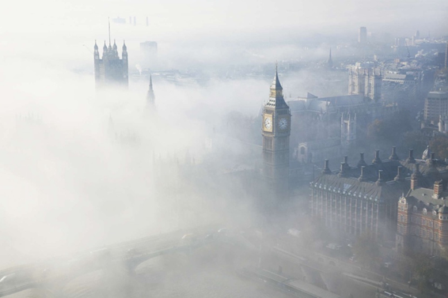
Comment on the quote below. Do you agree with it?
“I don’t desire to change anything in England except the weather.”
Oscar Wilde

Look at the picture.
Why is Britain sometimes called “Foggy Albion”?
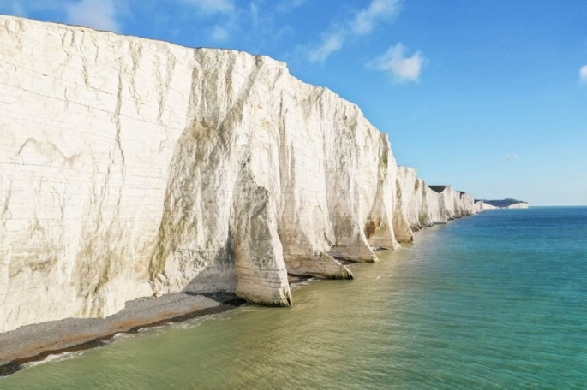
Do you know the origin of the name “Albion”?
Look at the picture of the White Cliffs of Dover and try to guess.
A hint: “albus” in Latin means “white”.

KEY WORDS AND WORD COMBINATIONS
aircraft | [ˈeə.krɑːft] | самолет/авиастроение  воздушное судно
cattle | [ˈkæt.əl] | крупный рогатый скот
cereals | [ˈsɪə.ri.əlz] | злаковые культуры
chemicals | [ˈkem.ɪ.kəlz] | химикаты, химическая  продукция
coal | [kəʊl] | уголь
coastline | [ˈkəʊst.laɪn] | побережье
conquest | [ˈkɒŋ.kwest] | завоевание
descendant | [dɪˈsendənt] | потомок
hill | [hɪl] | холм
horticulture | [ˈhɔːtɪkʌlʧə] | садоводство
invasion | [ɪnˈveɪ.ʒən] | вторжение
island | [ˈaɪlənd] | остров
maritime | [ˈmær.ɪ.taɪm] | морской
mild | [maɪld] | мягкий
motor vehicle | [ˈməʊ.tə ˌvɪə.kəl] | автомобиль, моторное  транспортное средство
mountain | [ˈmaʊn.tɪn] | гора
oilseed | [ˈɔɪl.siːd] | семя масличного растения
peninsula | [pɪˈnɪnsjʊlə] | полуостров
petroleum | [pəˈtrəʊ.li.əm] | нефтепродукты
poultry | [ˈpəʊl.tri] | домашняя птица, птицеводство
railroad | [ˈreɪl.rəʊd] | железная дорога
rolling plain | [ˈrəʊ.lɪŋ pleɪn] | холмисто-равнинная местность
rugged | [ˈrʌɡ.ɪd] | пересеченный (о местности)
shipbuilding | [ˈʃɪpˌbɪl.dɪŋ] | кораблестроение
temperate | [ˈtempərɪt] | умеренный
topography | tɒˈpɒgrəfɪ] | рельеф, ландшафт, топография
to aid in | [tə eɪd in] | помогать, способствовать
to appease | [tə əˈpiːz] | умиротворять
to be located | [tə bi ləʊˈkeɪtid] | быть расположенным
to be made up of | [tə bi ˌmeɪd ˈʌp əv] | состоять из
to succeed | [tə səkˈsiːd] | следовать за, быть преемником
undeveloped | [ˌʌn.dɪˈvel.əpt] | неразвитый
valley | [ˈvæl.i] | долина

VOCABULARY

Exercise 1
Look at these easily confused words. Use dictionaries to tell the difference.
Channel v. Canal
Economy v. Economics

Exercise 2
Match each group of words with a general term describing them. Continue the lists.
1) hill, plain, mountain… | a) industry
2) lake, river, ocean… | b) terrain
3) shipbuilding, petroleum processing, metalwork… | c) agriculture
4) poultry, cattle breeding, horticulture | d) body of water

Exercise 3
Match the words with similar meaning. Mention the difference if there is any. Use dictionaries if necessary.
1) windy | a) humid
2) wet | b) blowy
3) valley | c) drizzly
4) fog | d) dale
5) rainy | e) mist

Exercise 4
Match the words with opposite meaning.
1) humid | a) rolling
2) cloudy | b) rainy
3) sunny | c) arid
4) flat | d) overcast
5) dry | e) clear

Exercise 5
Match the words with their definitions and translate them into Russian.
1) industry | a) the position north or south of the equator
2) maritime | b) a piece of land that is completely surrounded by water
3) latitude | c) the group of people who work in a company, industry, country, etc.
4) longitude | d) the science or practice of farming
5) peninsula | e) the companies and activities involved in the process of producing goods for sale, especially in a factory or special area
6) island | f) an area of land that is almost surrounded by water but is joined to a larger piece of land
7) workforce | g) near the sea or coast
8) agriculture | h) the distance of a place east or west of an imaginary line between the North Pole and the South Pole

Exercise 6
Solve the clues using and read the keyword highlighted in blue.
¹
²
³
⁴
⁵
⁶
⁷
⁸
⁹
¹⁰
¹¹
¹²

1. The practice or work of farming.
2. The metal tracks on which trains run.
3. Something used to transport people or goods.
4. An area of low land between hills or mountains, often with a river running through it.
5. A raised part of the earth's surface, much larger than a hill.
6. The activity of building ships.
7. Manufacturing activity as a whole.
8. An area of land that is higher than the surrounding land.
9. Thin fog produced by very small drops of water.
10. An occasion when an army uses force to enter and take control of another country.
11. A part of the land next to the sea.
12. An extensive area of level or rolling treeless country.

READING

Exercise 7
Read the text about the United Kingdom and be ready to do the tasks that follow it.
THE UNITED KINGDOM: AN OVERVIEW
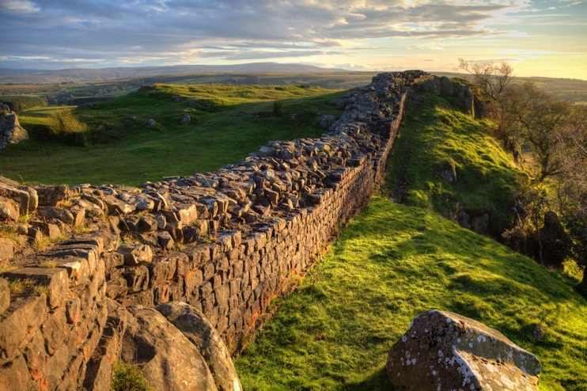
The United Kingdom (UK) is an island nation located in Western Europe. Its official name is the United Kingdom of Great Britain and Northern Ireland (Great Britain includes only England, Scotland, and Wales). The UK’s land area is made up of the island of Great Britain, part of the island of Ireland and many smaller nearby islands. The UK has coastlines along the Atlantic Ocean, the English Channel, and the North Sea.

Formation of the United Kingdom
The UK has a long history that consists of several different invasions, including a brief entry by the Romans in 55 B.C.E. Then, the huge part of the island was conquered by Vikings under the leadership of Halfdan Ragnarsson and Ivar the Boneless. The occupied area was called the Danelaw because Danish laws dominated laws of Anglo-Saxons. In 1066 the UK area was part of the Norman Conquest (interestingly, William the Conqueror, who took the English crown, was a descendant of Vikings), which aided in cultural and political development of the country.
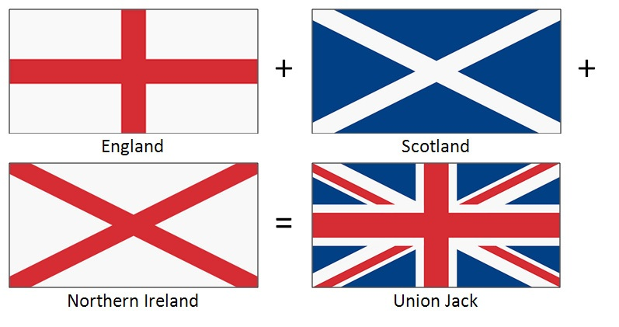
In 1282 England took over the independent Kingdom of Wales under Edward I and in 1301, his son, Edward II, was made the Prince of Wales in an effort to appease the Welsh people. The eldest son of the British monarch is still given this title today. In 1536 England and Wales became an official union. In 1603, England and Scotland also came under the same rule when James VI succeeded Elizabeth I, his cousin, to become James I of England. A little over 100 years later in 1707, England and Scotland became unified as Great Britain.
On January 1, 1801, a legislative union between Great Britain and Ireland took place and the region became known as the United Kingdom. However, throughout the 19th and 20th centuries, Ireland continuously fought for its independence. As a result, in 1921, the Anglo-Irish Treaty established the Irish Free State (which later became an independent republic). Northern Ireland however, remained a part of the UK which is today includes that region as well as England, Scotland, and Wales.
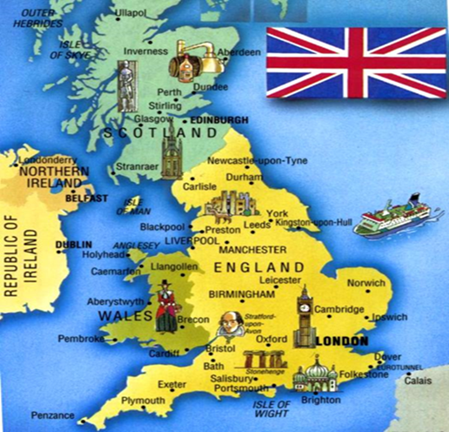
Geography and Climate of the United Kingdom
The United Kingdom is located in Western Europe to the northwest of France and between the North Atlantic Ocean and the North Sea. Its capital and largest city is London, but other large cities are Glasgow, Birmingham, Liverpool, and Edinburgh. The UK has a total area of 243,610 square kilometres. Much of the topography of the UK consists of rugged, undeveloped hills and low mountains but there are flat and gently rolling plains in the eastern and southeastern areas of the country. The highest point in the UK is Ben Nevis at 4,406 feet (1,343 m) and it is located in the northern UK in Scotland.
The climate of the UK is considered temperate and mild despite its latitude. Its climate is moderated by its maritime location and the Gulf Stream. However, the UK is known for being very cloudy and rainy throughout much of the year. The western parts of the country are wettest and also windy, while the eastern portions are drier and less windy. London, located in England in the south of the UK, has an average January low temperature of 2.4˚C and a July average temperature of 23˚C.


Economy and Land Use in the United Kingdom
The United Kingdom has the third largest economy in Europe (behind Germany and France) and it is one of the world's largest financial centers. The majority of the UK's economy is within the service and industrial sectors, and agriculture jobs represent less than 2% of the workforce. The main industries of the UK are machine tools, electric power equipment, automation equipment, railroad equipment, shipbuilding, aircraft, motor vehicles, electronics and communications equipment, metals, chemicals, coal, petroleum, paper products, food processing, textiles, and clothing. The agricultural products of the UK are cereals, oilseed, potatoes, vegetables cattle, sheep, poultry and fish.
(Retrieved from:https://www.thoughtco.com/)
Exercise 8
Find English equivalents of the following words and phrases in the text:
.
- островная страна | 6) законодательный союз
- состоять из | - квадратные километры
- под предводительством | - морское расположение
- потомок | - в течение
- стать преемником | - финансовый центр

Exercise 9
Answer the questions.
- What parts does the UK consist of?
- Why is the eldest son of the British monarch still given the title of the Prince of Wales?
- How did the Irish Free State appear?
- What does the topography of the UK consist of?
- Why is the climate of the United Kingdom mild?
- What is the typical weather in the United Kingdom?
- What is the largest sector of the UK’s economy?
- What industrial products does the UK produce?

Exercise 10
Mark the following statements as true or false.
Statement | True | False
1. The United Kingdom and Great Britain are the same thing.
2. Britain was never conquered by outlanders.
3. Scotland was annexed to England in the 18th century.
4. London is not the only large city in the UK.
5. The UK highest mountain is located in Wales.
6.The UK is famous for its harsh winters and snowy weather.
7. Agriculture represents the biggest part of the workforce.
8. The UK produces a lot of agricultural products such as poultry and fish.

Exercise 11
Match the halves of the sentences.
1. The UK has a long history that | a) still given this title today.
2. The oldest son of the British monarch is | b) within the service and industrial sectors.
3. Much of the topography of the UK consists of | c) Ireland continuously fought for its independence.
4. Its climate is moderated by | d) consists of several different invasions.
5. The majority of the UK's economy is | e) rugged, undeveloped hills and low mountains.
6. However, throughout the 19th and 20th centuries, | f) which aided in its cultural and political development.
7. A little over 100 years later in 1707, England and Scotland became | g) its maritime location and the Gulf Stream.
8. In 1066 the UK area was part of the Norman Conquest, | h) unified as Great Britain.

GRAMMAR
Study grammar rules on the use of THERE + TO BE (see GRAMMAR REFERENCE p.204)

Exercise 12
Fill in the gaps using the constructions given in the box.
There was There will be (x2) There are (x3) There has been (x2) There were (x2)
- __________ a period of Celtic rule in Great Britain before the Roman conquest.
- __________ challenges posed by rising sea levels due to climate change very soon.
- __________ many mysterious historical landmarks in Great Britain, such as Stonehenge.
- __________ many architectural wonders in the city of Oxford.
- __________ a long history of farming and agriculture in various regions of Great Britain which still lasts.
- __________ famous historical figures like Queen Elizabeth II and Winston Churchill in Great Britain.
- In the future, __________ discussions about the impact of the British Empire on world history.
- __________ challenges faced by small businesses in the economy of Great Britain at the moment.
- __________ a long-standing monarchy throughout the history of Great Britain.
- __________ several milestone documents in the history of UK. One of them is Magna Carta.

Exercise 13
Rewrite the sentences so they mean the same as the first. Use There + to be construction:
1. Different peoples invaded Great Britain throughout history. | There were…
2. In the past, England and Scotland conflicted with each other. | In the past, there…
3. Great Britain faced economic challenges after World War II.
4. Great Britain has diverse landscapes, including mountains and coastlines.
5. People worry about the impact of climate change on the United Kingdom.
6. Mild winters and cool summers are typical for the UK.
7. It rains frequently in England.
8. A lot of rivers and lakes contribute to the water supply in Great Britain.
9. People distinguish several distinct regions within Great Britain, like the Scottish Highlands.
10. Climate in Great Britain varies from region to region.

Exercise 14
Translate the sentences form Russian into English using There + to be construction.
- В Британии умеренный морской климат.
- В составе Соединенного Королевства находятся четыре страны.
- В Британии очень сильный финансовый сектор.
- Существуют свидетельства ранних человеческих поселений на Британских островах.
- В течение Реформации в Великобритании происходили религиозные конфликты.
- В Британии есть процветающие отрасли промышленности, такие как автомобильная или авиационно-космическая.
- В Британии продолжаются споры о влиянии Брексита на экономику.
- В Англии и Уэльсе есть много следов влияния Римской империи.
- В Восточной Англии много живописных рыбацких деревень.
- Долгое время в прошлом в Шотландии был свой король.

WATCHING AND LISTENING

Exercise 15
You are going to watch a video about the United Kingdom’s geography and history at https://www.youtube.com/watch?v=7dFVOjaf8SQ and complete the tasks below.

a. BEFORE YOU WATCH. Answer the preliminary questions:
1. Have you ever been to the United Kingdom? If yes, what places have you been to? If no, would you like to visit this country? What places would you like to see?
2. What do you know about the United Kingdom and its geography, culture, history?

b. WHILE YOU WATCH. Answer the questions:
1. Which nations does the United Kingdom consist of? Which nations comprise Great Britain?
2. Which kinds of sports were invented in the UK? What great British authors were mentioned in the video?
3. Is the UK covered by thick forests? Which percent of the land is with green forests nowadays?
4. Who were the first Britons? Where and why did they go?
5. Who gave the name to England? Who were they?
6. What generated the immense wealth and made the UK a huge overseas empire around the globe?
7. When and why did most of the British colonies become independent?
8. How did British kings use to rule? What did this council expand into?
9. Does the monarch have any power nowadays?
10. When did British industry lift the country and make it the most powerful nation?

c. Look at three extracts from the video. Some words are missing. Fill in the gaps using words in the box below. Make sure that you know each word in the box. Use a dictionary if necessary.
terrain invaders lochs wildlife species Celts mountain ridges habitat settled down marshes landscapes tall cliffs glaciers

1. Most of the Northern and Western part of the UK is covered in high-ground and (1) __________ separated by deep valleys. This (2) __________ was formed in the last ice age when thick glaciers covered it completely. In the south part of England, the countryside is filled with hills. North-west England and the Scottish Highlands are home to dozens of lakes known as (3) __________. These remained in existence when the Ice Age (4) __________ melted. The lochs tend to be long and narrow, and some are very deep.
2. British people are the creation of waves of (5) __________ and migrants who traveled to this place including (6) __________, Romans, Anglo-Saxons, Vikings and Normans. People from former colonies in the Caribbean, Africa, and Asia came to the United Kingdom to work and finally (7) __________ here during 1950s and 60s.
3. United Kingdom’s complex geology allows rise to a wide variety of (8) __________ and a range of habitats for its plant and animal life. Whereas this country is very crowded with many people, the most successful (9) __________ live alongside humans. The rugged mountains like the Scottish Highlands offer (10) __________ that is relatively untouched by humans. The country’s 7700 miles of shoreline ranging from (11) __________ to beaches to (12) __________ also provide homes for wildlife.

SPEAKING

Exercise 16
Work in small groups (2-3 students). Search for additional information on the Internet and share it with your groupmates.
- Nations comprising the UK.
- British sports.
- British literature and great authors.
- Wildlife of the British Isles.
- British industry.

WRITING

Exercise 17
Writing a Summary
a. Watch the video which can help you to write a good summary at https://www.youtube.com/watch?v=eGWO1ldEhtQ.

b. Mark the statements as True or False.
Statement | True | False
1. Summarizing is not an important skill for students to learn.
2. A summary should include all of the main points from the original material.
3. A summary should include specific details like numbers and statistics.
4. A good summary should not follow a paragraph structure.
5. The topic sentence of a summary should identify itself as a summary.
6. Supporting sentences in a summary should include the author's opinion.
7. It is not okay to copy and paste sentences directly from the original material when writing a summary.
8. A summary doesn’t have be objective and may include the writer's opinion.

c. What characteristics should a proper summary have?

Exercise 18
Jigsaw activity. Groupwork. Students should be split into three teams. Each team reads one article out of three suggested. When you read your text, you should summarize it. Exchange your summary with one of your groupmates (not from your group) and asses your groupmate’s summary (you should put your name under the assessment). To do this, you need to read the text which was summarized by your partner. In the end, you get two grades: for your own summary and for the accuracy of your assessment.

Article A: Scotland - A Short History
Article B: Irish Culture: 9 Things That Make Our Little Island Tick
Article C: Geography and Fun Facts About Great Britain

3.1.2. The British Constitution. Parliament and Government

LEAD IN
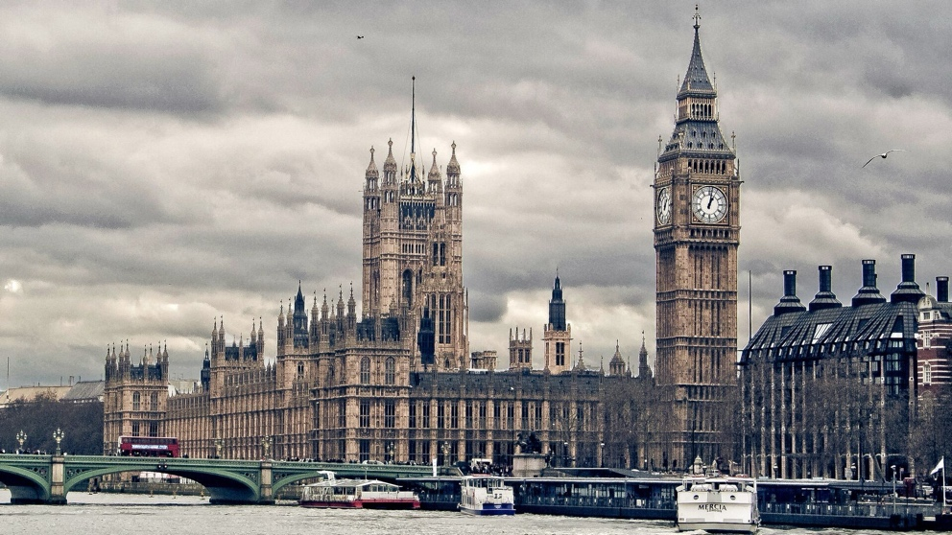
Answer the questions.
1. What do you know about the UK political system?
2. Do you find it good or bad?

Comment on the quote by Sir Winston Churchill.
“The monarchy is so extraordinarily useful. When Britain wins a battle she shouts, God, save the Queen; when she loses, she votes down the prime minister”.
Winston Churchill

KEY WORDS AND WORD COMBINATIONS
assembly | [əˈsem.bli] | собрание, ассамблея
authority | [ɔːˈθɒr.ə.ti] | полномочие, орган власти
ballot | [ˈbælət] | голосование
ballots | [ˈbæləts] | бюллетени для голосования
bicameral | [baɪˈkæm(ə)rəl] | состоящий из двух палат
bill | [bɪl] | законопроект
constituency | [kənˈstɪʧʊənsɪ] | избирательный округ
elections | [ɪ'lekʃ(ə)ns] | выборы
executive | [ɪgˈzekjʊtɪv] | исполнительный
House of Commons | [haʊs ɒv ˈkɒmənz] | Палата общин
House of Lords | [haʊs ɒv lɔːdz] | Палата лордов
issue | 1. [ˈɪʃ.uː]  2. [ˈɪs.juː] | предмет, вопрос
judicial | [ʤuːˈdɪʃəl] | судебный
legal document | [ˈliː.ɡəl ˈdɒk.jə.mənt] | юридический документ
legislative | [ˈleʤɪslətɪv] | законодательный
Member of Parliament (MP) | [ˈmembə ɒv ˈpɑːləmənt] | член парламента, депутат
on the contrary | [ən ðə ˈkɒn.trə.ri] | напротив, наоборот
political parties | [pəˈlɪtɪkəl ˈpɑːtiz] | политические партии
select committee | [sɪˌlekt kəˈmɪt.i] | специальный комитет
senior minister | [ˈsiː.ni.ər ˈmɪn.ɪ.stər] | главный министр
to be beholden to | [tə biː bɪˈhoʊldən tuː] | подчиняться, быть подотчетным
to enforce | [tuː ɪnˈfɔːs] | обеспечивать соблюдение
to ensure | [tə ɪnˈʃɔːr] | обеспечивать, гарантировать
to govern | [tə ˈɡʌv.ən] | управлять, руководить
to head | [tə hed] | возглавлять
to implement | [tuː ˈɪmplɪmənt] | выполнять, осуществлять, реализовывать
to make laws | [tuː meɪk lɔːz] | создавать законы, заниматься законотворческой деятельностью
to prosecute | [tə ˈprɒs.ɪ.kjuːt] | преследовать в судебном порядке, привлекать к суду
to respond | [tə rɪˈspɒnd] | отвечать, реагировать
to run the government | [tə rʌn ðə ˈɡʌvərn.mənt] | управлять государством
to scrutinize | [tuː ˈskruːtɪnaɪz] | тщательно изучать
to take place | [tə teɪk pleɪs] | проходить, состояться
ultimately | [ˈʌl.tɪ.mət.li] | в конечном итоге
uncodified | ['ʌn'kəudɪfaɪd] | некодифицированный

VOCABULARY

Exercise 1
Internet activity. Look at these usually confused words referring to politics and organizational structure of peoples. Search for information on the Internet and explain the difference between them.
Nation v. Country v. State v. Government

Exercise 2
Match the words with similar meaning.
1) to challenge | a) to discuss
2) to scrutinize | b) to guarantee
3) to inquire | c) to dispute
4) to debate | d) to investigate
5) to ensure | e) to ask

Exercise 3
Match the words with their definitions and translate them into Russian.
1) constitutional monarchy | a) a form of monarchy in which the monarch rules in his/her own right or power;
2) absolute monarchy | b) the branch of government having the power to make laws;
3) executive branch | c) a legislature with two houses, or chambers;
4) legislative branch | d) the head of government in a country with a parliamentary or semipresidential political system;
5) judicial branch | e) a system in which the king or queen's power is severely limited, because they act only on the advice of the politicians who form the government;
6) bicameral legislature | f) a formal statement of a planned new law discussed before being voted on;
7) Prime-Minister | g) a definite course or method of action selected from among alternatives and in light of given conditions to guide and determine present and future decisions;
8) bill | h) the branch of government responsible for the interpretation of laws and the administration of justice;
9) policy | i) one of the official areas of a country that elects someone to represent it in a parliament or legislature;
10) constituency | j) the branch of government responsible for the execution and enforcement of laws and policies and the administration of public affairs;

Exercise 4
a. Examine the table of possible collocations with the word “laws”. Find out the meaning of each collocation using the dictionaries and translate them into Russian.
to make/pass | laws
to remove | laws
to break | laws
to implement | laws
to enforce | laws

b. Use verbs from (a) to complete the sentences.
- House of Commons is authorized to ________, or, in other words, create laws.
- Police has the duty to ________ laws and arrest criminals.
- Government needs to ________ the new law on education and reduce the school dropout.
- Antisocial people are more likely to ________ laws.
- On the other hand, the courts not being the legislative branch are not empowered to ________ laws.

Exercise 5
a. Match the left column with the right one and complete the word combinations.
1) to chair | a) someone to account
2) to act | b) the views
3) to hold | c) the needs of people
4) to represent | d) debates
5) to meet | e) on someone’s behalf

b. Fill in the gaps using the word combinations from the previous part of the exercise.
- The MPs feel an obligation __________ of people who elected them.
- Parliament and the Government must _____ the nation’s _____.
- At the time of this basic treatment, an attempt could be made to identify the perpetrator and _____ him ________.
- The main purpose of governmental services is ________.
- The speaker is the person who_____ in the House of Commons keeping order and and calling MPs to speak.

READING

Exercise 6
Read the text and translate it.

HOW THE BRITISH POLITICAL SYSTEM WORKS
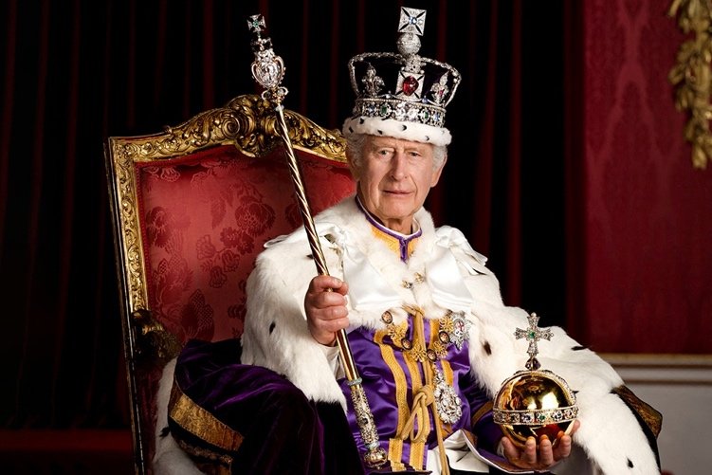
British politics can seem very confusing – there are lots of different political parties and branches of government, and even though we have a monarchy we are also a democracy. We’ve put together this handy guide to answer some common questions about the British political system.

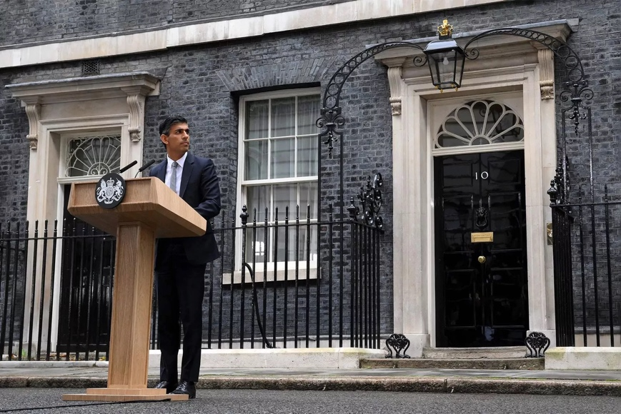
Who is in charge of the UK?
The first question which is asked when a person is learning about the UK’s political system is “Is the King or the Queen in charge of the UK?” The United Kingdom is a parliamentary democracy under a constitutional monarchy. This means that while a monarch is the head of state, he or she is not the head of government. The monarch does not get to make most of the decisions about how the government is run; that job belongs to the Prime Minister, or PM. Nowadays the Monarch’s role is mostly ceremonial.
Speaking of legislature, it is necessary to remember that the United Kingdom has no codified and written constitution. On the contrary, The UK has an uncodified constitution: its rules have never been written down together in a single legal document and some have not been written down at all. Supporters of uncodified constitutions would argue that if you try to reduce a nation’s entire legal, political, ethical and social rules into a single definitive list, you risk over-simplification.


Do England, Scotland, Wales, and Northern Ireland each have their own governments?
Yes and no. England is the most powerful country of the four and the British Government works for an English monarch. Scotland, Wales, and Northern Ireland are all ultimately beholden to English law. However, Scotland, Wales, and Northern Ireland all have governing bodies that work exclusively on issues in their own countries.

Branches of power in the UK
Legislative power is the power to make new laws or remove old ones. This power is held by Parliament, which is made up of the House of Lords and the House of Commons. The Scottish Parliament, the Welsh Assembly, and the Northern Irish Assembly also have legislative powers; however, they do not have as much authority as Parliament.
Executive power – the power to implement and enforce laws – is controlled by the British government, which works on behalf of a monarch, as well as the devolved governments of Scotland and Wales and the Northern Ireland Executive.
Judicial power, which is the power to prosecute those who break the law, is kept independent of the legislature and the executive. The highest court in the UK is the Supreme Court of the United Kingdom.

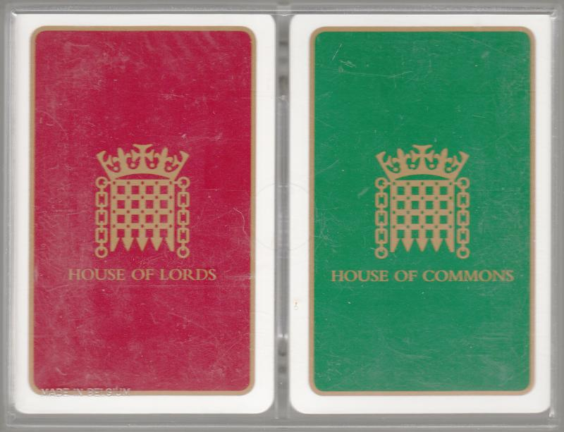
The two-house system
The UK has a bicameral legislature, which means that the business of Parliament takes place across two Chambers – The House of Commons and the House of Lords. Both Houses make laws, check and challenge government and represent views. The Lords and the Commons share the tasks of making laws, holding government to account, and debating the issues of the day.
The House of Commons is the elected part of Parliament. It is also responsible for funding government departments by passing laws which allow for the collection of taxes.
The House of Lords is one of two Houses of Parliament and provides a second opinion to the House of Commons and the government. It is not an elected body. The three main roles of the House of Lords are making laws, checking and challenging the work of the government and investigating public policy.
(Retreived from: https://greatbritishmag.co.uk/, https://assets-learning.parliament.uk)

Exercise 7
Find English equivalents of the following words and expressions in the text.

- глава правительства/ государства
- церемониальный
- законодательство
- кодифицированный
- юридический документ
- подчиняются английскому праву
- руководящий орган
- вопрос
- двухпалатный
- проверять и подвергать оценке

Exercise 8
Answer the questions.
- Which form of government is there in the UK?
- Who makes decisions about how the government is run?
- What is the argument of supporters of uncodified constitution?
- Does England have its own government?
- Who holds the power to make new laws and remove old ones?
- Who controls the executive power in the UK?
- What is the function of the judicial power?
- What legislature does the United Kingdom have?
- What are the functions of The House of Commons?
- What are the functions of The House of Lords?

Exercise 9
Read the false statements and correct them.
- King or Queen of England is both the head of the government and the head of the state.
- The United Kingdom has an ancient codified constitution.
- Scottish government can work on issues relating to the whole Kingdom.
- Powers in Great Britain are not separated.
- The UK Government works on behalf of a Prime Minister.
- Both chambers of British Parliament are elected by ordinary people.

WATCHING AND LISTENING

Exercise 10
You are going to watch the video about British Parliament at https://www.youtube.com/watch?v=RAMbIz3Y2JA) and do the tasks listed below.
  - BEFORE YOU WATCH. Answer the preliminary questions.
What do you know about British Parliament? How does it work? Is it similar or different to the Federal Assembly which we have in Russia?
- WHILE YOU WATCH. Fill in the gaps.
- MPs from the _______ question the government on policy and proposed laws. The _______ keeps the house in order by chairing these debates
- There are also people working behind the scenes who support the work of Parliament: _______, _______, _______ and many more.
- Another important way Parliament can _______ or look in detail at the work of government is through _______ _______.
- The committee writes a report with _______ that the government usually responds to within _______ days.
- Once agreed, a bill is drawn up, and the minister _______ for the policy introduces the _______ to Parliament for debate.
- General elections take place in the UK usually _______ every _______ years, and every seat is up for grabs.
- Party standing for election publish a declaration of their _______ during the campaign called a _______.
- One way to have a say in how the country is run is to use your _______. You have to be 18 or over to vote in general elections but you can register from the age of _______.
- Anyone can contact any Lord, or their local MP by _______, _______, or _______ to discuss an issue that's important to them or their community.
- By _______, _______, _______, and more you can also get involved with the work of Parliament.
- AFTER YOU WATCH. Answer the questions:
- Which two historical events gave birth to British Parliament?
- Which parts does Parliament consist of? What are their purposes?
- How many MPs are there? Must they belong to any political party?
- Who does the House of Lords consist of? How many Lords are there?
- How can Parliament influence the work of Government?
- How does Parliament make and shape laws?
- How are MPs elected through the General Elections?
- How can candidates campaign to get people to vote for them?
- What happens when there is a “hung Parliament”?
- How can people participate in the political life of the UK?

GRAMMAR
Study grammar rules on the use of COUNTABLE AND UNCOUNTABLE NOUNS (See GRAMMAR REFERENCE p.205)

Exercise 12
Read the words taken from Watching and Listening section and decide whether they are countable, uncountable, or can be both.

bill ballot healthcare discussion king opposition parliament crime nation power government state policy public education election people law

Exercise 13
Sort the words in the box into countable and uncountable words. Consult dictionaries if necessary. Some words can be brought into both categories.
education knowledge textbook reason mountain chicken furniture backpack tea castle car money advice cab wool chocolate water river luggage church table lake rain friendship news

Countable | Uncountable | Both
… | … | …

Exercise 14
Choose the correct variant in italics.
- In this case, I can give you several advices/pieces of advice.
- – Are you ready to order?
– Yes. I’d like a tea/tea and two coffees/coffee for my colleagues, please.
- The only item of furniture/furniture that decorated his bedroom was a wooden bed.
- Any living being needs water/waters.
- Remember! We mustn’t take many/much luggage!
- Jack’s money is/are only Jack’s problem.
- Use your knowledge/knowledges only for good.
- Mr. Grey has 4 cows and 7 sheep/sheeps in his barnyard.
- I have many/much toys at home.
- No news is/are good news.

SPEAKING

Exercise 15
Retell the text from Reading section and complement it with some additional information on one of the suggested topics:
- Political parties in the UK.
- The role of the monarch in the legislature process.
- The history of Parliament.

Theme 3.2.The United States of America: Geography, Economy, Politics

3.2.1. History, Geography, Climate, Economy of the US

LEAD IN

Read two opposing quotes. Which one do you like best? Why?
“It was wonderful to find America, but it would have been more wonderful to miss it” | "The discovery of America was a turning point in history, marking the beginning of a new era of exploration, colonization, and globalization"
Mark Twain | Francis Fukuyama
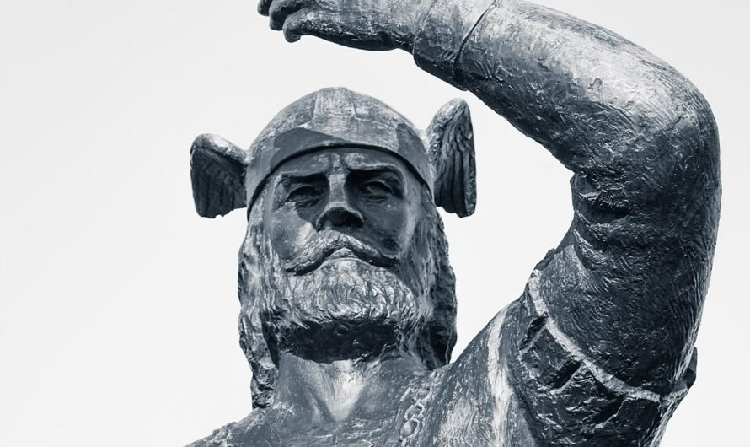
Do you know who the first Europeans to discover America were? Do you know such names as Vinland and Mayflower? Discuss it with your groupmates.

The United States “wears” many belts. One of them is called Rust Belt. Try to guess why it is rusty and what this name means.
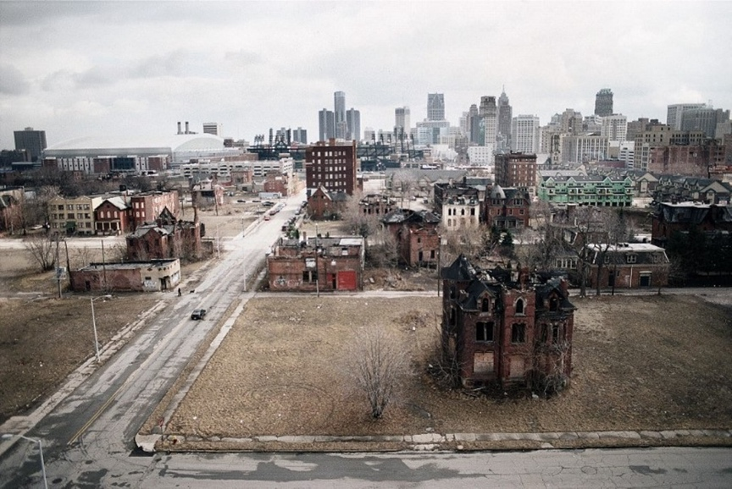

KEY WORDS AND WORD COMBINATIONS
agricultural output | [ˌæɡ.rɪˈkʌl.tʃər.əl ˈaʊt.pʊt] | сельскохозяйственное производство
by virtue of | [ˈvɜː.tʃuː] | по причине, в силу чего то
consumer goods | [kənˈsjuː.mə ɡʊdz] | потребительские товары
diverse population | [daɪˈvɜːs pɒp.jəˈleɪ.ʃən] | разнообразное население
economic  self-sufficiency | [ˌiː.kəˈnɒm.ɪk ˌself.səˈfɪʃ.ən.si] | экономическая самодостаточность
environment | [ɪnˈvaɪ.rən.mənt] | среда
ethnic | [ˈeθ.nɪk] | этнический
gasoline (AmE) | [ˈɡæs.əl.iːn] | топливо
grain | [greɪn] | зерно, зерновые культуры
immense | [ɪ'mens] | огромный
indigenous | [ɪnˈdɪʤ(ə)nəs] | коренной
investment capital | [ɪnˈvest.mənt ˌkæp.ɪ.təl] | инвестиционный капитал
landscape | [ˈlænd.skeɪp] | пейзаж
lumber | [ˈlʌm.bər] | пиломатериалы, древесина
mining | [ˈmaɪ.nɪŋ] | горнодобывающая промышленность
moist | [mɔɪst] | влажный
mountain ranges | [ˈmaʊntɪn ˈreɪnʤɪz] | горные хребты
nation’s wealth | [ˈneɪ.ʃən welθ] | национальное богатство, богатство страны
Native Americans | [ˌneɪ.tɪv əˈmer.ɪ.kənz] | коренные американцы
racial | [ˈreɪ.ʃəl] | расовый
sheer | [ʃɪər] | чистый
source | [sɔ:s] | источник
subregion | [ˈsəb-ˌriː.dʒən] | субрегион
to border on | [tə ˈbɔː.dər] | граничить
to enrich | [tə ɪnˈrɪtʃ] | обогатить
to feature | [təˈfiː.tʃər] | включать, содержать, иметь
to impinge on | [tə ɪmˈpɪndʒ] | оказывать влияние на что-то
to owe | [tə əʊ] | быть обусловленным, обязанным
wheat | [wiːt] | пшеница

VOCABULARY

Exercise 1
a. Match types of terrains with images.
rain forest desert prairie plain mountain ranges

 | 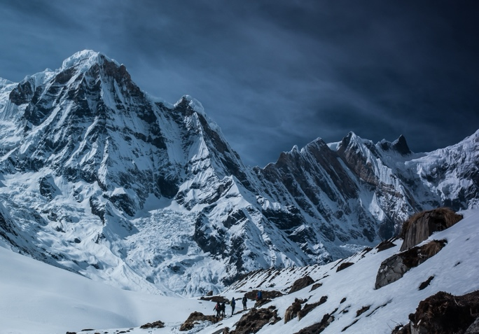
a. | b.
 | 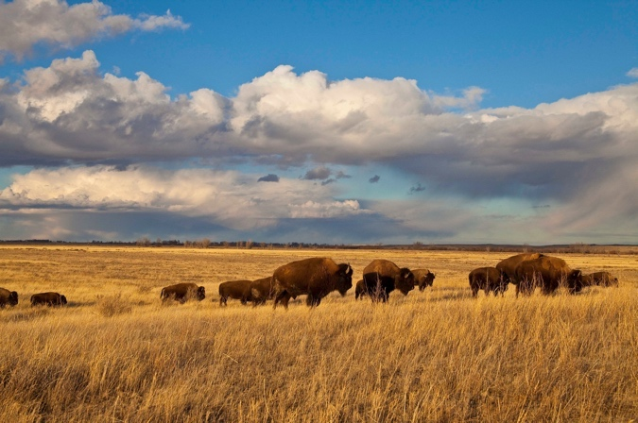
c. | d.
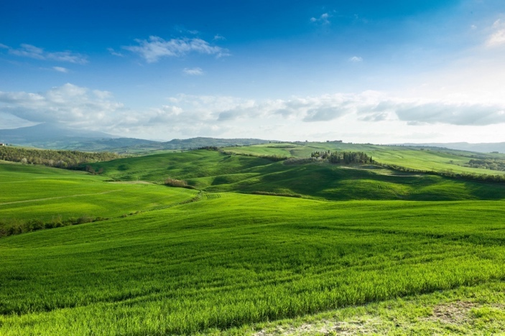
e.

Exercise 2
Match types of climates with their definitions. Use dictionaries if necessary.
- tropical climate | - an extremely hot and dry climate, characterized by small number of animal and plant species;
- arid climate | - is characterized by relatively moderate annual temperatures and distinct seasonal changes;
- polar climate | - the rainy and hot climate, zones of this climate receive more solar energy than anywhere else;
- temperate climate | - a climate characterized by cool summers and very cold winters.

Exercise 3
Match the words with their definitions and translate them into Russian.
1. Gross domestic product (GDP) | a) goods bought by one country from another;
2. Export | b) any of the materials such as water, coal, and wood that exist in nature and can be used by people;
3. Import | c) the total value of goods and services produced by a country in a year;
4. Natural resources | d) the population group that inhabited the area first;
5. Indigenous people | e) a product that you sell in another country.

Exercise 4
Fill in the gaps using the words from Key Words and Words Combinations section.
- The northern border of the country also has___________which are hundreds of meters high above sea level.
- New York offers a great variety of dishes as a result of its ethnically __________ population.
- Prices can vary significantly from state to state because state __________ taxes are different.
- The plant also produced __________, including mobile phones.
- The first people to live on the territory of the United States and Canada were __________.
- The stump symbolizes the importance of the __________ industry in Minnesota's history.
- He had a vision of a tolerant society living in __________ harmony.
- Data from these systems primarily provide a qualitative description of sea-floor __________.

READING

Exercise 5
Read the text about the USA and be ready to do the tasks that follow.

THE UNITED STATES OF AMERICA. AN OVERVIEW

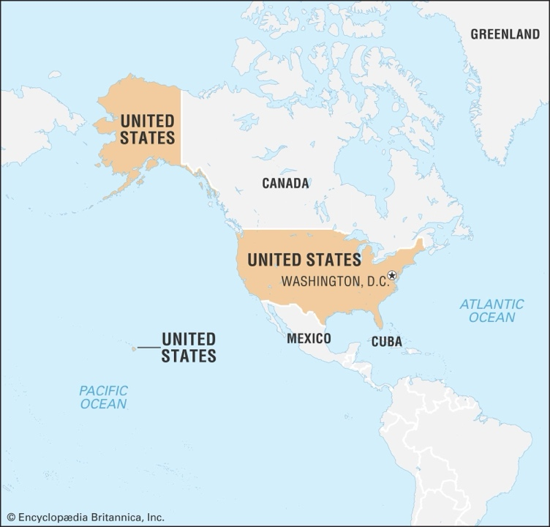
The United States is the third largest country in the world in area (after Russia and Canada). The national capital is Washington, which is coextensive with the District of Columbia, the federal capital region created in 1790.

Geography and Climate
The USA is washed by the Atlantic Ocean in the east and by the Pacific Ocean in the west. The country borders on Canada and Mexico.
The major characteristic of the United States is probably its great variety, much greater than in many countries. Its physical environment ranges from the Arctic to the subtropical, from the moist rain forest to the arid desert, from the rugged mountain peak to the flat prairie. The eastern regions consist of hills and low mountains, while the central interior is a vast plain (called the Great Plains region). The west has high rugged mountain ranges (some of which are volcanic in the Pacific Northwest). Alaska also features rugged mountains as well as river valleys. Hawaii's landscape varies but is dominated by volcanic topography.
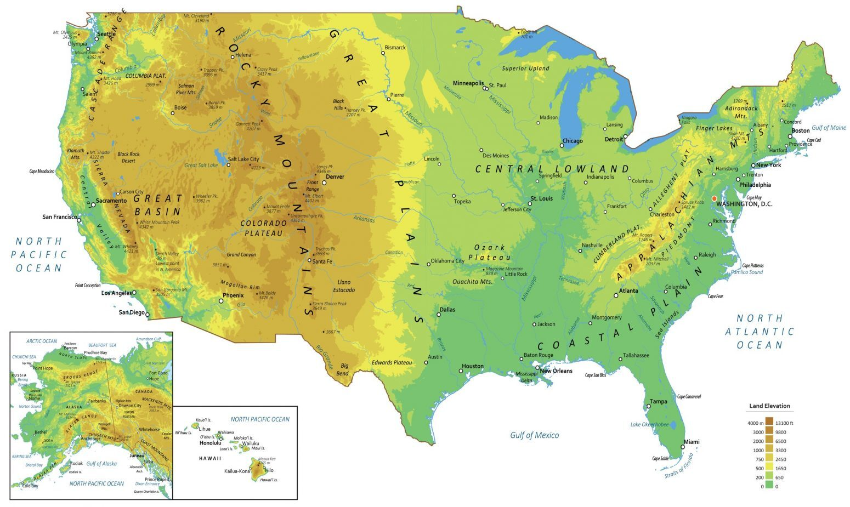
Like its topography, the climate of the U.S. also varies depending on location. It is considered mostly temperate but is tropical in Hawaii and Florida, arctic in Alaska, semiarid in the plains west of the Mississippi River and arid in the Great Basin of the southwest.

Population
The United States contains a highly diverse population. Unlike a country such as China that largely incorporated indigenous peoples, the United States has a diversity that to a great degree has come from an immense and sustained global immigration. Probably no other country has a wider range of racial, ethnic, and cultural types than the United States. In addition to the presence of surviving Native Americans (including American Indians, Aleuts, and Eskimos) and the descendants of Africans taken as enslaved persons to the New World, the national character has been enriched, tested, and constantly redefined by the tens of millions of immigrants who by and large have come to America hoping for greater social, political, and economic opportunities than they had in the places they left.

Traditional Regions of the USA
Typically, U.S. governmental agencies identify 5 different regions – Northeast, Southeast, Midwest, Southwest and The West. However, some of these regions can be subdivided into sub-regions. Such a division allow to better present the different territories.
Thus, the US can be divided into 7 regions:
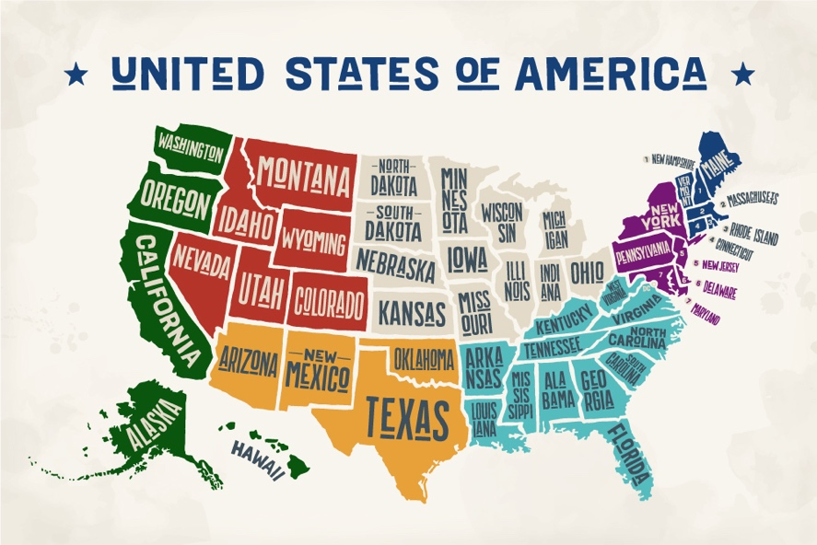
- New England (blue)
- Mid-Atlantic (purple)
- Southeast (light blue)
- Midwest (white)
- The Rocky Mountains (red)
- Southwest (yellow)
- Pacific Coastal (green)

Economy and Land Use
The United States is the world’s greatest economic power, measured in terms of gross domestic product (GDP). The nation’s wealth is partly a reflection of its rich natural resources and its enormous agricultural output, but it owes more to the country’s highly developed industry. The main industries include petroleum, steel, motor vehicles, aerospace, telecommunications, chemicals, electronics, food processing, consumer goods, lumber, and mining. Agricultural production, though only a small part of the economy, includes wheat, corn, other grains, fruit, vegetables, cotton, beef, pork, poultry, dairy products, fish, and forest products.
Despite its relative economic self-sufficiency in many areas, the United States is the most important single factor in world trade by virtue of the sheer size of its economy. Its exports and imports represent major proportions of the world total. The United States also impinges on the global economy as a source and destination of investment capital.
(Retrieved from: https://www.thoughtco.com/,
https:/www.britannica.com/place/United-States
https://www.usawelcome.net/ )

Exercise 6
Find English equivalents to the words given below.

- граничить
- разнообразие
- ландшафт
- вулканический
- огромный
- коренные народы
- потомки
- отражение
- самодостаточность
- воздействовать

Exercise 7
Which two statements correspond to the text?
- The eastern regions of America are hilly and mountainous.
- America’s population is largely made up of indigenous people.
- New England is the part of Great Britain.
- Rich natural resources contribute significantly to the nation’s wealth.
- American exports and imports represent minor proportions of the world trade.

Exercise 8
Which two statements contradict the text?
- The U.S. climate varies greatly depending on location.
- There is the presence of surviving Native Americans.
- U.S. governmental agencies identify 3 different regions within the United States.
- Petroleum and motor vehicles are among the main U.S. industries.
- Agricultural production makes up the largest part of the U.S. economy.

Exercise 9
Answer the question.
- What are Washington and the District of Columbia?
- What climate zones and landscapes does the United States include?
- What peoples compose the U.S. population?
- Are all peoples of the United States indigenous?
- What regions does America consist of?
- What are the sources of the country’s wealth?
- What are the main industries in the USA?
- How does the USA influence on the world economy?

GRAMMAR I
Study grammar rules on the use of ARTICLES (See GRAMMAR REFERENCE p.207)

Exercise 10
Here, some sentences from the text above. Articles or their absence is underlined. What can article’s use or absence can tell us?
- The United States is the third largest country in the world.
- The major characteristic of the United States is probably its great variety.
- The eastern regions consist of _ hills and _ low mountains, while the central interior is a vast plain.
- The United States contains a highly diverse population.

Exercise 11
Which toponyms should be used with the article and which without any?
Dallas Airport National Museum of Natural History
United States of America Midwest Pacific Ocean Philadelphia Lake Ontario Rocky Mountains Butcher Hill Mississippi Times Square Washington Street United Kingdom Mount McKinley

THE article | No article
… | …

Exercise 12
Translate the sentences from Russian into English paying special attention to the articles.
- Вдали виднелся высокий и черный горный хребет.
- Миссисипи и Миссури – крупные реки Северной Америки.
- В Пенсильванском университете можно получить хорошее образование.
- Гренландия – самый крупный остров в мире.
- Недалеко от деревни есть речка. Речка быстрая, но не глубокая.
- США – третья по населению страна и четвертая по величине.
- На востоке взошло солнце и осветило долину, которую на две части разделял небольшой ручей.
- Друзья подошли к дому, за которым они увидели высокую гору.

GRAMMAR II
Study grammar rules on the use of ADJECTIVES COMPARISON (See GRAMMAR REFERENCE p.211)

Exercise 13
Look Exercise 14 once again. How can articles be influenced by adjectives? Discuss it with your groupmates.

Exercise 14
Complete the sentences using prompts given in brackets. Put adjectives in either comparative or superlative form.
- Florida has __________ (high) average temperature in the USA.
- The Mojave Desert is __________ (dry) than the Great Salt Lake.
- The Gulf of Mexico is __________ (warm) than the Pacific Ocean.
- Any US state is __________ (isolated, little) than Hawaii.
- The Appalachian Mountains are __________ (old) mountain range in North America.
- The Great Plains have __________ (flat) land in the United States.
- New York is __________ (big, not, as … as) Texas.
- The Grand Canyon is __________ (famous) natural landmark in Arizona.
- Mount McKinley is __________ (high) mountain in North America.
- The Mississippi River is __________ (long) than the Colorado River.

Exercise 15
Translate the sentences from Russian into English.
- Население Калифорнии больше, чем население других штатов.
- Аппалачи древнее Скалистых гор.
- Река Миссисипи – самая широкая река в США.
- Даллас находится дальше от Нью-Йорка, чем Филадельфия.
- Великие Озера – это самая большая группа пресных водоемов на земле.
- Канзас менее заселен чем Айова.
- Средний Запад более индустриально развит, чем Юг страны.
- Вайоминг – наименее заселенный штат США.

WATCHING AND LISTENING

Exercise 16
Watch the video on the essential tips for a first visit to Washington DC at https://www.youtube.com/watch?v=h4KggqdonXU and complete the tasks below.

  - BEFORE YOU WATCH. Answer the preliminary questions:
Think of the places located in Washington DC which you want to visit. Can you name them? Why do you want to visit them?
  - WHILE YOU WATCH.
Mark the statements as True or False:
Statement | True | False
1. There are many free attractions in the U.S. capital.
2. It is very easy to predict the peak bloom for the cherry blossom accurately.
3. The metro features 4 color-coded lines.
4. Metrobuses are less expensive than metro.
5. 70 museums make up the Smithsonian institution.
6. It is worth taking a comfortable pair of shoes to Washington DC.
7. It is possible to see all the landmarks in Wahington DC within a day.
8. You cannot visit the Senate and House galleries of the Capitol.
9. The Washington National Cathedral is very old.
10. It is worth visiting the National Arboretum during the spring time.

c. AFTER YOU WATCH. Answer the questions.
1. When does the National Cherry Blossom Festival take place?
2. Why is it better not to drive in Washington DC?
3. What areas does the Washington DC metro service?
4. What is a Smartrip card?
5. What transport is accessible within the National Mall?
6. Can you bring mace or pepper spray with you?
7. Where are the most important documents in American history kept? What are they?
8. What locations except for museums and galleries does the speaker recommend visiting?
9. What activities can you attend at the Kennedy Center?
10. What is Union Market?

SPEAKING

Exercise 17
Plan your one- or two-day trip across Washington DC and describe it. When would you go there? What places would you visit in the morning? In the afternoon? In the evening? What means of transport would you prefer? Find some supplementary information on the Internet. Tell your groupmates about your trip.

WRITING

Exercise 18
Writing a Tourist Leaflet
a. Read the tips on writing a leaflet.
When writing a tourist leaflet, do not forget to mention the following things:
1. Brief description of a place.
You need describe the place you invite people to. Use as picturesque language as you can to persuade tourists to visit your place.
2. Any preparation needed?
Is your place challenging? Do you invite people to visit vast and thick woods? Or the place you want to attract people to is a high and unfriendly mountain? Prepare your target audience to it! Perhaps, one should have some specific equipment, skill or knowledge.
3. How to reach/go?
You should answer the question “How can I get there?”. Describe means of transport and routes to the place. Tell which transport and route will be cheaper, faster, and more comfortable. For example, people can go to your place by plane/by train/by bus/by car/by bicycle, or on foot.
4. Where to stay?
If you describe a place to visit, you need to mention some places to stay! Name hostels and hotels which are available for tourists. Also, you can mention some other ways to find a shelter like apartments/houses for daily rent or home swap.
5. What to see?
Here, name landmarks you find interesting and exciting. It could be buildings, monuments, areas, mountains, rivers or even natural phenomena. You know some unique restaurants, museums or theaters? Mention them! Also, you can tell your readers about “hidden gems” which are unknown to the majority of tourists but certainly worth seeing!
6. Best time to visit.
It is a very bad idea to go to Murmansk to watch the northern lights in June or go to Japan to see cherry blossom in December, right? Mention the best time for visiting in your tourist leaflet.
b. Pick a location and make a tourist leaflet about it. It can be a city/a region/a country/a continent.

3.2.2. The US Political System

LEAD IN

Comment on the quote below. Do you agree with it?
“Government of the people, by the people, for the people, shall not perish from the Earth”
Abraham Lincoln
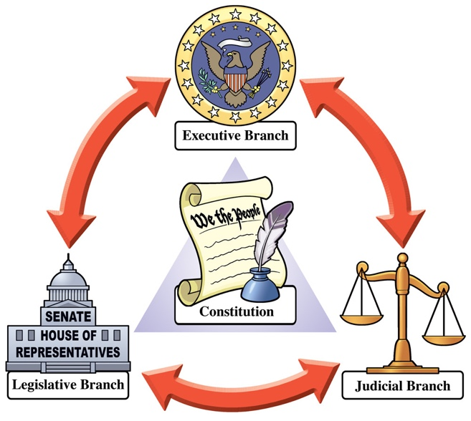

The USA is famous for its checks and balances system. How does it work? Try to guess and share your thoughts with your groupmates.

KEY WORDS AND WORD COMBINATIONS
article | [ˈɑːrtəkl̩] | статья
autocratic rule | [ɔːtəʊˈkrætɪk ruːl] | автократическое правление
census | [ˈsensəs] | перепись населения
circuit court | [ˈsɜːkɪt kɔːt] | окружной суд (США)
commander-in-chief | [kəˈmɑːndərɪnˈtʃiːf ] | верховный главнокомандующий
district court | [ˈdɪstrɪkt kɔːt] | федеральный окружной суд (США)
division of powers | [dɪˈvɪʒən ɒv ˈpaʊəz] | разделение властей
emergence | [ˌɪˈmɝːdʒəns ] | появление
governmental structures | [ˌɡʌvərnˈmentl̩ ˈstrʌktʃərz ] | государственные структуры
healthcare | [ˈhelθkər] | здравоохранение
legislative body | [ˈleʤɪslətɪv ˈbɒdɪ] | законодательный орган
system of checks and balances | [ˈsɪstɪm ɒv ʧeks ænd balances] | система сдержек и противовесов
tie-breaking vote | [taɪ-ˈbreɪkɪŋ vəʊt] | решающий голос
to abide | [tə əˈbaɪd] | подчиняться
to appoint | [tə əˌpɔɪnt ] | назначать
to assume duties | [tuː əˈsjuːm ˈdjuːtiz] | брать на себя обязанности
to be charged with | [tə bi ˈtʃɑːrdʒd wɪθ] | быть ответственным за, обвиняться в чем-либо
to be entitled | [tə bi enˈtaɪtl̩d] | иметь полномочия
to impeach | [ ˌɪmˈpiːtʃ ] | объявить импичмент
to overlap | [tə ˌoʊvəˈlæp] | перекрывать/наслаиваться
to override veto | [tə ˌoʊvəˈraɪd ˈviːtoʊ] | преодолевать вето
to reject a law | [tuː reject ɑ lɔː] | отклонить закон
to try and convict | [tə ˈtraɪ ənd ˈkɑːnvɪkt] | привлекать к ответственности и признавать виновным
treaty | [ˈtriːtɪ] | договор, межгосударственный договор

VOCABULARY

Exercise 1

American political system differs from the one we are used to seeing in Europe. Explain the difference between two types of votes and two types of governments. Use dictionaries if necessary.
POPULAR VOTE vs ELECTORAL VOTE

Exercise 2
a. Match words and word combinations with the definitions. Translate them into Russian.
1) presidential republic | a) country in which power is held by elected representatives;
2) parliamentary republic | b) the form of government where the main role in the management and formation of the state structure is played by the parliament;
3) democracy | c) government by a single person or small group that has unlimited power or authority;
4) autocracy | d) the form of government where the main role is played by a president who is both the head of state and the head of government.

b. Fill in the gaps using the words and word combinations from (a).
- In a __________, the head of government is the prime minister, who is elected by the parliament and is responsible for running the government.
- __________ is a system of government that emphasizes the participation and representation of its citizens.
- __________ suppressed dissent and political opposition, leaving little room for freedom of expression.
- The __________ model provides a clear separation of powers between the branches of government and allows for a strong executive authority.

Exercise 3
a. Match the left column with the right one and complete the word combinations. Use dictionaries if necessary.

1) to interpret | a) the position
2) to assume | b) a decision
3) to issue | c) the law
4) to take | d) (one’s) veto
5) to override | e) duties

b. Fill in the gaps using the word combinations from the previous part of the exercise.
- The court would have to __________ within 48 hours.
- Congress must __________ a presidential __________ if necessary.
- It is up to the courts to determine whether a law is invalid or __________.
- The federal government __________ against so-called anti-camping laws in an ongoing case against the city of Boise, Idaho.
- The elected President __________ immediately upon the conclusion of the predecessor's term of office.

Exercise 4
a. Match the words with their translation. Explain the meaning of these words. Use dictionaries if necessary.

- amendment | - коллегия выборщиков
- armed forces | - перепись населения
- census | - равенство голосов
- checks and balances | - поправка
- electoral college | - система сдержек и противовесов
- ticket | - вооруженные силы
- tie | - избирательный бюллетень

b. Fill in the gaps using the words from the table above.
- The US __________ Bureau, for example, considers there to be four regions of the US: the Northeast, the Midwest, the South, and the West.
- Today, opinions on the future of the __________ range from protecting it as the basis of American democracy to abolishing it completely as an ineffective system that may not accurately reflect the will of the people.
- The US ___________ consist of six services branches that are governed by Department of Defense.
- A Trump–DeSantis __________ can win in 2024.
- The framers of the U.S. Constitution built a system of __________ that divides power between the three branches of the U.S. government.
- The Second __________ to the United States Constitution protects the right to keep and bear arms.
- In the House, the Speaker has only a casting vote in the event of a tie.

READING

Exercise 5
Read the text about the U.S. political system and be ready to do the tasks that follow it.
THE U.S. POLITICAL SYSTEM
For most newcomers, the U.S. political system can seem complicated and confusing. What do the different branches of government do? What is the difference between federal and state governments?

The Separation of Powers
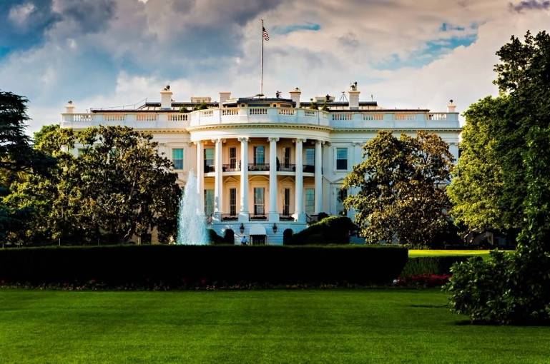
The structure of the U.S. government is defined in the U.S. Constitution which presupposes the separation of powers into three distinct branches. This division of powers — together with a system of checks and balances — is meant to prevent the emergence of autocratic rule.
1. Executive Branch
The executive branch is run entirely by the president of the United States who governs from the White House. The US President is the head of state and commander-in-chief of the armed forces, and is primarily charged with the task of enforcing the laws passed by the legislative branch. The President selects 15 Cabinet members, who specialize in a particular subset of policies and who act as advisors to the president. If the president is no longer able to assume his duties as head of state, the vice president, also a member of the executive branch, must then take the position.
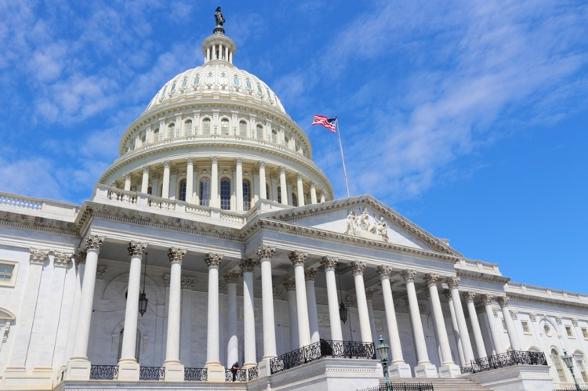
To check the power of the legislative branch, the president may, at his own discretion, veto (or reject) a law passed by the legislative body.
2. Legislative Branch
At its core, the legislative branch has two basic functions:
- to write the laws governing the country
- to allocate funds needed for running the government
To execute its tasks, the legislative branch, the Congress, is broken up into two chambers: the House of Representatives and the Senate.
The House of Representatives is meant to directly represent the will of the people. Thus, each state gets a number of representatives proportional to its population. It should be noted that the House has 6 non-voting members representing Puerto Rico, Guam, the Commonwealth of Northern Mariana Islands, American Samoa, the U.S. Virgin Islands, and the District of Columbia (commonly known as Washington D.C.).
Unlike the Senate, the House may put forth revenue legislation, elect the president in case of a tie, and impeach politicians at the federal level.
The Senate is meant to represent the will of the states. Each state is given 2 representatives, making for a total of 100 senators in the upper chamber. Each senator holds office for 6 years. The vice president acts as president of the Senate and may be called by the upper chamber to cast a tie-breaking vote. To further check the power of the president, the Senate must confirm each cabinet member before they take their post. The Senate may also try and convict federal officials who have been impeached by the House of Representatives.
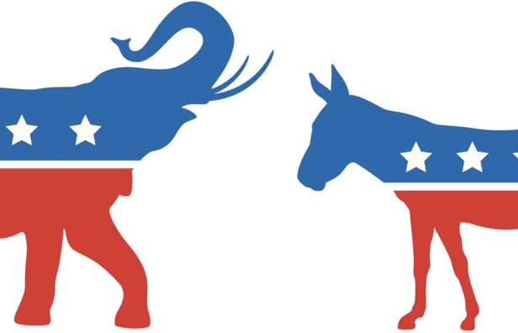
Together, the Senate and the House of Representatives form the Congress. The Congress may override a veto from the president if two-thirds of each chamber vote in favor.
In the United States, there is a two-party system, i.e. two major political parties, Democrats (donkeys) and Republicans (elephants), dominate the country’s politics and contest seats in both Chambers of the Congress.
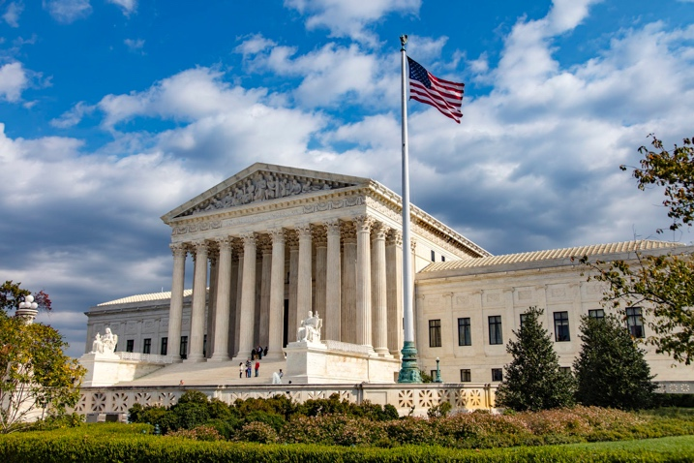
3. Judicial Branch
The judicial branch – comprising the Supreme Court, 94 district courts, and 13 circuit courts – has two fundamental powers:
- to interpret the law and apply its interpretations to specific cases
- to determine whether a given law abides by the precepts of the U.S. Constitution
Once the Supreme Court issues a decision regarding the interpretation of a law, the lower federal courts must adhere to that ruling.

Federalism
The United States is a living example of federalism. In such a system, two overlapping governmental structures can operate on the same patch of land. Each of the 50 states has its own state government, and each state government may write and enforce its own laws, as long as those laws do not contradict the federal statutes.
The 10th Amendment explicitly gives power to the states, so long as those powers have not been delegated by the Constitution to the U.S. government. This means state governments can do things like:
- administer a state court system;
- create schools;
- oversee municipal governments;
- regulate intrastate trade.
State governments can also perform functions concurrently with the federal government. They can, for instance:
- implement a tax system;
- build and operate infrastructure, such as roads and trains;
- oversee elections.
(Retrieved from: https://www.boundless.com/)

Exercise 6
Explain the opposition given below and describe the system of two overlapping governmental structures.
STATE GOVERNMENT vs FEDERAL GOVERNMENT

Exercise 7
Find English equivalents to the following words.

- сбивающий с толку
- предполагать/допускать
- отдельный
- по собственному усмотрению
- по своей сути
- распределять средства
- быть разделенным
- равное количество голосов
- представитель
- параллельно с этим

Exercise 8
Answer the questions.
- What is the purpose of the system of checks and balances?
- What happens if the president is no longer able to assume his duties?
- What are the powers of the House of Representatives?
- What can the Senate do?
- What parties dominate American politics?
- What are the functions of the judicial branch?
- Why is the United States a living example of federalism?
- What are the powers of state governments?

Exercise 9
Mark the statements as True or False.
Statement | True | False
1. The structure of the U.S. government is defined in the international law.
2. The president has the right to veto a law passed by the Congress.
3. All members of the House of Representatives are voting.
4. Each state is given a number of representatives in the Senate proportionate to its population size.
5. There are only two major parties in the United States.
6. The lower federal courts do not have to obey the Supreme Court’s interpretation of the law.
7. There are two parallel governmental structures in the US.
8. State governments can perform functions of the federal government.

GRAMMAR
Study grammar rules on the use of MODAL VERBS (See GRAMMAR REFERENCE p.212)

Exercise 10
In the previous section you’ve learnt the basic structure of the American state. Now read the text about the US President. It contains some Modal Verbs which are underlined. Examine the context and try to explain their usage.

The President of the United States
The President of the United States (or POTUS) is arguably one of the two most important figures in American government system, along with Congress.
To be the president, you must be at least 35 years old and have been a natural-born citizen of the United States or someone who has been naturalized for at least 20 years (according to Section 1 of Article II of the U.S. Constitution). However, some states can impose additional requirements like residency or actual residence within that state’s borders.
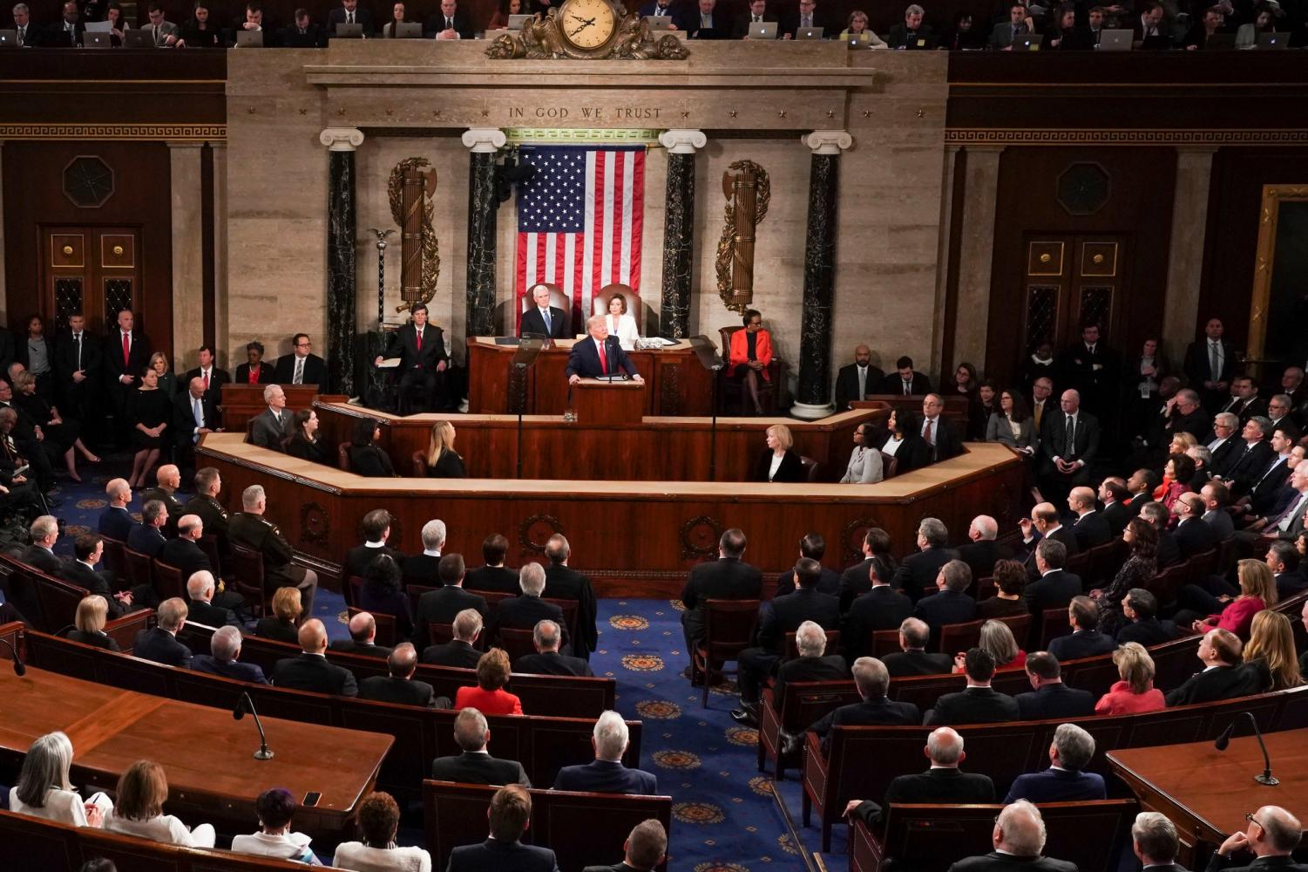
According to the Constitution, the president of the United States must make sure that all U.S. laws are carried out and that the federal government runs effectively. It is his or her primary concern. The president cannot introduce new legislation—that's one of the duties of Congress – but the head of the state may veto the bill before it can become law.
The president is to address the full Congress at least once a year to report on the State of the Union. This is called The State of the Union Address (SOTU). The contents of this speech should be governed by tradition, but it is generally used to outline specific policies in addition to serving as an opportunity for self-promotion.
As the nation's chief executive, the president has to oversee both domestic and foreign policy, but many of his powers cannot be enacted without the approval of the Congress.
The president and his administration represent the interests of the United States abroad, and this goes beyond formal treaties and appointments. Thus, the U.S. presidents have to meet with, entertain, and develop the relationships with other heads of state. With the Senate's approval, they can make treaties with foreign nations and appoint ambassadors to other countries and the United Nations.
The president is also to manage the government's commitments to the people of the United States as it pertains to programs such as education and healthcare and to make sure that the nation's economy is healthy and functional.
(Retrieved from: https://www.trumanlibrary.gov , https://www.thoughtco.com/)

Exercise 11
Choose the correct variant in italics.
- Voters must be/have to be US citizens in order to participate in the election.
- When voting, one mustn’t/doesn't have to publicly declare his political affiliation.
- Electoral College members should/have to cast their votes according to the state's popular vote.
- People have to/don’t have to respect differing political opinions.
- Citizens should/have to stay informed about political developments.
- Governmental officials must not/don’t have to disclose classified national security information.
- Members of Congress shouldn’t/mustn’t misuse their powers for personal gain.
- Any elected official must/has to represent their constituents’ needs.
- Candidates don't have to/should not disclose their detailed medical history.
- Political parties have to/should work together to find common ground on important legislation.
- The President doesn’t have to/must not use public funds for personal expenses.
- Politicians must/should follow specific laws when campaigning.

Exercise 12
Fill in the gaps using the modals given in the box.
were able to could cannot may managed to was able to weren’t able to can could may not

- Under the previous president, the lobbyist __________ influence the decision-making process within the House of Representatives.
- The senator __________ pass an important bipartisan bill through Congress.
- The party leaders __________ reach a compromise on the controversial issue.
- According to the American legislature, the U.S. Vice-President __________ break the electoral tie in the presidential elections.
- Before January 6, the protesters __________ gather freely in front of the Capitol to express their concerns.
- Making a lot of effort, the opposition party __________ challenge the ruling party on the matter of migration.
- Nowadays, candidates __________ attract a diverse range of supporters during presidential campaigns.
- According the U.S. Constitution, the president __________ declare wars on other countries. He or she has no rights to do it without the approval of Congress.
- The Senate __________ introduce bills concerning taxes or federal funds.
- Unfortunately, ordinary people __________ take part in the discussions about the proposed healthcare policies.

Exercise 13
Match the sentences from the left column with the correct meaning from the right one.
Sentence | Meaning
1. The upcoming policy reforms may lead to positive changes in the healthcare system. | a. It is possible that the upcoming policy reforms will lead to positive changes in the healthcare system.
 | b. It is certain that the upcoming policy reforms may lead to positive changes in the healthcare system.
2. The new legislation must address the concerns of minority communities. | a. I am sure that the new legislation doesn’t address the concerns of minority communities.
 | b. I am sure that the new legislation addresses the concerns of minority communities.
3. The changing demographic landscape can influence future elections. | a. It is unlikely that the changing demographic landscape will influence future elections.
 | b. It is likely that the changing demographic landscape will influence future elections.
4. Technological advancements may enhance transparency in governance. | a. It could be possible that technological advancements will enhance transparency in governance.
 | b. It is certain that technological advancements will enhance transparency in governance.
5. There must be potential for successful collaboration between community organizations and government agencies. | a. We strongly believe that government agencies should collaborate with community organizations.
 | b. We are not sure that government agencies should collaborate with community organizations.

WATCHING AND LISTENING

Exercise 14
Watch the video on the US Electoral College at https://www.youtube.com/watch?v=W9H3gvnN468 and do the tasks listed below.
        - BEFORE YOU WATCH. Answer the questions:
Do you know how Americans elect their presidents?
Is it similar to the elections in Russia? If not, how is it different?

        - WHILE YOU WATCH.
Mark the statements as True or False:
Statement | True | False
1. The Electoral College is a group of people who educate the population and explain them how to vote.
2. Nowadays, District of Columbia has no electors.
3. The number of electors of each state is based on population size.
4. If a candidate wins a state, he or she gets all the votes.
5. All states in the USA “cost” equal number of electoral votes.
6. A candidate cannot completely ignore small states or geographically large states with small populations.
7. “Safe states” are the states with low crime rates.
8. Mississippi, Alabama, Kansas and Idaho are traditionally “Republican” states.

c. AFTER YOU WATCH. Answer the questions:
- How many electors are there?
- How many electoral votes does each candidate need to win to become a president?
- What is the census?
- Why are such states like Texas, Florida, and New York so important to candidates?
- Is it possible for a candidate to win the presidency without winning the popular vote? Why?
- What are “swing states”?

SPEAKING

Exercise 15
Internet activity. Find some more curious and interesting facts (5-7 facts) about the American electoral system on the Internet and tell them to your groupmates.

WRITING

Exercise 16
Compare-and Contrast Essay
a. Watch the video at https://www.youtube.com/watch?v=hvMSeg1s7uc.

b. Answer the questions:
- What is the structure of a compare-and-contrast essay?
- What are the functions of each element?
- What is the main difference between a compare-and-contrast essay and other essays?
- What is block method? Describe it.
- What is the point-by-point compare-and-contrast essay?
- What is the purpose of the conclusion in a compare-and-contrast essay?
- Why is it important to mention the points of comparison in the thesis statement?

Exercise 17
Write a compare-and-contrast essay (min 120 words) on similarities and differences of British and American political systems. Use the information provided in theme 3.1.2. and theme 3.2.2. and find some additional information on the Internet. Stick to the structure suggested in the video from the previous exercise.

Theme 3.3. Russia: Country and State

LEAD IN
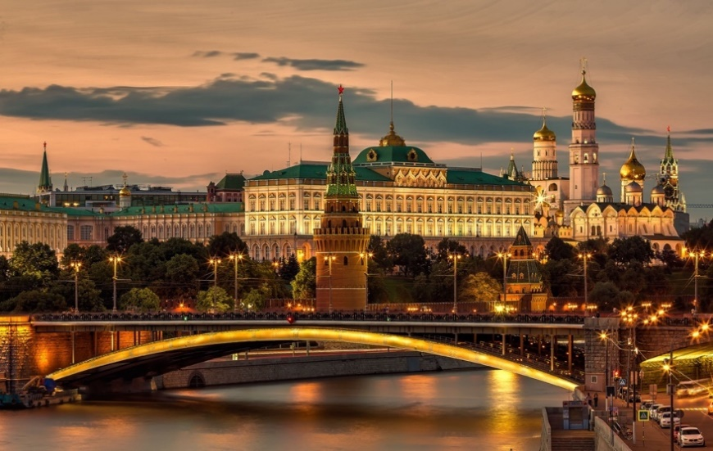

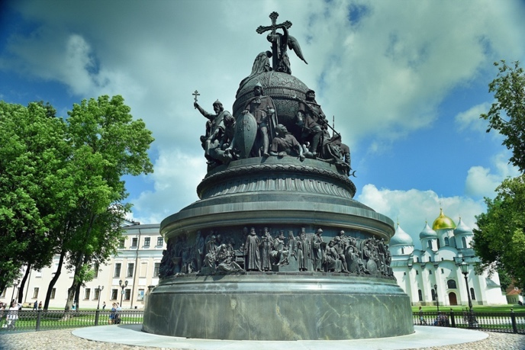
Look at the picture. Do you know this monument? Where is it located? What does it symbolize? If necessary, search for some information on the Internet and tell your groupmates about it.

Read the quote below. What do you think it means? Comment on it.
Russia is a riddle wrapped in a mystery inside an enigma.
Winston Churchill

KEY WORDS AND WORD COMBINATIONS
armaments | [ˈɑːməmənts] | вооружение
barley | [ˈbɑːli] | ячмень
biome | [ˈbaɪ.əʊm] | биом / природная зона
cardboard | [ˈkɑːdbɔːd] | картон
caviar | [ˈkævɪɑː] | икра
cod | [ kɒd] | треска
coniferous | [ kəˈnɪfərəs] | хвойный
draft law | [ drɑːft lɔː] | законопроект
duties | [ˈdjuːtɪz] | обязанности
export income | [ˈekspɔːt ˈɪnkʌm] | поступления от экспорта
federal entity | [ˈfedərəl ˈentɪtɪ] | субъект Федерации
freshwater | [ˈfreʃwɔːtə] | пресная вода
grassland | [ˈɡrɑːslænd] | степь / луг
herring | [ˈherɪŋ] | сельдь
hydroelectric power | [ˌhaɪdrəʊɪˈlektrɪk ˈpaʊə] | гидроэлектроэнергия
implementation | [ˌɪmplɪmenˈteɪʃn̩] | внедрение / исполнение
iron ore | [aɪən ɔː] | железная руда
irrigation | [ɪrɪˈɡeɪʃn̩] | орошение
nonferrous metals | [nanˈferəs ˈmetl̩z] | цветные металлы
oats | [əʊts] | овес
permafrost | [ˈpɜːməfrɒst] | вечная мерзлота
policy (domestic, foreign, financial, monetary) | [ˈpɒləsi (dəˈmestɪk, ˈfɒrən, faɪˈnænʃl̩, ˈmʌnɪtri)] | политика (внутренняя, внешняя, финансовая, денежно-кредитная)
pollack | [ˈpɑːlək] | сайда
precious metals | [ˈpreʃəs ˈmetl̩z] | драгоценные металлы
pulp | [pʌlp] | целлюлоза
regional body | [ˈriːdʒənl̩ ˈbɒdi] | региональный орган
roundwood | [raʊndwʊd] | лес-кругляк
rye | [raɪ] | рожь
salmon | [ˈsæmən] | лосось
seafood | [ˈsiːfuːd] | морепродукты
soil | [sɔɪl] | почва
state decoration | [steɪt dekəˈreɪʃn] | государственная награда
sterlet | [ˈstɜːlɪt] | стерлядь
term | [tɜːm] | срок
tier | [tɪə] | уровень
timber | [ˈtɪmbə] | лесоматериалы
time zone | [ˈtaɪm zəʊn] | часовой пояс
to be renowned | [tə bi rɪˈnaʊnd] | быть широко известным
to be vested | [tə bi ˈvestɪd] | быть наделенным правами
to resolve issues | [tə rɪˈzɒlv ˈɪʃuːz] | разрешать вопросы
to span | [tə spæn] | охватывать
to stretch through | [tə stretʃ θruː] | протягиваться через

VOCABULARY I

Exercise 1
Complete the text using the words below.
roundwood industrial products iron ore precious metals seafood grain export income coniferous

Once upon a time in a small (1) __________ forest town, there existed a community that thrived on the extensive deposits of natural resources. Nestled in the heart of the forest, the townspeople made their living by extracting (2) __________ from the nearby mines and harvesting (3) __________ for various uses.
Although the town was located far from the coast, it had access to delicious (4) __________ from the nearby rivers and lakes. The locals were able to enjoy it while also selling a portion for additional (5) __________.
Beyond the forest, the townspeople discovered vast fields where they could grow (6) __________ and found a lot of (7) __________ hidden within the earth.
With time, the town's prosperity grew, and their trading expanded to include not only grain and precious metals but also (8) __________. The once small and isolated community had blossomed into a bustling hub of commerce, all thanks to the diverse array of natural resources at their disposal.

Exercise 2
a. Match the names of biomes with their definitions.
1. Taiga | a) a large area of land with grass but no trees;
2. Tundra | b) the area of wet land in the far northern parts of the world that is covered with conifer trees;
3. Steppe | c) forests that has flat leaves and produces seeds inside of fruit;
4. Broadleaf forests | d) the area of land where, because it is cold, trees do not grow and ground below the surface is permanently frozen.

b. Fill in the gaps using the words from the previous section.
- Pechenegs were the people who came to Rus from the Great __________.
- The combination of fish, game and __________ berries distinguish Siberian cuisine from European cuisine.
- The Russian __________ is located on the coastline with the Arctic and is known for its total darkness in the winter.
- Сentral Russia is relatively warm region covered with ___________ forests.

Exercise 3
Translate the following sentences using the words from Key Words and Word Combinations section.
- Пшеница и рожь являются одними из основных злаков, выращиваемых в России.
- «Вечная мерзлота» – это слой почвы, температура которого не превышает 0 °C в течение очень долгого времени.
- Тресковые войны – это серия конфликтов между Соединенным Королевством и Исландией за право рыбачить в северной части Атлантического океана.
- Уральские горы протянулись от севера до юга России и образуют естественную границу между Европой и Азией.
- В России можно встретить практически все существующие на планете биомы.
- Кругляк и пиломатериалы – составляют большую долю прибыли Архангельской области.
- Магаданская область – крупный производитель драгоценных металлов.
- Хвойные леса густо покрывают всю Сибирь.

GRAMMAR
Study grammar rules on the use of SOME/ANY/NO/EVERY (See GRAMMAR REFERENCE p.216)

Exercise 4
Here, you a given five exercises from the text from Exercise 7. Comment upon the usage of words highlighted in bold.
- Russia has about 100,000 rivers, including some of the longest ones in the world.
- There are many lakes in Russia, but none of them can be compared to Baikal.
- Agricultural land constitutes no more than one-sixth of the country’s territory.
- Any raw materials required by modern industry can be found within its borders.
- Russia’s machine-building industry provides mostly everything the country needs.

Exercise 5
Correct the mistakes in the following sentences.
- I need to write an essay about the Time of Troubles. Do you know something about it?
- Everyone in Russia know who Alexander Pushkin is.
- There are none deserts in the central part of Russia.
- I have any understanding of the political history of Russia.
- I don’t know nothing about the Ural Mountains.
- There are any interesting facts about the petroleum processing industry of Russia.
- The eastern part of Russia has a lot of hills and mountains. The western part has no.
- Russia has a diverse economy. However, any industries are underdeveloped.

Exercise 6
Translate the sentences from Russian into English.
- Существуют ли какие-нибудь документы о ранних торговых путях на территории России?
- В истории России не было ни одной войны за независимость.
- Я прочитал много статей о погоде в России. Джон не прочитал ни одной.
- Любой автобус отсюда довезет тебя до станции метро «Университет».
- Как-то можно добраться из Казани в Хабаровск?
- Любой может приехать и восхититься красотой Кавказа.
- Ты знаешь что-нибудь об автомобилестроении Советского Союза?
- Все в России знают про события Великой Отечественной войны.
- Находясь на Кольском полуострове, ты всегда видишь какую-нибудь сопку.
- Ты знаешь что-нибудь о климатических зонах Российской Федерации?

READING I

Exercise 7
Read the text and translate it.

RUSSIA. THE TREASURY OF NATURAL RESOURCES
Russia, the largest country in the world, spans 11 time zones across two continents (Europe and Asia) and has coasts on three oceans (the Atlantic, the Pacific, and the Arctic). The largest border between Europe and Asia (the Ural Mountains) stretches through Russia from the north to the south.
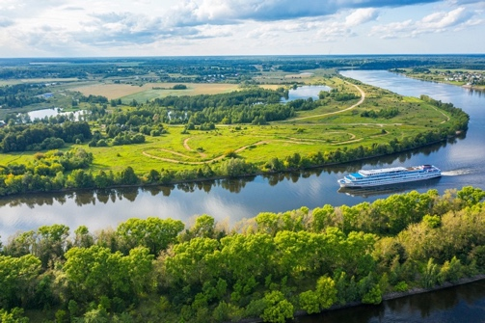
Russia has about 100,000 rivers, including some of the longest ones in the world. The Volga River, running through Сentral Russia into the Caspian Sea, is the longest river on the European continent. The river is also an important source of irrigation and hydroelectric power. There are many lakes in Russia, but none of them can be compared to Baikal. Lake Baikal, located in southern Siberia, is the world’s deepest lake and also the world’s largest freshwater lake.
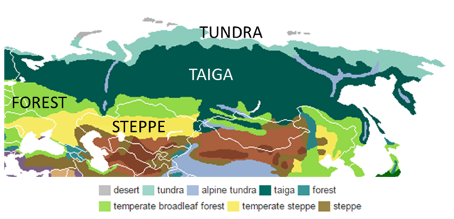
Russian tundra is characterized by very cold temperatures and limited tree growth. Here, temperatures can drop below -50°C and much of the soil is permafrost. South of the tundra is the taiga region, where sprawling coniferous, snow-capped forests dominate. South of the taiga region are areas of temperate broadleaf forests and steppe, an area of treeless, grassland plains.
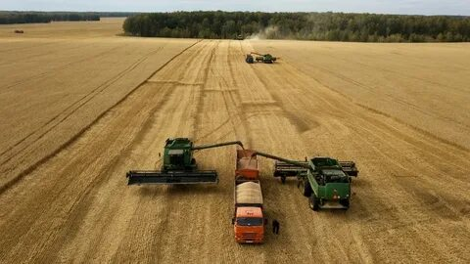
The harshness of the Russian environment is reflected in the small proportion of land that is used for farming. Agricultural land constitutes no more than one-sixth of the country’s territory. The main product of Russian farming has always been grain. Wheat is the chief grain, followed by barley, rye, and oats.
Russia contains the world’s largest forest reserves, and its lumbering, pulp, paper, and woodworking industries are particularly important. The country is among the world leaders in the production of lumber, roundwood, pulp and paper.
Russia produces about one-third of all canned fish and some one-fourth of the world’s total fresh and frozen fish. Salmon, pollack, cod, crabmeat, caviar, beluga, sterlet, and herring are among the most important.
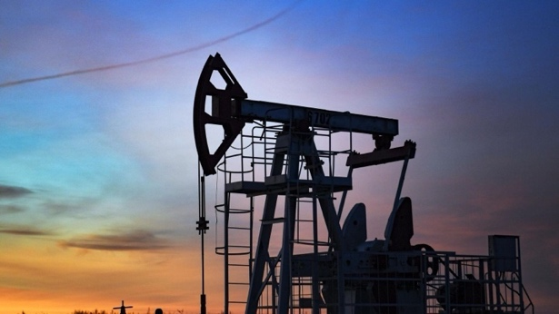
Russia has enormous energy resources and significant deposits of many different minerals. Any raw materials required by modern industry can be found within its borders. Its coal, oil and natural gas reserves are extremely extensive. Russia produces about one-sixth of the world’s iron ore and between one-tenth and one-fifth of all nonferrous, rare, and precious metals. Russia is a major producer of cobalt, chrome, copper, gold, lead, manganese, nickel, platinum, tungsten, vanadium, zinc, and aluminum.
Russia’s machine-building industry provides mostly everything the country needs, including steam boilers and turbines, electric generators, grain combines, automobiles, and electric locomotives, and it fills much of its demand for shipbuilding, electric-power-generating and transmitting equipment, consumer durables, machine tools, instruments, and automation components. Russia’s factories also produce armaments, including tanks, jet fighters, and rockets, which are sold to many countries and contribute significantly to Russia’s export income.
(Retrieved from: https://pressbooks.pub/worldgeo)

Exercise 8
Find Russian equivalents to the following words from the text.

- уникальная страна
- важный источник
- расположенный в
- хвойный лес
- суровость
- составляет
- запасы
- доходы
- сырье
- невероятно богатый

Exercise 9
Answer the questions.
- How many oceans does Russia have coasts on?
- What is the natural border between Europe and Asia?
- What is the role of The Volga?
- Why is the proportion of farming land in Russia is limited?
- What mineral resources is Russia rich in?
- What types of machinery does Russia produce?

Exercise 10
Mark the following statements as True or False.
Statement | True | False
1. Russia is located only on two continents.
2. The Volga is the largest river in the world.
3. Tundra is the warmest region of Russia and is characterized by thick forests.
4. Farming land constitutes less than one-sixth of the country’s territory.
5. Russia is among the world leaders in the production of timber and wood-related products.
6. Most of the raw materials are imported to Russia form other countries.
7. Russia’s machine-building industry produces mostly everything the country needs.
8. Russia doesn’t manufacture any armaments.

VOCABULARY II

Exercise 11
a. Match the words with their definitions and translate them into Russian.
1) duty | a) an object, such as a medal or the insignia of an order, that is awarded by a sovereign state to honor somebody;
2) bill | b) the state of being a member of a particular country and having rights because of it;
3) federal entity | c) a formal statement of a planned new law that is discussed before being voted on;
4) pardon | d) something that you have to do because it is part of your job;
5) state decoration | e) an occasion when someone who has committed a crime is officially forgiven;
6) citizenship | f) delimited territory that has autonomy, is populated and has a government, although it must follow the guidelines that govern the central federal power.

b. Fill in the gaps using the words given above.
- Dual __________ occurs when a person is a citizen of two countries.
- He was awarded by a Russian __________ – the Order of Friendship – for his contribution to defence, research and technological cooperation.
- Nowadays, Russia consists of 89 __________.
- Once the __________ is presented, the State Duma discusses its provisions and clarifies the nuances.
- The first __________ of the government is the security and safety of all citizens of Russia.
- Only the President has the right to grant __________ and provide amnesty.

Exercise 12
a. Match the words with their translations.
- draft law | - большинство
- minority | - верховенство права
- tier | - региональный орган
- majority | - уровень
- term | - меньшинство
- regional body | - срок
- rule of law | - законопроект

b. Fill in the gaps using the words given above.
- Ministers belong to the highest __________ of power.
- Democracy is the rule of the __________.
- The public demands to add clarifications to the controversial __________.
- The __________ of presidency is typically limited.
- The role and responsibilities of each __________ are described in the country’s federal laws.
- The Constitution proclaims the________and guarantees fundamental human rights to Russian people.
- A category of people who are somehow different from the majority of population is called a __________.

READING II

Exercise 13
Read and translate the text.

RUSSIA’S POLITICAL LANDSCAPE
Russia is renowned for having a complicated and diverse political structure. Russia’s political landscape has changed significantly throughout the ages, going from the Russian Empire to the Soviet Union and, most recently, the Russian Federation. Russia’s current political structure may be characterized as a federal, semi-presidential republic. There are several branches and tiers of government, each with distinct functions and duties.
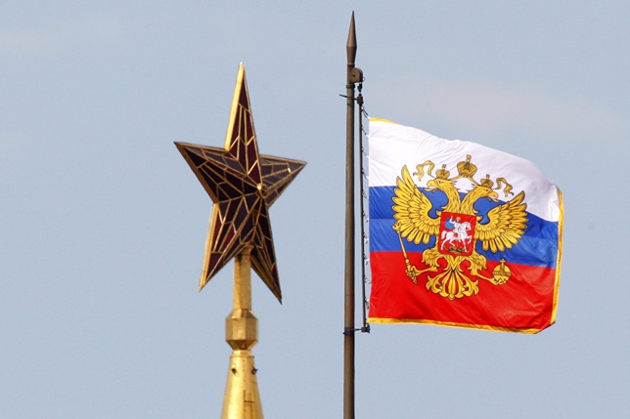
The executive power is split between the President and the Prime Minister, who is the head of the Government. The President is the head of state and is elected by popular vote every six years for a maximum of two consecutive terms. The President’s working residence is in the Moscow Kremlin. The President determines the basic domestic and foreign policy. He is the commander-in-chief of the armed forces. The president resolves issues of citizenship of the Russian Federation, awards state decorations and grants pardons. Government duties are split between a number of ministries. The head of Government, the Prime Minister, is appointed by the president and approved by the State Duma. The government is housed in the so-called White House in Moscow. It ensures the implementation of domestic and foreign policy, works out the federal budget, oversees the implementation of financial and monetary policy, ensures the rule of law, and human rights and freedoms.
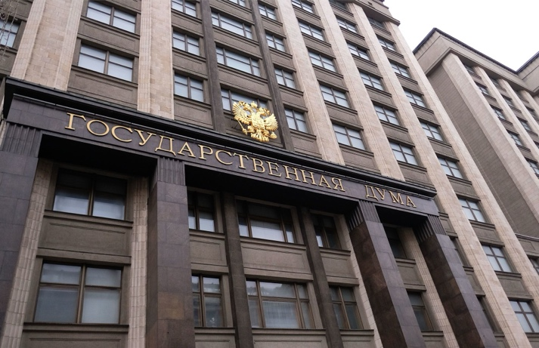
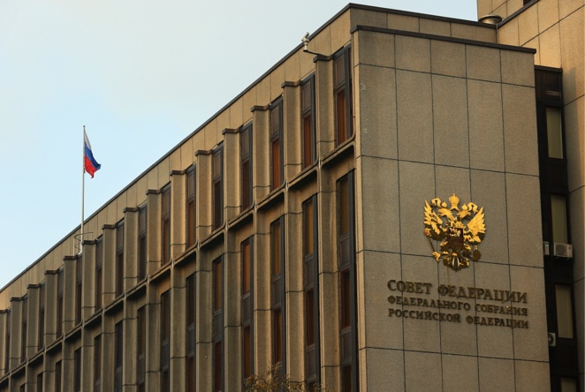
The legislative power is represented by the Federal Assembly of Russia. It has two chambers: the State Duma – the lower house, and the Federation Council – the upper house.
The Federation Council acts as a voice of Russia’s federal entities. Unlike the State Duma, the Council isn’t directly elected. It includes two representatives from each federal entity. The Federation Council has special powers of its own, including the declaration of a presidential election, impeachment of the President and decisions on the use of the armed forces outside Russia’s territory.
The State Duma is the lower house of the Russian Parliament. 450 deputies are elected for the terms of five years. All bills, even those proposed by the Federation Council, must first be considered by the State Duma. Once a bill is passed by a majority in the State Duma, a draft law is sent back to the Federation Council. If the Council rejects it, two chambers may form a commission to work out a compromise.
The judicial power is vested in courts and administered by the Ministry of Justice.
While Russia has several political parties, United Russia is the most powerful one. Despite this, the country still has a multi-party system.
Russia’s political structure is a complicated institution navigating its own political environment.
(Retrieved from: https://bestdiplomats.org/ , https://russiapedia.rt.com/)
Exercise 14
Scan the text and find English equivalents to the following words.

1) быть широко известным
2) функции и обязанности
3) прямые выборы
4) рабочая резиденция
5) вопросы гражданства
6) даровать помилование
7) так называемый
8) действовать в качестве голоса
9) законопроекты, предложенные Советом Федерации
10) выработать компромисс

Exercise 15
Which 2 statements correspond to the text?
- The executive power is represented only by the President.
- Russia is a federal, semi-presidential republic.
- The Prime Minister is elected by the popular vote each six years.
- The Government oversees the implementation of laws and regulations concerning all spheres of the country’s life.
- The judicial power is administered by the Ministry of Domestic Affairs.

Exercise 16
Which 2 statements contradict the text?
- The President determines both domestic and foreign policy.
- The State Duma’s major duty is to draft laws.
- The Federation Council consists of representatives of different political parties and is elected by people.
- Russia has a multi-party system.
- Russia’s political landscape has remained the same throughout the ages.

WATCHING AND LISTENING

Exercise 17
Watch the video about Russian federal subjects at https://www.youtube.com/watch?v=5CItQwyQgRc and do the tasks listed below.
              - BEFORE YOU WATCH. Answer the questions.
What do you know about Russian Federation’s structure?
What parts does it consist of?
What do you know about their rights and powers?
              - WHILE YOU WATCH. Answer the questions:
- Where was Russia’s political subdivision inherited from?
- What are the federal subject types in Russia? What type is the most common?
- Are “oblasts” and “krais” legally treated differently?
- Does the naming of an oblast always coincide with the name of its administrative center?
- What happened to autonomous oblasts (except for The Jewish Autonomous Oblast)?
- Are all autonomous okrugs in Russia subordinate to other subjects?
- How many republics are there in Russia? Why do they have such a high status?
- Are there any other official languages in Russia’s subjects except for Russian?
- Are the republics completely dependent on the central government?
- How many cities of the federal importance are there in Russia?

  - AFTER YOU WATCH. Fill in the gaps.
GDP per capita run-of-the-mill segue governance titular ethnicity clauses officially recognized majority international affairs odd case autonomy self-governing
- The difference in naming some of these regions does not have direct effects on ________.
- The federal cities, autonomous okrugs, and republics have different ________ in the constitution that affect how they govern themselves.
- The word “oblast” most nearly means “area” or “province” in English, so they’re pretty standard, ________ subdivisions most of us know and love.
- The only other ________ is with Sakhalin oblast which is named for its geography.
- Autonomous okrugs, or districts, are ________ regions that are subordinate to other oblasts in most cases.
- Yamalo-Nenets and Khanty-Mansi are both subordinate to Tumen oblast, which is one of the richest oblasts in ________ in part due to resources found in the okrugs.
- Almost giving it pseudo-republic status which is a perfect ________ to discuss the republics of Russia.
- These places have a ________ in their region, which is not necessarily the ________ but is at least a significant minority.
- The republics have a considerable amount of ________ from the central government and it was once said that they were just represented by the Russian government in ________.
- For the sake of time, I’ll only focus on the two ________ federal cities.

SPEAKING

Exercise 18
Which subject of Russia are you from? Tell your groupmates about its nature, economy and political structure. Use some of the following:
I think…. I believe…. I’d like to point out that As far as I’m concerned….
Well, it is considered that…. It is generally accepted that…. My impression is that…. It goes without saying that….

WRITING

Exercise 19
Formal Letter Writing

a. Watch the video with recommendations on writing a proper formal letter at https://www.youtube.com/watch?v=UBO-ib-V8LM.

b. Answer the questions:
  - What are the features of formal language?
  - What is the structure of a formal letter?

Exercise 21
a. Examine a formal letter to Transport Department of Moscow and be ready to write the analogous letter using this one as the example.

Your Name
Your Address
City, State ZIP Code
Date

Transport Department of Moscow
Address
City, State ZIP Code
Dear Sir/Madam …,
I am writing to express my concern regarding the current state of bus stops in Moscow. As a regular commuter, I have noticed that the majority of bus stops lack basic amenities such as shelter, seating, and lighting. This makes waiting for buses uncomfortable, especially during extreme weather conditions.
I would like to suggest that the Transport Department of Moscow consider building more comfortable bus stops with modern facilities such as solar batteries, Wi-Fi, and power banks. These amenities will not only enhance the comfort of commuters but also promote sustainable energy usage.
The installation of solar batteries will ensure that the bus stops are well-lit and powered, even during power outages. This will increase safety and security for commuters who may be waiting for buses at night. Additionally, providing Wi-Fi will enable commuters to stay connected and productive while waiting for their buses.
Finally, the inclusion of power banks will enable commuters to charge their mobile devices while waiting for their buses. This will be particularly useful for those who rely on their phones for work or communication.
I hope that the Transport Department of Moscow will take this suggestion into consideration and work towards improving the overall commuting experience for residents and visitors alike. Thank you for your attention to this matter.
Sincerely yours,
Your Name

b. Write a formal letter to the Government of Moscow. Stick to the structure and the layout of the formal letter presented in the video from the previous exercise and the example above. Remember to use formal language only.

For example, you may write to:
1. Transport Department of Moscow on the topic of parking deficiency near RTU MIREA.
or
2. Department of Housing, Utilities and Amenities of Moscow on the topic of trash pickup.

UNIT 4
Learning Foreign Languages

Theme 4.1. The Importance of Learning Languages

LEAD IN
Work in pairs and explain how you understand these proverbs.


“To learn a language is to have one more window from which to look at the world”. Chinese Proverb
“Learn a language, and you’ll avoid a war”.
Arab Proverbs

KEY WORDS AND WORD COMBINATIONS
excuse | [ɪksˈkjuːs] | отговорка, оправдание
flavor | [ˈfleɪvə] | вкус, колорит
fluency | [ˈfluːənsɪ] | беглость
inquisitive | [ɪnˈkwɪzɪtɪv] | любознательный
relevant | [ˈrelɪvənt] | актуальный, необходимый, нужный
route | [ruːt] | путь, способ
target | [ˈtɑːgɪt] | цель
to achieve | [tuː əˈʧiːv] | достигать
to be wrapped up | [tuː biː ræpt ʌp] | быть вовлечённым
to do smth on regular basis | [tuː duː smth ɒn ˈregjʊlə ˈbeɪsɪs] | делать что-то на регулярной основе, систематически
to envelop | [ɪn'veləp] | отражать
to express oneself | [tuː ɪksˈpres wɒnˈself] | выражать себя, самовыражаться, высказываться
to get in-depth with smth | [tuː get ɪn-depθ wɪð smth] | вникать, погружаться во что то
to go deeper into | [tuː gəʊ ˈdiːpə ˈɪntuː] | глубже вникать
to keep learning | [tuː kiːp ˈlɜːnɪŋ] | продолжать учиться
to look back | [tuː lʊk bæk] | оглядываться назад, оценивать, анализировать
to make sure | [tuː meɪk ʃʊə] | убедиться
to set realistic goals | [tuː set rɪəˈlɪstɪk ɡəʊlz] | ставить перед собой реалистичные цели

PRONUNCIATION PRACTICE

Exercise 1
Practice saying the key words and word combinations.

Exercise 2
Which of the following words have the stress on the second syllable?
Flavor excuse target important relevant inquisitive achieve route fluency

VOCABULARY

Exercise 3
Which word is odd?
Know misunderstand pick up learn master
Important essential optional necessary influential
Give up achieve complete obtain gain
Realistic real rational fantastic practical

Exercise 4
Match the words with similar meaning:
- excuse | - curious
- flavor | - goal
- inquisitive | - important
- target | - correct
- essential | - eloquence
- route | - atmosphere
- fluency | - way
- relevant | - apology

Exercise 5
- Make up all possible word combinations.
- to take in | - history
- to understand | - smth on a regular basis
- to have | - targets
- to achieve | - local cultures
- get in-depth with | - a chat
- to do | - languages
- to pick up | - contacts
- to set | - grammar
 | - goals

b.Make your own sentences with the word combinations from (a).

GRAMMAR
Study grammar rules on the use of the REPORTED SPEECH (see GRAMMAR REFERENCE p.219)

Exercise 6
        - Study the table.
Original Words (Direct Speech) | Reported Words (Indirect Speech)
You look nice. | I told her that she looked nice.
I cannot speak German. | He said that he could not speak German.
I am learning French. | She said that she was learning French.
Has he written a report? | I wondered if he had written a report.
John phoned. | She reported that John had phoned.
Will you marry me? | I asked him if he would marry me.

        - Complete the table.
Direct Speech | Reported Speech
Present Simple
 | Past Progressive
Present Perfect
Past Simple
 | Would

Exercise 7
Report the statements.
- “Mary works at Oxford University”, Jane said…
- “I’m learning Italian”, Tom said…
- “I’ve never been to Germany”, Mike said…
- “Tanya can’t use a computer”, Ella said…
- “Everybody must try to do their best”, Jill said…
- “Jane may write an article”, Rachel said…
- “I’ll achieve my goal”, Bill said…

Exercise 8
Write these sentences as reported questions.
- “What’s your favorite song in English?” he asked. (He wanted to know)
- “How old were you when they started learning languages?” (He asked)
- “How many languages can you speak fluently?”
- “What is your strategy for learning vocabulary and grammar?”
- “Are you a polyglot?”
- “How does learning a language help in understanding culture?”
- “Have you heard this song before?”
- “Why didn’t you learn the new words?”

Exercise 9
Rewrite these sentences in reported speech.
- “Make some coffee, Bob”, Carol said. ( Carol asked)
- “You must do the homework soon, Jane”, she said. (tell)
- “Remember to buy a power bank, Ann,” he said. (remind)
- “You should see a doctor, Mrs. White”, he said.(advise)
- “Keep all the windows closed, Bill” they said. (warn)
- “Go home, Paul”, Francis said. (tell)
- “Please go deeper into the language structures, Bob”, the teacher said. (advise)
- “And don't forget to take some beautiful photographs!” he asked. (remined)

Exercise 10
Translate the sentences from English into Russian.
- An MP wanted to know if I had any ideas about that bill.
- He reminded me not to forget my passport.
- The reporter asked the Senior Advisor to the President why he had chosen this career.
- Sarah claimed that she wanted to be a member of the House of Representatives.
- Noting the importance of developing economic cooperation, the PM said that there was good potential for that.
- He studied the moon's craters and said that the moon had mountains and valleys similar to those on earth.
- The Chairman reported that he had consulted on this proposal.
- Former President Donald Trump revealed Thursday that he would accept a short-term role as speaker of the House “if necessary” to unite the Republican Party.

Exercise 11
Translate the sentences from Russian into English.
- Он хотел узнать, знаком ли я с этим человеком.
- Губернатор ответил, что примет меры для решения проблемы занятости.
- Полицейский поблагодарил Тома и напомнил ему о том, что нужно быть осторожным.
- Репортеры спросили главу правительства, чувствует ли он большую ответственность.
- Премьер-министр также поинтересовался, увеличивается ли число работников на предприятиях.
- Многие жители России рассказали, что не были в отпуске уже много лет.
- Илон Маск признал, что инженеров Space X обучают по советским учебникам.
- Министр сказал, что правительство штата будет исполнять новый закон.
b. There is a Reported speech in the text (Ex.12). Find it and comment on its use.

READING

Exercise 12
a. Match the questions to the answers (the answers are mixed).
- How did you pick languages up?
- What is your methodology? What is your structure?
- What keeps you learning so many languages?
- How many languages can you speak fluently?
- Do you have any tips for learning languages?
- How old were you when you started learning languages?

b. Read and translate the interview with the famous polyglot Richard Simcott who has studied over 50 languages. Pay attention to the Modal verbs and their equivalents.

A | Federico Fellini said that a different language was a different vision of life. I love languages because they really envelop the culture of the country where they’re spoken. A language takes in elements of the local cultures, flavors, and history. Everything is wrapped up in the language and that’s how we express ourselves. So learning a language helps you to understand history, the culture, and how they think and feel. It also helps you to understand which words are important to them, and the questions that matter when they talk to you. I think it’s essential to have personal contact with the language you’re learning.
B | If you want to learn a language, you will. If you don’t really want to learn a language, you won’t! The reason is everyone has time. Saying you haven’t got time is an excuse because maybe you don’t really want it. You just say you want it! You’ve got to really decide – do you want to learn this language? If the answer is “yes”, then you have to be inquisitive and think about it logically. How can I achieve my goal of being able to talk about my family, for example? You need to be able to begin talking about things to do with you and then you build from there. Then, when you meet someone who speaks that language, you can have a quick chat with them.
C | Good question! Fluency means different things for different people, so I let other people decide what they think. If they say, I can’t speak their language very well, that’s fine.
D | There’s no one way of learning a language. From my own personal experience, I studied some languages at university, I learned Croatian from TV with subtitles. Different languages in different ways is the key. Music is another route or maybe I’ll go on a course. It also depends what I want to use the language for. So if I really want to be professional and learn a language very well, I need to really go deeper into the structures of the language to make sure that I’m getting my grammar right, and that I’ve got a wide vocabulary that I can use in an active way.
E | I think I was around five or six when I started properly learning languages. The first one was French, in fact, I can’t remember not speaking French anymore! I’ve always been able to speak it and then other languages I picked up as I went along. I just kept learning more and more!
F | The one common element for me is that I set myself realistic goals. I like to look back and see whether or not I’ve achieved those targets as that helps me with motivation. I learn vocabulary that is relevant and necessary and then get in-depth with the grammar so I can achieve those goals. It’s important to do all this on a regular basis!
(Retrived from: https://blog.lingoda.com)

Exercise 13
Answer the questions.
- How does learning a language help in understanding history and culture?
- What is a common element in language learning approach?
- What is the author's strategy for learning vocabulary and grammar?

WATCHING AND LISTENING

Exercise 14
You are going to watch a video “The Importance of the English Language in Today’s World” at
https://www.youtube.com/watch?v=wiRhY8TU9qQ
a. BEFORE YOU WATCH. Answer the questions:
- How many languages can you speak?
- Why do you find learning languages important?
- What motivates you to continue learning languages?

b. WHILE YOU WATCH. Listen and complete the summary of the video with the given words.
software learn job universities apps web-page to keep up joke entertainment successful taught competitive achievement smartphone sentence telecommunications trade diplomacy internet non-native media

- Today English is the most widely used language for newspaper, book and scientific publishing, international__________, international_______, mass__________, __________, and of course the_________.
- There are now more than 8,000 courses _______completely in English by leading __________in non-English speaking countries.
- So for people like me, ________English speakers, it would seem that if we want _________with the world, learning at least one foreign language, namely English, is a must.
- We learn it to find a good_______, to be more ________or even to immigrate.
- With the technology we have today, ________can translate a whole _______into your native language in a split second.
- There are _______that can translate almost any text captured by your ________camera in real time, and most ______ are served to you with subtitles or a voiceover available almost immediately after the recording is made.
- Our brains like to be proud, we like________, we like to be the best, and this is the best kind of achievement because it’s not________.
- The only person you are trying to out-best is you, and each new word, phrase and _______brings you victory.
- It doesn't have to be a big victory. It can be as small as understanding a_____ in a foreign language.
- It’s never too early to______, and it’s never too late.

с. AFTER YOU WATCH. Answer the questions:
- Why is learning a foreign language important?
- What are the areas where English is widely used?
- How many courses are taught completely in English by leading universities in non-English speaking countries?
- Why do non-native English speakers need to learn English?
- How did the speaker learn English?
- What are some examples of technology that can help with translation?
- How can learning a new language open up new opportunities and prepare you for challenges?

GRAMMAR REVISION
Tenses

Exercise 15
Choose the correct form in italics.
In the nineties, information technology has begun/began making headway, bringing in its wake a new order in the industrial world. It created/has created revolution giving employment for hundreds of thousands of people across the world. The educational institutions giving courses in information technology mushroomed/mushroom across the world. The programming languages were written/was written in English. People around the globe found/find the amazing benefits of the Internet, as A-Z information in the web was/were available only in English. The Internet brought/ has brought the entire world together, serving the mythical proverb that “the entire world is/was one family”.
So this mighty language has ever remained/remained a source full of dynamism. It is/was extra-ordinarily helpful in creating and developing understanding in the people and unlike other languages; it did not/does not develop communication blocks, while an exchange of information takes/took place. So far, it has stayed/stayed a great tool for communication, research and development.

SPEAKING

Exercise 16
Making a presentation.
a. Study some useful phrases for making a presentation and its structure.
THE STRUCTURE OF A PRESENTATION
1.Greeting the audience
Good morning/good afternoon, ladies and gentlemen.
Good afternoon, everyone. Thank you for coming.
2. Introducing yourself
My name is ….and I’m +position…
I’m + name + from + organization…
4. Stating the purpose
Today I'm going to tell you about...
I’m here today to talk about…
4. Stating the main points
My presentation consists of three parts:
First, I’ll tell you about...
Second, I’ll talk about...And finally... we’re going to look at ...
5. Main part
Let’s start/begin with ...
Now let’s move on to ...
And finally, I'd like to turn to…
6 Showing visuals and giving more details
I’d like to show you a picture/a photo...
I’d like to add (that)…
7. Summarizing
So, first I spoke about…
Then we talked about…
And finally we looked at…
8. Conclusion
In conclusion, I’d like to say that…
9. Handling questions
Now if you have any questions, I’ll be happy to answer them.

b.Work in groups and make presentations on the following topics:
- The Importance of Learning a Foreign Language in the Globalized World.
- The Role of Technology in Language Learning.
- Comparative Analysis of Language Learning Methods.

WRITING

Exercise 17
Writing a Summary.
Read the text, entitle it, divide into logical parts, determine the main idea of each part and write a Summary (see Unit 3.1.1 Ex.17 for useful language).
The words you choose to speak are as important as the decision to speak. This proverb presents the gist about the need for engineers to attain fluency in speaking English language. Engineering is the only subject, which has integrated the entire world through technology. The world has become a platform, where everyone could speak his mind, share ideas, and interact with others to make the dreams come true. English, as a language, has united the great minds in the past only to result in prolific ideas about inventions. When the skyscrapers, large flyovers, great cars and other mind-boggling inventions saw light of the day, the great engineers from around the world shouldered the responsibility and worked together to turn those into realities. The exchange of ideas took place only through English as the engineers could interact easily on the platform, where technology could grow in to fabulous inventions.
Let’s know about factors explaining the why fluency in English a “must” for engineers.
The first quality of the language is when people use it for exchange of information during communication, ‘simplicity’ of the language always remains its “brevity”. As a dialect, it is easiest to learn. People belonging to every profession could pick up smattering of communication through it and speak it to communicate in a work atmosphere. To communicate properly through this language, a person needs vocabulary strength of only 5oo words. If he has this much of word power, it is enough for effective communication at a work place. As the engineers use their technical jargon during communication, they would not need a really high-powered vocabulary to communicate during working hours. They could achieve highest efficiency simply by having minimum strength in vocabulary that would help them in expressing the most for their work.
In a work atmosphere of engineers, diagrams, sketches, and designs are essential for continuing the work. Engineers constantly interact among themselves using such tools for their work. Using simplest form of communication in English, they could express their ideas and work in unity to get complete command over the proficiency in work. Scientists, technologists, and engineers are very comfortable using this language in a highly dynamic work atmosphere. It helps them to remain in touch with each other without any difficulty. As the techno-savvy persons do not appreciate any pompous form of jargon and waste time using verbose, the “simplicity” of English language fulfills their need to a great extent.
In the nineties, information technology began making headway, bringing in its wake a new order in the industrial world. It created revolution in creating employment for hundreds of thousands of people across the world. The educational institutions giving courses in information technology mushroomed across the world. The programming languages in information technology were written in English. People around the globe found the amazing benefits of internet as A-Z in information in web was available only in English. Internet brought the entire world together, serving the mythical proverb that “the entire world is one family”.
So this mighty language has ever remained a source full of dynamism. It is extra-ordinarily helpful in creating and developing understanding in the people and unlike the other languages, it does not develop communication blocks, while an exchange of information takes place. So far, it has stayed a great tool for communication, research and development, when every revolution in technology has taken place.
(Retrieved from: https://www.askiitians.com)

SUPPLEMENTARY EXERCISES

Exercise 1
a. Choose the correct form of the verb (Active or Passive):

OXFORD IN NUMBERS
- The student body numbers/is numbered 24 000 people with almost 40% coming from outside the UK.
- Oxford boasts/ is boasted 47 libraries in total, including the largest university press in the world.
- Oxford's famous Bodleian Library is held /holds over 12 million items, including a Gutenberg Bible and Shakespeare’s First Folio.
- Over 11,000 people employ/are employed by the University of Oxford, making it the largest employer in the city.
- Oxford's Engineering Science program is attracted /attracts top students from around the world, with 43% of undergraduates coming from outside the UK.
- Undergraduate students make/are made up 53% of the total number.
- 9 million spends/is spent every year on financial support of for under- graduates.
- Oxford offers/is offered more than 300 different graduate programmes.
- Students teach/are taught by 1 800 lecturers.
- The academic staff includes/is included citizens of 100 countries.

b. Complete the sentences with the correct form of the verbs in brackets (Active or Passive):
CAMBRIDGE IN NUMBERS
- Cambridge University ___ (to found) in 1209.
- It _______ (to produce) 120 Nobel Laureates.
- Cambridge____ (to have) over 31 colleges and 100 academic departments.
- Undergraduate degrees____ (to obtain) at 29 colleges.
- 8 million volumes_______ (to contain) in the University library.
- The Fitzwilliam Museum ____ (to house) over half a million works of art and artifacts.
- 3 years of accommodation_____ (to guarantee) for Cambridge students.
- Cambridge University_____ (to employ) more than 2,500 academic staff.
- The annual turnover of Cambridge's tech industry ____ (to estimate) at over £4.8 billion.
- Over 13,300 international students____ (to study) at Cambridge.

Exercise 2
Internet Activity
Work in pairs. Student A looks at the official website of Oxford University Department of Engineering Science: https://eng.ox.ac.uk/

Student B looks at the official website of Cambridge University Department of Engineering: http://www.eng.cam.ac.uk/

Find answers to the following questions:
- When was the Department of Engineering founded?
- What degrees does the faculty offer?
- What courses can students take?
- What skills can the students learn?
- Who does the academic staff include?
- What students’ societies are there?
- Where can students live?
- What sports can they do?

Exercise 3
Complete the text with the correct forms of the verbs.
Studying engineering at Harvard is a dream for many aspiring engineers, and for good reason. This prestigious institution (to attract) some of the brightest minds in the field, and its rich history stretches back over a century.
Harvard's School of Engineering and Applied Sciences (SEAS) (to be) at the forefront of technological advancements. Over the years, its faculty and alumni (to make) significant contributions to various engineering disciplines, including the development of the first computer and the creation of artificial organs.
Harvard (to emphasize) an interdisciplinary approach to engineering education. Students (to encourage) to collaborate across departments and fields, fostering innovation and creative problem solving. This approach (to lead) groundbreaking research in areas such as bioengineering, robotics, and environmental science.
Harvard's engineering faculty (to include) Nobel laureates and leading experts in their respective fields. Their commitment to teaching and research (to inspire) countless students to pursue ambitious projects and contribute to the advancement of science and technology.
Exercise 4
Internet Activity
Work in pairs. Student A looks at the official website of Harvard University School of Engineering: https://seas.harvard.edu/
Student B looks at the official website of Princeton University Department of Engineering: https://engineering.princeton.edu

Find answers to the following questions:
- When was the Department/School of Engineering founded?
- What degrees does the university offer?
- What courses can students take?
- What skills can the students learn?
- Who does the academic staff include?
- What can you say about social life of the students?
- Where can students live?
- What sports can they do?

Exercise 5
a. Jigsaw activity. Split into two groups. Group A reads Text A, Group B reads Text B. After reading, exchange the information about universities.

TEXT A
BAUMAN TECHNICAL UNIVERSITY
Bauman Technical University, one of the most prestigious universities in Russia, was founded in 1830. This university is the oldest technical university in Russia and is considered the best in the field of engineering and applied sciences. The university was established to train the skilled and competent workforce that the government of the former Soviet Union needed. Since then, the university has grown rapidly due to its successful alumni and modern facilities.
There are 19 faculties and many different research centres available for students to use. More than 19,000 students are studying at these departments in various specialities. Approximately 3000 student loans and grants are offered annually by the university and the Russian government to highly motivated and talented students of the university.
By far, the university provides the largest number of employees and engineers for Russian companies and factories. The leading companies in Russia immediately hire more than 85% of the students.
The main campus of the university is located in the suburban areas of Moscow, the capital of Russia.
One of the main advantages of the university is a wide choice of departments. Bauman Technical University offers programmes in various areas of humanities, medicine, and engineering. Some of the university's departments, especially in mechanical engineering, are among the best in the world.
Another advantage of the university is its close co-operation with various factories and companies. The university claims to be an industrial university.
Bauman University has many cultural and social activities and facilities for students. Students can attend art clubs, participate in various competitions, events, and festivals.

TEXT B
SHANGHAI JIAO TONG UNIVERSITY
Shanghai Jiao Tong University is one of the famous institutions of higher education with the longest history and stellar reputation at home and abroad. It is a national key university directly under the Ministry of Education and jointly built with Shanghai Municipality.
Shanghai Jiao Tong University (SJTU) was founded in Shanghai, China, in 1896, with the goal of cultivating talented professionals for the nation. Today, SJTU has become one of the world's top 100 universities and a key university directly under the administration of the Ministry of Education of the People's Republic of China.
SJTU has 33 schools/departments, 12 affiliated hospitals, 2 affiliated medical research institutes, 23 directly affiliated units and 5 directly affiliated enterprises, with 17,460 full-time undergraduates, 14,670 full-time Master’s degree candidates, 11,031 full-time doctorate degree candidates, and 2,291 overseas students. SJTU faculty includes 3,512 full-time teachers. As a comprehensive university, SJTU offers 71 undergraduate programs covering 9 major disciplines: economics, law, literature, science, engineering, agriculture, medicine, management, and arts.
SJTU enjoys an increasingly high scientific research level and technological innovation level. In the recent 2 decades, SJTU led the country for the 12th consecutive year in terms of both the number of projects and the amount of funds received from the National Natural Science Foundation of China. In 2021, the number of CNS papers hit a historical high with a total number of 41. SJTU is encouraging talents all over the world.
SJTU also prioritizes the quality of its campus facilities, such as libraries, student innovation centres, laboratories, and sports facilities. Committed to education through culture, SJTU has integrated traditional Chinese culture into the campus culture development and has won a series of awards. SJTU took the lead in organizing a variety of activities nationwide and had excellent performances in sports events, drama, symphony orchestra, and other similar activities.

b. Speak about Russian Technological University MIREA. Use the phrases from Unit 2, Theme 2.1, 2.2., 2.3. and information on the official website:
https://english.mirea.ru/

Exercise 6
a) Read the text about the UK regions and be ready to do the task which follows it.
THE UNITED KINGDOM REGIONS GUIDE
England isn’t the same as Scotland. Scotland isn’t the same as Wales. Wales isn’t the same as Northern Ireland. Instead, all of these places are part of the United Kingdom. But that isn’t the same as Great Britain.
Simply put, the difference between the United Kingdom and Great Britain is that the UK includes Northern Ireland, and Great Britain doesn’t. That’s why the UK’s full official name is The United Kingdom of Great Britain and Northern Ireland.

How is the United Kingdom Divided?
The United Kingdom (or UK) is divided into different geographic areas, and is mostly made up of four different territories: England, Scotland, Wales and Northern Ireland.
While the first three of these are countries, Northern Ireland isn’t an official country, according to who you ask. Some consider it to be an independent country, while others don’t.
Though Northern Ireland shares a border (and some of a name) with the Republic of Ireland, the latter isn’t part of the United Kingdom. The Republic of Ireland is a different country independent of Northern Ireland.
The UK has a government which can and does make decisions on the behalf of the entire UK, but Scotland, Wales and Northern Ireland all also have their own political parliaments and assemblies which can make political decisions on behalf of their own countries or territories. England does not have its own separate devolved parliament.

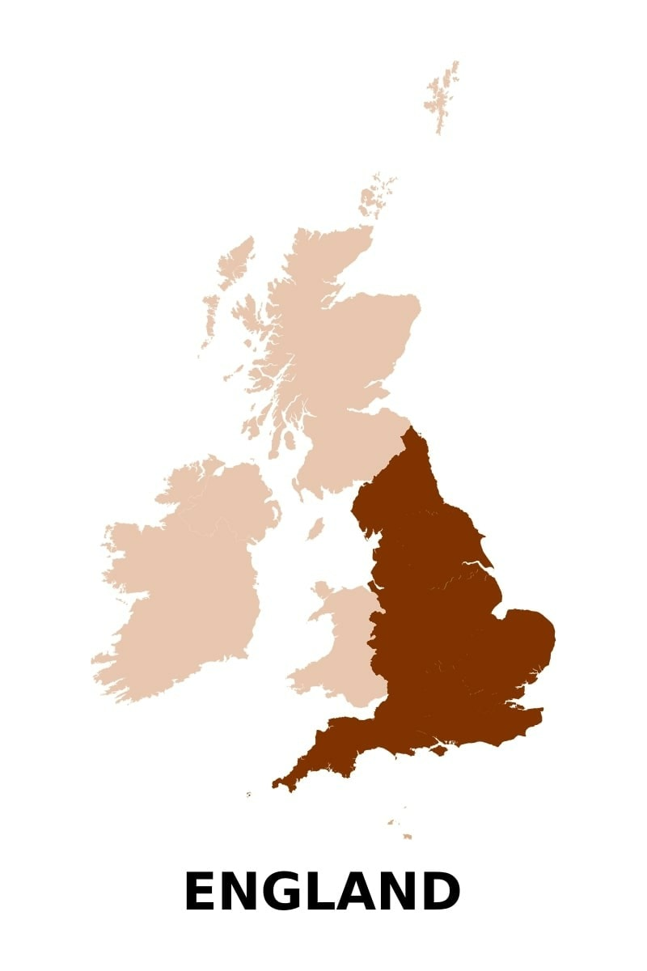
WHAT ARE THE FOUR REGIONS OF THE UK?
1. England
By far the most populated country in the UK, England is very diverse, with a huge multi-cultural population. With 250 languages spoken in England’s capital of London, it’s the world’s most linguistically-diverse city.
England’s economy is the largest amongst all the constituents of the UK. Service industries, particularly banking, insurance, and business services, account by far for the largest proportion of GDP and employ around 80% of the working population.

2. Scotland
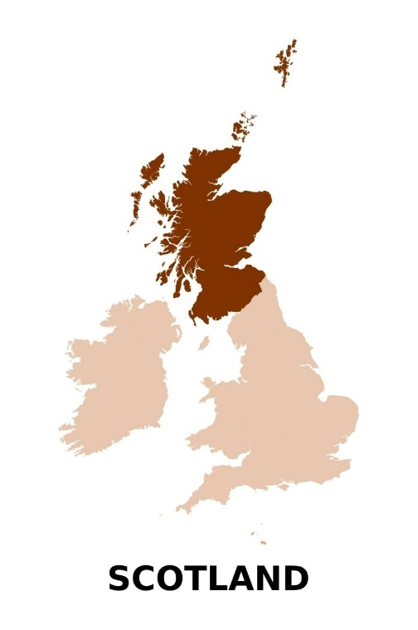
Remote, rugged and rural in many parts, Scotland has a very small population density, with 174 people per square mile, making it the least densely-populated country in the UK by far. The entire country has 3.5 million less inhabitants than Greater London alone.
Agriculture makes a significant contribution to Scotland’s rural economy with pork, beef and lamb producers contributing over £2 billion to Scotland’s annual GDP. Other growing sectors include sustainable energy, engineering and technology, particularly in life sciences and health.
Scotland lies in the north of the UK and has two major economic clusters:
- Edinburgh: the UK’s second-largest financial centre
- Aberdeen: a major hub for the oil and gas industry.
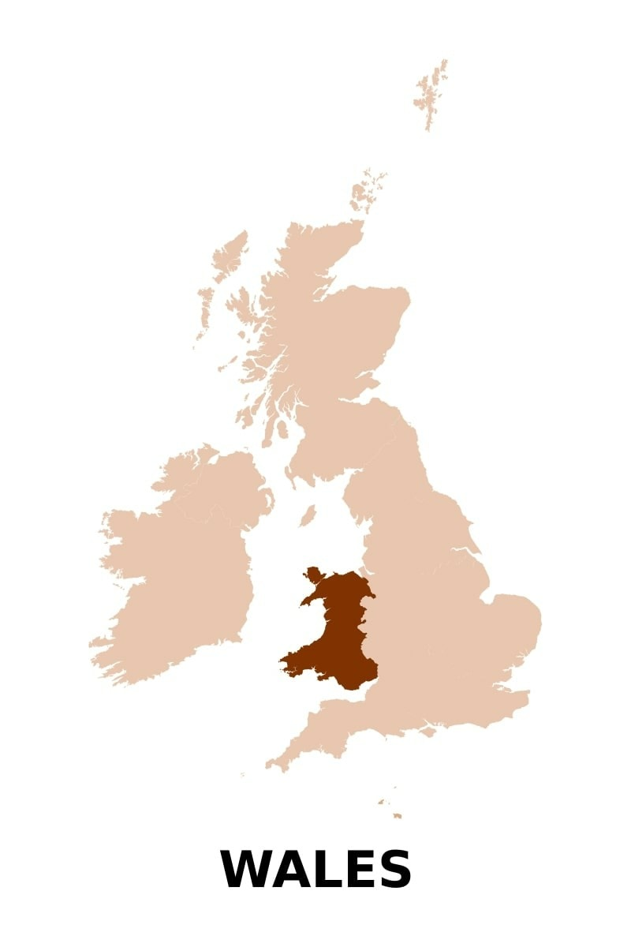
3. Wales
Wales is situated in the west of the UK and has a huge coastline, rugged mountains and incredibly beautiful beaches.
Its capital, Cardiff, is the main economic centre and financial services is one of the most important sectors. Agriculture and wind power facilities (both onshore and offshore) also play an important role.
There is, and always has been, a big social-economic and geographic integration between Wales and England. 95% of the population lives within an hour drive of England and around 100.000 people travel everyday between Wales and England for their jobs.

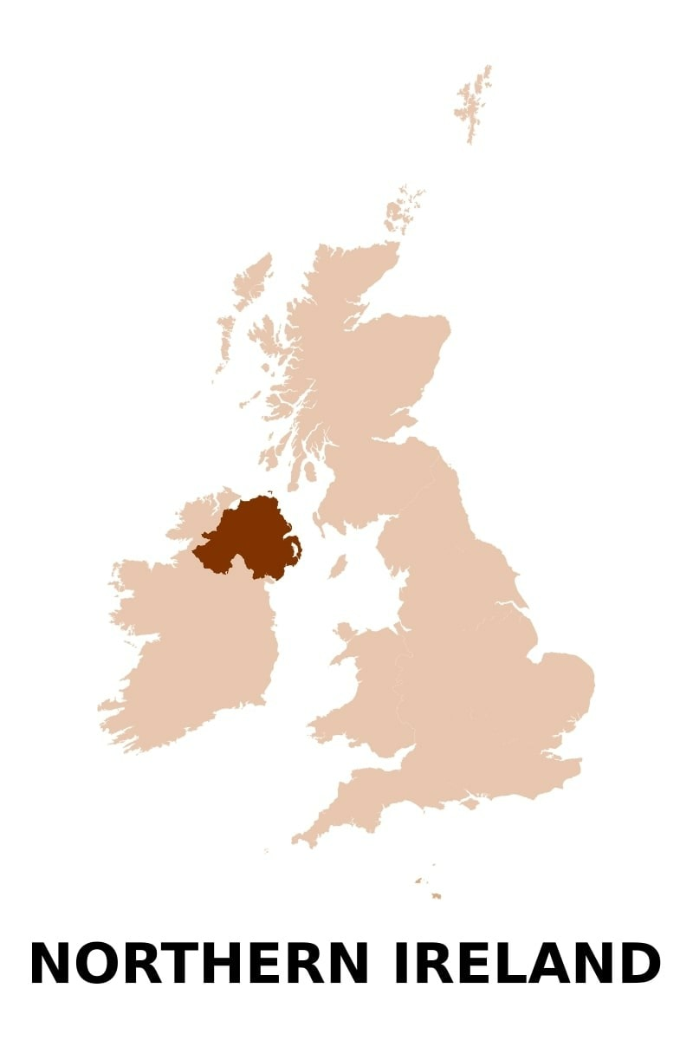
4. Northern Ireland
The smallest of the UK’s four major parts, Northern Ireland is situated in the northeast of the island of Ireland and is the UK’s smallest country which is separated from Great Britain by the Irish Sea.
There are many economic sectors, spread across the country. The most important industries are agriculture, aerospace (the eighth-largest hub in the world) and medical technology.
A third of Northern Ireland’s population live in Belfast, which is an indication of the capital’s economic importance. Northern Ireland also has a growing creative sector, especially in film, music and animation.

(Retrieved from: https://travelness.com, https://www.nlinuk.nl)

b. Mark the statements as True or False.
Statements | True | False
1. Some people don’t consider Northern Ireland an independent country.
2. England has its own separate parliament as other countries of the UK do.
3. Modern England’s economy is purely agricultural.
4. Scotland is the least densely-populated country in the UK.
5. Edinburgh is a hub for the oil and gas industry.
6. Wales has no coastline at all.
7. Wales is a highly integrated with England country.
8. Northern Ireland is the smallest part of the United Kingdom.
9. A third of population live in Northern Ireland’s capital.
10. The United Kingdom and Great Britain is the same thing.

Exercise 7
a. Watch a video on the House of Commons at URL: https://www.youtube.com/watch?v=0ToKcEvqXuM and answer the questions.
- Why was the building of the House of Commons Chamber rebuilt?
- What is the job of the Speaker and where is the Speaker’s place?
- Who sits to the Speaker’s right-hand side?
- Who sits to the Speaker’s left-hand side?
- Who is the Serjeant-at-Arms and what are his functions?
- What are the Dispatch Boxes?
- Why is the Official Report called Hansard?
- Why is the room much smaller than it looks on TV?

b. Watch a video on the House of Lords at URL: https://www.youtube.com/watch?v=-wVllfyvGfU and answer the questions.

- Who is the House of Lords made up of?
- Was the House of Lords Chamber rebuilt?
- What are the functions of the House of Lords?
- What does the Lord Speaker do?
- Why do the Lord Speaker sit on the Woolsack?
- Who are Crossbenchers and where do they sit?
- When does the Monarch visit the House of Lords?
c. Internet activity. Search for some additional information on the Internet on the suggested topics and present your research to your groupmates.
- History and functions of the House of Commons.
- History and functions of the House of Lords.
- Shadow Cabinet.
- Wool trade and its importance for the British Empire.

Exercise 8
Scan the QR-code below to open the web-site of the UK Parliament. Choose one room from the list suggested in House of Parliament virtual tour and describe it.
https://www.parliament.uk/visiting/virtualtour/

Model: There are a lot of green benches in the House of Commons Chamber. Some of them are for so-called backbenchers, MPs who don’t hold ministerial positions.

Exercise 9
a. Read the text about so-called “belt regions” of the USA.

FROM THE BIBLE BELT TO THE RUST BELT, THE UNITED STATES HAS 13 DISTINCT 'BELTS'
The United States can be divided and subdivided into countless regions, each sharing a unique set of characteristics that set it apart from the country as a whole.
You've probably heard of the Rust Belt, the region in the Midwest and Northeast where once-booming economies are on the decline. You may also be familiar with the Bible Belt, a stretch in the South where religion plays an outsize role in the region's culture and politics.
But what about the Jell-O Belt? Or the Stroke Belt? As it turns out, there are more than a dozen regions in the US that go by a "belt" moniker.
Here are the most prominent "belt" regions in the United States:
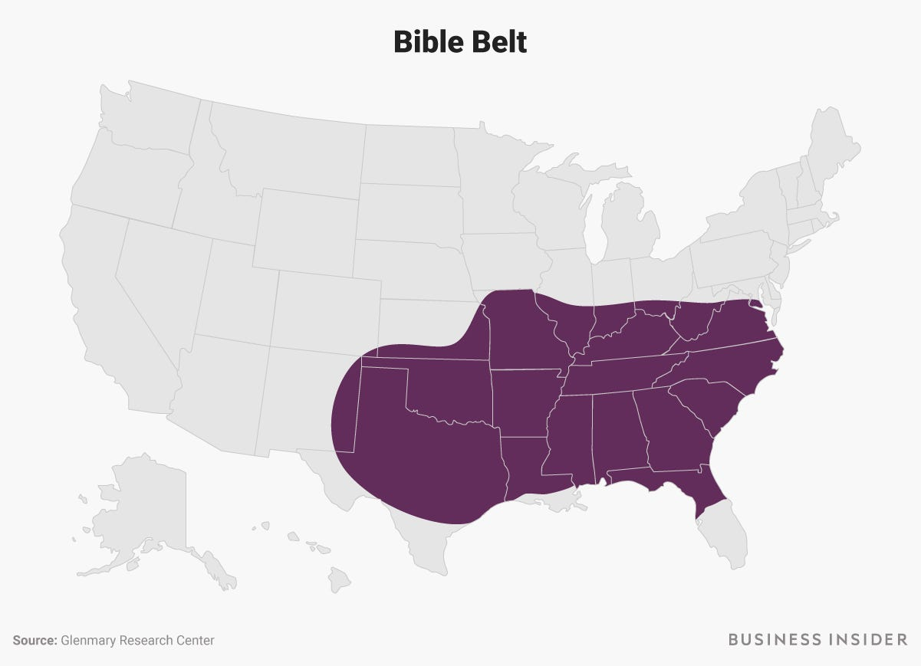
Bible Belt
The Bible Belt is an area of the US where evangelical Protestantism plays an especially strong role in society and politics. People in the Bible Belt tend to be socially conservative and have higher church attendance rates than people in other parts of the country.
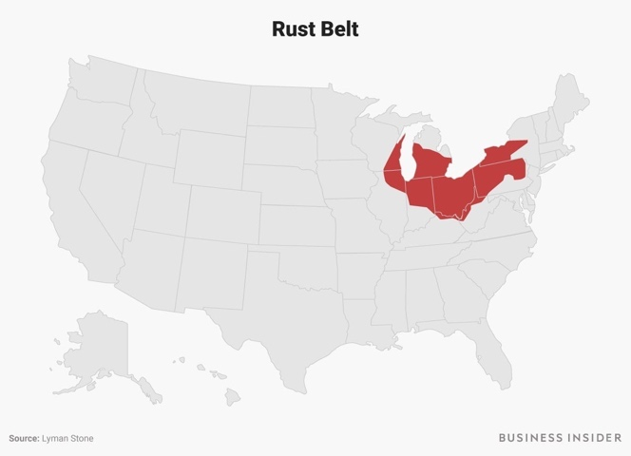
The Bible Belt is thought to include almost all of the Southeastern US and runs from Virginia down to northern Florida and west to parts of Texas, Oklahoma, and Missouri.

Rust Belt
The Rust Belt is a region running across parts of the Midwest and Northeast. Once known for thriving iron and steel industries, the Rust Belt gets its name from the abandoned factories and urban decay that have marked the region since the 1970s. Before this decline in the 20th Century, it was called the Manufacturing Belt or Factory Belt.
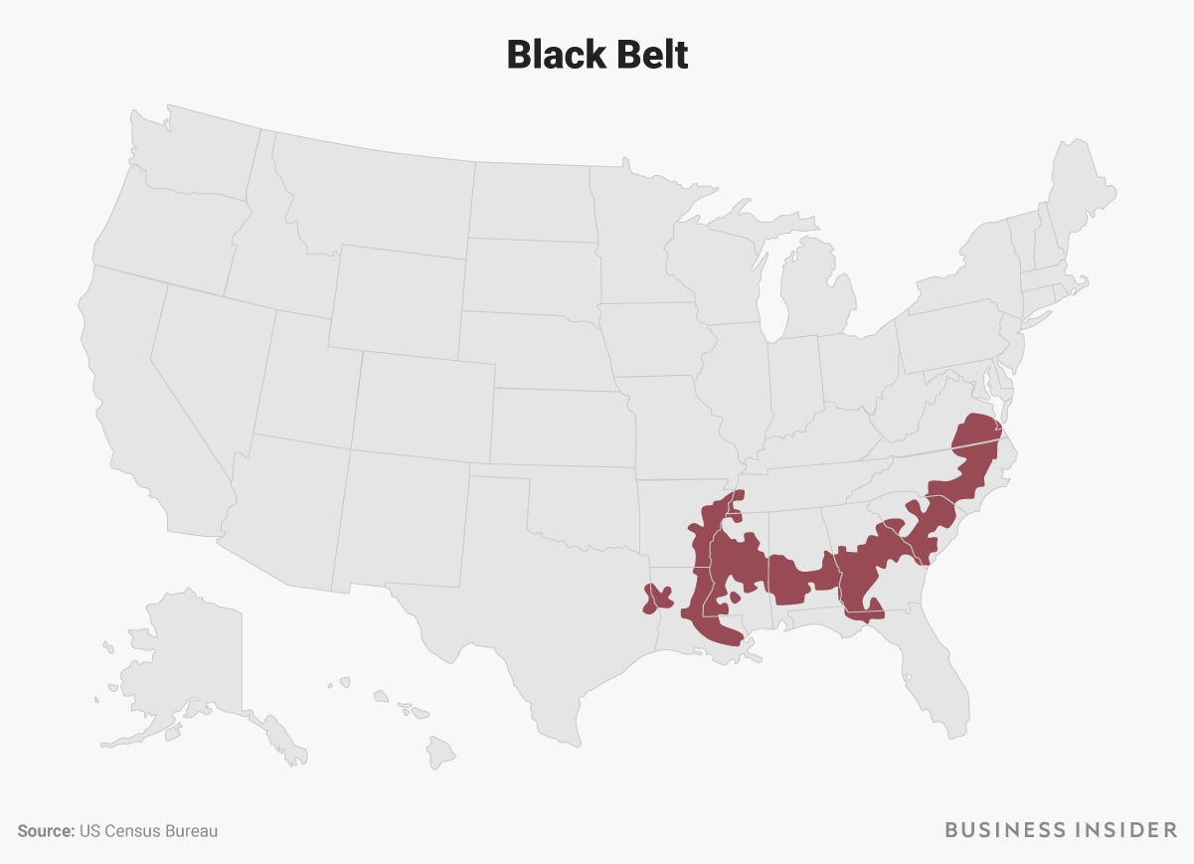
The region is usually said to include parts of New York, Pennsylvania, Ohio, Michigan, Indiana, Illinois, and Wisconsin. The area includes several political swing states, and residents of Rust Belt states often play critical roles in presidential elections.

Black Belt
The Black Belt is a region of the Southern US with a history of slave plantation agriculture and a high African-American population.
The term originally referred to a specific stretch in central Alabama known for its dark, fertile soil. That stretch eventually became associated with the slaves who tended to the land, and the term expanded to include the greater region where slavery and cotton farming were widespread.
Today, the term Black Belt generally encompasses a stretch of counties from Virginia down through the Deep South and including parts of Texas and Arkansas.

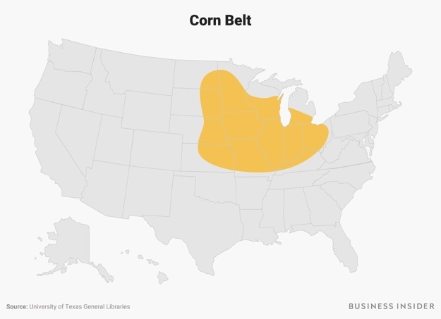
Corn Belt
The Corn Belt is a region of the Midwest that produces a disproportionate amount of the nation's corn.
The region stretches from Ohio to parts of Kansas, Nebraska, and the Dakotas, and encompasses parts of Minnesota in the north and Missouri and Kentucky in the south. Iowa and Illinois could be considered the heart of the Corn Belt, as the pair accounts for a third of all the corn in the US.

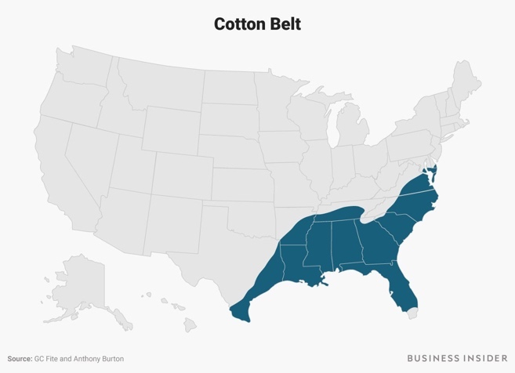
Cotton Belt
Like the Black Belt, the Cotton Belt is rooted in slavery — it encompasses the states where cotton was the predominant cash crop from the late 1700s into the 20th century.
The region includes much of the Southeast, and reaches as far north as Maryland and as far west as Texas.

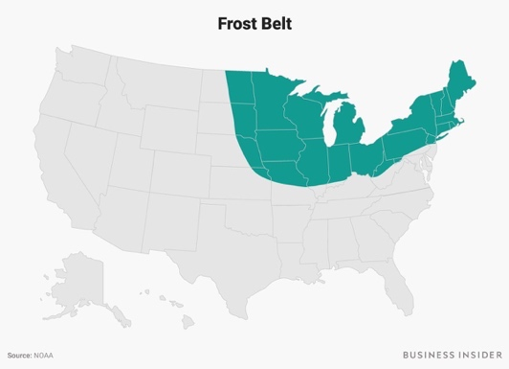
Frost Belt
As the name suggests, the Frost Belt is a region known for its icy winters and heavy snowfall. It includes the entirety of New England and much of the Mid-Atlantic and Midwest regions.
It's no surprise that the Frost Belt overlaps with the region known as the Salt Belt, which are the cold-weather states where heavy doses of salt are applied to the roads in the winter. A state's Salt Belt status is relevant to car owners and manufacturers, as road salt can cause corrosion in automobile parts.

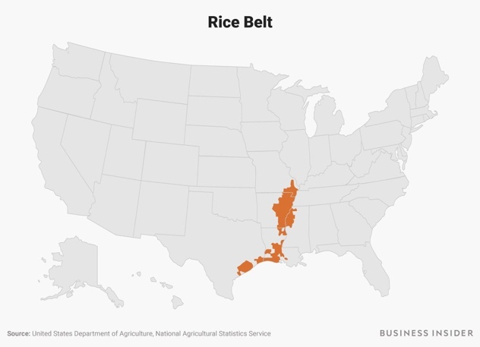
Rice Belt
The Rice Belt is a stretch of counties that produces almost all of the rice in the US.
As the nation's leader in rice production, Arkansas is the hub of the Rice Belt. The region also includes parts of Texas, Louisiana, Mississippi, and Missouri.

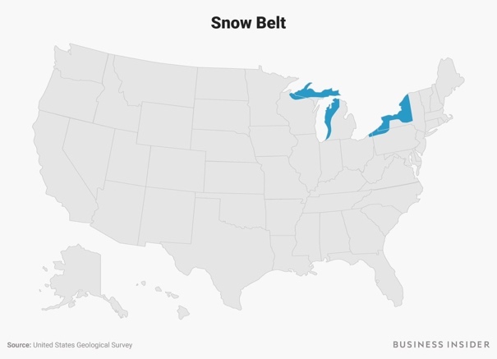
Snow Belt
The Snow Belt comprises three stretches of land near the Great Lakes that are among the snowiest in the US.
The region attributes its heavy snowfall to a phenomenon called lake-effect snow. That's when cold, dry air passes over the relatively warmer water of a lake, picking up moisture and dumping it downwind.
Each of the five Great Lakes yields a snow belt: Lake Ontario's is in upstate New York; Lake Erie's runs from Cleveland, Ohio, to New York; Lake Michigan's runs the entirety of western Michigan, and Lake Superior's includes northern Wisconsin and Michigan's Upper Peninsula.
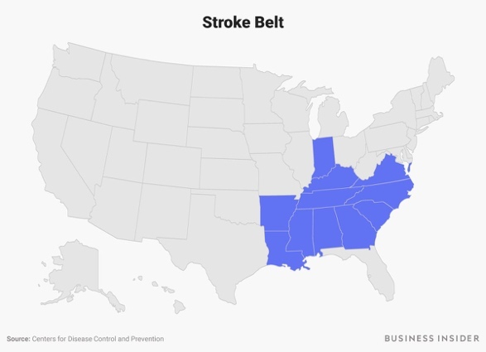
The same effects that produce lake-effect snow are also favorable to growing fruit, so these very regions also make up America's so-called Fruit Belt.

Stroke Belt
The Stroke Belt is a group of 11 states where the risk of having a stroke or other types of cardiovascular disease is significantly higher than the national average.
The states in the Stroke Belt, mostly in the Southeast, are Virginia, North Carolina, South Carolina, Georgia, Alabama, Mississippi, Louisiana, Arkansas, Tennessee, Kentucky, and Indiana.
According to a study published by the American Heart Association, contributors to the high stroke mortality rate in the region include a large Black population and residents with a "higher prevalence of inflammation and infection, and lower socioeconomic status."

Sun Belt
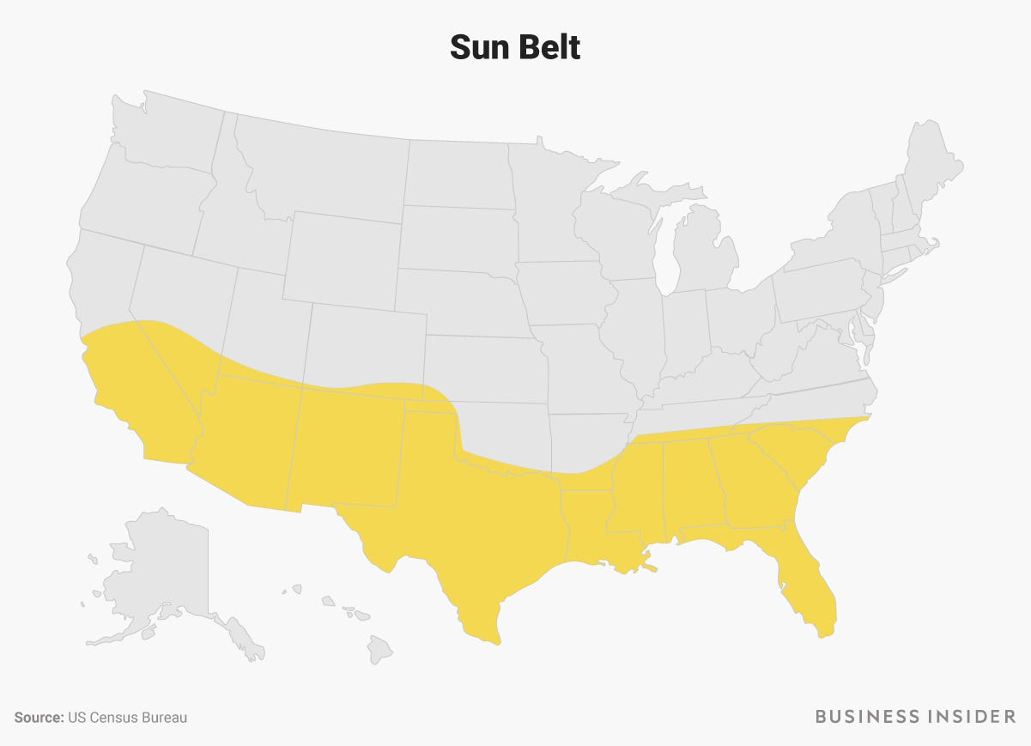
The Sun Belt stretches across the entire southern portion of the continental US and is known for its warm weather and sunny skies. The northern border of the region roughly aligns with the 36th parallel.
Since the end of World War II, the Sun Belt has seen a boom in its population and economic opportunities, and Census data show the region is growing at a faster rate than the Northeast and Midwest.

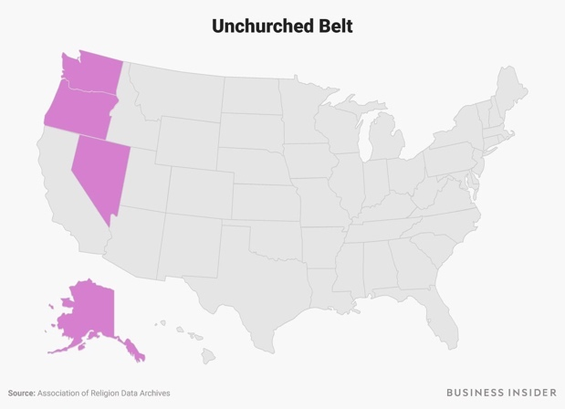
Unchurched Belt
The Unchurched Belt is sort of like the opposite of the Bible Belt. Located in the northwestern corner of the country, it's the region with the lowest rates of religious participation and church attendance in the nation.
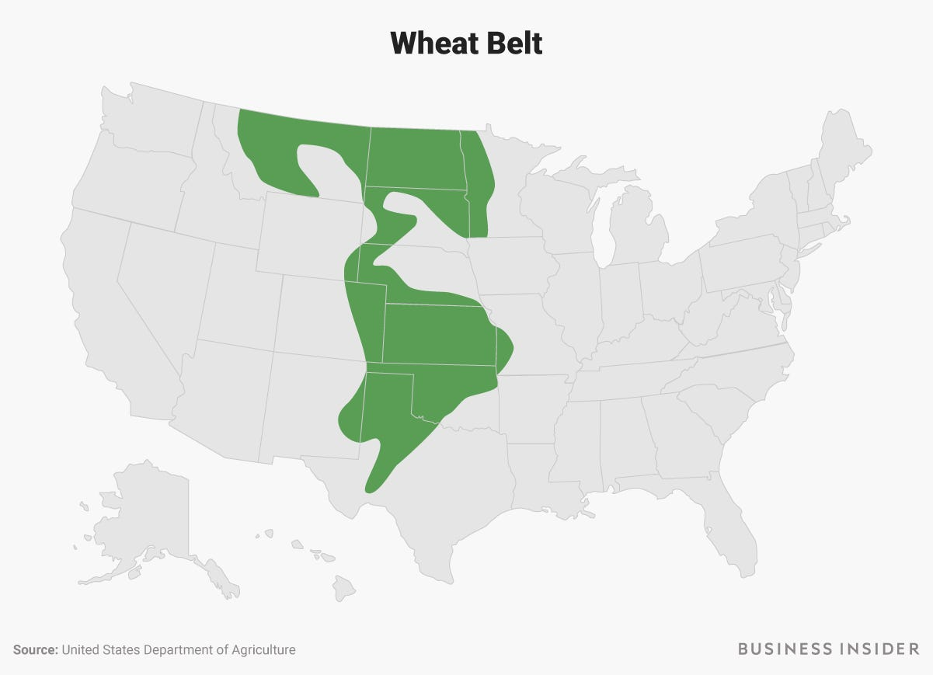
The four states in the Unchurched Belt are Nevada, Oregon, Washington, and Alaska.

Wheat Belt
The last of the major belt regions is the Wheat Belt — the part of the Great Plains where wheat is the primary crop.
Really, the region is made up of two different wheat-growing areas. The southern portion, including parts of Texas, Oklahoma, Kansas, Nebraska, Colorado, and Wyoming, grows hard red winter wheat. The northern portion, covering South Dakota, North Dakota, Minnesota, Montana, and up into Canada, grows hard red spring wheat.
(Retrieved from:https://www.businessinsider.com)

b. Answer the questions:
- What is the Bible Belt, and what are some of its defining characteristics?
- Which states are included in the Rust Belt, and why is it called that?
- How did the Black Belt get its name?
- Which states can be considered the heart of the Corn Belt.
- How does the Cotton Belt relate to the history of slavery in the US?
- What is another name of the Frost Belt? Why is it called like that?
- What is the Snow Belt, and how does lake-effect snow contribute to heavy snowfall in this region?
- Why is the risk of cardiovascular disease higher in the Stroke Belt?
- What is the Sun Belt, and how has it changed since World War II?
- How is the Unchurched Belt opposite to the Bible Belt?
- What areas does the Wheat Belt consist of?

c. Find additional information about one of the “Belts” and prepare a presentation about it.

Exercise 10
Watch the video at https://www.youtube.com/watch?v=bfUeekXbYzk.
BEFORE YOU WATCH. Answer the preliminary questions.
- How many states are included into the USA?
- In your opinion, does the US capital have more power than other states in the USA?

WHILE YOU WATCH. Mark the statements as True or False.
Statement | True | False
1. House of Representatives vote for Washington, DC statehood quite often.
2. The representative of DC’s residents cannot vote on bills
3. DC residents like people of American territories do not pay federal taxes.
4. According to US Constitution the federal government cannot be based in one of the states.
5. The fact that Congress completely controls DC’s budget is one of the major reasons why people of Washington DC want statehood.
6.Holmes Norton’s plan is to turn the whole District of Columbia into a newest and smallest state Douglass Commonwealth.
7. Statehood issue is a political question.
8. Since 1819, new states were added in pair to keep the balance between the political parties.
9. A coronavirus relief bill given to Washington, DC was equal to that given to each states.
10. The National Guard cannot be engaged in Washington, DC.

AFTER YOU WATCH.
Conduct a small investigation on the Internet. Write a brief essay (120-200 words) on one of the suggested topics.
Topics you may choose from:
- Powers and duties of states within in the USA.
- Powers and duties of American territories.
- Powers and duties of the District of Columbia.

Exercise 11
Watch the video on Ancient Rus’ history at https://www.youtube.com/watch?v=lfe1wEQzSzM and do the tasks listed below.
  - BEFORE YOU WATCH. Match the words form the left column to their translations from the right one.

1) succession | a) язычество
2) a monk | b) литературные памятники
3) archaeological evidence | c) Летопись Временных Лет
4) the Primary Chronicle | d) престолонаследие
5) accounts | e) грамотные ученые
6) Crusade | f) археологические свидетельства
7) literate scholars | g) монах
8) polytheistic religion | h) братоубийственные распри
9) fratricidal disputes | i) политеистическая религия
10) paganism | j) Крестовый поход

b.WHILE YOU WATCH. Answer the questions:
- What are the main sources of information about Slavs? Why is their number so limited?
- What branches did the Slavic tribes split into?
- How was the Kievan Rus born?
- What is the probable origin of the name ‘Rus’?
- What was the result of Orthodox Christianity adoption?
- What was the foundation of a newly created Slavic alphabet.
- What was the last blow leading to the Rus collapse?

c. Fill in the gaps using the information from the video.
- The answers lie in an epic story of ________, ___________, and the rise and fall of a ________ state known as Kievan Rus.
- As Nestor's story goes, after years of _________ by Vikings from the north, the region's tribes revolted and drove back the Northmen.
- With Rurik's son, Oleg, expanding his _______ into the south.
- The new princedom had complex relations with its neighbors, alternating between __________ and _________ with the Khazar and Byzantine Empires.
- For several generations, the Kievan Rus flourished from its rich _______ and _________.
- Rus princes paid little attention to ___________ of a mysterious unstoppable hoard until 1237, when 35,000 ________ archers led by Batu Khan swept through the Rus cities.
- For the next few centuries, the former lands of Kievan Rus ________ by Slavs, __________ by Vikings, _________ by Greeks, and _________ by Mongols would develop differences in society, culture and language that remain to the present day.

GRAMMAR REFERENCE

THE VERB “TO BE”
 | Present Simple | Past Simple | Future Simple
Positive | I am  He / she / it is We / you / they are | I / he / she / it  was  We / they / you  were | I / he / she / it / we / they / you will be
Negative | I am not  He / she / it is not We / you / they are not | I / he / she / it  was not  We / they / you  were not | I / he / she / it / we / they / you will not be
Question | Am I?  Is he / she / it? Are we / you / they? | Was I / he / she / it?  Were we / you/ they? | Will I / he / she / it / we / they / you be?

For more grammar practice visit the Internet site and do exercises online.
Verb to be: https://www.englisch-hilfen.de/en/exercises/tenses/be.htm

VERB TENSES – ACTIVE VOICE
 | Present Simple | Past Simple | Future Simple
Positive | I / you / we / they  live in Moscow.  He / she / it lives  in Moscow.  never, sometimes, often, usually, always | I / he / she / it / we / you / they moved / went to Vladivostok in 2021. ago, last night (Sunday, week, year, month), yesterday (morning, evening, afternoon) | I / he / she / it / we / you / they will study at Moscow State University.
Negative | I / you / we / they do not (=don’t) live in Moscow.  He / she / it does not (=doesn’t) live in Moscow. | I / he / she / it / we / you / they did not (=didn’t) move / go to Vladivostok in 2021. | I / he / she / it / we / you / they will not (=won’t) study at Moscow State University.
Question | Do I / you / we / they live in Moscow? Yes, I do. No, I don’t.  Does he / she / it live in Moscow? Yes, he does. No, he doesn’t.  Where do I / you / we / they live?  Where does he / she / it live? | Did I / he / she / it / we / you / they move / go to Vladivostok in 2021?  Yes, I did. No, I did not (=didn’t).  Where did I / he / she / it / we /  you / they move / go in 2021? | Will I / he / she / it / we / you / they study at Moscow State University? Yes,  I will. No, I will not (=won’t). Where will I / he / she / it / we /you / they study?

Study the forms of irregular verbs:
https://lingbase.com/ru/english/grammar/complete-list-of-irregular-verbs
For more grammar practice visit the Internet sites and do exercises online.

Present Simple:
https://www.perfect-english-grammar.com/present-simple-exercise-7.html

Past Simple:
https://www.perfect-english-grammar.com/past-simple-exercise-8.html

Future Simple:
https://www.perfect-english-grammar.com/simple-future-exercise-1.html

THE VERB “TO HAVE”

Positive | Negative | Yes/  No-Questions | Wh-Questions
I / we / you / they have  He / she / it  has | I / we / you / they don’t have  He / she / it  doesn’t have | Do I / we / you / they have  Does he / she / it have | What do I /  we / you / they  have?  What does he / she / it have?
For more grammar practice visit the site
https://www.english-room.com/grammar/havehas_01.htm
and do exercises online.

THE VERB + -ING FORM

 | Verbs | Examples
Likes and dislikes | like  love  enjoy  prefer  do (not) mind hate  dislike | Do you like watching movies?  I don’t mind getting up early.
sports and other activities | go swimming,  go skating,  go horseriding, go running,  go shopping | How often do you go shopping?  Next time let's go skating outdoors.

PROGRESSIVE (CONTINUOUS) ACTIVE

be + -ing Verb
Present | Past | Future
I am studying engineering.  She/He is studying engineering.  They/you/we are studying engineering. | I was studying engineering  He/she was studying engineering.  They/you/we were studying engineering. | I will be studying engineering.  He/she will be studying engineering.  They/we/you will be studying engneering.
I am not studying engineering.  She/He is not studying engineering.  They/you/we are not studying engineering. | I wasn’t studying engineering.  She/He was not studying engineering.  They/you/we were not studying engineering. | I will not (won’t) be studying engineering.  He/she will not (won’t) be studying engineering.  They/we/you will not (won’t) be studying engineering.
Is he/she studying engineering?  Are they/we/you studying engineering?  What is she/he studying?  What are they studying? | Was he/she studying engineering?  Were they/we/you studying engineering?  What was she/he studying?  What were they studying? | Will he/she/you/we/they be studying engineering?  What will he/she/we/you/they be studying?

State Verbs
Some verbs are NOT normally used in the Present Progressive: like, hate, want, need, prefer, know, realise, understand, recognise, believe, suppose, remember, mean, belong, fit, contain, consist, seem, owe etc.

We do not say: I am understanding. / He is knowing / They are wanting.
Some State verbs have several meanings and can be used in Progressive.

E.g.
Think:
I think he is clever. (= opinion, it’s a state) vs I’m thinking to buy a new flat. (= mental process, action)
Look:
Come on, now, you look pretty. (= it’s your state) vs Why are you looking at me? (=action of watching)
Taste:
Why does chocolate taste so good? (= it has a taste, it’s a state) vs Juliette is tasting her husband's new dishes (= action).
Smell:
The flower smells good. (= it has a scent, it’s a state) vs Why is he smelling it? (= action)
See:
Do you see this girl? (= it’s a state) vs We are seeing our friends tomorrow. (= are going to meet)
Have:
He has a house. (= possession, it’s a state) vs He is having dinner with my family. (= action)

For more grammar practice visit the Internet sites and do exercises online.
Present Progressive:
https://www.perfect-english-grammar.com/present-continuous-exercise-1.html
Past Progressive:
https://www.perfect-english-grammar.com/past-continuous-exercise-1.html
Future Progressive:
https://www.perfect-english-grammar.com/future-continuous-exercise-1.html

PASSIVE. SIMPLE AND CONTINUOUS

When we use Active voice, we point at the agent or the “doer” directly by putting it as the subject:
I wrote the email.
Who did it? – I did.
However, the subject and the “doer” do not always coincide. To show it, we use Passive voice where the “doer” is placed at the end of the sentence or simply left out. Compare:
Active voice: the subject and the agent coincide. | Passive voice: the subject and the agent do not coincide | Passive voice: we leave out the agent
I did this exercise. | The exercise was done by me. | The exercise was done.
In the example above the subject of the sentence is highlighted in bold, the “doer” is underlined.
Typically, Passive voice is used when we:
1) want to change the focus of the sentence;
2) the “doer” is not important;
3) the “doer” is not known;
4) do not want to say who the “doer” is.
To form the passive, we need to use the auxiliary verb “to be” and the third form of a verb. The core formula looks like this:
to be/to get + V3/Ved
In colloquial English, we can use “get” instead of “be” but only for actions, not states:
Did you get burned?
Passive voice with get is usually used in informal spoken English. It places considerable emphasis on the action. Often Passive voice with get is used when something happens accidentally or unexpectedly:
My laptop got stolen from the library. – I did not expect it.
This form of the passive voice is often used when we talk about some negative, undesirable, unpleasant things:
My husband got fired a week ago.
The verb get itself expresses change, a transition from one state to another, so it is not usually used with state verbs that do not express action as such. These include: think, believe, know, remember, understand, have, own, love, and many others.
In this section, we concentrate on the form of Simple Passive and Continuous Passive. You will find their passive forms in the table below:
 | Simple | Continuous
Present | am/is/are + V3/Ved | am/is/are + being + V3/Ved
Present | My work is presented in this magazine. | The road is being repaired now.
Past | was/were + V3/Ved | was/were + being + V3/Ved
Past | My laptop was stolen! | This temple was being built two years.
Future | will be + V3/Ved | will be + being + V3/Ved
Future | Tomorrow all the work will be done by machines. | You will be examined by the best doctors.
For more grammar practice visit the Internet site and do exercises online.
Passive Voice: https://www.english-grammar.at/online_exercises/passive-voice/passive-voice-index.htm

THE PERFECT TENSES

 | Perfect | Perfect Progressive (Continuous)
Present | Have/has+V3 | Have/has+been+Ving
Present | I/you/we/they have come.  I/you/we/they have not come.  Have I/you/we/they come?  He/she/it has decided.  He/she/it has not decided.  Has he/she it decided? | I/you/we/they have been travelling.  I/you/we/they have not been travelling.  Have I/you/we/they been travelling?  He/she/it has been reading.  He/she/it has not been reading.  Has he/she/it been reading?
Past | Had+V3 | Had+been+Ving
Past | I/you/we/they/ he/ it /she had finished the report by 5 o’clock.  I/you/we/they/ he/ it /she had not finished the report by 5 o’clock.  Had I/you/we/they/ he/ it /she finished the report by 5 o’clock? | I/you/we/they/ he/ it /she had been working at this project since 2000 until they finished it.  I/you/we/they/ he/ it /she had not been playing tennis since 2000.  How long had I/you/we/they/ he/ it /she been training before you won your first competition?
Future | will have+V3 | Will+have+been+Ving
Future | I/ I/you/we/they/ he/ it /she will have done this work by 9 o’clock tomorrow.  I/ I/you/we/they/ he/ it /she will not have done this work by 9 o’clock tomorrow.  Will I/you/we/they/ he/ it /she have done this work by 9 o’clock tomorrow? | By the time we join them, I/you/we/they/ he/ it /she will have been traveling for two weeks.  By 2025 I/you/we/they/ he/ it /she will not have been living in this country long enough to obtain citizenship.  How long will I/you/we/they/ he/ it /she have been practicing in the clinic when you graduate?
We often use for, since and how long with the Present Perfect simple to talk about ongoing states.
How long have you known each other?
We've known each other since we were at school.
We often use for, since and how long with the Present Perfect Continuous to talk about ongoing single or repeated actions.
How long have they been playing tennis?
They've been playing tennis for an hour.
They've been playing tennis every Sunday for years.
Sometimes the Present Perfect Continuous can emphasize that a situation is temporary.
I usually go to the gym on the High Street, but it's closed for repairs at the moment, so I've been going to the one in the shopping center.
NOTE! Stative verbs (believe, forget, remember, like, hate, contain, possess etc.) are NOT used in the Perfect Continuous Tenses.
I’ve known about the problem for a long time. (not I’ve been knowing)
How long have you had that camera? (not have you been having)
But note that you can use want and mean in the present perfect continuous (have/has been + -ing):
I’ve been meaning to phone Anna, but I keep forgetting.
Watch the video for a more detailed understanding of the topic:
Perfect Tenses:
https://www.youtube.com/watch?v=O9YRy8m1Rf8
Perfect Progressive (Continuous) Tenses:
https://www.youtube.com/watch?v=MkheJuWMEUU
For more grammar practice visit the Internet site and do exercises online.
https://www.english-grammar.at/online_exercises/tenses/tenses_index.htm

PERFECT PASSIVE
Present Perfect Passive
have/has + been + V(3)
The windows have been cleaned and now they look good.
The windows have not been cleaned.
Have the windows been cleaned?
Past Perfect Passive
had+been+V(3)
He had been arrested before his friend arrived.
He had not been arrested before his friend arrived.
Had he been arrested before his friend arrived?
Future Perfect Passive
will+have+been+V(3)
By 2080 workers will have been replaced by robots.
By 2025 workers will not have been replaced by robots.
Will workers have been replaced by robots by 2080?

We use the Present Perfect Passive to describe an action that started in the past and continues up to the present.
Structure: Object + has/have + been + past participle (V3) + (by + subject)
Example: The sandwich (Object) + has + been + eaten (V3) + by me (By + subject).

The Past Perfect Passive expresses a previous action or state that began in the past and continued up to another point in the past, and its consequences have implications for that second point in time.
Structure: had + been + past participle
Time expressions such as “by,” “before,” “by the time,” or “until” are often used to indicate the completion of the action.
Example: The report had been submitted by the deadline.

The Future Perfect Passive is used to talk about actions or events that will be finished by a certain moment in the future. When we use this tense, we are projecting ourselves forward into the future and looking back at an action that will be completed sometime later than now. Passive voice means that the subject of the sentence is acted upon.
Example: This report will have been written by the 1st of November.
The Future Perfect Passive is not very common in English because it is seldom required by the situation. Besides, it’s better to use active voice in speech and writing. But when it is used, it’s usually followed by a time expression, often with the word ‘by’.
Example: Don’t worry, all work will have been done by 4 p.m.

For more grammar practice visit the Internet site and do exercises online.
Present Perfect Passive: https://www.e-grammar.org/present-perfect-passive/test1-exercise1/
Past Perfect Passive: https://www.grammarism.com/past-perfect-passive-exercises/
Future Perfect Passive: https://www.grammarism.com/future-perfect-passive-exercises/

THERE + TO BE
We use such constructions when we mention the existence or presence of someone or something for the first time. It is necessary to mention that the construction needs to agree with a sentence’s subject. In other words, there is used when a subject is singular, there are is used with a plural subject:
There are four chairs in my room.
There is a big mistake in your report.
Be careful with words! If we replace there with, for example, it, the whole meaning of the phrase will change. There introduces new information, whereas it gives more detail about the information.
Phrase | Meaning
There is a smartphone in my pocket. | The speaker mentions that he or she has a smartphone in his/her pocket for the first time.
It is a smartphone in your pocket. | The speaker answers the question “What is beeping?”

There is has a contracted form there’s which it typical for informal speech.
There is a mistake in your report. | = | There’s a mistake in your report.
In speaking and in some informal writing, we can use there’s with both singular and plural subjects. However, be careful because it may be considered incorrect in formal writing or in academic/professional environment.
There’s a small box on the floor. | 
There’s pieces of torn paper everywhere (informal)
There’s a lot of students listening to the lecturer (formal) | 
For more grammar practice visit the site: https://agendaweb.org/grammar/there_is_are-exercises.html

COUNTABLE AND UNCOUNTABLE NOUNS
Nouns are one of the most important word classes in English. To use them properly, you need to remember that some of them can be counted and some of them don’t. So, nouns can be countable and uncountable.
Countable nouns
These nouns can be counted.
For example: one cat, two cats, three cats.
This means that we can use a/an article and numbers with them.
Uncountable nouns
Such nouns do not have a distinction between singular and plural. Abstract nouns, materials, liquids are the examples of uncountable nouns:
Friendship, woods, iron, rice
Some uncountable nouns are used only in in the singular, others are only used in the plural. In the table below, you can find some examples of these nouns.
Always singular | Always plural
information | clothes
advice | binoculars
furniture | headphones
accommodation | (sun)glasses
equipment | scissors
news | belongings
money | jeans
 | trousers
 | pants
 | goods

Some nouns can be either countable and uncountable. It depends on the context such words are in:
Countable | Uncountable
I have two chickens in my yard.  A chicken = an animal. | I will have some chicken, please.  Chicken = meat
I’ll give her a box of chocolates.  A chocolate = a small sweet | This tower is made of chocolate. Children will love it!  Chocolate = an ingredient
Would you like a tea or a coffee?  A tea/coffee = a cup of tea/coffee. | I like tea more than coffee.  Tea/coffee is a type of drink.
You should do several exercises.  Exercises = tasks | Do you take much exercise?  Exercise = physical activity
It was interesting hearing about his experiences as a doctor.  Experiences = something that happens to you that affects how you feel | Some HRs pay attention to not your formal qualification but to your real experience.  Experience = knowledge, or skill from doing, seeing, or feeling things
How many works by Lermontov do you know?  Works = books (or other results of human activity) | I have much work to do.  Work = job or other duties
He wrote two scientific papers.  A paper = an article/document | This crane is made of paper.  Paper = material

Note!
Some quantifiers can be used only with countable nouns, some of them are exclusively used with uncountable nouns.
With countable nouns | With uncountable nouns
Many | Much
Few/a few | Little/a little

Ways of counting uncountable nouns
To count what can’t be counted, you can use different quantifiers, such as:
- units: e.g., a bit of information; an item of furniture; a piece of advice; a sheet of paper, etc.
- containers: e.g., a bottle of water; a can of soup; a packet of sugar; a cup of coffee, etc.
- measurements: e.g., two kilometers of road; a liter of water; a kilo of meat, etc.
For more grammar practice visit the site https://englishweb.ru/grammar/countable-uncountable-exercises.html?ysclid=lpe8b9i7wn894284646

ARTICLES
Articles a/an and the are a type of determiners and go ONLY before nouns. We cannot use articles before adjectives, verbs, etc.
a dog
an orange
a big
If we want to use adjectives to modify a noun, we should put an adjective or adjectives between article and noun.
the big juicy orange
big juicy an orange
Mind the next sound! The sound which goes after articles influences the way how we use them in speaking.

 | INDEFINITE ARTICLE | DEFINITE ARTICLE
Before a consonant sound | We use a /ə/:  a house / a big house | We pronounce “the” as /ði:/:  the team – /ðə ti:m/
Before a vowel sound | We use an /ən/:  an apartment / an old house | We pronounce “the” as /ðə/:  the apple – /ði: æpəl/
Warning: Letters can be illusive!
a) some words that begin with a consonant letter in writing have a vowel sound:
an hour - /ən aʊə(r)/
an MP3 player - /ən empi:θri: …/
b) some words that begin with a vowel letter in writing have a consonant sound:
the union - /ðə ju:niən/

When do we use articles?
Here, we should remember that some nouns in English can be countable, some of them – cannot.
Type of noun | Article
Type of noun | GENERAL MEANING | PARTICULAR MEANING
Countable, singular | A/AN | THE
Countable, plural | no article | THE
Uncountable | no article | THE
Articles are very important tools in English which helps to indicate how concrete something we talk about is. Thus, we can display this rule as follows:
A
B
S
T
R
A
C
T
I
O
N
Definite article (THE). No abstraction, complete concreteness
Indefinite article (A/AN). The moderate level of abstraction.
Zero article. The highest level of abstraction.

So, we see that we should use no article in cases when a thing said is completely abstract. For example, abstract notions (e.g. love, hatred, freedom, education) or uncountable nouns (e.g. rice, furniture, advice).
Indefinite article (A/AN) is used when a thing said is rather concrete (it is countable physical object) but we cannot say which object exactly we talk about. In other words, “a chair” is concrete enough to be a physical object which can be counted, however, it is not “a concrete chair” but rather “some chair”, “one of a number of chairs”.
We should use definite article (THE) when a thing said is concrete (i.e. we point at this particular object). For example, “the chair” is not “one of a number of chairs” but “this particular chair”.
History fact. Indefinite article derived from the Old English numeral which meant “one”. Definite article “the” derived from an Old English demonstrative pronoun which also meant “this, that”. Now, compare this information with the theory of abstraction given above.
This concreteness may originate from the context of the situation (1) or from the information which has already been said (2).
1) Now, let’s imagine the following situation: John and Jack are in the same room and talk to each other. The room has only one door and two windows.
John: Gosh, it is so hot! Look at the sun, it is literally baking us! Could you open the door?
Jack: OK, no problem. Is that any better?
John: Much better! Perhaps, we open a window, shall we?
Jack: Which one?
So, we see that Jack understands immediately which door John is talking about because the room has only one door. However, there are two windows, so it is unclear to Jack which window he should open. Also, pay attention to “the sun”. The Solar System has only one sun, therefore, it is obvious to everyone what sun is said about.
2) Another situation: Jack and John continue talking. John is asking Jack whether he has any pets.
John: Yeah, dogs are amazing! So smart and funny creatures. By the way, Jack, do you have any pets?
Jack: I do. However, I am much more of a cat person, really. I have a cat. The cat is black with white paws. They look like tiny boots!
We see that the first time Jack mentions his cat he uses indefinite article, whereas, he uses the definite article mentioning his cat the second time. The first time, “a cat” is a piece of new (inconcrete) to John information. From his perspective, Jack’s phrase “I have a cat” means “There are many cats in the world. Jack has one of them”. However, when Jack starts describing his cat, it is already known, therefore, concrete, information. That is why he uses the definite article.
When can’t we use articles?
a) We cannot use articles before other words used to specify a noun (determiners). You should remember following determiners: possessive pronouns (my, his, etc.), any, some, no, this, that.
Do you read this book? |  | Do you read this the book?
I have no cat. |  | I have no a cat.
b) We cannot use articles before possessive expressions.
This is John’s bag. |  | This is the John’s bag
WARNING: articles may refer not to the main noun but to the noun in the possessive expression!
Example: the UK’s territory, the teacher’s glasses
Special cases of article use
Now, let’s have a look at some specific cases of article use.
Indefinite article  (A/AN) | Descriptions. We use a/an to describe a person or thing, usually with an adjective.
Indefinite article  (A/AN) | Fractions and large numbers. We use a/an to mean one:  half of a kilometer, one and a half, a thousand
Indefinite article  (A/AN) | Frequency and measurement. We use a\an to mean each:  once a day, twice a month, six euros a kilo, 100 kms an hour (BUT every hour)
Definite article (THE) | Countries with plural names or nouns like Republic, Kingdom, etc.:  The Netherlands, The Russian Federation
Definite article (THE) | Names of oceans, seas, rivers, mountain ranges:  The Appalachian Mountains, The Atlantic Ocean
Definite article (THE) | Names of museums, cinemas, theaters, hotels:  The National Theater, the Hilton Hotel, the American University Museum
Definite article (THE) | Places in town, types of shops:  the bank, the grocery
Definite article (THE) | Locations:  on the left, in the east
Definite article (THE) | Noun + of:  the Isle of Man, the City of London
Zero article | Most countries and continents:  Russia, Great Britain, Europe
Zero article | Cities, towns, states and regions:  Moscow, New York, Rhode Island
Zero article | Mountains, hills and lakes:  Mount McKinley, Lake Superior
Zero article | Most roads, streets, squares and parks:  Hyde Park, Times Square, Oxford Street (BUT the M25, the high street)
Zero article | Named airports and stations:  Miami Airport, Birmingham Bus Station
Zero article | Means of transport and communication:  on foot, by bus, by phone

For more grammar practice visit the site https://www.englishcurrent.com/exercises/study-articles-exercises-online/

ADJECTIVES. COMPARISON
There are two degrees of comparison: comparative and superlative forms. To use them properly, we need to split all adjectives into three classes. Each class has its rules how to build comparatives and superlatives.
Let’s have a look at the table presenting all three classes in different forms.
 | Absolute | Comparative | Superlative
1 | Fat  Friendly | fatter  friendlier | the fattest  the friendliest
2 | Wonderful | more wonderful | the most wonderful
3 | Good  Bad  Far  Old | better  worse  further (more common)/farther  older/elder | the best  the worst  the furthest/the farthest  the oldest/the eldest

1. The first class is one-syllable adjectives. They are short and form their comparative and superlative forms with suffixes -er and -est.
She is smarter than you think.
Also, two-syllable adjectives ending with -y can be brought to this class.
He is friendlier than Jack.
2. The second class is two- or more syllable adjectives. We cannot add suffixes to them, so the only way to build a comparative or a superlative is to add new words: more and most.
This is the most interesting book I’ve ever read!
DON’T MIX these two ways! It is a MISTAKE!
She is smarter than you think.
He is the most courageous person I’ve ever known.
She is more smarter than you think.  He is the most courageousest person I’ve ever known. | 
To show the reduced quantities, amounts or degree, we use quantifiers less (for comparatives) and the least (for superlatives):
Oil production is less important for the nation’s economy than food production.
Pick the least effective application and delete it from your device.
To compare things, we can use different constructions like “as adjective as” or “not as adjective as”.
Jack is as tall as Bob. | Jack and Bob’s height is similar.
Bob is not as tall as Jim. | Jim is taller than Bob.
For more grammar practice visit the site https://englishweb.ru/grammar/stepeni-sravnenia-uprazhnenia.html

MODALS
Modality helps us to express our attitude towards the surrounding reality. A speaker or writer can express certainty, possibility, willingness, obligation, necessity and ability by using modal verbs and expressions.
We DO NOT use to-particle after core modal verbs!
We can to go to the library.
We can go to the library.
Note! We can use past forms for present to:
1. be polite | Could you pass me the salt?
2. express uncertainty | Theoretically, it could happen but I don’t believe in it.
3. talk about unreal things | I’m so hungry that I could eat an elephant!
Let’s touch upon some categories of modality.

Ability
We use the modal verb “can” and two modal expressions, “to be able to” and “manage to” to express someone’s ability to perform an action. However, they are not always interchangeable.

1. Present
“Can” is roughly equal to “to be able to”, however, you need to remember that “can” is more common in everyday English.

2. Past
We use could, was/were able to and managed to to talk about some person’s ability in the past. To use them properly, you need to remember several things. If you make

a) a positive statement or a question about a single event, you should use “was/were able to”, NOT “could”:
Yesterday, I was able to get there within an hour.
Yesterday, I could get there within an hour

b) a positive statement or a question about general ability in the past, you should use “could”, NOT “was/were able to”
We could eat in the canteen for free for a year.
We were able to eat in the canteen for free for a year.

c) a negative sentence, there is no a particular difference between “couldn’t” and “wasn’t/weren’t able to”
I couldn’t fall asleep last night.
I wasn’t able to fall asleep last night.

d) a sentence expressing that something was particularly difficult, you should use “managed to” or “didn’t manage to”
The door was stuck but I managed to open it.

Permission
To ask for, give, and refuse permission, we use two verbs, may and can. What is the difference between them? May is used under semi-formal or formal circumstances.
May I ask a question? | We ask our teacher for a permission to ask a question.
Can I speak to George? | We ask George’s mother to call George.

Obligation
First, it is necessary to know the difference between modals of obligation which are must, have to, should and to be to.

1. Must
This modal verb is used when we talk about things which are necessary, though it may sound more urgent or imperative than the others.
You must write the report now!
Typically, this verb is used when someone is speaking about things which are necessary for them personally.
I must learn harder if I want to get a good education.
Plus, we can use this verb as a very definite recommendation for someone you know very well (whereas, should sounds milder) or as an instruction.
It is a brilliant movie – you must see it, John!
All passengers must have a boarding pass to get on board.

2. Have to
This modal construction is used when something is necessary because of some external circumstances.
You have to drive slowly! The speed limit is just 50 kmph!
Do I have to write to her right now or this is not urgent?

3. Mustn’t vs Don’t have to
Also, you need to remember about the difference between the negative forms of the verbs described above.
Don’t/doesn’t/didn’t have to is used when things we are talking about are not necessary, but someone we talk to can do it anyway.
Mustn’t is used when something is prohibited.

Sentence | Explanation
You mustn’t bring your own laptops to the classroom. | It is prohibited so students cannot use their own devices.
You don’t have to bring your own laptops to the classroom. | It is not necessary to do it but students can use their own devices.

4. Should
This modal is used for mild obligation. This mild obligation can be expressed in the form of:
a) something which is ideal or desirable.
There should be more free parking lots near the university.
There should be two more apples in the dish.
b) advice or suggestion.
You should tell them what you really think.
You should brush your teeth twice a day.

5. To be to
This modal is used when someone or something is required or obliged to do.
You are to report to the head office by 08:30.

Possibility
We can use the number of modals to talk about possible things and the degree of our certainty. Two questions we need to answer:
How possible is it?
How certain am I?

Here, we need to bear in mind two scales:
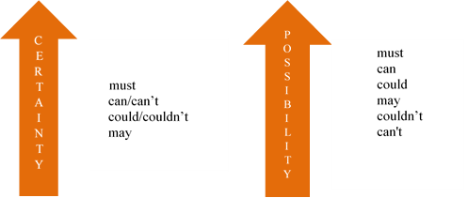

For more grammar practice visit the site:
https://www.english-grammar.at/online_exercises/modal-verbs/modal-verbs-index.htm

SOME/ANY/NO/EVERY
Some, any and no can be both determiners and pronouns (a pronoun form of no is none). You can see the table containing brief information on each below.
Determiner/Pronoun | Derivatives | NB!
Some | Something/someone/somebody/  somewhere/somehow | 1. Refers to indefinite or not important quantities (only in affirmative sentences).  2. Refers to someone or something particular but unknown.  3. May be used in questions when we are expecting the answer to be “yes”.
Any | Anything/anyone/anybody/  anywhere/anyhow | 1. Refers to indefinite or unknown quantities (in questions and negative sentences).  2. Means “it doesn’t matter which” (usually in affirmative sentences).
No/None | Nothing/no one/nobody/  nowhere | 1. Refers to an absence.  2. Mind the double negation!
Every | Everything/everyone/everybody/  everywhere | 1. Means “each member of a group”  2. Always singular!
As determiners
As determiners, some, any, no and every are used directly before nouns.
Some apples are needed to bake a cake.
Do you see any apples?
I can see no apples.
I need every apple you can find.

1. Some has two meanings: indefinite or not important quantities (a), the meaning opposite to “others”, “all” and “all” (b), and something particular but unknown (c).
a) In this meaning, some is used in affirmative sentences and in questions (when you expect the answer “yes”) ONLY with uncountable nouns and plural nouns.
I have some oranges.
I’m looking for some advice.
b) In this meaning, some contrasts with “others”, “all” and “enough”.
Why do some people live longer? (meaning: not others).
Some people agree with him (meaning: not all).
There were some apples left but I couldn’t bake a cake (meaning: not enough).
c) In this meaning, some is used basically with singular countable nouns:
There must be some way out of here.
Some idiot took my umbrella!

2. Any has two meanings: indefinite quantities (a) and “it does not matter which” (b).
a) We use any in questions and negative sentences and ONLY with uncountable nouns or plural nouns:
Do I need to get any milk?
There aren’t any books in English in this library.
b) In this meaning, we use any to describe something not limited with all types of nouns and USUALLY in affirmative sentences.
You can come over for dinner any evening.
You can choose any exercise you like.

3. No has one meaning: an absence of something.
I have no objections on the matter.
There are no bad students in the room.

In some contexts, no (and its derivatives) can be easily substituted with any (and its derivatives). It provides you with greater variability of speech, however, you need to be very careful with the double negation, which is considered incorrect in English.

+ | _
I have | no cats.
_ | +
I don’t have | any cats.

4. Every has one meaning: “each member of a group”. It is used only before singular nouns or uncountable nouns.
Every player wants to be a champion.
Please note that we should use singular pronouns and possessives to refer back to every + noun.
Every store has a manager in charge of it.
Every mall has its own parking lot.
As pronouns
Some of these determiners can be pronouns when the noun is understood. In such cases, we do not use any noun following.
Sorry, have you got some $1 coins with you? – Sure, I can lend you some (meaning: I can lend you some coins).
Sorry, have you got some $1 coins with you? – No, I don’t have any (meaning: I don’t have any coins).
Sorry, have you got some $1 coins with you? – No, I have none (meaning: I have no coins).

BE CAREFUL WITH NONE! None is a pronoun meaning “not one” or “not any” which can replace both countable and uncountable nouns.
I have a brother. My father has none (meaning: My father has no brothers).
I wish I had some courage to do this. Unfortunately, I have none (meaning: I have no courage).

Mind the agreement! When none is the subject, the verb can be either singular or plural according to what is implied.
I was looking for inspiration. None (inspiration – singular) ever comes.
I was looking for ideas. None (ideas – plural) ever come.
No one and nobody cannot be substituted with none.
No one came to my party.
None came to my party.

Derivatives
Each determiner has its own set of derivatives:
Derivatives of some: someone and somebody (a particular but unknown person), something (a particular but unknown object), somewhere (a particular but unknown place), somehow (a particular but unknown manner).
Derivatives of any: anyone and anybody (a specific or an open, unlimited set of people), anything (a specific or an open, unlimited set of objects), anywhere (a specific or an open, unlimited set of places), anyhow (a specific or an open, unlimited set of manners).
Derivatives of no: no one and nobody (an absence of people), nothing (an absence of things), nowhere (an absence of places).
Derivatives of every: everyone and everybody (a total number of people), everything (a total number of things), everywhere (a total number of places).

MIND THE NUMBER! All these derivatives are always SINGULAR!
Everyone goes to my party!
For more grammar practice visit the site https://www.english-grammar.at/online_exercises/modal-verbs/modal-verbs-index.htm

REPORTED SPEECH

Reported speech is our representation of other people's speech or our own words. Reported speech might be separated into two main types: direct speech and indirect speech. Indirect speech focuses more on the content of what was said rather than the exact words. In indirect speech, the reported clause's structure depends on whether the speaker is reporting a statement, a question or a command.
Indirect speech. Statements
When one transforms a direct statement into indirect, one should look carefully at the verb which stands in front of the direct speech:
Russian President says, “Russia plans to keep cooperating with other countries to harmonize global energy markets.” – Russian President says (that) Russia plans to keep cooperating with other countries to harmonize global energy markets.
Russian President said “Russia plans to keep cooperating with other countries to harmonize global energy markets” – Russian President said (that) Russia planned to keep cooperating with other countries to harmonize global energy markets.
Two clauses are connected with the conjunction "that". However, it may be omitted, especially, in informal speech.
A verb in its past form causes so-called 'backshift' in the reported clause. The tenses should be changed as follows:
Direct Indirect
Present Tenses | -> | Past Tenses
Present Simple | -> | Past Simple
Present Continuous | -> | Past Continuous
Present Perfect | -> | Past Perfect
Present Perfect Continuous | -> | Past Perfect Continuous
Past Simple Tenses | -> | Past Perfect Tenses
Past Simple | -> | Past Perfect
Past Continuous | -> | Past Perfect Continuous
Past Perfect\Past Perfect Continuous | -> | Past Perfect\Past Perfect Continuous
Future Tenses (will) | -> | Future-in-the-Past Tenses (would)

Sometimes there is no 'backshift'. It happens when the information given in indirect speech is still true or relevant or has not happened yet.
He said, "The Earth is round."– He said (that) the Earth is round.
Apart from changes to tenses, adverbs and demonstratives should be also changed:

Direct |  | Indirect
today | -> | that day
tonight | -> | that night
tomorrow | -> | the next\following day
next (week, month, etc.) | -> | the next\following (week, month, etc.)
ago | -> | before
yesterday | -> | the day before\the previous day
last (week, month, etc.) | -> | the last\previous (week, month, etc.)
now | -> | then
here | -> | there
this (place) | -> | that (place)

Indirect speech. Questions
The main distinctive feature of English questions is their word order. Typically, it can be described as "VSO", i.e. "verb, subject, object". When one makes any direct question indirect, one should keep the word order direct ("SVO", i.e. "subject, verb, object")
Then, one should distinguish two main types of English questions: general questions (also called yes/no questions) and special questions (wh-questions).

General questions (Yes, no questions)
Such questions may have a modal, an auxiliary verb, the verb "to be" (when a main verb) as the beginning:
May (a modal) the president veto a law?
Do (an auxiliary verb) you work at the Supreme Court?
Are ("to be" as a main verb) you an MP?
Transforming a direct question into indirect, one should connect two clauses by means of conjunctions "whether" or "if":
I asked whether/if the president may veto a law.
I asked whether/if you worked at the Supreme Court.
I asked whether/if he was an MP.
Note that the rule of backshift is applicable.

Special questions (Wh-questions)
The main difference between this type of questions and the previous type is that one does not need any word to connect clauses. On the contrary, a question word (a wh-word) is used to connect clauses.
Where is the Houses of Parliament? – I asked where the Houses of Parliament was.
It is necessary to distinguish subject and object questions. The words who\what may be both the subject and an object of a sentence:
Who (object) are you talking to? – I asked who you were talking to.
Who told you that? – I asked who had told you that.

Indirect speech. Commands
When it comes to reporting commands, a sentence consists of a reporting clause, and a reported clause beginning with an infinitive:
He asked the Prime Minister, "Develop new social policy initiatives and measures to boost employment”. –He asked the Prime Minister to develop new social policy initiatives and measures to boost employment.
The claimants asked the Commission, "Focus on the horse ID forms, please" – The claimants asked the Commission to focus on the horse ID forms.
We also use a to-infinitive clause in indirect reports with other verbs that mean wanting or getting people to do something. These verbs are called reporting verbs.

Indirect speech. Reporting verbs
Various reporting verbs require different patterns when they are used in reported speech. You can see some verbs below:

Patterns |  | Verbs | Examples
1. verb + that clause | no object | add, admit, announce, claim, complain, insist, reply, respond, say, state, suggest | Jack admitted that it was so challenging for him.
1. verb + that clause | + object | tell someone, warn someone | The House of Commons told us that no final decision had been taken on this issue.
2. verb + infinitive with to | no object | agree, claim, offer, refuse | The corporation agreed to pay a $10 million compensation.
2. verb + infinitive with to | + object | advise someone, ask someone, beg someone, encourage someone, invite someone, order someone, persuade someone, remind someone, tell someone, warn someone | My English teacher has advised me to read these books.
3. verb + gerund | no preposition | admit, advise, consider, regret, suggest | A computer hacker has admitted stealing hundreds of user accounts from a US military communications system.
3. verb + gerund | + preposition | admit to, apologize for, complain about, insist on, thank someone for | More than one third of drivers admit to breaking rules of road.

NB! Some reporting verbs (they are underlined in the table) have more than one pattern.

For more grammar practice visit the site https://www.english-grammar.at/online_exercises/reported-speech/reported-speech-index.htm and do exercises online.

WEBSITE RESOURCES
- https://www.oxfordonlineenglish.com/talking-about-family
- https://www.youtube.com/watch?v=8BSTLrX_lf4
- https://www.youtube.com/watch?v=-UX0X45sYe4
- https://www.youtube.com/watch?v=ijewO__atOc
- https://www.studynlearn.com/blog/informal-letter-format/
- https://www.youtube.com/watch?v=gMU9tk7fhQI
- https://www.youtube.com/watch?v=m1BsepAo854
- https://www.youtube.com/watch?v=Re3tfjcZBQk
- https://www.youtube.com/watch?v=qWijZcXRwDA
- https://www.youtube.com/watch?v=QcCJ8nZop-A
- https://www.theguardian.com/education/)
- https://www.youtube.com/watch?v=tNqyLJNie-s
- https://www.youtube.com/watch?v=9t60uMSlD-I
- https://www.youtube.com/watch?v=7dFVOjaf8SQ
- https://www.thoughtco.com/geography-of-the-united-kingdom-1435710
- https://www.youtube.com/watch?v=eGWO1ldEhtQ
- Scotland - A Short History
- Irish Culture: 9 Things That Make Our Little Island Tick
- Geography and Fun Facts About Great Britain
- https://greatbritishmag.co.uk/uk-culture/how-the-british-political-system-works
- https://assets-learning.parliament.uk/uploads/2019/12/
- https://www.thoughtco.com/geography-the-united-states-of-america-1435745
- https://www.britannica.com/place/United-States/The-newer-culture-areas
- https://www.usawelcome.net/explore/good-to-know/general-info
- https://www.youtube.com/watch?v=RAMbIz3Y2JA
- https://www.youtube.com/watch?v=h4KggqdonXU
- https://www.youtube.com/watch?v=W9H3gvnN468
- https://www.youtube.com/watch?v=hvMSeg1s7uc
- https://www.youtube.com/watch?v=lfe1wEQzSzM
- https://www.youtube.com/watch?v=5CItQwyQgRc
- https://www.youtube.com/watch?v=UBO-ib-V8LM
- https://blog.lingoda.com/en/interviews-with-famous-polyglots/
- https://www.youtube.com/watch?v=wiRhY8TU9qQ
- https://www.askiitians.com/iit-jee/
- https://eng.ox.ac.uk/
- http://www.eng.cam.ac.uk/
- https://seas.harvard.edu/
- https://engineering.princeton.edu
- https://english.mirea.ru/
- https://www.youtube.com/watch?v=0ToKcEvqXuM
- https://www.youtube.com/watch?v=-wVllfyvGfU
- https://www.parliament.uk/visiting/virtualtour/
- https://www.youtube.com/watch?v=bfUeekXbYzk
- https://www.businessinsider.com/regions-america-bible-belt-rust-belt-2018-4

BIBLIOGRAPHY
- Английский язык для юристов : Учебник / К. М. Левитан, С. В. Павлова, М. С. Пестова [и др.]. – Москва : Общество с ограниченной ответственностью "Издательство "КноРус", 2023. – 552 с.
- Английский язык для юристов : Учебник / М. А. Югова, Е. В. Тросклер, Н. В. Садыкова, С. В. Павлова. – 1-е изд.. – Москва : Издательство Юрайт, 2020. – 1 с. – (Высшее образование).
- Байдикова, Н. Л. Английский язык для технических направлений (B1–B2) : учебное пособие для вузов / Н. Л. Байдикова, Е. С. Давиденко. — Москва : Издательство Юрайт, 2023. — 171 с. — (Высшее образование).
- Дроздова Т.Ю., Маилова В.Г., Берестова А.И. English grammar: Reference and practice. Version 2.0. СПб.: Антология, 2012. – 424 с.
- Комарова, А. И. Английский язык. Страноведение : учебник для среднего профессионального образования / А. И. Комарова, И. Ю. Окс, В. В. Колосовская. — 2-е изд., испр. и доп. — Москва : Издательство Юрайт, 2023. — 456 с. — (Профессиональное образование).
- Кузьменкова, Ю. Б. Английский язык для технических направлений (A1) : учебное пособие для вузов / Ю. Б. Кузьменкова. — Москва : Издательство Юрайт, 2024. — 195 с. — (Высшее образование).
- Blokhin A. V. Alexander Stepanovich Popov the Inventor of Radio / Blokhin A. V. // Ural Radio Engineering Journal. — 2017. — Vol. 1, No. 1. — P. 8-24.
- Eastwood J. Oxford Practice Grammar. – Oxford; New York: Oxford University Press, 2006. – 439 p.
- Hayat Rezgui, "In Memory of Professor Andrei Nikolaievitch Tikhonov (1906-1993) on the 25th Anniversary of His Death," Journal of Humanistic Mathematics, Volume 8 Issue 1 (January 2018), pp. 332-349.
- James O’Driscoll. Britain for Learners of English, 2nd ed. Oxford University Press España, S.A., 2009
- Murphy R. English grammar in use: A self-study reference and practice book for intermediate learners of English. – Cambridge, Cambridge University Press, 2019. – 380 p.

