**INTER CAPMUS DELIVERY**

This website is an online platform that allows users to search for and discover restaurants on our campus. Users can view Menus, make orders, also give feedback. This website connects vendors on the campus to the students.

**Step 1:** First of all, you have to signup by filling in your username and password then by clicking on the signup button you will be redirected to the home page then log out and login in again.

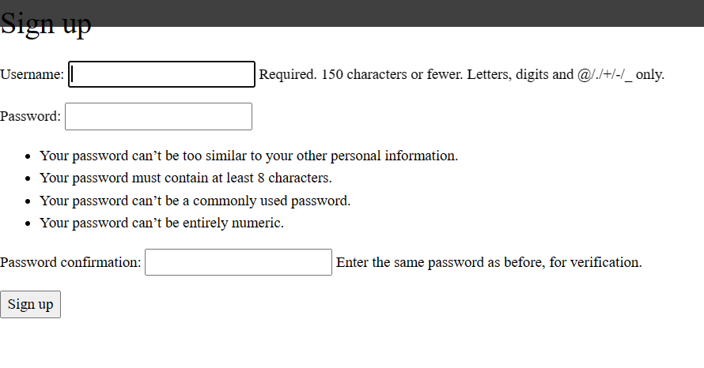

Step 2: When you click on login, you only have to enter your username and password.

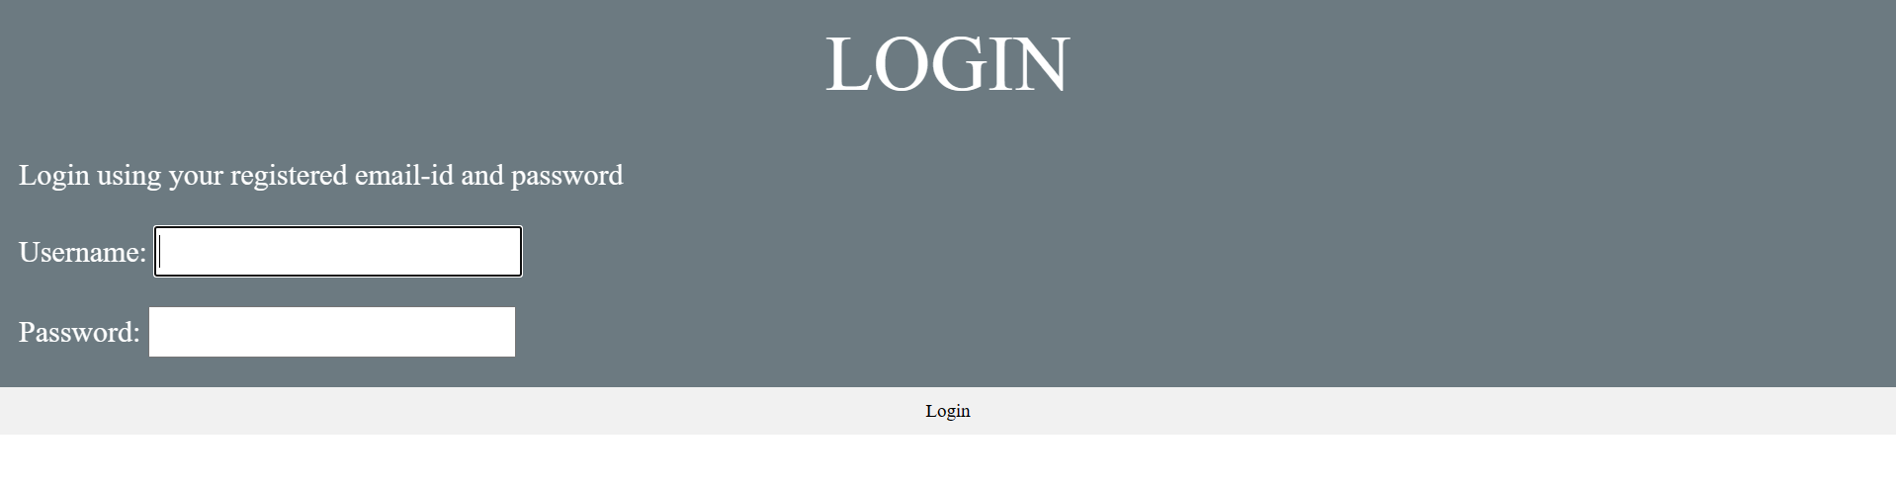

Step 3: Finally when the order is placed, you can successfully log out by clicking on the button.

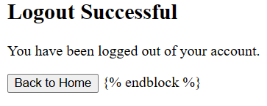

**Landing page:** The landing page is a home page that consists of the timing of the shop to be opened and also about our site. This home page consists of a home page button, menu button, contact button, log in, and signup button.

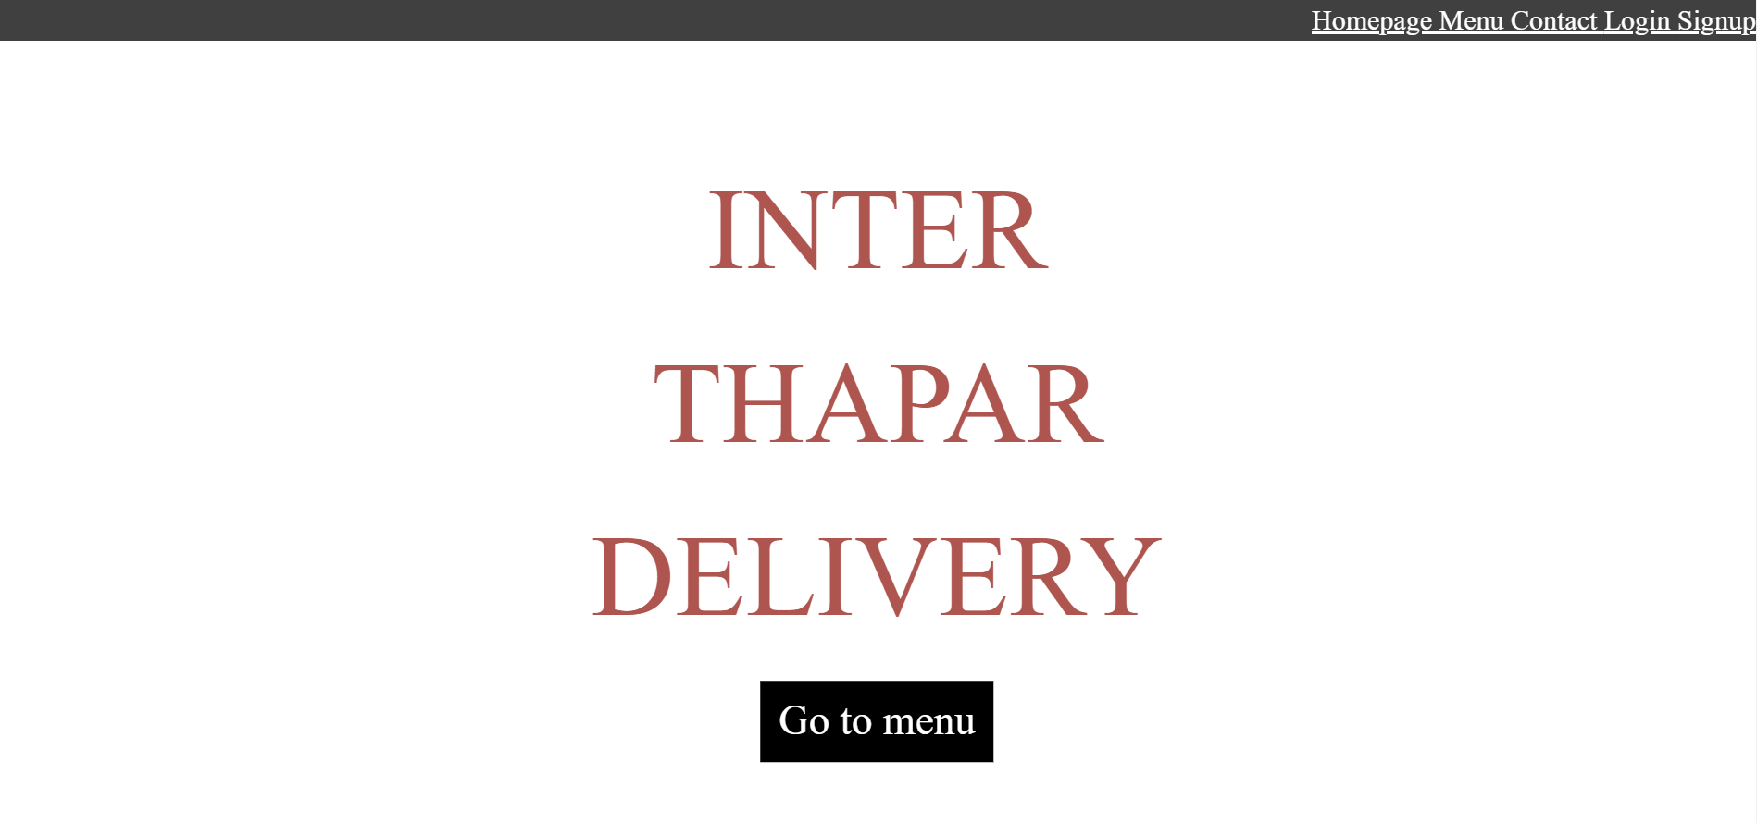

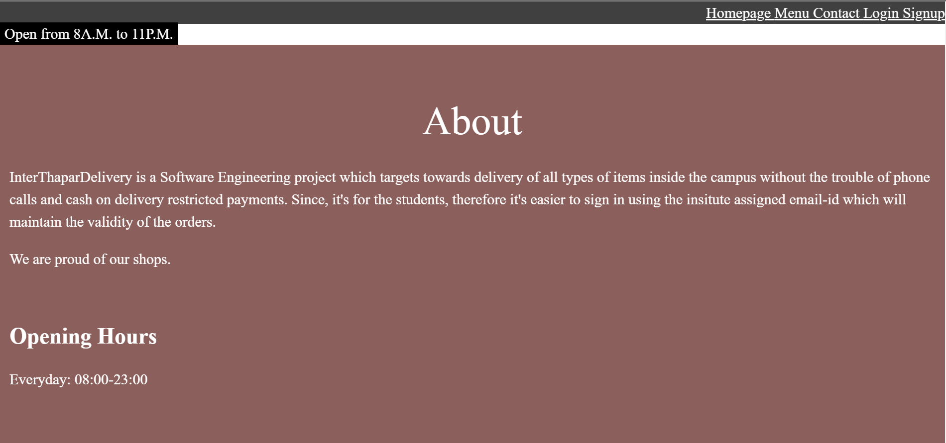

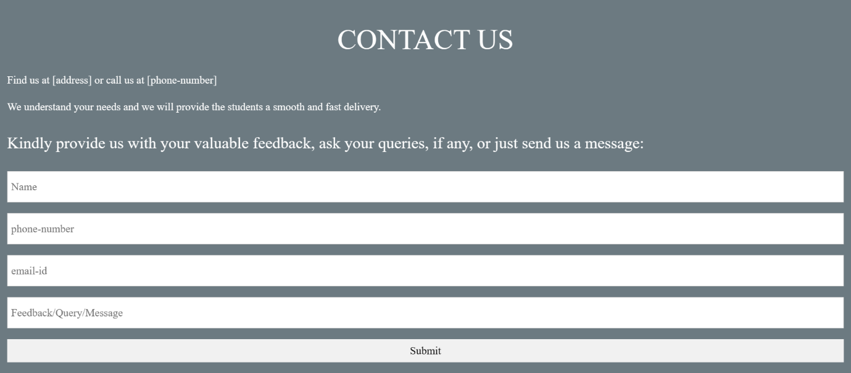**Contact Us page:** The contact page is the page by which users can raise their queries or any difficulty they face.

**Menu page:** The menu page consists of the list of the items to be delivered. There is a counter with the name of the food by which users can order multiple time the same item.

