Résultats pour erreur à 5 % durant 10 secondes, thetashiftratio=1 size=2

Gain=1, Learning step=0.5, Starting position (0,0,0), Target position (1,1,0)
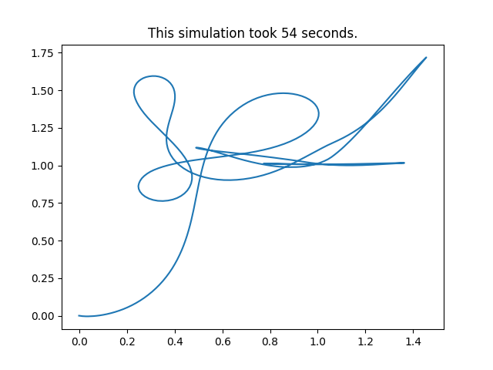
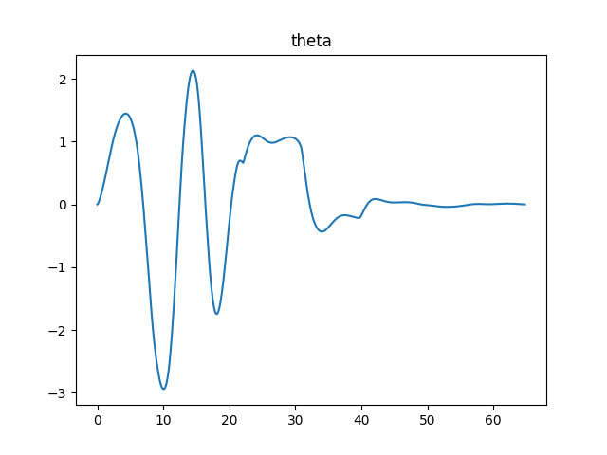
Simulation :

Robot :

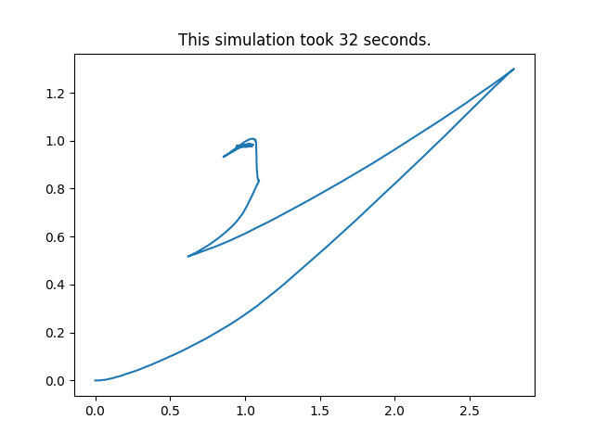
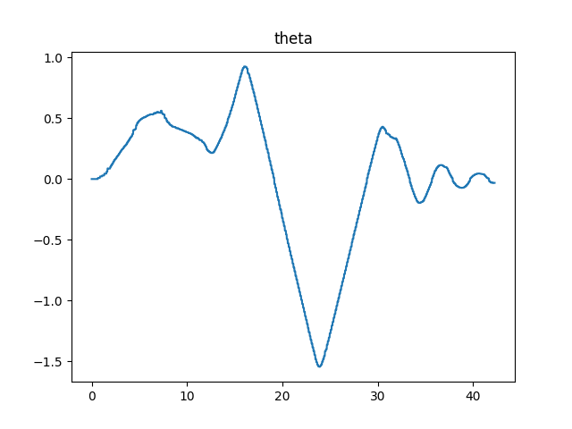
Gain=5, Learning step=0.5, Starting position (0,0,0), Target position (1,1,0)
Simulation
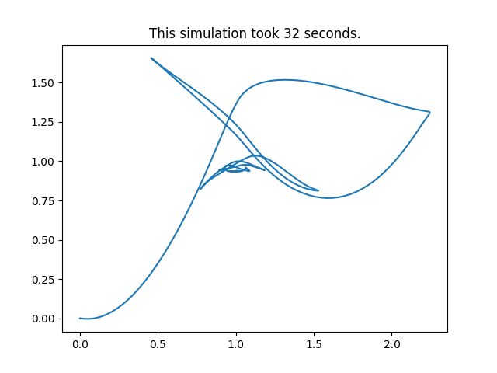
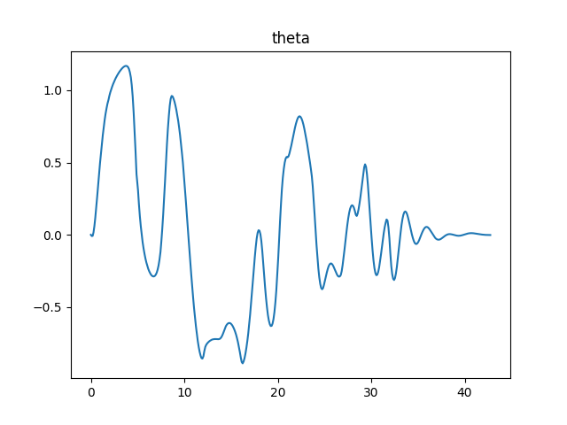

Robot
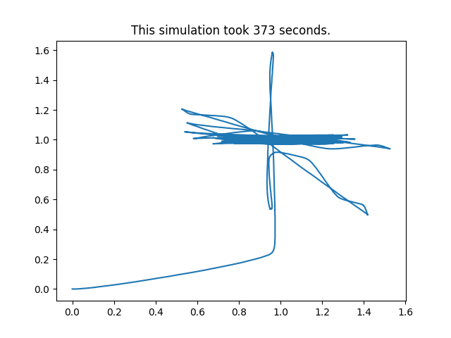
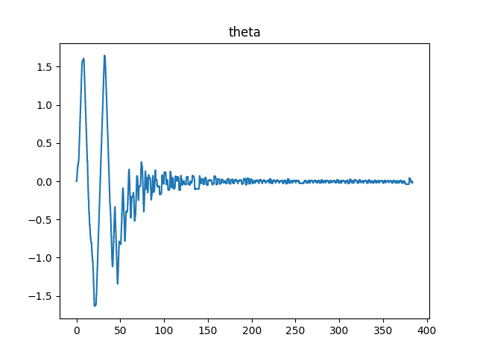
Gain=10, Learning step=0.5, Starting position (0,0,0), Target position (1,1,0)
Simulation
ne converge pas

Robot
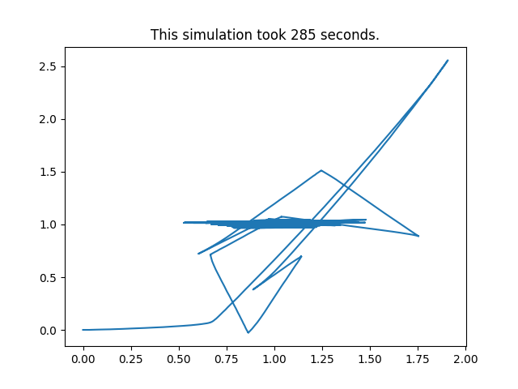
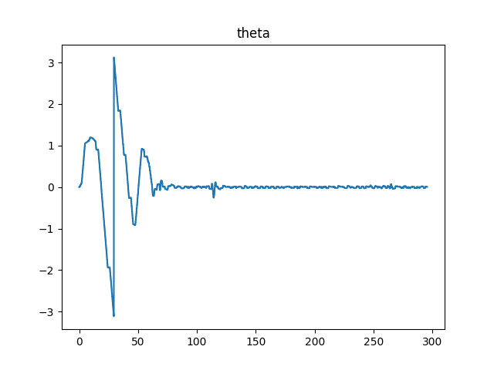

Gain=10, Learning step=0.2, Starting position (0,0,0), Target position (1,1,0)
Simulation
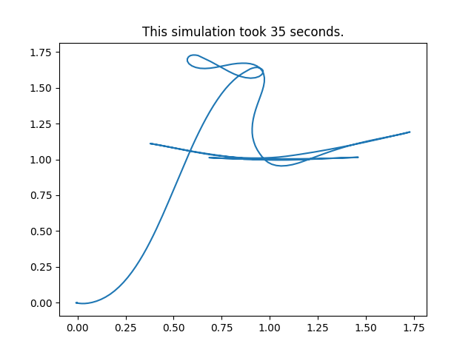
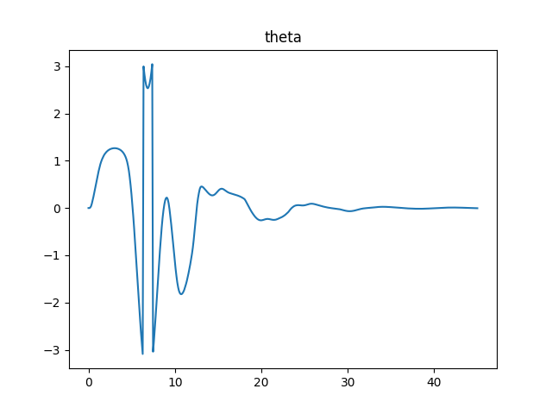
Robot
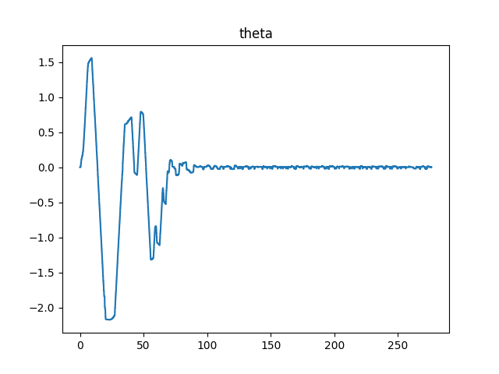
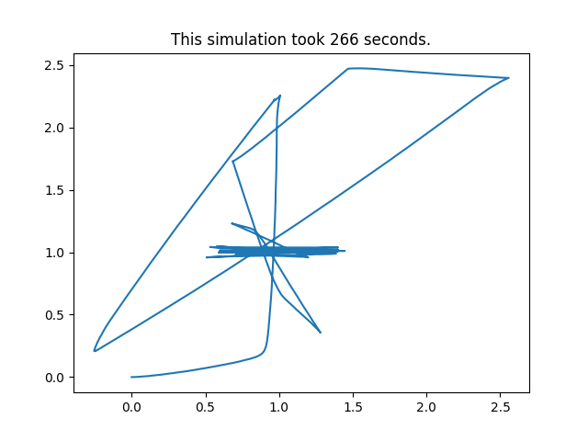
Gain=10, Learning step=0.1, Starting position (0,0,0), Target position (1,1,0)
Simulation

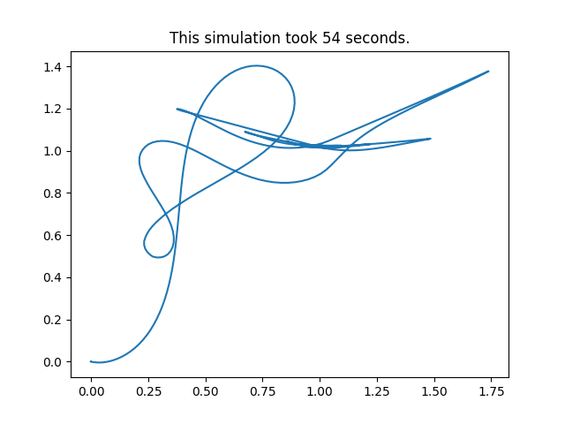
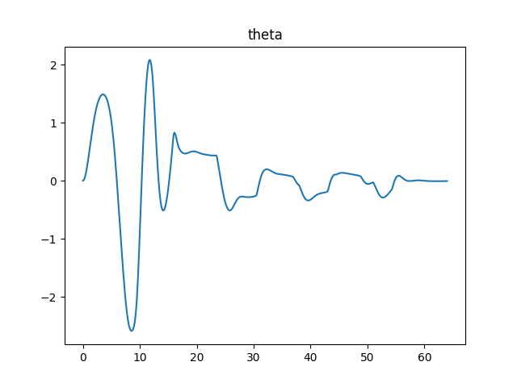

Robot
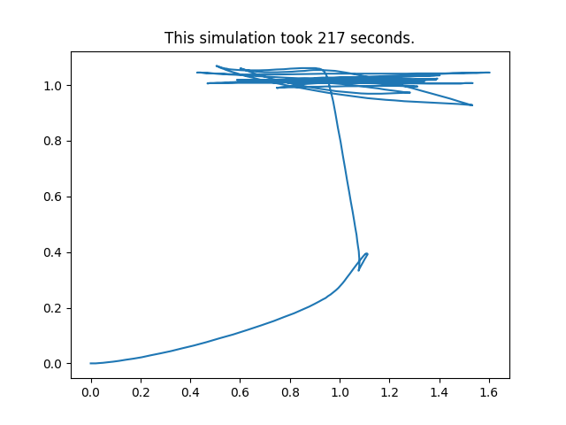
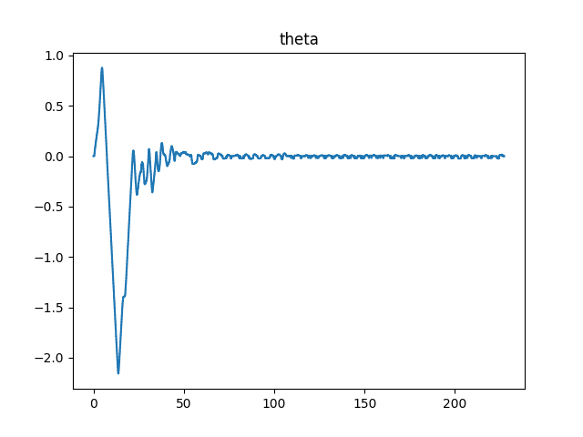

Gain=5, Learning step=0.1, Starting position (0,0,0), Target position (1,1,0)
Simulation
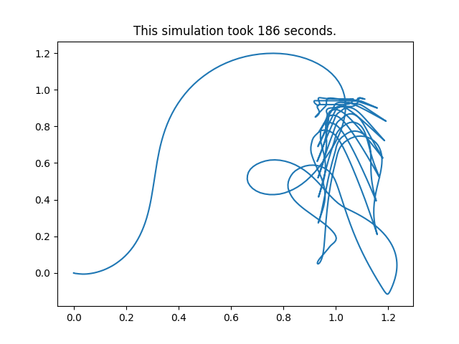
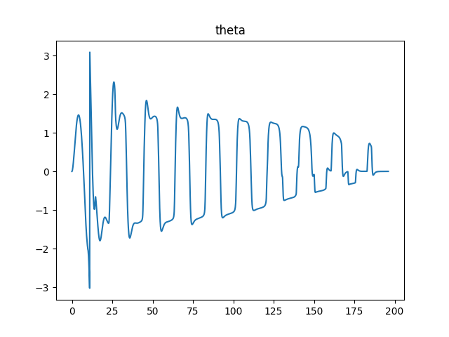

Robot :

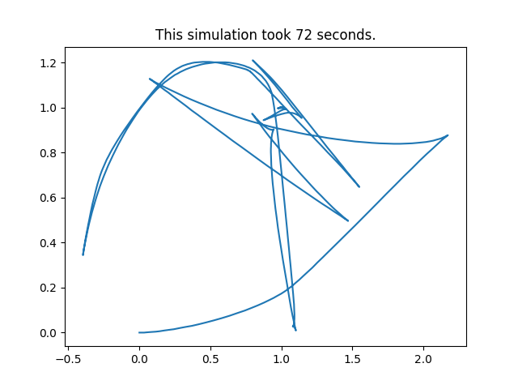
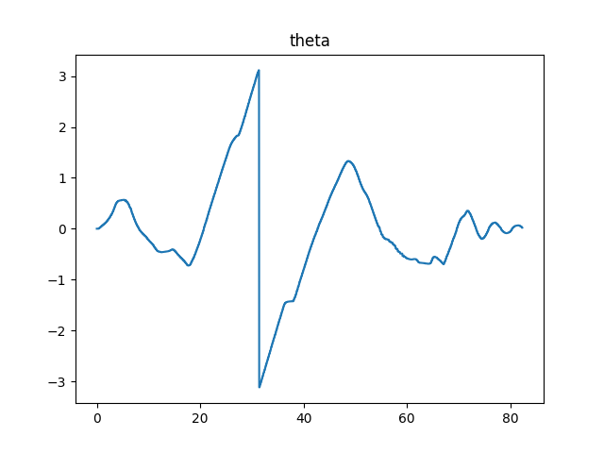

Gain=5, Learning step=0.2, Starting position (0,0,0), Target position (1,1,0)
Simulation
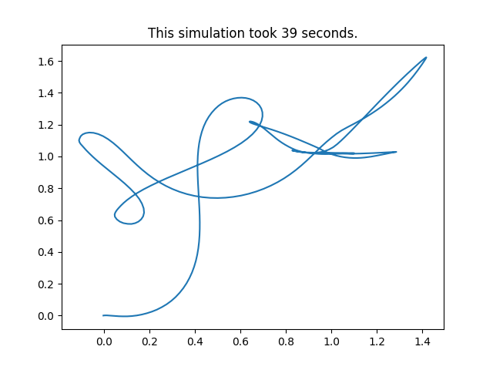
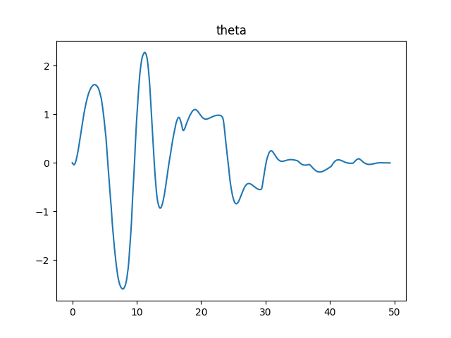
Robot

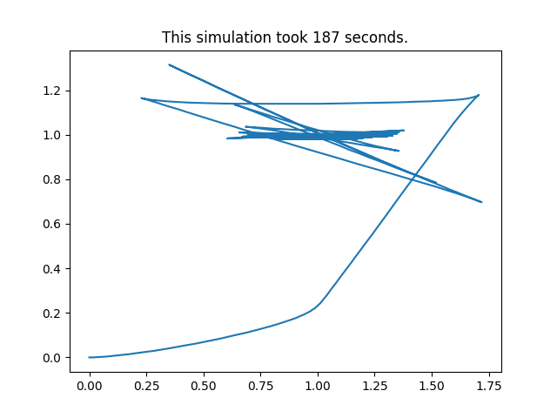
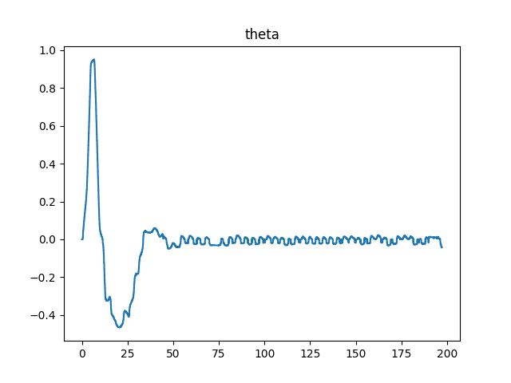

Gain=1, Learning step=0.2, Starting position (0,0,0), Target position (1,1,0)
Simulation
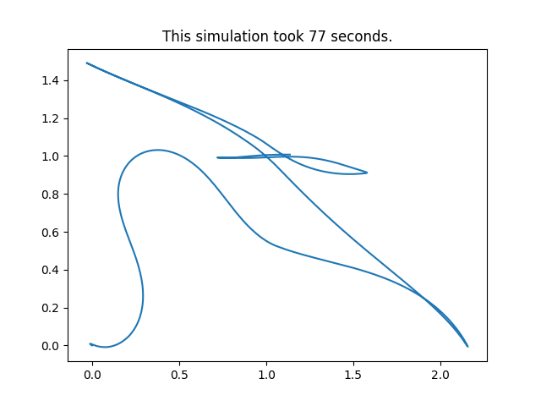
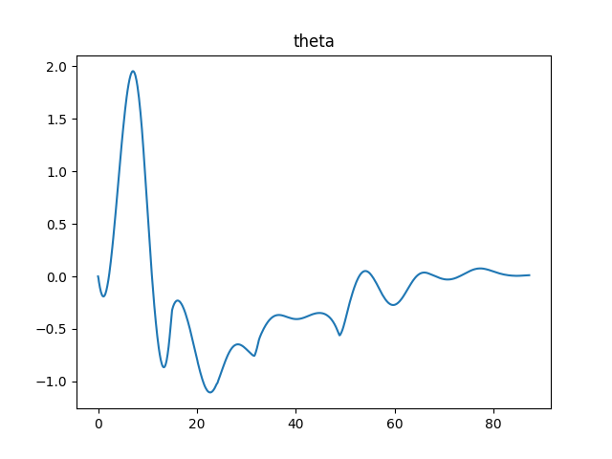
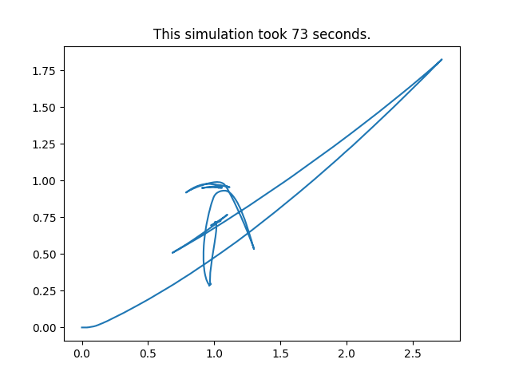
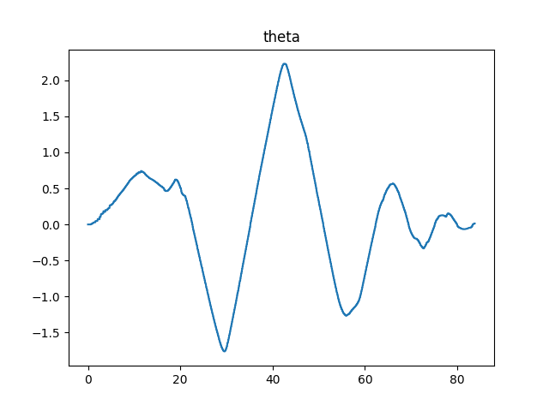
Robot :

Gain=1, Learning step=0.1, Starting position (0,0,0), Target position (1,1,0)
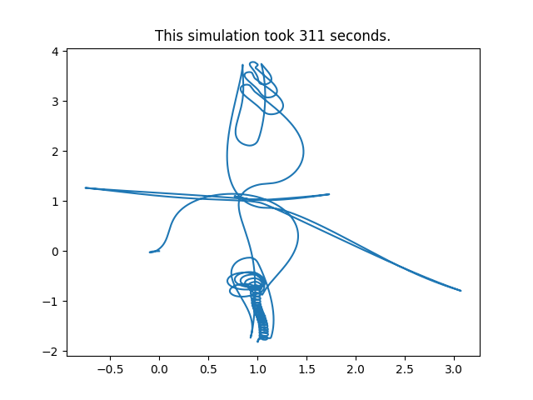
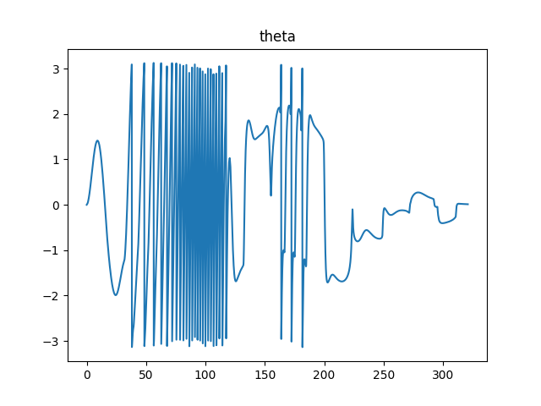
Simulation

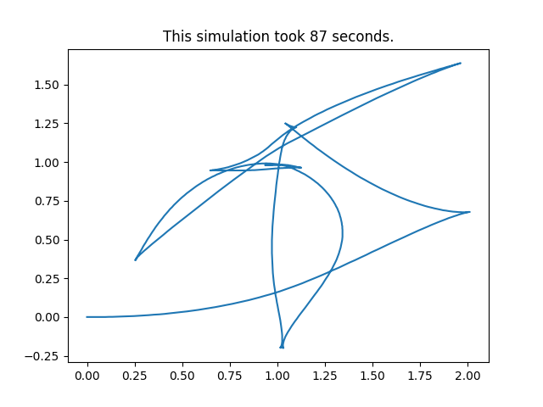
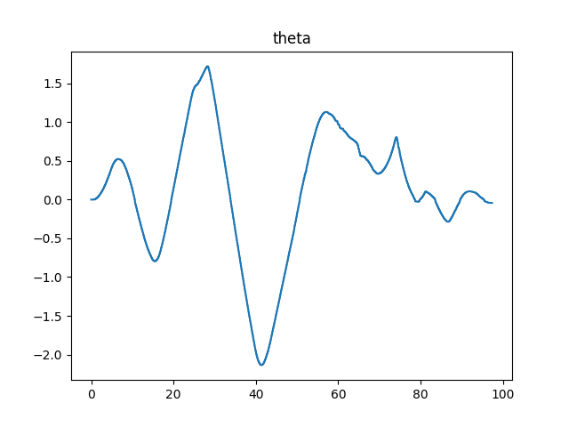
Robot

Gain=1, Learning step=0.5, Starting position (0,0,0), Target position (1,1,1)
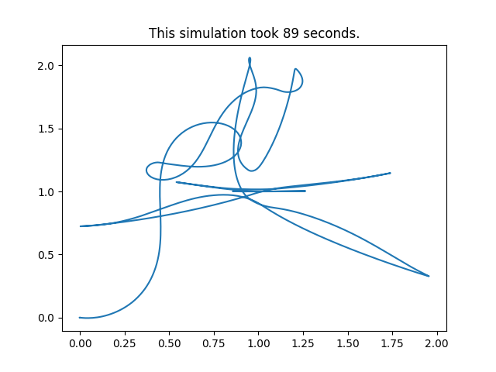
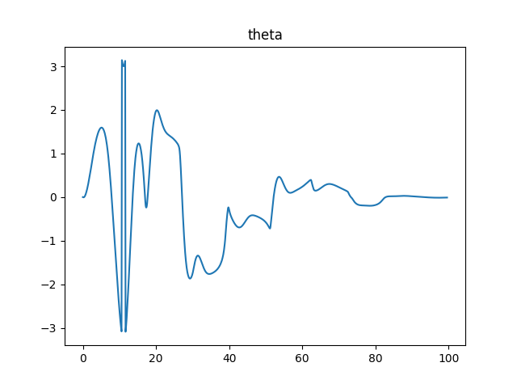
Simulation
Robot => n’a pas convergé

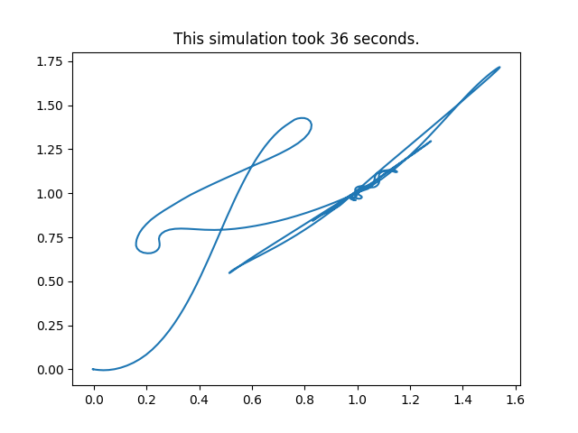
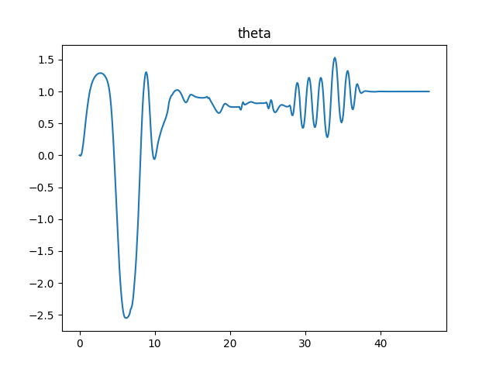
Gain=5, Learning step=0.5, Starting position (0,0,0), Target position (1,1,1)
simul

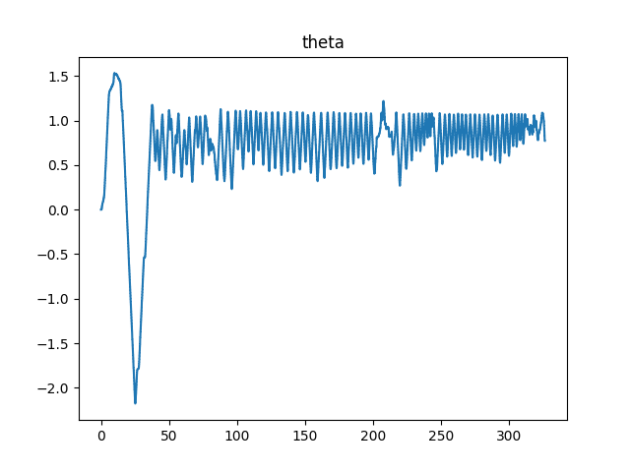
robot
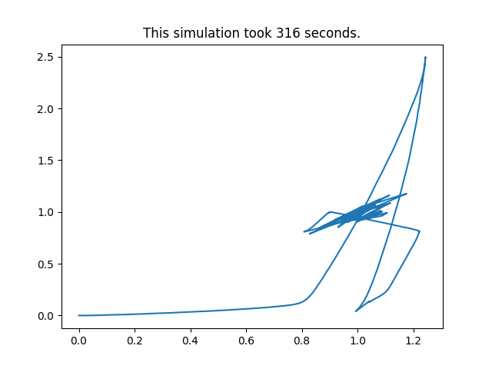

Gain=10, Learning step=0.5, Starting position (0,0,0), Target position (1,1,1)
simulation : ne converge pas

robot : expérience abandonnée, le robot fonce dans le mur

Gain=10, Learning step=0.2, Starting position (0,0,0), Target position (1,1,1)

simulation :
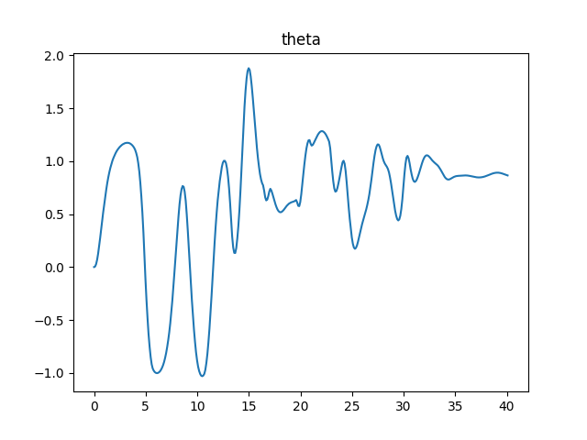
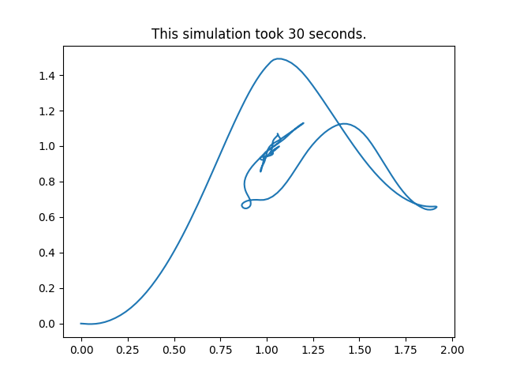
robot
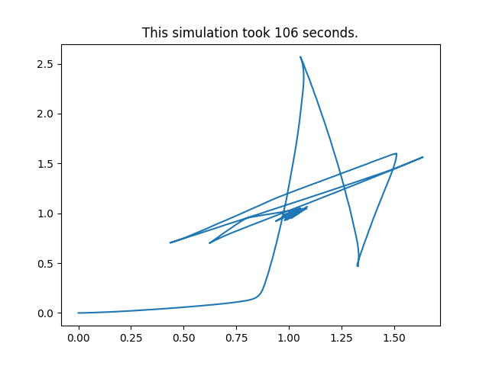
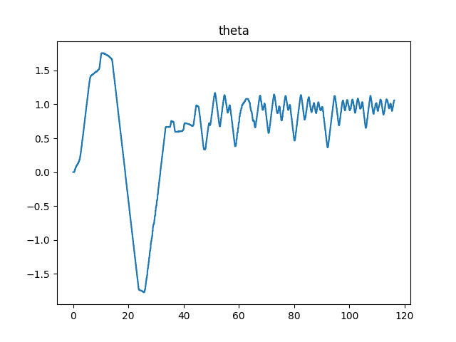

Gain=10, Learning step=0.1, Starting position (0,0,0), Target position (1,1,1)

simul
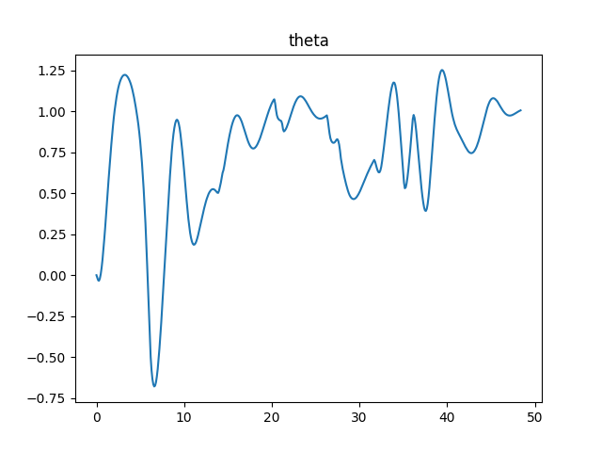
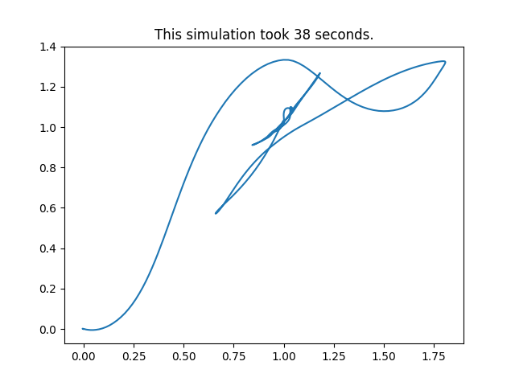

robot

expérience abandonnée : « fonçage de mur »

Gain=5, Learning step=0.2, Starting position (0,0,0), Target position (1,1,1)

simulation

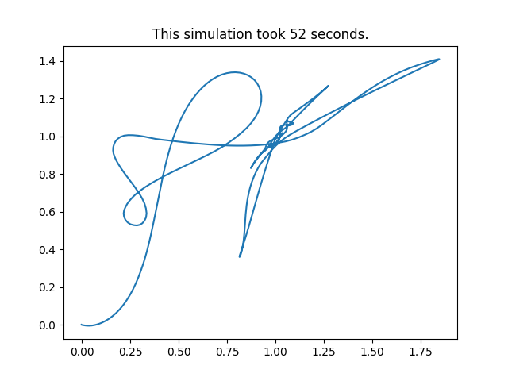
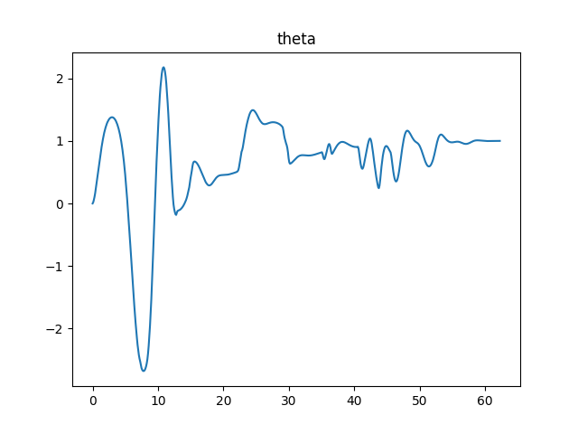

robot
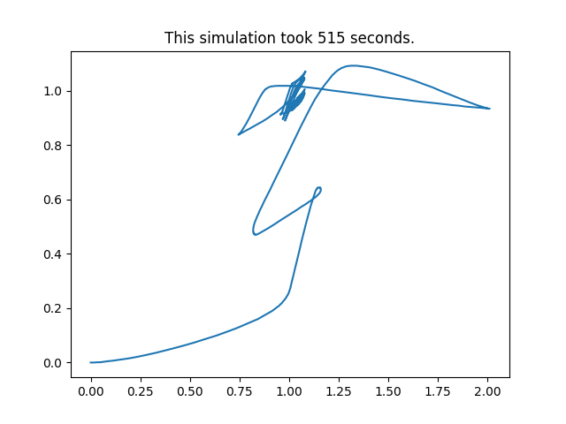
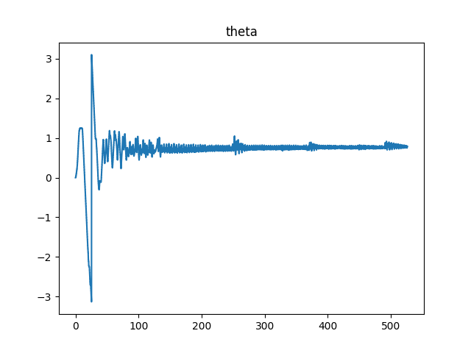
Gain=1, Learning step=0.2, Starting position (0,0,0), Target position (1,1,1)

Simulation
n’a pas convergé au bout de 800 secondes

robot
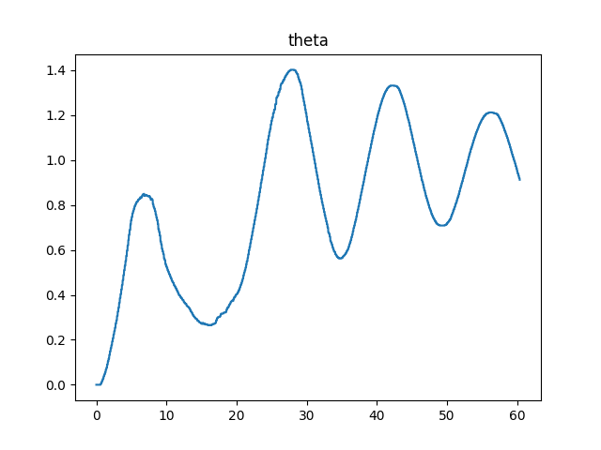
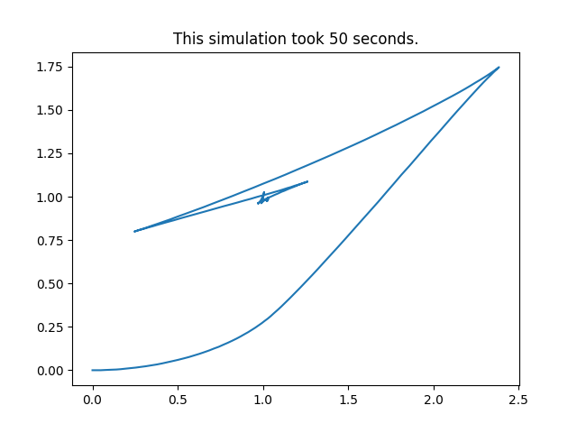

Gain=1, Learning step=0.1, Starting position (0,0,0), Target position (1,1,1)

simulation
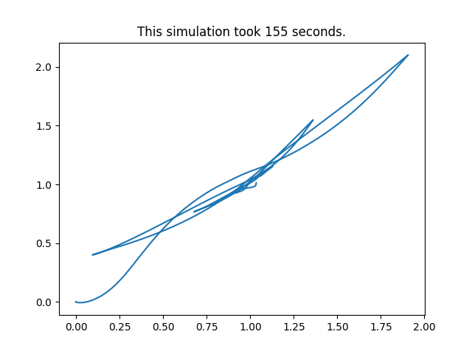
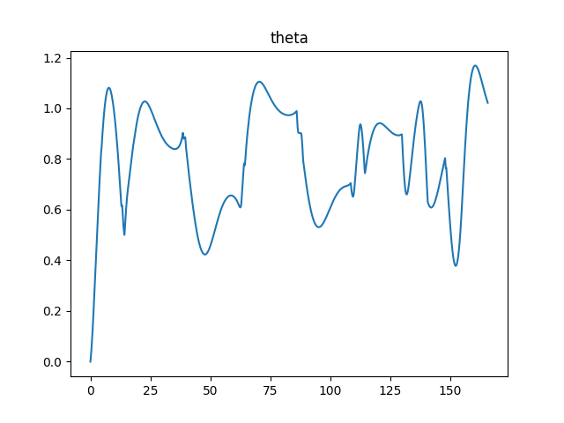

robot

