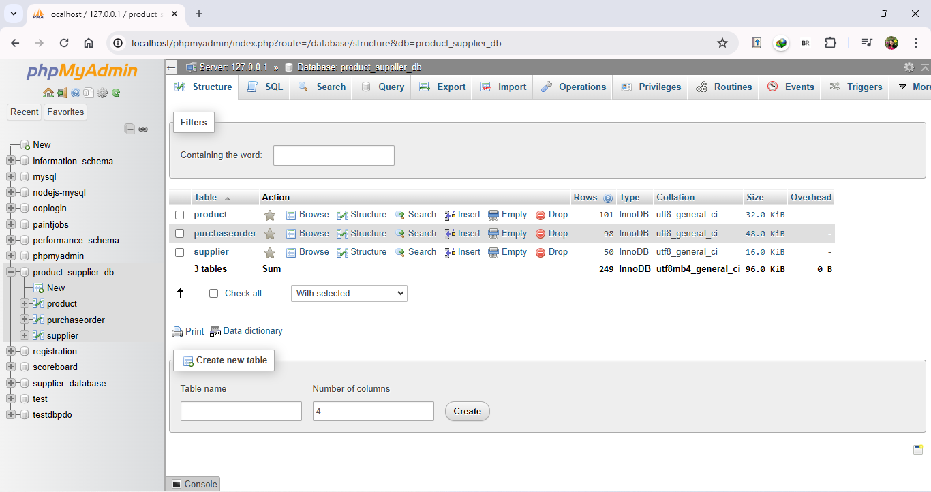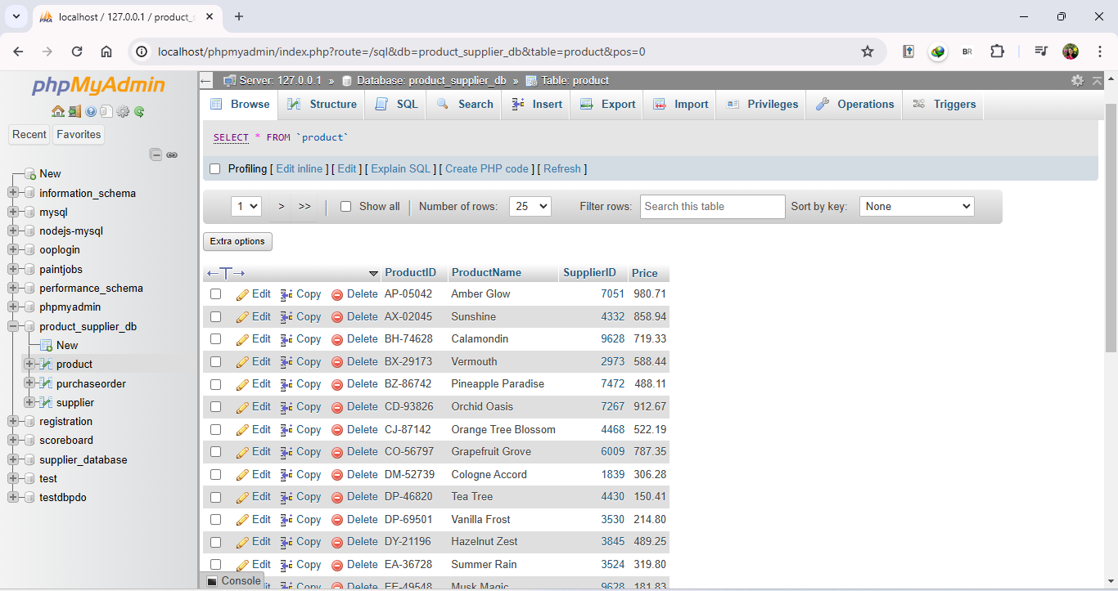

DATABASE IN PHPMYADMIN

**DATABASE**: product_supplier_db

**TABLE:** product

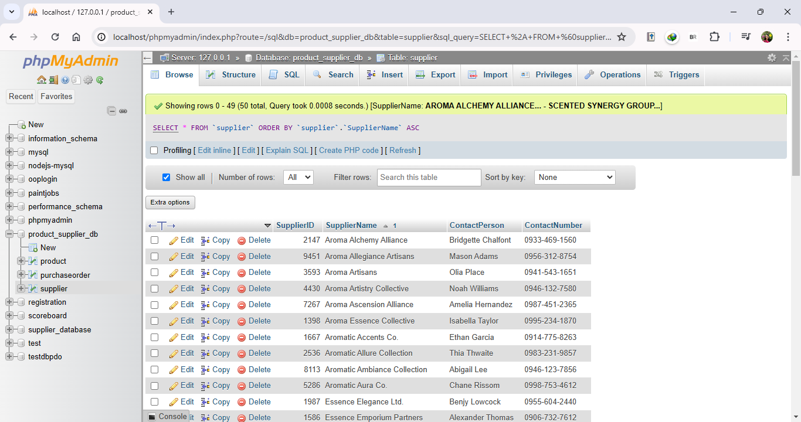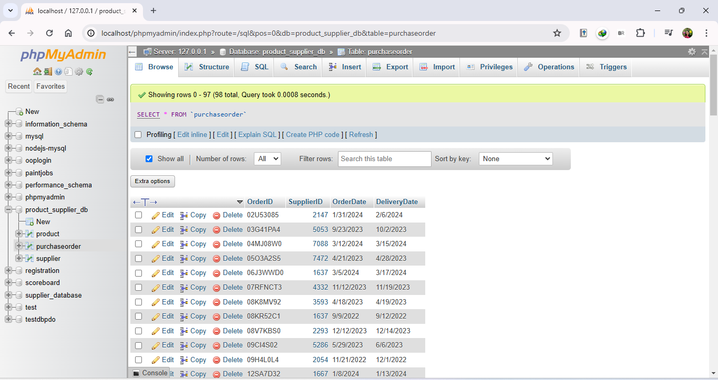

**TABLE:** supplier

**TABLE:** purchaseorder

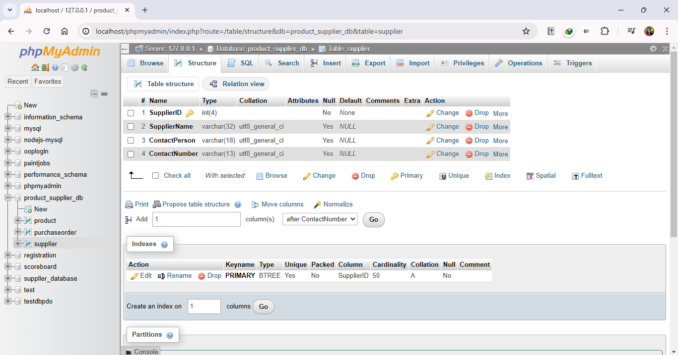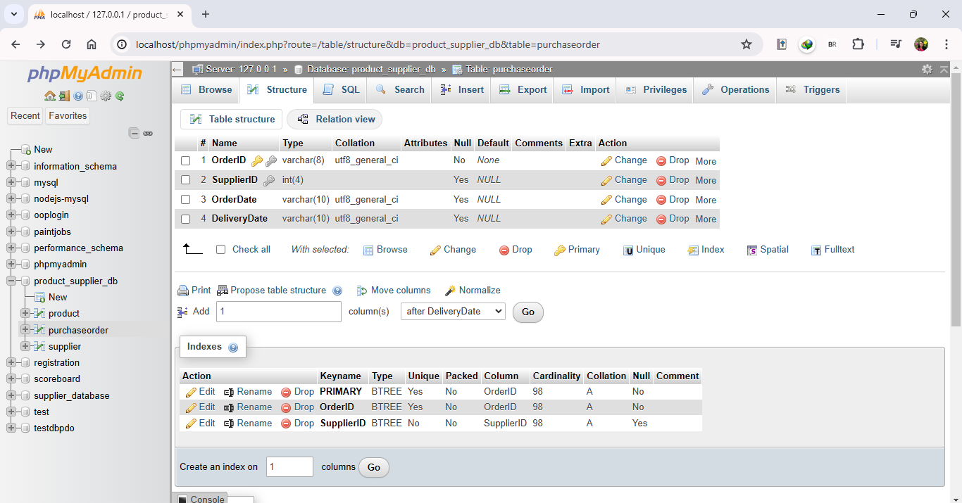

**TABLE:** supplier (Structure View)

**TABLE:** purchaseorder (Structure View)

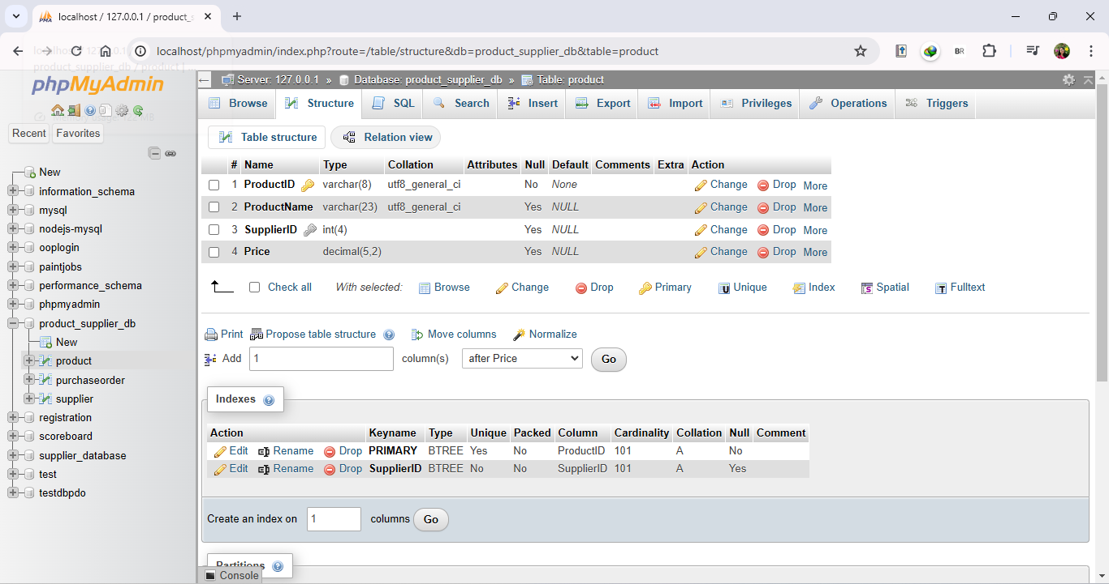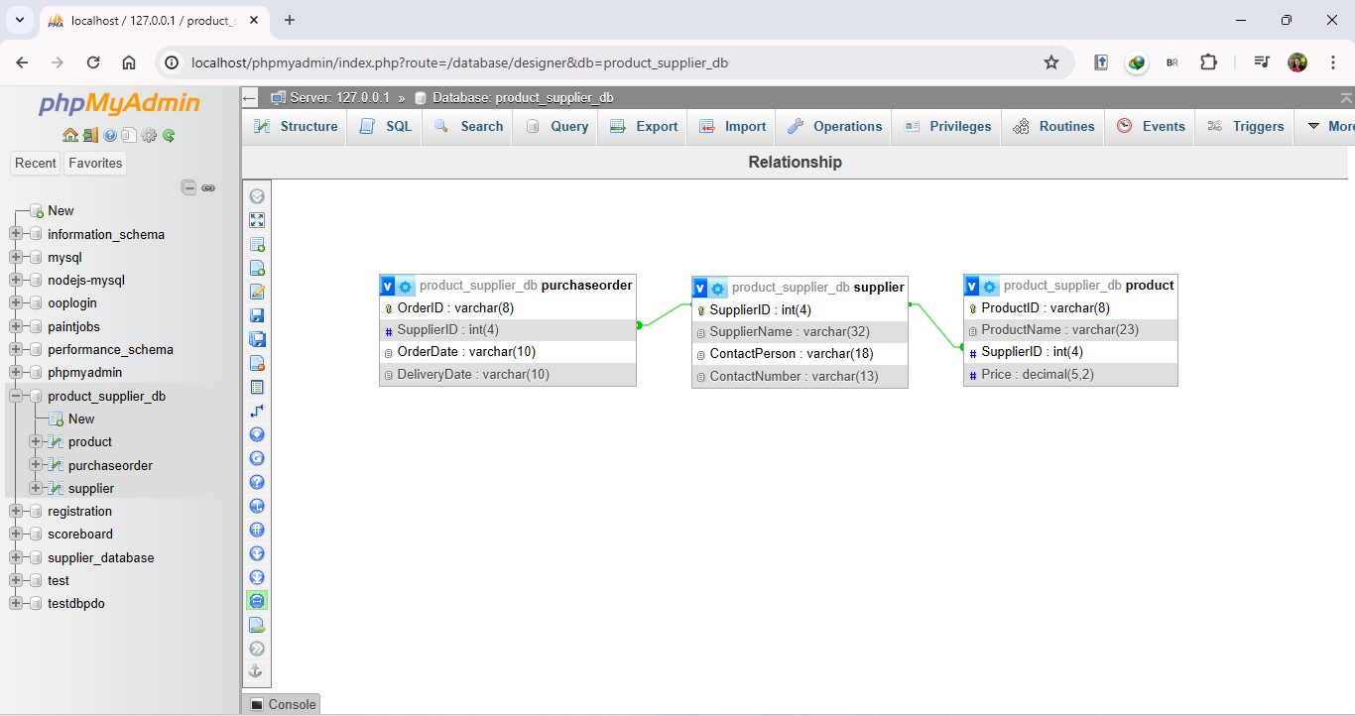

**TABLE RELATIONSHIP** (Designer View)

**TABLE:** product (Structure View)