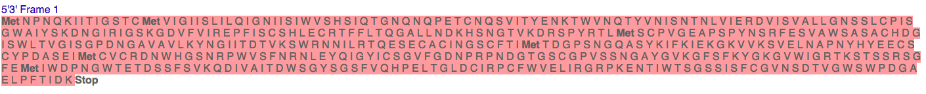
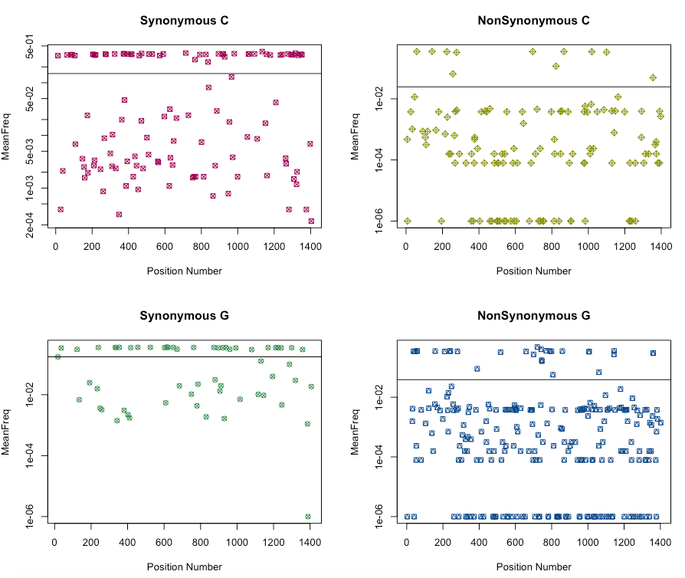

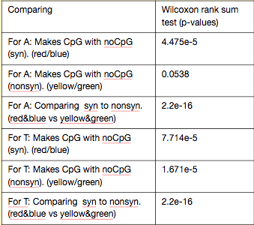

- Protein: Neuraminidase

Influenza HN1

- Protein: Neuraminidase

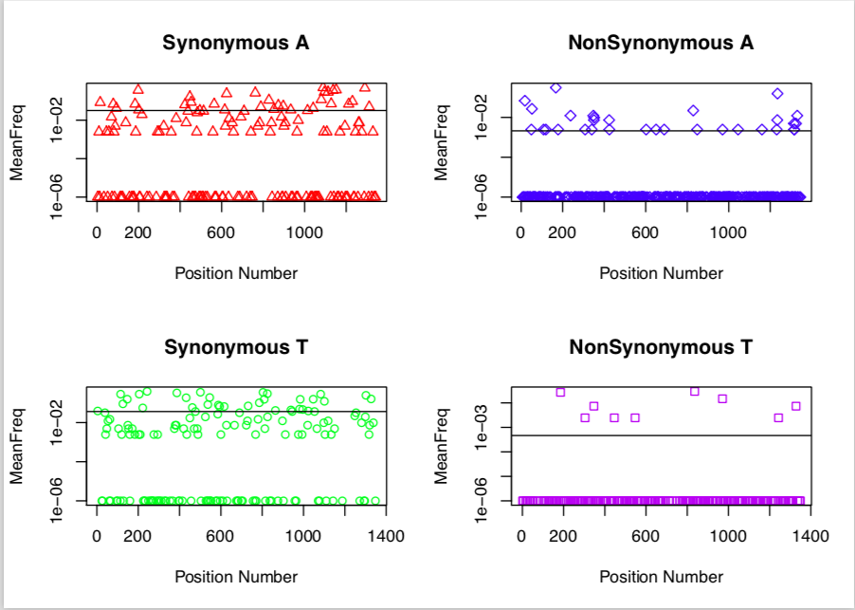
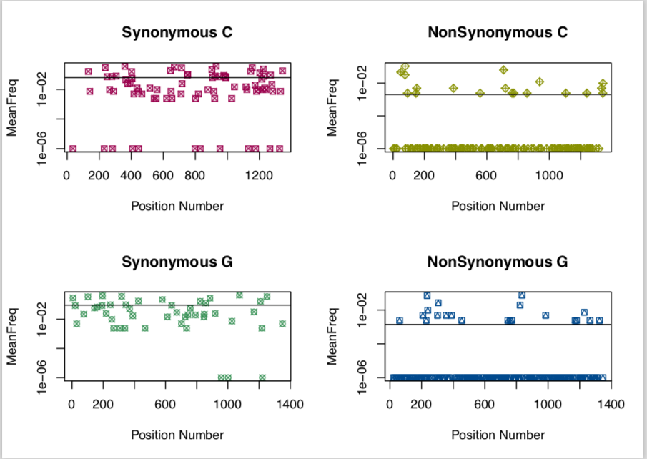

Comparing | Wilcoxon Rank Sum
For A: Makes CpG with noCpG (syn). (red/blue) | 0.6421
For A: Makes CpG with noCpG (nonsyn). (yellow/green) | 0.7229
For A: Comparing syn to nonsyn. (red&blue vs yellow&green) | < 2.2e-16
For T: Makes CpG with noCpG (syn). (red/blue) | 0.007057
For T: Makes CpG with noCpG (nonsyn). (yellow/green) | 0.2651
For T: Comparing syn to nonsyn. (red&blue vs yellow&green) | < 2.2e-16
