AWS SERVICES

1.IAM (Identity and Access management)

2.EFS (Elastic File System)

3.EBS (Elastic Block Storage)

4.LAMBDA

5.CLOUD WATCH

6.S3 (Simple storage service)

7.SQS (Amazon Simple Queue Service)

8.EC2 (Elastic Cloud Computing)

9.EFS

10.VPC (Virtual Private Cloud)

11.DYANAMODB

12.AUTOSCALING

13.SNS (Simple Notification Service)

14.ROUTE 53 (Registar Service)

15.ELASTIC BEANSTALK

16.RDS (Amazon Simple Queue Service)

17.CFN (CloudFormation)

18.SYSTEM MANAGER

19.INSPECTOR

20.MACIE

21.API GATEWAY

22.LIGHTSAIL

Devops Tools

1.Git

2.Ansible

3.CI/CD

4.Jenkins

5.SonarQube

6.Terraform

7.Docker

8.Kubernetes

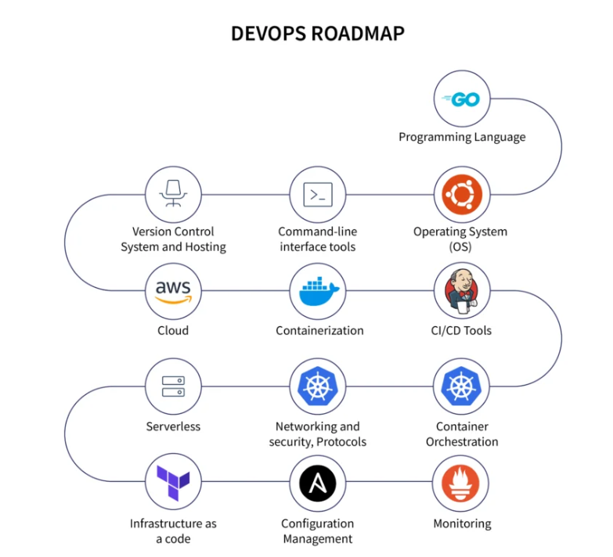

1. Learn programming languages.(Python, Ruby, Go, Node.js)
2. Study operating systems. (Linux, Unix, Windows, Sockets)
3. Version Control / Project Management Tool. (GitHub, GitLab)
4. Review networking security and protocols. (HTTP, HTTPS, SSL, SSH)
5. Understand Infrastructure as Code. (Containers, Container Orchestration, Configuration Management, Infrastructure Provisioning – Docker, Kubernetes, Terraform, Ansible, CHEF, Puppet, )
6. Explore Source Code Management and Build Tool Integration Techniques for Continuous Integration (CI):(Gradle, Maven, npm)
7. Learn How To Advance Continuous Integration For Continuous Testing (Continuous Delivery):(Jenkins, Bamboo, TeamCity)
8. Learn How To Deploy And Configure Dev, Test, And Prod Environment:(Ansible, Puppet, CHEF)
9. Invest in application and infrastructure monitoring.( Prometheus, Nagios, Datadog, New Relic, Sentry )
10. Observe cloud service providers. (AWS, Azure, Google Cloud, Heroku)
11. Study cloud design. (Data Management, Design, and Implementation)

Consider the following road map:

