1.Introduction

Team members: Krisztián Lovas (alias Shifu), Csaba László Veres, Vanda Kiss.

1.1 Topic of the project

Airsoft gun webshop.

This project aims to create a webshop where Airsoft guns can be purchased. The store offers a wide range of Airsoft-related weapons, accessories, protective gear, and uniforms categorized by types and manufacturers. Customers can choose from a selection of guns spanning from those used in World War II to modern-day weaponry.

1.2 Functions

The program features include registration and login functionalities. After registering on the site, email confirmation is required, and if someone forgets their password, they can request a new one, which also requires email confirmation. During purchases, it's possible to search for Airsoft products and filter them by weapon types (pistol, rifle, sniper rifles, WWII, modern), and manufacturers. Users can choose the type of product they want to purchase separately. There will be an info function about the selected product, where the buyer/user can learn about the operation and use of the weapon and its BIO bullets. Weapons can be compared based on their value and accuracy. The webshop includes listing, adding to cart, and purchasing functionalities. During purchase, the user needs to provide the address and other information for delivery, and whether they will pay for the product with a credit card or cash to the delivery person.

1.3 Target Audience

This online store is recommended for people interested in the Airsoft hobby, whether casually or at a serious level. We highly recommend it for both beginner and advanced Airsoft players, so they can either get acquainted with the hobby or participate in serious matches as part of teams.

2. Developer Documentation

2.1 Database

As a database, we use MySQL and XAMPP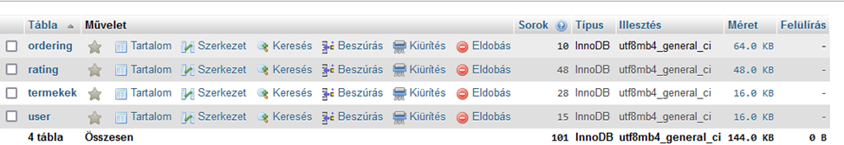

We use a database named "airsoft," which essentially consists of three important tables for now.

2.1.1 The ... Table

We have a table named "user" which contains information related to the users. Users are identified by their userID, and all essential details are stored within. This includes email address, password, profile picture, username, birth year, and their role (whether they are a regular user or an admin).

Then there is the "products" table, which contains information about the products. It includes the product ID, name, type of product (weapon, equipment, accessories, etc.), image, quantity, and price.

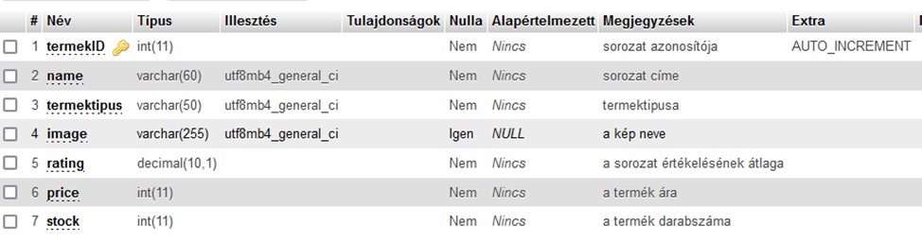

Finally, the third most important table is the "ordering" table. This table is linked to the other two tables by the productID and userID. It shows the orders, indicating which user wants to order which products and how many.

The tables are connected as follows:.

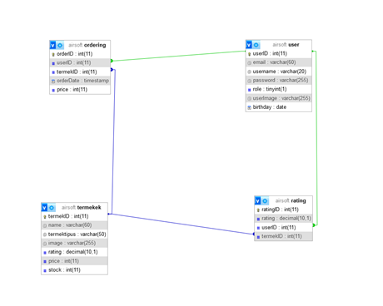

2.1.2 Developer Log:

Development Log:

Teamwork:

Three dedicated individuals worked on and developed this website. Each person had their own tasks. At work, Csabi handled programming, while Krisz and Vanda tested and reviewed Csabi's work and also assisted with design. Additionally, we continued our work on our personal computers.

Development Log:

November 2024: Material acquisition, planning, and discussions

Csabi gathered important materials about the products that could be used when uploading product images. The team thoroughly discussed what features the website should have and how it should look. After lengthy discussions, we ultimately decided to go with Csabi's vision and discussed who would do what.

December 2023: Database and registration/login development

After creating the webshop logo, Csabi started working on the database and the login and registration sections. We collectively discussed the design of the website, and Csabi wrote the backend and frontend parts. It was a bit challenging for him to position the elements properly, and during testing and checks, we encountered a few issues, but we successfully managed to complete it. Initially, only the login page was completed.

January 2024: Continuing the website development

Fortunately, the registration part was easier to write, as we learned a lot when working on the login section. This made it easy for Csabi to write the backend and frontend of the login. The website worked well during testing. After adding the 18+ permission, the main page of the Airsoft website could finally be created, but then we encountered difficulties. Numerous errors, problems, and crashes occurred, whether it was the website, frontend, backend, or database not working. At this point, we sought external help, and Csabi's friend helped stabilize the website again and provided us with useful tips.

February and March 2024: Completion of the website

After overcoming major difficulties and making fixes, we managed to restore the main page. Csabi faced serious headaches with XAMPP and SQL as they frequently froze and encountered other issues, but we finally managed to complete the website. He created the Admin and User sections, added purchasing, search, and other functionalities. There are still errors in the cart and ordering sections that we haven't figured out yet. The website is mostly done, but it's still under development, and there may be minor bugs that need patching.

3. User Documentation:

3.1 Program

When entering the Airsoft Arsenal website, a window pops up asking whether the user is over 18 years old. If not, it redirects them and does not allow entry. If yes, users can register and log in. This is necessary because even though Airsoft guns are not real firearms, they can still pose risks if used improperly, leading to accidents. Therefore, this feature ensures that only experienced users who understand the risks can access the website, preventing minors from entering.

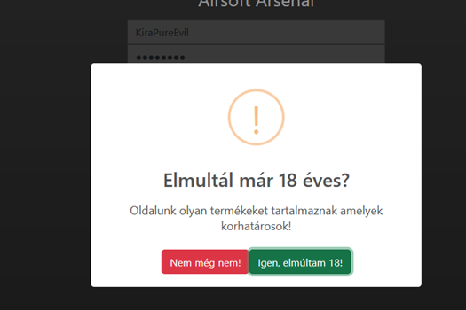

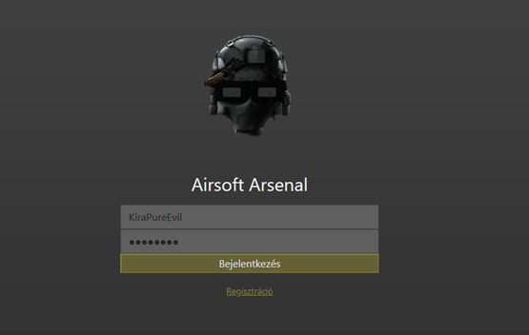

After clicking the "Yes, I am over 18!" button, the user is greeted with this interface. During login, the user needs to provide an email address and password, but if they don't have one, they obviously need to register. During registration, they need to provide an email, a username, and a password (which needs to be entered twice to avoid accidental typos, and it must be a complex password including uppercase and lowercase letters, numbers, and a minimum number of characters. Otherwise, the password will not be accepted). There is also a feature that allows the user to make the password visible after registration to ensure it is not mistyped. The website also has a unique logo depicting an airsoft helmet.

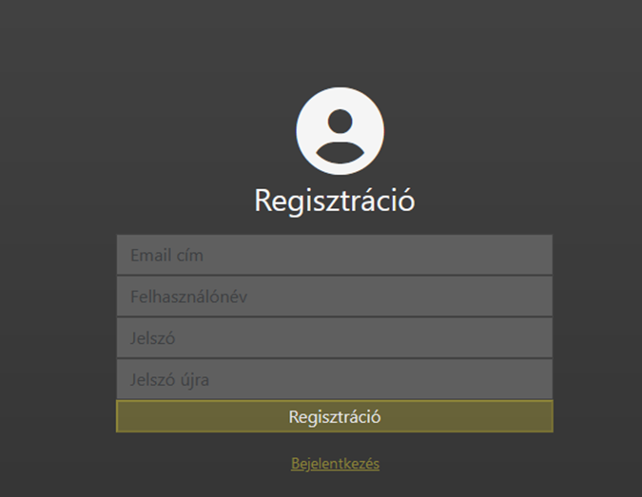

After logging in, depending on the role, users will be directed to the corresponding interface.

User Interface:

If it's just a regular user, this is the interface they'll see.

Here you can find the products and filter them during the search. If you know the name of what you want to buy, you type it in and it pops up. Or if you want to buy a certain type of product (e.g., only weapons), there are options at the top like "Weapons", "Equipment", and "Maintenance". Obviously, if you choose "Weapons", it will prioritize that and only show weapons.

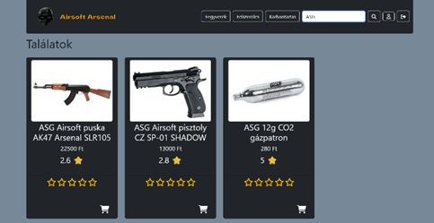

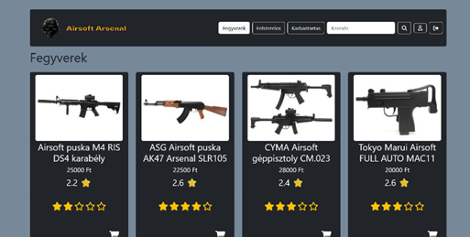

When the user logs out and clicks on the user icon (the little person) between searches, it displays the user's profile data on the left side. Here, the user can modify their data except for email and role. In the profile, the user can also modify their data by clicking on a small yellow box if there are any changes.

After selecting which product they want to buy, the user presses the cart button and purchases as much as they can, and as much as is available. Otherwise, it won't allow the purchase if the product is out of stock.

In the bottom right corner, there's a black cart within a yellow circle. Clicking on it, the user can confirm the order. After confirming the order, this data will be inserted into the ordering table. The cart functionality is implemented using a sweet alert.

Before making the purchase, it will ask if the user is sure they want to buy.

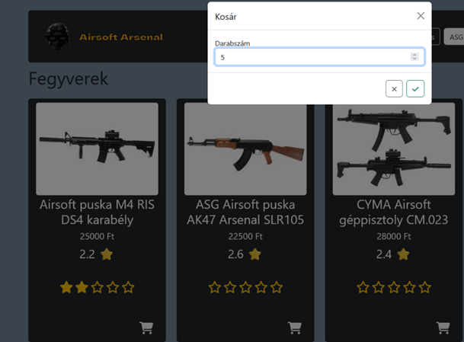

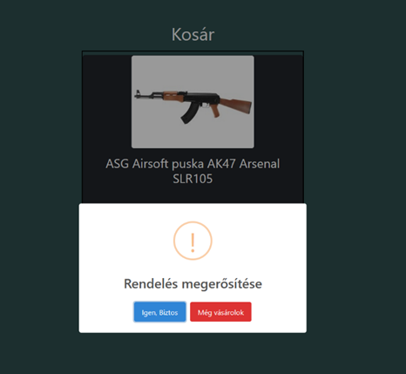

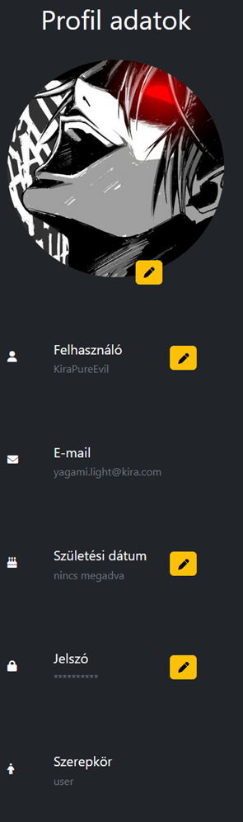 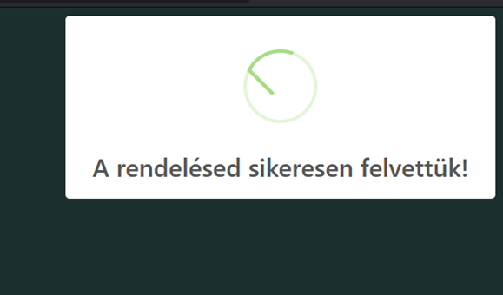

Admin chapter:

If a user has an admin role, they can see this view. It looks similar, but has different functionalities than what an average user would have.

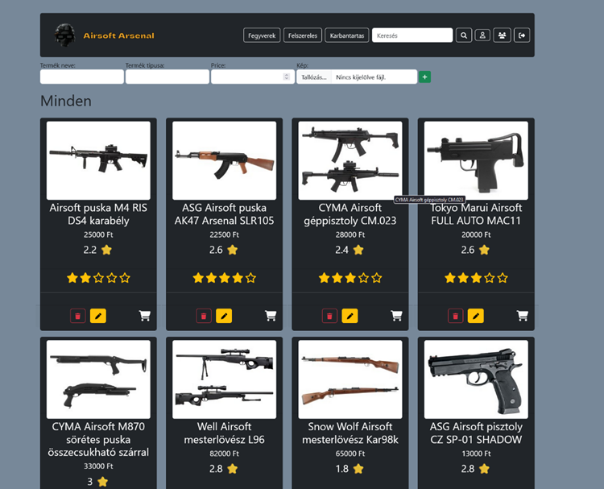

The Admin is capable of editing, modifying, and adding new products. They also have another interface where they can essentially see the users, modify their roles (so they can give or take admin rights), and delete users. They can search for users based on any user data, and the admin, on the other hand, can also edit and delete products.

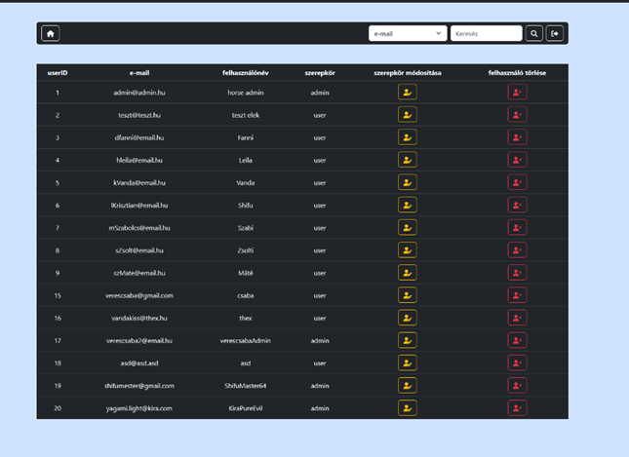

Testing

For our project, we created a separate folder for testing, which tests the program, logs in, and throws errors. We used Selenium WebDriver for this, installed in the folder, where we can specify which browser to open the website in. Our testing program differs in that our homepage uses SweetAlert, so testing is done differently but works perfectly fine. There's a test.js limited to one browser and a test2.js used for multiple browsers. Its function is to open the website in all installed browsers on the machine. It's important to note that if we specify a browser that isn't installed on the machine, the test will fail. (Supported browsers: Chrome, Firefox, Opera, Microsoft Edge, etc.). Also, as mentioned earlier, our homepage has a slightly different layout, so our code includes an additional security confirmation for age verification.

How it was made + simplification:

Our testing folder was built in Visual Studio with a new program for testing. It consists of test.js and test2.js. test.js is optimized for one browser, while test2.js is optimized for multiple browsers. It's crucial to emphasize that the test will only work with the browsers installed on the machine.

Here is a part of the test program specifically designed for a single browser.

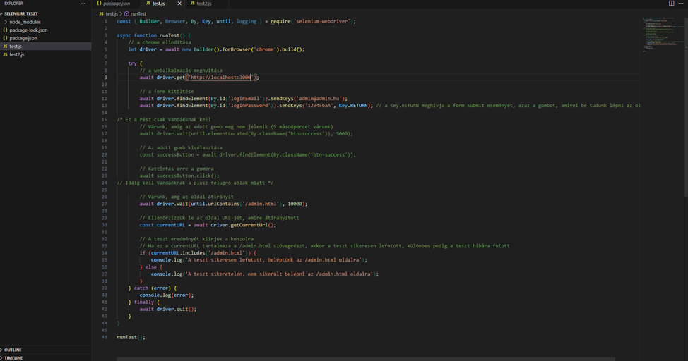

The second image shows the code for testing across multiple browsers.

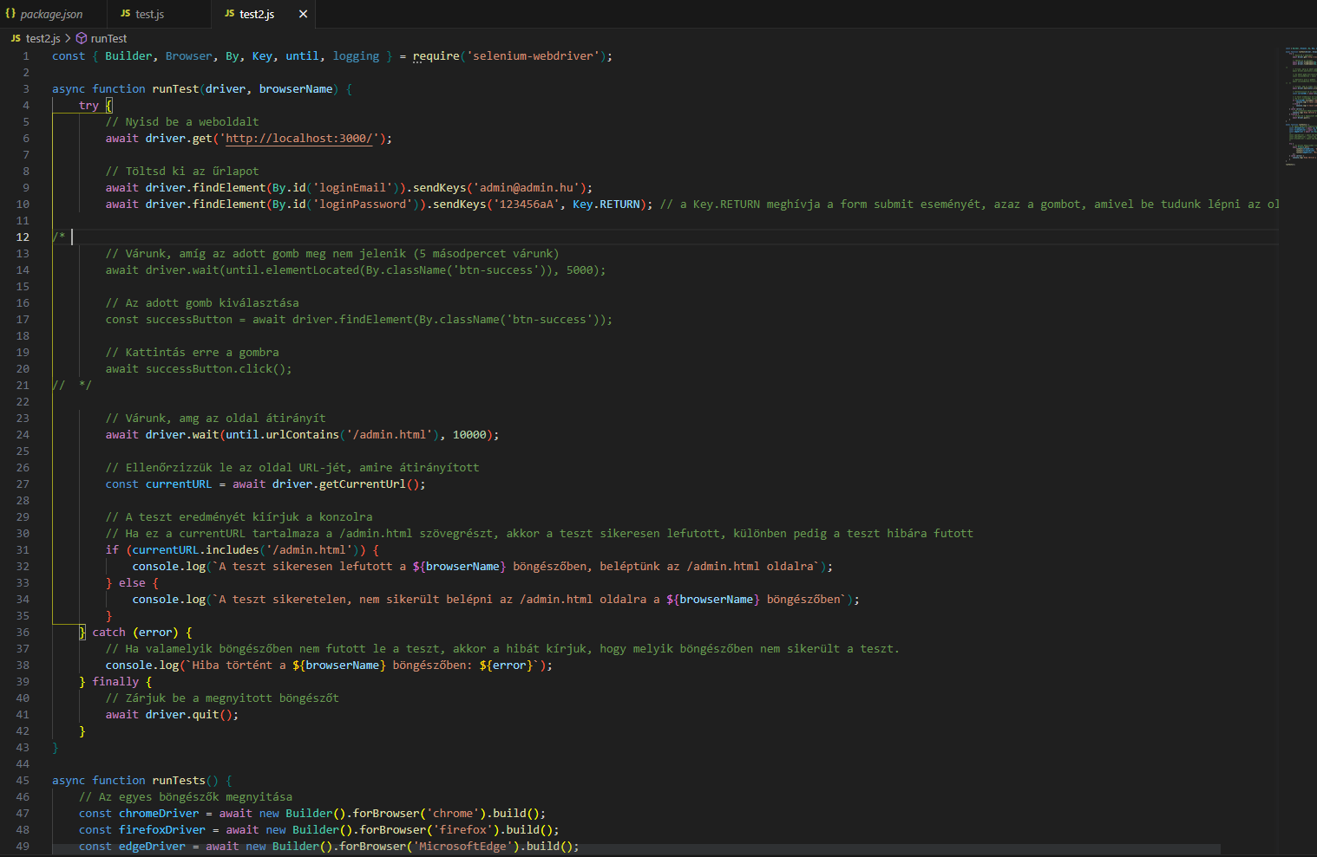

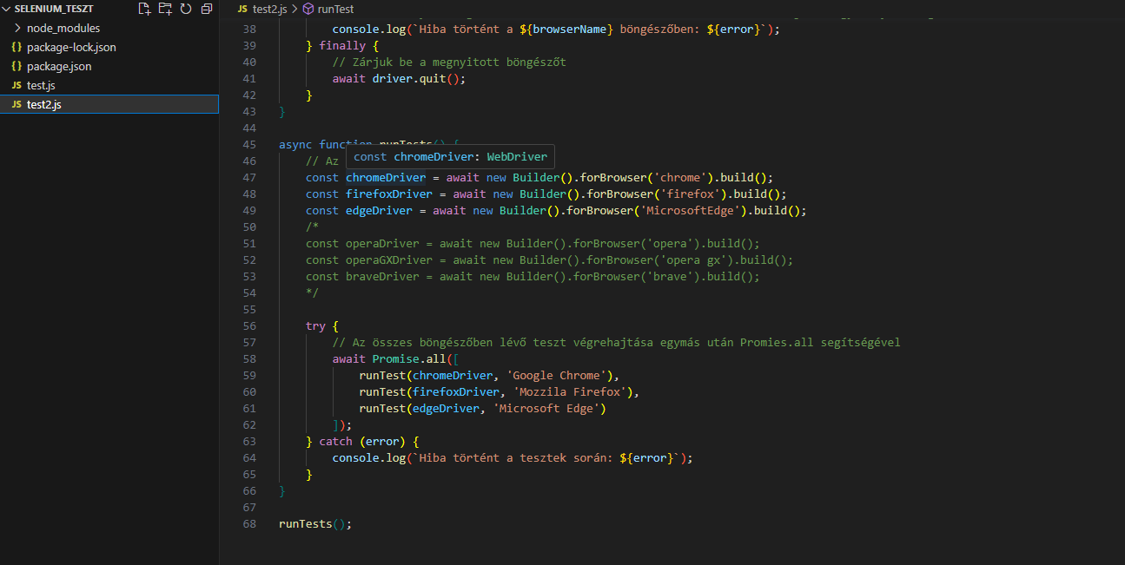

Our backend program is running concurrently, and it logs whether the login/authentication was successful or not.

