Технології програмування
Лабораторна робота №3
Бодяк Олександр
КБ-242
ООП
Мета роботи: Використовуючи теоретичне підґрунтя про ООП у мові Python переробити програму телефонного довідника студентів використовуючи принципи ООП для формування відомостей про студентів.
Хід виконання завдання:
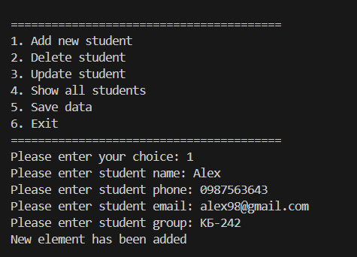
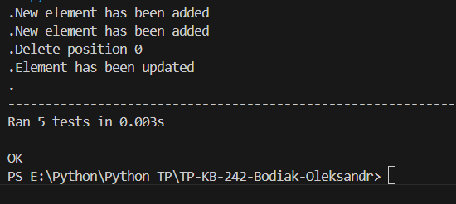

Текст програми:
Main.py:
import Student_list
import Student
import Utils

def main():
file = Utils.File("lab_3.csv")
student_list = Student_list.StudentList()

data_from_csv = file.read()
student_list.students = data_from_csv

def save_data():
file.write(student_list.students)
print("Data saved to CSV.")

while True:
print("\n" + "="*40)
print("1. Add new student")
print("2. Delete student")
print("3. Update student")
print("4. Show all students")
print("5. Save data")
print("6. Exit")
print("="*40)
choice = input("Please enter your choice: ")

if choice == "1":
student_list.addNewElement()
elif choice == "2":
student_list.deleteElement()
elif choice == "3":
student_list.updateElement()
elif choice == "4":
student_list.showAllElements()
elif choice == "5":
save_data()
elif choice == "6":
print("Saving data...")
save_data()
print("Exiting the program.")
break
else:
print("Invalid choice. Please try again.")

if __name__ == "__main__":
main()

Student_list.py:
from Student import Student

class StudentList:

def __init__(self):
self.students = []

def addNewElement(self):
name = input("Please enter student name: ")
phone = input("Please enter student phone: ")
email = input("Please enter student email: ")
group = input("Please enter student group: ")

new_student = Student(name, phone, email, group)

insertPosition = 0
for student in self.students:
if name > student.name:
insertPosition += 1
else:
break

self.students.insert(insertPosition, new_student)
print("New element has been added")
return

def deleteElement(self):
name = input("Please enter name to be deleted: ")
deletePosition = -1

for item in self.students:
if name == item.name:
deletePosition = self.students.index(item)
break

if deletePosition == -1:
print("Element was not found")
else:
print("Delete position " + str(deletePosition))
del self.students[deletePosition]
return

def updateElement(self):
name = input("Please enter name to be updated: ")
deletePosition = -1

for item in self.students:
if name == item.name:
deletePosition = self.students.index(item)
break

if deletePosition == -1:
print("Element was not found")
else:
del self.students[deletePosition]

name = input("Please enter student name: ")
phone = input("Please enter student phone: ")
email = input("Please enter student email: ")
group = input("Please enter student group: ")

new_student = Student(name, phone, email, group)

insertPosition = 0
for student in self.students:
if name > student.name:
insertPosition += 1
else:
break

self.students.insert(insertPosition, new_student)
print("Element has been updated")
return

def showAllElements(self):
for item in self.students:
print("Name: " + item.name + ", Phone: " + item.phone + ", Email: " + item.email + ", Group: " + item.group)
return

Student.py:
class Student:
def __init__(self, name, phone, email, group):
self.name = name
self.phone = phone
self.email = email
self.group = group

@property
def name(self):
return self._name

@name.setter
def name(self, value):
self._name = value

@property
def phone(self):
return self._phone

@phone.setter
def phone(self, value):
self._phone = value

@property
def email(self):
return self._email

@email.setter
def email(self, value):
self._email = value

@property
def group(self):
return self._group

@group.setter
def group(self, value):
self._group = value

Unit_tests_lab_03.py:
import unittest
import os
from unittest.mock import patch
from io import StringIO
from Student import Student
from Student_list import StudentList
from Utils import File

class TestStudentList(unittest.TestCase):

def setUp(self):
self.student_list = StudentList()

self.student_list.students = [
Student("Andriy", "+380501111111", "andriy@gmail.com", "КБ-241"),
Student("Maria", "+380502222222", "maria@gmail.com", "КБ-242")
]

def test_addNewElement(self):

initial_count = len(self.student_list.students)

with patch("builtins.input", side_effect=["Oleg", "+380503333333", "oleg@gmail.com", "КБ-243"]):
self.student_list.addNewElement()

self.assertEqual(len(self.student_list.students), initial_count + 1)
names = [s.name for s in self.student_list.students]
self.assertIn("Oleg", names)

self.assertTrue(names.index("Andriy") < names.index("Maria") < names.index("Oleg"))

def test_deleteElement_found(self):

initial_count = len(self.student_list.students)

with patch("builtins.input", return_value="Andriy"):
self.student_list.deleteElement()

self.assertEqual(len(self.student_list.students), initial_count - 1)
names = [s.name for s in self.student_list.students]
self.assertNotIn("Andriy", names)

def test_updateElement_found_and_resorted(self):

with patch("builtins.input", side_effect=["Andriy", "Aaron", "+380509999999", "aaron@gmail.com", "КБ-245"]):
self.student_list.updateElement()

names = [s.name for s in self.student_list.students]
self.assertIn("Aaron", names)
self.assertNotIn("Andriy", names)

self.assertEqual(names[0], "Aaron")
self.assertEqual(names[1], "Maria")

updated_student = self.student_list.students[0]
self.assertEqual(updated_student.phone, "+380509999999")

class TestFileHandler(unittest.TestCase):

def setUp(self):
self.test_file = "test_students_top5.csv"
self.csv_handler = File(self.test_file)

self.students = [
Student("Ivan", "+380501234567", "ivan@gmail.com", "КБ-241"),
Student("Maria", "+380509876543", "maria@gmail.com", "КБ-242")
]

def tearDown(self):
if os.path.exists(self.test_file):
os.remove(self.test_file)

def test_read_write_cycle(self):

self.csv_handler.write(self.students)
read_students = self.csv_handler.read()

self.assertEqual(len(read_students), len(self.students))

for i in range(len(self.students)):
self.assertEqual(read_students[i].name, self.students[i].name)
self.assertIsInstance(read_students[i], Student)

class TestIntegration(unittest.TestCase):

def setUp(self):
self.test_file = "test_integration_top5.csv"
self.csv_handler = File(self.test_file)
self.student_list = StudentList()

def tearDown(self):
if os.path.exists(self.test_file):
os.remove(self.test_file)

def test_full_workflow(self):

initial_students = [Student("Anna", "+380501111111", "anna@gmail.com", "КБ-241")]

self.csv_handler.write(initial_students)
self.student_list.students = self.csv_handler.read()
self.assertEqual(len(self.student_list.students), 1)

with patch("builtins.input", side_effect=["Victor", "+380503333333", "victor@gmail.com", "КБ-242"]):
self.student_list.addNewElement()

self.csv_handler.write(self.student_list.students)

final_students = self.csv_handler.read()
self.assertEqual(len(final_students), 2)
self.assertEqual(final_students[0].name, "Anna")
self.assertEqual(final_students[1].name, "Victor")

if __name__ == "__main__":
unittest.main(argv=['first-arg-is-ignored'], exit=False)

Utils:
import csv
from Student import Student

class File:
def __init__(self, filename):
self.filename = filename

def write(self, students):
if not students:
return

data = []
for student in students:
data.append({
'name': student.name,
'phone': student.phone,
'email': student.email,
'group': student.group
})

with open(self.filename, "w", newline='', encoding='utf-8') as f:
writer = csv.DictWriter(f, fieldnames=['name', 'phone', 'email', 'group'])
writer.writeheader()
writer.writerows(data)

def read(self):
students = []
try:
with open(self.filename, "r", encoding='utf-8') as f:
reader = csv.DictReader(f)
for row in reader:
student = Student(row['name'], row['phone'], row['email'], row['group'])
students.append(student)
except FileNotFoundError:
print(f"Файл {self.filename} не знайдено. Створено пустий список.")
except Exception as e:
print(f"Помилка при зчитуванні файлу: {e}")

return students

Посилання на github:
https://github.com/VeDeTeY/TP-KB-242-Bodiak-Oleksandr/tree/main/lab_03
Знімок екрану з посилання на github:
Main.py:
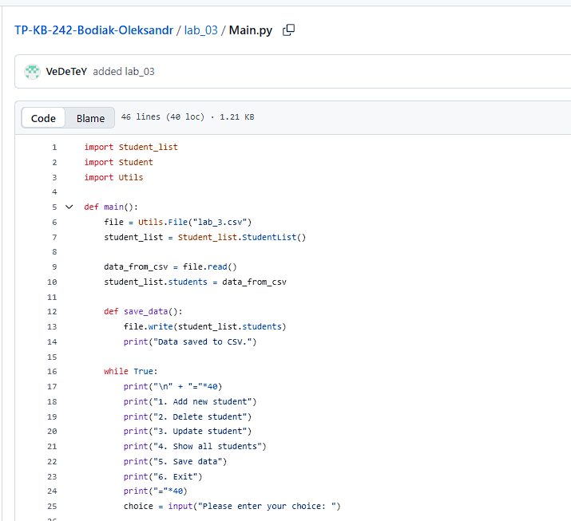
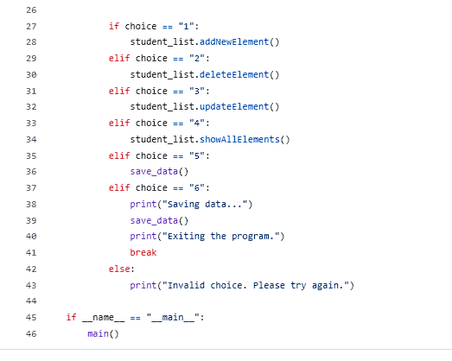
Student_list.py:
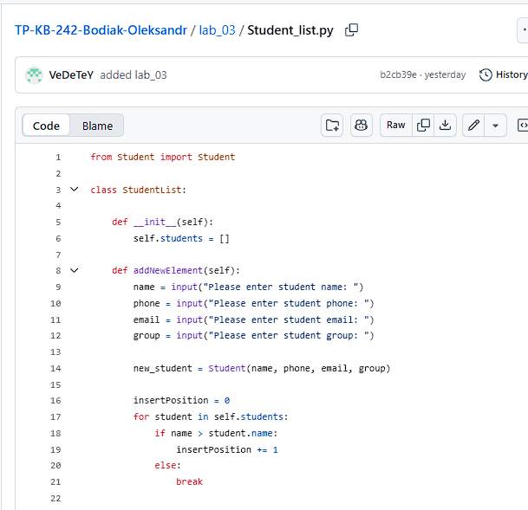
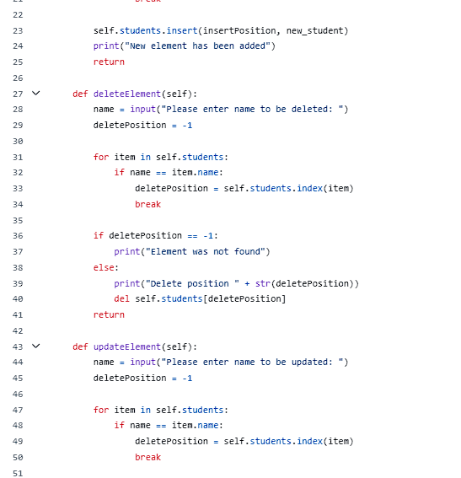
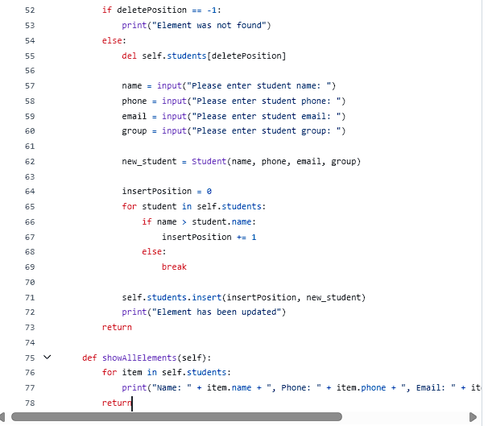
Student.py:
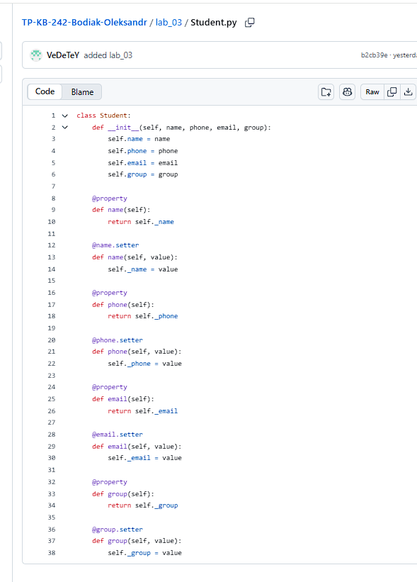
Unit_tests_lab_03.py:
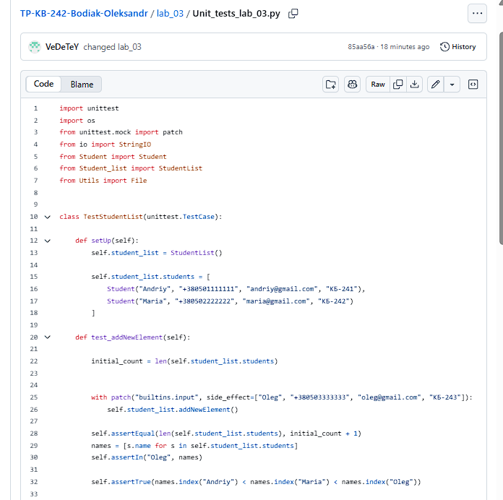
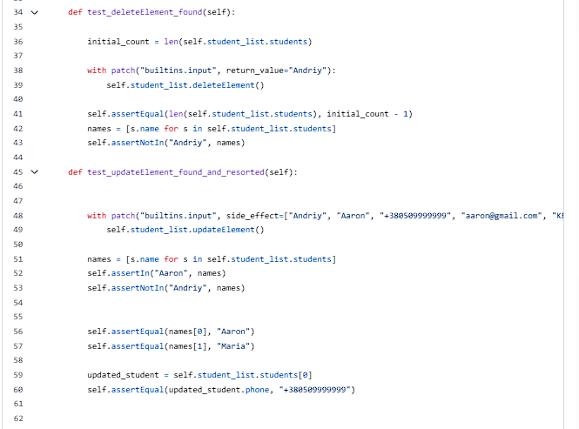
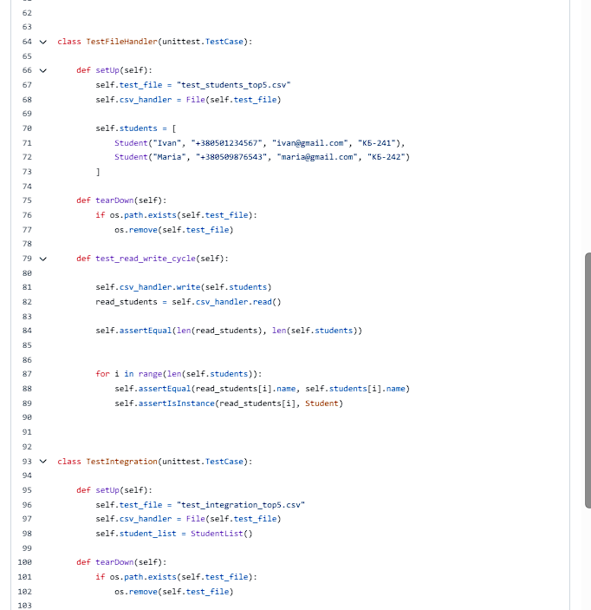
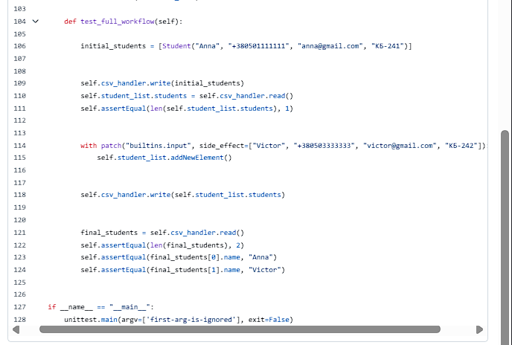
Utils:
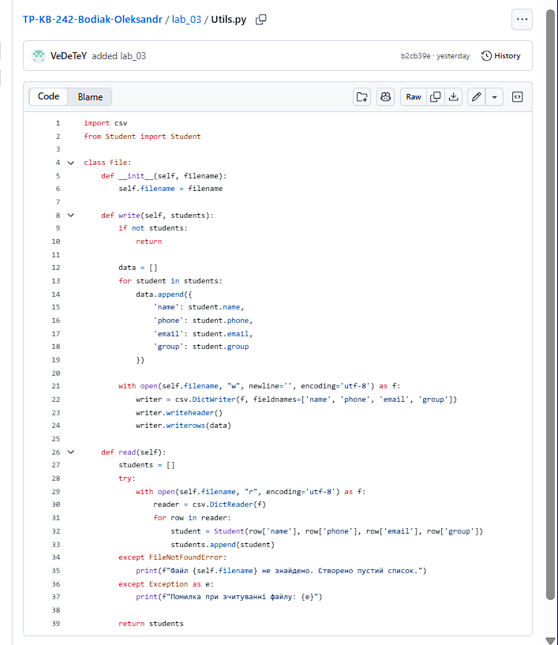
Висновок : використовуючи теоретичне підґрунтя про ООП дописав уже існуючий код, доробив програму додавши функціонал, що був указаний в завданні до лабораторної роботи. У ході виконання цієї лабораторної роботи розвинув вже існуючі та здобув нові навички. У ході виконання цієї лабораторної роботи я зміг використати свої навички на практиці.

